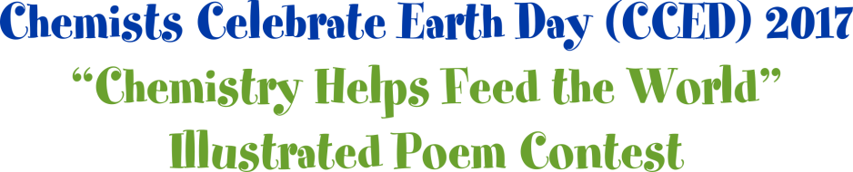

The [Section Name] Local Section of the American Chemical Society (ACS) is sponsoring an illustrated poem contest for students in Kindergarten through 12th grade.

Contest Deadline: [Enter Deadline]

Prizes: [Enter Prize Information]
Contact: [Enter contact and address information for submission]
Winners of the [Section Name] Local Section’s Illustrated Poem Contest will advance to the ACS National Illustrated Poem Contest for a chance to be featured on the ACS website and to win prizes!

Write and illustrate a poem using the CCED theme, “Chemistry Helps Feed the World.” Your poem must be no more than 40 words and in the following styles to be considered:

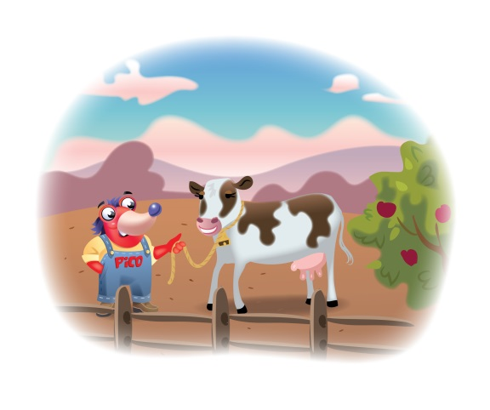
HAIKU - LIMERICK - ODE - ABC POEM - FREE VERSE - END RHYME - BLANK VERSE

Possible topics related to agriculture and chemistry include:
Crops Starch Sugars
Protein Fertilizer Carbohydrate

Entries will be judged based upon:

Contest Rules:
- Poems must conform to a particular style. No poem may be longer than 40 words.
- The topic of the poem and the illustration must be related to the CCED 2017 theme.
- All entries must be original works without aid from others.
- Each poem must be submitted and illustrated on an unlined sheet of paper (of any type) not larger than 11” x 14”. The illustration must be created by hand using crayons, watercolors, other types of paint, colored pencils, or markers. The text of the poem should be easy to read and may be printed with a computer before the hand-

drawn illustration is added, or the poem may be written on lined paper which is cut out and pasted onto the unlined paper with the illustration.
- Only one enter per student will be accepted.
- All entries must include an entry form.
- All illustrated poems and/or digital representations of the poems become the property of the American Chemical Society.
- Acceptance of prizes constitutes consent to use winners’ names, likenesses, and entries for editorial, advertising, and publicity purposes.
Relevance to and incorporation of the theme
Word choice and imagery
Colorful artwork

