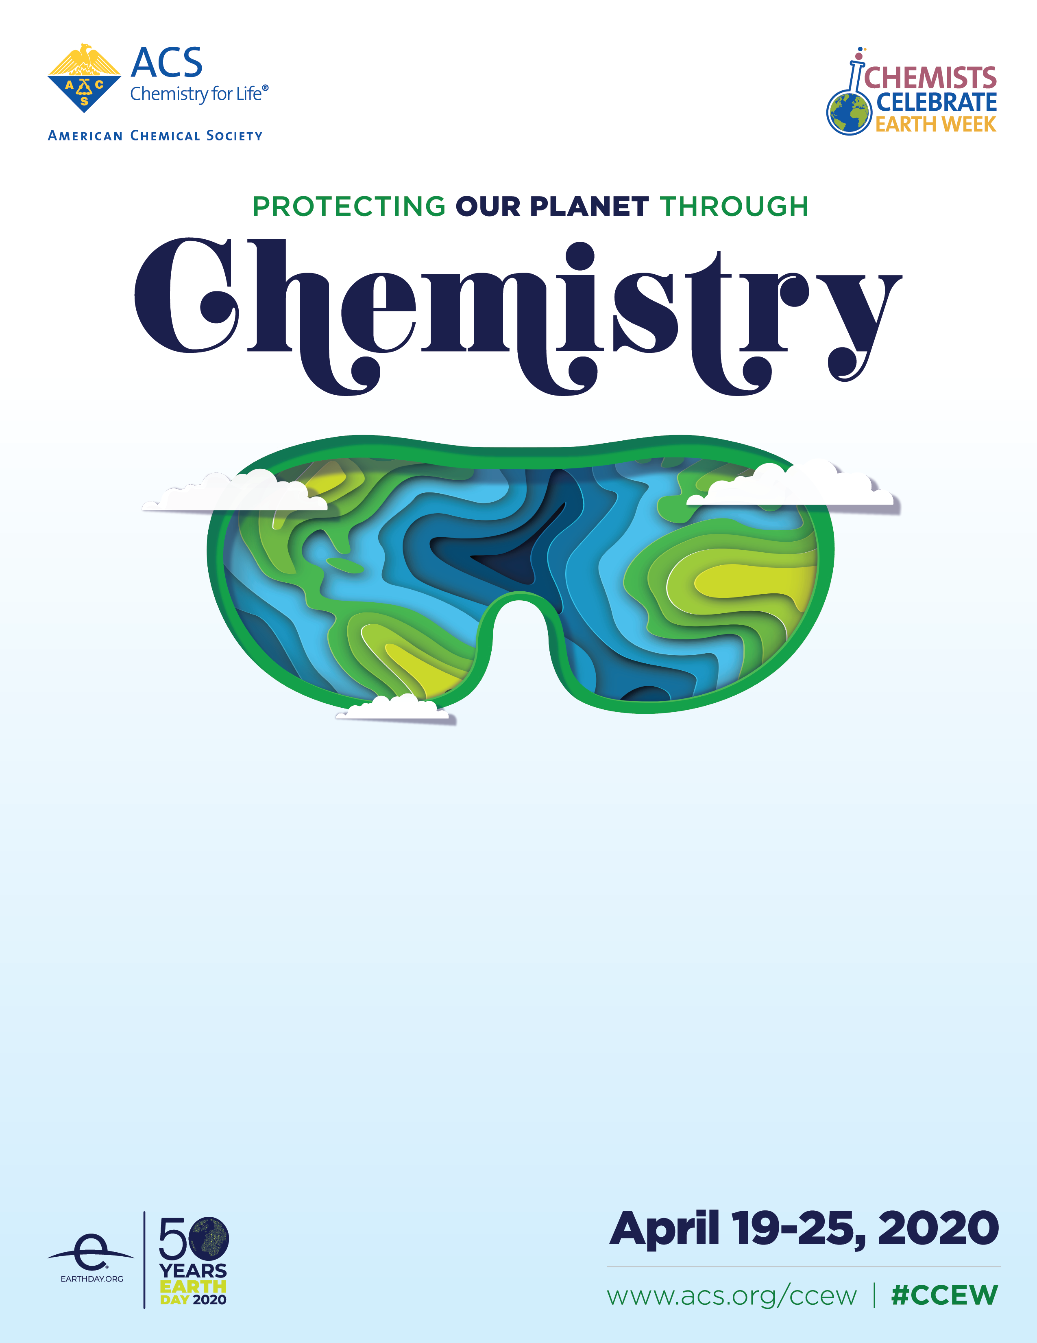

FREE HANDS-ON SCIENCE COMMUNITY EVENT

Join the [Name] Local Section of the American Chemical Society for a free community event for Chemists Celebrate Earth Week and celebrate the 50th anniversary of the world’s largest environmental movement, Earth Day! Learn about this year’s sustainability theme with [Number] exciting hands-on activities.

When: [Date and time of your event]
Where: [Location of your event]

Questions about the event, please contact [Your name] at [Your email].

We hope to see you there!

