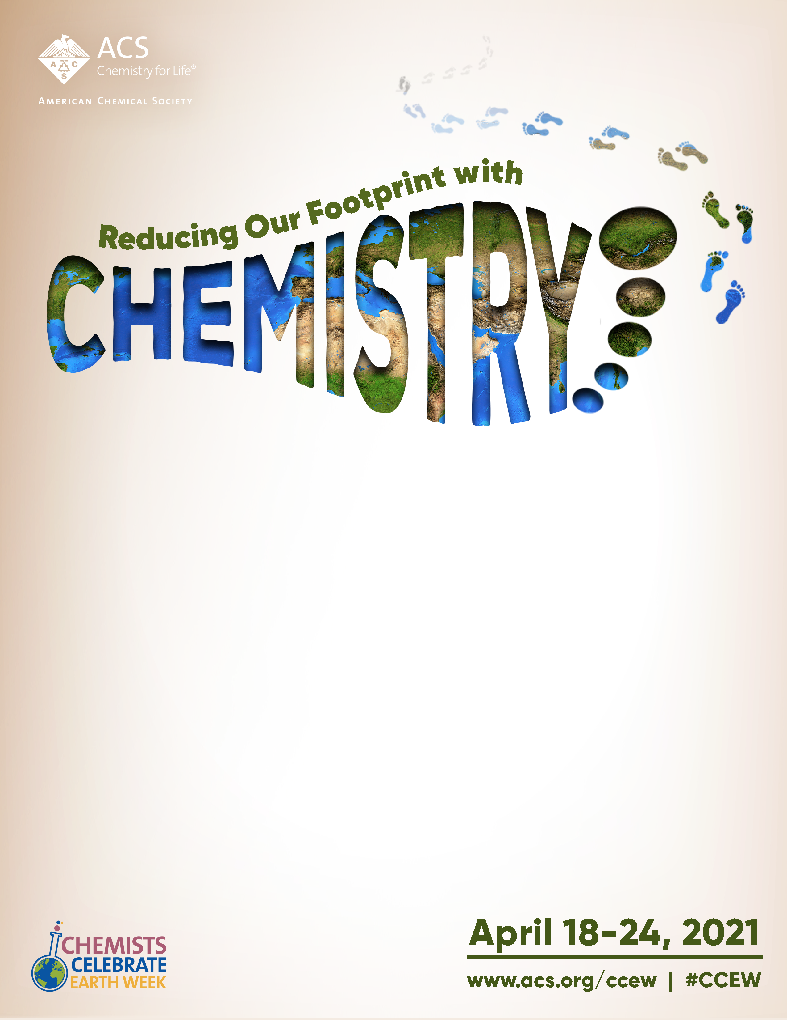

FREE HANDS-ON SCIENCE COMMUNITY EVENT

Join the [Name] Local Section of the American Chemical Society for a free community event for Chemists Celebrate Earth Week and celebrate the importance of chemistry for maintaining our environment! Learn about this year’s theme, Reducing Our Footprint with Chemistry, with [Number] exciting virtual activities.

WHEN: [Date and time of your event]
WHERE: [Location of your event]

Questions about the event, please contact [Your name] at [Your email].
We hope to see you there!

