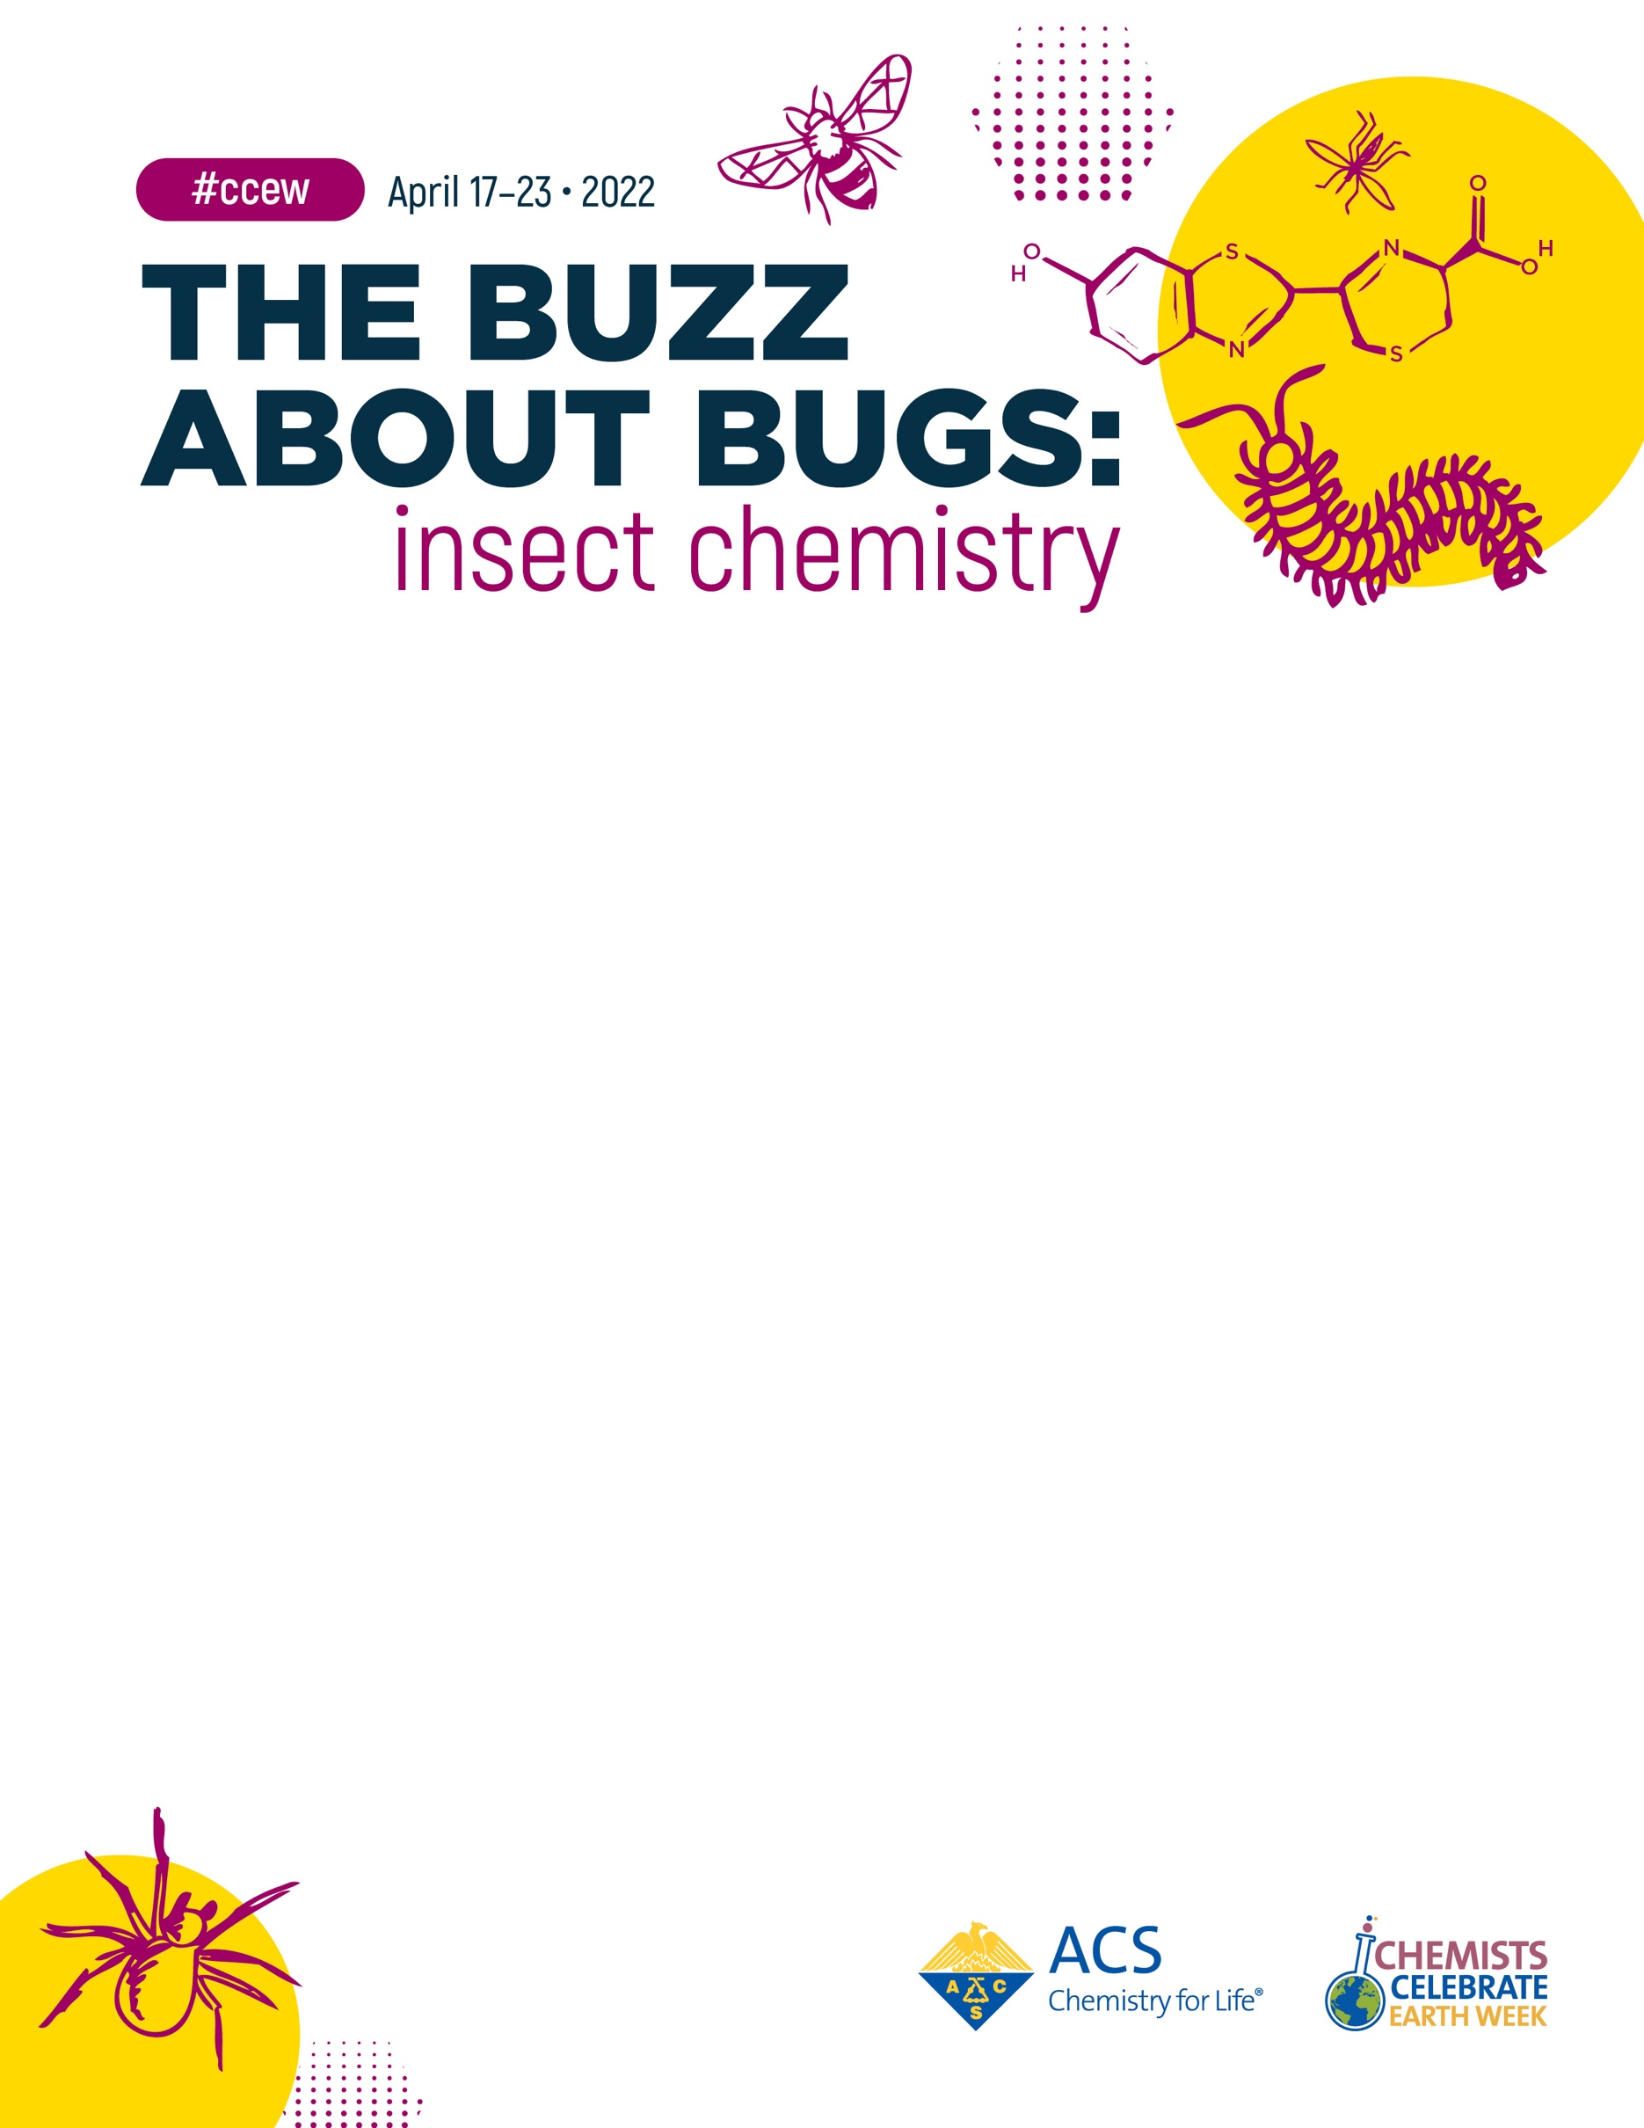

Join the [ACS Group Name] of the American Chemical Society for a free community event for Chemists Celebrate Earth Week and celebrate the importance of chemistry in everyday life! Learn about this year’s theme, The Buzz about Bugs: Insect Chemistry with [Number] exciting [virtual/hands-on] activities.

When: [Date and time of your event]
Where: [Location of your event]

Questions about the event, please contact [Your name] at [Your email].

We hope to see you there!

