2022 CCEW Illustrated Poem Contest

The Buzz About Bugs: Insect Chemistry

The [Section Name] Local Section of the American Chemical Society (ACS) is hosting an illustrated poem contest for students in Kindergarten through 12th grade. Entries must be sponsored by a local school or community group for verification purposes.

Contest Deadline: Sunday, April 24, 2022 at 11:59 PM Eastern
Local Prizes: [Enter prize information]
Local Contact: [Enter contact and email address]
Submission: [Enter submission information]

Winners of the [Section Name] Local Section’s Illustrated Poem Contest will advance to the National Illustrated Poem Contest for a chance to be featured on the ACS website and to win prizes!

Write and illustrate a poem using the CCEW theme, “The Buzz About Bugs: Insect Chemistry.” Your poem must be no more than 40 words and in the following styles to be considered:
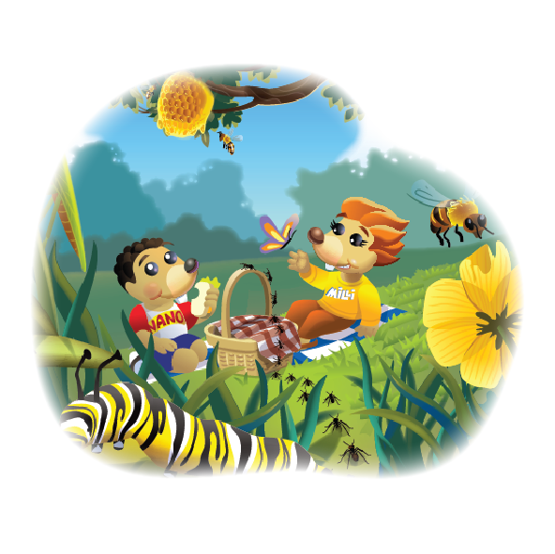
HAIKU - LIMERICK - ODE - ABC POEM - FREE VERSE - END RHYME - BLANK VERSE

Possible topics related to the CCEW 2022 theme include:
Entomology Eating Insects Insect Molecules
Insect Bites Pollination Pollinators

Entries will be judged based upon:
Artistic Merit - use of color, quality of drawing, design & layout
Poem Message - fun, motivational, inspiring about yearly theme
Originality Creativity - unique, clever and/or creative design
Neatness - free of spelling and grammatical errors

Contest rules:

- All poems must be no more than 40 words, and in one of the following styles to be considered: Haiku, Limerick, Ode, ABC poem, Free verse, End rhyme, and Blank verse.
- Entries are judged based upon relevance to and incorporation of the yearly theme (The Buzz about Bugs: Insect Chemistry), word choice and imagery, colorful artwork, adherence to poem style, originality and creativity, and overall presentation.
- All entries must be original works without aid from others. Physical drawings may be scanned or captured via camera and submitted to the online form. Illustrations may be created using crayons, watercolors, other types of paint, colored pencils, or markers.
- The illustration may also be electronically created by using a digital painting and drawing app on a computer, tablet, or mobile device. If the illustration is created using a digital painting or drawing app, the name of the program must be included on the entry form.

- The text of the poem should be easy to read and may be typed before the hand-drawn or digital illustration is added, or the poem may be written on lined paper, which is cut out and pasted onto the unlined paper with the illustration.
- No clipart or unoriginal images can be used.
- Only one entry per student will be accepted.
- Students must be sponsored by a school or another sponsoring group (e.g. Homeschool Association, Boys and Girls Club, Scout Troop, 4-H, etc.).
- All illustrated poems and/or digital representations of the poems become the property of the American Chemical Society.
- Acceptance of prizes constitutes consent to use winners’ names, likenesses, and entries for editorial, advertising, and publicity purposes.

