Color with Bugs
  - Facilitator Led Tabletop Activity
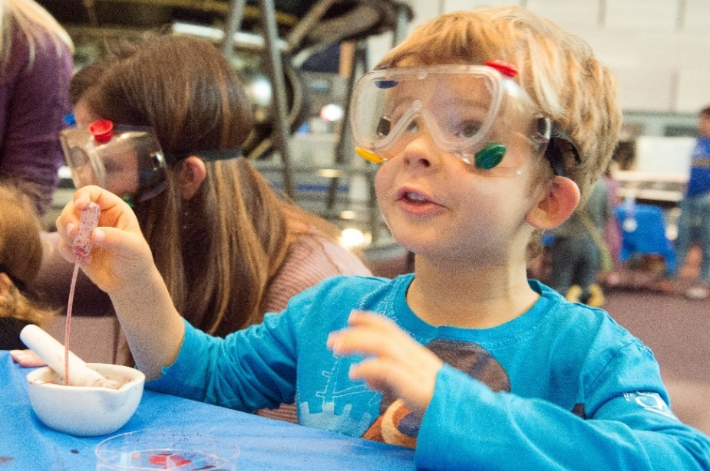

Crush cochineal beetles and add water to make a vibrant color-changing dye. Add drops of clear colorless citric acid and sodium carbonate solutions, test with pH paper, and explore what might happen if you mix the solutions together. Finally, use the resulting beetle juice to make a bright beautiful bookmark.

Question to investigate
Which colors can I make with cochineal beetle juice?

Chemistry concepts
- Ancient people used cochineal beetles and chemistry to color fabric!
- Cochineal beetle juice and pH paper, change color with acids and bases.
- Acids and bases are chemical opposites.

Activity logistics
- Ages: As written, this activity is best suited for elementary and middle school students.
- Group Size: This activity serves up to 48 children or teens over a period of 2 hours, with each iteration of the activity lasting approximately 10 minutes.
- Set-up: Arrange the materials along one side of an 8-foot table into four stations to reach up to four children at once.
- Facilitators: One facilitator can comfortably manage two stations at the same time.

Prepare in advance

What you’ll need

- 4 mortar and pestle sets
- Water in a cup
- 48 plastic droppers or pipets
- Sodium carbonate
- Citric acid
- 8 dropper bottles, 60 mL
- 4 clear plastic cups
- 2 scoops, 5 mL or teaspoon size
- Cotton string
- Heavy watercolor paper
- Scissors
- Hole-punch
- Paper towels
- Labels for the solutions
- pH paper
- Two printouts of the pH scale
- Cochineal beetle information card
- 250 mL beaker or similar-sized container
- 2 funnels
- 48 snack-sized zip-closing
plastic bags
- 4 clear plastic plates or Petri dishes
- 4 white plastic plates or
a solid white background
- 4 spill trays
- 4 sets of tongs
- 1 rinse container

Notes about the materials
- Each participant needs 2 dried cochineal beetles to conduct this activity.
The color is quite vibrant with this small number.
- This activity has been adapted from the Nature of Dye activity, which is one of eleven facilitator-supported hands-on activities together, titled, Explore Science: Let’s Do Chemistry from the National Informal STEM Education Network.
- Heavy-weight watercolor paper works better than cardstock or printer paper to make the bookmarks as it does not distort when it gets wet.

Make the solutions
- Add four scoops (20 mL by volume) of sodium carbonate to 240 mL of water.
Stir until dissolved.
- Use a funnel to pour the solution into four dropper bottles labeled sodium carbonate.
Secure the dropper tip and then the cap on each bottle.
- Add four scoops (20 mL by volume)
of citric acid to 240 mL of water.
Stir until dissolved.
- Use a funnel to pour the solution into four labeled dropper bottles labeled citric acid. Secure the dropper tip and then the cap on each bottle.

Prepare the blank bookmarks
- Cut the watercolor paper into strips 1-inch wide and 4 ½ inches long. Use a small hole punch to poke a hole in the center at one end.
- Cut cotton string into 6-inch lengths. Fold in half and loop through the hole.

Prepare on-site

Prepare four stations to accommodate up to four participant groups at one time
- Arrange four divided trays along the front of the table. Items on each tray as shown.
Dropper bottles with citric acid and sodium carbonate solutions
and tongs
Cup of water with a clean dropper

Mortar and pestle
with 2 cochineal beetles

- Place a clear plastic plate or Petri dish on top of four white plastic plates or pieces of paper and position just to the right of each tray.
- Place one blank bookmark just above each plate or petri dish.
- Half-fill the rinse container with water and place near the facilitator.
- Place paper towels and a trash bag or small trash receptacle near the facilitator. This mortar and pestle and clear plastic plate need to be cleaned between participants.

Facilitate the activity

Invite participation
- Introduce the activity by asking students if they’d like to paint with beetle juice.
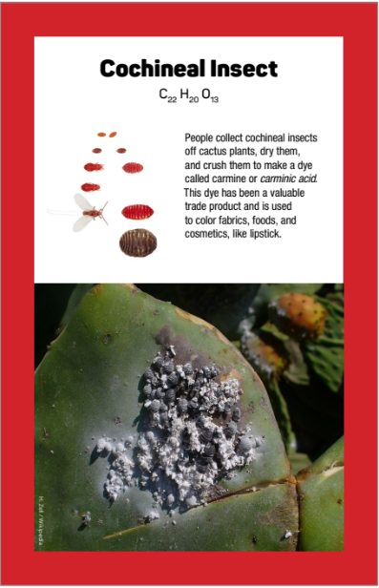
To make beetle juice, first, we need to crush some beetles!
There are two dried cochineal beetles in this mortar that you can crush with this pestle. Before you do, though, take a close look to see if you see any evidence that these little pieces were once living beetles.

[Show the cochineal beetle card.] Cochineal beetles live on cacti throughout the Southwestern portion of the United States, Mexico, Central America, and South America. The ancient Aztec and Maya peoples used the dye to color fabrics and this dye is still used today in make-up and some foods, such as red lipstick and pink or purple yogurt. So, you may have touched or tasted a product that used the amazing color from crushed cochineal beetles.

Are you ready to make some of this special beetle juice?
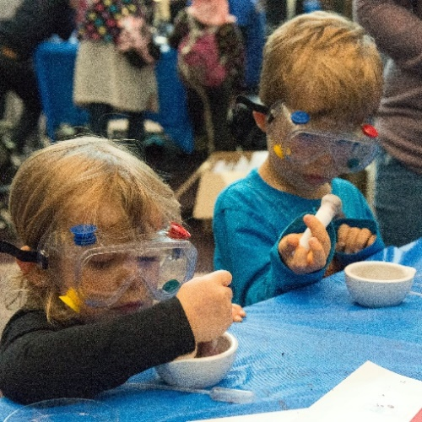

Support Exploration
- Instruct participants to make the beetle juice.
[If they aren’t there already, add two dried cochineal beetle bits to the mortar and pestle.] Use the mortar and pestle to crush the beetles into a powder. Then use the dropper to add two droppers-full of water to the mortar. Use the pestle to stir well.
- Transfer the beetle juice to a plate for testing.
Use your dropper to pick up the beetle juice and make
4 big dots on the clear plastic plate.
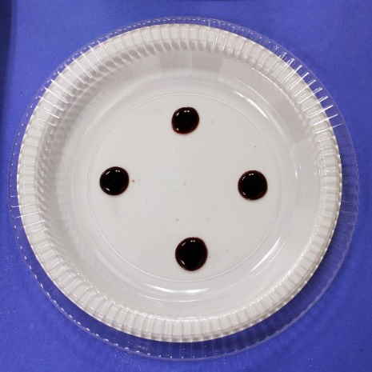
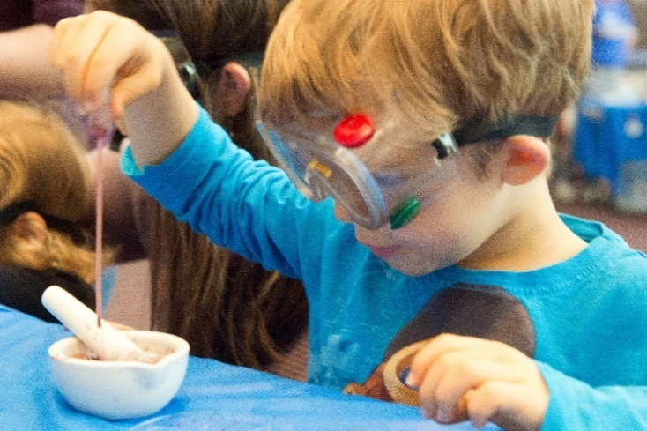

Deepen Understanding
- Use 2 pH testing strips to test the pH of citric acid and sodium carbonate solution.
We are going to add drops of citric acid and sodium carbonate solution to the drops on your plate. But before we do, I want to check something. Both liquids look the same, but they act differently when they combine with other substances. Let’s use a tool of chemistry, pH paper, to find out one way that they are different.

[Hand each participant two pieces of pH paper—one for each hand. Open the sodium carbonate solution and add one drop to one of the pieces of paper.]
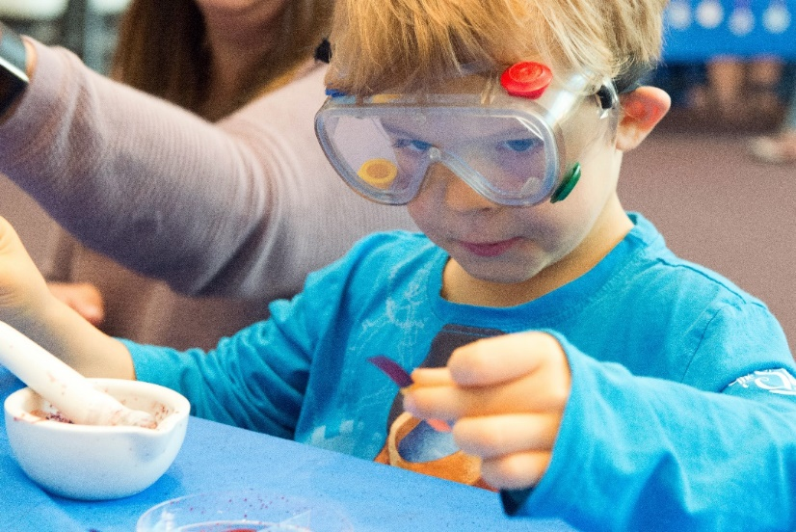
Look at this pH chart and match the colors on both pH strips to it.

If you had to give each a number, what number would you assign to each of your pH strips?

The purple color tells us that sodium carbonate solution is a type of chemical called a base. Soaps and detergents are often bases.
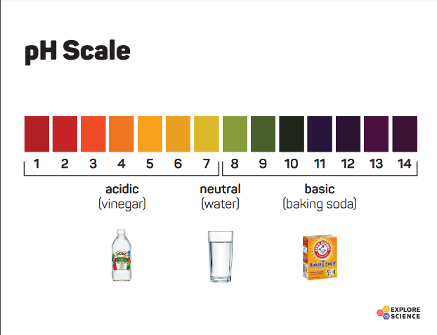
The yellow color of the plain pH paper shows that it starts out neutral.
Water and milk are neutral or near-neutral.

[Open the citric acid solution and add one drop to the other piece of pH paper.]

Look at this pH chart and match the color of this pH strip to it.

What number matches the color of this pH strip?

The orange color tells us that citric acid solution is a type of chemical called an acid. Vinegar, lemon juice, and sour candy are acids, too. Citric acid is found in citrus fruits, such as oranges, lemons, and limes.

Support Exploration
- Add drops of citric acid and sodium carbonate solutions to the drops of beetle juice.
This dye is very special because it makes a bright red color like you see left in your mortar and pestle, but it can also make other colors when you add acids and bases.
- Add 5 drops of citric acid to one of the four drops on the plate.
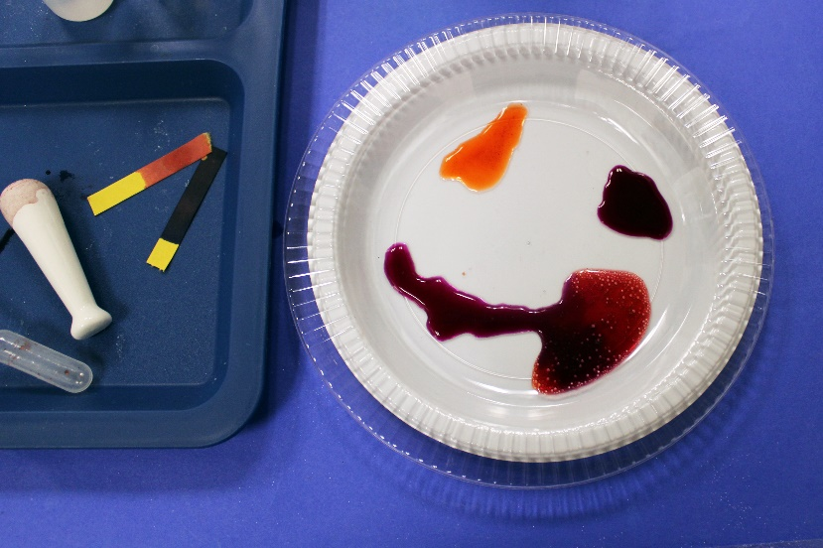
- Add 5 drops of sodium carbonate to a different drop on the plate.
- Jostle the clear plate a little bit to get the dots to spread out so that you can see the colors a little better.
- There are two drops left. Would you like to see what happens if you mix citric acid and sodium carbonate solutions in one drop? Give it a try!

[Invite participants to explore. They will notice bubbling as the acid and base react. This bubbling is like the bubbling in the self-inflating balloon activity. The bubbles are carbon dioxide gas.]

- Color a bookmark to take home.
Let’s use the colorful beetle juice from this experiment to color a bookmark that you can take home with you.
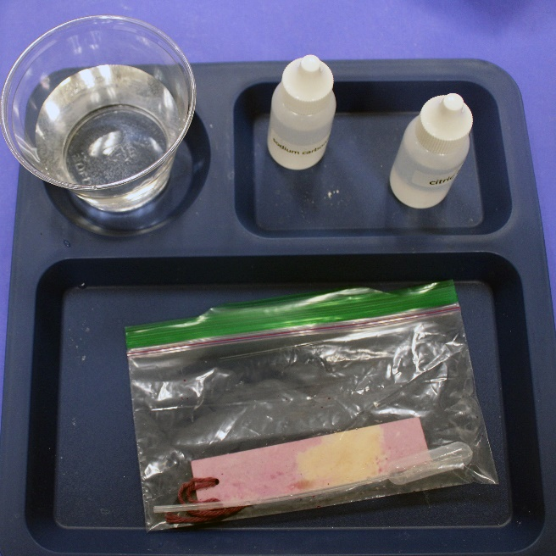
- Jostle the plate to spread out the drops a bit more and then place the bookmark on the plate to absorb the beetle juice.
- Use tongs to move the bookmark and slide both the paper and string through the liquid.

[Get a zip closing plastic bag ready for each participant and have them use the tongs to place the bookmark in the bag. Instruct them to put the dropper in the rinse water and squeeze it a few times to rinse it. Then add the dropper to the bag, seal it, and conclude the activity.]

Clean-up

Reset for the next group
- Use paper towels to dry trays, tongs, and plates. Mortar and pestles may need a dip in the rinse water before being dried. It is fine that they will become stained red.
- Place the used pH paper and used paper towels, with the solid trash.
- Any used pipets that are left behind should also be added to the solid trash.

At the end of the event
- Neutralize the liquid in the rinse water cup or bucket using sodium bicarbonate or citric acid before pouring it down the sink. Use the cochineal dye or pH paper to help.
- Rinse the trays, plates, tongs, and mortar and pestles with water. Use paper towels to pat items dry. They do not need to be perfectly clean or perfectly dry.
- Please carefully pack the mortar and pestles back in the bubble wrap and in their individual boxes to protect them as they are shipped back to ACS.
- Pack everything back in the large bin to return to ACS.

Frequently asked questions

Where can I buy cochineal beetles?
Cochineal beetles are sold to crafters and artists who use natural dyes to color cotton and wool yarn. You can order these beetles online through a general large distributor as well as from various craft stores.

Will cochineal beetle juice stain your hands and clothes?
Yes, this beetle juice will stain! Wash your hands, take a bath, and the color will come off your skin.

Does the color look the same on all fabrics or types of paper?
The colors are a little different on different types of paper and fabrics. The colors are most vibrant on wool and silk compared to cotton or polyester. If you are using paper, try using watercolor paper or filter paper. These papers are made to get wet and look good afterward.

How can I tell if cochineal beetles are used to color my food or make-up?
Look for words like carmine, carminic acid, or cochineal extract in the ingredients list.

