Dye-Sensitized Solar Cell

**HIGH SCHOOL**

**Green Chemistry & Sustainable Science**

Teacher Background Information:

There is a growing need to investigate alternative energy resources due to the depletion of petroleum, a widely used energy source. Solar energy, or energy from the sun, is a free, readily available, plentiful resource that can be collected by solar cells to generate electricity.

Although solar cells have been around for a long time, their use for energy generation is not widespread. This is because traditional solar cells are expensive and inefficient. To be considered a green chemistry technology, the technology must demonstrate three standards: performance, safety, and cost benefits. In this experiment, your students will make a dye-sensitized solar cell (DSSC) that is efficient, uses safe materials, and is inexpensive.

Unlike traditional solar cells that generate electricity through p/n junctions, the chemistry of the nanocrystalline TiO2 is based on red-ox (reduction-oxidation) chemistry. This means that the excitement of electrons to generate electron movement through the system is what drives electricity, which can be measured in terms of voltage (V). The mechanism of a photovoltaic cell has three steps (Figure 1):

1. A dye, adsorbed on a layer of semiconductor (TiO2), interacts with the visible light provided by the sun (just like the green pigment does in a leaf), promoting an electron from a lower-level orbital to an excited one.
2. The excited electron is injected by the dye into the semiconductor and, traveling through the bulk of it, reaches the electric contact with the outside circuit.
3. The electrons return to the cell to complete the circuit and bring the dye back to its “normal” state via an electrolyte solution that helps carry electrons through the cell.

The cells are a “sandwich” in which two conducting glass slides are overlapped. The photoanode is coated with the layer of TiO2 sensitized with the dye, and the other is coated with graphite in order to enhance the interaction with the electrolytic solution that is contained between the glass slides themselves.



*Figure 1.* Mechanism of a dye-sensitized solar cell.

Safety Information:

* Handle glass slides with care to prevent injury to yourself and breakage of the glass.
* Do not ingest any materials (students may be tempted with the blackberries).
* It is recommended that only teachers should handle the knife when cutting out the center of the parafilm.

**Learning Objectives:** Students will . . .

* Consider this process against the 12 principles of green chemistry
* Construct a dye-sensitized solar cell
* Evaluate and compare the differences in solar cell technologies

Key Terms:

* Conductivity, electricity, renewable energy, ions, green chemistry principles

Materials (per lab group):

* 1 transparent indium tin oxide conductive glass slide (ITO slide), 15 mm x 35 mm x 1 mm
* 1 TiO2-coated indium tin oxide conductive glass slide, 15 mm x 35 mm x 1 mm
* 4 drops of iodide electrolyte solution (0.5 M potassium iodide mixed with 0.05 M iodine in propylene glycol)
* 2 small binder clips
* 1 blackberry (thawed, frozen blackberries work well)
* 1 small spatula
* 1 graphite pencil
* 1 piece of parafilm, cut into 20 mm x 40 mm size
* 1 small aluminum dish pan (2 inches)
* 1 paper towel
* 1 razor blade
* Multimeter
* Light source (flashlight or sunlight)

***Note:*** *Handle the glass plates by the edges to avoid touching the faces of the plates.*

**Time Required:** 60- to 75-minute class period

NGSS Standards Met:

**HS-ESS3-2.** Evaluate competing design solutions for developing, managing, and utilizing energy and mineral resources based on cost-benefit ratios.

**HS-ESS3-4**. Evaluate or refine a technological solution that reduces the impact of human activities on natural systems.

Teacher Preparation:

1. Order/acquire two conductive glass plates coated with ITO per group.
2. Purchase frozen blackberries from your local grocery store (you can use fresh, but they tend to be a lot more expensive).
3. Prepare iodide electrolyte solution (0.5 M potassium iodide mixed with 0.05 M iodine in propylene glycol). Propylene glycol is the more environmentally friendly antifreeze, as opposed to ethylene glycol, which is not so friendly.
4. Use a multimeter with its setting placed on resistance (Ω) to determine which side of the glass slide has the indium tin oxide coating.
5. “Mask,” or cover, the glass slide along all four edges with 2 mm of tape with conductive side facing up. Secure the slide to the table by adhering the free side of the tape to the tabletop at a 45° angle. Your slide should look like the diagram below.

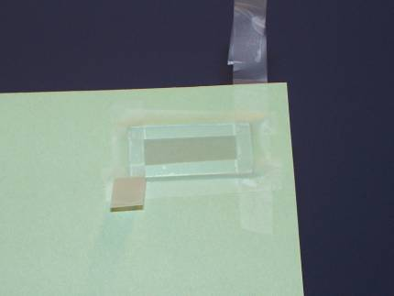

1. Prepare TiO2 paste and coat 80% of the inside of the conductive slide, leaving a 2 mm border all the way around (1 per student group). Paste is produced by mixing the following:
   * 1. Grind 15% TiO2 and 0.7% trimesic acid (1,3,5-tricarboxylbenzoic acid) with a mortar & pestle.
     2. Add 84.3% water by mass slowly and continue to grind as you add more water to make the paste.

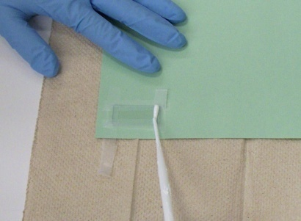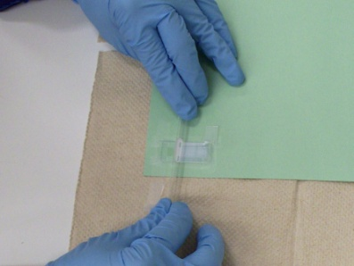

1. Add 3 drops of the TiO2 solution uniformly to the conductive glass and spread it across the glass using the body of a stirring rod until the glass is covered completely.
2. Allow the TiO2 to dry for 10 minutes, then remove tape slowly to avoid damaging the conductive glass.

Procedure:

1. Ask the class what they know about solar cells and if they know anyone who has them on their house.
2. Hand out the article “How Green Are Those Solar Panels, Really?” Have students read the article independently or read it as a class (you may also want to assign this article as homework reading prior to class).
3. Discuss the article and ask the students what they now think about solar panels.
4. Explain that, as good scientists, we should scientifically evaluate the process of making solar energy panels.
5. Hand out the Student Lab sheet.
6. Give students time to read “How are solar panels currently made?” and answer any questions.
7. Next, hand out the student sheet for evaluating the solar panel process against the 12 principles of green chemistry.
8. Discuss the results.
9. Explain to students that green chemists obviously have cause for concern when it comes to solar panels, and that there is an opportunity for a chemist to develop a better way of making solar panels.
10. Explain that they are now going to make a dye-sensitized solar cell, which is one of the ways that green chemists are working to improve solar energy production.
11. Allow students to work in small groups (working in pairs is ideal, but can be adjusted based on class needs/materials).
12. Hand out Post-Lab Questions and allow students to complete them. Review student responses.
13. Discuss what kinds of applications the volts generated by the class can power. Could the solar cell power a calculator, for instance?
14. Discuss the different locations that a small, flexible solar cell can be placed.

Disposal Information:

The paper towel, parafilm, parafilm paper backing, and used blackberry can be thrown into the trash. Clean all other items and return them to the teacher station. Teachers can rinse or wipe down the glass slides, aluminum dish, binder clips, spatula, knife, and multimeter probes (if necessary).

Dye-Sensitized Solar Cell—Student Lab

Pre-lab:

1. Read the background information article: <http://news.nationalgeographic.com/news/energy/2014/11/141111-solar-panel-manufacturing-sustainability-ranking/>
2. Read how solar panels are currently made.
3. Evaluate the solar panel technology against the 12 principles of green chemistry.

**How are solar panels currently made?**

**Solar Manufacturing Process Diagram**



**Step 1**. Silica is mined and refined into metallurgical grade silicon. This is reacted with hydrochloric acid (HCl) using very high temperatures where silane/polysilicon feedstock and silicon tetrachloride waste is produced.

**Step 2.** The resulting silane/polysilicon is heated to produce a crystalline silicon (c-Si) ingot that is doped to make c-Si into a semiconductor. The potent greenhouse gases sulfur hexaflouride (SF6) and nitrogen fluoride (NF3) are used in this step to clean the reactors and also in doping (doping adds impurities to a semiconductor to produce or modify its properties).

**Step 3.** The c-Si ingot is cut into wafers, which are etched with reactive solvents such as hydrofluoric acid to remove surface imperfections.

**Step 4.** Finally, the wafers are encapsulated with ethyl vinyl acetate (EVA) or Tedlar® to protect the surface, mounted onto a frame, and wired into the PV cell.

**Step 5.** Without extended producer responsibility, these cells will end up in smelters and dumps where any hazardous materials will cause air and water pollution.

**About the chemicals named above:**

**Silicon (Si)** is an element, and is the main component of sand. It is the second-most abundant element found in the earth’s crust. Silicon is considered non-toxic in its elemental form and most of its other forms (silicates). Only after it has been refined and under certain conditions will the form become hazardous.

**Silicon tetrachloride (SiCl4)** is a corrosive and is used in silicon-based PV cell production. It reacts with water to form hydrochloric acid and can cause tissue damage. Inhalation of SiCl4 causes severe respiratory problems, skin contact causes severe pain, and eye contact can cause permanent damage. It is one of a group of chemicals known as chlorosilanes.

**Silicon dioxide (SiO2),** or refined crystalline silica (fine powder), is a potent respiratory hazard, irritating skin and eyes on contact. Inhalation causes lung and mucus membrane irritation. Eye irritation results in watering and redness. Lung cancer is associated with occupational exposures to crystalline silica among miners, diatomaceous earth workers, granite workers, pottery workers, brick workers, and others.

**Hydrofluoric acid (HCl)** is a [solution](http://en.wikipedia.org/wiki/Solution) of [hydrogen fluoride](http://en.wikipedia.org/wiki/Hydrogen_fluoride) in [water](http://en.wikipedia.org/wiki/Water). While it is extremely corrosive and difficult to handle, it is technically a [weak acid](http://en.wikipedia.org/wiki/Weak_acid). The danger in handling hydrofluoric acid is extreme, as skin saturation with the acid in areas of only 25 square inches (160 cm2) may be relatively painless, yet ultimately fatal. High concentrations of hydrofluoric acid and hydrogen fluoride gas will also quickly destroy the corneas of the eyes.

**Nitrogen trifluoride (NF3)** is used to clean reactors and to dope polysilicon semiconductors. It emits toxic fumes when burned or reacted, and can cause asphyxiation. The IPCC considers NF3 a significant greenhouse gas, making fugitive emission control very important.

**Polysilicon** is the most widely used solar PV semiconductor. It is obtained by heating silane or trichlorosilane gas to 1500˚C.

**Sulfur hexafluoride (SF6)** is used to etch and dope semiconductors and to clean reactors in PV manufacturing. It is relatively inert and is considered an asphyxiant. The IPCC considers SF6 the most potent greenhouse gas known.

**Ethyl vinyl acetate (EVA)** is used to encapsulate solar PV cells. It is a non-toxic alternative to soft plastics like polyvinyl chloride (PVC), but may release volatile organic compounds (VOCs) during manufacture.

Information for this handout was taken from The Silicon Valley Toxics Coalition Report: “Toward a Just and Sustainable Solar Energy Industry.”

Background Information Article

How Green Are Those Solar Panels, Really?

As the industry grows, so does concern over the environmental impact.

By [**Christina Nunez**](http://www.nationalgeographic.com/contributors/n/christina-nunez.html), [National Geographic](http://news.nationalgeographic.com/)

PUBLISHED NOVEMBER 11, 2014

[](http://googleads.g.doubleclick.net/pcs/click?xai=AKAOjsub6-Y0pD5Xc5Xog1ips9gIikmUIc91irl8lYndzhLu0TnjxYpg0ZzWkdUnDS5_e_PwA6R_gq5KIwVRxWt6ppyvmIZUN_cUxKftmkZTITVEYYcTa1GxpPT2ChU2mGN-2nfMEbqYEfxswZmtPzmvLFVdJQOev_BYGRyp1EuKjDUezOLjjiMnsRv4wOTJDqJdikjU9p3N9MDbhnlkMuAETHmF8OaJNW2bsPRMPn9UNY-eCY7Tv_9SmiDQ1YYJgUIGwDiJ6vB_ZDtK7AD4YFvjl6WRHpNtXv8NTM5oa4MQBdJ6EBm6By1pQMR0lapbFABTo7M&sig=Cg0ArKJSzDOPFhhhriHi&adurl=http://natgeo.com)

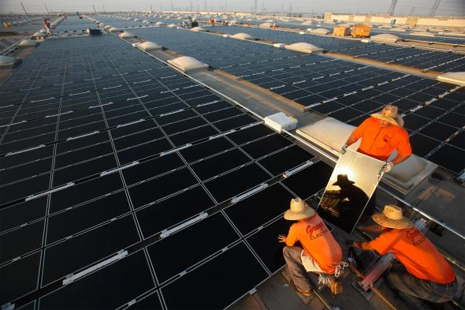

VIEW IMAGES

*Workers install solar panels in California. Although solar energy is a clean alternative to fossil fuels, making the panels themselves can have a negative environmental impact.*

PHOTOGRAPH BY MICHAEL MELFORD, NATIONAL GEOGRAPHIC CREATIVE

**As the world seeks cleaner power, solar energy capacity has increased sixfold in the past five years. Yet manufacturing all those solar panels, a Tuesday report shows, can have environmental downsides.**

Fabricating the panels requires caustic chemicals such as sodium hydroxide and hydrofluoric acid, and the process uses water as well as electricity, the production of which emits greenhouse gases. It also creates waste. These problems could undercut solar's ability to fight climate change and reduce environmental toxics.

A new ranking of 37 solar manufacturers, the [Solar Scorecard](http://www.solarscorecard.com/2014/), shows that some companies are doing better than others. Chinese manufacturer [Trina](http://www.trinasolar.com/us/index.html) scored best, followed by California-based [SunPower](http://us.sunpower.com/).

The annual scorecard was created by the [Silicon Valley Toxics Coalition](http://svtc.org/) (SVTC), a San Francisco-based nonprofit that has tracked the environmental impact of the high-tech industry since 1982. It's the group's fifth scorecard, and it shows that the industry is becoming more—not less—opaque when it comes to the sustainability of its manufacturing practices.

The coalition hopes the scorecard will increase transparency in a burgeoning industry that tends to be more focused on survival and growth than on tackling the dirtier side of an otherwise clean energy source.

**Patchy Data on Chemicals, Emissions**

The SVTC relies on companies' self-reported data for its scorecard, which looks at such things as emissions, chemical toxicity, water use, and recycling. The coalition says the market share of companies willing or able to share details about their operations is declining. It praises the third- and fourth-ranked companies, [Yingli](http://www.yinglisolar.com/us/) and [SolarWorld](http://www.solarworld-usa.com/) respectively, for responding to the survey every year and for showing a continued commitment to sustainability.

Name-brand companies on the scorecard represent about 75 percent of the solar panel industry, but more generic players that care less about their environmental impact have been entering the market, said Sheila Davis, the coalition's executive director. Her group is concerned that as these discount competitors gain market share, fewer companies will make sustainability a priority.

Varying regulations and manufacturing practices make it difficult to get standardized data about the environmental footprint of photovoltaic panels. A study [released in May](http://www.anl.gov/articles/solar-panel-manufacturing-greener-europe-china-study-says) by Northwestern University and Argonne National Laboratory found that the carbon footprint of a panel from China is twice that of one from Europe, because China has fewer environmental standards and more coal-fired power plants.

China has already seen a backlash. Panel manufacturer Jinko Solar, for example, has faced protests and [legal action](http://uk.reuters.com/article/2014/07/31/us-jinkosolar-lawsuit-idUKKBN0G020H20140731) since one of its plants, in the eastern province of Zhejiang, was accused of [dumping toxic waste](http://www.reuters.com/article/2011/09/18/us-china-solar-plant-protest-idUSTRE78H0FL20110918) into a nearby river.

Solar manufacturers in the United States are subject to both federal and state rules that dictate, for example, how and where they can dispose of toxic wastewater. In Europe recent [regulations](http://ec.europa.eu/environment/waste/weee/index_en.htm) mandate the reduction and proper disposal of hazardous electronic waste.

Still, researchers say it's difficult to get quality data across solar panel markets. The numbers available on the environmental impact of solar panel manufacturing in China are "quite different from those in the U.S. or in Europe," said Fengqi You, assistant professor of engineering at Northwestern University and a co-author of the May study. "It is a very complicated problem."

The SVTC hopes that pushing for more transparency now will lead to better practices later. "It's a new industry," said Davis. If companies adopt sustainable practices early on, she said, "then maybe over the next 10 or 15 years-as these panels begin to come down, the first wave of them, and we're beginning to recycle them-the new panels that are on the market are zero waste."

**Not Enough to Recycle Yet**

Right now, solar panel recycling suffers from a chicken-or-egg problem: There aren't enough places to recycle old solar panels, and there aren't enough defunct solar panels to make recycling them economically attractive.

Ben Santarris, strategic affairs director for SolarWorld, said his company has made efforts to recycle panels, but the volume isn't there yet. "We have product that's still performing to standard from 1978, so we don't have a big stream," he said. "It is a problem, because on one hand there is an interest in getting ahead of a swelling stream of returning panels. On the other hand, there's not a big market for it right now."

Recycling is particularly important because of the materials used to make panels, said [Dustin Mulvaney](http://www.dustinmulvaney.com/), an assistant professor of environmental studies at San José State University who serves as a scientific adviser to SVTC. "It would be difficult to find a PV module that does not use at least one rare or precious metal," he said, "because they all have at least silver, tellurium, or indium."

Because recycling is limited, Mulvaney said, those recoverable metals could go to waste: "Companies that are reporting on a quarterly basis, surviving on razor-thin margins—they're not thinking 20, 30 years down the road, where the scarcity issue might actually enter the conversation."

The silicon used to make the vast majority of today's photovoltaic cells is abundant, but a "silicon-based solar cell requires a lot of energy input in its manufacturing process," said Northwestern's You. The source of that energy, which is often coal, he added, determines how large the cell's carbon footprint is.

The SVTC said it's leading an effort to develop a first ever sustainability standard for solar panels, similar to the U.S. Green Building Council's Leadership in Energy and Environmental Design or [LEED](http://www.usgbc.org/leed), within the next two years. That effort will get under way as new solar panel factories come online in the U.S. and elsewhere: Mission Solar just [opened a plant](http://www.solarserver.com/solar-magazine/solar-news/current/2014/kw39/mission-solar-energy-opens-solar-pv-panel-manufacturing-facility-in-san-antonio-texas.html) in San Antonio, Texas, and SolarCity [plans to open](http://www.governor.ny.gov/press/09232014-solarcity-gigafactory-riverbend) a five-billion-dollar factory in western New York.

It remains to be seen whether solar companies will face enough external pressure to drive significant change in a business that, from a power-generation standpoint, already has plenty of environmental credibility.

"Despite the efforts of the SVTC," said Santarris, "there still is not nearly the awareness there should be that solar panels are not all created equal from an environmental standpoint."

But there is optimism that as the industry matures, solar companies will adopt stronger sustainability measures. In just the five years since the SVTC began its scorecard survey, Mulvaney said, it has seen a change.

"When we started this, there was no information on environmental performance, aside from the fact that it saves us from the dirtier fuels," he said. "Now these companies are producing sustainability reports."

*On Twitter: Follow* [*Christina Nunez*](https://twitter.com/cb_nunez) *and get more environment and energy coverage at* [*NatGeoGreen*](https://twitter.com/NatGeoGreen)*.*

*The story is part of a* [*special series*](http://news.nationalgeographic.com/news/energy) *that explores energy issues. For more, visit* [*The Great Energy Challenge*](http://www.greatenergychallenge.com/)*.*

[](http://www.nationalgeographic.com/contributors/n/christina-nunez.html)

[Christina Nunez](http://www.nationalgeographic.com/contributors/n/christina-nunez) is a writer and frequent contributor to National Geographic.

Evaluate Solar Panel Technology against the 12 Principles of Green Chemistry

Using the “How are Solar Panels currently made?” handout, evaluate each step against the 12 principles of green chemistry. Record the principles you identify as ones that chemists need to find an alternative for, and why.

Step 1:

Step 2:

Step 3:

Step 4:

Step 5:

Procedure:

Collect the following materials from the supply area:

* 1 transparent indium tin oxide (ITO) coated glass slide (referred to as ITO slide)
* 1 TiO2-coated indium tin oxide glass slide (referred to as TiO2 slide)
* Iodide electrolyte solution (0.5 M potassium iodide mixed with 0.05 M iodine in propylene glycol)
* 2 small binder clips
* 1 blackberry
* 1 spatula
* 1 pencil
* 1 piece of parafilm, cut to 20 mm x 40 mm size
* 1 small aluminum pan (or other small dish)
* 1 paper towel
* 1 razor blade/scalpel/precision utility knife knife (unless the teacher will solely handle it)
* Multimeter (set to measure voltage)

***Note:*** *Handle the glass plates by the edges to avoid touching the faces of the plates*

1. Place the blackberry in the aluminum pan.
2. Using a spatula, crush the blackberry to extract the juices. Scoop out the solid pulp.
3. Remove the glass slide containing the white TiO2 coating from its bag. **Handle the glass slide by the edges only**. Determine which side has the TiO2 coating.
4. Place the glass slide with the TiO2 face down into the aluminum pan. Allow to sit for 3-5 minutes.
5. Remove the ITO-coated glass slide from its bag. Determine which side the coating is on by using a multimeter with its setting placed on resistance (Ω). The indium tin oxide coating is on the side of the slide that gives a non-zero reading on the multimeter.
6. Using the tip of a graphite pencil, lay down the carbon catalyst by shading the indium tin oxide coated side of the slide. The graphite may not leave a visible mark.
7. Remove the TiO2 slide from the blackberry juice. Use the paper towel to gently blot the excess juices off the slide. Dry the slide as much as possible, but do not remove any of the TiO2 coating. Do not wipe the slide, as this may remove some of the TiO2 coating.
8. Remove and discard the wax paper backing from the parafilm and place the parafilm on top of the dye-coated TiO2 slide. Use the eraser end of the pencil to press the parafilm to the glass slide in the area that borders the TiO2
9. **READ ENTIRE STEP CAREFULLY BEFORE BEGINNING**: Using a razor blade, carefully cut out the area of the parafilm that sits on top of the TiO2. Press lightly with the blade, so that the conductive coating does not scratch off. Reinforce the parafilm seal around the edges of the TiO2 area with the eraser end of the pencil.

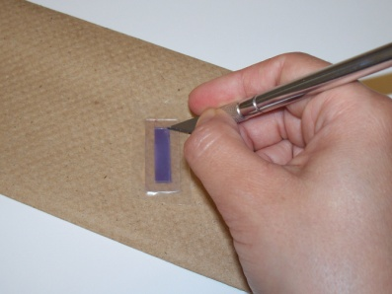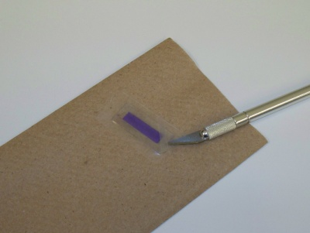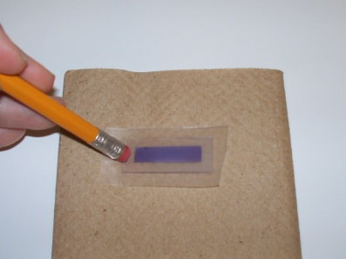

1. Place 1-2 drops of the iodide electrolyte solution on top of the TiO2. The parafilm should act as a wall that prevents the electrolyte solution from leaking out.
2. Place the ITO-coated glass slide on top of the TiO2 slide so that the conductive sides face each other. Stagger the slides to expose as much of the glass slide as possible and to cover the entire TiO2.

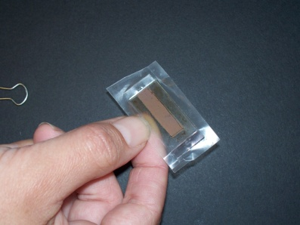

1. Use the 2 small binder clips to hold the slides together along the longer sides.
2. Carefully push back a small amount of the parafilm wall to expose a tiny part of the conductive side of the slide.
3. Place the multimeter probes on opposite ends of the solar cell’s conductive glass slides.

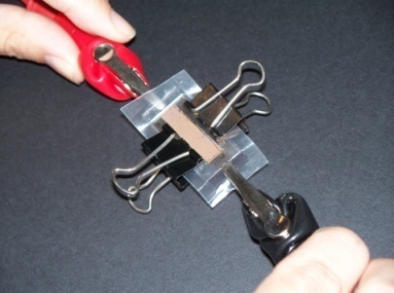

1. Place the solar cell under either sunlight or a flashlight.
2. With the multimeter set to measure electric potential, measure the voltage of the solar cell.
3. Record on the data table how many millivolts (mV) are generated for the light source.
4. Repeat steps 15–17 for 1 or 2 more light sources (see your teacher to clarify how many light sources you will need to collect data for).
5. Sum up how many volts the class would make as a whole if the cells were connected in a series.
6. Clean the workspace according to your teacher’s waste disposal instructions.
7. Answer the post-lab questions.

Data:

Class Data Table (teachers: add more rows as necessary)

|  |  |  |  |  |
| --- | --- | --- | --- | --- |
| **Students’ initials** | **Voltage from light source 1 (mV)** | **Voltage from light source 2 (mV)** | **Voltage from light source 3 (mV)** | **Observations/notes** |
|  |  |  |  |  |
|  |  |  |  |  |
|  |  |  |  |  |
|  |  |  |  |  |
|  |  |  |  |  |
|  |  |  |  |  |
|  |  |  |  |  |
|  |  |  |  |  |
| **AVERAGES** |  |  |  |  |

Post-Lab Questions:

1. Which light source had the highest average millivolt reading? Why do you think it generated the highest millivolt numbers?
2. Which light source had the lowest average millivolt reading? Why do you think it generated the lowest millivolt numbers?
3. How precise are the millivolt readings for each light source? *Teachers can set their own standards for what precise measurements mean in their class.*
4. What are 3–5 variables that contributed to the variation in millivolts produced within and/or between groups?
5. If you could re-do this lab, what are two things you would do differently, and why?
6. What was your biggest learning moment in this lab?
7. Solar Cell Technology Comparison: Using the 12 principles of green chemistry, chart the production differences between traditional solar cells and dye-sensitized solar cells. Refer to handouts and your lab to complete the grid. Remember: green chemistry is a growing, evolving, and dynamic field; use the last column to highlight areas where the solar cell production process can still be improved.

|  |  |  |  |
| --- | --- | --- | --- |
| **Principle** | **Traditional solar cell production** | **Dye-sensitized solar cell production** | **Areas of improvement** |
| #1  Pollution prevention |  |  |  |
| #2  Atom economy |  |  |  |
| #3  Less hazardous synthesis |  |  |  |
| #4  Design safer chemicals |  |  |  |

|  |  |  |  |
| --- | --- | --- | --- |
| **Principle** | **Traditional solar cell production** | **Dye-sensitized solar cell production** | **Areas of improvement** |
| #5  Safer solvents and auxiliaries |  |  |  |
| #6  Energy efficiency |  |  |  |
| #7 Renewable feedstocks |  |  |  |
| #8  Reduce derivatives |  |  |  |

|  |  |  |  |
| --- | --- | --- | --- |
| **Principle** | **Traditional solar cell production** | **Dye-sensitized solar cell production** | **Areas of improvement** |
| #9  Catalysis |  |  |  |
| #10  Design for degradation |  |  |  |
| #11  Real-time analysis |  |  |  |
| #12  Accident prevention |  |  |  |