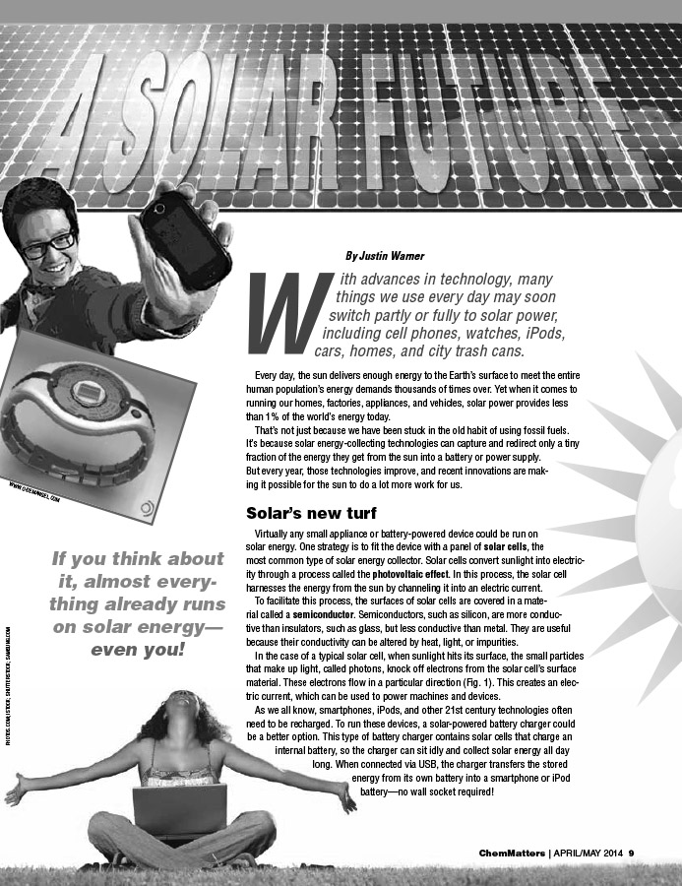


April 2014 Teacher's Guide for
A Solar Future

Table of Contents

About the Guide 2
Student Questions 3
Answers to Student Questions 4
Anticipation Guide 5
Reading Strategies 6
Background Information 8
Connections to Chemistry Concepts 18
Possible Student Misconceptions 18
Anticipating Student Questions 18
In-class Activities 19
Out-of-class Activities and Projects 20
References 21
Web Sites for Additional Information 22

About the Guide

Teacher’s Guide editors William Bleam, Donald McKinney, Ronald Tempest, and Erica K. Jacobsen created the Teacher’s Guide article material. E-mail: bbleam@verizon.net

Susan Cooper prepared the anticipation and reading guides.

Patrice Pages, ChemMatters editor, coordinated production and prepared the Microsoft Word and PDF versions of the Teacher’s Guide. E-mail: chemmatters@acs.org

Articles from past issues of ChemMatters can be accessed from a DVD that is available from the American Chemical Society for $42. The DVD contains 30 years of ChemMatters—all ChemMatters issues from February 1983 to April 2013.

The ChemMatters DVD also includes an Index—by titles, authors and keywords—that covers all issues from February 1983 to April 2013, and all Teacher’s Guides from their inception in 1990 to April 2013.

The ChemMatters DVD can be purchased by calling 1-800-227-5558.

Purchase information can be found online at www.acs.org/chemmatters.

Student Questions
(for “A Solar Future”)

  - Identify the two basic uses for solar energy described in the article.
  - According to the article, solar power currently provides what percent of the world’s energy?
  - What is a semiconductor?
  - Describe the energy conversion in a solar cell.
  - Describe the energy conversion in a solar thermal flat-plate collector.
  - Identify two environmental effects of solar-powered cars.
  - Describe the operation of the solar power plant mentioned in the article.

Answers to Student Questions
(for “A Solar Future”)

    - Identify the two basic uses for solar energy described in the article.
The technology exists to convert the sun’s energy into electricity and heat. The article describes solar cells which convert solar energy into electricity. And the article describes solar collectors which convert the sun’s energy to useable heating and cooling.
    - According to the article, solar power currently provides what percent of the world’s energy?
The article says 1% of the world’s energy is provided by solar power. Since virtually all of the Earth’s energy can be traced to the sun, you might want to note that this 1% figure represents the percent of the sun’s energy that is directly converted to heat or electricity using the technologies described in the article.
    - What is a semiconductor?
The article describes a semiconductor as follows: “A solar cell is made of two types of semiconductors, called p-type and n-type silicon: p-type silicon contains impurities that have fewer electrons than silicon, and n-type silicon has impurities that contain more electrons than silicon. When sunlight strikes a solar cell, electrons in the silicon are ejected, which results in the formation of a so-called electron-hole pair, where the “hole” is the vacancy left behind by the escaping electron. Electrons between the n-type and p-type layers move from the n-type to the p-type layer. Then, a metal wire collects these electrons and returns them to the back of the n-type layer through an external circuit, creating a flow of electricity.”
    - Describe the energy conversion in a solar cell.
Energy conversion in a solar cell consists of light, primarily in the ultraviolet range, striking the cell and being converted to electrical energy.
    - Describe the energy conversion in a solar thermal flat-plate collector.
In a solar thermal flat-plate collector, light from the sun enters the collector and is converted to infrared thermal energy, which is then absorbed by the fluid flowing through the collector. Since this energy raises the temperature of the fluid we can add one more conversion—thermal to kinetic energy.
    - Identify two environmental effects of solar-powered cars.
Cars that use solar energy leave a much smaller environmental footprint than conventional cars, since they emit no pollutants and no carbon dioxide.
    - Describe the operation of the solar power plant mentioned in the article.
In the Ivanpah plant, mirrors reflect sunlight toward a tank of water. The sun’s energy boils the water and the plant uses the resulting steam to power a turbine to produce the desired electricity.

Anticipation Guide
Anticipation guides help engage students by activating prior knowledge and stimulating student interest before reading. If class time permits, discuss students’ responses to each statement before reading each article. As they read, students should look for evidence supporting or refuting their initial responses.

Directions: Before reading, in the first column, write “A” or “D,” indicating your agreement or disagreement with each statement. As you read, compare your opinions with information from the article. In the space under each statement, cite information from the article that supports or refutes your original ideas.

Me | Text | Statement
 |  | - Currently, solar energy supplies about 10% of our energy needs worldwide.
 |  | - The most common type of solar energy collector is the solar cell.
 |  | - Semiconductors have a conductivity between conductors and insulators.
 |  | - The conductivity of semiconductors can be altered.
 |  | - Solar cells have only one type of semiconductor.
 |  | - Solar battery chargers can charge your electronic device using a USB connection.
 |  | - Solar watches have been around since the 1940s.
 |  | - A solar car race exclusively for high school students is planned for the future.
 |  | - A manned aircraft completed a 26-hour flight using only solar energy.
 |  | - A solar power plant that will supply electricity to 140,000 homes in California in 2014 uses solar cells.

Reading Strategies
These graphic organizers are provided to help students locate and analyze information from the articles. Student understanding will be enhanced when they explore and evaluate the information themselves, with input from the teacher if students are struggling. Encourage students to use their own words and avoid copying entire sentences from the articles. The use of bullets helps them do this. If you use these reading strategies to evaluate student performance, you may want to develop a grading rubric such as the one below.

Score | Description | Evidence
4 | Excellent | Complete; details provided; demonstrates deep understanding.
3 | Good | Complete; few details provided; demonstrates some understanding.
2 | Fair | Incomplete; few details provided; some misconceptions evident.
1 | Poor | Very incomplete; no details provided; many misconceptions evident.
0 | Not acceptable | So incomplete that no judgment can be made about student understanding

Teaching Strategies:

- Links to Common Core Standards for writing: Ask students to revise one of the articles in this issue to explain the information to a person who has not taken chemistry. Students should provide evidence from the article or other references to support their position.

- Vocabulary that is reinforced in this issue:

- Solvent
- Amphoteric compounds
- Semiconductor
- Structural formulas
- Polymerization

- To help students engage with the text, ask students which article engaged them most and why, or what questions they still have about the articles.
Directions: As you read the article, complete the graphic organizer comparing different ideas for using solar energy.

Product | Type of solar collector | Stage of development
Solar battery charger
Solar backpack
Car
Airplane
Houseboat
Solar power station

Directions: In the graphic organizer below, compare the semiconductors in a solar cell.

 | Semiconductors
 | p-type | n-type
Materials
Depletion zone
With sunlight

Background Information
(teacher information)

More on the sun’s energy output to Earth

If we are going to convert energy from the sun into heat or electricity as the article describes, perhaps we should first consider how much energy is available from the sun and how much we need here on Earth. The sun has a mass of 2 x 10³⁰ kg, mostly hydrogen and helium, and a radius equivalent to 109 Earths. Its surface temperature is about 5780 K and its power output is 3.9 x 10²⁶ watts. The amount of energy from the sun that falls on Earth's surface, called total solar insolation, is enormous. All the energy stored in Earth's reserves of coal, oil, and natural gas is matched by the energy from just 20 days of sunshine.

However, there are factors that prevent all of the energy or power from being useful on the surface of the Earth. We can get a better picture of the solar irradiance—the amount of solar power arriving on Earth from the sun—in these excerpts from NASA’s Window on the Universe Web site:

The Sun emits a tremendous amount of energy, in the form of electromagnetic radiation (EM), into space. If we could somehow build a gigantic ball around the Sun that completely enclosed it, and lined that ball with perfectly efficient photovoltaic solar panels, we could capture all of that energy and convert it to electricity... and be set in terms of Earth's energy needs for a very long time. Lacking such a fanciful sphere, most of the Sun's energy flows out of our solar system into interstellar space without ever colliding with anything. However, a very small fraction of that energy collides with planets, including our humble Earth, before it can escape into the interstellar void. The fraction of a fraction that Earth intercepts is sufficient to warm our planet and drive its climate system. …

… At Earth's distance from the Sun, about 1,368 watts of energy in the form of EM radiation from the Sun fall on an area of one square meter. Yes, these are the same watts we use to describe the energy usage of light bulbs and other household appliances…

… If Earth were a flat, one-sided disk facing the Sun ... and if it had no atmosphere... every square meter of Earth's surface would receive 1,368 watts of energy from the Sun. Although Earth does intercept the same total amount of solar EM radiation as would a flat disk of the Earth's radius, that energy is spread out over a larger area. The surface of a sphere has an area four times as great as the area of a disk of the same radius. So the 1,368 W/m² is reduced to an average of 342 W/m² over the entire surface of our spherical planet. ...

… Note that the values for average solar insolation (the term scientists use for the solar EM energy delivered to an area) reaching Earth that have been discussed so far are at the top of the atmosphere. As you can imagine, as sunlight passes through our atmosphere, some of it is scattered and absorbed, reducing the amount that actually reaches the ground.

http://www.windows2universe.org/earth/climate/sun_radiation_at_earth.html

Note that those 342 W/m² are a measure of the sun’s irradiance—the power of the sun’s energy per unit of area. It tells us that on every square meter of the Earth’s surface, 342 joules of energy are arriving every second. For more details on insolation—the amount of energy from the sun—and the sun’s irradiance, see http://www.windows2universe.org/earth/climate/sun_radiation_at_earth.html. Not only does not all the Sun’s energy reach the Earth’s surface, it does not reach it equally at all times. Think seasons and also think night and day. When you take these factors into account the average effective insolation is about 240 W/m².

Note that 1 watt of power is equal to 1 joule/second. Watts are units that measure energy per unit of time. Watts are a rate unit. For reference, 4.18 joules of energy are required to raise the temperature of 1.0 g of water 1.0 ºC. Another comparison: the now outmoded incandescent light bulbs were rated in watts—40, 60, 75 and 100. These are the same watts as those used in the article. An important note here: Watts are units of power and joules are units of energy. However, in discussions of the sun’s energy, power units and energy units are often used to represent energy.

And in what form is that incoming energy? You may want to use this opportunity to review (or preview) with your students the electromagnetic spectrum. Because we can see a small part of the spectrum we often think about the spectrum as forms of light, but that is not always true. There are multiple kinds of energy represented in the spectrum, and they vary according to their wave length or frequency. Below is a table with EM energies and their wave length ranges listed from longest wave length to shortest. The diagram below provides a visual of this information.

EM Energy Wave Length
Radio waves few centimeters to hundreds of meters
Microwaves 1 mm to 30 cm
Infrared 700 nm to 1 mm
Visible 400 to 700 nm
Ultraviolet 10 to 400 nm
X-rays 10 pm to 10 nm
Gamma rays < 10⁻¹¹ m
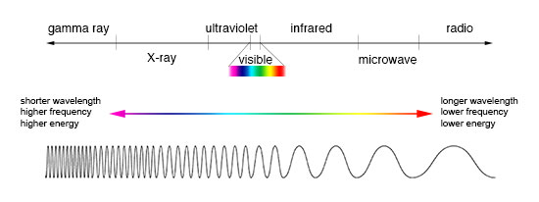
(http://imagine.gsfc.nasa.gov/docs/science/know_l1/emspectrum.html)

The part of this electromagnetic energy flowing into the Earth’s atmosphere ranges from ultraviolet to the visible spectrum and infrared range.

You can refer to any standard high school chemistry textbook for the relationship between the wavelength and frequency of a particular kind of electromagnetic energy. But just a few basics adapted from the Teacher’s Guide for the Kimbrough article cited near the end of this Teacher’s Guide:

The basic characteristic of electromagnetic radiations is that they travel at a velocity of 3 x 10⁸ m/s in a vacuum. The identifying characteristics of any wave are its velocity (C), frequency (ν) and wave length (λ). The equation that relates the three characteristics is:
C = (ν) (λ)

Any form of electromagnetic radiation, then, can be identified by its wave length or its frequency. From the equation we know that frequency and radiation vary inversely. Different forms of electromagnetic energy have different wave lengths (and frequencies), and regions of the spectrum are variously named.

On the diagram above, wave length increases from left to right so the frequency will decrease. For example, radiation in the microwave region has a longer wave length and lower frequency than radiation in the X-ray region.

So, electromagnetic energy comes to Earth from the Sun in the form of UV, visible and infrared energy. We can see that there is no electrical energy coming from the sun so what we need is technology that can convert the sun’s energy to electricity. How is this done? The article describes the technology, as do the next sections of this Teacher’s Guide.

More on photovoltaics and semiconductors

Photovoltaics is the direct conversion of light into electricity at the atomic level. The wave behavior of light explains a lot, but an understanding of photovoltaics requires that we view light as discrete particles of energy. This is also often described in high school chemistry texts, but a little more detail follows here.

The ability of light particles to knock electrons from a substance was first advanced by Max Planck and solidified as a concept by Albert Einstein in the early 1900s. He called it the photoelectric effect, and it is this concept that underpins photovoltaics. Details of this development are taken from the Teacher’s Guide for the Kimbrough article, referenced near the end of this Teacher’s Guide.

In his first 1905 paper, Einstein explained the photoelectric effect for which he eventually won the Nobel Prize in physics. He said, “According to the assumption considered here, when a light ray starting from a point is propagated, the energy is not continuously distributed over an ever increasing volume, but it consists of a finite number of energy quanta, localized in space, which move without being divided and which can be absorbed or emitted only as a whole.”

In this way Einstein re-defined how science thought of light. Until this time it was assumed to behave like a wave, which Einstein agreed was a sufficient explanation for purely optical events. But in order to explain events like the emission of electrons from a metal surface when light strikes the metal, it is necessary to think about light as discrete bundles of energy, later called photons.

The idea of particles of light was not original with Einstein. In a paper published in 1900, Max Planck advanced the idea that electromagnetic energy (light) could exist in discrete packages, or quanta, that had unique values. The energy values, E, for any bundle of light were in proportion to the frequency, ν (the Greek letter nu), of the light. The constant of proportionality would be a universal constant, h. Its value of
6.626 x 10^{–34} J x s is well known to current students of chemistry from the equation:
E = h ν. Planck’s idea, called the quantum theory, was not immediately accepted widely. Only when Einstein employed the idea in his 1905 paper to explain what were then discrepancies [in] the behavior of light did quantum theory begin to gain acceptance. Actually not until 1913 and Bohr’s concepts of quantized energy states for electrons in atoms was the quantum theory widely accepted.

Einstein showed that it was the frequency of light falling on the metal surface that dislodged electrons. Below a certain frequency, called the threshold frequency, the light had no effect on electrons. Light with frequencies higher than the threshold value caused electrons to be emitted faster. The intensity of the light was only a factor if the frequency was above the threshold value, and then increasing the frequency caused more electrons to be emitted. The threshold value is the minimum frequency that will cause an electron to be emitted.

The photoelectric effect, then, is a phenomenon in which particles of light (photons) have sufficient energy to cause electrons to be ejected away from their original atoms. If the frequency of light is less, electrons are not emitted. The important thing to note here is that in the photoelectric effect electrons are unbound from their atoms.

Suppose the incoming photons have sufficient energy to raise an electron to a higher energy level but not enough to totally remove it from its atom? This is possible, and it is what distinguishes the photovoltaic effect from the photoelectric effect. In solid-state physics, electrons in atoms of solids are said to exist in energy bands—the insulation band, the valence band and the conductive band. The first two bands roughly correspond to electron energy levels that chemists know. Bands are extensions of energy levels in solids since in solids the atoms are close enough to each other for the energy levels in a given atom to be influenced by the energies of the electrons in adjacent atoms. Thus in solids bands of similar energies emerge over and above the energy levels of individual atoms. A simplified structure looks something like this:
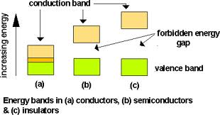
(http://webs.mn.catholic.edu.au/physics/emery/hsc_ideas_implementation.htm)

The diagram shows the energy bands and gaps in (a) conductors, (b) semiconductors and (c) insulators. The key here is the size of the gaps, or forbidden energies between the outmost electrons in the valence band and the conduction band. Electrons—called delocalized electrons—in the conduction bands can move through the solid lattice and thus carry charge, forming a current. In solids that are insulators there is a large energy gap between the valence band and the conduction band so it is unlikely that electrons in the valence band of these materials could jump to the conductive band, and thus they are unlikely to conduct a current. The gap is very small in conductors. In semiconductors the gap is large enough that lower energy photons cannot cause electrons to move from valence to conduction bands but small enough that higher energy photons can do so.

This is the fundamental theory that drives photovoltaic cells. Note also that the photoelectric effect is different from the photoelectric effect in that in the latter event electrons are removed from their original atoms and in the photovoltaic effect the electrons are moved to a higher energy band that allows them to move within the solid.

Semiconductors, then, are also key to understanding photovoltaics. Silicon, the semiconductor with which most students are familiar, exists as a crystal lattice in which each silicon atom is covalently bonded to four other silicon atoms. Since all of the valence electrons are involved in the bonding, silicon itself does not conduct an electric current. But if other elements are added to the silicon crystal in a process called doping then silicon becomes a conductor.

These impurities, or dopants, are most often elements near silicon on the periodic table. Here’s why. Frequently used dopants are arsenic (in the column immediately to the right of silicon on the periodic table) and gallium (in the column to the immediate left of silicon). Arsenic has five valence electrons, one more than silicon. Binding the arsenic to the silicon in the lattice requires only four of arsenic’s five valence electrons, leaving the extra one free to move within the crystal. The reverse is true for gallium. Gallium has three valence electrons, one less than silicon. So within the gallium-silicon structure there is an incomplete bond or a “hole” which allows room for electrons to move through the crystal lattice.

The way in which semiconductors function in a solar cell is described in the Teacher’s Guide for the Baxter article referenced below:

Photovoltaic cells are made in two layers. One layer of predominantly silicon has mixed in with it (“doped”) some arsenic. Arsenic has 5 valence electrons and silicon has 4. With these two elements mixed together in a crystalline lattice, there are 9 valence electrons between two atoms, an excess of electrons (think of the octet rule) or mobile electrons. A second layer of primarily silicon with some doping by aluminum or gallium means that the octet rule is not satisfied and there is a deficiency of electrons (only 7 total between a silicon atom and an aluminum or gallium atom) or “holes”.

As a result, electrons from the Si/As layer move to the Si/Al or Si/Ga layer, which makes the two layers charged (positive and negative). With such a situation, adding light of enough energy displaces the electrons that have migrated to the Al or Ga side (which has become negative from the extra electrons). The displaced electrons will migrate toward the positive layer containing the arsenic (it lost electrons to the Al or Ga layer initially). This means that a current is generated if an electrical conductor connects the two layers in the right way. A more technical reference is found at www.howstuffworks.com/solar-cell.htm/.

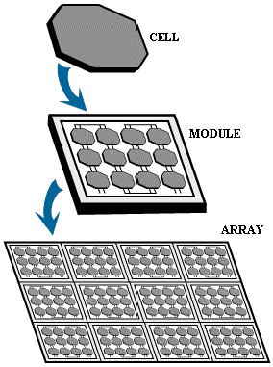
To sum up the process that takes place in a solar cell—when light energy strikes the solar cell, electrons are knocked loose from the atoms in the semiconductor material. If electrical conductors are attached to the positive and negative sides, forming an electrical circuit, the electrons can be captured in the form of an electric current—that is, electricity. This electricity can then be used to power a load, such as a light or an appliance.

Each cell can produce only 1–2 watts. However, a number of solar cells electrically connected to each other and mounted in a support structure or frame called a photovoltaic module can produce power desired for a household or commercial project. Modules are designed to supply electricity at a certain voltage, such as a common 12 volt system.

Multiple modules can be wired together to form an array (see diagram at left). In general, the larger the area of a module or array, the more electricity it will produce. Photovoltaic modules and arrays produce direct-current (DC) electricity.

(http://science.nasa.gov/science-news/science-at-nasa/2002/solarcells/ )

More on photovoltaic panels

Solar panels used to power homes and businesses are typically made from solar cells combined into modules that hold about 40 cells. A typical home will use about 10 to 20 solar panels to power it. The panels are mounted at an angle facing south, or they can be mounted on a tracking device that follows the Sun. Many solar panels combined together to create one system is called a solar array. For large electric utility or industrial applications, hundreds of solar arrays are interconnected to form a large utility-scale photovoltaic system. The photos below show several arrangements.

Thin-film solar tiles installed on the roof of a home in Ohio.

Thin-film solar tiles installed
on the roof of a home in Ohio

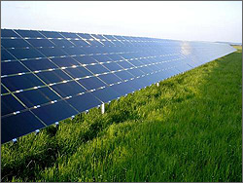

A large solar array in Germany

(Photos from http://www.nrel.gov/learning/re_photovoltaics.html)

Traditional solar cells are usually flat-plate, and generally are the most efficient. Second-generation solar cells are called thin-film solar cells because they are made from amorphous silicon or non-silicon materials such as cadmium telluride. Thin film solar cells use layers of semiconductor materials only a few micrometers thick. Because of their flexibility, thin film solar cells can double as rooftop shingles or other building structures.

Third-generation solar cells are being made from variety of new materials besides silicon, including solar inks using conventional printing press technologies, solar dyes, and conductive plastics. Some new solar cells use plastic lenses or mirrors to concentrate sunlight onto a very small piece of high efficiency material. This material is more expensive but because so little is needed, these systems are becoming cost effective. However, because the lenses must be pointed at the sun, the use of concentrating collectors is limited to the sunniest regions on Earth.

More on solar thermal panels

Although the article is focused on converting the Sun’s energy into electricity, many students will know about solar thermal panels—using solar energy to heat and cool buildings. So we are including here a brief section on solar thermal panels.

Solar thermal technology uses the Sun’s energy, rather than fossil fuels, to generate low-cost, environmentally friendly thermal energy. This energy is used to heat water or other fluids, and can also power solar cooling systems. A description of how solar thermal works appeared in the Teacher’s Guide for the Baxter article, referenced below:

If a house is equipped with an array of solar panels for heating air or water, light passes through glass (a ‘greenhouse”) and is absorbed on the dark surface of copper pipes that are coated with something like chromium oxide, which is black. The visible light (along with IR and some UV) is converted to heat and transferred by conduction through the metal to a circulating liquid, usually non-toxic propylene glycol which has a higher boiling point and density than water (though water is used in climates where freezing does not occur). Heat exchange between the propylene glycol and water in a tank occurs in copper tubing or fins. For warmer climates, water in a storage tank can be circulated to the solar panel, heated and returned to a storage tank with continuous cycling of the water between the tank and the solar panels.

For space heating, solar panels can be used to directly heat air rather a liquid. The heated air can also be passed through some kind of heat storage material such as water or stone for heat retrieval later. Ideally, one can “fine tune” a heat pump to extract heat from solar-heated air. The fine tuning is meant to have the heat pump operate in a very narrow heat range and not requiring back-up of resistance heating (electrical) for the colder winter temperatures. The alternate is to heat water or propylene glycol in a solar system that would circulate though a hot “water” heating system in the house. But the cost of this latter arrangement (more solar panels vs. those needed for hot water) usually does not justify this kind of system.

It is interesting to note that solar thermal collectors depend on the “greenhouse effect” to operate. A flat plate collector is essentially a rectangular box with a dark-colored bottom surface to absorb energy and with tubing running above it. Energy from the sun enters the collector. That energy is in the form of UV and visible radiation. The energy is absorbed by the dark surface and re-radiated as infrared thermal energy which is then transferred to the liquid in the tubing. That transition from UV-visible to infrared thermal is the greenhouse effect.

Solar thermal collectors are classified by the United States Energy Information Administration as low-, medium-, or high-temperature collectors. Low-temperature collectors are flat plates generally used to heat swimming pools. Medium-temperature collectors are also usually flat plates but are used for heating water or air for residential and commercial use. High-temperature collectors concentrate sunlight using mirrors or lenses and are generally used for electric power production. Two typical solar thermal configurations are shown in the diagram below.

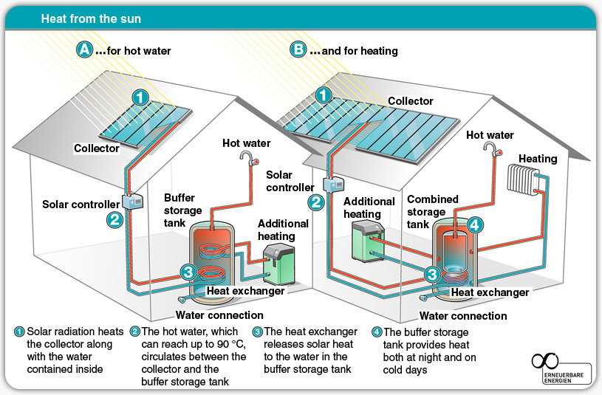

(http://solartribune.com/solar-thermal-energy/)

The properties of the heat transfer fluids that move the heat from collector to the house interior—usually into a storage tank—are also interesting. Among the properties that must be considered are the coefficient of expansion and viscosity because both of these properties determine how well the liquid moves in the system. Most important is the heat capacity of the fluid. And the freezing point, boiling point and flash point must be considered for practical reasons. Water, then, is a good fluid to use here because of its high heat capacity. However, it cannot be used where there is the threat of freezing. The “fix” for this is to use a glycol-water mixture—antifreeze—in either 40/60 or 50/50 ratio. Air is a good fluid to use but it has a very low heat capacity. Other fluids used include hydrocarbon oils, methyl alcohol and silicones.

Some companies are experimenting with molten salts as heat transfer media. In Spain, a solar power plant (producing electricity) uses a mixture of potassium and sodium nitrate to store and transfer heat collected from the sun by parabolic mirrors. The high melting points of the nitrates—308 ºC for sodium nitrate and 334 ºC for potassium nitrate—allows them to store heat well. The molten salts are then passed through a heat exchanger where the salt’s heat boils water and the resulting steam turns a turbine to produce electricity. The process nets 93 % of the energy used to melt the solids.

More on applications of solar energy

In addition to the uses of solar energy described in the article, here are a few more details:

Solar cooling—Solar energy can also be used to generate cool air. There are two kinds of solar cooling systems: desiccant systems and absorption chiller systems. In a desiccant system, air passes over a common desiccant or “drying material” such as silica gel to draw moisture from the air and make the air more comfortable. The desiccant is regenerated by using solar heat to dry it out. Absorption chiller systems, the most common solar cooling systems, use solar water heating collectors and a thermal-chemical absorption process to produce air-conditioning without using electricity. The process is nearly identical to that of a refrigerator, only no compressor is used. Instead, the absorption cycle is driven by a heated fluid from the solar collector. For a description of solar refrigerators see http://home.howstuffworks.com/solar-powered-refrigerator.htm.

Solar chargers—These are usually small photovoltaic devices used to charge cell phones and other electronics. To date, many of these chargers are inefficient, ranging from 10–20 % efficiency. Larger units are used for charging the devices for more people. These were provided by television stations and other companies in the mid-Atlantic and New England regions of the country during the crippling snow storms of the winter of 2013–14. Some of these units come equipped with batteries which the PV cells charge if no other device is connected.

Solar trash compacters—The article describes these briefly and provides a diagram. Here is a little more from the U.S. Environmental Protection Agency on how these compactors are saving money and the environment:

In 2009, Philadelphia replaced 700 public wire trash baskets with 500 BigBelly-brand solar trash compactors. These bins lower the number of trips needed to collect public waste by using solar energy to compact waste while it is in the bin. This allowed the City to save money from reduced collection costs and fuel use. The City had been making 17 trips each week to empty 700 wire baskets throughout Center City, at an annual cost of about $2.3 million. After replacing those 700 receptacles with 500 solar-powered compactors and 210 recycling units, the City collects only five times a week, at an annual operating cost of about $720,000-representing a 70 percent savings. The installation of solar compactors also enabled the Streets Department to deploy on-street recycling for the first time in Philadelphia.

(http://www.epa.gov/jius/projects/philadelphia/bigbelly_trash_compactors.html)

Solar vehicles—The article says that solar energy can be used to power cars, buses, boats and planes. Although cars are being made that run on electricity, there are no commercially available cars in which the electricity is provided by photovoltaic cells. The Chevy Volt, for example, is battery-operated and must be charged at a station like a gas station for gasoline-powered cars. Solar cars are being made on an individual or experimental basis, and in the cars the solar cells deliver electricity either to a motor directly or to a battery which then delivers electricity to the motor. Several manufacturers have employed solar power to assist with individual features on gas-powered cars. In 2006, Ford installed solar panels in the headlights of its concept car the Reflex, and the 2005 Mazda Senku used solar panels on its roof to help charge its battery.

Other applications—In addition to the uses described in the article, solar cells are currently used: to power outdoor lighting for both residential and commercial installations; for remote surveillance, remote data sensors and monitors; and for supplying electricity when connecting to the power grid is not economically feasible. New applications are being developed regularly.

To access a web site that lists ten “cool” (do not think a pun was intended) uses of solar power, see http://www.buzzfeed.com/thegeshow/top-10-coolest-uses-of-solar-panels.

More on solar power stations

Solar power stations, as described in the article, are being built at a more rapid rate currently. These plants essentially concentrate the Sun’s energy in one of two ways—either by concentrating the Sun’s energy and focusing it on PV cells or by using mirrors to concentrate the Sun’s energy, converting it to heat and transferring the heat to a conventional electric generator which is tied to the general electric power grid. They are, in fact, usually referred to as “concentrating photovoltaics (CP)” or “concentrating solar power plants (CSP).”

There are four basic solar power plant designs. In a photovoltaic solar power plant an array of cells concentrates energy and delivers DC current. These arrays of cells are connected to an inverter which changes DC current to AC current for use in the grid. Parabolic trough design employs a large number of parabolic mirrors which collect the sun’s energy to heat a fluid in pipes that run along the mirrors. The fluid delivers the heat to a steam generator that powers a turbine. In a power tower system, heliostats, which are mirrors that move with the movement of the sun, reflect energy to the top of a tower. From there a fluid transfers heat as in the parabolic design. Solar dish systems employ reflecting dishes similar to those found in satellite thermal concentrating (TC) systems. Each dish concentrates energy at a focal point, and a heat engine mounted on the dish produces electricity.

In a February 2014 press release, the United States Department of the Interior

… announced the approval of two solar energy projects located near the Nevada-California border that are expected to supply 550 megawatts of renewable energy, enough to power about 170,000 homes, and support more than 700 jobs through construction and operations. They will be constructed by First Solar, a solar photovoltaic panel manufacturer, which is also building similar projects in the region. In California, the Stateline Solar Farm Project will generate 300 MW and require 1,685 acres of public land. … Together, the projects could support more than 20,000 construction and operations jobs and, when built, generate nearly 14,000 megawatts of electricity, or enough to power 4.8 million homes. Thirteen of the projects are already in operation, including the Ivanpah Solar Electric Generating System, a 377-megawatt solar thermal plant that started commercial operations and delivering power to California’s electric grid last week.
(http://www.doi.gov/news/pressreleases/secretary-jewell-announces-two-solar-projects-approved-in-california-nevada.cfm)

All of these plants can have capacities suited to need—for small local uses (10 kilowatts) or power grid applications (up to 100 megawatts). Some systems use thermal storage during cloudy periods or at night.

Connections to Chemistry Concepts
(for correlation to course curriculum)

- Electromagnetic spectrum—Solar thermal and photovoltaics draw on different types of EM energy. Students will need to understand the spectrum.
- Dual nature of light—In order to understand the Earth’s energy budget and the photovoltaic effect students should be familiar with both the wave and particle theories of light.
- Activation energy—Semiconductors in the photovoltaics section need photons that have minimum energies in order to force electron-ejection.
- Atomic structure with emphasis on electrons—Both the photoelectric effect and the photovoltaic effect are the result of the interaction of electrons with light. Energy levels, orbitals and solid-state band theory are also involved.
- Valence electrons—The ability of semiconductors to move a current depends on the behavior of valence electrons in atoms.
- Covalent bonds—The bonding in materials that make up semiconductors is covalent bonding. Valence electrons are held strongly in elements like silicon and so there is a need for dopants to provide both electrons that can be moved and also spaces for them to move.
- Periodic Table—The role of dopants in semiconductors relies on the use of elements near each other on the periodic table. This is an excellent opportunity to review trends in properties of atoms on the table.

Possible Student Misconceptions
(to aid teacher in addressing misconceptions)

- “The photovoltaic effect operating in a solar cell will only occur with visible light.” It is actually UV radiation from the sun that is at work in photovoltaics. In general, it is the frequency (or wave length) of the radiation that determines the effect on PV cells.
- “You can generate both heat and electricity using the same solar panels.” This is not possible. The technology to convert solar energy into electricity is very different than the technology to collect heat. The article focuses on converting solar energy to electricity, but this Teacher’s Guide includes a section on solar thermal panels to help you make the comparison between the two processes. See “More on solar thermal panels”.

Anticipating Student Questions
(answers to questions students might ask in class)

- “What happens if a solar array on a building produces more electricity than the building needs at the time?” It is possible to connect solar cells with batteries, but they are very expensive. The better solution is net metering. The Solar Energy Industries Association describes net metering this way:

Net metering is a billing mechanism that credits solar energy system owners for the electricity they add to the grid. For example, if a residential customer has a PV system on the home's rooftop, it may generate more electricity than the home uses during daylight hours. If the home is net-metered, the electricity meter will run backwards to provide a credit against what electricity is consumed at night or other periods where the home's electricity use exceeds the system's output. Customers are only billed for their "net" energy use. On average, only 20–40% of a solar energy system’s output ever goes into the grid. Exported solar electricity serves nearby customers’ loads.
- “I thought solar cells had to be pure, but dopants seem to be impurities.” In order to conduct electricity, silicon has to be “doped” with atoms of elements near it on the periodic table in order to supply electrons that can move and also spaces for the electrons to move at the atomic level. While it is true that the silicon and each of the elements used as dopants must be pure, these dopants are both planned and necessary impurities.
- “The article describes solar photovoltaic technology. Are there other solar technologies?” There are actually three types of solar technologies—photovoltaics (described in the article), solar thermal collectors (see “More on solar thermal panels”), and in the section on solar power stations the article describes how reflectors can be used to concentrate thermal energy which then can be used to make steam which, in turn, is used to make electricity. Each of these is an active technology. There is also a wide range of passive solar technologies like sun rooms, “smart” window shades, awnings, walls and ceilings designed to control air circulation, and others.

In-class Activities
(lesson ideas, including labs & demonstrations)

- North Carolina State provides four activities on the Earth’s energy budget: http://www.nc-climate.ncsu.edu/edu/k12/.eeb.
- This series of activities from U.S. Department of Energy is designed for middle grade students but can be adapted for high school. The culminating activity has students designing their own photovoltaic system. http://www1.eere.energy.gov/education/pdfs/solar_photovoltaicenergy.pdf
- Another series of nine student activities from U.S. DOE on photovoltaic technology can be found here: http://www1.eere.energy.gov/education/pdfs/solar_photovoltaiccells.pdf.
- There are many solar lesson plans on this page that have been developed for specific states in the U.S. The most appropriate ones here are those for New York and Texas. Among the best lessons are building a solar battery charger, positioning solar panels, calibrating a radiation meter, and introduction to photovoltaic systems. (http://solar.ucsd.edu/education/lessons.html)
- British Columbia developed this lesson plan on solar racing cars: http://www.solarbc.ca/sites/solarbc.ca/files/pdf/solarcarraces.pdf.
- Another series of activities from British Columbia that includes converting a battery-operated toy to solar is found here: http://www.solarbc.ca/sites/solarbc.ca/files/pdf/thepowerofpv_nov25.pdf.
- This page has multiple solar energy activities, many for high school, including the U.S. DOE Solar Decathlon: http://www.solardecathlon.gov/education_teachers.html.
- The U.S. Department of Energy has a brief procedure to make a solar oven from a pizza box: http://www1.eere.energy.gov/education/pdfs/solar_pizza_oven_box.pdf.
- Purchase commercially manufactured photovoltaic cells, and have students use them in a lab setting to do useful work, like run a small electric motor or a small fan. Lesson plans in detail are here: http://www.ccmr.cornell.edu/education/modules/documents/PhotovoltaicCells.pdf.
- You can demonstrate the use of a salt to store heat by following this procedure: http://ncsu.edu/project/chemistrydemos/Thermochem/SatNaOAc.pdf.
- Sodium acetate is used in heat pads. A video clip of a working heat pad can be found at http://static.howstuffworks.com/mpeg/q290.mpg. Sodium acetate has also been used in the walls of homes for solar/thermal storage. Heat is stored in the salt as it dissolves, an endothermic process, and released as the salt crystallizes. The effectiveness of the system degrades over time unless certain additives (certain salts and some polymers) are added to the sodium acetate to keep it from layering (crystals sink to the bottom of the acetate solution).
- The U.S. Department of Energy has a lesson plan for making a solar cooker: http://www1.eere.energy.gov/education/pdfs/solar_oven.pdf.
- Students can build a solar hot water collector using this procedure from Teach Engineering: http://www.teachengineering.org/view_activity.php?url=collection/cub_/activities/cub_housing/cub_housing_lesson01_activity1.xml.
- The University of Oregon Solar Radiation Monitoring Lab provides a lesson plan for doing the chemistry and physics of solar cell operations. It provides information that can be used as a student handout.
(http://solardat.uoregon.edu/download/Lessons/PVLessonPlan1SolarCells.pdf)

Out-of-class Activities and Projects
(student research, class projects)

- Teams of students can organize an audit of the solar installations either in the homes of class members or in the neighborhoods of class members. The class can collect and compile this information and issue a “state of the solar neighborhood” report to the community.
- Students can research the number of days of sunshine in their area or in every state of the United States and decide where solar power is appropriate. Data can be accessed here: http://www.currentresults.com/Weather/US/average-annual-state-sunshine.php.
- Photovoltaics and solar thermal are just two of a number of alternate energy sources. Student research on the major energy sources in the United States along with alternate sources will help students place this article in context. Assign students research on energy sources and require that each group of students report to the other groups. Create a presentation format that shows how these sources are related to the others.
- You can assign students to make either models of solar cells or actual working cells in order to demonstrate that they understand how the technology works.
- Student can perform an energy audit on your school and recommend how PV cells or solar thermal collectors might be employed to save money. Incentive here might be to offer students some percent of the savings for a student fund for sports, clubs or activities. The Green Schools Initiative has some suggested procedures here: http://greenschools.net/article.php?id=99. The Alliance to Save Energy provides training for teachers and students: http://www.ase.org/projects/student-energy-audit-training.

References
(non-Web-based information sources)

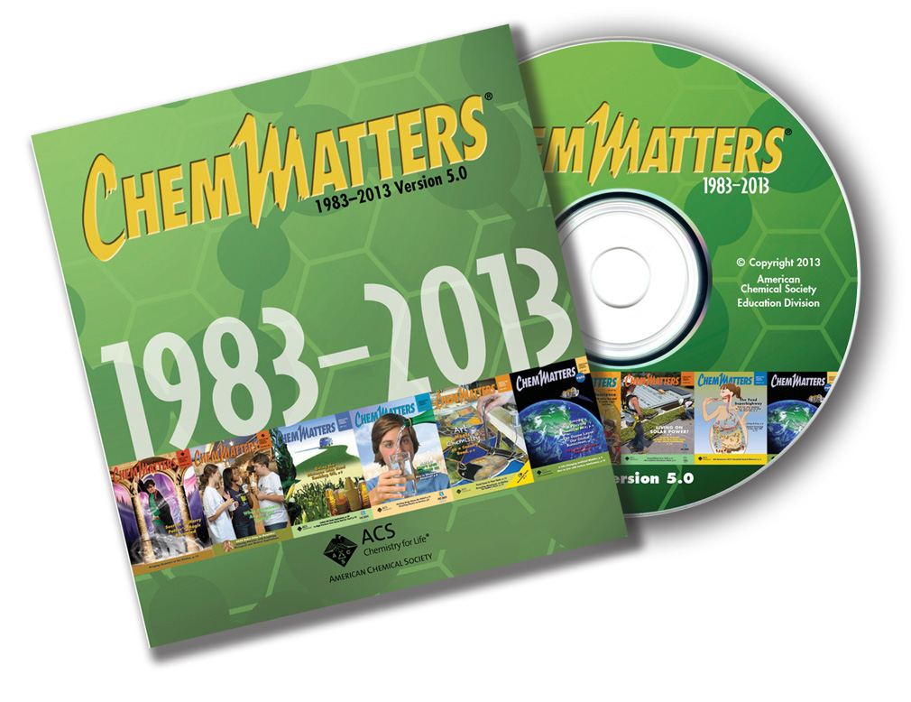
The references below can be found on the ChemMatters 30-year DVD (which includes all articles published during the years 1983 through April 2013 and all available Teacher’s Guides, beginning February 1990). The DVD is available from the American Chemical Society for $42 (or $135 for a site/school license) at this site: http://ww.acs.org/chemmatters. Scroll to the bottom of the page and click on the ChemMatters DVD image at the right of the screen to order or to get more information.

Selected articles and the complete set of Teacher’s Guides for all issues from the past three years are available free online on the same Web site, above. Simply access the link and click on the “Past Issues” button directly below the “M” in the ChemMatters logo at the top of the Web page.
30 Years of ChemMatters

Available Now!

Baxter, R. Computer Chips—Loaded Bits. ChemMatters 1997, 15 (4), pp 7–9. Baxter describes the role of silicon in the construction of computer chips, including n-type and p-type dopants.

Kimbrough, D. 1905: Einstein’s Miraculous Year. ChemMatters 2005, 23 (4), pp 4–6. This article describes papers that Einstein wrote during 1905 involving the existence of atoms, the photoelectric effect (and the dual nature of light) and special relativity. To understand photovoltaics in the current article, read the section in this article on the photoelectric effect.

Baxter, R. Chemistry Builds a Green Home. ChemMatters 2006, 24 (3), pp 9–11. In this article on home energy efficiency, alternative energy, and the environment, there is a section on photovoltaics that is worth reading.

Baxter, R. Metals’ Hidden Strengths. ChemMatters 2009, 27 (3), pp 11–12. This second article by Baxter has a brief section on photovoltaic cells.

Tinnesand, M. Harnessing Solar Power. ChemMatters 2011, 29 (3), pp 8–9. This article, also on solar energy, covers the topic of photovoltaics and has excellent diagrams about solar cells and silicon doping.

Tinnesand, M. Graphene: The Next Wonder Material? ChemMatters 2012, 30 (3),
pp 6–8. Although the primary focus of this article is graphene, it includes recent developments in photovoltaics.

Web Sites for Additional Information
(Web-based information sources)

More sites on the sun’s energy

NASA’s Earth Observatory web site has information on the energy coming to earth from the sun at http://earthobservatory.nasa.gov/Features/EnergyBalance/page4.php.

Solar energy basics are explained in the University of Oregon site: http://zebu.uoregon.edu/disted/ph162/l4.html.

The Encyclopedia of the Earth has some solar radiation basics here: http://www.eoearth.org/view/article/156098/.

NASA’s Windows to the Universe explains how and how much energy gets from the Sun to the Earth. (http://www.windows2universe.org/earth/climate/sun_radiation_at_earth.html)

One chapter from an online book provides solar data and concepts: http://www.powerfromthesun.net/Book/chapter02/chapter02.html.

This page from the American Chemical Society’s Climate Science Toolkit supplies a lot of information about the sun’s energy: http://www.acs.org/content/acs/en/climatescience/energybalance.html.

You can get data about solar radiation from the National Solar Radiation Data Base: http://rredc.nrel.gov/solar/old_data/nsrdb/.

An array of solar maps is available at the National Renewable Energy Lab Web site: http://www.nrel.gov/gis/solar.html.

More sites on photovoltaics

This cover story from ACS’ Chemical & Engineering News describes the state of photovoltaics: http://pubs.acs.org/cen/coverstory/8225/8225solarenergy.html.

The Union of Concerned Scientist has a site that gives a nice summary of both photovoltaics and thermal energy. (http://www.ucsusa.org/clean_energy/our-energy-choices/renewable-energy/how-solar-energy-works.html#Solar_Heat_Collectors)

Research and Development, an online magazine has an article that highlights recent research in photovoltaics: http://www.rdmag.com/videos/2014/01/how-tap-sun%E2%80%99s-energy-through-heat-well-light?et_cid=3721262&et_rid=443505599&location=top.

This chapter in the book Sustainable Energy by David McKay focuses on both photovoltaics and solar thermal: http://www.withouthotair.com/c6/page_38.shtml.

This page from NASA Science News profiles a solar voltaic cell: http://science1.nasa.gov/science-news/science-at-nasa/2002/solarcells/.

The always dependable How Stuff Works has multiple pages on solar cells: http://science.howstuffworks.com/environmental/energy/solar-cell1.htm.

And this site from How Stuff Works details the workings of semiconductors: http://electronics.howstuffworks.com/diode.htm.
This site provides a comparison between the photoelectric effect and the photovoltaic effect: http://sargosis.com/articles/science/how-pv-modules-work/the-photoelectric-and-photovoltaic-effects/.
The National Renewable Energy Lab lists recent developments in solar energy: http://www.nrel.gov/pv/.

How Stuff Works gives this description of solar cells: http://science.howstuffworks.com/environmental/energy/solar-cell.htm.

A 2014 edition of Chemical & Engineering News featured an article on recent developments in photovoltaics with emphasis on perovskite solar cells, a much more efficient technology made of organometallic tri-halides. (http://cen.acs.org/articles/92/i8/Tapping-Solar-Power-Perovskites.html)

More sites on solar thermal energy

The Arizona Solar Center provides an explanation of solar thermal collectors here: http://www.azsolarcenter.org/tech-science/solar-for-consumers/solar-hot-water/solar-hot-water-a-primer.html.

A basic description of how solar thermal technology works is contained in this site from the Solar Energy Industries Association. (http://www.seia.org/policy/solar-technology/solar-heating-cooling)

More sites on solar applications

Entec Solar lists various solar technologies and their advantages: http://www.entecsolar.com/Applications.asp.

From a variety of original sources, Buzzfeed compiled this list of interesting solar uses with photos: http://www.buzzfeed.com/thegeshow/top-10-coolest-uses-of-solar-panels.

Solar Power World lists more applications: http://www.solarpowerworldonline.com/2013/05/7-cool-solar-energy-applications/.

More sites on solar power plants

Another site from How Stuff Works describes solar power plants. (http://science.howstuffworks.com/environmental/green-tech/energy-production/solar-thermal-power.htm)

This Washington Post online article describes the Ivanpah solar plant that opened in early 2014: http://www.washingtonpost.com/business/technology/huge-thermal-plant-opens-as-solar-industry-grows/2014/02/13/111cb52a-946f-11e3-9e13-770265cf4962_story.html.

Another article, this one from Smithsonian Magazine, describes the Ivanpah plant in the Mojave Desert: http://www.smithsonianmag.com/science-nature/take-a-look-at-the-worlds-largest-solar-thermal-farm-91577483/.

