logo_chemmatters[1]

**October/November 2015 Teacher's Guide for**

***Eating with Your Eyes: The Chemistry of Food Colorings***

**Table of Contents**

[About the Guide 2](#_Toc430858169)

[Student Questions 3](#_Toc430858170)

[Answers to Student Questions 4](#_Toc430858171)

[Anticipation Guide 5](#_Toc430858172)

[Reading Strategies 6](#_Toc430858173)

[Background Information 9](#_Toc430858174)

[Connections to Chemistry Concepts 29](#_Toc430858175)

[Possible Student Misconceptions 30](#_Toc430858176)

[Anticipating Student Questions 31](#_Toc430858177)

[In-Class Activities 31](#_Toc430858178)

[Out-of-Class Activities and Projects 35](#_Toc430858179)

[References 36](#_Toc430858180)

[Web Sites for Additional Information 37](#_Toc430858181)

# About the Guide

Teacher’s Guide editors William Bleam, Regis Goode, Donald McKinney, Barbara Sitzman and Ronald Tempest created the Teacher’s Guide article material. E-mail: [bbleam@verizon.net](mailto:bbleam@verizon.net)

Susan Cooper prepared the anticipation and reading guides.

Patrice Pages, *ChemMatters* editor, coordinated production and prepared the Teacher’s Guide. E-mail: [chemmatters@acs.org](mailto:chemmatters@acs.org)

Articles from past issues of *ChemMatters* can be accessed from a DVD that is available from the American Chemical Society for $42. The DVD contains the entire 30-year publication of *ChemMatters* issues, from February 1983 to April 2013.

The *ChemMatters* DVD also includes Article, Title and Keyword Indexes that covers all issues from February 1983 to April 2013.

The *ChemMatters* DVD can be purchased by calling 1-800-227-5558.

Purchase information can be found online at [www.acs.org/chemmatters](http://chemistry.org/chemmatters/cd3.html).

# Student Questions

* 1. Why is green-colored ketchup not found on supermarket shelves?
  2. Why do people often avoid multicolored food?
  3. What is the reason for adding food coloring to hot dogs?
  4. Describe a property of beta-carotene that makes it suitable for use as a coloring agent for dairy products.
  5. What makes anthocyanin molecules water-soluble?
  6. What groups on anthocyanin molecules are responsible for their water solubility?
  7. Why did Starbucks remove cochineal dye from its strawberry flavored products?
  8. Why do manufacturers prefer artificial- to natural-coloring substances for their products?
  9. How do the elements that compose the molecular formula of Red No. 3 differ from the elements present in the other formulas shown in Table 1?
  10. What is the base material currently used to produce most synthetic food dyes?
  11. What happens when food-coloring molecules dissolve in water?
  12. In what ways do food scientists claim that eating involves more than just taste?

# Answers to Student Questions

* + 1. **Why is green-colored ketchup not found on supermarket shelves?**

*Although green colored ketchup has existed, consumers prefer red because this color matches the color they associate with the flavor of ketchup (and tomatoes).*

* + 1. **Why do people often avoid multicolored food?**

*People avoid multicolored food because it looks like it might be moldy and should not be eaten.*

* + 1. **What is the reason for adding food coloring to hot dogs?**

*Without the addition of food coloring, hot dogs would be gray and unappealing to customers.*

* + 1. **Describe a property of beta-carotene that makes it suitable for use as a coloring agent for dairy products.**

*Beta-carotene is fat soluble so it will dissolve in fatty dairy products such as butter giving them color.*

* + 1. **What makes anthocyanin molecules water-soluble?**

*The polar nature of anthocyanin molecules makes them water-soluble.*

* + 1. **What groups on anthocyanin molecules are responsible for their water solubility?**

*It is the –OH groups that make the anthocyanin molecules polar.*

* + 1. **Why did Starbucks remove cochineal dye from its strawberry flavored products?**

*Starbucks removed cochineal dye from its strawberry flavored products in response to customer complaints about eating bugs***.**

* + 1. **Why do manufacturers prefer artificial- to natural-coloring substances for their products?**

*Manufacturers prefer artificial- to natural-coloring substances because they are cheaper and can be mass produced.*

* + 1. **How do the elements that compose the molecular formula of Red No. 3 differ from the elements present in the other formulas shown in Table 1?**

*The molecular formula of Red No. 3 contains iodine (I) and does not contain sulfur (S) which is present in all the other molecular formulas.*

* + 1. **What is the base material currently used to produce most synthetic food dyes?**

*The base material currently used to produce most synthetic food dyes is petroleum or crude oil.*

* + 1. **What happens when ionic food-coloring molecules dissolve in water?**

*Ionic food-coloring molecules dissolve in water when the ions that form the solid become associated with the partial negative and partial positive charges on polar water molecules.*

* + 1. **In what ways do food scientists claim that eating involves more than just taste?**

*Food scientists claim that the smell, sound, feel and sight of food are just as important as its taste.*

# Anticipation Guide

Anticipation guides help engage students by activating prior knowledge and stimulating student interest before reading. If class time permits, discuss students’ responses to each statement before reading each article. As they read, students should look for evidence supporting or refuting their initial responses.

**Directions:**  *Before reading*, in the first column, write “A” or “D,” indicating your agreement or disagreement with each statement. As you read, compare your opinions with information from the article. In the space under each statement, cite information from the article that supports or refutes your original ideas.

|  |  |  |
| --- | --- | --- |
| **Me** | **Text** | **Statement** |
|  |  | 1. About 30% of the diet of the average U. S. resident is from processed foods. |
|  |  | 1. People have used natural food dyes for centuries. |
|  |  | 1. All anthocyanins have the same molecular structure. |
|  |  | 1. Some red food dye comes from insects. |
|  |  | 1. Synthetic food dyes are more expensive than natural food dyes. |
|  |  | 1. Most synthetic food dyes are made from petroleum. |
|  |  | 1. Food coloring molecules are usually nonpolar solids. |
|  |  | 1. Blue dye absorbs mostly red, orange, and yellow light. |
|  |  | 1. Food coloring molecules usually have alternating single and double bonds that allow electrons to be excited at relatively low energy. |
|  |  | 1. Natural products are always healthier than artificial ones. |

# Reading Strategies

These graphic organizers are provided to help students locate and analyze information from the articles. Students’ understanding will be enhanced when they explore and evaluate the information themselves, with input from the teacher if students are struggling. Encourage students to use their own words and avoid copying entire sentences from the articles. The use of bullets helps them do this. If you use these reading strategies to evaluate student performance, you may want to develop a grading rubric such as the one below.

|  |  |  |
| --- | --- | --- |
| **Score** | **Description** | **Evidence** |
| 4 | Excellent | Complete; details provided; demonstrates deep understanding. |
| 3 | Good | Complete; few details provided; demonstrates some understanding. |
| 2 | Fair | Incomplete; few details provided; some misconceptions evident. |
| 1 | Poor | Very incomplete; no details provided; many misconceptions evident. |
| 0 | Not acceptable | So incomplete that no judgment can be made about student understanding |

***Teaching Strategies:***

1. Links to **Common Core Standards for Reading**:
   1. ELA-Literacy.RST.9-10.5: Analyze the structure of the relationships among concepts in a text, including relationships among key terms (e.g., force, friction, reaction force, energy).
   2. ELA-Literacy.RST.11-12.4: Determine the meaning of symbols, key terms, and other domain-specific words and phrases as they are used in a specific scientific or technical context relevant to grades 11-12 texts and topics.
2. Links to **Common Core Standards for Writing**:
   1. ELA-Literacy.WHST.9-10.2F: Provide a concluding statement or section that follows from and supports the information or explanation presented (e.g., articulating implications or the significance of the topic).
   2. ELA-Literacy.WHST.11-12.1E: Provide a concluding statement or section that follows from or supports the argument presented.
3. **Vocabulary** and **concepts** that are reinforced in this issue:
   1. Solution chemistry
   2. Chemical equilibrium
   3. Acids and bases
   4. pH
   5. Buffers
   6. Molecular structures
4. The infographic about autumn leaves on page 19 will engage students with more information about some of the natural dyes found in “Eating With Your Eyes.”
5. To help students engage with the text, ask students which article **engaged** them most and why, or what **questions** they still have about the articles. The Background Information in the *ChemMatters* Teachers Guide has suggestions for further research and activities.

**Directions**: As you read, complete the graphic organizer below to compare and contrast natural and artificial food dyes. You could include information found in the infographic on page 19 of this issue of *ChemMatters*.

|  |  |  |
| --- | --- | --- |
|  | **Natural Food Dyes** | **Artificial Food Dyes** |
| **Examples, including colors** |  |  |
| **Advantages** |  |  |
| **Disadvantages** |  |  |
| **How they work** |  |  |

**Summary:** After reading this article, will you notice the dyes in your food? Explain your reason(s) on the back of this paper.

# Background Information

**(teacher information)**

**More on the discovery of synthetic coloring agents**

In the Middle Ages, only royalty could wear the color purple. Tyrian purple dye was first used by the Phoenicians in 1570 BC. It was extracted from small snails and was valued because it did not fade. The cost was prohibitive because 12,000 snails had to be smashed to yield 1.5 grams of dye, enough to dye only one handkerchief! Laws prohibited commoners from inordinate expenditures on clothing, so only royalty was permitted to wear this color.

William Henry Perkin (1838-1907) is credited with the discovery of the first synthetic organic chemical dye. Perkin was only 15 years old when he began studying at the Royal College of Chemistry in London. At 18, Perkin was working on the synthesis of quinine from bark of the cinchona tree found in Bolivia and Peru. Quinine is used to cure malaria.

Perkin was working in a crude laboratory in his apartment, when he accidentally discovered that mauveine (also known as aniline purple) could be extracted with alcohol to produce an intense purple dye that would neither wash out nor fade from silk material. His discovery provided the foundation for the discovery of many colorful aniline dyes.

(<http://www.humantouchofchemistry.com/william-henry-perkin.htm>)

(<http://perryponders.com/2015/04/23/a-chemist-accidentally-discovered-purple-when-looking-for-a-cure-for-malaria/>)

**More on links between the brain and food color**

Charles Spence, an Oxford experimental psychologist says, "Half the brain is visual in some sense, versus just a few per cent for overall taste senses. So in cortical real estate, vision is always going to win." This, he explains, is why color helps us decide if a food is fit for consumption as well as what flavor we will expect.

Spence has found that the package may also affect expected flavor. His research showed that people could be confused into thinking that salt and vinegar potato chips tasted like cheese and onion flavored when he switched the chip bags. He theorized that our brains make quick association shortcuts. We look at the color of the bag and expect the taste of the chips to match the color of the familiar bag. ([*http://www.theguardian.com/lifeandstyle/wordofmouth/2013/mar/12/how-taste-different-colours*](http://www.theguardian.com/lifeandstyle/wordofmouth/2013/mar/12/how-taste-different-colours))

**More on the association of color with taste**

This research is usually done with colored liquids and solid gelatin solutions. The following studies were cited in “Preconceptions of Taste Based on Color”. In this paper published in *The Journal of* Psychology, 2003, 137 (3), pp 233–242, Christopher Koch of the Department of Psychology, George Fox University, and Eric Koch, Department of Business Administration, Texas Tech University, describe the results of several studies, including a description of their own findings from a questionnaire administered to 45 college students. Data from two of the studies are described below. A description of the Koch findings follows this information.

(<http://digitalcommons.georgefox.edu/cgi/viewcontent.cgi?article=1034&context=psyc_fac>)

In 1997, C. Strugnellinvestigated “Colour and its role in sweetness perceptions.” In his tests, he first asked participants to rank liquids by their sweetness. In the second stage of the tests, he kept the concentration of sweetness constant but changed the colors of the liquids. He found that participants ranked red colored liquids the sweetest and blue liquids the least sweet on their sweetness scale. **(**<http://www.ncbi.nlm.nih.gov/pubmed/9134097>)

1998 studies by R. L. Alley and T. R. Alley used sucrose solutions of four different colors in both liquid and solid gelatin form with a colorless solution as the control. Rebecca L. Alley (D. W. Daniel High School Central, South Carolina) gave 50 junior high school students ten samples of each solution. Overall the students ranked the liquids sweeter than the solids and the colored solutions sweeter than the colorless. The color did not seem to make a difference. The results of their studies were published in the *Journal of Psychology* in September 1998. (<http://www.ncbi.nlm.nih.gov/pubmed/9729847>)

Studies done by the Kochs, mentioned above, in 2003 at the University of Oregon involved 45 student volunteers. They investigated the “role of color in perceived taste using soft drinks as target beverages”. Soft drinks were chosen due to prior studies that found that people associate certain colors with these drinks. They used ten colors (red, green, yellow, blue, brown, orange, purple, black, gray and white) and eight tastes associated with soft drinks (sweet, sour, bitter, salty, citrusy, syrupy, fruity and bubbly). Their questionnaire contained 80 questions asking students to rank both colors and tastes on a   
1–10 scale. For example, “On a scale of 1 to 10 with 10 being the sweetest, how sweet is the color red?” Data was displayed by ranking of the colors as positively or negatively associated with each taste. For example, the table at right shows red and orange positively associated with sweet and red negatively (seldom) associated with sour, bitter, salty, citrusy and bubbly.

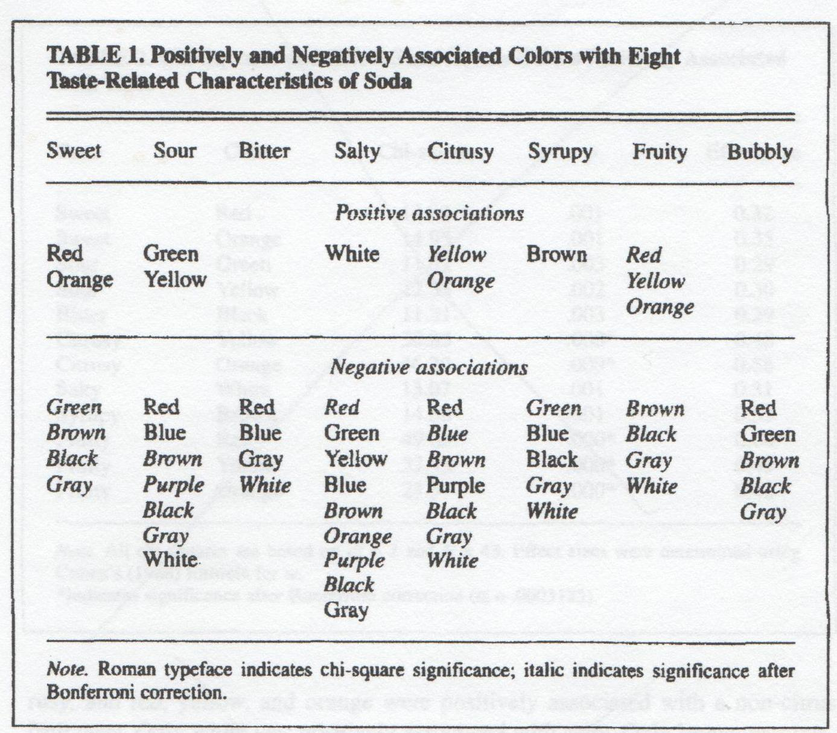

*(*[*http://digitalcommons.georgefox.edu/cgi/viewcontent.cgi?article=1034&context=psyc\_fac*](http://digitalcommons.georgefox.edu/cgi/viewcontent.cgi?article=1034&context=psyc_fac)*)*

**More on connections between taste and color**

In summarizing the research on connections between taste and color completed in the 1980s through 2003, Koch and Koch claim that

* Most colors are not associated with a particular taste.
* Color is commonly considered a taste enhancer.
* Color probably affects the desirability of food. As suggested in the Rohrig food dyes article, off-color may indicate that food is moldy and should not be eaten.
* A pink color may indicate that beef or chicken is undercooked.
* Former associations between certain colors and food may influence taste.

Additional research is suggested to determine if a person’s perception of taste can be changed by varying familiar color/taste combinations. Another problem to investigate is the possible connection between the package color and label with the taste of its contents.

(<http://digitalcommons.georgefox.edu/cgi/viewcontent.cgi?article=1034&context=psyc_fac>)

**More on launching black cheese burgers**

In September 2014, Burger King announced the introduction of black colored cheese burgers complete with black buns, black sauce and black cheese. The “Kuro Burger”, translated as “Black Burger”, was a tremendous hit in Japanese establishments. The buns and cheese are colored with bamboo charcoal; the sauce is made of garlic, onions, and squid ink; and the hamburger patty is generously spiced with black pepper before grilling. A cooking video with complete directions can be found in this teachers’ guide suggested as an “Out-of-Class Activity”.

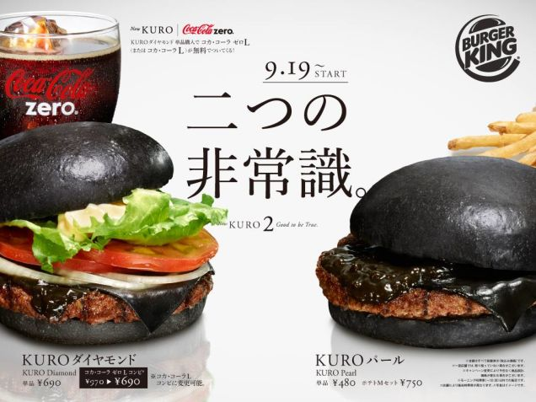

The Japanese Kuro Burger at Burger King

*(*[*http://kotaku.com/in-japan-burger-king-has-a-black-cheese-burger-1632883542*](http://kotaku.com/in-japan-burger-king-has-a-black-cheese-burger-1632883542)*)*

The Black Burgers were not as welcome in North America. Hayley Peterson, a reporter for *businessinsider*, says, **“**Burger KingJapan's black burgerslook unbelievably gross in real life.” (<http://www.businessinsider.com/burger-kings-black-burgers-look-gross-2014-9>)

Somewhat similar but more descriptive comments came from Josh Elliott of *Canadian CTVNews*. Josh said, “People have certain expectations when it comes to food and drink. Corn is yellow, coffee is black and chicken is white. But would you try teal corn, red chicken or blue coffee?” Burger King did not attempt to introduce the black burgers to the Canadian market. (<http://www.ctvnews.ca/business/black-burgers-the-newest-offering-in-crazy-coloured-food-1.2004111>)

Eva Hyatt studies food preferences as a marketing professor at Appalachian State University. When interviewed by *The Atlantic*, she said, “The Japanese are used to eating black seaweed, fermented black bean-paste-based foods, black walnut powder, squid ink, and a lot of gray, muted-colored foods, so a black burger bun and cheese would not seem too alien to them.” (<http://www.theatlantic.com/health/archive/2014/09/food-color-trumps-flavor/380743/>)

**More on Burger King and McDonald’s competition**

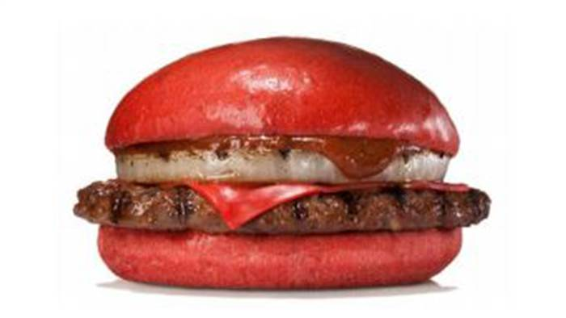

Burger King’s Aka Samurai Beef Burger *(*[*http://www.today.com/food/burger-king-japan-sell-red-burgers-t27256*](http://www.today.com/food/burger-king-japan-sell-red-burgers-t27256)*)*

McDonald’s quickly produced a black burger knockoff, so rival Burger King introduced the “Aka Burger” (aka means red in Japanese). Beginning in July 2015, Aka Burgers were available in Samurai Beef and Samurai Chicken with a red bun and red cheese.

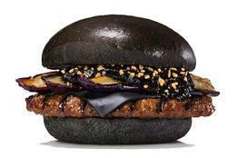

The Burger King Kuro Shogun

*(*[*http://blogs.wsj.com/japanrealtime/2015/06/17/burger-king-japan-to-sell-red-burgers/*](http://blogs.wsj.com/japanrealtime/2015/06/17/burger-king-japan-to-sell-red-burgers/)*)*

The *Wall Street Journal* reports that the aka burger is served with a red hot sauce made from miso and red hot peppers. Also, to keep ahead of the curve, Burger King will add deep-fried eggplant to its black burger producing the new “Kuro Shogun” (at right) which was to debut on August 21, 2015.

**More on processed foods**

The Rohrig food dyes article reports that about 70% of our diet is processed foods. What does “processed” mean? There is no legal definition of “processed”. The International Food Information Council Foundation (IFICF) defines food processing as, “Any deliberate change in a food that occurs before it's available for us to eat.” Manufacturers are currently not required to provide processing information on labels. There are some strong movements to require labeling of products that use genetically modified crops (GMOs). The IFICF “Fact Sheet: Common Food Production Practices and Their Unique Contributions to the Food Supply” contains much information on modern food production systems and government regulation. (<http://www.foodinsight.org/Content/3843/Final_Food_Production_Fact_Sheet_5.11.pdf>)

The term “Processed Food” is very broad and frequently conveys a negative connotation. Using the IFICF definition of food processing, food is considered processed even if it is only chopped, frozen or dried. The table below contains a few examples of the processing that certain types of food undergo before they reach our tables.

|  |  |
| --- | --- |
| **Type of Food** | **Examples** |
| Foods that require little processing or production (also called “minimally processed”). | Washed and packaged fruits and vegetables; bagged salads; roasted and ground nuts and coffee beans |
| Foods processed to help preserve and enhance nutrients and freshness of foods at their peak. | Canned tuna, beans and tomatoes; frozen fruits and vegetables; pureed and jarred baby foods |
| Foods that combine ingredients such as sweeteners, spices, oils, flavors, colors, and preservatives to improve safety and taste and/or add visual appeal. (Does not include “ready-to-eat” foods listed below.) | Some packaged foods, such as instant potato mix, rice, cake mix, jarred tomato sauce, spice mixes, dressings and sauces, and gelatin |
| “Ready-to-eat” foods needing minimal or no preparation. | Breakfast cereal, flavored oatmeal, crackers, jams and jellies, nut butters, ice cream, yogurt, garlic bread, granola bars, cookies, fruit chews, rotisserie chicken, luncheon meats, honey-baked ham, cheese spreads, fruit drinks and carbonated beverages |
| Foods packaged to stay fresh and save time | Prepared deli foods and frozen meals, entrées, pot pies and pizzas |

*(*[*http://www.foodinsight.org/sites/default/files/what-is-a-processed-food.pdf*](http://www.foodinsight.org/sites/default/files/what-is-a-processed-food.pdf)*)*

**More on labeling foods as “Natural”**

Since the U.S. Food and Drug Administration (FDA) does not define “natural”, no restrictions are placed on its use in product labeling. Thus, you will often see packages labeled “natural” to simply imply healthful, nutritious contents. In general this label usually means the absence of artificial food coloring or synthetic flavoring. Meat and poultry labeling, under the auspices of the U.S. Department of Agriculture (USDA), is much stricter. Under USDA rules a meat product can bear the “natural” label only if it is free of “artificial flavorings, coloring, ingredient, or chemical preservative” and the food processing is no more than minimal.

(<http://www.foodinsight.org/Content/3843/Final_Food_Production_Fact_Sheet_5.11.pdf>)

Although there is no overall legal definition, natural food colorings are considered to be materials that are found in nature and prepared with minimal processing. Pigments extracted directly from plants, minerals and animals are considered natural. Natural materials contain no petroleum products. DDW – The Colour House offers the following descriptions of some frequently confused terms:

**Naturally derived colouring**

1. sources from substance that occurs in nature. Its origin is natural - whether vegetal (plant), microbiological, animal or mineral.
2. results from traditional food preparation processes

**Nature identical colouring**

1. meets none of the above criteria
2. through chemical synthesis replicates molecular structure to become identical to the naturally derived colouring.

(<http://www.ddwcolor.com/colorant/carotenoids/beta-carotene/>)

**More on food color poisoning**

In ancient times natural food coloring was not always safe for the consumer—particularly when the colorant came from minerals. Early legislation in Europe attempted to regulate the use of food coloring. In 1396 the French banned coloring in butter; in 1574 pastry coloring was added to this law; and in 1531 any German accused of using saffron as a colorant could be sentenced to death by burning!

In the 1820s, sweets were colored with a variety of colorful and frequently toxic compounds. Mercury sulfide, red lead, white lead, yellow lead chromate and a mixture of copper salts including copper arsenate caused frequent food poisoning and death. When William Henry Perkin (see the first section of the Background Information for this Teacher’s Guide) discovered artificial dyes, some manufacturers used them to cover and thus disguise poor quality or rotten food. In 1860, following the poisoning of about 200 people in England, the British government began to regulate the use of food coloring.

The U.S. Food and Drug Administration (FDA) was established in 1927 to investigate the toxicology of artificial colorants. In 1951 many children were poisoned after eating popcorn colored with Orange #1. In response the FDA revisited its approval list of sixteen artificial colorants. In 1960, this list was reduced to the seven currently approved artificial colorants. These are listed in Table 1 of the Rohrig article.

**More on** **natural food coloring**

**Carotenoids**

Carotenoids are a large class of pigments that can be extracted from plants, algae and photosynthetic bacteria. The human body synthesizes vitamin A, essential for vision, the immune system and growth, from carotenoids present in the fruits and vegetables of a normal diet.

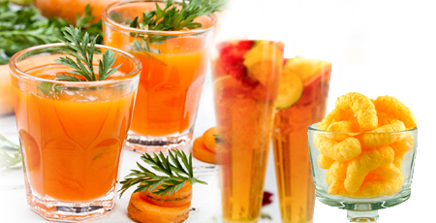

Various foods containing carotenoids

*(*[*http://www.ddwcolor.com/colorant/carotenoids/beta-carotene/*](http://www.ddwcolor.com/colorant/carotenoids/beta-carotene/))

DDW – The Colour House claims that the natural beta-carotene that they extract (and sell) is far superior to the synthetic version. They find that the natural pigment readily dissolves as a very slightly cloudy solution, contains vitamin A, and does not form a sediment or stain the bottle as does the synthetic colorant.

As stated in the Rohrig article, excessive amounts of beta-carotene can color your skin. Drinking excessive amounts of carrot juice, eating too many yellow-orange vegetables and taking beta-carotene supplements can cause *carotenosis*. This is a condition where the skin on your nose, the palms of your hands and the soles of your feet turn yellow-orange because you are feeding your body more beta-carotene than it can use to make vitamin A. Once you reduce your intake of these vegetables and supplements, the color will fade and leave no harmful side effects.

The body stores fat-soluble beta-carotene and uses it only as needed to make Vitamin A (also called retinol). However, some people take excessive Vitamin A supplements as a “cancer cure”. Since the Vitamin A molecule is also fat soluble, excess amounts are retained primarily in the liver. The American Cancer Society reports that while vitamin A is important for your health, consuming excessive amounts of supplements can lead to a serious medical condition, hypervitaminosis A. If, in addition to color changes in the skin, the vision is blurred along with dizziness and bone pain, hypervitaminosis A can be fatal. A fact sheet from the National Institutes for Health (NIH) reports several studies:

**Carotene and Retinol Efficacy Trial (CARET)**: This U.S. trial examined the effects of daily supplementation with beta-carotene and retinol (vitamin A) on the incidence of lung cancer, other cancers, and death among people who were at high risk of lung cancer because of a history of smoking or exposure to asbestos. The trial began in 1983 and ended in late 1995, 2 years earlier than originally planned. Results reported in 1996 showed that daily supplementation with both 15 mg beta-carotene and 25,000 International Units (IU) [retinol](http://www.cancer.gov/Common/PopUps/popDefinition.aspx?id=CDR0000046057&version=Patient&language=English) was associated with increased lung cancer and increased death from all causes (all-cause mortality) ([13](http://www.cancer.gov/about-cancer/causes-prevention/risk/diet/antioxidants-fact-sheet#r13)). A 2004 report showed that these adverse effects persisted up to 6 years after supplementation ended, although the elevated risks of lung cancer and all-cause mortality were no longer statistically significant ([14](http://www.cancer.gov/about-cancer/causes-prevention/risk/diet/antioxidants-fact-sheet#r14)). Additional results, reported in 2009, showed that beta-carotene and retinol supplementation had no effect on the incidence of prostate cancer ([15](http://www.cancer.gov/about-cancer/causes-prevention/risk/diet/antioxidants-fact-sheet#r15)).

* 1. Omenn GS, Goodman GE, Thornquist MD, et al. Effects of a combination of beta carotene and vitamin A on lung cancer and cardiovascular disease. *New England Journal of Medicine* 1996;334(18):1150-1155.
  2. Goodman GE, Thornquist MD, Balmes J, et al. The Beta-Carotene and Retinol Efficacy Trial: incidence of lung cancer and cardiovascular disease mortality during 6-year follow-up after stopping beta-carotene and retinol supplements. *Journal of the National Cancer Institute* 2004;96(23):1743-1750.
  3. Neuhouser ML, Barnett MJ, Kristal AR, et al. Dietary supplement use and prostate cancer risk in the Carotene and Retinol Efficacy Trial. *Cancer Epidemiology, Biomarkers & Prevention* 2009;18(8):2202-2206.

(<http://www.cancer.gov/about-cancer/causes-prevention/risk/diet/antioxidants-fact-sheet>)

**Chlorophyll**

Natural chlorophyll, extracted from plants such as alfalfa, is heat- and light-sensitive and insoluble in water because the molecule is nonpolar. Therefore, for food use it must be mixed first with a small amount of vegetable oil.

The two major photoreceptors located in plant leaves are chlorophyll type A and chlorophyll type B. These are the molecules responsible for photosynthesis. Note the similarities in their structures shown below:

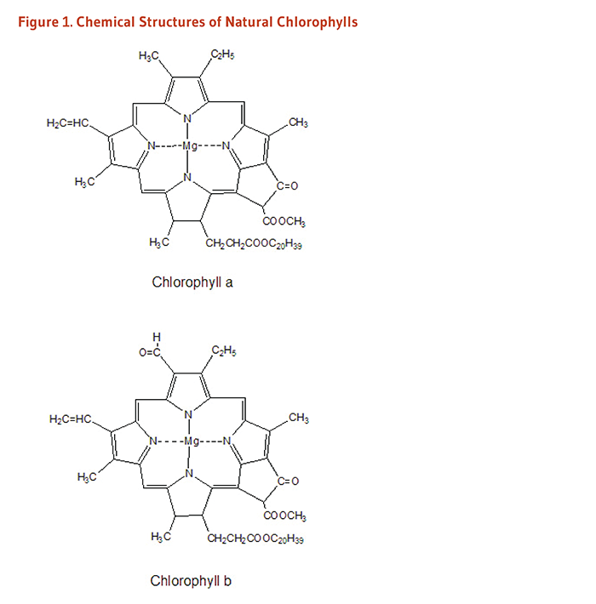*(*[*http://lpi.oregonstate.edu/mic/dietary-factors/phytochemicals/chlorophyll-chlorophyllin*](http://lpi.oregonstate.edu/mic/dietary-factors/phytochemicals/chlorophyll-chlorophyllin)*)*

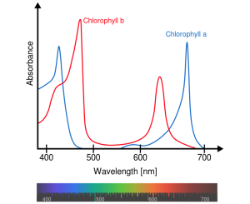 Both types are large molecules with a central (porphyrin) ring where magnesium is complexed to four nitrogen atoms. Their colors differ slightly: type a is blue-green; type b is yellow-green. The two structures show functional group differences: structure a has a methyl

(–CH3) side chain and b has an aldehyde (–CHO) as seen on the upper left of the structures above. Type a chlorophyll is essential for photosynthesis to occur. It serves as reaction centers for photosynthetic processes. Chlorophyll b is an accessory pigment that absorbs at wavelengths where chlorophyll a is less effective and transfers this energy to chlorophyll a. (<http://dyna-gro-blog.com/the-difference-between-chlorophyll-a-b-and-photosynthesis-overview/>)

A plot of the absorption spectra for chlorophyll A and B is shown above.

*(*[*https://commons.wikimedia.org/wiki/File:Chlorophyll\_ab\_spectra2.PNG*](https://commons.wikimedia.org/wiki/File:Chlorophyll_ab_spectra2.PNG)*)*

In 1997 Frank S. Lisa Sagliano at the University of Florida developed a procedure for freeze drying liquid chlorophyll extracted from spinach leaves. This was the first stable natural chlorophyll product. It can be purchased in powdered form.

To form a stable synthetic compound, the magnesium in the middle of the molecule is replaced by copper. The synthesized colorant (sodium copper chlorophyllin) is a stable, water soluble molecule, approved for use as a food colorant by the European Union (EU). An oil soluble version is also available. The USA permission for food use is restricted for use as a colorant for “dry citrus beverage mixes” such as colorings for orange, lemon or lime flavored powdered beverages and gelatins.

(<http://www.ddwcolor.com/colorant/chlorophyll-chlorophyllin/>)

On November 30, 1999, Kraft Foods, Inc. received patent number US 5993880A for the use of sodium copper chlorophyllin: “Non-staining, acid-stable, cold-water-soluble, edible green color and compositions for preparing acidic foods and beverages”.(<http://www.google.com/patents/US5993880>)

Chlorophyll types a and b found in plant leaves are fat-soluble compounds, as are their copper chlorophyllin salts. The copper salt can be saponified with sodium hydroxide to form sodium copper chlorophyllin, a water-soluble compound shown in the structures below. Note the three sodium ions on the trisodium compound and two sodium ions on the disodium indicate polarity and thus water solubility.

(<https://books.google.com/books?id=MiLSBQAAQBAJ&pg=PA517&lpg=PA517&dq=how+do+you+make+an+oil+soluble+version+of+sodium+copper+chlorophyllin&source=bl&ots=Q8FbQep5fx&sig=vr5SAbf4K4jL4hAMM0fm_i5wgVk&hl=en&sa=X&ved=0CB4Q6AEwAGoVChMIkdjf8PnKxwIVyNGACh2r5woC#v=onepage&q=how%20do%20you%20make%20an%20oil%20soluble%20version%20of%20sodium%20copper%20chlorophyllin&f=false>)

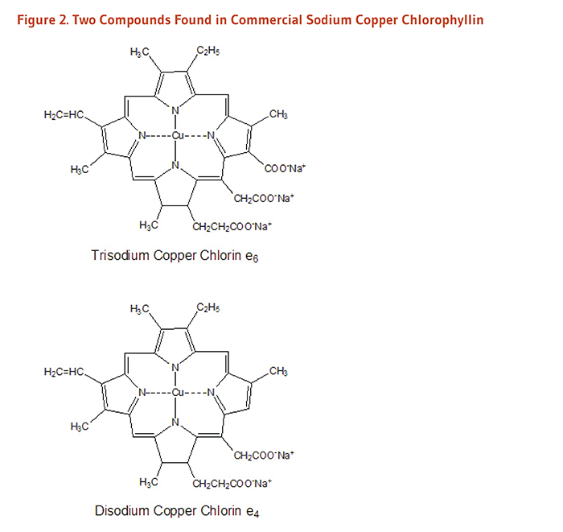

*(*[*http://lpi.oregonstate.edu/mic/dietary-factors/phytochemicals/chlorophyll-chlorophyllin*](http://lpi.oregonstate.edu/mic/dietary-factors/phytochemicals/chlorophyll-chlorophyllin)*)*

**Anthocyanins**

Red cabbage, beets, blueberries and radishes are some sources of anthocyanin pigment. The concentration of anthocyanins varies within each plant source, and their chemical structure depends upon the pH of the soil. The parent structure of anthocyanins is the flavylium cation, described in the Rohrig article and pictured below.

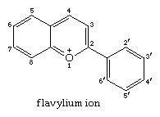

*(*[*http://www.britannica.com/science/heterocyclic-compound/Six-membered-rings-with-one-heteroatom#ref1004954*](http://www.britannica.com/science/heterocyclic-compound/Six-membered-rings-with-one-heteroatom#ref1004954)*)*

The molecular structure of these pigments changes as the pH of the solution or soil changes. From acidic to basic, the structures show color shifts from red to purple to blue. The molecular structure of anthocyanins is reversible; a pH change from basic to acid results in structural changes that present colors from blue to purple to red. Students may be familiar with red cabbage juice and know that the colors of some flowers such as violets and pansies depend upon the soil pH.

As weak organic acids, anthocyanin molecules donate protons to a solution. The pigment color depends upon the number of ionizable protons attached to the structure. Note that the molecule and ions shown below reflect light differently, thus producing color changes as the pH changes. The Rohrig article says that over 500 different anthocyanins have been identified in plants. The Web site for DDW—The Color House shows three structures for an anthocyanin, the molecule and two ions, plus the color reflected. Note that “B-L” stands for Bronsted-Lowry acid-base theory. The discussion column on the right explains that the second ion is the conjugate base of the molecule and the third ion is the conjugate base of the second ion.

|  |  |
| --- | --- |
| antho2 | Molecule 1 represents the anthocyanin with two protons (the 2 red H) to donate - a B-L acid.  **The molecule reflects red light.** |
| antho1 | Molecule 2 represents the B-L conjugate base of molecule 1, but it still has one proton to donate.  **The molecule reflects blue light.**  This molecule can either act as a B-L conjugate base and accept a proton - changing its color back to red - or act as a  B-L acid and donate its other proton. |
| antho0 | Molecule 3 represents the B-L conjugate base of molecule 2, with no more protons to donate.  **The molecule reflects greenish-yellow light.**  This molecule can no longer donate protons, but as a B-L conjugate base it can accept protons. Accepting 1 proton changes its color back to blue - while accepting 2 protons changes its color back to red. |

*(*[*http://www.ddwcolor.com/colorant/anthocyanins/*](http://www.ddwcolor.com/colorant/anthocyanins/)*)*

Anthocyanins serve well as food colorants because they are nearly flavorless and odorless. They can also be used as pH indicators. (See the “In-class Activities” section of this Teacher’s Guide for a suggested student investigation.) As seen in the chart at right, their solution color varies from red in acidic solutions to blue in slightly basic solutions and almost colorless in very basic solutions.

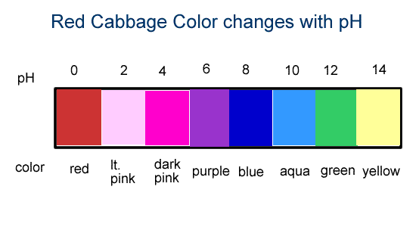

*(*[*http://www.coolscience.org/*](http://www.coolscience.org/)*)*

**Turmeric**

The spice turmeric has three curcuminoids, the active pigments that give Indian curry and mustard their deep yellow color. Turmeric comes from the rhizomes of the curcuma longa plant which grows in southwest India, China, South America, and the East Indies. The bulb-like roots are ground to produce turmeric.

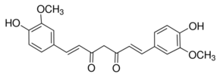

Curcuma longa (curcumin)

*(*[*http://www.sigmaaldrich.com/catalog/product/sigma/c1386?lang=en&region=US*](http://www.sigmaaldrich.com/catalog/product/sigma/c1386?lang=en&region=US)*}*

Various healing properties have been attributed to turmeric for at least 4000 years. While some have been substantiated, many are not based on reliable data. The University of Maryland Medical Center reports that many of the studies do not involve humans, and others use an injectable form of curcumin. Their Web site summarizes some of the benefits and risks.

Curcumin is a powerful antioxidant, inflammation reducer and blood thinner. It has also been known to assist in the treatment of ulcers, indigestion, osteoarthritis, heart disease, inflammation of the iris, and cancer. Curcumin may interact with other medications. Long term use may cause ulcers, gallstones, and low blood sugar. Details of these studies can be found on their site: (<http://umm.edu/health/medical/altmed/herb/turmeric>).

**Carminic acid from bugs**

The Aztecs were coloring their garments with the vibrant red extract from the female cochineal bug before Europeans arrived in South America in the 1500s. This small bug is found on prickly pear cactus in Mexico, Peru and the Canary Islands. Students may be familiar with the leaves (pads) of this plant because “nopales” are frequently used in Mexican cuisine. Sun drying and crushing thousands of bugs was required to produce the powdered dye.

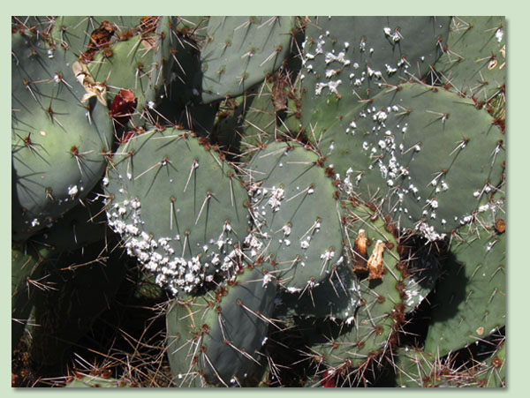

Cochineal infestation on prickly pear cactus

*(*[*http://www.thecactusdoctor.com/CochinealEradication.html*](http://www.thecactusdoctor.com/CochinealEradication.html)*)*

(<http://www.livescience.com/36292-red-food-dye-bugs-cochineal-carmine.html>)

The female cochineal bug

*(*[*http://www.vegparadise.com/news13.html*](http://www.vegparadise.com/news13.html)*)*

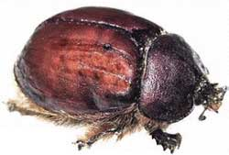

The white clumps on the nopales of the cactus plant shown above are clusters of microscopic cochineal bugs. They are considered a pest on this highly infected plant. The average female chochineal bug is only about five millimeters long.

**More on hypersensitivity to natural food colorings**

As stated in the Rohrig article, some people suffer minor to severe allergic reactions from contact with carmine in cosmetics such as eye shadow and lipstick. Especially susceptible are those who work with carmine in industrial settings. Allergic response can lead to dermatitis, asthma and anaphylactic response, a severe life-threatening allergic response. Additional details are available on this Web site:

(<http://www.inchem.org/documents/jecfa/jecmono/v46je03.htm>).

As of January 5, 2011, the U.S. Food and Drug Administration (FDA) requires that product labels for all foods and cosmetics containing cochineal extract (red dye from cochineal beetles) and/or carmine (red pigment made from dye of cochineal beetles) must notify consumers that they contain these pigments. This information is stated in “Guidance for Industry” on the FDA Industry Web site, below. This government site also includes frequently asked questions (FAQs) with answers regarding this regulation. (<http://www.fda.gov/ForIndustry/ColorAdditives/GuidanceComplianceRegulatoryInformation/ucm153038.htm>)

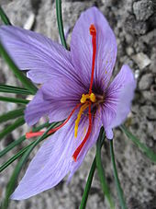 Although not considered major food allergens, some people may experience hives or asthma from other natural coloring agents such as carotenoids, annatto (seeds of fruit from the achiote tree), and saffron (red stigmas of the flower) used to color and flavor rice for Italian risotto and Spanish paella. Additional information is located on these sites: (<https://en.wikipedia.org/wiki/Annatto>) and (<http://www.drugs.com/npp/saffron.html>).

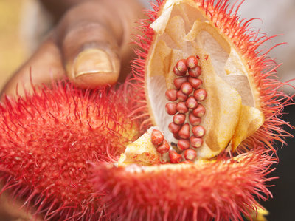

Annatto is produced from seeds from the achiote tree.

*(*[*http://www.npr.org/sections/thesalt/2015/02/19/387319835/chocolate-makeover-nestle-dumps-artificial-colorings*](http://www.npr.org/sections/thesalt/2015/02/19/387319835/chocolate-makeover-nestle-dumps-artificial-colorings)*)*

Saffron color is concentrated in red stigmas of the flower.

*(*[*https://en.wikipedia.org/wiki/Saffron*](https://en.wikipedia.org/wiki/Saffron)*)*

**More on commercial response to public demands—natural colorants**

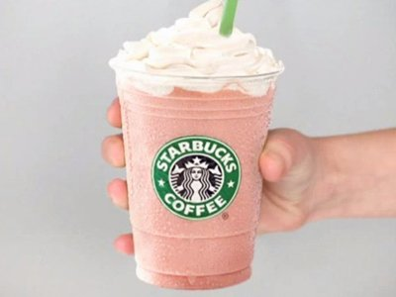

In March 2012 Starbucks responded to complaints from vegetarians, vegans and those whose religious beliefs prohibit consumption of animals by removing cochineal extract from its strawberry frappuccinos. The chain replaced the powdered bugs with lycopene, a tomato based coloring. Purple sweet potatoes can also be used as a natural cochineal extract replacement.

(<http://www.businessinsider.com/how-cochineal-insects-color-your-food-and-drinks-2012-3>)

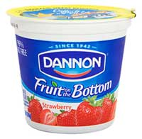 Other manufacturers have not followed suit. For example, Dannon will not remove cochineal extract from its strawberry yogurt. In July 2013, Elaine Watson, editor of FoodNavigator-USA, quotes Dannon, “Carmine is a safe natural food color, and we label it clearly on pack”. (<http://www.foodnavigator-usa.com/Suppliers2/Dannon-rejects-calls-to-remove-crushed-bugs-from-its-yogurts-Carmine-is-a-safe-natural-food-color-and-we-label-it-clearly-on-pack>

*(Photo:* [*http://www.vegparadise.com/news13.html*](http://www.vegparadise.com/news13.html)*)*

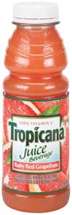 *Vegetarians in Paradise: News from the Nest* also warns vegetarians and others who want to avoid animal products that Tropicana’s “Season's Best Ruby Red Grapefruit Juice” and their “Pure Premium Orange Strawberry” drinks show cochineal extract on their labels.

The label on the Strawberry drink reads, “made from fresh oranges, not concentrate, 100% pure squeezed orange juice with calcium and strawberry and natural flavors and ingredients." Ingredients listed: “100% pure squeezed pasteurized juice, Fruit Cal (calcium hydroxide, malic acid, and citric acid), banana puree, white grape juice concentrate, strawberry juice concentrate, natural flavors, and **cochineal extract** [editor emphasis] (color)”. Note that in response to allergic reactions and personal diet objections, FDA approves the use of natural cochineal extract as long as it is listed on the label. (<http://www.vegparadise.com/news13.html>)

*(*[*http://www.vegparadise.com/news13.html*](http://www.vegparadise.com/news13.html)*)*

**More on** **synthetic food coloring**

“FD&C” from the table in the Rohrig article is the acronym for the U.S. Federal Food, Drug, and Cosmetic Act (FD&C Act). This set of laws was passed by Congress in 1938. This legislation gave the FDA authority to oversee the safety of food, drugs and cosmetics.

**The 1938 Food, Drug, and Cosmetic Act**

More consumer-oriented than its predecessor, the 1938 Food, Drug, and Cosmetic Act was a watershed in US food policy. In contrast to the limited health-based standards that the Ministry of Health proposed in Britain during the Depression, the US, largely through the efforts of women’s groups, pioneered policies designed to protect the pocketbooks of consumers, and food standards were enacted to ensure the ‘value expected’ by consumers. [46] The 1938 Act eliminated the ‘distinctive name proviso’ and required instead that the label of a food ‘bear its common or usual name’. The food would be misbranded if it represented itself as a standardised food unless it conformed to that standard. The law provided for three kinds of food standards: 1) standards (definitions) of identity, 2) standards of quality, and 3) standards regulating the fill of container. Regulators had the discretionary authority to set standards ‘whenever in the judgment of the Secretary such action will promote honesty and fair dealing in the interests of consumers’.[47]

[46]Legislative History, vol. 2, p. 93.  
[47]Pub. L. No. 75-717, 52 Stat. 1040 (1938)

(<http://www.fda.gov/AboutFDA/WhatWeDo/History/ProductRegulation/ucm132818.htm>)

These are the two additional food colorings that The FDA added (with restrictions) to the seven listed in the Rohrig article.

* Citrus Red 2, orange color, C18H16N2O3: for use on the rind of early season ripe oranges when there was insufficient cold weather to produce the natural color. At high levels, this colorant is a suspected carcinogen. (<https://en.wikipedia.org/wiki/Citrus_Red_2>)
* Orange B, red color, C22H16N4Na2O9S2: for use only on hot dogs and sausage casings with a limit of 150 ppm of the final product weight. The only U.S. supplier of Orange B has ceased producing it, but the colorant still remains on the limited use list. (<https://en.wikipedia.org/wiki/Orange_B>)

**More on how dyes produce visible color**

The following university Web sites provide information for students who are studying how food coloring is produced at the particle level. University students are performing laboratory experiments designed to study and determine how certain organic compounds absorb light of ultraviolet or visible wavelengths, the UV-Vis range. These articles provide an excellent source of information to augment the material in the Rohrig article.

The University of Massachusetts Amherst Web site article, “A Brief Discussion of Color”, uses experimental test results to explain the electromagnetic energy involved in the production of color in the visible spectrum. Structural formulas are used to show the conjugated (alternating single and multiple bonds) that allow the absorption of visible light.

(<https://people.chem.umass.edu/samal/269/color.pdf>)

Dartmouth University provides free access to an explanation of “The Spectra of Conjugated Dyes and Investigation of Beer's Law”. This piece was written to augment a college-level laboratory exercise and MAY be suitable for AP chemistry students. Quantum mechanical theory is developed to explain light scattering. The article is written for university students learning to calculate the amount of energy involved in light scattering in food dyes. It uses “The Quantum-Mechanical Particle-in-a-box” theory to “predict the wave functions and energy levels of the electrons responsible for the visible wavelength transitions and therefore the color of the dye” in Kool-Aid and Gatorade. Colorimetry and Beer's Law, paper chromatography and the structural formulas of food dyes are illustrated and explained.Students will be analyzing a solution of the drink to determine whether the colored drink is composed of one or more colorants.

(<https://www.dartmouth.edu/~chemlab/chem6/dyes/full_text/chemistry.html>)

**More on lake pigments**

The label on a package of M&Ms lists: “coloring (includes Blue 1 Lake, Red 40 Lake, Yellow 6, Yellow 5, Red 40, Blue 1, Blue 2 Lake, Yellow 6 Lake, Yellow 5 Lake, Blue 2”. Lake colors are synthetic food colorants. They are insoluble in water and they disperse in oil making them a preferred color for coating candies such as M&Ms.

Lake pigments are organic compounds that have been precipitated with an inert (nonreactive) binder that is usually colorless, tasteless, odorless and insoluble. Barium or calcium sulfates and aluminum hydroxide or oxide can serve as neutral binders. The organic compound determines the wavelength of light absorbed and reflected by the precipitate. (<http://www.foodadditivesworld.com/lakes.html>)

Natural Red 4 can be produced by boiling carminic acid (the natural extract is produced by the female cochineal bug) in a basic sodium carbonate solution containing a small amount of ethanol and precipitating it with aluminum or calcium cations. The dye is pH sensitive as seen in the pH and color ranges below:

**CARMINE COLOR**

**Differs with pH of Solution**

|  |  |  |  |  |  |  |  |  |  |  |  |  |  |  |  |  |
| --- | --- | --- | --- | --- | --- | --- | --- | --- | --- | --- | --- | --- | --- | --- | --- | --- |
| resized_300x282_web-cochineal | |  |  |  | | --- | --- | --- | | Shade | pH 3.0  pH 4.0  pH 7.0 | orange to red or purple  red or purple  red or purple | | Acceptable pH Range | 3.5 - 9.0 | | | Stability | heat  light  acid | excellent  excellent  excellent | | Forms | powder, liquid | | | Solubility | dispersible in water or oil | | |

*(*[*http://www.foodcolor.com/carmine-color*](http://www.foodcolor.com/carmine-color)*)*

The carmine precipitate is a "lake" known as Natural red 4. Once dried, the powder contains approximately 50% carminic acid. It is insoluble in oil but soluble in an alkaline water solution. The solution is stable above pH 6.

(<http://www.colormaker.com/natural-ingredients_carmine.html>)

**Natural Red 4**

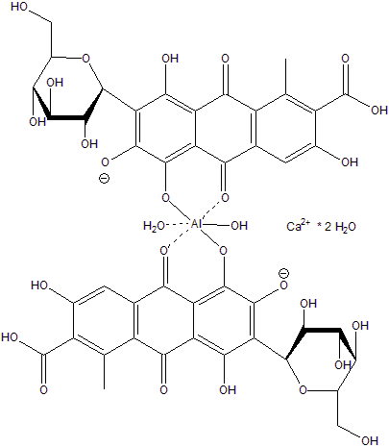

*(*[*http://www.ddwcolor.com/colorant/carminic-acid-carmine-cochineal/*](http://www.ddwcolor.com/colorant/carminic-acid-carmine-cochineal/)*)*

**More on the difference between dyes and lakes**

Both dyes and lakes are used for food coloring. Dyes are produced in either light powder or granular forms. To be FD&C certified, they must undergo a rigorous premarket approval by the FDA. The manufacturer submits a petition with data demonstrating that the dye is safe for human consumption and appropriate for use as a food dye. Subsequently each batch must be certified by the FDA. Dyes are water soluble so they can be used to color products that contain sufficient water for dissolution such as drinks and baked goods. (<http://www.fda.gov/ForIndustry/ColorAdditives/RegulatoryProcessHistoricalPerspectives/>)

Lakes are insoluble compounds made from dyes. They color fats and oils by dispersion. For food use, a lake must be prepared from an FDA certified food dye. A lake pigment is named for its metallic salt binder. For example, Red No. 40 can be used as the base material to produce Red No. 40 aluminum lake. This comes in two dilutions: a low dye which is 15–17% pure Red No. 40 and a high dye containing 36–42% of the original dye. Lake colors do not readily dissolve so they are the best choice for coating M&Ms and coloring lipstick.

<http://www.ifc-solutions.com/color_guide.html>)

**More on commercial response to public demands—synthetic colorants**

The *Berkeley Wellness* newsletter (November 2014) states, “According to the Institute of Food Technologists, natural colors outsold artificial ones globally in 2011 for the first time ever.” (<http://www.berkeleywellness.com/healthy-eating/food-safety/article/food-coloring-goes-natural>)

On January 20, 2015 the supermarket chain, Whole Foods, announced on their blog,

“Our Quality Standards: No Artificial Colors or Flavors”.

The blog adds that, since natural coloring agents are not as intense as the artificial ones, the product cost is greater for both the manufactures and the consumers.

(<http://www.wholefoodsmarket.com/blog/our-quality-standards-no-artificial-colors-or-flavors>)

The compound 4-methylimidazole (4-MEI) is a brown-colored byproduct formed during cooking procedures such as caramelizing (oxidizing) sugar, grilling meats and roasting coffee. “Caramel coloring” on a label may not indicate that 4-MEI is the coloring agent. See additional information in next section, “More on caramel coloring”, of this Teacher’s Guide. The FDA does not consider that the current data shows short-term danger from its consumption. Both the FDA and the European Food Safety Authority (EFSA) find current exposure levels below a danger threshold for human consumption. Yet, the FDA is continuing to monitor data on its use. (<http://www.fda.gov/food/ingredientspackaginglabeling/foodadditivesingredients/ucm364184.htm>)

4-methylimidazole (4-MEI)

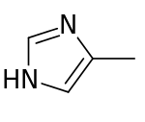

*(*[*https://en.wikipedia.org/wiki/4-Methylimidazole*](https://en.wikipedia.org/wiki/4-Methylimidazole))

Public response to the use of 4-MEI has been extremely negative and politicians in California as well as Whole Foods have listened. In 2011, California listed 4-MEI as a carcinogen in Proposition 65. The food coloring gives cola drinks their characteristic brown color. This legislation requires that a cancer warning be placed on the label of every product containing 4-MEI sold in the state. In response, Coca Cola and Pepsi changed their formulas eliminating 4-MEI. The FDA does not restrict its use, citing that one would have to drink 1000 cans of soda per day to reach the threshold of cancer in rodents.

This comes from the January 23, 2015 The American Beverage Association report on 4-MEI:

**Statement:**

First and foremost, consumers can rest assured that our industry's beverages are safe. Contrary to the conclusions of Consumer Reports, FDA has noted there is no reason at all for any health concerns, a position supported by regulatory agencies around the world. In fact, FDA has noted that a consumer ‘would have to drink more than a thousand cans of soda in a day to match the doses administered in studies that showed links to cancer in rodents.’ However, the companies that make caramel coloring for our members' soft drinks are now producing it to contain less 4-MEI, and nationwide use of this new caramel coloring is underway. (<http://www.ameribev.org/news-media/news-releases-statements/more/324/>)

**More on caramel coloring**

When a product lists “caramel coloring”, this may mean that the food is colored by Class I or Class II Caramel Coloring rather than 4-MEI. Class I coloring is made by oxidizing sugar (caramelization) and the Class II process uses sulfite compounds (see table below). Some people may suffer allergic reactions to sulfites.

Internationally, the United Nations Joint Food and Agriculture Organization/World Health Organization Expert Committee on Food Additives ([JECFA](https://en.wikipedia.org/wiki/JECFA)) recognizes four classes of caramel color, differing by the reactants used in their manufacture, each with its own [INS](https://en.wikipedia.org/wiki/International_Numbering_System) and [E number](https://en.wikipedia.org/wiki/E_number), listed in the table below.

|  |  |  |  |  |  |
| --- | --- | --- | --- | --- | --- |
| **Class** | **INS No.** | **E Number** | **Description** | **Restrictions on preparation** | **Used in**[[7]](https://en.wikipedia.org/wiki/Caramel_color#cite_note-7) |
| I | 150a | E150a | Plain caramel, caustic caramel, spirit caramel | No ammonium or sulfite compounds can be used | Whiskey and other high proof alcohols |
| II | 150b | E150b | Caustic sulfite caramel | In the presence of sulfite compounds but no ammonium compounds  can be used | Cognac, sherry and some vinegars |
| III | 150c | E150c | Ammonia caramel,  baker's caramel, confectioner's caramel, beer caramel | In the presence of ammonium compounds  but no sulfite compounds  can be used | Beer, sauces, and confectionery |
| IV | 150d | E150d | Sulfite ammonia caramel,  acid-proof caramel,  soft-drink caramel | In the presence of both  sulfite and ammonium compounds | Acidic environments such as soft drinks |

[7] <http://www.ddwcolor.com/select-your-class-class-i-caramel/>

([*https://en.wikipedia.org/wiki/Caramel\_color*](https://en.wikipedia.org/wiki/Caramel_color))

Additional information about caramel coloring Classes I and II is located on: <http://www.sethness.com/caramel_color_products/classI.php>.

**More on restaurant and food manufacturers’ removal of artificial colors**

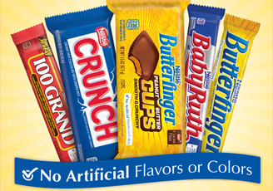

*(*[*http://www.nestleusa.com/media/pressreleases/nestl%C3%A9-usa-commits-to-removing-artificial-flavors-and-fda-certified-colors-from-all-nestl%C3%A9-chocolate-candy-by-the-end-of-20*](http://www.nestleusa.com/media/pressreleases/nestl%C3%A9-usa-commits-to-removing-artificial-flavors-and-fda-certified-colors-from-all-nestl%C3%A9-chocolate-candy-by-the-end-of-20)*)*

The following are just a few of the major food producers who are jumping on the bandwagon to remove synthetic colors, as evidenced by this February 17, 2014 announcement: “Nestlé USA Commits to Removing Artificial Flavors and FDA-Certified Colors from All Nestlé Chocolate Candy by the End of 2015.” Natural annatto will replace the synthetic Red dye No. 40 and Yellow dye No. 5.

(<http://www.nestleusa.com/media/pressreleases/nestl%C3%A9-usa-commits-to-removing-artificial-flavors-and-fda-certified-colors-from-all-nestl%C3%A9-chocolate-candy-by-the-end-of-20>)

In April 2015 the Kraft Foods Group announced that Kraft Macaroni & Cheese customers may find their product a bit less colorful when they remove Yellow dyes No. 5 and No. 6 from their recipe. The company will begin replacing these synthetic dyes with natural paprika, annatto and turmeric in January 2016. The Web site below contains a 1:37 Mac and Cheese video that your students may find interesting.

(<http://www.usatoday.com/story/money/2015/04/20/kraft-macaroni--cheese-mac--cheese-artificial-preservatives-dyes/26073081/>)

On May 15, 2015 Panera Bread announced that they are the first restaurant chain to eliminate artificial coloring from their foods. To quote from their Web site: ”Beginning today, Panera bakery-cafes nationwide will offer new “clean” salad dressings that are made without artificial sweeteners, colors, flavors and preservatives.” In addition to salad dressings, Panera announced plans to have removed artificial coloring from 85% of their menu items by 2016. (<https://www.panerabread.com/panerabread/documents/press/2015/no-no-list-release%205-5-15.pdf>)

*The* May 26, 2015 *The Wall Street Journal* reports that Yum Brands’ Pizza Hut (by the end of July) and Taco Bell (by the end of the year) will remove artificial colors from their foods. Doritos Locos Tacos will be the one exemption because best-selling Doritos Chips is owned by PepsiCo, Inc. (<http://www.wsj.com/articles/taco-bell-to-remove-artificial-flavors-coloring-1432638320>)

In June 2015 General Mills (Trix, Lucky Charms, Cheerios, Reese’s Puffs …) announced that it will remove artificial colors from its cereals by the end of 2017. The dyes will be replaced by fruit and vegetable juices and natural vanilla will replace artificial vanilla. (<http://www.theatlantic.com/health/archive/2015/06/general-mills-to-phase-out-artificial-cereal-dyes/396536/>)

"People eat with their eyes, and so ... the trick is, how can we maintain an appealing look, just not using the artificial colors?" said Jim Murphy, the president of General Mills’ cereal division. "People don't want colors with numbers in their food anymore."

(<http://www.washingtonpost.com/news/wonkblog/wp/2015/06/22/the-real-reason-general-mills-is-cutting-fake-flavors-from-trix-lucky-charms-and-other-cereals/>)



[*http://www.washingtonpost.com/news/wonkblog/wp/2015/06/22/the-real-reason-general-mills-is-cutting-fake-flavors-from-trix-lucky-charms-and-other-cereals/*](http://www.washingtonpost.com/news/wonkblog/wp/2015/06/22/the-real-reason-general-mills-is-cutting-fake-flavors-from-trix-lucky-charms-and-other-cereals/)

NOTE: No plans were announced to reduce the sugar on their flakes!

*Chemical and Engineering News (*June 29, 2015, p. 15) announced General Mills’ plans to use only natural food coloring in 40% of its cereals. Picture at right shows Trix before (left) and after (right) the removal of artificial coloring.

# Connections to Chemistry Concepts

**(for correlation to course curriculum)**

1. **Solubility (at the particle level)**—The use of a particular colorant depends on its solubility in the material to be colored. For example, the beta-carotene molecule is nonpolar so it is an appropriate choice for coloring nonpolar margarine or butter. In contrast, the food coloring dyes that color the coating of Skittles candy are water soluble. This article provides the opportunity to discuss solubility as a competition between three forces (or energies): the strength of attraction between the particles of

* the solute
* the solvent
* the solute and the solvent.

If the attraction between particles of the solute and the solvent is strongest, the attractions between the solute and solvent particles can be broken and solubility will occur.

1. **Solubility of ionic and covalently bonded substances**—This presents an opportunity to reinforce the understanding of the difference between the properties of water-soluble ionic compounds and water-soluble covalently bonded molecules at the particle level. The dissolving of a soluble salt in water involves the release of hydrated ions into a solution. In contrast, dissolving sugar involves the release of hydrated covalently bonded sugar molecules into the solution.
2. **Intermolecular forces**—The structural formula of the anthocyanin molecule, Figure 2 of the Rohrig article, shows exposed hydroxyl groups that can readily hydrogen bond with water molecules. This provides the opportunity to discuss the water solubility of this molecule in terms of intermolecular forces, the strength of the hydrogen bonding force between anthocyanin and water molecules.
3. **Molecular structure**—The molecular structures of beta-carotene and anthocyanin provide the basis for understanding how structure determines the physical and chemical properties of a molecule.
4. **Organic structural diagrams**—Students may need help interpreting the figures of organic molecules. Organic chemists have developed a shorthand method to facilitate the drawing of large molecules while showing bond angles. Carbons are assumed to be present at each junction of two lines in the drawing and the correct number of hydrogen atoms required to complete an octet are also assumed. Other atoms and functional groups are written into the structure.
5. **Bronsted-Lowry acid-base theory**—While discussing acids and bases, the ability of anthocyanins to reflect light of different colors can provide a connection between conjugate acid/base theory and the background of students who experienced red cabbage indicator experiments in elementary school. Students will be surprised to see yellow colored turmeric turn a bright red in a basic solution.
6. **Atomic emission spectra and basic quantum theory**—Alternating double and single bonds decreases the energy required to excite electrons and promote transitions between the ground state and higher energy levels, thus scattering light in the visible spectrum and giving color to our food. This provides a chemical explanation of a real world phenomena.
7. **Electromagnetic spectrum**—Salt and sugar molecules can only absorb and emit light in the ultraviolet range, wavelengths that our eyes cannot detect, in contrast to the visible range colors absorbed and transmitted by organic dye molecules.

# Possible Student Misconceptions

**(to aid teacher in addressing misconceptions)**

1. **“My cousin told me that to make my diet healthy I should stop eating processed foods.”** *Food processing just means making a deliberate change in the food before it is placed on the supermarket shelves. Even whole fruits crushed in a blender to make a fresh fruit smoothie and frozen broccoli have been processed. Your cousin might correctly suggest that you avoid the processed foods that are sweetened with high fructose corn syrup and preserved with nitrites, sodium and oils.*
2. **“I will gain weight if I eat processed foods.”** *Probably not. You will gain weight if you eat more calories than your body uses. The excess calories may be stored as fat.*
3. **“I’ll be certain to eat foods that use natural dyes because they’re safe.”** *Not all natural dyes are risk free. Some people experience allergies from natural dyes such as carmine, annatto and saffron.*
4. **“From biology I know that a sugar molecule contains 12 atoms of carbon, 22 atoms of hydrogen and 11 atoms of oxygen. For each molecule of sugar that dissolves in water, 45 separated atoms are mixed into the solution.”** *The 45 atoms of a sugar molecule are tightly bound by covalent bonds. The molecule stays as a unit, attracted to water molecules by intermolecular forces of attraction between molecules.*
5. **“I plan to include a lot of carrot juice in my diet so that my vision will become super sharp.”** *Unless you are malnourished, your normal diet contains sufficient beta-carotene to produce as much Vitamin A as needed for your vision. Additional beta-carotene will not improve your vision.*
6. **“The anthocyanin molecule contains hydrogen bonds between the hydrogen and the oxygen in the –OH group.”** *Hydrogen bonding is an intermolecular force of attraction between the —H atoms of the water molecules and the —OH on the anthocyanin molecules. A covalent bond holds the hydrogen and oxygen together within the anthocyanin molecule.*
7. **“Blue means basic, so blueberries must be very basic.”** *An acid-base indicator is a chemical compound that changes color at different levels of hydrogen ion concentration (pH). There are many acid-base indicators with different color changes. Litmus is a commonly used indicator that turns blue in basic solutions, as is universal indicator. Blueberries contain anthocyanin that has a color range that differs from litmus and universal indicator. In anthocyanin, blue indicates slightly basic (pH = 8) and yellow indicates a strong basic solution (pH = 14).*

# Anticipating Student Questions

**(answers to questions students might ask in class)**

1. **“Why has the FDA only approved seven synthetic dyes?”** *The Federal Food, Drug, and Cosmetic Act (FD&C Act) identifies a substance that imparts color as a color additive and thus is subject to rigorous premarket approval requirements. This involves testing and presentation of data that certifies the safety and suitability of the additive for food use. In addition, each batch of the colorant must be evaluated to be certain that it is safe for human consumption.*
2. **“Where can I buy colorless Pepsi?”** *“Crystal Pepsi” was introduced in 1992, then removed from shelves when it did not sell well. But following 34,000 written requests by cult-like followers interested in a Pepsi without color additives, the company is considering a reintroduction of their caffeine free product. Additional information can be found in the June 11, 2015 issue of* Fortune Magazine*. (*[*http://fortune.com/2015/06/11/pepsi-crystal/*](http://fortune.com/2015/06/11/pepsi-crystal/)*)*
3. **“What is the meaning of the Rs shown on the molecular formula for anthocyanin?”** *Rs are an organic chemist’s abbreviation for the location of possibly different functional groups attached to the molecule. In Figure 2 of the Rohrig article, the R3 is identified as the location of a sugar molecule.*
4. **“What is anaphylactic shock? How can it be fatal?”** *Anaphylactic shock is a very severe, sudden-onset, allergic reaction for example to foods, drugs or an insect sting that may result in a severe asthma attack, shown to be fatal in as many as two percent of cases.*
5. **“Do food color additives cause hyperactivity in children?”** *According to the FDA, current data does not show a definitive link between Attention Deficit/Hyperactivity Disorder (ADHD) and FDA certified food coloring additives.*
6. **“Do natural food coloring agents add nutritional value to foods?”** *The primary purpose of food colorants is to improve and maintain the appearance of food as it is processed and prepared for the table. Although the natural colorant may be obtained from healthy foods such as vegetables, only small amounts are needed to color foods so the health benefit is minimal.*
7. **“Why should we be concerned about allergic reactions? Why doesn’t the government just ban all artificial food colorants?”** *Artificial food colorants usually maintain their color longer than natural ones because their color is not affected by high temperatures and humidity. They can be used as water soluble dyes or chemically changed into lakes that can be dispersed in oil based foods. There is more opportunity for different colors that make food appealing and fun. And, they are much cheaper because they can be mass produced.*

## In-Class Activities

**(lesson ideas, including labs & demonstrations)**

1. Prepare a mini-lab on solubility for students. Each student group will need a petri dish, clear plastic or glass dish (or even an aluminum pie plate) with 1 cm depth of half-and-half dairy product, 4 different food colors, toothpicks and small amount of liquid detergent. Tell students to place one drop of each food color 90o apart near the edges of the cream; dip a toothpick into the detergent and gently touch to the center of the cream; observe, play and record observations. Following the lab, ask students to explain their observations in a discussion of solubility, polar, nonpolar, hydrophobic, etc. Tie the discussion to the properties of food coloring agents and interactions with the food that is dyed.

A similar experiment is described at <http://chemistry.about.com/od/chemistryhowtoguide/a/magicmilk.htm>. College-level chemistry explanations can be found on this University of Colorado, Boulder site: <http://www.colorado.edu/MCEN/flowvis/galleries/2011/Team-1/Reports/Velasquez_Gary.pdf>; and a good two minute video showing reactions can be found here: <https://www.youtube.com/watch?v=rqQSlEViNpk>.

1. The properties of lakes are investigated in the *Chemistry in the Community* (*ChemCom*) 6th edition lab 7D.7 “Analyzing Food Coloring Additives”. Food coloring dyes are compared to the dyes in the coatings of M&Ms and Skittles.

This 1988 article from *J. Chem. Educ.*, “Theideal solvent for paper chromatographyof food dyes” describes experimental data showing that the ideal solvent for paper chromatography of food dyes such as the colored coating on M&M candies is a 0.1% sodium chloride solution. You might want to give students the chance to discover this for themselves by replicating parts of the experiment in your own classes. (Markow, P. Theideal solvent for paper chromatographyof food dyes. *J. Chem. Educ.*, 1988, *65* (10)*,* pp 899–900; abstract only here: <http://pubs.acs.org/doi/abs/10.1021/ed065p899>. The article is available only to subscribers at this same URL.)

1. Ask students to draw a picture of how they would see salt dissolving in water at the particle level. Then, show a short video on the solubility of an ionic compound. For example: *How Water Dissolves Salt,* a video from the Canadian Museum of Nature (English and French). (<https://www.youtube.com/watch?v=xdedxfhcpWo>).

The PhET (Physical Education Technology) project has been expanded beyond physics to include simulations appropriate for computer interactive activities for chemistry, biology, earth science and mathematics students. These simulations on solubility are good. Teachers have developed lesson plans and activities for specific simulations. These are two that may provide appropriate enhancement as you teach solubility: (<http://phet.colorado.edu/en/simulation/legacy/soluble-salts><http://phet.colorado.edu/en/simulation/sugar-and-salt-solutions>) This simulation specifically shows the difference between salt and sugar as they dissolve in water. Caveat – the sugar molecule is small relative to salt. The strength is that it shows molecules vs. ions separating. A PhET simulation on light absorption by molecules is found at this URL: (<http://phet.colorado.edu/en/simulation/molecules-and-light>).

1. Make and use red cabbage juice indicator. Complete basic and advanced laboratory directions and a detailed description of the acid-base chemistry involved are located on this site: <http://www.coolscience.org/CoolScience/Teachers/Activities/CabbageJuice.htm>.

Flinn Scientific has produced a video (8:56 min.) showing how to make and test red cabbage indicator. (<https://www.youtube.com/watch?v=nEQ4uOoIx0s>)

1. A Khan video (9:36 min.) shows basic information about light. This video does not discuss light-scattering effects. (*Introduction to Light, Light and Electromagnetic Radiation:* <https://www.khanacademy.org/science/cosmology-and-astronomy/universe-scale-topic/light-fundamental-forces/v/introduction-to-light>)
2. This site shows a picture of brightly colored ice cones (below). As an introduction to the discussion of the impact of color on taste, ask students what flavor they associate with each cone. Compare and discuss the reasons for their choices. (<http://www.theguardian.com/lifeandstyle/wordofmouth/2013/mar/12/how-taste-different-colours>)

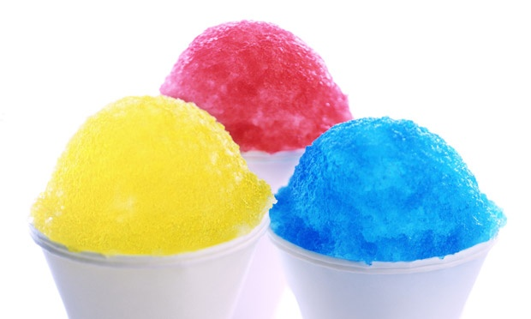

(Kathryn Russell Studios/Getty Images)

1. Making hand lotion provides a good way to show the dispersion of an oil (nonpolar substance) in water (polar substance) using an emulsifier to keep the oil dispersed. Students can experiment changing their lotion from the oil to the water phase by adding additional water to the solution. They can also identify the stage (water or oil) with the addition of food coloring. A lake can be used to color lotion in the oil phase; a dye will color in the water phase. (<http://www.laney.edu/wp/pinar-alscher/files/2014/09/14-Preparation-of-a-Hand-Cream.pdf>)
2. These two laboratory investigations published in *The Journal of Chemical Education* were designed for high school students to extract and analyze FD&C dyes:
   1. ”Extraction and separation of FD&C dyes from common food sources: Their separation utilizing column chromatography” was written as a high school laboratory experiment by E. W. Bird and F. Sturtevant and published in 1992. (Bird, E.W. and Sturtevant, F. Extraction and separation of FD&C dyes from common food sources: Their separation utilizing column chromatography. *J. Chem. Educ.,* 1992, *69* (12), p 996; abstract only here: <http://pubs.acs.org/doi/abs/10.1021/ed069p996>. The article is available only to subscribers at this same URL.)
   2. Analysis of FD&C food dyes in powdered drink mixes using a spectrophotometer is described as a high school laboratory experience in a 2004 *J. Chem. Educ.* article, “The Quantitative Determination of Food Dyes in Powdered Drink Mixes. A High School or General Science [College] Experiment”. In this experiment, students determine the total amount of dye present, the quantity per serving and the mass percent of dye in a sample, as well as construct calibration curves from their data. The lab requires two to three hours. (Sigmann, S. and Wheeler, D. The Quantitative Determination of Food Dyes in Powdered Drink Mixes. J. Chem. Educ., 2004, 81 (10), p 1475; abstract only available here: <http://pubs.acs.org/doi/abs/10.1021/ed081p1475>. The article with complete laboratory instructions is available only to subscribers at this same URL.) A free version of the experiment can be found here: <http://www.wfu.edu/chemistry/courses/jonesbt/280L/Experiment%205/Dyes%20in%20Kool-Aid.pdf>.
3. Here is another high school student activity, labeled as AP, to use paper chromatography to identify the FD&C dyes present in various commercial food colors. (<http://staffweb.psdschools.org/rjensen/aplabs/chromatography_of_food_dyes.doc>)
4. Several commercial companies sell kits for investigating food dyes:
   1. Flinn Scientific
      1. AP level “Analysis of Food Dyes in Beverages - Advanced Inquiry Laboratory Kit”, investigation 1, allows students to study the concentration of Blue No. 1 dye in sports drinks. This link provides the abstract and lab kit purchase information: <http://www.flinnsci.com/store/Scripts/prodView.asp?idproduct=22576>.
      2. AP level “Separation of a Dye Mixture Using Chromatography - Advanced Inquiry Laboratory Kit”, investigation 5, allows students to separate mixtures of the seven FDA-approved food dyes. Students relate nature of successful solvents to intermolecular forces and the structures of the dyes. These links provide the abstract and lab kit purchase information: <http://www.flinnsci.com/store/Scripts/prodView.asp?idproduct=22582>.
      3. “Food Dye Chromatography—Student Laboratory Kit” allows first-year students to experiment with the 7 FDA-approved food dyes to learn more about polarity and paper chromatography. (<http://www.flinnsci.com/store/Scripts/prodView.asp?idproduct=22213>)
      4. Quantitative Determination of Food Dyes—Student Laboratory Kit helps students determine how much food dye is in dry powder drink mixes. (<http://www.flinnsci.com/store/Scripts/prodView.asp?idproduct=22222>)
   2. Vernier Software provides this experiment: “Visible Spectra of Commercial Dyes:   
      the Forensic Version”, which has students experiment using a visible spectrometer to determine which of several sports drinks has been tainted by a CuSO4 solution which poisons an athlete, by establishing spectral curves for the approved food dyes and CuSO4, and then comparing these to the curves for the sports drinks found at the scene of the “crime”. (<http://www.vernier.com/innovate/food-dye-forensics-experiment-using-the-spectrovis-plus/>)
   3. Ward’s Science’s “Kool Column Chromatography & Spectrophotometric Analysis Kit” uses a spectrophotometer to obtain spectral curves for FD&C dyes and then uses liquid chromatography to separate the dyes in grape Kool-Aid. (<https://www.wardsci.com/store/catalog/product.jsp?catalog_number=6730973>)
   4. Carolina Scientific provides this activity: “Carolina ChemKits®: Food Dye Chromatography” does approximately the same thing as the Ward’s activity cited above, except that it uses paper chromatography and not liquid chromatography for the separation. (<http://www.carolina.com/chromatography/carolina-chemkits-food-dye-chromatography/FAM_840644.pr?question>=)

# Out-of-Class Activities and Projects

**(student research, class projects)**

1. The information in the following table was taken from the food dyes article. Check the Internet to research additional natural food coloring pigments. Add them to this list:

|  |  |  |
| --- | --- | --- |
| **Natural Food Coloring Pigment** | **Color** | **Food Use** |
| chlorophyll | Green | mint or lime flavored candy or ice cream |
| anthocyanin | deep purple/blue | blue corn chips, colored soft drinks, grape jelly |
| turmeric | deep yellow | mustard, Indian foods (curry) |
|  |  |  |
|  |  |  |
|  |  |  |
|  |  |  |
|  |  |  |

1. Ask students to investigate natural food dyes and the possible health risks that they might pose. Suggest they begin with the ones listed in the article: cochineal, annatto and saffron.
2. Assign a student recipe project such as making natural food colorings. Their findings with photos of their products could become part of an electronic recipe book for the class. A 4:39 video clip, “How to Make Natural Food Coloring - Concentrated Color Recipe”*,* provides detailed instructions. Teacher warning: this video begins by telling the audience that, “synthetic dyes are poison and can harm your body” so you may need to discuss misconceptions before students begin the project. (<https://www.youtube.com/watch?v=Q0dhvWA5iq4>) The *Food Network* produced a similar video without the “danger warning”. This site provides printed instructions to accompany the video with the suggestion to freeze the pigment in ice cube trays for later use to color cookies and icing. (<http://blog.foodnetwork.com/fn-dish/2014/12/how-to-make-homemade-food-coloring/>)
3. A recipe for making at home a “healthy” blueberry-cabbage juice drink, loaded with anthocyanins, is located at: <http://www.eatingwell.com/recipes/blueberry_cabbage_power_juice>.
4. “Who can make the best black burger” could take the form of a class challenge. The YouTube video (15:55) shows how to blacken dough with bamboo charcoal for the black buns, use soy and squid ink to blacken the sauce and generously season the hamburger with black pepper. (<https://www.youtube.com/watch?v=0dRBroR36nI>)

The complete recipe can be found at <http://a-nutritionist-mom.blogspot.com/2013/11/very-good-bamboo-charcoal-rotiboy-bun.html>. For a recipe for homemade American cheese blackened with squid ink go to <http://www.browneyedbaker.com/diy-american-cheese/>. Amazon sells food grade activated bamboo charcoal and Alma Gourmet sells squid ink. (<http://www.almagourmet.com/store/>)

1. A possible link between color additives and attention deficit/hyperactivity disorder (ADHD), can provide the prompt for a research project culminating in a class debate regarding the claim that this link exists. WebMD states that after 30 years of study, “To date, no conclusive evidence has been found to show that food coloring causes [ADHD](http://www.webmd.com/add-adhd/default.htm).” However, several Internet sites provide dire warnings for parents. This site along with the one from Mayo Clinic below provides an excellent opportunity to help students evaluate the reliability of their information sources. The FDA strongly advises that research continue to investigate the claims expressed on some Web sites. (<http://www.webmd.com/add-adhd/childhood-adhd/food-dye-adhd>).

This topic is rich with controversy and misconceptions about the scientific process of collecting and analyzing data as opposed to making claims based on anecdotes. John E. Huxsahl M.D. of the Mayo Clinic says, “There's no solid evidence that food additives cause attention-deficit/hyperactivity disorder (ADHD).” Although some studies have found a possible link between food coloring and ADHD, the FDA Advisory Committee states that the data is not sufficient to establish this connection. (<http://www.mayoclinic.org/diseases-conditions/adhd/expert-answers/adhd/faq-20058203>)

# References

**(non-Web-based information sources)**

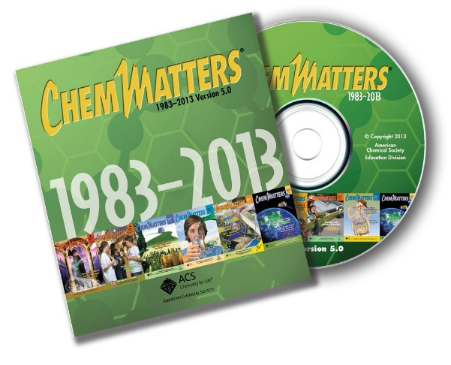

**30 Years of *ChemMatters***

Available Now!

**The references below can be found on the *ChemMatters* 30-year DVD (which includes all articles published during the years 1983 through April 2013 and all available Teacher’s Guides, beginning February 1990). The DVD is available from the American Chemical Society for $42 (or $135 for a site/school license) at this site:** [http://ww.acs.org/chemmatters](http://www.acs.org/chemmatters)**. Click on the “Archive” tab in the middle of the screen just under the *ChemMatters* logo. On this new page click on the “Get 30 Years of ChemMatters on DVD!” tab at the right for more information and to purchase the DVD.**

**Selected articles and the complete set of Teacher’s Guides for all issues from the past three years are available free online at the same Web site, above. Simply access the link and click on the aforementioned “Archive” tab.**

Darrow, F. W. Analyzing Colors. *ChemMatters*,1994,*12* (4), p 3. Teacher’s Guide. Full directions are given for using paper chromatography procedures to analyze the color pigments in M&M candies. This procedure could be modified to include Skittles candies and commercial synthetic food coloring.

McKone, H. T. The Unadulterated History of Food Dyes. *ChemMatters*, 1999,*17* (4), pp 6–7. Some of the interesting and tragic history of food dye toxicity is presented as an introduction to our current laws and procedures that certify the safety of food color additives. Students may find the historical vignettes about the effects of food dyes quite colorful (no pun intended).

The April 1999 *ChemMatters* Teacher’s Guide for the McKone food dyes article discusses the Delaney Clause that “prohibits the approval of a food additive if it has been found at *any level* to induce cancer in experimental animals or humans.”

McKone, H. T. Chewing Gum—Sticking to the Story. *ChemMatters*, 2000, *18* (4), pp 14–15. While the focus of this article is on the manufacture and forensics of chewing gum, during production “a touch of safe food coloring” is added. This provides an opportunity to point out to students that gum bases are waxes and paraffins thus the food coloring must be a lake that is produced from a certified food dye.

Hersey, J. and Heltzel, C. Your Colorful Food. *ChemMatters*, 2007, *25* (1), pp 12–15. This article includes many of the topics addressed in the Rohrig Food Dyes article. Both the article and its Teacher’s Guide can be used to enhance student research on the history, toxicity (including possible behavior problems in children linked to food dyes), natural and synthetic food dyes and how we connect colors with foods.

\_\_\_\_\_\_\_\_\_\_\_\_\_\_\_\_\_\_\_\_

Garfield, S., *Mauve: How One Man Invented a Color that Changed the World;* W. W. Norton and Company: New York, 2000. Perkins’ discovery led to the coloring of our blue jeans! This book recounts the fascinating story of Perkins’ life and the impact of his serendipitous discovery.

This 1988 article from *J. Chem. Educ.*, “Theideal solvent for paper chromatographyof food dyes” describes experimental data showing that the ideal solvent for paper chromatography of food dyes is a 0.1% sodium chloride solution. (Markow, P. Theideal solvent for paper chromatographyof food dyes. *J. Chem. Educ.*, 1988, *65* (10)*,* pp 899–900; abstract only here, <http://pubs.acs.org/doi/abs/10.1021/ed065p899>. The article is available only to subscribers at this same URL.)

Koch, C. and Koch, E. C. Preconceptions of Taste Based on Color. *The Journal of Psychology: Interdisciplinary and Applied,* 2003,*137* (3), pp 233–242. The article contains a table of positive and negative associations between color and taste. The abstract is available here: (<http://www.tandfonline.com/doi/abs/10.1080/00223980309600611?src=recsys&>; only subscribers can access the full article.)

# Web Sites for Additional Information

**(Web-based information sources)**

**More sites on the role of visual information and flavor perception by humans**

This government site has compiled information from many studies relating to the impact of visual information including color clues on the perception of flavor by humans. Discussions include the effect of previous experiences with food that serve as a basis for our preconceptions. (<http://www.ncbi.nlm.nih.gov/books/NBK92852/>)

Kantha Shelke, a food chemist and spokeswoman for the Institute of Food Technologists, says, “Would we really want to ban everything when only a small percentage of us are sensitive?” She describes how our brain’s response to color, “actually overrides the flavor of our food”. (<http://www.foodrenegade.com/the-color-of-food-artificial-vs-natural/>)

An article from the Kochs, “Preconceptions of Taste Based on Color”,contains an interesting table of positive and negative associations between color and taste. It was originally published in *The Journal of Psychology: Interdisciplinary and Applied,* 2003,*137* (3), pp 233–242. It is available without subscription from the George Fox University in Oregon.

(<http://digitalcommons.georgefox.edu/cgi/viewcontent.cgi?article=1034&context=psyc_fac>)

**More sites on natural food colorants**

This *Scientific American* article is one of the “Selected references” listed for the Rohrig article. The focus is on natural sources of blue dye, including the history and some concerns. (<http://www.scientificamerican.com/article/where-does-blue-food-dye/>)

Regular packets of M&Ms contain blue candies, but blue colors are not present in original packages of Skittles. A limited edition was announced in January 2015. (<http://www.talkingretail.com/products-news/confectionery/blue-skittles-launching-limited-edition-packs/> )

An article in the *Washington Post* suggests that if you switch to natural food colorings, you will probably have to adjust to foods that have less vibrant coloring. Also, you must choose your source carefully. The amount of onion used to obtain a desired hue, may change the flavor of your food. (<http://www.washingtonpost.com/lifestyle/wellness/replace-artificial-food-coloring-with-natural-options/2014/11/11/e4bae6ee-6071-11e4-91f7-5d89b5e8c251_story.html>)

The Linus Pauling Institute at Oregon State University conducts extensive research on carotenoids. Their site provides easy access to specific information through links to the biological activity, disease prevention, health issues, and safety and toxicity of various carotenoids. There are tables for specific carotenoids showing food source, serving size and milligrams of carotenoid per serving. (<http://lpi.oregonstate.edu/mic/dietary-factors/phytochemicals/carotenoids>)

This site from *Business Insider* shows pictorially how cochineal bugs are “planted”, harvested and processed to produce carmine red: <http://www.businessinsider.com/how-cochineal-insects-color-your-food-and-drinks-2012-3?op=1>.

**More sites on** **how to write structural formulas of organic compounds**

Well-presented information and illustrations of the shorthand used by organic chemists is located here: (<http://www.harpercollege.edu/tm-ps/chm/100/dgodambe/thedisk/chrom/org.htm>)

The Khan Academy has a series of four videos that show students how to write structural formulas and bond-line formulas for isomeric forms of simple organic compounds:

1. *Condensed Structures* (6:49 minutes)
2. *Bond-Line Structures* (12.57 minutes)
3. *Three-Dimensional Bond-Line Structures* (10:58 minutes)
4. *Structural (constitutional) Isomers* (9:52 minutes)

For students who understand the basics, you may want to begin with the fourth video clip.

(<https://www.khanacademy.org/science/organic-chemistry/gen-chem-review/bond-line-structures>.)

**More sites on a general summary of the use of food additives, including colorants**

This is an excellent, clearly written reference that covers many of the frequently asked questions about the use of both natural and artificial food coloring. It was prepared under a partnering agreement with the FDA. (<http://www.foodinsight.org/Food_Ingredients_Colors>)

**More sites on current government regulations**

The official FDA site is a good place to keep up to date and find answers to student questions about government regulations regarding the use of food additives and colorants. The material can be printed in brochure format, a nice piece for student reading and/or research. (<http://www.fda.gov/Food/IngredientsPackagingLabeling/FoodAdditivesIngredients/ucm094211.htm>)

**More sites on** **black burger battles**

*USA Today Network* features an October 5, 2014 presentation by Jessica Durando about the Burger King and McDonald’s competition for burger sales in Japan. Your students may find this an interesting real-world market competition involving food coloring.

(<http://www.usatoday.com/story/news/nation-now/2014/10/02/mcdonalds-japan-black-burger-burger-king/16571975/>)

*The Atlantic* discusses acceptance of the black burger in the USA. *Color Trumps Flavor* can be found at (<http://www.theatlantic.com/health/archive/2014/09/food-color-trumps-flavor/380743/>).