Teacher’s Guide

Don’t Sweat It: How Moisture-Wicking Fabrics Keep You Cool and Dry

October 2022

Table of Contents
Anticipation Guide 2
Activate students’ prior knowledge and engage them before they read the article.
Reading Comprehension Questions 3
These questions are designed to help students read the article (and graphics) carefully. They can help the teacher assess how well students understand the content and help direct the need for follow-up discussions and/or activities. You’ll find the questions ordered in increasing difficulty.
Graphic Organizer 5
This helps students locate and analyze information from the article. Students should use their own words and not copy entire sentences from the article. Encourage the use of bullet points.
Answers 6
Access the answers to reading comprehension questions and a rubric to assess the graphic organizer.
Additional Resources 9
Here you will find additional labs, simulations, lessons, and project ideas that you can use with your students alongside this article
Chemistry Concepts and Standards 10
Name: ______________________________

Anticipation Guide

Directions: Before reading the article, in the first column, write “A” or “D,” indicating your Agreement or Disagreement with each statement. Complete the activity in the box.
As you read, compare your opinions with information from the article. In the space under each statement, cite information from the article that supports or refutes your original ideas.
Me | Text | Statement
 |  | 1. Cotton is the best choice for athletic clothing.
 |  | 2. Wool retains more water when wet than cotton.
 |  | 3. Water is a polar molecule because oxygen pulls on shared electrons more than hydrogen.
 |  | 4. Water molecules stick together well.
 |  | 5. Molecular polarity determines solubility.
 |  | 6. Cotton fibers are nonpolar.
 |  | 7. Nylon and polyester are good choices for sweat-wicking fabrics.
 |  | 8. Yarns with a circular cross section work best for sweat-wicking fabrics.
 |  | 9. Once a fabric is designed, wicking tests are done to make sure the fabric performs as expected.
 |  | 10. Evaporation of water from your skin cools you because weak cohesive bonds are broken as water evaporates.

Student Reading
Comprehension Questions

Name: ______________________________
Directions: Use the article to answer the questions below.

- Why do shirts made from cotton become uncomfortable when a person sweats?

- A 150 gram sample of fabric is saturated with water and its saturated mass is determined to be 161 grams, what is the moisture regain value?

- Three things that are considered to be polar are the earth, a battery, and a water molecule. Explain why each of these things can be classified as polar.

- An electric field is set up such that the positive side is on the left and the negative side is on the right. Describe how a water molecule would be oriented when in that field.

- All atoms are surrounded by electrons. Explain how a hydrogen atom in a water molecule can have a positive charge even though it is surrounded by electrons.

- A water meniscus is formed when water is placed in a graduated cylinder. Is this an example of cohesion or adhesion? Explain.

- List any observation about water that could serve as evidence that your skin contains polar molecules.

- On the partial Lewis structure of nylon below, draw arrows on every bond that is polar, such that the arrowhead points toward a region of negative charge.

- Model two separate examples of hydrogen bonding by drawing a water molecule properly oriented at each location and connected with a dashed line to the specific portion of the partial Nylon structure below where the interaction would be strongest.

- Why is a purely hydrophobic material not the best choice for wearing during activities in which a person would sweat?

- Explain how capillary action relates to moisture wicking.

- Why is yarn with a circular cross section less efficient in wicking away moisture than yarn with cross sections of other shapes?

- Why does your body cool down when your sweat evaporates from the shirt you are wearing?
Student Reading Comprehension Questions, cont.

Questions for Further Learning
Write your answers on another piece of paper if needed.

- Moisture regain values are listed on the first page of the article for cotton, wool, nylon and polyester, as well as for a cotton/polyester blend. Find the molecular structures for each of the four unblended fabrics. Analyze the areas of each type of molecule that are likely to attract or to repel water. Justify the moisture regain values based on this analysis.

- Research the effectiveness of two competing brands of moisture wicking clothing. Summarize and compare the types of fabrics and how the threads are engineered to maximize the wicking through the fabric.

Graphic Organizer

Name: ______________________________

Directions: As you read, complete the graphic organizer below to describe how moisture-wicking fabrics work.
Term | Definition in your words | How the term applies to moisture-wicking fabrics
Molecular polarity
Capillary action
Adhesion
Cohesion
Cellulose
Nylon
Polyester
Wool
Wicking tests

Summary: On the back of this sheet, write a one-sentence summary (18 words or less) of the article.

Answers to Reading Comprehension Questions & Graphic Organizer Rubric

- Why do shirts made from cotton become uncomfortable when a person sweats?
The cotton fibers are hydrophilic and attract the water molecules. This prevents them from evaporating and leaves the shirt wet, which feels uncomfortable.

- A 150 gram sample of fabric is saturated with water and its saturated mass is determined to be 161 grams, what is the moisture regain value?
11g water / 150g fabric = 0.073 = 7.3% moisture regains

- Three things that are considered to be polar are the earth, a battery, and a water molecule. Explain why each of these things can be classified as polar.
The earth is a single object with opposite magnetic poles (north and south); A battery is a single object with opposite electric poles (positive and negative terminals of the battery); A water molecule is a single particle with opposite electric poles (the oxygen side has a negative charge and the hydrogen side has a positive charge).

- An electric field is set up such that the positive side is on the left and the negative side is on the right. Describe how a water molecule would be oriented when in that field.
The oxygen atom of the water molecule would be oriented to the left and the two hydrogens would be pointing to the right.

- All atoms are surrounded by electrons. Explain how a hydrogen atom in a water molecule can have a positive charge even though it is surrounded by electrons.
The electrons in the hydrogen atom are being drawn away by the more electronegative oxygen atom. This partially exposes the nucleus of the hydrogen atom, allowing it's positive field to extend beyond the nucleus.

- A water meniscus is formed when water is placed in a graduated cylinder. Is this an example of cohesion or adhesion? Explain.
Adhesion. The walls of the graduated cylinder are made from glass, which is a silicon oxide compound. The structure of the compound is polar and thus attracts the water molecules. This attraction is between two different substances, making it adhesion, rather than cohesion which is between molecules of the same substance.

- List any observation about water that could serve as evidence that your skin contains polar molecules.
Example response: Water does not bead up on the skin, showing it has some attraction to the skin surface.

- On the partial Lewis structure of nylon below, draw arrows on every bond that is polar, such that the arrowhead points toward a region of negative charge.

- Model two separate examples of hydrogen bonding by drawing a water molecule properly oriented at each location and connected with a dashed line to the specific portion of the partial Nylon structure below where the interaction would be strongest.

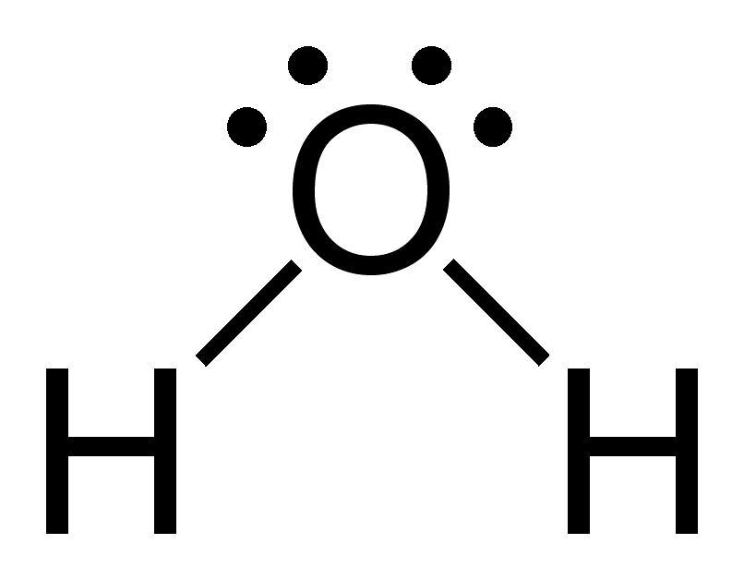

- Why is a purely hydrophobic material not the best choice for wearing during activities in which a person would sweat?
A purely hydrophobic material would resist water from both the inside and out. This would trap the water between the skin and the shirt, making the sweat build up, rather than evaporating.

- Explain how capillary action relates to moisture wicking.
Capillary action is the result of adhesive forces between water and a columnar surface and cohesive forces between water molecules. Some water molecules attract to the surface and other water molecules attract to those, which results in an overall flow of water through the column. The diameter and shape of the column, compared to the size of the water molecules, affects the amount of capillary action that can result. Moisture wicking relies on capillary action, so the threads must be engineered to leave an empty space with an appropriate size to allow for maximum capillary action through the fabric.

- Why is yarn with a circular cross section less efficient in wicking away moisture than yarn with cross sections of other shapes?
When the threads are all circular, the space between threads is very tight and does not allow enough attraction to draw the water molecules through the space and to the other side of the fabric.

- Why does your body cool down when your sweat evaporates from the shirt you are wearing?
Water requires energy to evaporate because the forces attracting the water molecules together must be overcome to allow them to leave individually. The energy from your body goes into the sweat, giving it the necessary energy. Since the energy leaves your body, it cools you down.

Graphic Organizer Rubric
If you use the Graphic Organizer to evaluate student performance, you may want to develop a grading rubric such as the one below.

Score | Description | Evidence
4 | Excellent | Complete; details provided; demonstrates deep understanding.
3 | Good | Complete; few details provided; demonstrates some understanding.
2 | Fair | Incomplete; few details provided; some misconceptions evident.
1 | Poor | Very incomplete; no details provided; many misconceptions evident.
0 | Not acceptable | So incomplete that no judgment can be made about student understanding

Additional Resources and Teaching Strategies

Additional Resources

- Labs and demos
  - Lab- Put your fabric to the test: https://www.acs.org/content/acs/en/education/outreach/celebrating-chemistry-editions/2022-ncw/put-your-fabric-to-the-test.html
  - Video- The Chemistry of Clothes: https://www.calacademy.org/educators/the-chemistry-of-clothes
  - Demo- Making rayon: https://edu.rsc.org/experiments/making-rayon/1745.article

- Simulations
  - Molecule Polarity: https://phet.colorado.edu/en/simulations/molecule-polarity

- Lessons and lesson plans
  - Lesson T-Shirt Chromatography: https://teachchemistry.org/periodical/issues/march-2019/teaching-essential-concepts-with-t-shirt-chromatography
  - Lesson What Makes Water So Special: https://teachchemistry.org/classroom-resources/what-makes-water-so-special

- Projects and extension activities
  - Designing an Effective Respiratory Mask: https://teachchemistry.org/classroom-resources/designing-an-effective-respiratory-cloth-mask
  - Tie Dye: https://teachchemistry.org/classroom-resources/tie-dye
  - Video- Layered Fabrics in Heat Resistance: https://teachchemistry.org/classroom-resources/ingenious-this-sandwich-will-save-your-life-in-an-arc-flash-video-questions

Teaching Strategies
Consider the following tips and strategies for incorporating this article into your classroom:
- Alternative to Anticipation Guide: Before reading, ask students if they buy clothing with sweat-wicking properties, and why. Ask how they think the fabrics in the clothing work. Their initial ideas can be collected electronically via Jamboard, Padlet, or similar technology.
  - As they read, students can find information to confirm or refute their original ideas.
  - After they read, ask students what they learned about the properties of moisture-wicking fabrics.
- After students have read and discussed the article, ask students whether they will pay more to purchase moisture-wicking clothing, and how the information in the article informs their decision.
- This article relates to the theme for National Chemistry Week 2022: Fabulous Fibers. You can find related activities at https://www.acs.org/content/acs/en/education/outreach/ncw.html

Chemistry Concepts and Standards

Connections to Chemistry Concepts
The following chemistry concepts are highlighted in this article:
- Physical properties
- Covalent bonding
- Electronegativity
- Intermolecular forces
- Molecular structure
- Functional groups

Correlations to Next Generation Science Standards
This article relates to the following performance expectations and dimensions of the NGSS:
HS-PS1-3. Plan and conduct an investigation to gather evidence to compare the structure of substances at the bulk scale to infer the strength of electrical forces between particles.
HS-ETS1-2. Design a solution to a complex real-world problem by breaking it down into smaller, more manageable problems that can be solved through engineering.
Disciplinary Core Ideas:
- PS.1.A: Structure and Properties of Matter
- ETS1.B: Developing Possible Solutions
Crosscutting Concepts:
- Cause and effect
- Energy and matter
- Structure and function
Science and Engineering Practices:
- Constructing explanations (for science) and designing solutions (for engineering)
Nature of Science:
- Science addresses questions about the natural and material world.

See how ChemMatters correlates to the Common Core State Standards online.

