



**Tools and Resources**

***“What’s Artificial Snow, and How Is It Made?”***

December 2018/January 2019

<http://www.acs.org/chemmatters>

**Teacher’s Guide:**



**Teacher’s Guide:**

**Tools and Resources**

***“What’s Artificial Snow,   
and How Is It Made?”***

**December 2018/January 2019**

**Table of Contents**

Connections to Chemistry Concepts 3

Teaching Strategies and Tools 4

Standards 4

Vocabulary 5

Possible Student Misconceptions 6

Anticipating Student Questions 7

Activities 10

References 12

Web Resources for More Information 13

# Connections to Chemistry Concepts

|  |  |
| --- | --- |
| **Chemistry Concept** | **Connection to Chemistry Curriculum** |
| **Phase changes/Freezing** | The article focuses on the phase change of freezing liquid water into solid snow, and how it occurs both naturally in the environment and artificially through the use of snow guns and nucleators. |
| **Nucleation sites** | The formation of raindrops and snowflakes in clouds is enhanced when nucleation sites are present, and the article discusses this concept while providing examples of nucleation materials. |
| **Surface tension** | Reducing the surface tension in water droplets allows artificial snow to be produced more effectively as explained in the article, and the mechanism of surfactants in removing greasy stains is described. Also, the beading of water as included in the article is a function of surface tension. |
| **Surfactant** | The use of surfactants to reduce the high surface tension of water and produce smaller (atomized) droplets is an important point in this article. |
| **Polar molecules** | The polar nature of water molecules and the essentially nonpolar nature of greasy molecules causes consumers to need surfactants in the form of soaps and detergents, as explained with diagrams in this article. |

# Teaching Strategies and Tools

## Standards

* Links to **Common Core Standards for Reading**:
  + **ELA-Literacy.RST.9-10.1:** Cite specific textual evidence to support analysis of science and technical texts, attending to the precise details of explanations or descriptions.
  + **ELA-Literacy.RST.9-10.5:** Analyze the structure of the relationships among concepts in a text, including relationships among key terms (e.g., force, friction, reaction force, energy).
  + **ELA-Literacy.RST.11-12.1:** Cite specific textual evidence to support analysis of science and technical texts, attending to important distinctions the author makes and to any gaps or inconsistencies in the account.
  + **ELA-Literacy.RST.11-12.4:** Determine the meaning of symbols, key terms, and other domain-specific words and phrases as they are used in a specific scientific or technical context relevant to grades 11-12 texts and topics.
* Links to **Common Core Standards for Writing**:
  + **ELA-Literacy.WHST.9-10.2F:** Provide a concluding statement or section that follows from and supports the information or explanation presented (e.g., articulating implications or the significance of the topic).
  + **ELA-Literacy.WHST.11-12.1E:** Provide a concluding statement or section that follows from or supports the argument presented.

## Vocabulary

* **Vocabulary** and **concepts** that are reinforced in this issue:
  + Structural formulas
  + Crystalline structure
  + Environmental impacts of personal and societal decisions
  + Electromagnetic radiation
  + Colligative properties
  + Gas laws
* Consider asking students to read “Open for Discussion: A Slippery Slope” on page 4 to learn about concerns regarding using artificial snow prior to reading the article “What’s Artificial Snow, and How Is It Made?”
* Students from warmer climates may be unaware of the use of salt to melt ice on roadways. Ask them if they have ever traveled to cold climates and if they had trouble walking on icy sidewalks, or if they have seen this problem in movies or television. Show students the ACS Reactions video referenced on page 14 AFTER they have read the article to help them understand why salt is used to deice roads and how it works.
* Two of the articles relate to personal health (UV eye protection and cupping). Ask students how the articles might impact their decisions regarding their health and why.
* Two of the articles relate to environmental impacts of our decisions (artificial snow and salting roads). Ask students how the information from the articles might help them make decisions in the future, and factors they might consider as citizens asked to provide input on related projects.
* To help students engage with the text, ask students which article **engaged** them most and why, or what **questions** they still have about the articles, and what they would like to explore further.
* Ask students if they have questions about some of the issues discussed in the articles.

# Possible Student Misconceptions

1. **“Artificial snow is the same as natural snow because they are both frozen water.”** While they are similar, artificial and natural snow have some minor differences. Natural snow typically forms larger, lighter flakes, while artificial snow is usually smaller, heavier crystals. Because artificial snow is denser, it tends to compact less than natural (powdery) snow. And, even though artificial snow can last longer than natural snow, skiing and snowboarding equipment may tend to “catch” more on the artificial snow, causing more falls.
2. 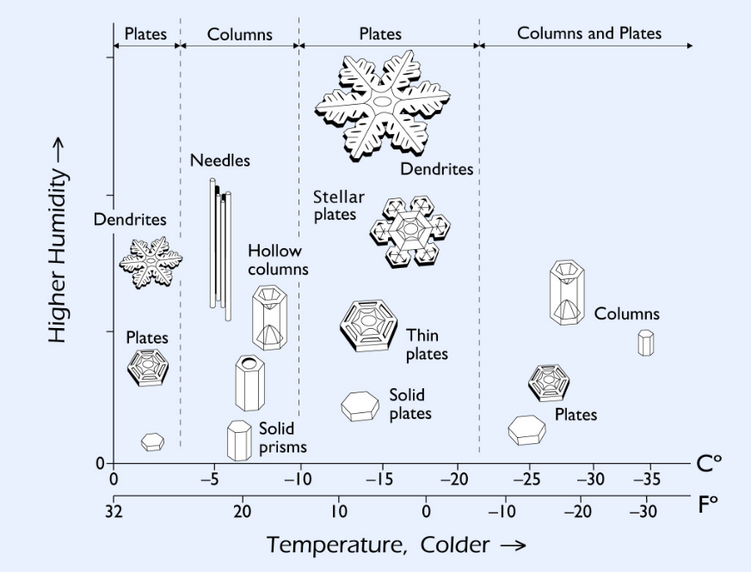**“All snowflakes have six points.”** While all snowflakes have six sides, they do not all have six points. Six-pointed snowflakes are common; however, there are many different types of snowflakes. The six-pointed snowflakes are called stellar dendrites, but there are also columnar, needle, graupel (soft hail), and other types, all containing six sides. While the basic ice crystal or snowflake shape is hexagonal, there are many variations on the hexagonal shape based on weather conditions.

([*http://web.ipac.caltech.edu/staff/bts/PH_10_2007/libbrecht/rpp5_4_R03-1.pdf*](http://web.ipac.caltech.edu/staff/bts/PH_10_2007/libbrecht/rpp5_4_R03-1.pdf))

1. **“Cloud seeding reduces natural precipitation downwind of the seeded area.”** Clouds do not have a finite quantity of water vapor in them. If they did, this statement would be true. However, clouds continually absorb water vapor from the air, which allows them to produce precipitation downwind of the cloud-seeded area. Sometimes, the seeding produces additional precipitation downwind.

# Anticipating Student Questions

1. **“Why do snowflakes need a nucleator to form?”** The science of snowflake formation is not entirely understood. In warmer clouds, it appears that an ice nucleus formed around a nucleator must be present for the water vapor to freeze and allow the snowflake to successfully grow. Some experiments indicate that in order for water vapor to freeze (without a nucleator), the cloud temperatures must be below –35 °C (–31 °F). So, the nucleation site seems to facilitate snowflake formation at relatively higher temperatures. A related example might be making rock candy (crystalized sugar). When a stick or string with a textured surface is placed in a supersaturated solution of sugar, the sugar crystals form more readily on the textured surface than if no nucleation sites were present. Scientists often use a “seed crystal” or a technique like scratching the walls of a glass container to help initiate crystallization in a solution.
2. **“How do surfactants work?”** Surfactants, or surface-active agents, are compounds having both a hydrophilic (polar) end and a hydrophobic (nonpolar) end, making them amphiphilic (having both polar and nonpolar groups within the molecule). Common surfactants include detergents, emulsifiers, wetting agents, and foaming agents. Because water is a polar molecule, the hydrophilic end of the surfactant can interact with it, while the hydrophobic end of the surfactant can interact with the oily, greasy, or nonpolar substance. The interaction of the water, grease, and the surfactant forms structures called micelles (see diagram at right), where the nonpolar tails of the surfactant molecules embed into the grease and the polar heads form a hydrophilic layer around the grease. The micelle structures can then be carried away by the water.

*(*[*http://www.planet-science.com/categories/under-11s/chemistry-chaos/2011/06/soap---how-does-it-get-things-clean.aspx*](http://www.planet-science.com/categories/under-11s/chemistry-chaos/2011/06/soap---how-does-it-get-things-clean.aspx)*)*

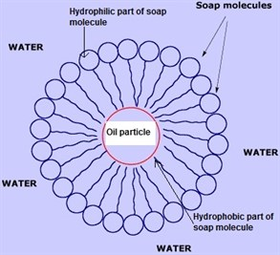

In the case of artificial snow, the surfactants act to reduce the surface tension of water, allowing the water to break into much smaller droplets that can freeze more easily and produce a finer-textured snow.

1. **“Is it true that no two snowflakes are alike?”** In short, this statement is true. Snowflakes are hexagonally shaped, but their individual shapes are quite complex and contain an average of 1018 water molecules. If you could look at every snowflake, you would probably not find any duplicates. However, nano-snowflakes that are extremely small-—only 10 water molecules or so—are likely to have similar shapes. But since we cannot see these nano-snowflakes with the naked eye, and you are unlikely to encounter one, the statement is essentially true.
2. **“How does cloud seeding work?”** Even in regions where there is low humidity, there are usually clouds or some atmospheric moisture. Cloud seeding attempts to facilitate the collection of that water vapor around a particle or nucleation point. The seeding material can be various salts—including sodium chloride (table salt) and calcium chloride (road salt). However, the most common salt used is silver iodide (AgI), because its structure is similar to natural ice crystals. There are three types of cloud-seeding methods: static, where the nucleation material provides a place for condensation to occur; dynamic, where scientists try to increase vertical air currents and improve the quantity of moisture in the clouds; and hygroscopic, where moisture-attracting salts are shot into lower parts of clouds and collect water as they fall back down.
3. **“What is a hygroscopic material?”** A hygroscopic material is one that absorbs or adsorbs moisture from its surroundings. This process generally occurs at or near room temperature.

Examples of hygroscopic materials are some salts, including silver iodide and sodium chloride, as well as honey, silica gel (those moisture-absorbent packets often found in packages), ethanol, sulfuric acid, and sodium hydroxide (lye). Both sulfuric acid and sodium hydroxide are used industrially as drying agents to remove moisture, due to their high hygroscopicity. When water vapor is collected by a hygroscopic material, the water causes physical changes to that material, including an increase in volume, color, boiling point, and viscosity. The hygroscopic nature of ethanol that is added to many gasolines can cause moisture to collect in the fuel, causing problems with small engines and some machines (corroding parts, clogging filters, etc.).

1. **“What is the history of making artificial snow?”** While people have probably skied for a few thousand years, the desire for reliable snow—and a way to make it—didn’t take hold until the early 1900s, when skiing became more popular as a sport. The earliest snow machines were noisy, unreliable, and produced poor-quality snow. In many cases, the artificial snow was nothing more than essentially chipped blocks of ice spread or sprayed over the slopes or ski jumps. Improvements in equipment design in the 1940s and 1950s included the use of compressed air to force small water droplets through a nozzle and produce better-quality artificial snow. This improvement was effective enough that many resorts started using machines to augment natural snow. By the 1970s, as skiing continued to attract more enthusiasts, the demand for a longer season increased, and skiers expected better quality and quantity of snow, all snow machines used compressed air to atomize the water into fine droplets, added a fan to disperse the artificial snow, improved nozzle designs, and were engineered to operate more economically. In 1975, a protein nucleator was discovered that then became the trademarked artificial snow Snomax. As the popularity of skiing increased, and the need for large quantities of reliable snow for resorts grew, the snow-making machinery was improved. Computer controls, sensors, more powerful fans, better atomization of the water droplets, and other changes were made to allow resorts to lengthen their winter sports season and improve snow conditions.
2. **“How is snow created on movie sets and for other special effects?”**The Hiolski article mentions that faux snow is often a paper-based material. The cellulose paper snow can be produced in many different textures, sizes, and solubilities. The paper snow is usually sprayed on surfaces and may be dampened to make it stick to surfaces better. Snow can also be produced from foams, similar to some types of soap bubbles. The quickly dissipating foam snow is preferred for uses when the snow effect is needed in the air more than on the ground or when the faux snow might present a safety problem, such as for dancers on a stage. Other faux snow can be produced from polymer substances similar to the sodium polyacrylate used as moisture absorbers in baby diapers. Still more special effects types of snow used by professionals includes those made of rice starch, potato flakes, Epsom salts, cotton, and a variety of plastics and foams.

# Activities

**Labs and demos**

**“Solubility and Compound Type” lab:** This high school lab activity uses unknown substances to determine whether they are polar, nonpolar, or ionic by testing solubility and explaining the results based upon intermolecular and intramolecular forces. (Access is restricted to AACT members, but the article will be available for free until February 1, 2019 at <https://teachchemistry.org/classroom-resources/solubility-and-compound-type>)

**“Hands-on Activity: Soap vs. Shampoo Surfactant Lab”:** This high school lab activity requires 90 minutes over at least two days to make soap (unless purchased commercially), which students then compare to shampoo as they study surface tension, viscosity, ion interactions, and pH. Complete student and teacher support materials are included. (<https://www.teachengineering.org/activities/view/usm_surfactant_activity1>)

**Simulations**

“**Surface Tension: Capillary Rise Method”:** Students can manipulate this simulated lab to measure and then calculate the surface tension of seven liquids. The simulation provides operation guidelines and comprehensive, mathematical background information on surface tension. (<http://web.mst.edu/~gbert/SurfaceTension/cap.html>)

**“Molecular Polarity” (PhET):** This simulation allows students to explore the chemistry (including polarity, electronegativity, bonding, and diploes) behind the surfactants sidebar in the Hiolski article. (<https://phet.colorado.edu/en/simulation/legacy/molecule-polarity>)

**Media**

**“How Is Artificial Snow Made?”, video (2:20):** This video from ACS Reactions explains how artificial snow was made for the 2014 Winter Olympics at Sochi and provides a quick explanation of producing artificial snow. (<https://www.youtube.com/watch?v=ftMFMlk6FlA>)

**“The Science of Snowflakes”, video (5:59):** This PBS video starts with Wilson Bentley taking snowflake photographs starting in 1885, documenting the variety of flakes, and continues with the laws of chemistry and physics controlling the shapes of snowflakes. (<https://www.youtube.com/watch?v=fUot7XSX8uA>)

**Lessons and lesson plans**

**“Modeling the Melting of Ice” lesson:** This lesson plan (with complete teacher and student materials) requires 120–180 minutes to complete, depending on teacher choices, and it uses modeling techniques for students to create particulate-level diagrams of ice melting and explains the kinetic and potential energy changes in this phase change. (Access is restricted to AACT members, but the article will be available for free until February 1, 2019 at <https://teachchemistry.org/classroom-resources/modeling-the-melting-of-ice>)

**“Snowflake Webquest” lesson:** This lesson uses the Internet and the SnowCrystals.com Web site to pretest and then directs students to research and complete the worksheet to learn about types of snowflakes, their formation, their structures, and more. (<https://sciencespot.net/Media/SnowflakeWebquest.pdf>)

**Projects and extension activities**

**Use Clues to Solve an Ice Mystery” activity:** While targeted at grades 6–8, this activity analyzing the characteristics of different types of ice and their locations could be interesting to some students. The site also provides audio, video, and additional resources to related concepts in the activity. (<https://www.sciencefriday.com/educational-resources/use-clues-to-solve-an-ice-mystery/>)

**“Preserving Snow Crystals” lab project:** For students in snowy locations, this Web site provides information on three processes for capturing and preserving snowflakes; one process uses superglue, another uses Formvar (polyvinyl acetal resin), and the last uses acrylic spray paint. (https://www.its.caltech.edu/~atomic/snowcrystals/preserve/preserve.htm

# References

**The references below can be found on the *ChemMatters* 30-year DVD, which includes all articles published from the magazine’s inception in October 1983 through April 2013; all**

**available Teacher’s Guides, beginning February 1990; and 12 *ChemMatters* videos. The DVD is available from the American Chemical Society for $42 (or $135 for a site/school license) at this site:** [***http://www.acs.org/chemmatters***](http://www.acs.org/chemmatters)**. Click on the “Teacher’s Guide” tab to the left, directly under the “*ChemMatters Online"* logo and, on the new page, click on “Get 30 Years of *ChemMatters* Magazine!” (the icon on the right of the screen).**

**Selected articles and the complete set of Teacher’s Guides for all issues from the past three years are available free online at the same Web site, above. Click on the “Issues” tab just below the logo, *“ChemMatters Online”*.**

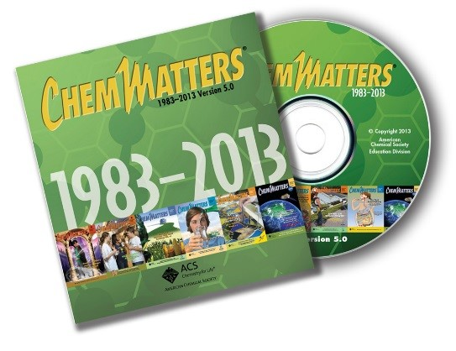

“Artificial Snow: Powder for the Slopes” explains the science, manufacture, characteristics, and uses of artificial snow, making this article an excellent companion to the Hiolski article. (Rohrig, B. Artificial Snow: Powder for the Slopes. *ChemMatters*. 2000, *18* (4), pp 10–11)

“Clouds” provides information about types, formation, and properties of clouds, including formation of snow and cloud seeding. (Rosenthal, A. Clouds. *ChemMatters*. 2003, *21* (3), pp 12–15)

The Science of Snowflakes: Crystals from the Clouds” contains relevant material to the Hiolski article because it discusses snowflake formation, types, and chemistry. (Hazard, A. The Science of Snowflakes: Crystals from the Clouds. *ChemMatters*. 2009, *27* (4), pp 9–10)

“Battling Wildfires: When Water Won’t Cut It” contains an explanation of surface tension and surfactants, plus an illustration about how surfactants lower surface tension. (Karabin, S. Battling Wildfires: When Water Won’t Cut It. *ChemMatters*. 2010, *28* (1), pp 10–12)

The Teacher’s Guide for Karabin’s article above includes more information on surface tension, as well as activities involving surface tension, including floating a needle on water, black pepper on water with detergent added, and playing with magic sand.

# Web Resources for More Information

**Artificial snow**

The 2018 Winter Olympics events in PyeongChang used 90–98% artificial snow.

(<https://www.npr.org/sections/thetorch/2018/02/23/588308424/despite-frigid-weather-the-snow-in-pyeongchang-is-fake>)

This article contains information on the science of artificial snow, including machine-made snow, additives, sustainability, and additional references.

(<https://www.chemistryviews.org/details/ezine/8935791/Faking_It_The_Science_of_Artificial_Snow.html>)

**History of Artificial snowmaking**

This is a chronology of events involving artificial snow in Canada and the U.S.

(<http://newenglandskimuseum.org/wp-content/uploads/2012/06/snowmaking_timeline.pdf>)

**Snowflakes**

This website has information about snowflakes and an infographic about snowflake shapes.

(<https://www.compoundchem.com/2014/12/10/snowflakes/>)

This website is a rich resource with information (and additional links) on: Natural Snowflakes, Designer Snowflakes, Growing Snowflakes, Snowflake Science, and Snow and Ice Activities.

(<http://snowcrystals.com/>)

**Artificial vs natural snow**

This article looks at the differences between artificial and natural snow with respect to skiing and snowboarding.

(<https://charlikerns.wordpress.com/2012/02/04/is-natural-snow-better-than-man-made-for-skiing-and-snowboarding/>)

**2022 Beijing Winter Olympics**

With Beijing’s minimal annual snowfall, this article explains why the Winter Olympics held there, and likely future sites, will feature artificial snow.

(<https://qz.com/1213121/beijing-2022-winter-olympics-will-rely-entirely-on-artificial-snow/>)

**Special effects artificial snow**

This article details the use of artificial snow in seven movies by title and year beginning with *The Gold Rush* in 1925 through *The Day After Tomorrow* in 2004.

(<https://www.popularmechanics.com/culture/movies/g1092/snow-job-how-hollywood-fakes-winter-on-film/>)

This video, “How It’s Made – 1193 Special Effects Snow” (4:53), explains how artificial snow is made on a film set using special soap bubbles.

(<https://www.youtube.com/watch?v=ZzjvLyBU_B4>)

**Nucleation**

Read about how common bacteria serve as nucleation sites in forming snow in this article.

(<http://berkeleysciencereview.com/bacteria-frosted-snow-flakes/>)

Both homogeneous and heterogeneous nucleation are briefly addressed in this in-depth article, “Formation and Growth of Ice Crystals”.

(<http://www.atmo.arizona.edu/students/courselinks/fall11/atmo551a/ATMO_451a_551a_files/ColdClouds.pdf>)

**Surface tension**

This site provides explanations, pictures, and examples of the surface tension of water.

(<http://hyperphysics.phy-astr.gsu.edu/hbase/surten.html>)

**Surfactants**

Great detail regarding surfactants including illustrations, manufacture, types (anionic and cationic), chemical structures, and uses are found in this article.

(<http://www.essentialchemicalindustry.org/materials-and-applications/surfactants.html>)

**Hygroscopy**

This article explains a hygroscopic material, differentiates it from the similar-sounding term hydroscopic, and provides additional information on hygroscopy.

(<https://www.thoughtco.com/definition-of-hygroscopic-605230>)

**Cloud seeding**

This article discusses the lure of cloud seeding and the challenges for western U.S. states.

(<https://www.pewtrusts.org/en/research-and-analysis/blogs/stateline/2018/02/20/why-cloud-seeding-is-increasingly-attractive-to-the-thirsty-west>)

This article looks at cloud-seeding methods in China and other parts of the world along with its critics and supporters.

(<https://science.howstuffworks.com/nature/climate-weather/meteorologists/cloud-seeding.htm>)