Teacher’s Guide

Beat the Heat… With Paint!

April 2021

Table of Contents
Anticipation Guide 2
Activate students’ prior knowledge and engage them before they read the article.
Reading Comprehension Questions 3
These questions are designed to help students read the article (and graphics) carefully. They can help the teacher assess how well students understand the content and help direct the need for follow-up discussions and/or activities. You’ll find the questions ordered in increasing difficulty.
Graphic Organizer 6
This helps students locate and analyze information from the article. Students should use their own words and not copy entire sentences from the article. Encourage the use of bullet points.
Answers 7
Access the answers to reading comprehension questions and a rubric to assess the graphic organizer.
Additional Resources 10
Here you will find additional labs, simulations, lessons, and project ideas that you can use with your students alongside this article.
Chemistry Concepts, Standards, and Teaching Strategies 11

Anticipation Guide
Name: ______________________________
Directions: Before reading the article, in the first column, write “A” or “D,” indicating your Agreement or Disagreement with each statement. Complete the activity in the box.
As you read, compare your opinions with information from the article. In the space under each statement, cite information from the article that supports or refutes your original ideas.
Me | Text | Statement
 |  | - Air conditioning actually makes cities warmer.
 |  | - Greenery warms up faster and cools down slower than buildings.
 |  | - AC usage would be significantly reduced by lowering the temperature inside buildings 1 °C.
 |  | - When a refrigerant condenses from a gas to a liquid, heat is absorbed.
 |  | - Gases will absorb energy of any wavelength.
 |  | - Most roofs on commercial buildings in the U.S. today are painted black.
 |  | - A porous paint with air trapped in the paint layer can help keep buildings cool.
 |  | - Planting trees helps cool cities.
 |  | - Reflective pavements are the same temperature as blacktop.
 |  | - Heat kills more people each year than any other natural disaster.

Student Reading
Comprehension Questions
Name: ______________________________
Directions: Use the article to answer the questions below.

- Give two reasons why the use of air conditioning systems contributes to warming the planet.

- Find out about the “urban heat island effect” and briefly describe it.

- Label the air conditioner schematic below, using different colors for each. Show the path through the air conditioner of:
  - The air molecules from the warm room.
  - The air molecules from outside.
  - The refrigerant molecules.

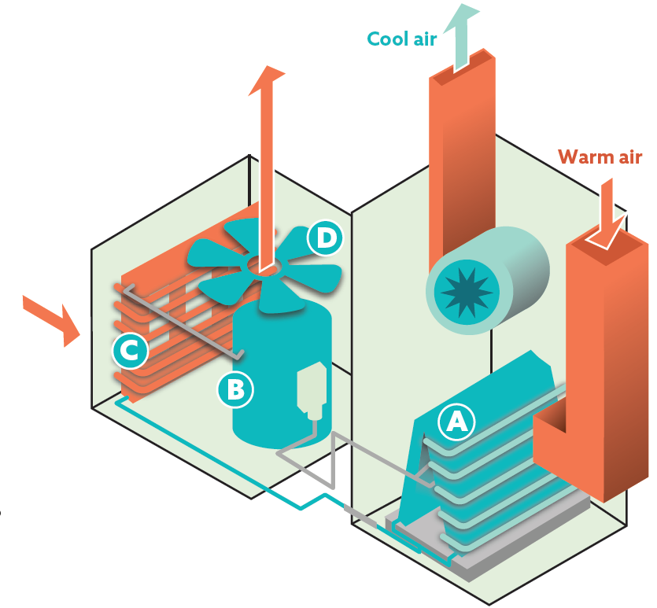

- Describe all heat transfers that occur at or near each of the components below, as shown in the air conditioner diagram. For each transfer, identify where the heat energy originated and where it was after the transfer.
  - Evaporator coils (Letter A)
  - Condenser (Letter C)

- Describe the relationships between the pressure, volume, and temperature of the refrigerant as it travels through the compressor.

Student Reading Comprehension Questions, cont.
- The temperature of Earth and its atmosphere depend on many interactions between matter and energy. One of these interactions involves the molecules in the atmosphere that are called greenhouse gases. These are the gases that can absorb radiation of certain wavelengths. Use the image at the top of page 7 of the article to answer the following questions about the matter and energy interactions.
  - Most of the solar radiation that reaches Earth’s surface is in which range(s) of the electromagnetic spectrum?

  - Most of the energy radiated away from Earth is in which range(s) of the electromagnetic spectrum?

  - All objects that are not at absolute zero temperature (0 K or -273 ºC) emit electromagnetic radiation. Hotter objects radiate higher-energy radiation, which has shorter wavelengths. Why do the sun and Earth give off radiation in different ranges of the spectrum?

  - Greenhouse gases “recycle” energy given off by Earth by absorbing the energy that corresponds to certain motions (see “Absorbing Energy” graphic on page 6) and re-radiating it.
    - According to the spectra on page 7, do greenhouse gases in the atmosphere absorb more of the incoming energy or more of the outgoing energy? Explain your answer.

    - If greenhouse gases didn’t exist, Earth would not be warm enough for humans to live. Why, then, are we trying to reduce the amount of greenhouse gases that we put into the atmosphere?

- How does light reflection on the Sahara Desert silver ants stop them from overheating even when the sun is shining directly on them?

- What aspect of the silver ants phenomenon is the inspiration for the “super-cool paint”?

- How are the solutions described in the article on page 8, for buildings and roads in a city, related to air conditioning?

Student Reading Comprehension Questions, cont.
Questions for Further Learning
Write your answers on another piece of paper if needed.

- Open the simulation at the following link: https://acswebcontent.acs.org/ChemistryInContextSuite/applets/ozone/ozone.html
Drag the black square to various parts of the spectrum to see whether the motions of ozone correspond to absorbing each type of radiation. Summarize the interactions of ozone with electromagnetic radiation by listing the ranges with which it can interact and the overall effect of those interactions.

- Open the simulation at the following link: https://acswebcontent.acs.org/ChemistryInContextSuite/applets/IRWindows/IRWindows.html?darkMode=false
- Click “Display Options” and choose “Black Body Curve.” This shows the range of radiation continually given off by Earth.
- Click “Display Options” again and choose “Scaled Spectra.”
- Note that the x-axis is in “wavenumbers,” which is inversely related to wavelength. The atmospheric window show on page 7 of the article corresponds to wavenumbers of 1250 – 770 cm⁻¹.
- Click the molecules to see the ranges of radiation each will absorb (these show as downward peaks). You can click again to remove the spectrum. The scaled spectra accounts for both the radiation range and the amount of absorption based on the relative concentration in the atmosphere.
Using the information you learn from the simulation, explain what an “atmospheric window” is, and why one exists in the range of 8-13 micrometers.

Graphic Organizer
Name: ______________________________
Directions: As you read, complete the graphic organizer below to describe ways to keep building surfaces cool to limit heat transfer to the inside of buildings.
 | Passive radiative cooling | Cooling paint
Power Source needed?
Scientific principle(s)
Scientists involved (names and/or location)
Materials description
(Drawings OK)

Summary: Write a short email to a friend describing what you learned about the importance of reducing AC use, and three ways to keep cities cooler.

Answers to Reading Comprehension Questions & Graphic Organizer Rubric
- Give two reasons why the use of air conditioning systems contributes to warming the planet.
It takes a lot of electricity. Electricity generation is responsible for a lot of greenhouse gas emissions.
It takes the heat from inside and pumps it outside, thus warming the outside air.

- Find out about the “urban heat island effect” and briefly describe it.
Basically, the lack of greenery and the prevalence of hard, absorbing surfaces, like roads and buildings, causes the heat to stay around longer. Also, the high buildings and narrow streets limit air flow to move the hot air away. All of these things cause many cities to be significantly warmer than the surrounding suburbs.

- Label the air conditioner schematic below, using different colors for each. Show the path, through the air conditioner, of:
  - the air molecules from the warm room. (black arrows)
  - the air molecules from outside. (blue arrows)
  - the refrigerant molecules. (red arrows)

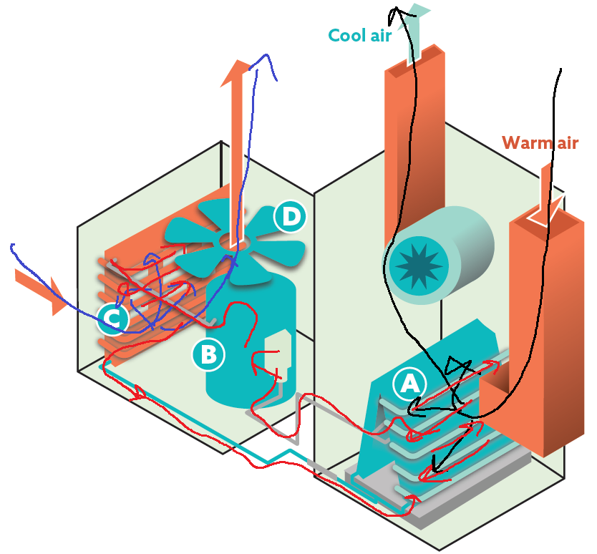
- Describe all heat transfers that occur at or near each of the components below, as shown in the air conditioner diagram. For each transfer, identify where the heat energy originated and where it was after the transfer.
  - Evaporator coils (Letter A)
Fast-moving air molecules from the room run into the cold metal piping and transfer heat to the piping, thus slowing and cooling the original air. The piping quickly conducts the heat energy to the refrigerant molecules inside, warming them up and vaporizing them.
  - Condenser (Letter C)
The refrigerant molecules are now very fast-moving and vaporized from the compressor, making them hotter than the outside air. The fan pulls the outside air into the unit and, when it contacts the metal piping of the condenser, the heat from the refrigerant molecules is transferred through the metal and into the air, making it even warmer. This warm air is pushed back outside via the fan, and the now-condensed refrigerant molecules travel back to the evaporator.
- Describe the relationships between the pressure, volume, and temperature of the refrigerant as it travels through the compressor.
The vaporized refrigerant travels to the compressor, with an original volume that is large. The compressor quickly decreases the volume, which greatly increases the temperature and the pressure. [Note: This is a near-adiabatic change, meaning the volume changes too fast for heat to be transferred, so all of the energy from the pressure-volume work (being done on the gas) becomes part of the internal energy of the gas, thus raising its temperature.]
- The temperature of Earth and its atmosphere depend on many interactions between matter and energy. One of these interactions involves the molecules in the atmosphere that we call greenhouse gases. These are the gases that can absorb radiation of certain wavelengths. Use the image at the top of page 7 of the article to answer the following questions about the matter and energy interactions.
  - Most of the solar radiation that reaches Earth’s surface is in which range(s) of the electromagnetic spectrum? Mostly visible range
  - Most of the energy radiated away from Earth is in which range(s) of the electromagnetic spectrum? Mostly infrared range
  - All objects that are not at absolute zero temperature (0 K or -273 ºC) emit electromagnetic radiation. Hotter objects radiate higher-energy radiation, which has shorter wavelengths. Why do the sun and Earth give off radiation in different ranges of the spectrum?
The sun is much hotter than Earth, so it emits a wider range of radiation, with a peak toward shorter wavelengths than the peak of the cooler earth.
  - Greenhouse gases “recycle” energy given off by Earth by absorbing the energy that corresponds to certain motions (see “Absorbing Energy” graphic on page 6) and re-radiating it.
    - According to the spectra on page 7, do greenhouse gases in the atmosphere absorb more of the incoming energy or more of the outgoing energy? Explain your answer.
More of the outgoing energy. The incoming energy has less area darkened, and the dark areas show ranges where the atmosphere absorbs energy.
    - If greenhouse gases didn’t exist, Earth would not be warm enough for humans to live. Why, then, are we trying to reduce the amount of greenhouse gases that we put into the atmosphere?
Though we do need greenhouse gases to survive, if there are too many, then the amounts of energy going into and out of Earth system become unbalanced. In the case of extra greenhouse gases, this can cause Earth to warm too much.

- How does light reflection on the Sahara Desert silver ants stop them from overheating even when the sun is shining directly on them?
If the light energy is reflecting off the ant’s body, then the ant isn’t absorbing the energy. If the ant doesn’t absorb the energy, it will not heat up.

- What aspect of the silver ant phenomenon is the inspiration for the “super-cool paint”?
The tiny hairs cause air pockets to interrupt the incoming radiation. Rather than being absorbed, the radiation scatters. This can be very useful if applied to paint because the paint could divert the sun’s energy from getting into the building.

- How are the solutions described on page 8 in the article, for buildings and roads in a city, related to air conditioning?
All of these solutions help to reduce the heat going into the buildings or hovering around the city. If the insides of the buildings are cooler and the outside is also cooler, than less air conditioning will be needed. If less air conditioning is used, then less electricity will be needed, thus reducing the need for carbon-emitting electricity generation.

Graphic Organizer Rubric
If you use the Graphic Organizer to evaluate student performance, you may want to develop a grading rubric such as the one below.
Score | Description | Evidence
4 | Excellent | Complete; details provided; demonstrates deep understanding.
3 | Good | Complete; few details provided; demonstrates some understanding.
2 | Fair | Incomplete; few details provided; some misconceptions evident.
1 | Poor | Very incomplete; no details provided; many misconceptions evident.
0 | Not acceptable | So incomplete that no judgment can be made about student understanding

Additional Resources
Labs and demos
What is Temperature?: In this demonstration, students will observe food dye mixing with water at different temperatures. https://teachchemistry.org/classroom-resources/what-is-temperature

Lab: Heating and Cooling Curve: In this lab, students will create a phase change graph by adding and removing heat to observe and record data during actual phase changes. Instead of just memorizing a heating/cooling curve they see in a textbook, students create their own. https://teachchemistry.org/classroom-resources/heating-cooling-curve

Simulations and activities
Simulation Activity: Heating Curve of Water: In this simulation, students will investigate qualitatively and quantitatively what happens as water changes states. This lesson accompanies the simulation from the May 2015 issue of Chemistry Solutions. https://teachchemistry.org/classroom-resources/simulation-activity-heating-curve-of-water

Color Matching Paint Video and Questions: In this activity, students will watch a video and answer related questions about how technology, specifically focusing on spectrophotometry, can be used for paint matching. https://teachchemistry.org/classroom-resources/color-matching-paint-video-questions

Future of Paint Video and Questions: In this activity, students will watch a video and answer related questions about the fascinating and innovative scientific advancements of paint. https://teachchemistry.org/classroom-resources/future-of-paint-video-questions

Simulation Activity: Understanding Specific Heat: In this simulation activity, students will play the role of engineer in deciding which materials are the best candidates for a building project. https://teachchemistry.org/classroom-resources/simulation-activity-understanding-specific-heat

Lessons and lesson plans
What Makes Something Feel Warm?: In this lesson students actively engage in thinking about energy issues in chemistry and the nature of energy (thermal) transfer. https://teachchemistry.org/classroom-resources/what-makes-something-feel-warm

The Ozone Layer: In this lesson, students will develop an explanation for the consequences of ozone depletion on Earth by planning and carrying out an investigation. https://teachchemistry.org/classroom-resources/the-ozone-layer

Projects and extension activities
Heat Flow Process Engineering Optimization: In this activity, students will use a team-based approach to solve the problem of upscaling a chemical process from lab scale to production scale for a hypothetical reaction. https://teachchemistry.org/classroom-resources/heat-flow-process-engineering-optimization
Sustainable Energy Evaluation Activity: In this project, students will develop a presentation to compare the pros and cons of a sustainable resource. https://teachchemistry.org/classroom-resources/sustainable-energy-evaluation

Chemistry Concepts, Standards, and Teaching Strategies

Connections to Chemistry Concepts
The following chemistry concepts are highlighted in this article:
- Physical properties
- Endothermic and exothermic
- Electromagnetic spectrum

Correlations to Next Generation Science Standards
This article relates to the following performance expectations and dimensions of the NGSS:

HS-PS3-3
Design, build, and refine a device that works within given constraints to convert one form of energy into another form of energy.
HS-ETS1-3
Evaluate a solution to a complex real-world problem based on prioritized criteria and tradeoffs that account for a range of constraint, including cost, safety, reliability, and aesthetics, as well as possible social, cultural, and environmental impacts.

Disciplinary Core Ideas:
- PS3.B: Conservation of Energy and Energy Transfer
- ETS1.C: Optimizing the Design Solution
Crosscutting Concepts:
- Cause and effect: Mechanism and explanation
- Systems and System Models
- Energy and Matter
- Structure and Function
Science and Engineering Practices:
- Developing and using models
- Constructing explanations and designing solutions
Nature of Science:
- Science is a human endeavor.

Correlations to Common Core State Standards
See how ChemMatters correlates to the Common Core State Standards at www.acs.org/chemmatters.

Teaching Strategies
Consider the following tips and strategies for incorporating this article into your classroom:
- Before reading the article, consider showing the ACS Reactions Video, “How Air Conditioning Works” at https://youtu.be/PT38gaGciP4 to review how AC warms the planet.
- Alternative to Anticipation Guide: Before reading, ask students how paint could be used to cool buildings and why it is important to keep buildings cool.
  - As they read, students can find information to confirm or refute their original ideas.
  - After they read, ask students what they learned about designing materials to prevent warming the planet.
- This article could be used with energy changes and specific heat, while exploring the different ways that various substances absorb energy.
- Heat transfer is a constant theme throughout the article and students could be challenged to identify places where heat is transferred both usefully and as waste.
- The interaction of electromagnetic radiation and matter is a great way to bring the focus to both the importance of and the dangers of greenhouse gases in the atmosphere.
- This is a great example of bio-inspired design, as the paint was engineered to behave similarly to the silver ant’s reflective surface.

