logo_chemmatters[1]

**April/May 2015 Teacher's Guide for**

***Parabens: A Source of Concern?***

**Table of Contents**

[About the Guide 2](#_Toc415151535)

[Student Questions 3](#_Toc415151536)

[Answers to Student Questions 4](#_Toc415151537)

[Anticipation Guide 5](#_Toc415151538)

[Reading Strategies 6](#_Toc415151539)

[Background Information 8](#_Toc415151540)

[Connections to Chemistry Concepts 17](#_Toc415151541)

[Possible Student Misconceptions 18](#_Toc415151542)

[Anticipating Student Questions 19](#_Toc415151543)

[In-Class Activities 19](#_Toc415151544)

[Out-of-class Activities and Projects 20](#_Toc415151545)

[References 20](#_Toc415151546)

[Web Sites for Additional Information 22](#_Toc415151547)

# About the Guide

Teacher’s Guide editors William Bleam, Regis Goode, Donald McKinney, Barbara Sitzman and Ronald Tempest created the Teacher’s Guide article material. E-mail: [bbleam@verizon.net](mailto:bbleam@verizon.net)

Susan Cooper prepared the anticipation and reading guides.

Patrice Pages, *ChemMatters* editor, coordinated production and prepared the Microsoft Word and PDF versions of the Teacher’s Guide. E-mail: [chemmatters@acs.org](mailto:chemmatters@acs.org)

Articles from past issues of *ChemMatters* can be accessed from a DVD that is available from the American Chemical Society for $42. The DVD contains the entire 30-year publication of *ChemMatters* issues, from February 1983 to April 2013.

The *ChemMatters* DVD also includes Article, Title and Keyword Indexes that covers all issues from February 1983 to April 2013.

The *ChemMatters* DVD can be purchased by calling 1-800-227-5558.

Purchase information can be found online at [www.acs.org/chemmatters](http://chemistry.org/chemmatters/cd3.html).

# Student Questions

**(taken from article)**

* 1. Name five (5) products that contain parabens.
  2. What does “the dose makes the poison” mean?
  3. Why are parabens added to personal-care products?
  4. What is an ester?
  5. How do parabens differ from one another?
  6. Describe a polar molecule.
  7. The polar end of a paraben molecule has an –OH group. Why is this end polar?
  8. What type of intermolecular attraction occurs between water and parabens?
  9. Which parabens are most soluble in water? Explain why.
  10. What does the acronym NOAEL stand for? What does it mean?
  11. Which organizations mentioned in the article have studied the effects of parabens in personal-care products?

# Answers to Student Questions

**(from article)**

* + 1. **Name five (5) products that contain parabens.**

*Products that contain parabens include*

1. *shampoos*
2. *moisturizers*
3. *makeup*
4. *toothpaste*
5. *conditioner*
6. *lotions*
7. *deodorants*
   * 1. **What does “the dose makes the poison” mean?**

*“The dose makes the poison” means that a substance can produce harmful effects only if it reaches a high enough concentration.*

* + 1. **Why are parabens added to personal-care products?**

*Parabens are added as preservatives to prevent the products from decomposing as a result of microbial growth or undesirable chemical changes.*

* + 1. **What is an ester?**

*Esters are organic compounds formed by the dehydration reaction between a carboxylic acid and an alcohol.*

* + 1. **How do parabens differ from one another?**

*They differ from each other by the alkyl group.*

* + 1. **Describe a polar molecule.**

*A polar molecule contains regions of partial positive and partial negative charge that are due to uneven distribution of electrons in a molecule.*

* + 1. **The polar end of a paraben molecule has an –OH group. Why is this end polar?**

*The –OH group is polar because the oxygen is more electronegative than hydrogen. Therefore the oxygen is able to attract the shared electrons more strongly than the hydrogen atom. The oxygen atom has a higher concentration of electrons and therefore a partial negative charge leaving the hydrogen with a partial positive charge.*

* + 1. **What type of intermolecular attraction occurs between water and parabens?**

*Parabens and water are attracted to each other through hydrogen bonding.*

* + 1. **Which parabens are most soluble in water? Explain why.**

*Methyl paraben and ethyl paraben are the most soluble in water. They are more soluble because of the short methyl and ethyl group on these parabens which gives the –OH group a comparatively larger role in interacting with the water.*

* + 1. **What does the acronym NOAEL stand for? What does it mean?**

*NOAEL stands for no-observed-adverse-effect-level. This is the level of exposure of an organism at which there is no significant increase in the severity of adverse effects.*

* + 1. **Which organizations mentioned in the article have studied the effects of parabens in personal-care products? And what was their conclusion?**

*The U.S. Food and Drug Admiration and the American Cancer Society have both studied the data concerning parabens. They concluded that either there is no cause for worry about using cosmetics that contain parabens (U.S.F.D.A.), or there is insufficient evidence to believe parabens in personal-care products increase the risk for developing breast cancer (American Cancer Society).*

# Anticipation Guide

Anticipation guides help engage students by activating prior knowledge and stimulating student interest before reading. If class time permits, discuss students’ responses to each statement before reading each article. As they read, students should look for evidence supporting or refuting their initial responses.

**Directions:**  *Before reading*, in the first column, write “A” or “D,” indicating your agreement or disagreement with each statement. As you read, compare your opinions with information from the article. In the space under each statement, cite information from the article that supports or refutes your original ideas.

|  |  |  |
| --- | --- | --- |
| **Me** | **Text** | **Statement** |
|  |  | 1. The basic principle of toxicology is “The does makes the poison.” |
|  |  | 1. Parabens are preservatives added to food and medicine as well as products we put on our bodies. |
|  |  | 1. Parabens can be found in nature. |
|  |  | 1. Parabens have a distinctive odor that most people find pleasant. |
|  |  | 1. There are only two commonly used parabens. |
|  |  | 1. A molecule’s polarity determines its solubility in different substances. |
|  |  | 1. Paraben’s molecules are polar. |
|  |  | 1. Paraben molecules are more soluble in water than oil. |
|  |  | 1. The concentration of parabens in most cosmetics is at least 1% (by mass). |
|  |  | 1. To date, no studies have been done to analyze the effect of parabens on human health. |

# Reading Strategies

These graphic organizers are provided to help students locate and analyze information from the articles. Student understanding will be enhanced when they explore and evaluate the information themselves, with input from the teacher if students are struggling. Encourage students to use their own words and avoid copying entire sentences from the articles. The use of bullets helps them do this. If you use these reading and writing strategies to evaluate student performance, you may want to develop a grading rubric such as the one below.

|  |  |  |
| --- | --- | --- |
| **Score** | **Description** | **Evidence** |
| 4 | Excellent | Complete; details provided; demonstrates deep understanding. |
| 3 | Good | Complete; few details provided; demonstrates some understanding. |
| 2 | Fair | Incomplete; few details provided; some misconceptions evident. |
| 1 | Poor | Very incomplete; no details provided; many misconceptions evident. |
| 0 | Not acceptable | So incomplete that no judgment can be made about student understanding |

***Teaching Strategies:***

1. Links to **Common Core Standards for Reading**:
   1. ELA-Literacy.RST.9-10.5: Analyze the structure of the relationships among concepts in a text, including relationships among key terms (e.g., force, friction, reaction force, energy).
   2. ELA-Literacy.RST.11-12.4: Determine the meaning of symbols, key terms, and other domain-specific words and phrases as they are used in a specific scientific or technical context relevant to grades 11-12 texts and topics.
2. Links to **Common Core Standards for Writing**:
   1. ELA-Literacy.WHST.9-10.2F: Provide a concluding statement or section that follows from and supports the information or explanation presented (e.g., articulating implications or the significance of the topic).
   2. ELA-Literacy.WHST.11-12.1E: Provide a concluding statement or section that follows from or supports the argument presented.
3. **Vocabulary** and **concepts** that are reinforced in this issue: Chirality; Enantiomer; Amino acid; Protein; Enzyme; and Organic molecular structures.
4. To help students engage with the text, ask students which article **engaged** them most and why, or what **questions** they still have about the articles. The Background Information in the *ChemMatters* Teachers Guide has suggestions for further research and activities.

***Directions*:** As you read the article, complete the graphic organizer below to describe what you learned about parabens.

|  |  |  |
| --- | --- | --- |
| 3 | **New things you learned about parabens** |  |
| 2 | **Facts about parabens you want to share with your friends** |  |
| 1 | **Question you have about parabens** |  |
| Contact! | **After reading the article, will you be concerned about using products containing parabens? Explain.** |  |

# Background Information

**(teacher information)**

**More on** **preservatives in personal-care products**

Preservatives are substances added to consumer products that prevent the growth of microorganisms. They are added to clean products to reduce the risk of contamination from the consumer. Bacteria and fungi are the two types of microorganisms commonly encountered in personal-care products.

Bacteria prefer a neutral to slightly alkaline environment and must have available water to be able to grow. Fungi are further divided into yeasts and molds. Yeasts grow as single-celled organisms while the molds are multicelled and grow large enough to be visible to the naked eye. The molds have an absolute requirement for oxygen so are usually only found on the surface of product. The fungi prefer a neutral to slightly acid environment and also must have available water for growth. The molds can grow with lower available water than the other organisms and are often found contaminating the semi dried remnants on the sides of containers. The effects of growth of microorganisms in personal care products include odor production, pH shift, viscosity change, visible surface growth or color change. These make the product unusable and may result in a recall of the affected batch. The growth of pathogenic organisms may also have public health implications such as causing wound or eye infections from the use of contaminated products.

(<http://www.personalcaremagazine.com/Print.aspx?Story=6254>)

The perfect preservative for personal-care products is the goal of manufacturers. The ideal preservative would have to have the following qualities. It would:

1. Have a broad spectrum activity against all microorganisms
2. Be effective in low concentrations
3. Be colorless and odorless
4. Not react with the other ingredients
5. Be more soluble in water than in oil
6. Not be affected by temperature changes
7. Not alter its activity due to changes in pH
8. Be safe at all concentrations
9. Have a low cost.

No known preservative meets all these criteria. There are three common classes of preservatives used in personal-care products today. They are parabens, formaldehyde-releasers and isothiazolinones.

**Parabens**

More than 85% of personal-care products contain parabens. According to the FDA:

Parabens are among the most commonly used preservatives in cosmetic products. Chemically, parabens are esters of p-hydroxybenzoic acid. The most common parabens used in cosmetic products are methylparaben, propylparaben, and butylparaben. Typically, more than one paraben is used in a product, and they are often used in combination with other types of preservatives to provide preservation against a broad range of microorganisms. The use of mixtures of parabens allows the use of lower levels while increasing preservative activity.

(<http://www.fda.gov/Cosmetics/ProductsIngredients/Ingredients/ucm128042.htm>)

By using a combination of several parabens the effectiveness extends over a broader range of bacteria and fungi. Parabens are colorless and odorless, relatively inexpensive and are effective over a range of pH from 4 to 8. Parabens have been added to health care products since 1950 with no proven side effects. These characteristics make them a favorable choice for use in personal-care products.

**Formaldehyde-releasers**

Formaldehyde is a very common preservative. It interferes with membrane proteins, which kills the microorganism. Although it is a naturally occurring substance, it is considered a carcinogen in concentrations greater than 1.0%. Products that contain more than 0.5% must be labeled “contains formaldehyde”. It can cause skin allergies in concentrations above 0.2%. For these reasons it is not used as a preservative in personal-care products. Instead, about 20% of skin care products use formaldehyde-releasers.

http://upload.wikimedia.org/wikipedia/commons/7/76/Formaldehyde-3D-balls-A.png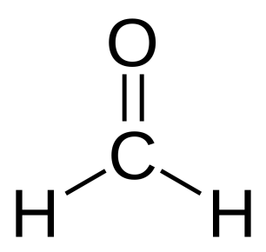

Formaldehyde

2-D structural formula 3-D ball-and-stick model

([*http://upload.wikimedia.org/wikipedia/commons/5/57/Formaldehyde-2D.svg*](http://upload.wikimedia.org/wikipedia/commons/5/57/Formaldehyde-2D.svg))

([*http://upload.wikimedia.org/wikipedia/commons/7/76/Formaldehyde-3D-balls-A.png*](http://upload.wikimedia.org/wikipedia/commons/7/76/Formaldehyde-3D-balls-A.png))

Formaldehyde-releasers are compounds that are made from formaldehyde and have varying stabilities. They are effective by decomposing to reform formaldehyde in small quantities. The formaldehyde is released slowly over time which makes it safer. Formaldehyde-releasers’ are popular with manufacturers due to their low cost and effectiveness.

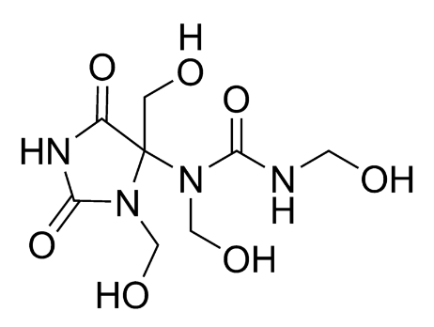

Diazolidinyl urea, an example of a formaldehyde releaser:

([*http://upload.wikimedia.org/wikipedia/commons/thumb/f/f8/Diazolidinyl\_urea\_correct\_formula.png/800px-Diazolidinyl\_urea\_correct\_formula.png*](http://upload.wikimedia.org/wikipedia/commons/thumb/f/f8/Diazolidinyl_urea_correct_formula.png/800px-Diazolidinyl_urea_correct_formula.png))

+ 4 🡪

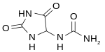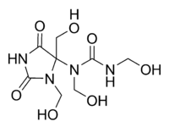

The production of diazolidinyl urea, a formaldehyde-releaser. The reverse reaction produces formaldehyde.

([*https://encrypted-tbn2.gstatic.com/images?q=tbn:ANd9GcSEZttQzBgCcuq-rtv2olK1e4kACmtWk8G1VDlbloCKhHh1tJMe*](https://encrypted-tbn2.gstatic.com/images?q=tbn:ANd9GcSEZttQzBgCcuq-rtv2olK1e4kACmtWk8G1VDlbloCKhHh1tJMe))

**Isothiazolinone**

Isothiazolinone is a class of compounds that are broad-spectrum antimicrobials. They are heterocyclic compounds. The derivatives of isothiazolinone are commonly used as preservatives in water-based personal-care products such as shampoo. They are also used in cooling-water systems and paper mill-water systems. Methylyisothiazolinone, often referred to as MIT, is one of the commonly used isothiazolinones. It is a powerful cytotoxin. There is growing concern over the use of isothiazolinones because of sensitization and allergic reactions.

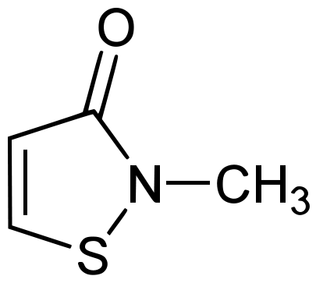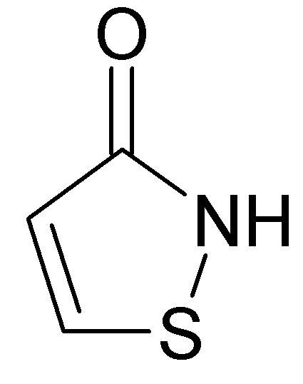

**Isothiazolinone Methylisothiazolinone**

([*http://upload.wikimedia.org/wikipedia/commons/3/34/Isothiazolinone.png*](http://upload.wikimedia.org/wikipedia/commons/3/34/Isothiazolinone.png))

**(**[*http://upload.wikimedia.org/wikipedia/commons/thumb/f/f4/Methylisothiazolinone.svg/405px-Methylisothiazolinone.svg.png*](http://upload.wikimedia.org/wikipedia/commons/thumb/f/f4/Methylisothiazolinone.svg/405px-Methylisothiazolinone.svg.png))

**More on** **dehydration reactions**

A dehydration reaction is a type of condensation reaction. In a condensation reaction two smaller molecules are combined to make a larger one with the elimination of a small molecule. In a dehydration reaction, the small molecule eliminated is water. Other molecules that can be eliminated include such things as ammonia, hydrogen chloride and methanol in condensation reactions. For a dehydration reaction to occur there are two requirements of the smaller molecules. One of the molecules must have a hydroxyl group, an –OH, and the second molecule must have a hydrogen atom. The hydroxyl group and the hydrogen atom combine to form water. The simplest description of this reaction can be given by:

X-OH + Y-H 🡪 XY + HOH

There are many examples of dehydration reactions. Here are just a few.

1. A combination of two amino acids to create a dipeptide and forming a peptide bond:

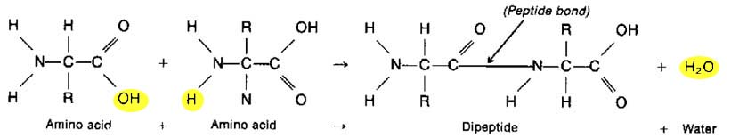

([*http://www.hobart.k12.in.us/jkousen/Biology/dhsprot2.jpg*](http://www.hobart.k12.in.us/jkousen/Biology/dhsprot2.jpg))

1. Two monosaccharides joining to make a disaccharide and forming a glycoside bond:

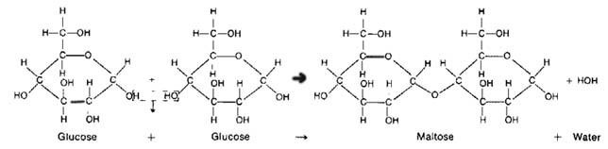

([*http://www.hobart.k12.in.us/jkousen/Biology/dhscarbo.jpg*](http://www.hobart.k12.in.us/jkousen/Biology/dhscarbo.jpg))

1. The combination of fatty acids and glycerol to form a triglyceride, a fat:

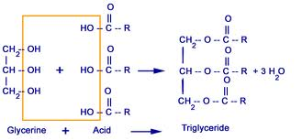

([*http://www.citycollegiate.com/biochemistry21.gif*](http://www.citycollegiate.com/biochemistry21.gif))

1. The dehydration of alcohols to make an ether

CH3CH2-OH + HO-CH2CH3 🡪 HOH + CH3CH2-O-CH2CH3

Ethanol + ethanol 🡪 water + diethyl ether

**More on** **esters**

Esters comprise a class of compounds that is found throughout nature. All esters tend to have distinct aromas and are largely responsible for the aromas of fruits. They have a wide variety of uses such as flavorings in food, scents in perfume, pharmaceuticals (aspirin), and preservatives (parabens). Fats, also known as triglycerides, are esters.

Esters are formed in a condensation (dehydration) reaction between a carboxylic acid and an alcohol.

alcohol + carboxylic acid 🡪 ester + water

The reaction can be catalyzed using hydrogen ions. Frequently, concentrated sulfuric acid is used as the catalyst for that reason. Here is an example.

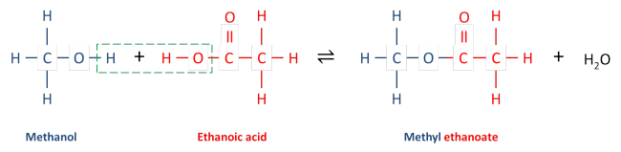

([*https://anhourofchemaday.files.wordpress.com/2013/05/esterification.png?w=650*](https://anhourofchemaday.files.wordpress.com/2013/05/esterification.png?w=650))

The product of this reaction, methyl ethanoate, imparts the flavor of peppermint.

Esters are named from the alkyl group of the alcohol first (methanol 🡪 methyl). Then the parent name of the carboxylic acid is used by dropping the –oic acid and adding –oate (ethanoic acid 🡪 ethanoate).

Properties of esters as reported in the *ChemMatters* Teacher’s Guide from December 2011 were copied here:

Physical Properties:

1. Physical State: Lower molecular weight esters are colorless liquids. Higher weight esters are waxy solids.

2. Odor: All esters have a strong odor.

3. Solubility: Lower weight esters are soluble in water. The solubility decreases with increase in molecular weight. See examples below. Esters form hydrogen bonds with water. Esters are soluble in organic solvents. Esters themselves are good organic solvents.

**Name Mol. Mass Solubility (g/100 g water)**

ethyl methanoate 64 10.5

ethyl ethanoate 76 8.7

ethyl propanoate 102 1.7

4. Acidic nature: Esters are neutral to litmus tests.

Chemical Properties:

As the article [“Alice A. Ball: Young Chemist Gave Hope to Millions”] describes, esters are one class of organic compounds. Ester molecules tend to be polar molecules and so have dipole interactions and dispersion forces. They do not form hydrogen bonds.

Hydrolysis of esters: Esters break down into their respective organic acid and alcohol from which they are formed in a process called hydrolysis. Hydrolysis of ester with an alkaline solution like sodium hydroxide is known as saponification (soap making).

(<http://www.acs.org/content/acs/en/education/resources/highschool/chemmatters/teachers-guide.html>)

**More on estrogen**

Estrogen is a generic class of compounds responsible for the estrous cycle. Estrogen is generally considered a female hormone, while testosterone a male hormone; however both are present in both sexes. They are primarily produced by the ovaries, but a small amount is also produced in the adrenal cortex, the testes, the fetal-placenta unit, fat tissue and breast tissue. Estrogens are chemical messengers. Once estrogen is secreted by the tissues it travels through the bloodstream until it enters a tissue.

Estrogens have an effect on target tissues by binding to fractions of cells called estrogen receptors. These receptors are protein molecules found inside those cells that are targets for estrogen action. Only estrogens (or closely related molecules) are able to bind to these receptors.

The target tissues affected by estrogen molecules all contain estrogen receptors; other organs and tissues in the body do not. Therefore, when estrogen molecules circulate in the bloodstream and move throughout the body, they exert effects only on cells that contain estrogen receptors.

Estrogen receptors exist in the cell's nucleus, together with DNA molecules.

In the absence of estrogen molecules, these estrogen receptors are inactive and have no influence on DNA (which contains the cell's genes). But when an estrogen molecule enters a cell and passes into the nucleus, the estrogen binds to its receptor, in doing so causing the shape of the receptor to change. This estrogen-receptor complex then binds to specific DNA sites, called estrogen response elements, located near genes that are controlled by estrogen.

After attachment to estrogen response elements in DNA, this estrogen-receptor complex binds to coactivator proteins and more nearby genes become active. The active genes produce molecules of messenger ribonucleic acid (RNA), which guide the synthesis of specific proteins. These proteins can then influence cell behavior in different ways, depending on the cell type involved.

(<http://www.medicalnewstoday.com/articles/277177.php>)

Estrogen consists of three related hormones, estradiol, estriol, and estrone.

**Estradiol** is the strongest of the three hormones. It is responsible for female characteristics such as breast development, pubic hair and regulation of menstrual cycles and reproductive systems. It is also important to women’s bone health. It does contribute to health problems such as endometriosis and female cancers.

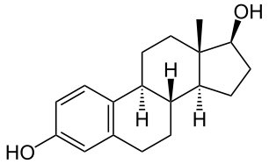

Estradiol

([*http://upload.wikimedia.org/wikipedia/commons/thumb/0/00/Estradiol.svg/306px-Estradiol.svg.png*](http://upload.wikimedia.org/wikipedia/commons/thumb/0/00/Estradiol.svg/306px-Estradiol.svg.png))

**Estriol** is only produced in significant quantities during pregnancy. It is a metabolic waste product of estradiol metabolism. Estriol is the weakest of the estrogens. It is only 8% as potent as estradiol and 14% as effective as estrone.

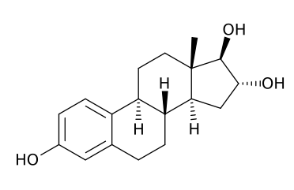

Estriol

([*http://en.wikipedia.org/wiki/Estriol#mediaviewer/File:Estriol.svg*](http://en.wikipedia.org/wiki/Estriol#mediaviewer/File:Estriol.svg))

**Estrone** is the least abundant of the three hormones. Small amounts of it are made throughout the body, especially in fatty tissue and muscle. It is the main estrogen present after menopause.

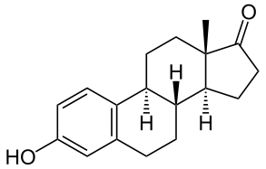

Estrone

([*http://en.wikipedia.org/wiki/Estrone#mediaviewer/File:Estron.svg*](http://en.wikipedia.org/wiki/Estrone#mediaviewer/File:Estron.svg))

Estrogen affects many systems in the body. In the female reproductive system it simulates the growth of the egg follicle; causes the vaginal wall to thicken and increases its acidity that reduces bacterial infections; enhances and maintains the mucous membrane, the endometrium, in the uterus; and causes the breasts to grow during adolescence. Estrogen affects the brain by increasing serotonin and the number of serotonin receptors in the brain; modifying the production and effect of endorphins; protecting nerves from damage; and stimulating nerve growth. Skin is affected by estrogen, improving collagen content, increasing skin thickness and improving blood supply to the skin. Estrogen also aids in bone building.

Estrogen can also be responsible for many diseases. About 80% of breast cancers are stimulated to grow by estrogen triggering the estrogen receptors in the cancer cells. Elevated levels of estrogen is believed to play a role in endometrial cancer by stimulating the excessive buildup of the lining of the uterus. Osteoporosis, the most common bone disease, is most common in menopausal women, where it is caused by a drop in estrogen.

**More on intermolecular forces**

Intermolecular forces are the forces between molecules, especially the attractive forces. They govern physical properties like boiling point, melting point, vapor pressure, viscosity, surface tension and solubility. They also affect the way chemicals react due to their attraction. Several types of intermolecular attractions exist, but they all depend on the attraction between positive and negative charges, the electrostatic attraction. The three basic types of intermolecular attractions are dipole-dipole attraction, hydrogen bonding and London dispersion forces.

**Dipole-Dipole attractions**: Polar molecules are a result of the uneven distribution of electrons within a molecule caused by polar bonds and an asymmetric molecule. When there is a difference in electronegativity, the ability to attract shared electrons within a covalent bond, the electrons shift to create a partial negative end and a partial positive end of the molecule. This creates a dipole moment. Molecules with dipole moments can attract each other electrostatically by lining up the positive end of one molecule next to the negative end of an adjacent molecule creating the dipole-dipole attraction. Dipole-dipole attractions are only about 1% as strong as ionic or covalent bonds.

Example of dipole-dipole attractions:

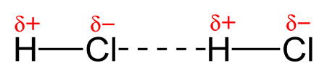

([*http://upload.wikimedia.org/wikipedia/commons/5/59/Dipole-dipole-interaction-in-HCl-2D.png*](http://upload.wikimedia.org/wikipedia/commons/5/59/Dipole-dipole-interaction-in-HCl-2D.png))

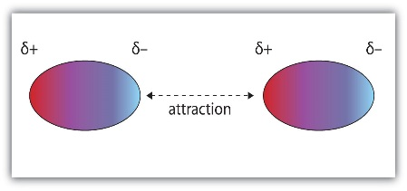

([*http://images.flatworldknowledge.com/ball/ball-fig10\_002.jpg*](http://images.flatworldknowledge.com/ball/ball-fig10_002.jpg))

**Hydrogen-bonding** is really a special case of dipole-dipole attraction. Particularly strong dipole-dipole forces occur when hydrogen is bonded to a small, highly electronegative atom. The three highly electronegative atoms are fluorine, oxygen and nitrogen. The partially positive hydrogen atom is attracted to the partial negative charge of nitrogen, oxygen or fluorine atoms of another molecule. The large polarity and the small size cause the hydrogen bonding to be much stronger (4–30 kJ/mole) than any other dipole-dipole attractions (less than 4 kJ/mole).

Examples of hydrogen bonding. The hydrogen bond is represented by the dashed lines.

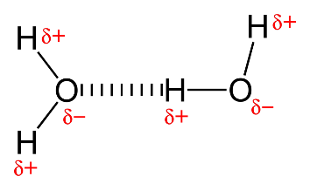

([*http://upload.wikimedia.org/wikipedia/commons/thumb/b/b5/Hydrogen-bonding-in-water-2D.png/1024px-Hydrogen-bonding-in-water-2D.png*](http://upload.wikimedia.org/wikipedia/commons/thumb/b/b5/Hydrogen-bonding-in-water-2D.png/1024px-Hydrogen-bonding-in-water-2D.png))

**H H H**

**| | |**

δ+

δ-

δ+

δ-

**H—N - - - - - H—N - - - - - H—N**

**| | |**

**H H H**

**London dispersion forces:** Nonpolar molecules and noble gases must also experience some type of attractive force since, under certain conditions, they will liquefy. In nonpolar molecules the electrons ae considered evenly distributed throughout the molecule. However electrons are in constant random motion and a temporary dipole can be created by the shifting of the electrons. These temporary dipoles can repel or attract the electrons in a neighboring nonpolar molecule. This instantaneous dipole that occurs accidentally in a given atom or molecule can then induce a similar dipole in a neighboring molecule. Although this dipole may only exist for a fraction of a second is does create a short-lived attraction between molecules. The strength of this attraction, although weak, depends on how easily the electron clouds can be distorted. Larger atoms or molecules with large number of electrons far from the nucleus are more easily distorted and therefore form stronger attractions. This explains why nonpolar molecules like those in vegetable oil are liquid at room temperature.

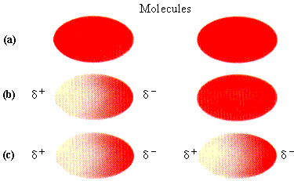

Example of London dispersion forces:

* 1. Electrons are evenly distributed in a nonpolar molecule;
  2. Electrons are temporarily distorted creating an instantaneous dipole;
  3. The instantaneous dipole on the left induces a dipole in the on the right.

([*https://www.chem.wisc.edu/deptfiles/genchem/sstutorial/Text9/Tx98/tx98p1.GIF*](https://www.chem.wisc.edu/deptfiles/genchem/sstutorial/Text9/Tx98/tx98p1.GIF))

# Connections to Chemistry Concepts

**(for correlation to course curriculum)**

1. **Risk-Benefit Analysis**—Throughout this article, the risk versus the benefit of using personal-care products with parabens is analyzed. This provides the opportunity to discuss the importance of analyzing and comparing risks and benefits of a particular substance.
2. **Organic chemistry**—Parabens are organic molecules. The article provides the structures and nomenclature of each of the parabens. It also discusses the functional groups that make up their structures. In addition, since parabens are esters, the article describes this classification of organic molecules.
3. **Dehydration reactions**—Esters are produced in a dehydration reaction between a carboxylic acid and an alcohol. The article describes the production of parabens in this type of reaction.
4. **Polarity**—The article describes what a polar and a nonpolar molecule is. It explains how a paraben molecule has a polar end and a nonpolar end.
5. **Solubility**—Parabens are slightly soluble in water, as well as in oil. The concept of “like dissolves like” is used to explain this characteristic.
6. **Electronegativity**—The difference in electronegativity between oxygen and hydrogen in a hydroxyl group is discussed and used to explain the polarity in the paraben molecules.
7. **Intermolecular forces**—Parabens dissolve in water by forming hydrogen bonds between the water and the hydroxyl group in the paraben molecule. Parabens dissolve in oil because of London dispersion forces of attraction that occur between the oil and the alkyl group on the paraben molecule.

# Possible Student Misconceptions

**(to aid teacher in addressing misconceptions)**

1. **“All-natural ingredients in personal-care products are safer.”** *Natural preservatives are not as safe as paraben and other synthetic preservatives. Natural preservatives commonly used are essential oils and herbs such as rosemary, clove, cinnamon, lavender, grape seed, and citrus oils. Many of these can be potent allergens and can cause skin allergies. These tend to be organism-specific, meaning they are effective against one organism but not another. The synthetic preservatives tend to be broad-spectrum, being effective against a variety of microorganisms. It is also important to remember that parabens and formaldehyde are commonly found in nature, too. And after all, strychnine, arsenic and poison ivy are natural—and they are not safe!*
2. **“Preservatives in skin care products are bad.”** *Preservatives in skin care products are essential. Skin care products become easily contaminated with bacteria and fungi from ones’ hands in application. Since the skin care products contain water, oil, and carbohydrates, they are great mediums for the growth of microorganisms. Preservatives help to prevent the growth of microbes. They help prevent bacteria from multiplying. This helps to prevent the products from spoiling and causing skin infections. They substantially prolong the shelf-life of these products as well.*
3. **“Parabens cause breast cancer.”** *At the current time there is no evidence to support this statement. According to the U.S.F.D.A.:*

The Cosmetic Ingredient Review (CIR) reviewed the safety of methylparaben, propylparaben, and butylparaben in 1984 and concluded they were safe for use in cosmetic products at levels up to 25%. Typically parabens are used at levels ranging from 0.01 to 0.3%.

On November 14, 2003, the CIR began the process to reopen the safety assessments of methylparaben, ethylparaben, propylparaben, and butylparaben in order to offer interested parties an opportunity to submit new data for consideration. In September 2005, the CIR decided to re-open the safety assessment for parabens to request exposure estimates and a risk assessment for cosmetic uses. In December 2005, after considering the margins of safety for exposure to women and infants, the Panel determined that there was no need to change its original conclusion that parabens are safe as used in cosmetics. (The CIR is an industry-sponsored organization that reviews cosmetic ingredient safety and publishes its results in open, peer-reviewed literature. FDA participates in the CIR in a non-voting capacity.)

A study published in 2004 (Darbre, in the Journal of Applied Toxicology) detected parabens in breast tumors. The study also discussed this information in the context of the weak estrogen-like properties of parabens and the influence of estrogen on breast cancer. However, the study left several questions unanswered. For example, the study did not show that parabens cause cancer, or that they are harmful in any way, and the study did not look at possible paraben levels in normal tissue.

FDA is aware that estrogenic activity in the body is associated with certain forms of breast cancer. Although parabens can act similarly to estrogen, they have been shown to have much less estrogenic activity than the body’s naturally occurring estrogen. For example, a 1998 study (Routledge et al., in Toxicology and Applied Pharmacology) found that the most potent paraben tested in the study, butylparaben, showed from 10,000- to 100,000-fold less activity than naturally occurring estradiol (a form of estrogen). Further, parabens are used at very low levels in cosmetics. In a review of the estrogenic activity of parabens, (Golden et al., in Critical Reviews in Toxicology, 2005) the author concluded that based on maximum daily exposure estimates, it was implausible that parabens could increase the risk associated with exposure to estrogenic chemicals.

FDA believes that at the present time there is no reason for consumers to be concerned about the use of cosmetics containing parabens. However, the agency will continue to evaluate new data in this area. If FDA determines that a health hazard exists, the agency will advise the industry and the public, and will consider its legal options under the authority of the FD&C Act in protecting the health and welfare of consumers.

(<http://www.fda.gov/cosmetics/productsingredients/ingredients/ucm128042.htm>)

# Anticipating Student Questions

**(answers to questions students might ask in class)**

1. **“Do males have estrogen?”** *Men do produce estrogen in smaller quantities than females. On occasion these levels can be higher than in post-menopausal women.*
2. **“What is the purpose of estrogen in men?”** *Estradiol is believed to be responsible for the formation and maturation of sperm. It also plays a role in bone strength, sexual maturation and cholesterol metabolism.*

## In-Class Activities

**(lesson ideas, including labs & demonstrations)**

1. The synthesis of esters in a laboratory activity is always fun and easy to do on a small-scale level. There are many instructions for the production of esters available. Two good procedures are given here:

The lab procedure begins on page 5 of this document. This one provides a student friendly procedure as well as teacher notes. (<http://dwb.unl.edu/ChemSource/SourceBook/126ORGN.pdf>)

This is also a good student-friendly procedure for the production of esters. (<http://courses.chem.indiana.edu/c122/documents/Experiment4_Esters_001.pdf>)

1. Aspirin is another ester that can be easily synthesized in the lab. Here are several good laboratory procedures that could be used.

(<http://www.chem.latech.edu/~deddy/chem104/104Aspirin.htm>)

(<http://www.laney.edu/wp/cheli-fossum/files/2012/01/8-Synthesis-of-Aspirin.pdf>)

(<http://wwwchem.csustan.edu/consumer/aspirincons/aspirincons.htm>)

1. If you would like to present a lesson on esters, check out this site. It has a slide show that describes esters, their synthesis, characteristics and uses. (<http://www.slideshare.net/bleonacoba/esters-all-properties>)
2. Students can investigate the polarity of molecules with this simulation: <http://phet.colorado.edu/en/simulation/molecule-polarity>.
3. Students can perform lab activities that investigate the relationship between polarity of molecules and solubility. One such lab is designed as a guided inquiry lab in that the students are asked to write the basic procedure. The investigation is called “Solvents” in *Chemistry in the Community* textbook produced by the American Chemical Society. The procedure can be found on line at <https://books.google.com/books?id=0PD6rPkc0CYC&pg=PA59&lpg=PA59&dq=laboratory+activity+polarity&source=bl&ots=6BwpXYCPKf&sig=NavFUU8yZInfYDbuBFcDQCD7id8&hl=en&sa=X&ei=V4jbVMjzDsupgwSQo4H4Ag&ved=0CDcQ6AEwBDgK#v=onepage&q=laboratory%20activity%20polarity&f=false>.

The reference for the text book is: American Chemical Society. *Chemistry in the Community*, W.H. Freeman and Company: New York, NY 2002, pp 59–61.

1. A more traditional lab that investigates solubility and polarity can be found at <http://www.scienceteacherprogram.org/physics/Flomberg01.html>.
2. A series of activities that investigate the concept of “the dose makes the poison” can be found at the Web site <http://science.education.nih.gov/supplements/nih2/chemicals/guide/pdfs/lesson2.pdf>. Lesson #2 has the activities focused on the dose of chemicals. The complete set of activities of this series can be found here: <https://science.education.nih.gov/supplements/nih2/chemicals/guide/guide_toc.htm>.
3. Another activity dealing with “the dose makes the poison” can be found at <http://agr.wa.gov/FoodAnimal/AnimalFeed/InstructionDocs/DosePoison.pdf>.

# Out-of-class Activities and Projects

**(student research, class projects)**

1. Students could investigate the relationship between parabens and cancer. They could then debate the pros and cons of using parabens in personal-care products.
2. Students could be assigned to investigate health claims about other additives in personal-care products. In their research they could determine information such as the chemistry of the product, what type of products contain the additive, the quantities present in the product, the potential effects of the additive, and the dose that would cause an adverse effect. There are many claims about many additives. Some suggestions are phthalates, triclosan, formaldehyde, lead acetate, butylated hydroxytoluene, and sodium laurel sulfate.
3. Students could investigate what the U.S. Food and Drug Administration does and does not regulate in terms of personal-care products and cosmetics.

# References

**(non-Web-based information sources)**



**30 Years of *ChemMatters***

Available Now!

**The references below can be found on the *ChemMatters* 30-year DVD (which includes all articles published during the years 1983 through April 2013 and all available Teacher’s Guides, beginning February 1990). The DVD is available from the American Chemical Society for $42 (or $135 for a site/school license) at this site:** [http://ww.acs.org/chemmatters](http://www.acs.org/chemmatters)**. Scroll about half way down the page and click on the *ChemMatters* DVD image at the right of the screen to order or to get more information.**

**Selected articles and the complete set of Teacher’s Guides for all issues from the past three years are available free online on the same Web site, above. Simply access the link and click on the “Past Issues” button directly below the “M” in the *ChemMatters* logo at the top of the Web page.**

Becker, R. Question from the Classroom. *ChemMatters* **2006**, *24* (2), pp 2–3. Becker explains the polarity of molecules and intermolecular attractions. He explains the relationship between oil and water and dispels the myth that they are not attracted to each other. This is a well-written article that provides excellent explanations.

Laliberte, M. Sick Buildings—Air Pollution Comes Home. *ChemMatters* **2006**, *24* (3), pp 12–14. Within this article on indoor air quality there is a good discussion of formaldehyde. Formaldehyde is also used as a preservative in personal-care products. The use and properties of formaldehyde are described in the article.

The October 2006 *ChemMatters* Teacher’s Guide for the above article elaborates on the properties, characteristics and uses of formaldehyde.

Rohrig. B. Paintball! Chemistry Hits its Mark. *ChemMatters* **2007**, *25* (2), pp 4–7. A good discussion of polar molecules and solubility is included in this article.

The April 2007 *ChemMatters* Teacher’s Guide for the above article on paintball includes an informative section on hydrogen bonding.

Heiss, R. Mmmm… Flavorful Food! *ChemMatters* **2011**, *29* (4), pp. 6–8. This article discusses the chemicals in food and the flavors they impart. Esters and the flavor role they play are described within this article.

More information on esters can be found in the December 2011 *ChemMatters* Teacher’s Guide for the Heiss article on food flavors above.

Haines, G. Mascara: That Lush Look You Love! *ChemMatters* **2012**, *30* (4), pp 15–16. This article describes the composition of mascara including a discussion of parabens.

The *ChemMatters* Teacher’s Guide for the December 2012 article on mascara above has more information on parabens and cancer, as well as information from the U.S. Food and Drug Administration.

# Web Sites for Additional Information

**(Web-based information sources)**

**More sites on** **preservatives**

This article discusses preservatives in personal-care products. It also discusses the controversies over their use and what manufactures are doing to find alternatives. (<http://cen.acs.org/articles/92/i23/Close-Scrutiny-Cosmetic-Preservatives-Continues.html>)

This article has an extensive discussion of preservatives. It includes an explanation of the purpose of preservatives and why they are important in personal-care products. It describes a wide variety of substances that are used as preservatives. (<http://www.personalcaremagazine.com/Print.aspx?Story=6254>)

At this Web site you will find not only a good explanation of preservatives but also a wonderful graphic that aids in the explanation: <http://cosmeticsinfo.org/HBI/6>.

This article describes the controversies over the use of preservatives, including parabens, in personal-care products. (<http://cen.acs.org/articles/88/i20/Preservatives-Under-Fire.html>)

This article describes isothiazolinones, which is another group of commonly used preservatives. (<http://wealthocean.com/wordpress/wp-content/uploads/2013/07/Isothiazolinones.pdf>)

**More sites on** **dehydration reactions**

Dehydration reactions and hydrolysis reactions are briefly explained at this site. Graphics are used to illustrate the reactions. (<http://science.halleyhosting.com/sci/soph/organic/dehydration.htm>)

This site explains condensation (dehydration) reactions. It provides several examples of the reactions in a clear, concise manner. (<https://www.boundless.com/chemistry/textbooks/boundless-chemistry-textbook/polymers-24/synthetic-organic-polymers-173/condensation-reactions-657-5664/>)

Dehydration reactions are defined and explained to be a type of condensation reaction. This sit provides several examples of these reactions using easy to understand illustrations. (<http://www.buzzle.com/articles/dehydration-synthesis.html>)

This video clip (5:19) presented by Mark Rosengarten is a tutorial on dehydration reactions. He clearly presents etherification and esterification reactions. He describes the functional groups and nomenclature in the video. (<https://www.youtube.com/watch?v=SjS6BjKXm6M>)

This short video clip (3:39) clearly demonstrate the condensation (dehydration) reactions between a carboxylic acid and an alcohol. It too includes clear diagrams and nomenclature of the organic compounds involved. (<https://www.youtube.com/watch?v=sRhH1aYo5UY>)

This site has a short animation that demonstrates a dehydration reaction and compares it to a hydrolysis reaction: <http://www.cengage.com/biology/discipline_content/animations/reaction_types.html>.

**More sites on** **esters**

This site describes esters and illustrates their structure. It includes information on their physical properties. It also describes some more complicated, naturally-occurring esters. (<http://www.chemguide.co.uk/organicprops/esters/background.html>)

The nomenclature, structure, synthesis and properties of esters are clearly presented in this University of California at Davis ChemWiki site: <http://chemwiki.ucdavis.edu/Organic_Chemistry/Esters>.

This is another site describing esters. It describes and gives several examples of various simple esters. (<http://www.3rd1000.com/chem301/chem301v.htm>)

This site has a slide show that describes esters, their synthesis, characteristics and uses. This could easily be used as part of a lesson on esters. <http://www.slideshare.net/bleonacoba/esters-all-properties>

The Khan Academy video (10:30) clearly presents the nomenclature and properties of esters. (<https://www.khanacademy.org/science/organic-chemistry/carboxylic-acids-derivatives/acid-derivatives-jay/v/nomenclature-and-properties-of-esters>)

**More sites on estrogens**

Extensive information about estrogens is given at this site. It describes what they are, how they work, where they come from, how they affect the body, the role they play in men, and diseases associated with estrogen. (<http://www.medicalnewstoday.com/articles/277177.php>)

This is an archival Web site from Cornell University. It describes estrogen and its relationship to breast cancer. (<http://envirocancer.cornell.edu/factsheet/general/fs10.estrogen.cfm>)

Hormones, especially estrogen and testosterone, are the focus of this article. It describes what hormones are and describes estrogens and testosterone. It discusses the affects these hormones have on the body, as well as the effects that varying levels of each of these hormones have on the body. (<http://www.webmd.com/women/guide/normal-testosterone-and-estrogen-levels-in-women>)

**More sites on intermolecular forces**

These two sites provide clear explanations of the different intermolecular forces. Both have good illustrations to aid in the explanations.

(<http://chemwiki.ucdavis.edu/Physical_Chemistry/Physical_Properties_of_Matter/Atomic_and_Molecular_Properties/Intermolecular_Forces/Intermolecular_Forces>) and

(<http://chemed.chem.purdue.edu/genchem/topicreview/bp/intermol/intermol.html>)

This (5:19) video provides an excellent, clear explanation of intermolecular forces. It also describes the effects of these forces on the properties of molecules. It would be an excellent introduction on intermolecular forces. (<https://www.youtube.com/watch?v=S8QsLUO_tgQ>)

This Khan Academy video (8:35) describes the polarity of molecules and the various type of intermolecular forces. This is actually the third in a series; the first deals with electronegativity and bonding, and the second explains dipole moments. (<https://www.khanacademy.org/science/organic-chemistry/gen-chem-review/electronegativity-polarity/v/intermolecular-forces-and-molecular-bonds>)