logo_chemmatters[1]

**April/May 2016 Teacher's Guide for**

***Frozen Fish Stick Blues***

**Table of Contents**

[About the Guide 2](#_Toc446168397)

[Student Questions 3](#_Toc446168398)

[Answers to Student Questions 4](#_Toc446168399)

[Anticipation Guide 5](#_Toc446168400)

[Reading Strategies 6](#_Toc446168401)

[Background Information 9](#_Toc446168402)

[Connections to Chemistry Concepts 22](#_Toc446168403)

[Possible Student Misconceptions 22](#_Toc446168404)

[Anticipating Student Questions 23](#_Toc446168405)

[In-Class Activities 23](#_Toc446168406)

[Out-of-Class Activities and Projects 24](#_Toc446168407)

[References 25](#_Toc446168408)

[Web Sites for Additional Information 25](#_Toc446168409)

# About the Guide

Teacher’s Guide editors William Bleam, Regis Goode, Barbara Sitzman and Ronald Tempest created the Teacher’s Guide article material. E-mail: [bbleam@verizon.net](mailto:bbleam@verizon.net)

Susan Cooper prepared the anticipation and reading guides.

Patrice Pages, *ChemMatters* editor, coordinated production and prepared the Microsoft Word and PDF versions of the Teacher’s Guide. E-mail: [chemmatters@acs.org](mailto:chemmatters@acs.org)

Articles from past issues of *ChemMatters* can be accessed from a DVD that is available from the American Chemical Society for $42. The DVD contains the entire 30-year publication of *ChemMatters* issues, from February 1983 to April 2013.

The *ChemMatters* DVD also includes Article, Title and Keyword Indexes that covers all issues from February 1983 to April 2013.

The *ChemMatters* DVD can be purchased by calling 1-800-227-5558.

Purchase information can be found online at [www.acs.org/chemmatters](http://chemistry.org/chemmatters/cd3.html).

# Student Questions

**(taken from the article)**

**Frozen Fish Stick Blues**

* 1. What is the limit for mercury in fish recommended by the U.S. Food and Drug Administration (FDA)?
  2. The U.S. Environmental Protection Agency (EPA) recommends consuming a limited amount of mercury. What is that recommendation?
  3. What is a microgram?
  4. List three types of seafood that the article says are safe to eat.
  5. Explain how mercury gets into fish.
  6. What are the two reasons not to eat tuna, cited in the article?
  7. According to Figure 1, what are the three sources of mercury in the environment?
  8. Mercury(II) sulfide is formed by microbes and is small enough to pass through microbial cells. What happens to the mercury once it is inside the cell?
  9. How does the methylmercury change inside a fish?
  10. Explain how the methylmercury is carried to the brain.
  11. What type of fish are in the fish sticks in this article?

# Answers to Student Questions

**(taken from the article)**

**Frozen Fish Stick Blues**

* + 1. **What is the limit for mercury in fish recommended by the U.S. Food and Drug Administration (FDA)?**

*The FDA says that grocery stores should not sell fish that has more than 1 part per million of mercury.*

* + 1. **The U.S. Environmental Protection Agency (EPA) recommends consuming a limited amount of mercury. What is that recommendation?**

*The EPA recommends not to eat more than 0.1 microgram of mercury per day per kilogram of your body mass.*

* + 1. **What is a microgram?**

*A microgram is one millionth of a gram.*

* + 1. **List three types of seafood that the article says are safe to eat.**

*The article states that it is safer to eat shrimp, sardines and tilapia.*

* + 1. **Explain how mercury gets into fish.**

*Plankton ingest mercury. Plankton are eaten by small fish, which are eaten by larger fish, passing the mercury onto each other, right on up the food chain.*

* + 1. **What are the two reasons not to eat tuna, cited in the article?**

*Tuna contains high levels of mercury and the tuna population is decreasing because they are overfished.*

* + 1. **According to Figure 1, what are the three sources of mercury in the environment?**

*These three sources all release mercury into the air, according to Figure 1:*

1. *Volcanic eruptions,*
2. *burning of coal and*
3. *mining of iron*
   * 1. **Mercury(II) sulfide is formed by microbes and is small enough to pass through microbial cells. What happens to the mercury once it is inside the cell?**

*Once inside the cell the mercury atoms bind to methyl groups (–CH3) to form methylmercury. The methylmercury diffuses into the water and is taken up by the plankton.*

* + 1. **How does the methylmercury change inside a fish?**

*Inside a fish the methylmercury has a high affinity for sulfur containing anions, especially the thiol group (-SH) on the amino acid cysteine, and forms the compound methylmercury cysteine.*

* + 1. **Explain how the methylmercury is carried to the brain.**

*Methylmercury cysteine looks like the amino acid methionine. Proteins that usually bind with methionine will bind with methylmercury cysteine carrying the methylmercury to the brain.*

* + 1. **What type of fish are in the fish sticks in this article?**

*Pollock, which is low in mercury, is the fish in the fish sticks.*

# Anticipation Guide

Anticipation guides help engage students by activating prior knowledge and stimulating student interest before reading. If class time permits, discuss students’ responses to each statement before reading each article. As they read, students should look for evidence supporting or refuting their initial responses.

**Directions:**  ***Before reading,*** in the first column, write “A” or “D,” indicating your agreement or disagreement with each statement. As you read, compare your opinions with information from the article. In the space under each statement, cite information from the article that supports or refutes your original ideas.

|  |  |
| --- | --- |
| **Text** | **Statement** |
|  | 1. Farmed fish have no mercury in them. |
|  | 1. One ten-millionth of a gram is the same as 0.1 microgram. |
|  | 1. As far as mercury is concerned, tuna are safer to eat than shrimp. |
|  | 1. Mercury gets into fish through the food chain. |
|  | 1. Elemental mercury (Hg) is more dangerous than the mercury ion (Hg2+). |
|  | 1. Mercury can get into the air through natural and human-caused events. |
|  | 1. Methylmercury is very dangerous because it binds with the sulfur in an amino acid in our bodies. |
|  | 1. Methionine is an amino acid. |
|  | 1. Methylmercury damages the brain and other organs. |
|  | 1. Pollock, the fish found in many fish sticks, has high levels of mercury. |

# Reading Strategies

These graphic organizers are provided to help students locate and analyze information from the articles. Student understanding will be enhanced when they explore and evaluate the information themselves, with input from the teacher if students are struggling. Encourage students to use their own words and avoid copying entire sentences from the articles. The use of bullets helps them do this. If you use these reading and writing strategies to evaluate student performance, you may want to develop a grading rubric such as the one below.

|  |  |  |
| --- | --- | --- |
| **Score** | **Description** | **Evidence** |
| 4 | Excellent | Complete; details provided; demonstrates deep understanding. |
| 3 | Good | Complete; few details provided; demonstrates some understanding. |
| 2 | Fair | Incomplete; few details provided; some misconceptions evident. |
| 1 | Poor | Very incomplete; no details provided; many misconceptions evident. |
| 0 | Not acceptable | So incomplete that no judgment can be made about student understanding |

***Teaching Strategies:***

1. Links to **Common Core Standards for Reading**:

ELA-Literacy.RST.9-10.1:Cite specific textual evidence to support analysis of science and technical texts, attending to the precise details of explanations or descriptions.

ELA-Literacy.RST.9-10.5: Analyze the structure of the relationships among concepts in a text, including relationships among key terms (e.g., force, friction, reaction force, energy).

ELA-Literacy.RST.11-12.1:Cite specific textual evidence to support analysis of science and technical texts, attending to important distinctions the author makes and to any gaps or inconsistencies in the account.

ELA-Literacy.RST.11-12.4: Determine the meaning of symbols, key terms, and other domain-specific words and phrases as they are used in a specific scientific or technical context relevant to grades 11-12 texts and topics.

1. Links to **Common Core Standards for Writing**:

ELA-Literacy.WHST.9-10.2F: Provide a concluding statement or section that follows from and supports the information or explanation presented (e.g., articulating implications or the significance of the topic).

ELA-Literacy.WHST.11-12.1E: Provide a concluding statement or section that follows from or supports the argument presented.

1. **Vocabulary** and **concepts** that are reinforced in this issue:

Personal and community health

Reactive oxygen species

Fuel production and use

Molecular structures

Polymers

1. Some of the articles in this issue provide opportunities, references, and suggestions for students to do further research on their own about topics that interest them.
2. To help students engage with the text, ask students which article **engaged** them most and why, or what **questions** they still have about the articles. The Background Information in the *ChemMatters* Teachers Guide has suggestions for further research and activities.
3. In addition to the writing standards above, consider asking students to debate issues addressed in some of the articles. Standards addressed:

**WHST.9-10.1B** Develop claim(s) and counterclaims fairly, supplying data and evidence for each while pointing out the strengths and limitations of both claim(s) and **counterclaims** in a discipline-appropriate form and in a manner that anticipates the audience’s knowledge level and concerns.

**WHST.11-12.1.A** Introduce precise, knowledgeable claim(s), establish the significance of the claim(s), distinguish the claim(s) from alternate or opposing claims, and create an organization that logically sequences the claim(s), counterclaims, reasons, and evidence.

**Directions:** As you read the article, complete the graphic organizer below to describe the problem with mercury in fish.

|  |  |  |
| --- | --- | --- |
| 3 | **New things you learned** |  |
| 2 | **Ways a knowledge of chemistry can help you choose safe fish to eat** |  |
| 1 | **Question you have about mercury in fish** |  |
| Contact! | **What would you like to tell others about mercury in fish?** |  |

# Background Information

**(teacher information)**

**More on** **biomagnification and bioaccumulation**

Many people confuse the terms bioaccumulation and biomagnification. These terms do both refer to the accumulation of toxic substances in the bodies of organisms, but they have distinctly different meanings.

**Bioaccumulation** refers to how pollutants enter the food chain. Bioaccumulation is the increase in the concentration of a chemical in a biological organism over time when compared to the chemical’s concentration in its environment. Compounds accumulate in living organisms when they are taken in and stored faster than they are broken down (metabolized) or excreted. Compound uptake, the entrance of a chemical in an organism, can occur by breathing, swallowing or absorbing it through the skin. One factor affecting bioaccumulation involves the time between the uptake and the eventual elimination. Other factors affecting bioaccumulation are the duration of the exposure and concentration of the chemical.

**Biomagnification**, also known as bioamplification, refers to the tendency of pollutants to concentrate as they move up a food chain. The process results in the accumulation of a chemical in an organism at higher levels than are found in its food. As reported by Dave McShafrey from Marietta College in Ohio:

In order for biomagnification to occur, the pollutant must be:

1. long-lived
2. mobile
3. soluble in fats
4. biologically active

If a pollutant is short-lived, it will be broken down before it can become dangerous. If it is not mobile, it will stay in one place and is unlikely to be taken up by organisms. If the pollutant is soluble in water it will be excreted by the organism. Pollutants that dissolve in fats, however, may be retained for a long time. It is traditional to measure the amount of pollutants in fatty tissues of organisms such as [fish.](http://www.flmnh.ufl.edu/fish/) In mammals, we often test the [milk](http://www.cciw.ca/glimr/data/sogl-final-report/fig14.html)produced by females, since the milk has a lot of fat in it and because the very young are often more susceptible to damage from toxins (poisons). If a pollutant is not active biologically, it may biomagnify, but we really don't worry about it much, since it probably won't cause any problems.

(<http://w3.marietta.edu/~biol/102/2bioma95.html>)

The illustration below succinctly shows the difference between bioaccumulation and biomagnification.

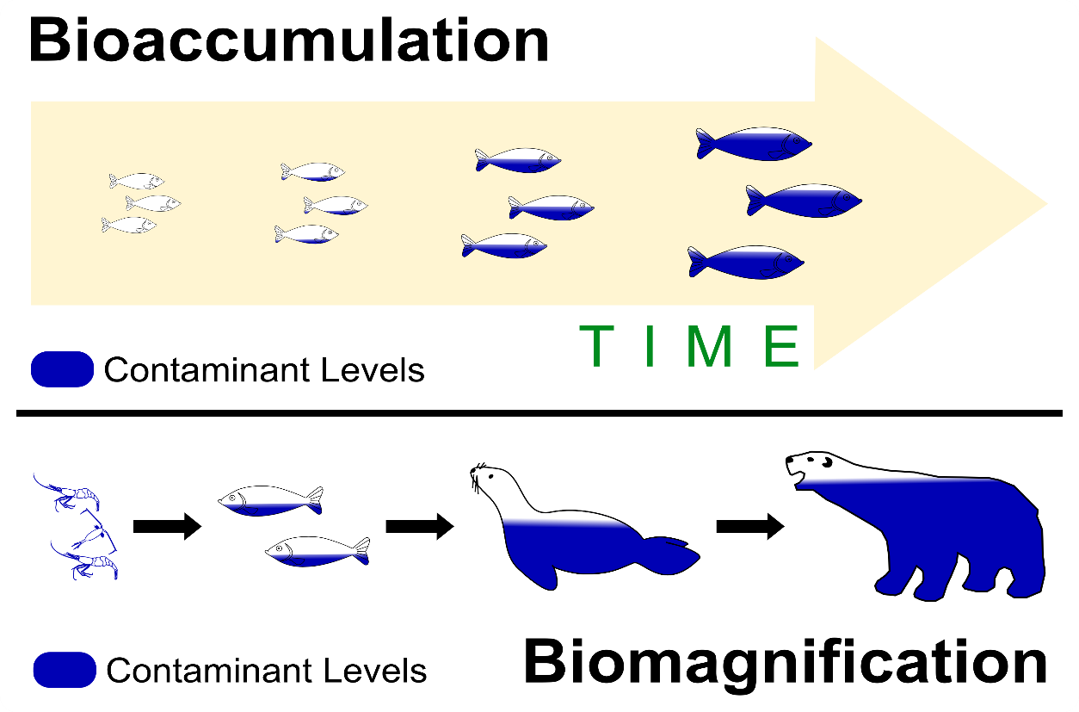

*(*[*http://learn.anaee.com/wp-content/uploads/2015/01/Bioacc-VS-Biomag1.png*](http://learn.anaee.com/wp-content/uploads/2015/01/Bioacc-VS-Biomag1.png)*)*

**More on** **mercury**

**History**

Mercury is the only metal that is liquid at room temperature. The symbol, Hg, comes from the Greek word *hydrargyrum*, which means “water-silver” or quicksilver. Alchemists gave it the name mercury because of the element’s rapid liquid flow, which was like the Roman god, Mercury, known for his speed. Mercury is the only element to retain its alchemical name as its modern common name.

Mercury is one of a few elements that have been known since antiquity. It was discovered stored in a glass container in a 3500 year old Egyptian tomb in Kuma. Mercury and cinnabar, the most common ore of mercury, are mentioned in ancient manuscripts of the Chinese, Hindus, Egyptians, Greeks and Romans. Each had its own beliefs about mercury, and it was used as everything from a medicine to a talisman.

The Egyptians and the Chinese may have been using cinnabar as a red pigment for centuries before the birth of Christ. In many civilizations mercury was used to placate or chase away evil spirits. The alchemists thought that mercury, which they associated with the planet Mercury, had mystical properties, and they used it in their attempts to transmute base metals into gold. The Greeks knew of mercury and used it as a medicine. Mercury and mercury compounds were used from about the 15th century to the mid-20th century to cure syphilis. Because mercury is extremely toxic and its curative effect is unproven, other syphilis medicines are now used.

(<http://nature.berkeley.edu/classes/eps2/wisc/hg.html>)

Although mercury was believed to be an all-important substance, many of the ancients also knew it to be toxic. The mining of mercury presented the first evidence of its poisonous effects. People working in these mines started to have tremors and progressed to severe mental derangement. The Romans sent slaves, criminals and other undesirables to work in their mercury mines. They realized that it was likely that the prisoners would become poisoned and it would spare them the need for a formal execution.

Mercury(II) chloride, HgCl2, was used from the 15th to the 20th centuries to treat syphilis. It had terrible side effects, causing neuropathies (problems with the nerves), kidney failure, severe mouth ulcers, loss of teeth, and even death.

The saying “Mad as a Hatter” is related to the early production of felt hats that used a mercury compound.

To make felt, hatters separated fur from the skin of small animals in a process called carroting. In this process, the secondary nitrous gas released from mercury(II) nitrate caused the fur to turn orange, lose shape, and shrink. The fur also then became darker, coiled, and more easily removed.Prior to the use of mercury to remove fur, hatters used camel urine, which is mostly water but also contains nitrogen waste in the form of urea. When applied to fur, urea disrupts chemical bonds and causes protein denaturation.During the expansion of hat-making into 19th-century France and England, hatters frequently replaced camel urine with their own. Subsequently, it was noticed that an individual workman treated with mercury(II) chloride for syphilis consistently produced superior felt. As a result, mercury(II) nitrate came into wide use to obtain the same effects as the workman's mercury-contaminated urine.

(<https://www.cas.org/news/insights/science-connections/mad-hatter>)

By the 18th century the mercury(II) nitrate, Hg(NO3)2, was widely used in making felt hats. After absorbing the mercury compound for years, hat makers often suffered mercury poisoning, with symptoms that included staggered walk, tunnel vision, and brain damage which made them appear crazy. The phrase “mad as a hatter” became popular as a way to refer to someone that appeared insane. This gave rise to the character, the Mad Hatter, in Lewis Carroll’s *Alice’s Adventure in Wonderland*.

**Properties**

|  |  |
| --- | --- |
| **Physical** | **Chemical** |
| Freezing point -38.8 oC | Not very reactive to acids |
| Boiling point 356.6 oC | Toxic |
| Density 13.5 g/cm3 | Does not readily react with oxygen in the air |
| Heavy silvery metal | Common ions formed +1, +2  (+2 is more stable) |
| Only metal liquid at room temperature | Only rarely occurs free in nature |
| Poor conductor of heat (compared to other metals) |  |
| Good conductor of electricity |  |
| High surface tension |  |
| High vapor pressure and high volatility for metal |  |
| Dissolves metals like Ag, Au and Cu to form alloys called amalgams |  |

**Uses**

The most prominent use of mercury today is in the industrial production of chlorine. The mercury cell process (see diagram below) was developed in 1892 by Hamilton Castner and Karl Kellner. It is also known as the Castner-Kellner process. Chlorine is produced from an aqueous sodium chloride solution using electrolysis. There was a problem with the process because it produced sodium metal which reacts violently with water. The scientists solved the problem by making a container with a layer of mercury. As the sodium forms it dissolves in the mercury. For years this was a popular method for making mercury, but today they are phasing out this method because of the harmful effects of mercury.

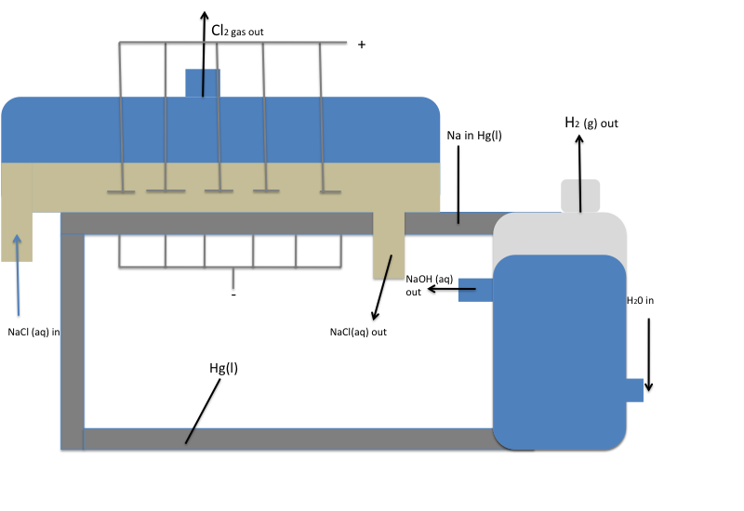

The mercury cell process

*(*[*http://chemwiki.ucdavis.edu/Analytical\_Chemistry/Electrochemistry/Case\_Studies/Case\_Study%3A\_Industrial\_Electrolysis*](http://chemwiki.ucdavis.edu/Analytical_Chemistry/Electrochemistry/Case_Studies/Case_Study%3A_Industrial_Electrolysis)*)(*[*http://learn.anaee.com/wp-content/uploads/2015/01/Bioacc-VS-Biomag1.png*](http://learn.anaee.com/wp-content/uploads/2015/01/Bioacc-VS-Biomag1.png)*)*

The mercury cell process

*(*[*http://chemwiki.ucdavis.edu/Analytical\_Chemistry/Electrochemistry/Case\_Studies/Case\_Study%3A\_Industrial\_Electrolysis*](http://chemwiki.ucdavis.edu/Analytical_Chemistry/Electrochemistry/Case_Studies/Case_Study%3A_Industrial_Electrolysis)*)(*[*http://learn.anaee.com/wp-content/uploads/2015/01/Bioacc-VS-Biomag1.png*](http://learn.anaee.com/wp-content/uploads/2015/01/Bioacc-VS-Biomag1.png)*)*

**Mercury Cell Process**

**Anode Side**

* The anodes are placed in the aqueous NaCl solution, above the liquid mercury.
* The reduction [Editors’ note: this is really **oxidation**] of Cl– occurs to produce chlorine gas, Cl2 (g).

**Cathode Side**

* A layer of Hg (l) at the bottom of the tank serves as the cathode.
* With a mercury cathode, the reaction of H2O (l) to H2 has a fairly high over potential, so the reduction of Na+ to Na occurs instead. The Na is soluble in Hg (l) and the two combine to form the Na-Hg alloy amalgam. This amalgam can be removed and then mixed with water to cause the following reaction:

2 Na (in Hg) + 2 H2O → 2 Na+ + 2OH− + H2 (g) + Hg(l)

* The Hg (l) that forms is recycled back into the liquid at the bottom of the tank that acts as a cathode.
* H2 gas is released.
* NaOH is left in a very pure, aqueous form.

(<http://chemwiki.ucdavis.edu/Analytical_Chemistry/Electrochemistry/Case_Studies/Case_Study%3A_Industrial_Electrolysis>)

The second major use of mercury is in the production of switches and other electrical applications. Mercury electrical switches consist of a small tube with two electrical contacts at one end. If the tube is tilted so that the mercury collects at this end, then contact is made and the circuit is complete. The circuit is broken when the mercury flows to the other end. These switches are used in such things as aircraft altitude indicators, fall alarms (alarm sounds if a worker falls), tilt alarms in vending machines, and old doorbells and thermostats.

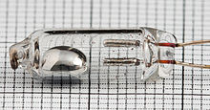

A mercury switch

*(*[*https://upload.wikimedia.org/wikipedia/commons/thumb/5/53/Mercury\_Switch\_without\_housing.jpg/220px-Mercury\_Switch\_without\_housing.jpg*](https://upload.wikimedia.org/wikipedia/commons/thumb/5/53/Mercury_Switch_without_housing.jpg/220px-Mercury_Switch_without_housing.jpg)*)*

Fluorescent lamps contain mercury, some of which is in the vapor form, and some of which vaporizes from heat generated when the lamp is turned on. Electric current passing through the mercury vapor excites electrons in the atoms, which causes them to emit ultraviolet radiation. The walls of the glass tube are coated with a phosphor, a substance that exhibits the property of luminescence—giving off visible light—when the ultraviolet radiation strikes it. The phosphor coating fluoresces, producing the visible light. Fluorescent lamps convert electricity into visible light much more efficiently than incandescent lamps, which rely on heat causing incandescence of the metal filament. Because of the hazards mercury presents, manufactures have reduced the amount of mercury in fluorescent lamps by 60 percent.

Mercury batteries were very popular, until the deleterious effects of mercury became widely known. These batteries have the advantage of having a long shelf-life and producing a steady voltage. In the 1980s, more than 1000 tons of mercury per year were used to make batteries. By 1996, less than 1 ton was used in batteries. The Mercury-Containing and Rechargeable Battery Management Act of 1996 prohibits the use of mercury in all batteries except for button cell batteries and mercuric oxide batteries. The mercury button cells are used in small portable devices such as watches, hearing aids, calculators and cameras. The mercuric oxide batteries are produced largely for the military and medical equipment that needs a stable current and long life.

For decades mercury has been used in devices for scientific research, including thermometers and barometers. The mercury thermometer was invented by Daniel Fahrenheit in 1714. A mercury thermometer consists of a bulb containing mercury attached to a glass tube with a narrow diameter. Mercury works well in thermometers for many reasons. It is a good conductor of heat and has a high coefficient of expansion. As a result it takes little heat to cause it to expand, which makes it easy to measure its linear expansion in a thermometer in relation to temperature. Mercury has a high boiling point so it is suitable to measure higher temperatures. It is shiny and doesn’t stick to the glass.

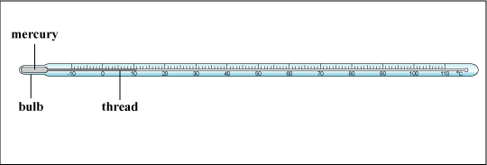

*(*[*http://www.hk-phy.org/contextual/heat/tep/act\_thermometers\_e.html*](http://www.hk-phy.org/contextual/heat/tep/act_thermometers_e.html)*)*

Mercury was also widely used in barometers to measure atmospheric pressure. The invention of the mercury barometer is credited to Evangelista Torricelli, the first scientist to propose using mercury for this device. Several barometers had been made before this, but they used water as the liquid moved by the atmosphere. This resulted in huge changes in the height of the column (which was about 34 feet tall!). Torricelli suggested using mercury because the great density of mercury (13.7 g/cm3) resulted in relatively small, easily measurable differences in the height of the glass-encased mercury column as air pressure changed, sometimes rather drastically. The mercury column itself never rose more than about 760 mm (2-1/2 feet) high, compared to the 34 feet of water.

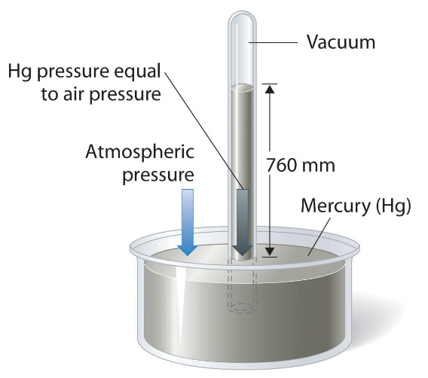

A mercury barometer

*(*[*http://2012books.lardbucket.org/books/principles-of-general-chemistry-v1.0/section\_14/8cec964659fd2bb7ec4dc6c2c78eb4f9.jpg*](http://2012books.lardbucket.org/books/principles-of-general-chemistry-v1.0/section_14/8cec964659fd2bb7ec4dc6c2c78eb4f9.jpg)*)*

This made it ideal for use in these instruments.

Because of the hazards of mercury, these thermometers and barometers are gradually being phased out. In fact, for that reason the National Institute of Standards and Technology will no longer calibrate mercury thermometers. (Note: If you are a relatively young teacher, you might not have ever even encountered a mercury thermometer in your own chemistry lab—and certainly not a mercury barometer.) Many alternatives exist, such as alcohol-filled thermometers and digital thermometers, and aneroid and digital barometers. The EPA has encouraged the reduction of use of these mercury-filled instruments. As reported by the EPA:

Some states and municipalities have passed laws or ordinances barring the manufacture, sale and/or distribution of mercury fever thermometers. This is to help remove the threat of thermometer breakage and the subsequent release of mercury vapor indoors. Thirteen states have passed such laws. They are: California, Connecticut, Illinois, Indiana, Maine, Maryland, Massachusetts, Michigan, Minnesota, New Hampshire, Rhode Island, Oregon, and Washington.

(<http://www.epa.gov/mercury/mercury-thermometers>)

Mercury readily forms alloys with other metals such as gold, silver, zinc and copper. These alloys with mercury are called amalgams. Amalgams have been used throughout history. Mercury has been used to extract gold from ore since as early as 1000 A.D. The mercury dissolves the gold and then the mercury is boiled off. Silver is extracted in much the same way. Dental amalgams have been used for over 150 years in fillings. The dental amalgam consists of mercury combined with silver, tin, copper, and sometimes, zinc.

Compounds of mercury have been used since early times as well. Mercury(II) sulfide, HgS, also known as vermillion or cinnabar, has a red color which is used as a coloring agent. Mercury(I) chloride, Hg2Cl2, is an antiseptic. Mercury(II) fulminate, Hg(CNO)2, is an explosive and sensitive to impact. It is used in percussion caps for munitions.

**Mercury in the environment**

Mercury enters the environment through natural sources such as volcanoes, and the breakdown of minerals in rocks and soil. This release of mercury from natural sources has remained fairly constant over the years. The mercury concentration in the environment is increasing due to human activity.

During the 4000 years of man’s use of mercury, it is estimated that 350,000 tons of mercury have been released from the depths of Earth into the air, surface land and water. This is where its toxicity becomes problematic. The combustion of fossil fuels, especially from coal-fired power plants, releases large amounts of mercury into the air. Other human sources of mercury pollution arise from mining, smelting and solid waste combustion. The diagram below shows the many sources of mercury pollution in the environment.

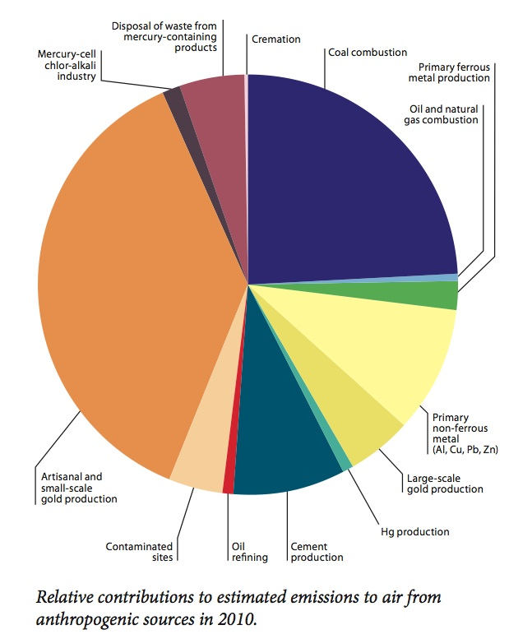

*(*[*http://i.livescience.com/images/i/000/057/351/i02/mercury-pollution-sources.jpeg?1380219257*](http://i.livescience.com/images/i/000/057/351/i02/mercury-pollution-sources.jpeg?1380219257)*)*

Once mercury enters the atmosphere, it can travel great distances and circulate for years. It eventually will either fall to the ground or be absorbed in water. Once there it can be methylated and enter the food chain. According to the U.S. Geological Survey:

Methylation is a product of complex processes that move and transform mercury. Atmospheric deposition contains the three principal forms of mercury, although inorganic divalent mercury, Hg(II), is the dominant from. Once in surface water, mercury enters a complex cycle in which one form can be converted to another. Mercury attached to particles can settle onto the sediments where it can diffuse into the water column, be resuspended, be buried by other sediments or be methylated. Methylmercury can enter the food chain, or it can be released back to the atmosphere by volatilization.

(<http://www.usgs.gov/themes/factsheet/146-00/>)

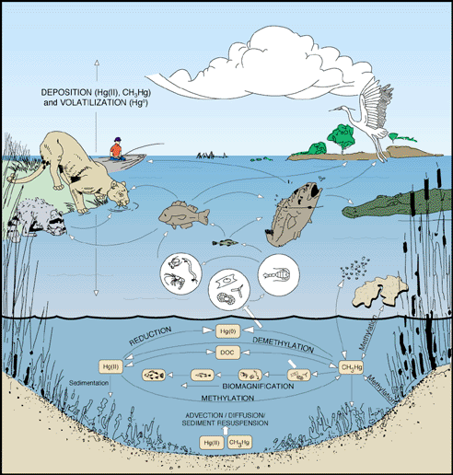

Mercury methylation and movement through ecosystems

*(*[*http://www.usgs.gov/themes/factsheet/146-00/fig5.gif*](http://www.usgs.gov/themes/factsheet/146-00/fig5.gif)*)*

**Mercury poisoning and its effect on health**

No level of mercury in the human body is normal. There is no specific function for mercury in our body. However, everyone is exposed to some level of mercury. Exposure may occur through inhalation of mercury vapor, ingestion or dermal contact (absorbed through the skin). Fortunately, most exposures are low level and often occur through chronic exposure (long term contact). Some people are exposed to high levels or acute exposure to mercury. An example of this would be an industrial accident involving mercury. According to the World Health Organization:

Factors that determine whether health effects occur and their severity include:

* the type of mercury concerned;
* the dose;
* the age or developmental stage of the person exposed (the foetus is most susceptible);
* the duration of exposure;
* the route of exposure (inhalation, ingestion or dermal contact).

(<http://www.who.int/mediacentre/factsheets/fs361/en/>)

There are three basic categories for mercury; elemental mercury, inorganic salt of mercury, and organic mercury. If elemental mercury is ingested, it is absorbed relatively slowly (less than 0.01% of a dose is absorbed) and may pass through the digestive system without causing much harm. There exists a greater risk if mercury vapor is inhaled. According to an article in the *Journal of Preventative Medicine and Public Health*:

Inhalation is a major exposure route of elemental mercury in the form of mercury vapor. Inhaled mercury vapor is readily absorbed, at a rate of approximately 80%, in the lungs, and quickly diffused into the blood and distributed into all of the organs of the body. Absorbed elemental mercury is oxidized to the mercuric form (Hg++) in the red blood cells and tissues, a process that takes several minutes. However, inhaled mercury vapor, in contrast to inorganic mercury salts, accumulates in the central nervous system.

(<http://www.ncbi.nlm.nih.gov/pmc/articles/PMC3514464/>)

The inhalation of mercury vapors can cause nerve, brain and kidney damage, respiratory illness, skin rashes, tremors, and anemia.

Exposure to inorganic mercury salts generally occurs either through ingestion or absorption through the skin. Since mercury salts are nonvolatile solids, inhalation poisoning is rare. The more soluble the mercury salt is the more likely it will be absorbed. Inorganic mercury salts are not fat soluble, and they do not readily cross the blood-brain barrier or the blood-placenta barrier. They tend to be excreted in the urine and feces. The highest concentration is found in the kidney. Chronic inorganic mercury poisoning is rare, and the target organ affected is the kidney. Symptoms may include issues with the ability to urinate. Inorganic mercury salts are corrosive, which enhance gastrointestinal absorption. They are generally irritants to the skin, causing dermatitis and discoloration of the nails. Acute high doses of mercury salts cause chest pain and severe gastrointestinal symptoms that result from the corrosive damage to the gastrointestinal tract.

Organic mercury poisoning, especially due to methylmercury and dimethylmercury, is the most common form of mercury poisoning today. Methylmercury (CH3Hg+) has no industrial uses and is formed in the environment from the methylation of the mercury(II) ion. Methylmercury exposure primarily occurs through ingestion. Fish is the primary source for the ingestion of organic mercury. Organic mercury compounds are fat soluble and bioaccumulate in the body. These compounds are also able to cross the blood-brain and blood-placenta barriers. Developing embryos and infants are 5–10 times more sensitive to the effects of methylmercury than adults. Methylmercury damages the central nervous system and affects the immune system, by altering the immune and genetic systems. Symptoms of methylmercury poisoning in adults include visual field constriction (tunnel vision), behavioral changes, memory loss, headaches, tremors, loss of fine motor control, tingling or pricking of extremities and lips, and hair loss. Organic mercury damage tends to be irreversible.

There are many ways to reduce the mercury in the environment and thereby reduce human exposure to mercury. Promoting clean energy is essential in reducing environmental mercury. Coal contains mercury that is emitted when coal is burned in coal-fired power plants and industrial boilers. Eliminating the use of mercury in gold mining and promoting non-mercury extraction methods would reduce mercury contamination. The mining of mercury should not be needed if what is available now is recycled. Phasing out of non-essential mercury products would reduce the mercury entering the environment.

**More on** **the advantages and disadvantages of eating fish**

Eating fish and shellfish has many advantages for one’s health. According to the U.S. Food and Drug Administration, fish and shellfish should be an important part of a healthy diet. Fish and shellfish are a major source of omega-3 fatty acids, they are rich in vitamin D and they are a high-quality protein source that is low in saturated fat. Eating fish is good for the heart and blood vessels. In fact, it is reported that eating two three-ounce servings of fatty fish per week reduces the risk of dying from heart disease by 36%. According to the Harvard School of Public Health:

Eating fish fights heart disease in several ways. The omega-3 fats in fish protect the heart against the development of erratic and potentially deadly cardiac rhythm disturbances. They also lower blood pressure and heart rate, improve blood vessel function, and, at higher doses, lower triglycerides and may ease inflammation.

<http://www.hsph.harvard.edu/nutritionsource/fish/>

Omega-3 fatty acids cannot be synthesized by the human body so they must be consumed in one’s diet. For that reason they are called essential fatty acids. Omega-3 fatty acids are called omega-3s because they have a double bond at the third carbon atom from the end of the carbon chain.

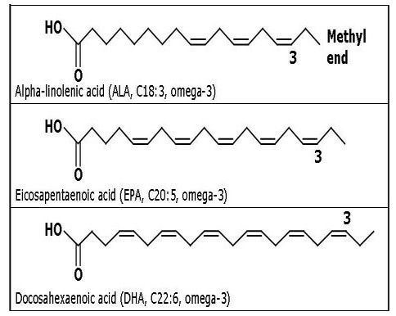

Examples of Omega-3 Fatty Acids

*(*[*http://images.tutorvista.com/cms/images/101/structure-of-omega-3-fatty-acids.PNG*](http://images.tutorvista.com/cms/images/101/structure-of-omega-3-fatty-acids.PNG)*)*

Omega-3 fatty acids provide a number of health benefits. Besides helping to maintain cardiovascular health, they are important for prenatal and postnatal neurological development. There is some evidence that they may reduce tissue inflammation, alleviate symptoms of rheumatoid arthritis, reduce depression and slow the mental decline in older people.

The disadvantage of eating fish and shellfish is that they all contain traces of mercury. Mercury enters streams, rivers, lakes and oceans primarily from rain and surface water runoff. Bacteria convert the mercury to methylmercury. The methylmercury is taken up by plankton. The plankton bioaccumulate the mercury and then small fish consume the plankton. The older the fish the more methylmercury they absorb. As these fish are eaten the mercury moves up the food chain and biomagnifies. Predatory fish, like sharks and swordfish, have higher concentrations of mercury. When humans consume fish, the mercury accumulates in their bodies as well. The risk of consuming the mercury in fish is greatest for young children and women of childbearing age.

The benefits and risks of consuming a regular diet of fish is a controversial topic. According to a Harvard School of Public Health report:

At the levels commonly consumed from fish, there is also limited and conflicting evidence for effects of mercury in adults; thus, the Environmental Protection Agency, the Food and Drug Administration, the Institutes of Medicine report, and the analysis by Mozaffarian and Rimm all conclude that this evidence is insufficient to recommend limitations on fish intake in adults, given the established benefits of fish consumption for cardiovascular disease. In fact, the easiest way to avoid concern about contaminants is simply to eat a variety of fish and other seafood.

(<http://www.hsph.harvard.edu/nutritionsource/fish/>)

The U.S. Food and Drug Administration recommends following these three safety tips when considering eating fish or shellfish—especially women and young children

**3 Safety Tips**

1. **Do not eat**

They contain high levels of mercury.

* **Shark**
* **Swordfish**
* **King Mackerel**
* **Tilefish**

1. **Eat up to 12 ounces (2 average meals) a week of a variety of fish and shellfish that are lower in mercury.**

* Five of the most commonly eaten fish that are low in mercury are shrimp, canned light tuna, salmon, pollock, and catfish.
* Another commonly eaten fish, albacore ("white") tuna has more mercury than canned light tuna. So, when choosing your two meals of fish and shellfish, you may eat up to 6 ounces (one average meal) of albacore tuna per week.

1. **Check local advisories about the safety of fish caught by family and friends in your local lakes, rivers, and coastal areas.**

* If no advice is available, eat up to 6 ounces (one average meal) per week of fish you catch from local waters, but don't consume any other fish during that week.

**Follow these same recommendations when feeding fish and shellfish to your young child, but serve smaller portions.**

(<http://www.fda.gov/food/resourcesforyou/consumers/ucm110591.htm>)

**More on trace measurement units**

Health effects of any toxic substance, like mercury, partially depends on the level of exposure or the dose; the greater the dose, the more serious the effects. Some chemicals can be toxic in very low doses so it is important to understand the units commonly used for measuring these contaminants.

The most common units used to measure very small amounts of contaminants in our environment are parts per million (ppm) and parts per billion (ppb). These units are the ratio of the substance (contaminant) compared to the total solution.

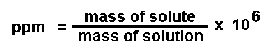

(<http://www.chemtech.org/cn/cn1305/images/12-ppm.gif>)

Sometimes the weight of the contaminant is compared to the total weight.

Metric system units go in steps of 10, 100, and 1,000. For example, a milligram is a thousandth of a gram (moving the decimal point three places to the left) and a gram is a thousandth of a kilogram (again a difference of three places to the left on the decimal point). Thus, a milligram is a thousandth of a thousandth, or a millionth of a kilogram moving the decimal point six places. So, a milligram is one ppm of a kilogram; therefore, one ppm is the same as one milligram per kilogram.

(<http://www.nesc.wvu.edu/ndwc/articles/ot/fa04/q&a.pdf>)

In liquid solutions, measuring mass may not be feasible. Measurement of volume uses the liter. One liter of pure water has a mass of one kilogram. If the contaminant is a solid it is measured in milligrams; one milligram/liter, 1 mg/L, is 1 ppm. So, simply stated,

1 ppm = 1 mg/kg = 1 mg/L.

Parts per billion, ppb, is a measurement for even smaller concentrations. It can be represented by:

**https://www.nauticus.org/chemistry/images/ppbg.jpg**

(<https://www.nauticus.org/chemistry/images/ppbg.jpg>)

In terms of mass, a ppb is equal to a microgram/kilogram, 1 µg/kg, or a microgram/liter, 1 µg/L. It is important to know the difference between ppm and ppb, since a common mistake is reporting a concentration as ppm when it is actually ppb.

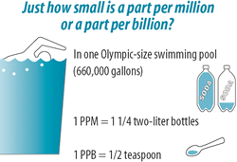

*(*[*http://www.abcwua.org/uploads/images/pool.gif*](http://www.abcwua.org/uploads/images/pool.gif)*)*

# Connections to Chemistry Concepts

**(for correlation to course curriculum)**

1. **Elemental mercury and its compounds**—Environmental impact of mercury and how it is converted to compounds of mercury such as methylmercury is explained. This could be used as you are teaching about elements and the periodic table.
2. **Properties**—You can cite parts of the article when discussing physical and chemical properties of mercury.
3. **Oxidation**—Elementary mercury is oxidized to mercury(II) ions, Hg2+. This is an excellent example to use as you are teaching about oxidation and reduction.
4. **Organic chemistry and functional groups**—The article explains the formation of methylmercury. The explanation includes methyl groups (–CH3) and thiol groups (–SH).
5. **Concentrations**—The article explains how the mercury concentration increases as it moves up the food chain. This process is referred to as biomagnification
6. **Parts per million**—This is the unit of concentration used to measure trace amounts of mercury in fish. This could be used as a real world example when teaching various units of concentration.

# Possible Student Misconceptions

**(to aid teacher in addressing misconceptions)**

1. **“It is better to avoid eating fish because of the mercury.”** *According to the American Heart Association all Americans should eat at least two fatty fish meals a week to improve heart health. The risk from mercury by eating fish and shellfish is not a major health concern. The health risks of not eating fish far outweigh the risk of mercury toxicity. However, people should avoid eating shark, swordfish, king mackerel and tilefish because of their high mercury content.*
2. **“Vaccines contain mercury and should be avoided.”** *A mercury-based preservative called thimerosal has been used for decades in the United States in multi-dose vaccines. It is added to the vials of vaccine to prevent the growth of bacteria and fungi. There is no evidence of harm caused by the low dose of thimerosal in vaccines. In 1999, vaccine manufacturers agreed to reduce or eliminate the amount of thimerosal in vaccines as a precaution. According to the Centers for Disease Control and Prevention, measles, mumps, and rubella vaccines do not and never did contain thimerosal. Neither do chickenpox, inactivated polio and pneumococcal vaccines. Influenza vaccines are available with and without thimerosal.*

# Anticipating Student Questions

**(answers to questions students might ask in class)**

1. **“Does cooking eliminate mercury from the fish?”** *Cooking does not change the concentration of mercury in fish. Methylmercury is bound to the proteins in the fish’s muscle. To vaporize the mercury from the fish it would have to be heated to 357 oC (674 oF), which would never happen because the fish would burn first.*
2. **“My mother says her fillings contain mercury. Is that dangerous?”** *The safety of the mercury amalgam fillings is a controversial topic. They do release low levels of mercury vapor that can be inhaled and absorbed by the lungs. The U.S. Food and Drug Administration (FDA), after reviewing scientific evidence to determine whether these low levels of mercury vapor are a problem, considers mercury dental amalgams safe for children over 6 and adults. In addition*

*The ADA Council on Scientific Affairs prepared a comprehensive literature review on amalgam safety that summarized the state of the evidence for amalgam safety (from January 2004 to June 2010). Based on the results of this review, the Council reaffirmed at its July 2009 meeting that the scientific evidence supports the position that amalgam is a valuable, viable and safe choice for dental patients.*

*(*[*http://www.ada.org/en/about-the-ada/ada-positions-policies-and-statements/statement-on-dental-amalgam*](http://www.ada.org/en/about-the-ada/ada-positions-policies-and-statements/statement-on-dental-amalgam)*)*

1. **“Is mercury something we need in small amounts in our diet?”** *Mercury is not needed in the body. It has no purpose for humans, so ideally the levels would be zero.*

# In-Class Activities

**(lesson ideas, including labs & demonstrations)**

1. Students can interact with a simulation of biomagnification of mercury at this site. It also includes follow-up questions that help with their understanding. (<http://oceanexplorer.noaa.gov/edu/learning/player/lesson13/l13la1.html>)
2. Students could participate in a food web game that demonstrates the biomagnification of substances such as mercury. The following sites have explicit directions on how to conduct such an activity:
   1. In this game the students play the role of grasshoppers, shrews, or hawks. The grasshoppers will be given a bag of “food,” which consists of white paper squares, and “mercury” (colored paper squares). Students will collect the “mercury” as it moves up the food chain. (<http://participatoryscience.org/curriculum-activity/food-chain-game>)
   2. *Bioaccumulation and Food Chains* is a similar activity using colored tokens or poker chips. In this game the students are either zooplankton, rainbow trout, walleye or eagles. This game is followed by an extensive analysis of the data collected, leading to students differentiating between bioaccumulation and biomagnification. The instructions can be found at the end of this site, on page 44: <http://sharkresearch.rsmas.miami.edu/assets/pdfs/learning-tools/high-school/MODULE%205%20Management,%20Conservation,%20Research%20and%20Actions%20-%20SECTION%203%20Mercury%20Toxicity%20Data.pdf>.
3. Biomagnification can also be demonstrated using food coloring and water. This can be done either as a teacher demonstration or a simple laboratory activity for students. Instructions for this can be found on page 15 of this site: <http://sharkresearch.rsmas.miami.edu/assets/pdfs/learning-tools/high-school/MODULE%205%20Management,%20Conservation,%20Research%20and%20Actions%20-%20SECTION%203%20Mercury%20Toxicity%20Data.pdf>.
4. In an activity called *Mercury in the Environment: Percent Mercury in Coal,* students can determine the percent-by-mass of elements in coal. The “coal sample” is a bag of different colored beads. Each color represents a different element. The most abundant colored bead will represent carbon. An explanation and instructions for this activity can be found beginning on page 26 of <http://sharkresearch.rsmas.miami.edu/assets/pdfs/learning-tools/high-school/MODULE%205%20Management,%20Conservation,%20Research%20and%20Actions%20-%20SECTION%203%20Mercury%20Toxicity%20Data.pdf>.
5. A series of lessons on mercury including mercury in the environment and mercury in the food chain can be found at <http://www.kendallville-in.org/pdf/mercury/mercury_high_school_activity.pdf>.
6. “The Ups and Down of Thermometers” is an interactive lesson on thermometers produced by the American Chemical Society. It is designed for middle school but could be adapted for older students as well. (<http://www.middleschoolchemistry.com/lessonplans/chapter1/lesson3>)
7. You can use analogies to help students understand measurements that are either very large or very small. The activity at <http://www.toxicsaction.org/sites/default/files/tac/sfa/messaging_with_analogies.pdf> provides students with practice understanding various units.
8. Students can investigate the meaning of parts per million using a 10% solution and diluting it until its concentration is one part per million. As description of such an activity can be found at <http://ed.fnal.gov/trc_new/sciencelines_online/fall96/activities.html>.
9. Along the same lines as the activity above, an excellent example of a serial dilution laboratory activity can be found at this site: <http://www.lcsd.wednet.edu/cms/lib06/WA01001184/Centricity/Domain/14/Serial_Dilution_Lab.pdf>.

# Out-of-Class Activities and Projects

**(student research, class projects)**

1. Students could research the pros and cons of eating fish and write a position paper on the topic.
2. Students could be assigned to research and write about the industrial uses of mercury. Topics could include the use of mercury in gold mining, in iron mining and in chlorine and polyvinyl chloride production.
3. Students could also be assigned to investigate and report on the major sources of mercury in the environment, which could include power plants, pesticides, and volcanos. It could also include an investigation of China’s contribution to mercury pollution.
4. Students could research and report and, possibly, debate in class the use of mercury in dental amalgams. The health effects on the human body (or lack thereof) due to amalgam fillings is a topic of ongoing scientific research and debate.
5. Students could research and report on other contaminants that biomagnify in fish and pose hazards for humans. These could include PCBs, DDT, dioxin, and chlordane.

# References

**(non-Web-based information sources)**

**The references below can be found on the   
*ChemMatters* 30-year DVD, which includes all articles   
published from the magazine’s inception in October 1983 through April 2013, all available Teacher’s Guides, beginning February 1990, and 12 *ChemMatters* videos. The DVD is available from the American Chemical Society for $42 (or $135 for a site/school license) at this site:** [**http://ww.acs.org/chemmatters**](http://www.acs.org/chemmatters)**. Scroll all the way down to the bottom of the page and click on the icon at the right, “Get the past 30 Years of *ChemMatters* on DVD!”**

**Selected articles and the complete set of   
Teacher’s Guides for all issues from the past three   
years are available free online at the same Web site, above. Click on the “Issues” tab just below the logo, *“ChemMattersonline”*.**

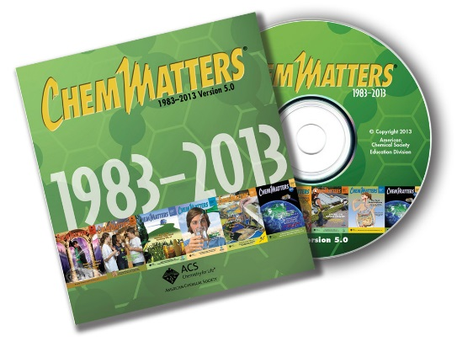

***30* Years of *ChemMatters!***

Available Now!

Graham, T. Mystery Matters: Nightmare on White Street. *ChemMatters*, 1996, *14* (4), pp 9–11. This article relates the story of four people poisoned by mercury vapors created by the smelting of mercury amalgam to recover the silver.

Rohrig, B. Thermometers. *ChemMatters*, 2006, *24* (4), pp 14–17. This article describes the history of thermometers and describes a variety of different types of thermometers, including the mercury thermometer.

Sitzman, B. and Goode, R. Open for Discussion: Lighten Up! *ChemMatters*, 2012, *30* (4), p 5. This one page article describes how fluorescent light bulbs work. It also describes the advantages and disadvantages of using them.

# Web Sites for Additional Information

**(Web-based information sources)**

**More sites on** **biomagnification and bioaccumulation**

Biomagnification and bioaccumulation are explained and compared at this site: <https://environment.knoji.com/what-is-the-difference-between-bioaccumulation-and-biomagnification/>.

This site also explains both biomagnification and bioaccumulation. It also describes the biomagnification of various pollutants such as DDT, heavy metals, PCBs, and cyanide. (<http://w3.marietta.edu/~biol/102/2bioma95.html>)

This short video (2:21) clearly explains the biomagnification and bioaccumulation of DDT. The graphics make the concepts very clear. (<https://www.youtube.com/watch?v=FoKgsLEm_XA>)

At this site there is information on bioaccumulation and biomagnification of mercury. It also has a variety of activities that help to teach these concepts. It would make an excellent resource for developing lesson plans on these topics. (<http://sharkresearch.rsmas.miami.edu/assets/pdfs/learning-tools/high-school/MODULE%205%20Management,%20Conservation,%20Research%20and%20Actions%20-%20SECTION%203%20Mercury%20Toxicity%20Data.pdf>)

**More sites on** **mercury**

**History of mercury**

A concise history of the discovery and early uses of mercury can be found at this site: <http://www.chemicool.com/elements/mercury.html>.

More historical information about mercury can be found here: <http://nature.berkeley.edu/classes/eps2/wisc/hg.html>.

**Properties of mercury**

Interesting facts about mercury are given at this site: <http://www.livescience.com/39232-facts-about-mercury.html>.

This site contains information on the discovery, properties, occurrence, uses, and health effects of mercury. (<http://www.chemistryexplained.com/elements/L-P/Mercury.html>)

At this site a tabulation of information about mercury is given. It includes general information, physical and chemical properties, the application, environmental problems and toxicity of mercury. (<http://www.uwm.edu.pl/kchem/mercury/mercury.html>)

This video (5:12) produced by the Royal Society of Chemistry discusses and demonstrates characteristics of mercury. It is a safe way to observe the liquid metal. (<http://www.rsc.org/periodic-table/video/80/Mercury?videoid=oL0M_6bfzkU>)

**Uses of mercury**

This article describes the production of chlorine using the mercury cell process. It includes an animated illustration that clearly shows the process. (<http://www.eurochlor.org/the-chlorine-universe/how-is-chlorine-produced/the-mercury-cell-process.aspx>)

An explanation of how a mercury switch works is given at this site: <http://www.wisegeek.com/what-is-a-mercury-switch.htm>.

This article provides a detailed explanation, including graphics, on how a fluorescent bulb works. (<http://home.howstuffworks.com/fluorescent-lamp.htm>)

This EPA site briefly describes the use of mercury batteries today: <http://www.epa.gov/mercury/mercury-batteries>.

The use of mercury thermometers at home, for educational purposes, and in industry is described at this EPA site. It also discusses the phasing out of these thermometers as well as restrictions on their use. (<http://www.epa.gov/mercury/mercury-thermometers>)

A short article that describes mercury amalgams and also gives their advantages and disadvantages can be found here: <http://web.health.gov/environment/amalgam1/amalgamu.htm>.

Mercury is shown dissolving gold (forming an amalgam) in this short video (1:56). (<https://www.youtube.com/watch?v=gKxCw889qck>)

**Mercury in the environment**

This site gives information on the some of the top mercury pollution sources and what can be done about them. (<http://www.rodalewellness.com/health/mercury-pollution-and-exposure>)

An extensive article on mercury pollution in the marine environment can be found at this site. This report was compiled by the Coastal and Marine Mercury Ecosystem Research Collaborative at Dartmouth College. It includes information on the processes related to the inputs, cycling, and uptake of mercury in marine ecosystems; effects on human health; and policy implications. (<http://www.dartmouth.edu/~toxmetal/assets/pdf/sources_to_seafood_report.pdf>)

This article from *Chemical and Engineering News* describes the legislation made by the EPA to limit the emissions of mercury by power plants and its review by the Supreme Court. (<http://cen.acs.org/articles/93/i18/High-Court-Weighs-EPA-Mercury.html>)

The National Park Service created this video (4:21) that is filmed in Acadia National Park. It describes how mercury gets into the air and pollutes the environment. It includes a description of biomagnification and how wildlife is affected. (<https://www.youtube.com/watch?v=xRqAS4Eow-c>)

**Mercury poisoning and its effects on health**

This article by the World Health Organization describes how one is exposed to mercury and how to reduce one’s exposure. The health effects of mercury exposure and poisoning are also described. (<http://www.who.int/mediacentre/factsheets/fs361/en/>)

This detailed article describes exposure to mercury. It explains the metabolism and toxicity of both elemental mercury and inorganic mercury. (<http://www.ncbi.nlm.nih.gov/pmc/articles/PMC3514464/>)

This *Chemistry and Engineering News* article explains how methylmercury enters the body and the reactions it undergoes. It describes the effects of the methylmercury on the body. (<http://pubs.acs.org/email/cen/html/033007161508.html>)

At this site the health effects and symptoms of mercury poisoning are described. It specifically describes the health effects of methylmercury, elemental mercury and inorganic mercury. (<http://www.medicinenet.com/mercury_poisoning/page3.htm#what_are_the_health_effects_and_symptoms_of_mercury_exposure_or_poisoning>)

In this article the phrase “mad as a hatter” is explained. It describes the production of felt hats and how the hatters were exposed to and poisoned by mercury. (<https://www.cas.org/news/insights/science-connections/mad-hatter>)

**More sites on** **advantages and disadvantages of eating fish**

This Harvard School of Public Health article explains the benefits of eating fish. It also describe some possible risks. (<http://www.hsph.harvard.edu/nutritionsource/fish/>)

The article at this site states and explains eleven benefits of eating fish. (<http://authoritynutrition.com/11-health-benefits-of-fish/>)

The U.S. Food and Drug Administration cites facts about the benefits of eating fish. It provides safety tips for the consumption of fish. In addition the article answers commonly asked questions about mercury in fish. (<http://www.fda.gov/food/resourcesforyou/consumers/ucm110591.htm>)

A quick reference card that states which fish have the least, moderate, high and very high mercury content can be found at the site. This is suitable for printing. (<http://www.nrdc.org/health/effects/mercury/walletcard.pdf>)

The levels of mercury in fish are given at this U.S. Food and Drug Administration site: <http://www.fda.gov/Food/FoodborneIllnessContaminants/Metals/ucm115644.htm>.

A mercury calculator is available at this site. You enter your weight, the type of seafood and the amount you eat to determine the amount of mercury you consume per week. (<https://seaturtles.org/programs/mercury/>)

**More sites on trace measurement units**

This article clearly explains the parts per million and parts per billion units. It also provides some excellent analogies to help in the understanding of the size of these units. (<http://www.nesc.wvu.edu/ndwc/articles/ot/fa04/q&a.pdf>)

At this site ppm is defined. Sample problems and sample calculations are also provided. (<http://www.chemteam.info/Solutions/ppm1.html>)

At this site measurement units and analogies are given in a table format. It could serve as a quick reference. (<http://www.llojibwe.org/drm/environmental/content/concentrations.pdf>)