logo_chemmatters[1]

**December 2015 / January 2016 Teacher's Guide for**

***Double, Double, Oil and Trouble***

**Table of Contents**

[About the Guide 2](#_Toc436734637)

[Student Questions 3](#_Toc436734638)

[Answers to Student Questions 4](#_Toc436734639)

[Anticipation Guide 5](#_Toc436734640)

[Reading Strategies 6](#_Toc436734641)

[Background Information 9](#_Toc436734642)

[Connections to Chemistry Concepts 23](#_Toc436734643)

[Possible Student Misconceptions 23](#_Toc436734644)

[Anticipating Student Questions 24](#_Toc436734645)

[In-Class Activities 24](#_Toc436734646)

[Out-of-Class Activities and Projects 25](#_Toc436734647)

[References 26](#_Toc436734648)

[Web Sites for Additional Information 27](#_Toc436734649)

# About the Guide

Teacher’s Guide editors William Bleam, Regis Goode, Donald McKinney, Barbara Sitzman and Ronald Tempest created the Teacher’s Guide article material. E-mail: [bbleam@verizon.net](mailto:bbleam@verizon.net)

Susan Cooper prepared the anticipation and reading guides.

Patrice Pages, *ChemMatters* editor, coordinated production and prepared the Microsoft Word and PDF versions of the Teacher’s Guide. E-mail: [chemmatters@acs.org](mailto:chemmatters@acs.org)

Articles from past issues of *ChemMatters* can be accessed from a DVD that is available from the American Chemical Society for $42. The DVD contains the entire 30-year publication of *ChemMatters* issues, from February 1983 to April 2013.

The *ChemMatters* DVD also includes Article, Title and Keyword Indexes that covers all issues from February 1983 to April 2013.

The *ChemMatters* DVD can be purchased by calling 1-800-227-5558.

Purchase information can be found online at [www.acs.org/chemmatters](http://chemistry.org/chemmatters/cd3.html).

# Student Questions

* 1. What is the chemical difference between a fat and a fatty acid?
  2. Describe an ester bond, which is the bond that links fatty acids to the glycerol backbone is a triglyceride molecule.
  3. What is the difference between a saturated molecule and an unsaturated molecule?
  4. Describe the *cis* and *trans* forms of double bonds.
  5. Some fats are described as “monounsaturated” and other fats are called “polyunsaturated.” What’s the difference?
  6. How are omega-fatty acids named?
  7. What are essential fatty acids?
  8. Why is the dietary ratio of linoleic acid to α-linoleic acid important?
  9. The article describes ways of mitigating the dietary imbalance between linoleic acid and α-linoleic acid. What are they?

# Answers to Student Questions

* + 1. **What is the chemical difference between a fat and a fatty acid?**

*A fatty acid is a carboxylic acid with a long hydrocarbon chain, usually with 3–19 carbon atoms, attached. When three of these fatty acids are chemically combined with a glycerol molecule via ester bonds, the result is called a triglyceride, which is another name for a fat. [See “More on the chemistry of fatty acids and fats” for actual structures and additional details.]*

* + 1. **Describe an ester bond, which is the bond that links fatty acids to the glycerol backbone is a triglyceride molecule.**

*In fats an ester bond occurs between one of the hydroxyl groups, –OH, in glycerol and the carboxyl group, –COOH, in the fatty acid.*

* + 1. **What is the difference between a saturated molecule and an unsaturated molecule?**

*A saturated molecule contains only single bonds between carbon atoms and an unsaturated molecule contains at least one carbon-carbon double bond. In the case of fats, the double bonds are between carbons in the fatty-acid side chain.*

* + 1. **Describe the *cis* and *trans* form of double bonds.**

*The terms* cis *and* trans *are used to describe different arrangements of atoms located adjacent to double bonds. Although carbon-carbon bonds are at an angle to each other, the general shape of the resulting molecule is a straight line.* Cis *forms of double bonds result in “kinks” in that linear structure.*

* + 1. **Some fats are described as “monounsaturated” and other fats are called “polyunsaturated.” What’s the difference?**

*There is only one double bond in a monounsaturated fat, and two or more double bonds in a polyunsaturated fat.*

* + 1. **How are omega-fatty acids named?**

*Omega fatty acids are polyunsaturated fatty acids. The naming system for them numbers the carbon atoms (1, 2, 3 ...) from the end of the molecule opposite the carboxyl group.*

* + 1. **What are essential fatty acids?**

*They are fatty acids that the body cannot make from other biochemicals in the body. The two essential fatty acids are linoleic acid and α-linoleic acid. They must be present in the diet in order for the body to make other fatty acids it needs from those two.*

* + 1. **Why is the dietary ratio of linoleic acid to α-linoleic acid important?**

*The same enzymes are used to convert these two compounds into other fatty acids. If there is too much linoleic acid in the diet then there are insufficient enzymes available to convert α-linoleic acid. The U.S. Department of Agriculture recommends a linoleic acid: α-linoleic acid ratio of 10:1, but in the diet of many Americans the actual ratio is greater than that.*

* + 1. **The article describes ways of mitigating the dietary imbalance between linoleic acid and α-linoleic acid. What are they?**
       1. *The simplest way to deal with the linoleic acid to α-linoleic acid imbalance would be to reduce consumption of food that contains linoleic acid. That’s difficult because so many foods contain the acid.*
       2. *The second way would be consume more food or food supplements that contain α-linoleic acid, such as flax seed.*
       3. *The third way described is to eat more food that contains the two main chemical intermediates that are produced from linoleic acid and α-linoleic acid, and which then are converted to other important compounds in the body. These two intermediates are eicosapentaenoic acid (EPA) and docosahexaenoic acid (DHA). Fish are good sources of these two compounds.*

# Anticipation Guide

Anticipation guides help engage students by activating prior knowledge and stimulating student interest before reading. If class time permits, discuss students’ responses to each statement before reading each article. As they read, students should look for evidence supporting or refuting their initial responses.

**Directions:**  *Before reading*, in the first column, write “A” or “D,” indicating your agreement or disagreement with each statement. As you read, compare your opinions with information from the article. In the space under each statement, cite information from the article that supports or refutes your original ideas.

|  |  |  |
| --- | --- | --- |
| **Me** | **Text** | **Statement** |
|  |  | 1. Fatty acids have long hydrocarbon tails. |
|  |  | 1. Fats are composed of triglycerides, but oils are not. |
|  |  | 1. Saturated fats have only single bonds in the side chain. |
|  |  | 1. *Cis* and *trans* double bonds produce different shapes that are easy to distinguish on a flat computer screen. |
|  |  | 1. The omega number on a fatty acid tells where the double bond is located on the carbon chain. |
|  |  | 1. We must obtain essential fatty acids from our food. |
|  |  | 1. The ratio of linoleic acid to α-linoleic acid we eat affects the production of compounds needed for healthy immune and nervous systems. |
|  |  | 1. Cholesterol is carried by HDLs and LDLs. |
|  |  | 1. Nutritionists recommend a higher amount of HDLs compared to LDLs in our blood. |
|  |  | 1. Olive oil is a good choice for keeping your arteries from narrowing. |

# Reading Strategies

These graphic organizers are provided to help students locate and analyze information from the articles. Student understanding will be enhanced when they explore and evaluate the information themselves, with input from the teacher if students are struggling. Encourage students to use their own words and avoid copying entire sentences from the articles. The use of bullets helps them do this. If you use these reading and writing strategies to evaluate student performance, you may want to develop a grading rubric such as the one below.

|  |  |  |
| --- | --- | --- |
| **Score** | **Description** | **Evidence** |
| 4 | Excellent | Complete; details provided; demonstrates deep understanding. |
| 3 | Good | Complete; few details provided; demonstrates some understanding. |
| 2 | Fair | Incomplete; few details provided; some misconceptions evident. |
| 1 | Poor | Very incomplete; no details provided; many misconceptions evident. |
| 0 | Not acceptable | So incomplete that no judgment can be made about student understanding |

***Teaching Strategies:***

1. Links to **Common Core Standards for Reading**:

* ELA-Literacy.RST.9-10.1:Cite specific textual evidence to support analysis of science and technical texts, attending to the precise details of explanations or descriptions.
* ELA-Literacy.RST.9-10.5: Analyze the structure of the relationships among concepts in a text, including relationships among key terms (e.g., force, friction, reaction force, energy).
* ELA-Literacy.RST.11-12.1:Cite specific textual evidence to support analysis of science and technical texts, attending to important distinctions the author makes and to any gaps or inconsistencies in the account.
* ELA-Literacy.RST.11-12.4: Determine the meaning of symbols, key terms, and other domain-specific words and phrases as they are used in a specific scientific or technical context relevant to grades 11-12 texts and topics.

1. Links to **Common Core Standards for Writing**:

* ELA-Literacy.WHST.9-10.2F: Provide a concluding statement or section that follows from and supports the information or explanation presented (e.g., articulating implications or the significance of the topic).
* ELA-Literacy.WHST.11-12.1E: Provide a concluding statement or section that follows from or supports the argument presented.

1. **Vocabulary** and **concepts** that are reinforced in this issue:

* Chemical safety
* Molecular structures
* Energy conservation
* Lipids
* Hydrophobic and hydrophilic structures
* Enzymes
* Evaluating scientific claims

1. Some of the articles in this issue provide opportunities, references, and suggestions for students to do further research on their own about topics that interest them.
2. To help students engage with the text, ask students which article **engaged** them most and why, or what **questions** they still have about the articles. The Background Information in the *ChemMatters* Teachers Guide has suggestions for further research and activities.

**Directions**: As you read the article, complete the graphic organizer below to describe different fats and fatty acids found in the body.

|  |  |  |  |  |
| --- | --- | --- | --- | --- |
| **Name** | **Description** | **Example** | **Role in the body** | **Healthy?** |
| **Fat** |  |  |  |  |
| **Fatty acid** |  |  |  |  |
| **Saturated fat** |  |  |  |  |
| **Unsaturated fat** |  |  |  |  |
| **Omega-3 fatty acid** |  |  |  |  |
| **Omega-6 fatty acid** |  |  |  |  |
| **EPA** |  |  |  |  |
| **DHA** |  |  |  |  |
| **HDL** |  |  |  |  |
| **LDL** |  |  |  |  |

* **Summary:** On the back of this paper, write a sentence describing something you learned about fats from the article, and how the will help you decide what foods to eat.

# Background Information

**(teacher information)**

**More on Student Questions**

We provide here a slightly more complete answer to several of the student questions, to help students better understand the answers above that we provided from the article.

Question 2: **Describe an ester bond, which is the bond that links fatty acids to the glycerol backbone is a triglyceride molecule.**

*As the ester bond forms, the hydrogen from the –OH and the –OH from the carboxyl group form water. In the diagram below the ester bonds are shaded in yellow on the left.*

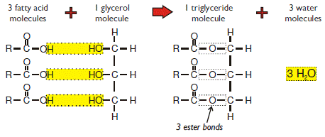

*(*[*http://www.gradeboosters.co.uk/Biology-Bio\_Molecules\_page\_2.php*](http://www.gradeboosters.co.uk/Biology-Bio_Molecules_page_2.php)*)*

Question 4: **Describe the *cis* and *trans* form of double bonds.**

*If we think of a plane running through the bonds we can think about atoms being on one side or other of the plane surface. As the article describes, if the hydrogen atoms connected to the carbon atoms in a double bond are on the same side of the plane, then we call that arrangement the* cis *form. If the hydrogens are on opposite sides of the imaginary plane surface then we have the* trans *arrangement. The diagram below illustrates the two forms.*

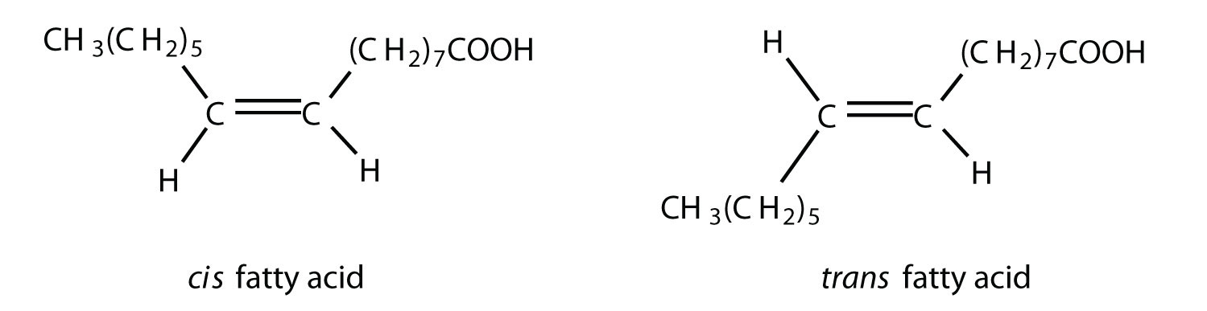

*(*[*http://2012books.lardbucket.org/books/introduction-to-chemistry-general-organic-and-biological/s20-lipids.html*](http://2012books.lardbucket.org/books/introduction-to-chemistry-general-organic-and-biological/s20-lipids.html)*)*

*Note that the* cis *and* trans *forms have the same composition, but different structures. This difference in structure creates differences in macroscopic properties of the substances. See “More on the chemistry of fatty acids and fats” for actual structures and additional details.*

Question 6: **How are omega-fatty acids named?**

*The numbering of the carbon atoms at the far end of the molecule, away from the carboxyl group, begins with the carbon farthest left in the formula below. The location of the first carbon atom in a double bond in the molecule is labeled “3” so this is an omega-3 fatty acid.*

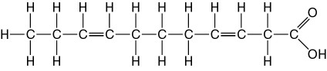

*(*[*http://www.easynotecards.com/notecard\_set/7197*](http://www.easynotecards.com/notecard_set/7197) *)*

**More on** **food,** **fats and disease in the American diet**

The struggle to find an evidenced-based balanced diet described in the Warmflash article is a microcosm of the national (and international) debate about the recommended components of a healthy diet and the evidence to support the claims. Medical societies, the federal government and even individual authors have cited evidence and made claims for one “diet” or another. When we look back at food and disease in America, we see that much of the recent debate, meaning post World War II, has been about the effect of food nutrients on cancer, heart disease or obesity. We will focus more on these issues in the last section of the Teacher’s Guide.

We will return to developments in the debate about the health effects of dietary fats in the last section of the Teacher’s Guide, and review current findings about the role of fats in our diet.

**More on** **the chemistry of fatty acids and fats**

In order to understand omega-3 fats, your students will need to have a broader understanding of fatty acids and fats (lipids). In this section of the Teacher’s Guide we will explain the basic chemistry of fats. The following text is adapted from the Teacher’s Guide accompanying the April, 2015 ChemMatters article Pickett, M. The Skinny on Fats. *ChemMatters*, 2015, *33* (2) pp 16–18.

Let’s look at the chemistry of lipids, starting with their basic structure. Think of the lipid molecule as having two parts—a fatty acid component and a glycerol component. Fatty acids are just carboxylic acids with long carbon chains (see diagram at right). The example in the diagram is palmitic acid. This 15-carbon alkane chain is a typical example, since most fatty acids have chains from 16-18 carbons. The part of the structure at right in the diagram above is a carboxylic acid functional group made up of a carbon atom, two oxygen atoms and a hydrogen atom. The carboxylic acid “end” of the molecule has acid properties and is polar, but the long alkane chain is non-polar. For fatty acids with longer hydrocarbon chains, the entire molecule is nonpolar, which makes it hydrophobic.



*(*[*http://www.longevinst.org/nlt/nlt15fattyacid.htm*](http://www.longevinst.org/nlt/nlt15fattyacid.htm)*)*

The long hydrocarbon chains in fatty acids may contain all single covalent bonds between the carbon atoms, or one or more of the carbon-carbon bonds may be double covalent bonds. If all the carbon-carbon bonds are single covalent bonds then the molecule is considered saturated. If one or more of the bonds is a double covalent bond, the molecule is unsaturated. An example of a saturated fatty acid and an unsaturated fatty acid are shown in the diagrams below.

Lauric acid is a saturated fatty acid. Notice that all the C-C bonds are single bonds.

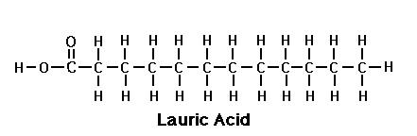

*(*[*http://www.raw-milk-facts.com/fatty\_acids\_T3.html*](http://www.raw-milk-facts.com/fatty_acids_T3.html)*)*

Oleic acid is an unsaturated fatty acid because there is a double bond between two of the carbon atoms in the chain. In the diagram, oleic acid is labeled as a “monounsaturated” fatty acid because there is only one double bond. If there were more than one double bond in the molecule, it would be a polyunsaturated fatty acid.

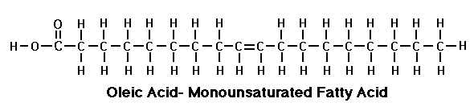

*(*[*http://www.foodnetworksolution.com/wiki/word/1643/oleic-acid*](http://www.foodnetworksolution.com/wiki/word/1643/oleic-acid)*)*

Such a fatty acid, alpha-linoleic acid, is polyunsaturated as shown below by the arrows pointing to the two double bonds.

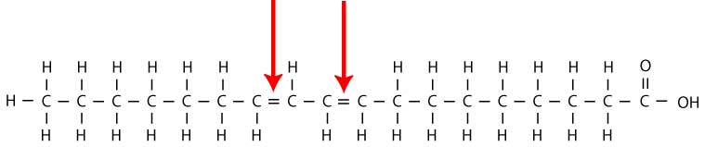

*(*[*http://modernherbalmedicine.com/articles/fat-facts-2.html?page=3*](http://modernherbalmedicine.com/articles/fat-facts-2.html?page=3)*)*

So we can have saturated fatty acids or unsaturated fatty acids, and within the latter category we can have monounsaturated and polyunsaturated compounds. Omega fatty acids are polyunsaturated fatty acids. (PUFAs) This nomenclature carries through to fats themselves. More on this later.

Another important factor in the chemistry of fatty acids (and fats) is the fact that saturated and unsaturated fatty acids differ in their molecular geometry. Molecules of saturated fatty acids have a more linear configuration. The C-C bonds in the molecule are sp3 hybrids with resulting bond angle of 109.47o. The chain of carbon atoms, however, forms a general straight-line shape, allowing the somewhat linear adjacent molecules to “pack” close together. This closer packing results in somewhat stronger intermolecular forces between molecules of saturated fatty acids. The forces are, in fact, dispersion forces. Recall that London dispersion forces are temporary attractive forces that result from the electrons in two adjacent atoms occupying positions that make the atoms form temporary instantaneous dipoles.

London forces are the attractive forces in nonpolar substances, like the long chains in fatty acids, as shown in the upper diagram, at right. They are the weakest of the van der Waals forces. Because these dispersion forces in saturated fatty acids are stronger than they are in unsaturated fatty acids, saturated fatty acids are mostly solids at room temperature. On the other hand, unsaturated fatty acid molecules have one or more “kinks” or bends resulting from the shape of the double bond(s)—see lower diagram at right. These molecules cannot pack as closely and, therefore, exhibit weaker dispersion forces. Most of these fatty acids are liquids at room temperature.

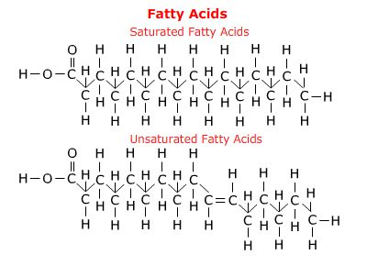

*(*[*http://telstar.ote.cmu.edu/biology/MembranePage/index2.html*](http://telstar.ote.cmu.edu/biology/MembranePage/index2.html)*)*

The other major component of fats is glycerol, which is an organic alcohol, meaning that, within the chemical structure, there is at least one alcohol functional group, –OH. Glycerol is a tri-alcohol, so there are three –OH groups. The structure for glycerol is shown at right. It is also known as glycerine, and its IUPAC name is   
1,2,3-trihydroxypropane.

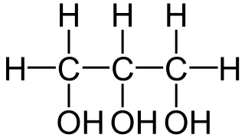

*Glycerol*

*(*[*http://biobook.nerinxhs.org/bb/cells/biochemistry/1000px-Glycerin\_-\_Glycerol.svg.png*](http://biobook.nerinxhs.org/bb/cells/biochemistry/1000px-Glycerin_-_Glycerol.svg.png)*)*

In its pure form glycerol has the following properties:

Formula: C3H8O3

Molar mass: 92.09 g/mol

Appearance: colorless liquid

Taste: sweet

Odor: odorless

Density: 1.261 g/mL

M.P: 17.8 oC

B.P.: 290 oC

Soluble in water

Forms orthorhombic crystals when cooled below 0 oC

Industrially it can be produced from plants like soybean. More than 950,000 tons of glycerol are produced in the U.S. each year. In food and beverages it is used as a humectant (a moistener) and a sweetener, where it has an energy density similar to sugar. It serves to improve smoothness in personal-care products like cough syrups, toothpastes, hair-care products and soaps. At one time it was a component of anti-freeze, where it interferes with water-water hydrogen bonds to lower the freezing point of the mixture.

All fats are a combination of a glycerol backbone and three fatty acid chains in what is chemically an ester. As illustrated in the diagram below, the fatty acid molecules are added to the glycerol backbone by means of ester bonding. Since there are three of these bonds in every lipid or fat molecule, they are commonly known as triglycerides.

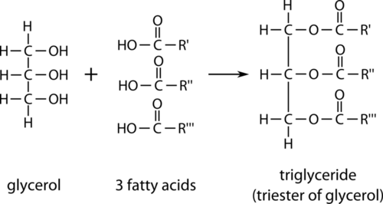

*(*[*http://www.ck12.org/book/CK-12-Chemistry-Intermediate/section/26.3/*](http://www.ck12.org/book/CK-12-Chemistry-Intermediate/section/26.3/)*)*

Even though the glycerol is polar and water soluble, the longer fatty acid chains are non-polar and insoluble, and the properties of lipids tend to be dominated by fatty acid properties. So what we need to focus on are the lipid properties that result from those fatty acid properties.

Your students will likely remember from biology class that fat molecules store more than twice as much energy as carbohydrates or proteins—37.8 kJ/g (9 kcal/g) for fats vs. 16.7 kJ/g (4 kcal/g) for carbohydrates and proteins. Because the body stores energy primarily as fat, it is worth noting that restricting fats in the diet is often seen as a healthy step. Taking into account the fact that most of the energy supplied to the body is the result of the oxidation of fats and carbohydrates, restricting fat intake might not be a good idea. In fact, people who adhere to a low-fat or fat-free diet often increase their carbohydrate intake in order to maintain their energy.

A *ChemMatters* article reviews many of the issues that fats have traditionally presented for American diets:

The term “fat” does not refer to one particular molecule, but rather to a large number of possible molecules with similar structures. All fat molecules—whether in solid or liquid fat—are formed by attaching three molecules of fatty acids to one molecule of glycerol.

Fats get their special chemical properties and health effects from the kinds of fatty acids they contain. Fatty acids are carbon chains that may have from 3 to 18 carbon atoms. The chain may also contain one or more carbon–carbon double bonds. Fatty acids are called polyunsaturated if there are two or more double bonds; monounsaturated, if there is one, and saturated, if there are none. Saturated means that the carbon atoms in the hydrocarbon chain are bonded to the maximum possible number of hydrogen atoms—not the case when there are double bonds present.

Polyunsaturated fats like corn and safflower oil and monounsaturated fats like olive and canola oil tend to be liquids at room temperature. Saturated fats like butter and lard are solids.

The article continues:

One important step toward lowering the risk of heart disease is to reduce the amount of *trans* fatty acids we consume. When a carbon–carbon double bond exists in a hydrocarbon chain, there are two different ways of arranging the hydrogen atoms attached to the two carbons. They can be placed on the same side of the double bond, an arrangement called the *cis* configuration, or they can be placed on opposite sides of the carbon–carbon double bond—the *trans* configuration.

Natural unsaturated fats have double bonds in the *cis* configuration. During food manufacturing, however, that *cis* configuration can be altered. In preparing many products—margarine, for example—manufacturers expose polyunsaturated oils to hydrogen. This process, called hydrogenation, is used to convert the liquid oil to a solid spreadable product. Hydrogenation eliminates some of the double bonds by saturating them with hydrogen. The remaining double bonds are converted to the *trans* configuration.

Several studies now suggest that *trans* fatty acids tend to raise blood cholesterol levels more than *cis* fatty acids, although not as much as saturated fats. Based on these studies, authorities like the American Heart Association have recommended that people try to use oils that haven’t been hydrogenated.

(Banks, P. Fats—Fitting Them into a Healthy Diet. *ChemMatters*, 2000, *18* (3), pp 6–8)

We should include here a very brief review of the language and names of compound classes. As noted above, the term “lipid” is a very general term to designate organic compounds that include fats, oils, waxes and steroids, and assorted other compounds. What they have in common is that they are all hydrophobic, as noted above. This is not a very satisfying or specific definition. Among chemists a better definition would be“Lipids are fatty acids and their derivatives, and substances related biosynthetically or functionally to these compounds.” Triglycerides, then, are esters made up of a glycerol—an organic alcohol—backbone and three fatty acids.

In most common uses, the term “triglyceride” and the term “fat” are synonymous. Fats can be either unsaturated or saturated, as noted above, and saturated fats may be monounsaturated (one double bond in the molecule) or polyunsaturated (more than one double bond). Saturated fats have different health implications from unsaturated fats. And if the fat is unsaturated the molecule may exist in more than one isomeric form, called either *cis* or *trans.* In the *cis* isomer the atoms attached to the doubled bonded carbons are arranged on the same side of the double bond and in the *trans* isomer those atoms are on opposite sides of the double bond. This shift also changes the properties of the molecules. Your students will have seen references to this issue because of the negative publicity about “*trans*-fats.”

Recall from earlier in this section of the Teacher’s Guide that fats (triglycerides) are made up of three fatty acid molecules and a glycerol molecule that acts as a backbone for the larger molecule. Because the fatty acid components of fat molecules tend to be longer –C-C– chains, the properties of these fatty acids determine the overall properties of the molecule. As we think about fats and diet and health, we need to remember that fatty acids (and, therefore, fats) may be either saturated or unsaturated. Also recall that these saturated molecules are generally linear in shape and so “stack” together so that there are relatively strong London dispersion forces between them. The existence of these attractive forces means that the melting points of saturated fats are high relative to other fats, and this, in turn, means that saturated fats tend to be solids at room temperature. So we find saturated fats in foods like the ones listed on the American Heart Association web site:

Saturated fats occur naturally in many foods. The majority come mainly from animal sources, including meat and dairy products. Examples are:

* 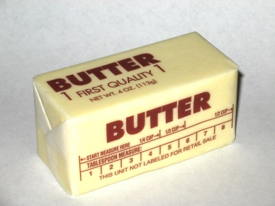fatty beef,
* lamb,
* pork,
* poultry with skin,
* beef fat (tallow),
* lard and cream,
* butter,

*(*[*http://en.wikipedia.org/wiki/Butter*](http://en.wikipedia.org/wiki/Butter)*)*

* cheese and
* other dairy products made from whole or reduced-fat (2 percent) milk.

(<https://www.heart.org/HEARTORG/GettingHealthy/NutritionCenter/HealthyEating/Saturated-Fats_UCM_301110_Article.jsp>)

Fats that contain one or more double covalent bonds are labeled “unsaturated” because additional hydrogen atoms could be added to some of the carbon atoms. There may be one double bond (monounsaturated) or multiple double bonds (polyunsaturated) in the molecule. The existence of double bonds has an effect on the molecular geometry. Molecules of unsaturated fats have slight bends or “kinks” in them, making it difficult for neighboring molecules to pack tightly together as saturated molecules can.

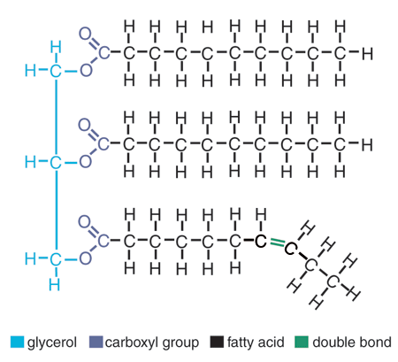

*(*[*http://creationwiki.org/pool/images/7/74/Triglyceride.gif*](http://creationwiki.org/pool/images/7/74/Triglyceride.gif)*)*

The molecule diagrammed at left shows the bending of the fat molecule at the double bond. As a result the London dispersion forces between unsaturated molecules are weaker, resulting in lower melting points. So, unsaturated fats tend to be liquids at room temperature. Sources of unsaturated fats include canola oil, peanut oil, olive oil, avocados, almonds, hazelnuts, pecans, pumpkin seeds, sesame seeds, sunflower oil, corn oil, soybean oil, flax seeds, walnuts, and fish.

*Trans* fats are man-made (although some animals produce small amounts) and the least healthy type. It can lead to serious health problems The major issue is that *trans* fat tends to raise "bad" LDL- cholesterol and lower "good" HDL- cholesterol, although not as much as saturated fat.

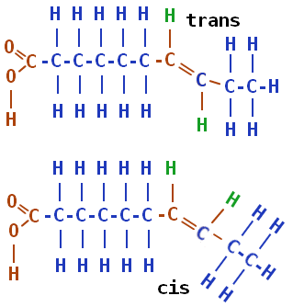 To the right is a diagram of *cis* and *trans* isomers for a fatty acid. The position of the hydrogen atoms (in green) that are attached to the double-bonded carbon atoms determine the isomer. In the lower structure both hydrogen atoms are on the same “side” of the double bond, making it the *cis* isomer. The upper diagram shows those hydrogen atoms on opposite sides of the double bond in the *trans* configuration. Biologically the two isomers have different properties.

*(*[*http://chemistry.tutorvista.com/organic-chemistry/alkene-nomenclature.html*](http://chemistry.tutorvista.com/organic-chemistry/alkene-nomenclature.html))

**More on** **omega fatty acids**

The Warmflash article focuses primarily on omega-3 and omega-6 fatty acids. These are an important group of polyunsaturated fatty acids (PUFAs). Omega-3 fatty acids are *essential* fatty acids, meaning that they are essential for health, and since the human body cannot manufacture them, we must consume them in our diet.

The University of Maryland Medical Center provides a closer look at some of the most important health functions of omega fatty acids:

High Cholesterol

People who follow a Mediterranean-style diet tend to have higher HDL (good) cholesterol levels, which help promote heart health. Inuit Eskimos, who get high amounts of omega-3 fatty acids from eating fatty fish, also tend to have increased HDL cholesterol and decreased triglycerides (fats in the blood). Several studies show that fish oil supplements reduce triglyceride levels. Walnuts, which are rich in alpha linolenic acid or ALA, which can convert to omega-3s in the body, have been reported to lower total cholesterol and triglycerides in people with high cholesterol levels.

High Blood Pressure

Several clinical studies suggest that diets rich in omega-3 fatty acids lower blood pressure in people with hypertension. An analysis of 17 clinical studies using fish oil supplements found that taking 3 or more grams of fish oil daily may reduce blood pressure in people with untreated hypertension. Doses this high, however, should only be taken under the direction of a physician.

Heart Disease

The role of omega-3 fatty acids in cardiovascular disease is well established. One of the best ways to help prevent heart disease is to eat a diet low in saturated fat, and to eat foods that are rich in monounsaturated and polyunsaturated fats (including omega-3 fatty acids). Clinical evidence suggests that EPA and DHA (eicosapentaenoic acid and docosahexaenoic acid), the two omega-3 fatty acids found in fish oil help reduce risk factors for heart disease, including high cholesterol and high blood pressure. Fish oil has been shown to lower levels of triglycerides (fats in the blood), and to lower the risk of death, heart attack, stroke, and abnormal heart rhythms in people who have already had a heart attack. Fish oil also appears to help prevent and treat atherosclerosis (hardening of the arteries) by slowing the development of plaque and blood clots, which can clog arteries.

Large population studies suggest that getting omega-3 fatty acids in the diet, primarily from fish, helps protect against stroke caused by plaque build up and blood clots in the arteries that lead to the brain. Eating at least 2 servings of fish per week can reduce the risk of stroke by as much as 50%. However, high doses of fish oil and omega-3 fatty acids may increase the risk of bleeding. People who eat more than 3 grams of omega-3 fatty acids per day (equivalent to 3 servings of fish per day) may have higher risk for hemorrhagic stroke, a potentially fatal type of stroke in which an artery in the brain leaks or ruptures. Studies also suggest that omega-3 fatty acids may have antioxidant properties that improve endothelial function and may contribute to heart benefits

Diabetes

People with diabetes often have high triglyceride and low HDL levels. Omega-3 fatty acids from fish oil can help lower triglycerides and apoproteins (markers of diabetes), and raise HDL. So eating foods or taking fish oil supplements may help people with diabetes. Another type of omega-3 fatty acid, ALA (from flaxseed, for example) may not have the same benefit as fish oil. Some people with diabetes can't efficiently convert ALA to a form of omega-3 fatty acids that the body can use. Also, some people with type 2 diabetes may have slight increases in fasting blood sugar when taking fish oil. So talk to your doctor to see if fish oil is right for you

Rheumatoid Arthritis

Most clinical studies examining omega-3 fatty acid supplements for arthritis have focused on rheumatoid arthritis (RA), an autoimmune disease that causes inflammation in the joints. Several small studies have found that fish oil helps reduce symptoms of RA, including joint pain and morning stiffness. One study suggests that people with RA who take fish oil may be able to lower their dose of non-steroidal anti-inflammatory drugs (NSAIDs). However, unlike prescription medications, fish oil does not appear to slow progression of RA, only to treat the symptoms. Joint damage still occurs.

(<https://umm.edu/health/medical/altmed/supplement/omega3-fatty-acids>)

Humans can synthesize saturated fatty acids and some monounsaturated fatty acids from carbohydrates and proteins in the body but lack the enzymes needed to insert a *cis* double bond at the third or sixth omega carbon. Humans *are* able, however, to synthesize long chain polyunsaturated fatty acids (PUFAs) from linoleic acid and α-linoleic acid, both of which are omega fatty acids. The latter acid is most important because from it the body derives eicosapentaenoic acid (EPA) and docosahexaenoic acid (DHA), both of which are used to synthesize other PUFAs. The biochemistry of these conversions is complex, but the structures of EPA and DHA are shown below.

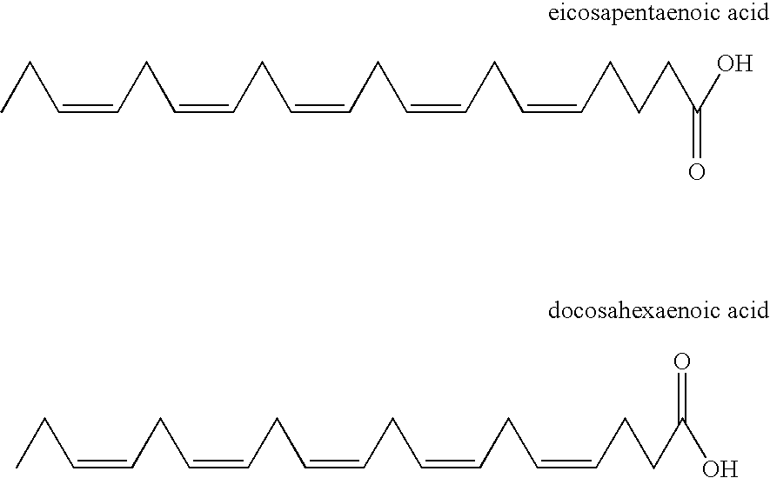

*(*[*http://www.google.com.lb/patents/US6998501*](http://www.google.com.lb/patents/US6998501)*)*

Why are these omega fatty acids considered essential to the body? As noted earlier, they cannot be synthesized by the body, but just as important, they are key components of cell membranes and they affect membrane properties like permeability, flexibility and the activity of membrane enzymes. They are present in retinal cells, red blood cells, brain cells, immune cells and cardiac tissue. So a diet that contains omega fatty acids is important, as the article says. The best sources of omega-3 include fish, vegetable oils, nuts (especially walnuts), flax seeds, flaxseed oil, and leafy vegetables. Omega-6 fatty acids are concentrated in foods like vegetable oils, salad dressings, nuts and seeds, dairy and eggs and chicken. For specific data on omega fatty acid food see <http://nutritiondata.self.com/foods-000140000000000000000.html> and <http://nutritiondata.self.com/foods-000141000000000000000-w.html>.

Most Americans take in far more of omega-6 fats than they do omega-3 fats. Some experts have suggested that this higher intake of omega-6 fats could pose cardiovascular problems, but this has not been supported by evidence in humans. Many studies and trials in humans also support cardiovascular benefits of omega-6 fats. Although there is no question that many Americans could benefit from increasing their intake of omega-3 fats, there is evidence that omega-6 fats also positively influence cardiovascular risk factors and reduce heart disease.

Recall from the prior section of this Teacher’s Guide that fatty acids may be either saturated or unsaturated. If a fatty acid is saturated the long hydrocarbon chain is rather uniform. It begins with -CH3 at the end then includes a series of –CH2 units until you reach the carboxyl group at the other end. If, however, the molecule is unsaturated then there is a double bond somewhere in that long hydrocarbon chain. But where?

The Warmflash article explains how fatty acids are named using the omega numbering system, which begins numbering carbon atoms at the end of the molecule opposite the carboxyl group—at the omega end. In fats the carbon atoms are numbered beginning with the carbon which is opposite the carboxyl group. That carbon is called the omega carbon. The location of the double bond is indicated by the first carbon involved in a double bond. For example, in the diagram below, the omega carbon is in blue and the first double bond (noted by the red arrow) carbon is carbon #3, so this is an omega-3 fatty acid.

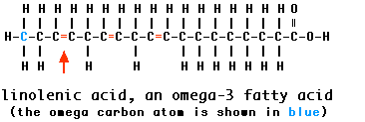

*(*[*http://users.rcn.com/jkimball.ma.ultranet/BiologyPages/F/Fats.html*](http://users.rcn.com/jkimball.ma.ultranet/BiologyPages/F/Fats.html)*)*

Note in this example that there are other double bonds in the molecule (naturally, since omega fatty acids are polyunsaturated). The omega system only identifies the first double bond.

Another naming convention, the delta system or numerical, tells us much more about the molecule. In this naming scheme the carbons are numbered beginning with the carboxyl carbon. A series of numbers is used to describe the total number of carbon atoms in the molecule, the number of double bonds and the number of the carbons first involved in each of the double bonds.

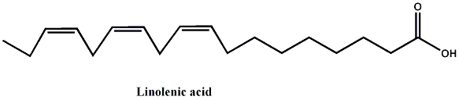

*(*[*http://chm2210sp10.wikispaces.com/linolenic+acid*](http://chm2210sp10.wikispaces.com/linolenic+acid)*)*

So, the naming for linoleic acid, diagrammed above, would be 18:3:Δ9,12,15. This notation indicates that there are a total of 18 carbon atoms in the molecule, 3 double bonds, the first located at the 9 carbon, the second at the 12 carbon and the third at the 15 carbon. The omega system, however, is the system commonly used in food labeling and in articles describing the nutritional value of these molecules.

**More on fats, cholesterol and heart disease**

The Warmflash article concludes with a description of the relationship between fats, including omega fatty acids, cholesterol and atherosclerosis or heart disease. The relationship depends in part on how cholesterol is transported through the blood stream. The following text, from the Teacher’s Guide accompanying the April, 2015 *ChemMatters* article Pickett, M. The Skinny on Fats. *ChemMatters*, 2015, 33 (2) pp. 16-18, describes that process.

Physicians warn us that too much cholesterol in our blood is a warning sign for heart attack or stroke. But we know that in order for substances like cholesterol or fats to be in our blood, they must be water soluble. We already know that fats are insoluble in water, and the article tells us that cholesterol is only slightly soluble. How are these substances transported via the blood throughout the body?

There are two parts to this answer. Fat molecules are very large. In order to pass through the intestinal wall the molecules must be broken up*.* Fats are mixed with a biological detergent called bile, which is produced in the liver and stored in the gall bladder. The mixing (emulsifying) of the detergent with the fats allows for the non-polar end of the detergent to interact with the non-polar end of the fat (the fatty acid end) while the polar end of the detergent bonds with the polar end of the fat (the glyceride end) just as regular soaps and detergents would do when you wash greasy dishes with soap or detergent. Once the fat is emulsified in the digestive “juices”, it can be broken apart by hydrolysis to yield water soluble fatty acids, glycerols and mono- and di-glycerides which are then small enough and soluble enough to pass through the intestinal wall into the blood stream.

In intestinal cells, the parts are reassembled and the resulting fats are combined with phospholipids, simply modified triglycerides in which one of the fatty acid chains is replaced with a phosphate radical as shown in the diagram at right. The phosphate is polar, and as a result the phosphate “end” of the phospholipid molecule is polar and hydrophilic and the fatty acid “end” is nonpolar and hydrophobic. When they interact with fats and cholesterol they orient themselves so that the polar heads are facing the water molecules and the hydrophobic fatty acids are oriented toward the cholesterol. The phospholipid acts as a bio-emulsifier connecting blood (water) and cholesterol so that the cholesterol can be transported through the blood. This unit combines with specialized carrier molecules called apoproteins and the resulting globular structure is called a lipoprotein (see diagram at right, below). The hydrophilic phospholipid layer forms the outer shell and interacts with water via hydrogen bonding while the hydrophobic fat and cholesterol are in the interior of the globule and are attracted to the phospholipid via dispersion forces.



*(*[*http://users.atw.hu/blp6/BLP6/HTML/C0389780323045827.htm*](http://users.atw.hu/blp6/BLP6/HTML/C0389780323045827.htm)*)*

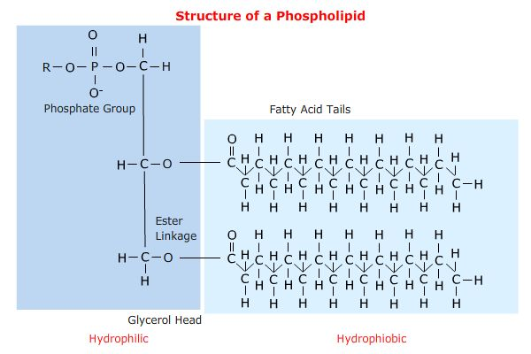

*(*[*http://telstar.ote.cmu.edu/biology/MembranePage/index2.html*](http://telstar.ote.cmu.edu/biology/MembranePage/index2.html)*)*

Some of these carrier units are more dense and some are less dense, due to differences in the percent of fat in the unit. We know the lower density units as LDL or low density lipoprotein, and we know the high density units as HDL or high density lipoprotein. Your students may recognize LDL as the so-called "bad cholesterol," which carries cholesterol away from the liver, to various organs. In contrast, HDL's tendency to remove excess cholesterol from arteries to return it to the liver has earned it the name "good cholesterol".

**More on an updated on the fats debate**

The recommendations to include omega fatty acids in the diet, primarily in fish and in fish oil supplements, is part of a long history of dietary information supplied by the U.S. government and a variety of health-related professional organizations like the American Heart Association and others.

In 1894, the U.S. Department of Agriculture (USDA) published the first dietary standards for the country (see a digital copy of the document at <http://www.ars.usda.gov/SP2UserFiles/Place/80400530/pdf/hist/oes_1894_farm_bul_23.pdf>). The first recommendations for daily food consumption appeared in 1917, and there were five food groups listed: milk and meat, cereals, vegetables and fruits, fats and fat foods (note that these were recommended), and sugars and sugary foods. In 1941, the National Academy of the Sciences issued the first Recommended Daily Allowances (RDA) tables, in 1942, the USDA released its “Basic Seven” daily food groups, which were reduced in 1956 to basic fours-- milk and milk products; meat, fish, poultry, eggs, dry beans, and nuts; fruits and vegetables; and grain products

Until the 1940s, heart disease was a relatively minor public health issue in the United States. In that time the major cause of death was infectious disease, and a high-calorie diet was considered helpful in recovering from illness. By the 1950s, however, heart disease had become a major health risk, accentuated perhaps by the heart attack suffered by President Eisenhower in 1955. And dietary fat and cholesterol rose to the top of the list of reasons for the increase. According to a 1998 *Journal of Nutrition* article:

Real interest in dietary fat and its effects—particularly with regard to its role in cardiovascular disease—was stimulated by several papers published in the early 1950s. Gofman and his colleagues at the University of California, Berkeley published a paper in Science ([Gofman et al. 1950](http://jn.nutrition.org/content/128/2/449S.long" \l "ref-6)) that detailed findings related to their new technique of separating plasma lipoproteins by ultracentrifugation. They showed that levels of certain of these lipoprotein classes were related to atherosclerotic heart disease and implicated dietary fat as a factor in this relationship. At about the same time Ancel Keys embarked on his worldwide epidemiologic investigations of dietary fat and heart disease prevalence, which showed that the level of dietary fat was related to mortality from heart disease ([Keys 1953](http://jn.nutrition.org/content/128/2/449S.long#ref-13)). In his “Seven Countries” study, [Keys (1970)](http://jn.nutrition.org/content/128/2/449S.long#ref-14) found a significant association between fat and saturated fat intake and heart disease mortality. [Yerushalmey and Hilleboe (1957)](http://jn.nutrition.org/content/128/2/449S.long#ref-34) pointed out that if 21 other countries were included, the association observed by Keys was weak and that a similar association could be advanced between animal protein intake and heart disease.

The role of dietary cholesterol in the etiology of heart disease had been a subject of much earlier research and speculation. The early history is detailed in a book published in 1958 ([Kritchevsky 1958](http://jn.nutrition.org/content/128/2/449S.long" \l "ref-17)). The observation that cholesterol was a constituent of the atherosclerotic plaque was noted in a pathology text published 150 years ago ([Vogel 1847](http://jn.nutrition.org/content/128/2/449S.long#ref-33)). Any number of investigators showed that atherosclerotic aortas contained significantly more cholesterol than normal ones. Others showed that cholesterol feeding alone was sufficient to establish cholesterol-rich lesions in the arteries of rabbits and chickens. Atherosclerotic lesions could be established in rats, dogs and monkeys by cholesterol feeding plus other dietary and hormonal manipulations. Although these findings led to innumerable experimental studies of cholesterol/fat feeding and atherosclerosis, [Stehbens (1989)](http://jn.nutrition.org/content/128/2/449S.long#ref-29) has argued persistently that the human and experimental lesions in animals are different enough to cast doubt on the validity of the experimental lesion as an example of human disease. Although the role of cholesterolemia and hyperlipidemia in the etiology of human atherosclerosis was not accepted unanimously in the 1950s, it was considered sufficient by some authorities to establish a case against high intakes of dietary fat and cholesterol. This was enough to open the door to dietary guidelines offered to the public for possible prevention or amelioration of heart disease.

(<http://jn.nutrition.org/content/128/2/449S.long>; accessed online February 27, 2015)

But by the early 2000s much of Keys’ work was being discredited as a result of errors in his study—errors like not choosing randomly the countries in the study, like selecting key data that fit his theories and excluding results that did not fall in line with his conclusions. By the time these shortcomings were revealed, however, Keys’ ideas about the role of dietary fats were well entrenched in U.S. dietary guidelines and accepted as fact.

The anti-fat advice continued well after Keys’ work was debunked. The 2005 report *Nutrition and Your Health: Dietary Guidelines for Americans* from theU.S. Department of Agriculture (USDA), fats were still to be avoided, recommending that only 2-35 per cent of daily calories come from fats, especially saturated fats in order to reduce the risks of cardiovascular disease.

In 2013 and 2014, new study results were reported indicating no difference in cardiovascular disease between people who ate saturated fats and those eating unsaturated fats. Nutritional science is beginning to question “the lipid hypothesis.” The headlines in popular newspaper and magazines that announced these results claimed that there was no link at all between saturated fat and heart disease, but these kinds of claims are not fully documented and are being debated in science circles. There seems to be little agreement on the current status of fats in our diet.

How, then, did claims arise that consuming omega-3 fatty acids could *protect* against heart disease, claims that runs counter to the prevailing opinion that fats have a negative influence on health? The story begins in the 1970s with two Danish clinical chemists, Hans Olaf Bang and Jørn Dyerberg, who specialized in nutrition. They became interested in the diets of the Inuit Eskimos of Greenland and visited a small town of about 1,300 where they drew blood samples from about ten per cent of the population. Bang and Dyerberg found that the Inuit had lower levels of lipids such as cholesterol and triglycerides, but they had a higher proportion of omega-3 fatty acids, which are common in oily, cold-water fish. They then obtained hospital records and death certificates from Greenland’s chief medical officer, and those records seemed to indicate an abnormally low rate of heart disease. The problem was that those records represented a very small fraction of the entire population and future studies would conclude that the rate of heart disease in the Inuit is likely comparable to that of western European countries.

The two Danish researchers reported what they found, and actually never made a claim that eating an Eskimo diet rich in omega fatty acids would protect against heart disease. Other scientists and the popular media reports misinterpreted and misreported their results, and in doing so spread the now still popular idea that omega fatty acids offer protection against heart disease. Fish oil supplements are so popular, in fact, that in 2015, approximately ten per cent of people in the U.S. take them in some form. However, clinical trials taking place between 2005 and 2012 found no protective effect from omega fatty acids.

Even more interesting is a 2015 study published in *Science* magazine in 2015, which reported that the ancestors of the Inuit evolved unique genetic adaptations for metabolizing omega-3s and other fatty acids, which indicates that changes in Inuit DNA are responsible for any possible reduced rates of heart disease if, in fact, Inuit rates are lower. The abstract of the report:

The indigenous people of Greenland, the Inuit, have lived for a long time in the extreme conditions of the Arctic, including low annual temperatures, and with a specialized diet rich in protein and fatty acids, particularly omega-3 polyunsaturated fatty acids (PUFAs). A scan of Inuit genomes revealed signals at several loci, with the strongest signal located in a cluster of fatty acid desaturases that determine PUFA levels. The selected alleles are associated with multiple metabolic and anthropometric phenotypes and have large effect sizes for weight and height, with the effect on height replicated in Europeans. By analyzing membrane lipids, we found that the selected alleles modulate fatty acid composition, which may affect the regulation of growth hormones. Thus, the Inuit have genetic and physiological adaptations to a diet rich in PUFAs.

(<http://www.sciencemag.org/content/349/6254/1343>; accessed online October 30, 2015)

While not conclusive, this study indicates that it was not the PUFAs themselves that offered cardiovascular protection to the Inuit but rather their genetic adaptations that evolved over time.

So it seems that regardless of which kinds of fats (or fatty acids) we are talking about, the scientific evidence and resulting nutritional advice continues to evolve. We are in a period of changing attitudes about the role of fats in our diet. More and more is now known about the chemical changes that fats undergo in the body and the chemicals that result. One way to look at this uncertainty is to remind students that science is often in this position. We develop a model or a way of thinking about an idea, accept it as long as it explains the available evidence but change the model or our way of thinking as new evidence comes along. So as we learn more about the chemistry of fatty acids and their biochemical roles in the body, we also alter our thinking about the right amount to consume in our diet.

# Connections to Chemistry Concepts

**(for correlation to course curriculum)**

1. **Chemical nomenclature**—Various systems for naming fatty acids are discussed in the article and this provides an opportunity to apply other organic naming systems
2. **Organic compounds**—All of the fats and related molecules described in this article are organic compounds.
3. **Double bonds**—Double bonds share two pairs of electrons between them. These bonds are considered unsaturated, and additional atoms such as hydrogen can be added (bonded) producing a different molecule. The difference in such properties between saturated and unsaturated molecules is especially important for health reasons in the case of fats
4. **Saturated vs. unsaturated**—. These molecules can accept additional elements such as hydrogen. This process of accepting additional hydrogen atoms changes the physical characteristics of fats.
5. **Isomers: *cis* and *trans***—This form of isomerism occurs in unsaturated fats. These isomers occur in molecules of the same molecular formula but with different geometric arrangements of groups attached next to each other.
6. **Biochemistry**—Chemical reactions play a critical role in living organisms. A continuing area of research lies in understanding the chemical reactions and their effects on the organism.
7. **Chemistry and public health**—The U.S. dietary guidelines are based on the scientific evidence that biochemists can provide to non-scientists who establish public health policy. The Warmflash article suggests that some areas of evidence seem contradictory, and resolving these presents future career options for your students.

# Possible Student Misconceptions

**(to aid teacher in addressing misconceptions)**

1. **“Omega-3 fatty acid is just a commercial brand of fatty acid.”** *Anyone who is exposed to television infomercials or print ads will see dozens of ads for omega fatty acids, and this may lead students to believe that “omega-3” or “omega-6” is simply a branded product name. As the article points out, the term “omega” refers to an end carbon in an unsaturated fatty acid chain and is the basis for identifying where the double bond is located in the molecule.*
2. **“All dietary fats are bad.”** *There are both “good” and “bad” fats. Our bodies need fat for a variety of purposes, including synthesizing cell membrane structures, hormones, nerve tissue, and body insulation against temperature changes, among other things. Saturated fats and* trans *fats have bad effects on cholesterol levels (cholesterol is needed by our bodies but too much is not good), while polyunsaturated fats and monounsaturated fats have good effects on cholesterol levels.*
3. This article causes us to rethink the idea of a “misconception.” The article points out that our pre-occupation with avoiding dietary fat is now being questioned. As a result, students, and, in fact, adults may be harboring misconceptions about fats and not out of ignorance but because information presented to them as “fact” may not be factual according to current scientific research. Current students may, in fact, have fewer misconceptions about lipids and cholesterol

# Anticipating Student Questions

**(answers to questions students might ask in class)**

1. **“The article makes it sound like omega fatty acids are special or unique chemical compounds. Are they? ”** *Chemically, no. They are simply polyunsaturated fatty acids (PUFAs). The unusual way of naming them may make them sound unique but they are not. However, the health claims made about them differ from other types of fat or fatty acid in that they are claimed to prevent disease rather than cause it, as it often the case with other fats.*

## In-Class Activities

**(lesson ideas, including labs & demonstrations)**

1. This activity is designed to determine the mass of fat in a fast food item like French fries. Observe all safety precautions. (<http://www.chymist.com/Fat%20in%20potato%20chips.pdf>)
2. The Institute of Food Technologists offers the 63-page booklet “Food Chemistry Experiments” at <http://www.accessexcellence.org/pizza/pdf/fcbook.pdf>. It contains a chapter on lipids with a student experiment on extracting lipids from chocolate and potato chips, extensive chemistry background information on lipids, and related puzzles.
3. Students can isolate fats from milk using a procedure found on pages 15–21 of this *ChemSource* document <http://dwb.unl.edu/ChemSource/SourceBook/115FOOD.pdf>.
4. Also see pages 22–23 of the *ChemSource* document from #3, above, <http://dwb.unl.edu/ChemSource/SourceBook/115FOOD.pdf>, for a teacher demonstration version of the activity.
5. This biotechnology lesson plan from the University of Waikato in New Zealand gives students insights into how and why omega-3 fish oil would be added to various products. (<http://biotechlearn.org.nz/content/download/28739/180484/file/Promoting%20omega-3%20enriched%20food.doc>)
6. One response to the advice to reduce fat consumption has been the development of margarine and other spreads. This activity enables students to determine the per cent of water in three types of margarine. The video clips in the activity show some of the procedure. Note that you need QuickTime to run these clips. (<http://chemmovies.unl.edu/chemistry/beckerdemos/BD046.html>)

# Out-of-Class Activities and Projects

**(student research, class projects)**

1. Have student collect print ads for omega fatty acid products and compare claims. Then have students research the current science of omega fatty acids and compare the claims to the research.
2. You can assign students or teams of students to collect food labels and determine the amount of fats (by category—saturated, unsaturated, *trans*) and cholesterol, and also categorize the labels by food type. Collect class data and look for trends.
3. Students might interview family members and friends to determine whether they restrict fats in their diet in any significant way. Students should be asked to make up the interview questions based on the article and other research.
4. Another variety of survey would be to ask family and friends how much they understand about omega fatty acids and why they do or do not use them.
5. Still another type of interview would be to ask community members like physicians, nurses, dieticians and related professionals about the role of lipids, especially omega fatty acids, in human health.
6. Students can make ball and stick models at home of important fatty acid molecules and bring them to class to display.
7. There are a lot of articles in the press currently about the new research findings related to fatty acids, cholesterol and lipids and their influence on cardiovascular health. Assign students to collect article and bring them to class for discussion.

# References

**(non-Web-based information sources)**



**30 Years of *ChemMatters***

Available Now!

**The references below can be found on the *ChemMatters* 30-year DVD (which includes all articles published during the years 1983 through April 2013 and all available Teacher’s Guides, beginning February 1990). The DVD is available from the American Chemical Society for $42 (or $135 for a site/school license) at this site:** [http://ww.acs.org/chemmatters](http://www.acs.org/chemmatters)**. Click on the “Archive” tab in the middle of the screen just under the *ChemMatters* logo. On this new page click on the “Get 30 Years of ChemMatters on DVD!” tab at the right for more information and to purchase the DVD.**

**Selected articles and the complete set of Teacher’s Guides for all issues from the past three years are available free online at the same Web site, above. Simply access the link and click on the aforementioned “Archive” tab.**

Baugh, M. Oil Changes. *ChemMatters*, 1989, *7* (4), pp 7–9. The author uses the dietary guidelines in 1989 to examine types of fat—saturated, unsaturated, etc.—and explain the different fat-related terms and explains what these terms mean on a food label.

Benson, K. Fast Food--Fast Fats. *ChemMatters*, 1990, *8* (1), pp 13–15. This article urges students to understand the fat content of favorite foods, like fast food, in order to avoid things like heart disease.

Ruth, C. A Calorie-Free Fat? *ChemMatters*, 1999, *17* (2), pp 9–11. Against the backdrop of the anti-fats dietary guidelines at the time, this article explains the development, structure and properties of olestra, an artificial fat.

Banks, P. Fats—Fitting Them into a Healthy Diet. *ChemMatters*, 2000, *18* (3), pp 6–8. In addition to a brief introduction on the chemistry of fats, the author examines fats in the context of health and the then-existing dietary guidelines.

Kimbrough, D. The Solid facts About Trans Fats. *ChemMatters,* 2007, *25* (4), pp 15–16. This article explains the structure of fats, including saturated and unsaturated fats and also explains the structure and properties of *cis* and *trans* fat isomers and partial hydrogenation.

Nolte, B. Tanking Up with Cooking Oil. *ChemMatters*, 2011, *29* (2) pp 5–7. After a brief explanation of fats and oils, this article features the use of cooking oils as fuels in automobile.

Pickett, M. The Skinny on Fats. *ChemMatters*, 2015, *33* (2) pp 16–18. The chemistry of fats is the central focus of this article with added emphasis on the connection between fats, diet and disease.

# Web Sites for Additional Information

**(Web-based information sources)**

**More sites on** **lipids**

The Lipid Library from AOCS, a professional society devoted to the chemistry of fats and oils, <http://lipidlibrary.aocs.org/>, is just what it sounds like—an online reference to multiple lipid topics including this tutorial on fatty acids and fats: <http://www.lipidmaps.org/resources/tutorials/lipid_tutorial.html#L>.

One of the most helpful sites on lipids and related topics is provided by Elmhurst College in their *Virtual ChemBook*. The homepage for lipids is <http://www.elmhurst.edu/~chm/vchembook/550lipids.html>, and this page provides an introduction to the topic. Other *ChemBook* lipid topics are catalogued below.

* This page provides fatty acid structural formulas and charts showing the amount of saturated and unsaturated fatty acids, both from plant and animal sources in various common foods: <http://elmhcx9.elmhurst.edu/~chm/vchembook/551fattyacids.html>.
* This site shows an organizational chart for different classes of lipids: <http://elmhcx9.elmhurst.edu/~chm/vchembook/552triglycerides.html>.
* On this page are phospholipid structures, examples and other information: <http://www.elmhurst.edu/~chm/vchembook/553phosglycerides.html>.

This site supplies a simple summary of important topics related to fats: <http://www.chemistryexplained.com/Di-Fa/Fats-and-Fatty-Acids.html>.

A very nice and complete site on fats, oils, waxes, etc. is provided by the University of Cincinnati’s Claremont College, as part of a biology course syllabus: <http://biology.clc.uc.edu/courses/bio104/lipids.htm>.

The tried-and-true “How Stuff Works” has this site on lipids: <http://science.howstuffworks.com/innovation/edible-innovations/fat.htm>.

The *Hyperphysics Textbook* has a page on phospholipids, strangely enough. (<http://hyperphysics.phy-astr.gsu.edu/hbase/organic/phoslip.html>, as part of a site on lipids: <http://hyperphysics.phy-astr.gsu.edu/hbase/organic/lipid.html#c1>)

From Carnegie Mellon University comes this page on lipids with a strong section on phospholipids. (<http://telstar.ote.cmu.edu/biology/MembranePage/index2.html>)

**More sites on omega fatty acids**

The Harvard University School of Public Health provides this perspective on the role of omega fatty acids and health**.** The site includes a list of scientific reference at the end. (<http://www.hsph.harvard.edu/nutritionsource/omega-3-fats/>)

The role of omega fatty acids in the human body is described in complete detail by this site from the University of Maryland Medical Center, and also includes references: <http://umm.edu/health/medical/altmed/supplement/omega3-fatty-acids>.

The American Heart Association lists these recommendations about omega-3 fatty acids: <http://www.heart.org/HEARTORG/GettingHealthy/NutritionCenter/HealthyDietGoals/Fish-and-Omega-3-Fatty-Acids_UCM_303248_Article.jsp>.

This article from *Scientific American* describes some of the conflicting research about omega fatty acids and diet: <http://www.scientificamerican.com/article/fish-oil-supplement-research-remains-murky/>.

The Linus Pauling Institute at Oregon State University has a very detailed listing of information about essential fatty acids. (<http://lpi.oregonstate.edu/mic/other-nutrients/essential-fatty-acids>)

**More sites on dietary guidelines and health**

The Mayo Clinic offers traditional advice on dietary fat intake. (<http://www.mayoclinic.org/healthy-lifestyle/nutrition-and-healthy-eating/in-depth/fat/art-20045550?pg=2>)

Likewise, the American Heart Association offers traditional advice on omega fatty acids and diet. (<http://www.heart.org/HEARTORG/GettingHealthy/NutritionCenter/HealthyDietGoals/Fish-and-Omega-3-Fatty-Acids_UCM_303248_Article.jsp#.VjXkoLerSM8>)

This September 17, 2015 article from the *New York Times* tells the story of the Inuit Eskimos and omegas: <http://www.nytimes.com/2015/09/22/science/inuit-study-adds-twist-to-omega-3-fatty-acids-health-story.html?_r=0>.

This USDA site gives a brief history of U.S. dietary guidelines: <http://www.health.gov/dietaryguidelines/dga2005/report/html/G5_History.htm>.

Another USDA site provides a more detailed history of the guidelines with links to the guidelines since 1980. (<http://www.nal.usda.gov/fnic/pubs/DGA.pdf>)

The *Journal of Nutrition* gives a lot of background on the changing content and role of U.S. dietary guidelines. (<http://jn.nutrition.org/content/128/2/449S.long>)

This is an early version of the 2015 proposed dietary guidelines issues during the public comment period: <http://www.health.gov/dietaryguidelines/2015-scientific-report/PDFs/02-executive-summary.pdf>.

From the Harvard University School of Public Health comes a report, “making the case to end the myth of the low-fat diet”: <http://www.hsph.harvard.edu/nutritionsource/fats-full-story/>.