December 2015 / January 2016 Teacher's Guide for

Bacteria Buster! Triclosan Kills Bacteria, but Is It Safe?

Table of Contents

About the Guide 2
Student Questions 3
Answers to Student Questions 4
Anticipation Guide 5
Reading Strategies 6
Background Information 9
Connections to Chemistry Concepts 29
Possible Student Misconceptions 30
Anticipating Student Questions 30
In-Class Activities 31
Out-of-Class Activities and Projects 32
References 33
Web Sites for Additional Information 34

About the Guide

Teacher’s Guide editors William Bleam, Regis Goode, Donald McKinney, Barbara Sitzman and Ronald Tempest created the Teacher’s Guide article material. E-mail: bbleam@verizon.net

Susan Cooper prepared the anticipation and reading guides.

Patrice Pages, ChemMatters editor, coordinated production and prepared the Microsoft Word and PDF versions of the Teacher’s Guide. E-mail: chemmatters@acs.org

Articles from past issues of ChemMatters can be accessed from a DVD that is available from the American Chemical Society for $42. The DVD contains the entire 30-year publication of ChemMatters issues, from February 1983 to April 2013.

The ChemMatters DVD also includes Article, Title and Keyword Indexes that covers all issues from February 1983 to April 2013.

The ChemMatters DVD can be purchased by calling 1-800-227-5558.

Purchase information can be found online at www.acs.org/chemmatters.

Student Questions
  - Why did Bath and Beauty Works add triclosan to their “Tangelo Orange Twist” and “Sugar Lemon Fizz” soaps?
  - What has led to health concerns about products containing triclosan?
  - When you use triclosan-containing products, how does the triclosan enter the body?
  - Why is triclosan detected in the urine of people who do not knowingly use triclosan-containing products?
  - What were the results of studies on teenagers from the United States and Norway who have been exposed to triclosan?
  - Why are scientists concerned about the similarities between the structure of the triclosan molecules and thyroid hormone molecules?
  - Why do animal studies show severe health effects not seen in humans who have been exposed to triclosan?
  - How do triclosan molecules prevent the formation of fatty acids?
  - Why does the loss of fatty acids kill bacteria?
  - What unique property of triclosan led to its use for hospital surgeries in the 1970s?
  - What use of triclosan was approved by the U.S. Food and Drug Administration in the 1990s?
  - Why are some consumers opposed to the use of triclosan-containing products?

Answers to Student Questions
    - Why did Bath and Beauty Works add triclosan to their “Tangelo Orange Twist” and “Sugar Lemon Fizz” soaps?
Bath and Beauty Works added triclosan to their “Tangelo Orange Twist” and “Sugar Lemon Fizz” soaps to make them antibacterial.
    - What has led to health concerns about products containing triclosan?
Results from animal studies have led to health concerns about products containing triclosan.
    - When you use triclosan-containing products, how does the triclosan enter the body?
When you use triclosan-containing products, the chemical is absorbed via the gastrointestinal tract, mouth and skin.
    - Why is triclosan detected in the urine of people who do not knowingly use triclosan-containing products?
Triclosan is detected in the urine of people who do not knowingly use triclosan-containing products because many of us are in fact exposed to triclosan.
    - What were the results of studies on teenagers from the United States and Norway who have been exposed to triclosan?
Studies of teenagers from the United States and Norway who have been exposed to triclosan show triclosan exposure is “… associated with a diagnosis of allergy or hay fever and a measurable sensitivity to air and food allergens.”
    - Why are scientists concerned about the similarities between the structure of the triclosan molecules and thyroid hormone molecules?
Scientists are concerned about the similarities between the structure of triclosan molecules and hormone molecules because if triclosan mimics thyroid hormones, triclosan could have far reaching health effects on the brain, heart and bones, especially in children and teens.
    - Why do animal studies show severe health effects not seen in humans who have been exposed to triclosan?
Animals show severe health effects not seen in humans because the level of triclosan used in animal studies is typically higher than the level of triclosan to which humans are exposed.
    - How do triclosan molecules prevent the formation of fatty acids?
Triclosan molecules prevent the formation of fatty acids by binding to the bacterial cell enzymes required to catalyze fatty acid production.
    - Why does the loss of fatty acids kill bacteria?
The loss of fatty acids kills bacteria because without fatty acids, bacteria cannot build and maintain the cell walls necessary for cells to grow and divide.
    - What unique property of triclosan led to its use for hospital surgeries in the 1970s?
The property of triclosan that led to its use for hospital surgeries is that triclosan binds to an enzyme present in bacterial cells but not in human cells, so it can’t cause unintended problems in humans.
    - What use of triclosan was approved by the U.S. Food and Drug Administration in the 1990s?
The use of triclosan in Colgate Total toothpaste to fight gingivitis was approved by the U.S. Food and Drug Administration in the 1990s.
    - Why are some consumers opposed to the use of triclosan-containing products?
Some consumers are opposed to the use of triclosan-containing products because they are concerned about triclosan’s ability to mimic other molecules.

Anticipation Guide
Anticipation guides help engage students by activating prior knowledge and stimulating student interest before reading. If class time permits, discuss students’ responses to each statement before reading each article. As they read, students should look for evidence supporting or refuting their initial responses.

Directions: Before reading, in the first column, write “A” or “D,” indicating your agreement or disagreement with each statement. As you read, compare your opinions with information from the article. In the space under each statement, cite information from the article that supports or refutes your original ideas.

Me | Text | Statement
 |  | - Studies have shown that triclosan accumulates in our tissues.
 |  | - Many people who do not report using products with triclosan have triclosan in their urine.
 |  | - Some studies have linked triclosan exposure to allergies, but no cause and effect relationship has been found.
 |  | - Triclosan’s chemical structure is similar to hormones naturally found in our bodies.
 |  | - Triclosan contains the same elements as thyroxine and estradiol.
 |  | - Triclosan molecules prevent the production of fatty acids in bacteria, killing the bacteria.
 |  | - The enzymes in bacteria and humans are the same.
 |  | - Triclosan has been used in the United States since the 1970s.
 |  | - Long carbon chains are hydrophobic.
 |  | - Scientific articles must undergo peer review prior to publication.

Reading Strategies
These graphic organizers are provided to help students locate and analyze information from the articles. Student understanding will be enhanced when they explore and evaluate the information themselves, with input from the teacher if students are struggling. Encourage students to use their own words and avoid copying entire sentences from the articles. The use of bullets helps them do this. If you use these reading and writing strategies to evaluate student performance, you may want to develop a grading rubric such as the one below.

Score | Description | Evidence
4 | Excellent | Complete; details provided; demonstrates deep understanding.
3 | Good | Complete; few details provided; demonstrates some understanding.
2 | Fair | Incomplete; few details provided; some misconceptions evident.
1 | Poor | Very incomplete; no details provided; many misconceptions evident.
0 | Not acceptable | So incomplete that no judgment can be made about student understanding

Teaching Strategies:

- Links to Common Core Standards for Reading:
- ELA-Literacy.RST.9-10.1: Cite specific textual evidence to support analysis of science and technical texts, attending to the precise details of explanations or descriptions.
- ELA-Literacy.RST.9-10.5: Analyze the structure of the relationships among concepts in a text, including relationships among key terms (e.g., force, friction, reaction force, energy).
- ELA-Literacy.RST.11-12.1: Cite specific textual evidence to support analysis of science and technical texts, attending to important distinctions the author makes and to any gaps or inconsistencies in the account.
- ELA-Literacy.RST.11-12.4: Determine the meaning of symbols, key terms, and other domain-specific words and phrases as they are used in a specific scientific or technical context relevant to grades 11-12 texts and topics.

- Links to Common Core Standards for Writing:
- ELA-Literacy.WHST.9-10.2F: Provide a concluding statement or section that follows from and supports the information or explanation presented (e.g., articulating implications or the significance of the topic).
- ELA-Literacy.WHST.11-12.1E: Provide a concluding statement or section that follows from or supports the argument presented.

- Vocabulary and concepts that are reinforced in this issue:
- Chemical safety
- Molecular structures
- Energy conservation
- Lipids
- Hydrophobic and hydrophilic structures
- Enzymes
- Evaluating scientific claims

- Some of the articles in this issue provide opportunities, references, and suggestions for students to do further research on their own about topics that interest them.

- To help students engage with the text, ask students which article engaged them most and why, or what questions they still have about the articles. The Background Information in the ChemMatters Teachers Guide has suggestions for further research and activities.
Directions: As you read the article, complete the graphic organizer below to describe concerns about triclosan and how triclosan works.

Concerns and Tests
Links to allergies | Tests on humans or animals? | Evidence:
Decreased growth rate | Tests on humans or animals? | Evidence:
Increased cancer risk | Tests on humans or animals? | Evidence:
How triclosan works
Effect on cell membrane
Effect on enzyme
Relationship to substrate

Summary: After reading this article, how do you feel about the safety of triclosan? Will you use products containing triclosan? Use information from the article to explain your answer on the back of this paper.

Background Information
(teacher information)
More on the history of triclosan

Triclosan is the generic name for Ciba Irgasan DP300. This synthetic antimicrobial compound was developed in the laboratories of Ciba, a Swiss specialty chemical company, in the 1960s. Ciba manufactures triclosan in Grenzach, Germany.

Due to its ability to effectively treat resistant staphylococci bacterial infections, triclosan was used as a primary antimicrobial agent in hospital scrubs in the 1970s. Triclosan stays on the skin for up to twelve hours after washing. In addition, it not only kills bacteria (bactericidal) but it prevents their growth and reproduction (bacteriostatic). The alkalinity of ordinary soap is bactericidal, but usually not bacteriostatic.

Gradually, triclosan’s efficacy as an antibacterial and antifungal agent drove triclosan on a path beyond its use for the elderly and sick in hospitals to incorporation into a plethora of consumer products as a sanitizer and preservative. This has led to questions about its necessity and concerns about the safety of its widespread use. Non-governmental activist groups urge the public to put pressure on government agencies to restrict its use in consumer products.

More on products containing triclosan

About 70% of liquid soaps, including the dish soaps seen on our supermarket shelves, contain triclosan. Ecolab dispensers in schools, public buildings and hospitals may be a familiar sight to you and your students. Ecolab, a major producer of sanitizing soaps, foams and hospital scrubs since 1923, is located in Saint Paul, Minnesota. If you live or will be visiting the area, you may request an interesting and informative educators’ tour of their facilities (telephone: 800-352-5326). (https://en.wikipedia.org/wiki/Ecolab#Products_and_services)
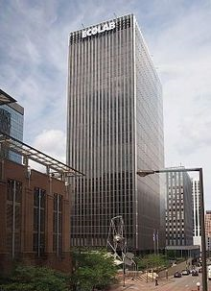
Bacti-Stat AE
0.3% triclosan

(http://www.ecolab.com/product/bacti-stat/?program=antimicrobial-soap)
Eco-Lab Headquarters Building,
St. Paul, MN

(https://en.wikipedia.org/wiki/Ecolab#Products_and_services)
BactifoamPlus
1% triclosan
On May 17, 2014 the Duluth News Tribune announced that Governor Mark Dayton signed a bill making Minnesota the first state in the U.S. to ban the use of triclosan in consumer soaps and cleaning products. The ban (effective on January 1, 2017) covers consumer products, not products sold by firms such as Ecolab to health care and/or food industries.

Due to increasing amounts of triclosan found in the sediments of eight Minnesota lakes and rivers, the Minnesota Pollution Control Agency announced that the state will not renew current state contracts for the purchase of triclosan-containing products. (http://www.duluthnewstribune.com/content/new-minnesota-environmental-law-bans-triclosan)

More on other uses of triclosan

Although soap manufacturers are the largest consumers of triclosan, it is also added to deodorants, lotions, creams and toothpastes. There is also widespread use of this agent to curb the growth of fungus, mildew and bacteria in many consumer and industrial products where it acts as a deodorizer and preservative. Even textile fabricators use triclosan to increase their products’ resistance to mold and bacterial growth.

The U.S. National Institutes of Health (NIH) publishes a list of triclosan-containing products, last updated August 2015, at http://hpd.nlm.nih.gov/cgi-bin/household/brands?tbl=chem&id=75&query=triclosan&searchas=TblChemicals.

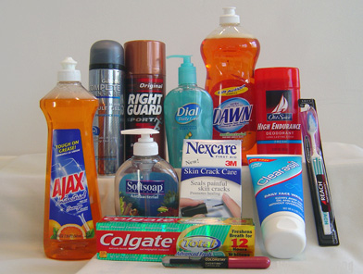
The non-governmental organization (NGO) consumer site “Beyond Pesticides” published an undated comprehensive list with specific product names along with the disclaimer: “Due to public pressure, many major manufacturers have quietly begun reformulating their products without triclosan. Product formulations may change without notice.” This implies that their list may be out-of-date. Items are listed in categories such as: soap (liquid, body wash, sanitizers), dental care (toothpaste, mouthwash), cosmetics (lotions, lip gloss, mascara), deodorant (natural, stick), first aid (antiseptic, spray), kitchenware (cutting boards, ice cream scoops), personal care products (acne kits, lip balm, clothes (socks, undergarments), office and school supplies (pencils, binders) and other (humidifiers, ear plugs, hockey helmets). (http://www.beyondpesticides.org/antibacterial/products.php)
(https://www.beyondpesticides.org/assets/media/documents/pesticides/factsheets/Triclosan%20cited.pdf)

Triclosan is marketed under the name Microban when incorporated into the manufacture of plastics and clothing and as Biofresh when added to acrylic fibers. Microban additives inhibit bacterial and fungal growth, although some do not contain triclosan. The Microban Web site states that not all their products contain triclosan: “Microban utilizes a breadth of antimicrobial technologies.” However, they do not say which of their products uses triclosan. (http://www.microban.com/who-we-work-with/product-types/amertac_usa/faq)

More on the physical properties of triclosan

Troclosan is an off-white crystalline powder with a slightly aromatic odor. It is insoluble in aqueous solutions unless they are alkaline. It is soluble in most organic solvents and it readily dissolves in plastics. Triclosan does not add an offensive odor or taste and is chemically stable to 200 ºC, so it can easily be incorporated into plastic food containers to prevent bacterial and fungal growth. The structural formula is shown in the Harper triclosan article, Figure 1a. A full description of physical and chemical properties of triclosan as well as its toxicity to lab animals, biological half-life, details of biological test results and a list of commercial vendors can be found on the PubChem site. (http://pubchem.ncbi.nlm.nih.gov/compound/triclosan)

The picture below shows triclosan crystals and advertises it as a “Personal Care Antiseptic” and a “hot sale product”. The link for the PubChem site shown above contains a long list of vendors.
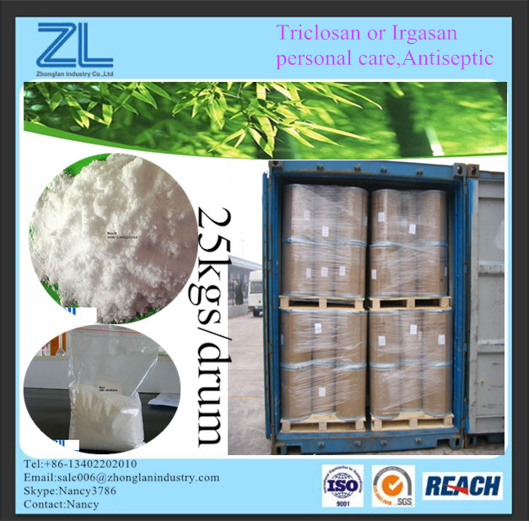

(http://www.chinabiosol.com/product-detail/triclosan/)

More on chemistry of fatty acid production

As described in the Harper triclosan article, triclosan attacks bacteria by inhibiting fatty acid synthesis. Triclosan binds to the bacterial enoyl-acyl carrier protein reductase (ENR) enzyme, which is made by the bacterial gene FabI. This enzyme catalyzes a key regulatory step in the process of linking together fatty acids to form bacterial cell walls. Without these walls, bacterial cells cannot divide and multiply to form bacterial colonies. ENR accepts nicotinamide adenine dinucleotide phosphate (NADPH) as a coenzyme (see pictures below) in this process. Note that this is an oxidation/reduction reaction. NADPH is the reduced form of NADP⁺.

An enoyl is an acyl group derived from an unsaturated (alkenoic) carboxylic acid by removal of a hydroxyl group (or groups) from an oxygen-containing acid (oxoacid). Note that alkenoic means that the acid is from an unsaturated hydrocarbon, an alkene. (https://en.wikipedia.org/wiki/Acyl)

ENR is the final enzyme in the pathway responsible for the production of bacterial fatty acids. Triclosan is a small molecule that, with the assistance of the coenzyme pictured below, can interfere with the action of ENR. (http://www.chem.leeds.ac.uk/colin-fishwick/research.html)

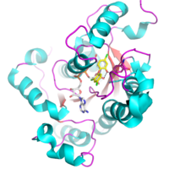

enoyl-acyl carrier protein reductase (ENR) enzyme

(http://www.chem.leeds.ac.uk/colin-fishwick/research.html)

The two coenzymes that assist ENR in the production of bacterial fatty acids are pictured below:

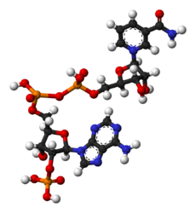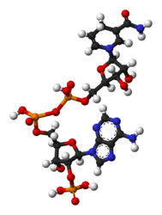
nicotinamide adenine dinucleotide nicotinamide adenine dinucleotide phosphate
NADP⁺ NADPH

(https://en.wikipedia.org/wiki/Nicotinamide_adenine_dinucleotide_phosphate)

This coenzyme is found in the living cells of bacteria, but not in the cells of mammals. The enzymes that catalyze fatty acid production in mammalian cells are both sequentially and structurally different from those present in bacterial enzymes. Triclosan does not interfere with fatty acid production in humans, thus it was thought to be an excellent choice for use as a bactericide in hospitals. (http://www.ncbi.nlm.nih.gov/pubmed/15105103)

More on the human microbiome

Although antibacterial soaps provide more lasting protection from bacteria than washing with non-triclosan-containing products, some people question whether this is necessary. The Harper article states that triclosan kills all bacteria—including those that are important to our health.

In the past ten years, scientists have increasingly studied the human microbiome, the microorganisms present in the environment of the human body. Along with fungi, viruses and mites, the human microbiome consists of an enormous number of bacterial cells. The human body contains ten times more bacterial than human cells. Many of these cells are beneficial aids to our digestive processes, growth and our immune system; others have the potential to be pathogenic. (http://www.scientificamerican.com/article/ultimate-social-network-bacteria-protects-health/?print=true)

The Human Microbiome Project (HMP), an extension of the Human Genome Project (HGP), is a U.S. National Institutes of Health (NIH) initiative launched in 2008. The goal of this five year project was to investigate links between the human microbiome and human health or disease.

The number of publications mentioning the microbiome or microbiota has risen sharply since the 2008 launch of NIH’s Human Microbiome Project.

MICROBIOME MANIA
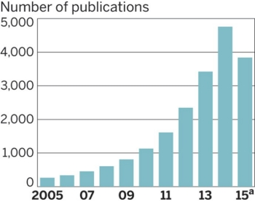

(PubMed: (http://cen.acs.org/articles/93/i38/Harnessing-Hordes-Microbiome.html?type=paidArticleContent)

More on the sequence of microbiome studies

Initial studies of the human microbiome focused on sequencing the genome and identifying the microbes that live on and in humans. Currently scientists are attempting to discover connections between microbes and human diseases and to determine whether microbes cause or simply contribute to human diseases. The next step is to determine how to manipulate the interaction between microbes and their substrate, the human body. For example, a small molecule such as triclosan can be used to interrupt the formation of the fatty acids that form bacterial cell walls.

Two factors have expedited this research:
- New techniques have been developed that greatly expedite the process of genome sequencing.
- The expense of keeping massive amounts of data has been tremendously reduced by use of “the cloud”.

Yet, as cautioned in the Chemical and Engineering News article “Harnessing the Hordes”, “Although dysbiosis (microbial imbalance in the body) has been correlated with many diseases, researchers still need to prove it is causing or contributing to those diseases and not the consequence of them.” (http://cen.acs.org/articles/93/i38/Harnessing-Hordes-Microbiome.html?type=paidArticleContent; the article is available only to members of the American Chemical Society at this same URL.)

More on the human skin microbiome

The diversity of the human skin microbiome has been substantially reduced over the years. Studies of isolated populations in the Peruvian Amazon and Africa show much more bacterial diversity in their skin microbiomes than people living in industrial societies. Maria Gloria Dominquez-Bello, an associate professor of medicine at New York University (NYU), says, “Humans in the U.S. have lost a third of their microbial diversity, mostly on their skin and in their stomachs and digestive tracts.” Martin Blaser, Director of the Human Microbiome Project at NYU and author of the book Missing Microbes: How the Overuse of Antibiotics is Fueling our Modern Plagues states that, “The problem is due in part to the overuse of antibiotics, C-sections and modern sanitation.” Many scientists including Blaser think that our use of antibiotics may be the reason for the increase in asthma, allergies, diabetes, and autoimmune diseases during the last three decades. (http://www.pbs.org/newshour/updates/theres-extinction-happening-stomach/)

Before birth, the skin is devoid of microbes, but bacterial colonization begins the instant that a baby enters the world. The microbiome that forms differs if birth occurs from cesarean section or if the first bacteria come from the mother’s birth canal. Studies show that bacterial colonies are also different on the skin of a breast-fed baby than on a formula-fed child. As a person grows, environmental factors influence the skin microbiome. As bacteria diversify, a more stable atmosphere is created. This provides better protection against harmful species. In addition, response to illness, disease, antibiotics and diet all create changes the microbiome. In general, species variation is highest during childhood and decreases with age.

Briefly these are the events that affect the microbiome at each stage of life:
- Birth: the birth environment—how and where birth occurs
- 1 day to 6 months: usually few environmental changes; type of food—different bacterial species have different food preferences
- 6 months to 3 years: continued changes in nutrition; people and things in the environment; illnesses; antibiotic treatment
- 3 years to adult: continued response to illness, injury and diet changes; major events such as puberty, pregnancy and menopause
- Old age: number of species decrease; colonies on specific human populations become more similar than on individual people

More on human skin bacteria

Healthy human skin provides a physical barrier that limits penetration by microbes and toxins. It is characterized as cool, acidic (pH of approximately 5) and dry. The skin environment also provides unique residences for specific bacterial species such as folded places, varying skin densities and glands.

The bacterial species on the skin are unique to individual people and differ by the microclimate in each skin area. Dry skin areas such as the forearm, buttock and parts of the hand are populated by the greatest diversity of bacterial species. Females have more diverse species than males. It is unclear whether this is due to physiological factors or environmental differences in the female hygiene and use of cosmetics. Bacterial species are also different on the right and left hand of a person. Perhaps this results from increased exposure to environmental factors by the favored hand.

The following chart shows the location and types of bacterial species found on the human body. Additional details about these bacterial species are located in the article, “The Skin Biome”, by Elizabeth A. Grice and Julia A. Segre, on this free-access NIH website: http://www.ncbi.nlm.nih.gov/pmc/articles/PMC3535073/.

Topographical Distribution of Bacteria on Skin Sites

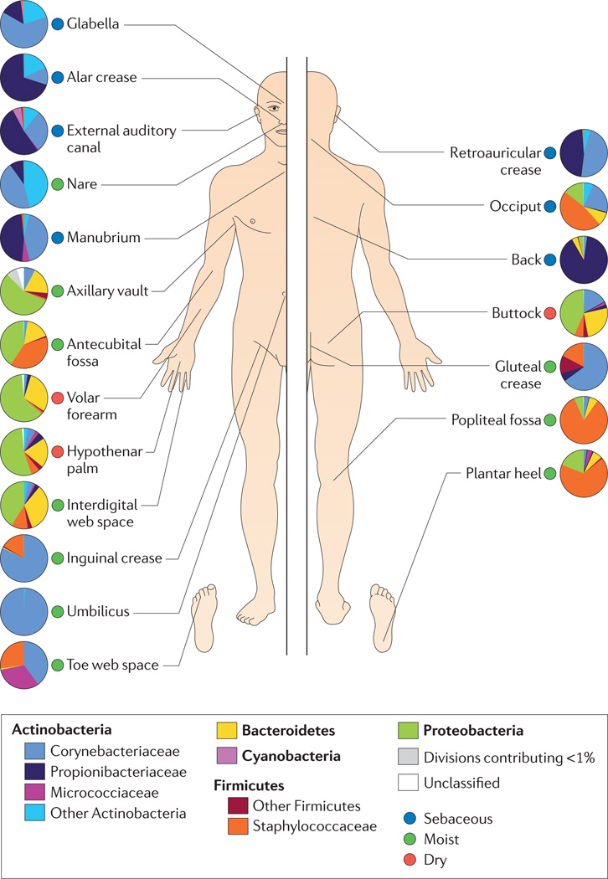

(http://www.ncbi.nlm.nih.gov/pmc/articles/PMC3535073/)

More on “good” human skin bacteria

Most skin bacteria are harmless and some are even beneficial. Commensal bacteria are those that are harmless and may provide benefits to the host. Scientific research shows that the chemistry of the skin biome is very complex and often involves microorganisms working together. For example, Propionibacterium acnes (P. acnes), the bacteria that causes acne, also breaks down the triglycerides in sebaceous gland secretions, releasing fatty acids that help maintain the acidic pH of the skin surface. Many pathogenic bacteria are inhibited by this acidic environment. (http://www.nature.com/jidsp/journal/v6/n3/full/5640052a.html)

The following studies show the importance of some of the bacteria found in the normal human skin microbiome: (Note: The URLs below contain abstracts only; full text is available for purchase.)
- Commensal bacteria in the skin play important roles in providing anti-inflammatory responses to environmental allergens that affect the skin. (http://www.ncbi.nlm.nih.gov/pubmed/25262465)
- In the human nasal cavity, the commensal bacterium Staphylococcus epidermidis (S. epidermidis) prevents the colonization of Staphylococcus aureus (S. aureus), a pathogenic bacterium. Studies of the nasal cavities of human volunteers show that when S. epidermidis is present, S. aureus is absent. (http://www.nature.com/nature/journal/v465/n7296/abs/nature09074.html)
- The composition of skin microbiota affects the skin’s attractiveness to malarial mosquitoes. Studies have found that skin with a high abundance of bacteria, but low diversity of bacterial species is more attractive. These studies have implications for the development of effective repellants. (http://www.ncbi.nlm.nih.gov/pubmed/22216154)

Bacteria that are normally commensal may become pathogenic when they are able to invade the skin. This occurs in cases where the skin barrier of people with compromised immune systems is breached, such as in chronic wounds (often from surgery). Although these bacteria have not caused the initial wound, they may contribute to the persistence of an infection. (http://www.ncbi.nlm.nih.gov/pmc/articles/PMC3535073/)

More on the targets of triclosan

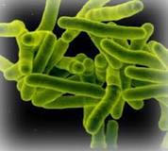
Initially it was thought that triclosan killed by simply attacking bacterial cells. Current scientific research shows the specificity of these attacks on the bacterial ENR, the enzyme required for fatty acid production via the process described in the Harper article and in the “More on chemistry of fatty acid production” section of this Teacher’s Guide. Triclosan is effective against gram-negative and gram-positive bacteria and mycobacteria, bacterial pathogens that cause very serious mammalian diseases such as tuberculosis and leprosy. (http://femsle.oxfordjournals.org/content/202/1/1)
mycobacteria

(http://www.genomeindia.org/mycobacterium/images/mycobacterium.jpg)

Triclosan’s effectiveness against serious pathogens led to its widespread use as a preferred biocide in hospital settings. However, this also led to widespread use as a disinfectant and preservative in personal care products and household items. As the use of triclosan increased, scientists began to question whether bacteria could acquire resistance through mutations involved in normal physiological processes, or from the acquisition of foreign resistant genes (gene transfer). More information on the process of acquired resistance can be found at http://amrls.cvm.msu.edu/microbiology/molecular-basis-for-antimicrobial-resistance/acquired-resistance.

Laboratory studies performed in the 1990s showed that repeated exposure to low sub-lethal concentrations of triclosan produced lower bacterial susceptibility to triclosan. Since 2000, laboratory data has verified resistance to triclosan by dermal, intestinal and environmental microorganisms. A study done by the Norwegian Scientific Committee for Food Safety concluded that the widespread use of triclosan may present a potential public health risk. (http://www.ncbi.nlm.nih.gov/pubmed/16922622; abstract only on this URL, the full text is available for purchase)

More on the link between triclosan and antibiotics

Triclosan is a biocide, a chemical molecule capable of destroying living organisms, including bacteria, fungi, protozoa and viruses. Antibiotics are used to destroy bacterial infections. Biocides and antibiotics are both antimicrobial agents. Scientists are concerned that the increased use of triclosan may lead to bacterial resistance to both triclosan and to antibiotics. (http://ec.europa.eu/health/scientific_committees/opinions_layman/triclosan/en/l-3/1-biocides.htm)

Bacteria employ multiple ways to develop biocide resistance. The mechanisms that bacteria use to colonize in spite of the presence of triclosan are similar to those involved in developing antibiotic resistance. Thus, the concern is that the overuse of triclosan-containing products will not only produce bacterial resistance to triclosan, but it may reduce and/or eliminate the effectiveness of currently used antibiotics. This URL provides a detailed description on research of the mechanisms involved in the formation of bacterial resistance: http://femsle.oxfordjournals.org/content/202/1/1.

More on antibiotic resistance

According to the November 2015 newsletter from the ICAHN School of Medicine, 23,000 Americans will die from antibiotic resistant bacteria every year. This number represents pre-mature deaths caused by antibiotic resistance. (http://www.focusonhealthyaging.com/; newsletter available to subscribers only)

Scientific American magazine republished an article from a December 16, 2014 issue of Chemistry World titled: “Antibiotic Resistance Will Kill 300 Million People by 2050”, with subtitle: “New report says pharma companies make more money from other drugs, so shy away from new antibiotic development”. Note that “pharma” refers to pharmaceutical companies. (http://www.scientificamerican.com/article/antibiotic-resistance-will-kill-300-million-people-by-2050/)

The Review on Antimicrobial Resistance (AMR) referenced in the article above uses the figure given by The World Health Organization (WHO). WHO places the predicted number at 10 million deaths from drug-resistant infections by 2050. AMR had found that global cost predictions increased the urgency to tackle the HIV epidemic, so to spur government action, AMR quantified their prediction of the worldwide economic cost: Up to $100 trillion lost due to these infections. David Cameron, UK Prime Minister, responded, “If we fail to act, we are looking at an almost unthinkable scenario where antibiotics no longer work and we are cast back into the dark ages of medicine.” (http://amr-review.org/)

More on “Superbugs” or MRSA

Antibiotic-resistant bacteria often referred to as “superbugs” are a type of staph bacteria, Methicillin-resistant Staphylococcus aureus (MRSA), that are resistant to many antibiotics currently used to treat Staphylococcus aureus (S. aureus) infections. Excessive use of triclosan may lead to the emergence and proliferation of bacteria that are resistant to both biocides and antibiotics.

A common misconception of the general public is that antibiotics can be used to treat flu. Furthermore, some claim that flu vaccines should be avoided because their use contributes to the overuse of antibiotics. Influenza is a viral infection; preventive vaccines contain inactivated or attenuated viruses.

Blaise Boles, a microbiologist at University of Michigan, Ann Arbor, swabbed the noses of 90 adults. When the swabs were analyzed, it was found that those that contained triclosan were twice as likely to also contain S. aureus.

This suggests that the bacteria may have adapted to triclosan. Low concentrations of triclosan over long periods can contribute to mutations of Fabl, the bacterial gene that produces the enzyme ENR. Altered Fabl produces versions of ENR that reduce the ability of the triclosan molecule to lock to ENR and block its ability to catalyze the fatty-acid synthesis required for S. aureus bacteria to form their cell walls. Thus, they can replicate and grow to form colonies. (http://mbio.asm.org/content/5/2/e01015-13.full)

More on triclosan’s environmental presence

Up to 96% of the triclosan in commercial products is washed down the drain. Any staph bacteria present in the plumbing either dies or becomes triclosan-resistant. Since triclosan is added to so many products, particularly those used in personal care such as soaps and toothpastes, increasing amounts of these molecules enter our waste water treatment systems. In 2002 the U.S. Geological Survey reported that triclosan was one of the top ten major organic wastewater contaminants of American rivers. (http://pubs.acs.org/doi/full/10.1021/es500495p)

Since waste water treatment plants do not have the technology to remove substantial amounts of triclosan, humans and other animals are exposed to low level, but potentially dangerous, concentrations. A 2014 study published by the National Institutes for Health (NIH) quantifies the amount of triclosan in sewage sludge and the significant amount remaining after waste water treatment. The study credits the high loads of triclosan coming from the use of consumer products with creating an overload on treatment systems. (http://www.ncbi.nlm.nih.gov/pmc/articles/PMC3989550/)

The University of California-San Diego’s “UCSD Health” bulletin reports on triclosan’s presence in the environment: “It is one of the seven most frequently detected compounds in streams across the United States.” (http://health.ucsd.edu/news/releases/Pages/2014-11-17-dirty-side-of-soap.aspx)

More on triclosan’s mimicry

In addition to bacterial resistance, triclosan molecules can mimic other molecules as described in the Harper article. Figure 1 in the article shows the ring structures in triclosan (1a) similar to those in thyroxine (1b) and estradiol (1c). This similarity led scientists to exam the possibility that triclosan could mimic the biological behavior of these hormones.

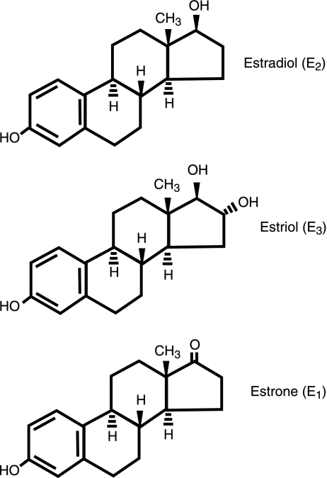
Triclosan is an estrogen mimic. This means that it is an artificial hormone that behaves biologically the same as estrogen. In the Harper article, Figure 1c shows the structural formula for estradiol, one of three forms of the estrogen hormone. While all three forms are involved in important functions and signaling in biological systems, the concentration levels of these forms varies according to developmental stages.
three forms of the estrogen hormone

(http://www.ncbi.nlm.nih.gov/pmc/articles/PMC2518256/)

In humans, estradiol is the most commonly measured form associated with the female reproductive stage; estriol is measured during pregnancy; and estrone is more prevalent after menopause. Studies link estrogen to cancer, suggesting that triclosan may be carcinogenic. A detailed, quantitative study of the estrogen forms and their biological roles, including the processes of disease, was published in The Journal of the Federation of American Societies for Experimental Biology and the full text is located on this NIH website: http://www.ncbi.nlm.nih.gov/pmc/articles/PMC2518256/.

Research at the University of Wisconsin-Eau Claire Watershed Institute found that overexposure to estrogens was characterized by delayed sexual maturity in aquatic animals. Males showed a decrease in reproductive anatomy and females laid thinner eggs. This paper lists triclosan in hand soap as one of the estrogen mimics that is washed down the drain into our water systems: http://www.uwec.edu/Watershed/research/pollutiontour/estrogen-and-estrogen-mimics.htm.

More on thyroxine mimicry

Thyroxine, the major hormone secreted by the thyroid gland, is responsible for regulating metabolism. As in estrogen chemistry, triclosan chemically mimics thyroxine and binds to its receptor sites. Once blocked by triclosan, the thyroid hormone cannot function.

The importance of experimental design is described in paper number 14 “Germ Fighter Works as Endocrine Disrupter” presented to the Washington Research and Information Working Group of the Collaborative on Health and the Environment. The paper describes the research process used to study triclosan effects on frog metabolism at the University of Victoria, British Columbia, Canada (UVic).

This paper credits researcher C. C. Helbing with a “very clever” design because, instead of exposing tadpoles to triclosan alone, she added the thyroid hormone (not present in tadpoles) to the triclosan. Cathy Propper of Northern Arizona University suggests that the research results indicate that the triclosan molecule may not actually mimic thyroid hormones, but it does interfere with their function and increases the speed of their impact. These studies will be described below in the next section on frog studies. (http://washington.chenw.org/bulletins/CHEWAbulletin11-1-06.html; click on paper 14 in the agenda provided in this URL)

More on animal studies

Frogs

Much of the current ongoing research on the effects of triclosan in the environment comes from laboratories at the University of California at Davis (UC-D) and the UVic.

Fat-soluble triclosan can easily cross cell membranes of aquatic animals. This property presents the potential for bioaccumulation over the full life cycle of frogs. Research shows that triclosan’s hormone disrupting ability can occur at lower than normally considered toxic levels. Details on UVic measurement techniques used to collect quantitative data on the presence of triclosan in animal tissue is located at the URL: http://www.sepscience.com/Sectors/Enviro/Articles/1866-/Development-of-A-Rapid-Liquid-Chromatography-Tandem-Mass-Spectrometry-Method-for-The-Determination-of-Triclosan-in--Animal-Tissue-Matrices.

In June 2007 Nik Veldhoen of UVic published data from research on the effects of triclosan on the North American bullfrog. This work showed that triclosan induced changes in the thyroid hormone involved in metamorphosis from tadpole to frog by affecting the expression of the hormone receptor involving the binding protein. His team found that when tadpoles were immersed in low environmental concentrations of triclosan, they showed an increase in hind limb development and a decrease in body weight. (http://www.researchgate.net/publication/6783914_The_Bactericidal_Agent_Triclosan_Modulates_Thyroid_HormoneAssociated_Gene_Expression_and_Disrupts_Postembryonic_Anuran_Development)

As mentioned in the section above, the key to the success of their experimental design was the exposure of tadpoles to a combination of triclosan and thyroid hormones. The accelerated hind-limb development of tadpoles indicated that the signal to turn tadpole fins into frog legs was altered as described in paper number 14:

This experimental design is very clever because [Helbing] looked at both the presence and absence of thyroid hormone," says Tom Zoeller, an endocrinologist at the University of Massachusetts, Amherst. If Helbing had merely exposed the tadpoles to triclosan alone, she would have missed adverse effects on the thyroid system, he says. But because she added thyroid hormone along with triclosan, she could see that the triclosan made the thyroid hormone much more potent than it would have been under normal circumstances. These results hint that triclosan does not mimic thyroid hormones but instead speeds up their impact, says Cathy Propper, an endocrinologist at Northern Arizona University. Although the mechanism is unknown, triclosan may be making protein receptors in the cell more sensitive to thyroid hormones, Zoeller speculates. Because thyroid-hormone signaling is essential for the development of the human brain and body, the new study raises red flags for human health, Zoeller says.

(http://washington.chenw.org/bulletins/CHEWAbulletin11-1-06.html)

Another study at several universities in British Columbia, Canada, investigated the effect of triclosan on Pacific tree frogs. Even when the research team found low environmental concentrations of triclosan, the thyroid signalling pathway required for normal growth and development was compromised. This paper discusses the challenges and techniques required to produce reliable data on the amount of triclosan in frog tissues. (http://www.sepscience.com/Sectors/Enviro/Articles/1866-/Development-of-A-Rapid-Liquid-Chromatography-Tandem-Mass-Spectrometry-Method-for-The-Determination-of-Triclosan-in--Animal-Tissue-Matrices)

Rats and mice

Experiments on mice performed at UC-Davis and the University of Colorado show that triclosan affects the flow of calcium ions through molecular channels in muscle cells. This impairs the contraction of heart and skeletal muscles. Within 20 minutes of exposure to triclosan, mice showed a 25 percent reduction in heart function. In addition, after an hour exposure, the strength of their grip was reduced 18 percent. (http://news.ucdavis.edu/search/news_detail.lasso?id=10301) Additional research details of the laboratory procedures and data obtained by the UC-Davis research team are published by the Proceedings of the National Academy of Sciences (PNAS) in “Triclosan impairs excitation-contraction coupling and Ca²⁺ dynamics in striated muscle.” (http://www.pnas.org/content/109/35/14158.full)

An eight month study of adult female rats exposed to triclosan showed estrogen-induced changes in smooth muscle tissue of the uterus. In addition, similar studies of male and female rats found suppression of thyroid hormones. http://toxsci.oxfordjournals.org/content/117/1/45.long)

Robert Tukey, UC-San Diego, found that triclosan disrupted liver function in mice. Also, when mice were given chemically-induced tumors, those exposed to triclosan for six months (equivalent to 18 human years) had larger and more frequent tumors than seen in mice that were not exposed to triclosan.
(http://news.ucdavis.edu/search/news_detail.lasso?id=11092)

Fish

In 1998, the U.S. Environmental Protection Agency (EPA) estimated that the U.S. produced more than 1 million pounds of triclosan. Thus, triclosan is continually added to many products, especially those used in personal care. These are washed down the drain to enter our water system. Triclosan has been detected in algae, fish and dolphins. Patricia Fair, research physiologist and author of the National Oceanic and Atmospheric Association (NOAA) dolphin study, reported: “The fact that this chemical is found in the environment and is being detected in a top level predator certainly warrants concern.” (http://www.scientificamerican.com/article/dolphin-development-antibacterial-soap-triclosan/)

Research at the University of California-Davis and the University of Colorado found that triclosan affects muscle contraction at the cellular level and slows swimming in fish. After a week in triclosan-contaminated water, fathead minnows showed significantly reduced swimming activity. (http://news.ucdavis.edu/search/news_detail.lasso?id=10301)

“Links” to humans

The U.S. Centers for Disease Control and Prevention (CDC) “Fact Sheet” on triclosan (http://www.cdc.gov/biomonitoring/Triclosan_FactSheet.html) reports that triclosan was detected in the urine of 75% of the people tested in 2003–2004. The CDC “Fourth National Report on Human Exposure to Environmental Chemicals”, February 2015, gives measurements of urinary triclosan. The data table shows amounts by age group, gender and ethnicity for the years 2003–2012. This data is located on pages 26–29 of the CDC report.
(http://www.cdc.gov/biomonitoring/pdf/FourthReport_UpdatedTables_Feb2015.pdf)

There have been recent concerns about the possible effects on human health, since triclosan has been detected in human breast milk, blood and urine samples as stated in the Harper article and seen in the CDC data. When discussing a possible link between triclosan and allergies, Harper speaks of the importance of recognizing the difference between a link and laboratory data that demonstrates causation. When reading material from the Internet, students will need to make this distinction in order to make reliable claims about environmental concerns.

Nipavan Chiamvimonvat, UC-Davis professor of cardiovascular medicine, cautioned about extrapolating animal studies to effects on humans. He said, “In patients with underlying heart failure, triclosan could have significant effects because it is so widely used. However, without additional studies, it would be difficult for a physician to distinguish between natural disease progression and an environmental factor such as triclosan.”
(http://news.ucdavis.edu/search/news_detail.lasso?id=10301)

Tukey, also from UC-Davis, said, “Triclosan’s increasing detection in environmental samples and its increasingly broad use in consumer products may overcome its moderate benefit and present a very real risk of liver toxicity for people, as it does in mice, particularly when combined with other compounds with similar action.” Note that this is a link, not a cause supported by laboratory research. (http://news.ucdavis.edu/search/news_detail.lasso?id=11092)

More on dioxin formation

About 98 percent of triclosan in waste water is removed from the liquid phase by anaerobic and aerobic bacterial digestion during initial waste water treatment, but much of this is concentrated in the solid sludge (biosolids). Tracing triclosan as it travels beyond the water purification plant into our environment:
- Liquid phase: triclosan returns to streams, lakes, underground water systems
- Solid phase: triclosan trucked to landfills and agricultural fields or bagged as fertilizer for home gardens (Note: Triclosan can bioaccumulate to some degree.) (http://www.ncbi.nlm.nih.gov/pmc/articles/PMC3989550/)
- Solid phase: triclosan incinerated to generate electricity
(http://www.ncbi.nlm.nih.gov/pmc/articles/PMC3989550/)

The structural formula, Figure 1 in the Harper article, shows triclosan’s benzene rings and chloride attachments. Chlorinated derivatives of triclosan are formed during chlorination to disinfect drinking water. Upon exposure to the sun’s ultraviolet radiation, these molecules react photochemically to form polychlorinated dibenzo-p-dioxins. (See picture below.) Core samples from Minnesota lakes showed low levels of dioxins prior to triclosan use. Since 1964 when triclosan was patented, the quantity of dioxins has increased in the sediments of lakes that receive discharge from waste water treatment plants (WWTP). In a lake where no wastewater was expelled, no triclosan or its derivatives were detected. (http://pubs.acs.org/doi/abs/10.1021/es3045289?prev=&journalCode=esthag; this URL contains the abstract only; subscription to Environmental Science and Technology is required for full text access.)

Photochemical Formation of Dibenzo-p-dioxins from Triclosan

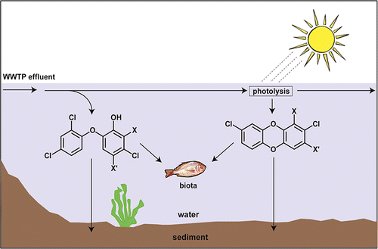

(http://pubs.acs.org/doi/abs/10.1021/es3045289?prev=&journalCode=esthag)

When Douglas Latch of Seattle University added triclosan to water in the Suwannee River, Georgia at noon in the summer sunlight, 3–12 percent of the triclosan rapidly photo-degraded to dioxins. (http://www.ncbi.nlm.nih.gov/pubmed/15779749; abstract only available at this URL.)

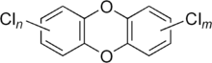
Polychlorinated dibenzodioxins (see figure at right) are a group of probable carcinogens that contain two benzene rings, a diether and multiple chlorines. These molecules are fat soluble so they accumulate in the bodies of aquatic animals. Dioxins are considered a serious health threat to humans. Interference with regulatory hormones causing reproductive and development problems and immune system damage may be attributed to heavy exposure. A thorough review of dioxins is located on this URL in a paper accepted by Elsevier from the Chemical Engineering Journal, Hong Kong University, Science and Technology: http://www.hia21.eu/dwnld/20120419_17.pdf.
Structure of polychlorinated dibenzo-p-dioxins (n and m can range from 0–4 chlorine atoms)

(https://en.wikipedia.org/wiki/Polychlorinated_dibenzodioxins)

In addition to photochemical production of dioxins from triclosan, the heat involved in the incineration process used by waste water treatment facilities can also form dioxins from triclosan. (http://www.hia21.eu/dwnld/20120419_17.pdf)

More on U.S. government testing and regulations

Due to its wide range of uses, triclosan is regulated by three government agencies, the U.S. Food and Drug Administration (FDA), the U.S. Environmental Protection Agency (EPA), and the U.S. Consumer Product Safety Commission (CPSC). Each regulatory body covers different types of products:
- FDA: foods, drugs, medical supplies, cosmetics, tobacco, veterinary products
- EPA: drinking water, pesticides, indirect food use (e.g., plastic food storage containers, fabrics)
- CPSC: ensures safety of consumer products, their sale and manufacture (e.g., children’s cribs, all-terrain vehicles)
(http://www.fda.gov/AboutFDA/Transparency/Basics/ucm194879.htm)

The FDA is responsible for products intended for use on the human body and the EPA covers uses not applied to the human body. If a product claims to “kill germs” such as triclosan-containing soap, FDA classifies it as a “drug”; if it makes only cosmetic claims such as “improves skin” or “fights odors”, it is considered a cosmetic. The EPA’s jurisdiction includes all products not intended for use on the human body, such as kitchen cleaners and hospital disinfectants. These are categorized as “pesticides”.

The FDA has approved the addition of triclosan to Colgate Total toothpaste because evidence shows that the triclosan in this product is effective against gingivitis. Thus, it is considered a “drug”. In terms of its use in antibiotic-resistant soaps, the FDA has received no evidence that it provides an extra health benefit so it is classified as a “cosmetic”. In fact, the FDA has not accepted evidence that soap products containing triclosan are more effective than soap and water. (http://www.fda.gov/ForConsumers/ConsumerUpdates/ucm205999.htm)

More on FDA and EPA working together on triclosan

Since uses for triclosan involve both FDA and EPA jurisdictions, the two agencies are working together to determine government consistency on regulations. Sharing data from human clinical trials and animal studies enhances their ability to thoroughly evaluate the benefits and risks of triclosan use on human health.
(http://www.fda.gov/ForConsumers/ConsumerUpdates/ucm378393.htm)

Both the FDA and EPA regulate using risk-benefit analysis based on data obtained from human and animal studies. The burden of truth is placed on the manufacturer. For approval, the drug must be deemed safe and effective for its intended use, benefits must outweigh risks, labeling must be appropriate and before the expiration date the drug’s purity, quality and strength must be guaranteed. Regulations are explained on page 14 of this URL: https://www.beyondpesticides.org/assets/media/documents/pesticides/factsheets/Triclosan%20cited.pdf.

The EPA requires a comprehensive risk assessment for all registered uses of a chemical. The Reregistration Eligibility Decision (RED) application for triclosan covers 99 pages and includes data for human health concerns, environmental exposure and associated risks. Although there is no direct food use of triclosan, this paper describes and evaluates indirect uses such as for paper, cutting boards and counter tops. In March 2005, EPA classified triclosan as “Not Likely to be Carcinogenic to Humans”.
(http://archive.epa.gov/pesticides/reregistration/web/pdf/2340red.pdf)

More on information for consumers

The FDA published a bulleted list of “What Consumers Should Know” (about triclosan-containing products). Information was updated November 25, 2013:
- Triclosan is not known to be hazardous to humans.
- FDA does not have sufficient safety evidence to recommend changing consumer use of products that contain triclosan at this time.
- In light of questions raised by recent animal studies of triclosan, FDA is reviewing all of the available evidence on this ingredient’s safety in consumer products. FDA will communicate the findings of its review to the public in winter 2012.
- At this time, FDA does not have evidence that triclosan added to antibacterial soaps and body washes provides extra health benefits over soap and water. Consumers concerned about using hand and body soaps with triclosan should wash with regular soap and water.
- Consumers can check product labels to find out whether products contain triclosan.
(http://www.fda.gov/forconsumers/consumerupdates/ucm205999.htm)

More on International regulations

The Scientific Committee on Consumer Safety (SCCS) of the European Commission provides opinions on health and safety risks of nonfood consumer products (such as triclosan) and services. On April 9, 2014 they issued “Commission Regulation (EU) No 358/2014”. Item number 3 concerns the use of triclosan (Note: SCCP is the acronym for Scientific Committee on Consumer Products.):

3) The SCCP considered that the continued use of triclosan as a preservative at the current maximum concentration limit of 0,3 % in all cosmetic products is not safe for the consumer because of the magnitude of the aggregate exposure, and the SCCS confirmed this position. However, the SCCP considered that its use at a maximum concentration of 0,3 % in toothpastes, hand soaps, body soaps/shower gels and deodorants, face powders and blemish concealers is safe. In addition, the SCCS considered that other uses of triclosan in nail products where the intended use is to clean the fingernails and toenails before the application of artificial nail systems at a maximum concentration of 0,3 % and in mouthwashes at a maximum concentration of 0,2 % are safe for the consumer.

(http://eur-lex.europa.eu/legal-content/EN/TXT/?uri=uriserv:OJ.L_.2014.107.01.0005.01.ENG)

Beginning in 2010, the German Federal Institute for Risk Management (BfR) banned the use of triclosan in food contact plastics. The BfR also released this statement, “Triclosan is often present in very low concentrations and it is used although it does not offer any hygiene advantages that could not be achieved with conventional cleaning agents.”
(http://www.bfr.bund.de/cm/349/bfr_supports_ban_on_triclosan_in_food_contact_materials.pdf)

More on nongovernmental organizations (NGOs)

NGOs are policy and action groups that provide information to consumers and advocate for consumer rights and protections. Among other projects, they aim to protect people from false information in advertising, food labeling (including additives like triclosan) and biotechnology.

Often, effective ways to encourage companies to consider consumer needs involve posting concerns online, lobbying and urging people to boycott a product. The Harper triclosan article reports that two NGOs, the Campaign for Safe Cosmetics and the Center for Environmental Health, sent alerts to their supporters regarding triclosan in Bath and Body Works’ teenage focused soaps. A blog on “non-toxic kids”, another NGO, urges readers to take a “Triclosan-Free pledge” and address their concerns to EPA and the CEO of Bath and Body Works. This blog contains an embedded link to the address for the CEO. (http://non-toxickids.net/2011/07/bath-and-body-works-take-toxic.html)

Perhaps at the urgings of NGOs, Bath and Body has introduced a newly formulated “Deep Cleansing Hand Soap” that has “antibacterial” dropped from its name. In other words, their spring 2014 soaps are triclosan-free. (http://www.musingsofamuse.com/2014/02/bath-body-works-relaunches-hand-soaps-spring-2014.html)

More on how to identify NGO sites

When students are looking for reliable information to support their claims regarding triclosan, they should be aware that NGOs are usually supported by private donations (a link button frequently appears on the website) and/or supported by products that they sell. For example:
- The blog on the non-toxic kids site mentioned in this Teacher’s Guide section above contains advertisements for the blogger’s books
- Ciba Specialty Chemicals (maker of triclosan) posted an article on Chemical Industry News and Market Intelligence titled: “Ciba defends antibacterial triclosan in soap”. (http://www.icis.com/resources/news/2008/06/23/9132724/ciba-defends-antibacterial-triclosan-in-soap/)
- The NGO Food & Water Watch page has a link to “Donate” where the article “What’s lurking in your soap? The trouble with triclosan” is located. (https://www.foodandwaterwatch.org/insight/what%E2%80%99s-lurking-your-soap-trouble-triclosan)
- The NGO The Environmental Working Group advocates in areas of toxic chemicals. Enter the home page and a giant pop-up appears with, “Help EWG Fight -- DONATE”. (http://www.ewg.org/)

Currently many are campaigning for removal of triclosan from products by implying that consumers should boycott triclosan-containing products based on “links” to animal research that they imply as “causes” of illnesses. Reliable NGOs will provide verifiable sources of information such as peer-reviewed journals or U.S. government Web sites.

Others provide no information sources. The Washington Post reports that Brian Sansoni, representative of the U.S. cleaning products industry, considers triclosan concerns unfounded. He says, “These products and ingredients have been reviewed, regulated and researched for decades," and "We believe the science strongly supports the safety and efficacy of these products. It's more important than ever that consumers continue to have access to these products. It's a time of increased threats from disease and germs." (http://www.washingtonpost.com/wp-dyn/content/article/2010/04/07/AR2010040704621.html)

The boxed list of guidelines for evaluating Internet claims on page 25 of the Harper article is an excellent resource for students.

Connections to Chemistry Concepts
(for correlation to course curriculum)
- Organic structural diagrams—Figure 1a in the Harper article provides the opportunity to discuss the stability of benzene rings as well as pointing out that oxygen joins the two rings as a slightly bent ether structure and a hydroxyl group, plus 3 chlorines are attached to the rings.
- Mechanisms of enzymes and structural mimicry—Students who have studied biology may be familiar with the “lock and key” description of enzymatic actions. Ask them to try to visualize how the benzene rings of triclosan (Figure 1a) can fit into and block the sites where thyroxine (1b) and estradiol (1c) hormones normally bind.
- Organic catalysis—Students may be familiar with the sometimes spectacular, explosive effects of adding an inorganic catalyst to a reaction (e.g., adding a piece aluminum foil to a saturated copper sulfate solution to show the slow reaction, then adding 3 M hydrochloric acid to catalyze the reaction; then, asking students to consider what would happen if this rapid reaction occurred in their bodies). Biochemical reactions that involve breaking covalent bonds must be slower (even when catalyzed by enzymes) to prevent stress or even death of the host.
- Chemical Bonding—The difference between inorganic and organic catalysis explained in number 3 above provides the opportunity to discuss and compare ionic and covalent bonding.
- Hormones—Hormones function as enzymes (organic catalysts). There may be students in your classroom who are familiar with thyroid deficiencies. For example, goiter may be caused by an iodine deficiency. To avoid this problem, many countries add elemental iodine to table salt. In the chemistry lab, iodized salt will form a slightly cloudy solution so teachers purchase non-iodized salt for laboratory use. This presents an opportunity to bring some supermarket chemistry into your course.
- Fatty acids—Students may require some help understanding the processes involved in bacterial fatty acid formation. To enhance student interest, a hands-on laboratory experience for making biodiesel from fatty acids is suggested as “In-Class Activities” number 4 in this Teacher’s Guide.
- Scientific Process—The Harper triclosan article presents the opportunity to discuss how scientists use experimental design to solve problems. For example, one well planned experiment involves exposing people to triclosan before their allergies begin.
- Evaluation of scientific claims—As preparation for student research projects, a discussion of methods to evaluate the reliability of claims is essential. Guidelines given in boxed information in the Harper article will provide a good beginning.

Possible Student Misconceptions
(to aid teacher in addressing misconceptions)
- “I think that I’ll just stop using all hand sanitizers due to the possible effects of triclosan on teenagers.” Read labels carefully. Many products sanitize with chemicals such as ethyl alcohol rather than triclosan.
- “There is probably no way that I can tell if my hand soap contains triclosan.” Antibacterial soaps are considered over-the-counter drugs by the U.S. Food and Drug Administration (FDA). If your soap contains triclosan, it will be listed in the Drug Facts box on the soap wrapper.
- “Since triclosan is in our environment, the U.S. Environmental Protection Agency (EPA) should regulate its use in toothpaste.” The EPA regulates triclosan in pesticides but over-the-counter products such as toothpaste are regulated by the FDA.
- “It would be easier if all triclosan products were banned.” Hospital based uses including scrubs for surgeons are often essential to curtail life-threatening bacterial infections.
- “I work out a lot and am very healthy, so I’ll skip the flu shot and use triclosan-containing soap to kill dangerous bacteria.” Triclosan will kill bacteria, but a flu vaccine is needed to prevent influenza because the flu is caused by viruses, not bacteria.
- “My family always uses antibacterial soap with triclosan; it is a little more expensive but when it comes to protecting our family’s health, we feel that the extra protection is more important than the cost.” Studies have shown that triclosan-containing products are not significantly better at killing germs than plain soap. While plain soap and water go a long way toward protecting your health, additional studies are required to assess the possible long-term effects of triclosan on the human body, and animal studies have shown severe effects on the reproductive and metabolic processes of fish, frogs and mice.

Anticipating Student Questions
(answers to questions students might ask in class)
- “I’ve never heard of the Campaign for Safe Cosmetics; is this something from the government?” The Campaign for Safe Cosmetics is not a U.S. government program. It is a non-profit environmental working group that advocates for the removal of toxic chemicals from the environment by providing information to the public.
- “If triclosan can cause health problems, why is it added to the material used to make children’s toys?” Triclosan’s ability to kill bacteria has made it a choice addition to reduce bacterial contamination of materials used to make children’s toys.
- “Why are large corporations removing triclosan from their products?” Many corporations are removing triclosan from their products, most often in response to customer concerns.
- “What does it mean when the article says, ‘show correlation but not causation’?”
For example: Showing “correlation” means that triclosan and allergic reactions are linked; “not causation” means that triclosan may not cause allergic reactions.
- “Why do doctors say that we need some bacteria on our skin?” Not all bacteria are harmful, most of them are important to our health and they play an important role in preventing the colonization of harmful bacteria.
- “What do triclosan-affected frogs look like?” Triclosan affects the normal hormonal process involved in the metamorphosis of tadpoles to frogs. When tadpoles are exposed to triclosan, their fins do not develop as normal hind legs of frogs, indicating a disruption of the production of the thyroid hormones.
- “The molecules of triclosan and thyroxine look different to me, so how can triclosan mimic them?” While the molecular structures are not identical, they both contain benzene rings. This implies that the ring(s) of triclosan can lock into the normal thyroxine site.
- “How can I tell if there is triclosan in a product that I am using?” If an over-the-counter product contains triclosan, it must be listed as an ingredient on the label.
- “Does Bath and Body Works still sell “Tangelo Orange Twist” and “Sugar Lemon Fizz” soaps containing triclosan?” No, due to customer concerns, Bath and Body Works has introduced a new line of soaps that do not contain triclosan.

In-Class Activities
(lesson ideas, including labs & demonstrations)
- Review organic nomenclature by asking student groups to match the chemical name for triclosan to its chemical structure as shown in the Harper article. The name accepted by the International Union of Pure and Applied Chemistry (IUPAC) is 5-chloro-2-(2,4-dichlorophenoxy)phenol. There are several other names for the same structure used in scientific journals. Probably an easier name for students to dissect is: 2,4,4’-trichloro-2’-hydroxydiphenyl ether. Student groups will easily see the 3 chlorines as trichloro; recognize the hydroxy as the –OH group; note that diphenyl indicates 2 benzene rings and learn that the ether functional group –O– joins the two rings.
- The six-minute YouTube video from the University of Oklahoma, “The Ancestral Human Microbiome—Adventures in Genomics” can be used to provide a good introduction to the significance of the decrease in microbiome diversity in industrial societies and the future challenges that this involves. Although triclosan is not mentioned, the video could lead to a student discussion and sharing of the prevalence of antibacterial products such as triclosan in their everyday lives. (https://www.youtube.com/watch?v=UNm8dVHBA7I)
- Here’s a hands-on laboratory activity to test the effects of triclosan: Students will make two lines on each of two agar plates with their unwashed fingers. One plate will be the control, the other will be prepared by mixing a small amount of triclosan-containing material (such as antibacterial soap, Colgate toothpaste, etc.) before agar is poured. After incubation, compare the amount of plate growth to determine if (and how much) triclosan affects the hand microbiome. Ask a biology teacher for instructions on preparing sterile plates, incubation, student safety and disposal. These URLs contain labs that can be modified for this experiment: (http://www.geglobalresearch.com/blog/comparing-application-methods-for-antibacterial-hand-lotion and http://www.biologycorner.com/worksheets/bacteria_lab.html)
- “Synthesizing and Evaluating Biodiesel Fuel” is a laboratory exercise from the American Chemical Society text Chemistry in the Community, 6th Edition, Experiment 4D.8. In this experiment, students will prepare an ester using fatty acids (canola oil, a triglyceride composed of glycerol bonded to three fatty acids), alcohol (methanol), catalyst (potassium hydroxide), and salt (to dehydrate the product). Note: Many similar laboratory procedures can be accessed on the Internet. For example, Loyola University of Chicago allows free access to both a teacher’s manual and the student lab at http://web.cals.uidaho.edu/biodiesel/high-school-curriculum/.
- You could set up an in-class discussion on the choice to use antibiotics such as triclosan: This TED^{X} Cambridge talk provides extensive background information on the microbiome and the implications for health when it is altered by antibiotics. Bernat Olle presents an interesting personal scenario of illness during his honeymoon in Nepal. He and his bride are hundreds of miles from a hospital. The video runs 17.45 minutes so you may choose to use clips from it or ask students to view it at home. (https://www.youtube.com/watch?v=yScP4Cm0-gE)
- Catalysis Activity: Demonstrate or design a student lab to study the difference in rate between inorganic catalysts and enzymes. Study the rate of decomposition of household hydrogen peroxide by adding small pieces of fruit containing enzymes (potato, apple, banana, etc.) compared to the rate of decomposition with a small amount of iron (III) chloride or potassium iodide, inorganic catalysts. The rate can be compared by counting the bubbles of O₂ released per minute during decomposition.

Out-of-Class Activities and Projects
(student research, class projects)
- Prepare for classroom debate: Should triclosan be banned? The side bar for the Harper article contains some guidelines to help students evaluate the scientific validity of material that they find on the Internet. Stress the importance of using data from reliable sources to support their arguments.
- Hold a contest: Ask students, “Who can find the most commercial products that contain triclosan?” Tell students to construct a data table to record the name of the item, the manufacturer and the percent of triclosan in the product. This could lead to a classroom discussion about the type of products that contain triclosan, the reason for its inclusion and the students’ thoughts and concerns about the importance of the use of triclosan in certain consumer products.
- Ask students to write a letter or an editorial for their school or local paper expressing their views on the use of triclosan.
- A paper, debate or discussion on the use of antibiotics and antibacterial agents such as triclosan could be introduced by a “view at home” Technology, Entertainment and Design (TED) talk (17.29 minutes) featuring Clair Fraser, Director of the Institute for Genome Sciences at the University of Maryland School of Medicine. This talk presents data to support the hypothesis that frequent use of antibiotics to treat childhood diseases may create less diversity and cause less stability of the human microbiome leading to increased susceptibility to illnesses such as asthma and allergies. (https://www.youtube.com/watch?v=GSRGlbXkJs4}

References
(non-Web-based information sources)
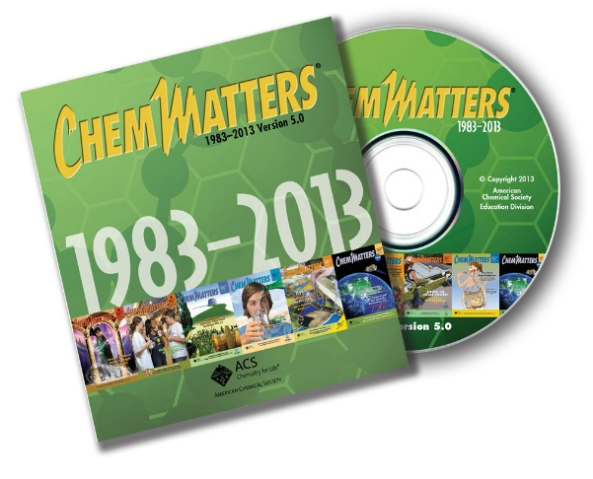
30 Years of ChemMatters

Available Now!

The references below can be found on the ChemMatters 30-year DVD (which includes all articles published during the years 1983 through April 2013 and all available Teacher’s Guides, beginning February 1990). The DVD is available from the American Chemical Society for $42 (or $135 for a site/school license) at this site: http://ww.acs.org/chemmatters. Click on the “Archive” tab in the middle of the screen just under the ChemMatters logo. On this new page click on the “Get 30 Years of ChemMatters on DVD!” tab at the right for more information and to purchase the DVD.

Selected articles and the complete set of Teacher’s Guides for all issues from the past three years are available free online at the same Web site, above. Simply access the link and click on the aforementioned “Archive” tab.

Baxter, R. Antibacterials─Fighting Infection Where it Lives. ChemMatters, 2002, 20 (3), pp 10–11. Baxter says that some doctors and scientists are concerned because triclosan kills good as well as bad bacteria, and its use may lead to bacterial resistance.

Washam, C. Drugs down the Drain. ChemMatters, 2011, 29 (1), pp 11–13. Washam discusses the problem of drugs including triclosan going through wastewater treatment facilities and reacting with the chlorine used to disinfect wastewater. The article reports that the city of Palo Alto, CA has banned the use of triclosan-containing soap from its government facilities.

Sitzman, B. and Goode, R. Hand Sanitizers, Soaps, and Antibacterial Agents: The Dirt on Getting Clean. ChemMatters, 2011, 29 (4), p 4. This article describes the potential problems involved in the overuse of antibiotic cleaners such as triclosan and asks students to consider whether they should be banned from over-the-counter products.

Haines, G. Mascara: That Lush Look You Love. ChemMatters, 2012, 30 (4), pp 14–15. Mascara contains parabens for preservation because they kill molds and bacteria, as does triclosan. Haines says that parabens may cause cancer and hormone imbalance.

Pickett, M. Underarm yourself with Chemistry. ChemMatters, 2014, 32 (2), pp 6–8. This article describes the role of triclosan in deodorants. Triclosan has been used since 1972 to kill odor-producing bacteria.

Gmurczyk, M. Parabens: A Source of Concern? ChemMatters, 2015, 33 (2), pp 8–9. Parabens are molecules that mimic estrogen. Parabens are used as preservatives in cosmetics, resist molds and bacteria, and may cause cancer and hormonal imbalance. They are thought to be safe for food and drugs, but they are found in breast cancers. As discussed in the Harper article, triclosan can also mimic estrogen. This might be another topic for the “correlation or causation” debate.
____________________

Abstracts for the following archived references to Chemical and Engineering News are available only to members of the American Chemical Society; members can purchase the full text for a nominal fee.

Kemsley, J. Triclosan under the Microscope. Chemical and Engineering News, 2014, 92 (25), pp 10–23. Scientists question whether the benefits outweigh the risks of the use of triclosan in every day products.

Erickson, B. Personal Care Experts, Advocates Question Safety of the Antibacterial Triclosan in Toothpaste. Chemical and Engineering News, 2014, 92 (33), p 7. An activist group, the Natural Resources Defense Council has filed a lawsuit against the FDA, using data that shows a link between triclosan and fetal bone malformation in animals. Colgate claims that this is “irrelevant to human health” and that triclosan is “safe and effective for treating gingivitis”.

Hogue, C. Legislatures Acted on Triclosan, Microbeads, and Flame Retardants. Chemical and Engineering News, 2014, 92 (51), p 32. In the absence of federal legislation, states are beginning to regulate the use of triclosan in commercial products.

Web Sites for Additional Information
(Web-based information sources)
More sites on the microbiome

This link presents data from studies done by the University of Utah Health Sciences. The human biome is described in several different age stages from baby to adult. Each stage is accompanied with a nicely done sketch that you may want to share with your students.
(http://learn.genetics.utah.edu/content/microbiome/changing/)

More sites on triclosan data

PubChem, an open chemistry data base, provides comprehensive details about the characteristics and chemistry of triclosan. Listed are the physical characteristics, chemical structure, supply vendors, biochemistry, safety precautions and disposal and details of biological test procedures with their results.
The site lists sixteen categories, each contains embedded links to additional information. Some that might be of particular interest your students include:
- 4─Chemical and Physical Properties of Triclosan
- 9.1─Methods of Manufacturing
- 11.1.1─Safety and Hazard identification
- 13.2─Literature with links to PubMed citations of research into triclosan’s effects on allergen sensitivity, asthma and hypertension as well as research on links between triclosan toothpaste and cardiovascular diseases
(http://pubchem.ncbi.nlm.nih.gov/compound/triclosan)

More sites on cause vs correlation

The cover story in this September 28, 2015 Chemical and Engineering News article discusses the extensive current research to discover the connections between the human microbiome (including bacteria) and our health. This article states, “In many cases, the findings are merely correlations. Researchers still need to prove that an imbalance in the microbial community is a cause or contributor, rather than a consequence, of disease.” In addition to describing research on the human microbiome and ways to use small molecules to modify microbe-human interactions, this article suggests the importance of understanding the possible long-term outcomes before attempting to alter the human microbiome. The ethics of when to apply and how to use scientific data is implied. You may find that this provides an opportunity to discuss scientific ethics with your students.
(http://cen.acs.org/articles/93/i38/Harnessing-Hordes-Microbiome.html?type=paidArticleContent; the article is available only to ACS members at this same URL.)

