logo_chemmatters[1]

**February 2015 Teacher's Guide for**

***Air Travel: Separating Fact from Fiction***

**Table of Contents**

[About the Guide 2](#_Toc410167235)

[Student Questions 3](#_Toc410167236)

[Answers to Student Questions 4](#_Toc410167237)

[Anticipation Guide 5](#_Toc410167238)

[Reading Strategies 6](#_Toc410167239)

[Background Information 8](#_Toc410167240)

[Connections to Chemistry Concepts 19](#_Toc410167241)

[Possible Student Misconceptions 20](#_Toc410167242)

[Anticipating Student Questions 20](#_Toc410167243)

[In-Class Activities 20](#_Toc410167244)

[Out-of-class Activities and Projects 21](#_Toc410167245)

[References 22](#_Toc410167246)

[Web Sites for Additional Information 23](#_Toc410167247)

[More Web Sites on Teacher Information and Lesson Plans 26](#_Toc410167248)

# About the Guide

Teacher’s Guide editors William Bleam, Regis Goode, Donald McKinney, Barbara Sitzman and Ronald Tempest created the Teacher’s Guide article material. E-mail: [bbleam@verizon.net](mailto:bbleam@verizon.net)

Susan Cooper prepared the anticipation and reading guides.

Patrice Pages, *ChemMatters* editor, coordinated production and prepared the Microsoft Word and PDF versions of the Teacher’s Guide. E-mail: [chemmatters@acs.org](mailto:chemmatters@acs.org)

Articles from past issues of *ChemMatters* can be accessed from a DVD that is available from the American Chemical Society for $42. The DVD contains the entire 30-year publication of *ChemMatters* issues, from February 1983 to April 2013.

The *ChemMatters* DVD also includes Article, Title and Keyword Indexes that covers all issues from February 1983 to April 2013.

The *ChemMatters* DVD can be purchased by calling 1-800-227-5558.

Purchase information can be found online at [www.acs.org/chemmatters](http://chemistry.org/chemmatters/cd3.html).

# Student Questions

* 1. How common is the fear of flying?
  2. Compare the safety of flying in an airplane to traveling in a car.
  3. Describe what creates air pressure?
  4. How is air pressure affected by altitude?
  5. Commercial jets typically cruise at altitudes from 30,000 to 40,000 feet. What are the advantages of flying so high?
  6. At sea level the pressure is 14.7 pounds per square inch (psi). Why is the airplane cabin not pressurized to 14.7 (psi) when in flight?
  7. Airplanes cabins are pressurized to 10.9 psi. Why is this pressure used?
  8. As the airplane ascends why do your ears pop?
  9. List three ways to open the Eustachian tube to relieve the pressure.
  10. Why would a person have to exert super human strength to open the airplane door when in flight?
  11. What is “suction”?
  12. If a hole opens in an airplane, the outrushing of air only lasts for a few seconds. Explain why.
  13. How does the reduced pressure in the airplane affect carbonated beverages?

# Answers to Student Questions

* + 1. **How common is the fear of flying?**

*One out of every four people have a fear of flying.*

* + 1. **Compare the safety of flying in an airplane to traveling in a car.**

*Flying in an airplane is 2,200 times safer than riding in a car.*

* + 1. **Describe what creates air pressure.**

*Air pressure is caused by the molecules of air colliding with objects in all directions and exerting a force on its surfaces.*

* + 1. **How is air pressure affected by altitude?**

*As the altitude increases there are fewer air molecules so there are fewer collisions and less force, so as altitude increases the air pressure decreases.*

* + 1. **Commercial jets typically cruise at altitudes from 30,000 to 40,000 feet. What are the advantages of flying so high?**

*At these high altitudes the airplanes are above the clouds and inclement weather. There is less turbulence as a result. Since there are fewer air molecules there is less air resistance so airplanes can fly further and faster at this altitude.*

* + 1. **At sea level the pressure is 14.7 pounds per square inch (psi). Why is the airplane cabin not pressurized to 14.7 psi when in flight?**

*Airplane cabins are not pressurized to 14.7 psi because the external pressure at high altitudes could be as low as 4.4 psi and, if the cabin was pressurized to 14.7 psi, the fuselage would need to be much stronger to withstand this much internal pressure.*

* + 1. **Airplanes cabins are pressurized to 10.9 psi. Why is this pressure used?**

*A pressure of 10.9 psi is used because this is the air pressure at 8000 feet, and most people do fine breathing air at this pressure and do not notice the decreased oxygen level.*

* + 1. **As the airplane ascends why do your ears pop?**

*Ears pop because as the airplane rises and the pressure decreases the Eustachian tube opens to let a little air out to lower the pressure in the middle ear so that it is equal to the external pressure.*

* + 1. **List three ways to open the Eustachian tube to relieve the pressure.**

*Three ways to relieve the pressure in the middle ear are chew gum, swallow and yawn.*

* + 1. **Why would a person have to exert super human strength to open the airplane door when in flight?**

*The airplane doors open inward. Due to the difference between the external pressure (4.4 psi) and the cabin pressure (10.9 psi) there is a force of 16,848 pounds holding the door closed. A person would have to exert a force greater than that in order to open the door.*

* + 1. **What is “suction”?**

*“Suction” is the result of air moving from high pressure to low pressure.*

* + 1. **If a hole opens in an airplane, the outrushing of air only lasts for a few seconds. Explain why.**

*The outrushing of air only last a few seconds until the cabin pressure is equal to the outside pressure.*

* + 1. **How does the reduced pressure in the airplane affect carbonated beverages?**

*With reduced pressure it is easier for the bubbles of carbon dioxide gas dissolved in the beverage to escape and with less pressure pushing down on the fluid the bubbles can grow bigger and release more carbon dioxide. This makes the beverage go flat faster.*

# Anticipation Guide

Anticipation guides help engage students by activating prior knowledge and stimulating student interest before reading. If class time permits, discuss students’ responses to each statement before reading each article. As they read, students should look for evidence supporting or refuting their initial responses.

**Directions:**  *Before reading*, in the first column, write “A” or “D,” indicating your agreement or disagreement with each statement. As you read, compare your opinions with information from the article. In the space under each statement, cite information from the article that supports or refutes your original ideas.

|  |  |  |
| --- | --- | --- |
| **Me** | **Text** | **Statement** |
|  |  | 1. You are more likely to die in a car crash on the way to the airport than during an airplane flight. |
|  |  | 1. Fewer than 50% of those involved in plane crashes survive. |
|  |  | 1. The air pressure inside a flying airplane is the same as the air pressure on the ground below the plane. |
|  |  | 1. Air pressure at the top of Mount Everest is about half as much as air pressure at sea level. |
|  |  | 1. Your Eustachian tube is normally closed. |
|  |  | 1. Your ears pop when your Eustachian tube opens. |
|  |  | 1. It is physically impossible for the world’s strongest human being to open an airplane door during flight. |
|  |  | 1. Airplane windows are made of glass that is one inch thick. |
|  |  | 1. Skydivers jump from pressurized airplane cabins. |
|  |  | 1. Soft drinks go flat faster on an airplane. |

# Reading Strategies

These graphic organizers are provided to help students locate and analyze information from the articles. Student understanding will be enhanced when they explore and evaluate the information themselves, with input from the teacher if students are struggling. Encourage students to use their own words and avoid copying entire sentences from the articles. The use of bullets helps them do this. If you use these reading and writing strategies to evaluate student performance, you may want to develop a grading rubric such as the one below.

|  |  |  |
| --- | --- | --- |
| **Score** | **Description** | **Evidence** |
| 4 | Excellent | Complete; details provided; demonstrates deep understanding. |
| 3 | Good | Complete; few details provided; demonstrates some understanding. |
| 2 | Fair | Incomplete; few details provided; some misconceptions evident. |
| 1 | Poor | Very incomplete; no details provided; many misconceptions evident. |
| 0 | Not acceptable | So incomplete that no judgment can be made about student understanding |

***Teaching Strategies:***

1. Links to **Common Core Standards for Reading**:\
   1. ELA-Literacy.RST.9-10.5: Analyze the structure of the relationships among concepts in a text, including relationships among key terms (e.g., force, friction, reaction force, energy).
   2. ELA-Literacy.RST.11-12.4: Determine the meaning of symbols, key terms, and other domain-specific words and phrases as they are used in a specific scientific or technical context relevant to grades 11-12 texts and topics.
2. Links to **Common Core Standards for Writing**:
   1. ELA-Literacy.WHST.9-10.2F: Provide a concluding statement or section that follows from and supports the information or explanation presented (e.g., articulating implications or the significance of the topic).
   2. ELA-Literacy.WHST.11-12.1E: Provide a concluding statement or section that follows from or supports the argument presented.
3. **Vocabulary** and **concepts** that are reinforced in this issue:
   1. Skepticism
   2. Amino acid
   3. Protein
   4. Enzyme
   5. Organic molecular structures
   6. Polymer
4. To help students engage with the text, ask students which article engaged them most and why, or what **questions** they still have about the articles. The Background Information in the *ChemMatters* Teacher’s Guide has suggestions for further research.

**Directions**: As you read the article, complete the graphic organizer below using your own words to explain the answer to each question in the article, and provide an interesting fact you learned as you read the explanation for each question.

|  |  |  |
| --- | --- | --- |
| **Question** | **Explanation** | **Interesting Fact** |
| Are you really more likely to die in a car crash on the way to the airport than during an airplane flight? |  |  |
| Is the air pressure inside a flying airplane the same as the air pressure on the ground? |  |  |
| Why do ears pop during takeoffs and landings? |  |  |
| If someone decides to open the airplane door or break a window during a flight, wouldn’t everyone be quickly sucked out of the airplane? |  |  |
| Do carbonated beverages go flat faster on an airplane? |  |  |

# Background Information

**(teacher information)**

**More on the history of the airline industry in the United States**

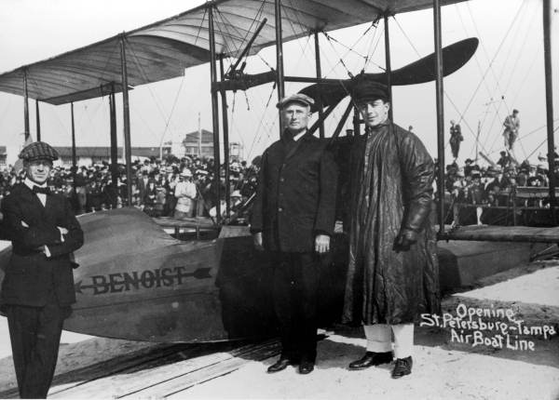 One hundred years ago marked the first scheduled air service in Florida on January 1, 1914. Thomas Benoist built a seaplane, called Flying Boat #43, to transport people across Tampa Bay. The one paying customer, A.C. Phiel, won the auction for the trip by paying $400. The trip was 18 miles and took 23 minutes. The St. Petersburg-Tampa Air Boat Line continued running for four months offering 2 flights a day at a cost of $5 for a one way trip.

*The Flying Boat #43 on January 1, 1914. Percy E. Fansler, general manager of Tampa Air Boat Line at the left; Mayor A.C. Phiel and Tony Jannus, pilot*

*(*[*http://iata-production.s3.amazonaws.com/filestorage/images/13/1914%20first%20commercial%20flight%20image.jpg?width=444&height=255&quality=80&crop=0&method=ratio*](http://iata-production.s3.amazonaws.com/filestorage/images/13/1914%20first%20commercial%20flight%20image.jpg?width=444&height=255&quality=80&crop=0&method=ratio)*)*

These and other early flights were exciting and made the news, but commercial flying was not popular. People were afraid of the flying machines and the early aircraft was not much faster than the train. During World War I the airplane became a valuable asset, and major improvements, including larger motors, allowed the planes to achieve greater speeds. After the war there was an abundance of planes; therefore no new planes were being built and many aircraft builders went out of business. Many European countries began subsidizing their airline industries and offered flights over the English Channel. In the United States the aviation industry was also saved by the government using airplanes to transport mail. In 1917 the U.S. Congress appropriated $100,000 for airmail service between New York and Washington, D.C. By 1920 the airmail was being delivered across the continent, thus saving 22 hours. By the mid-1920s the Post Office mail service was booming. The U.S. Government sought the private sector to continue the service and, through the Contact Air Mail Act of 1925, gave legislative authority for the government to seek bids from the private sector. This opened the door for the creation of the private U.S. airline industry. The winners of the contracts would eventually become known as United Air Lines, Transcontinental and Western Air (TWA), American Airways (later American Airlines), Pan Am and Eastern Air Lines.

With Charles Lindbergh’s famous trip from New York to Paris in 1927 the age of air travel was solidified. In order to get people to fly instead of using the train, the planes needed to improve. They needed to be safer, faster and larger, and manufacturers went to work.

There were so many improvements to aircraft in the 1930s that many believe it was the most innovative period in aviation history. Air-cooled engines replaced water-cooled engines, reducing weight and making larger and faster planes possible. Cockpit instruments also improved, with better altimeters, airspeed indicators, rate-of-climb indicators, compasses, and the introduction of artificial horizon, which showed pilots the attitude of the aircraft relative to the ground - important for flying in reduced visibility.

(<http://www.avjobs.com/history/>)

With these improvements the first modern passenger airliner was built by Boeing in 1933, called the Boeing 247. It had a 3 person crew and room for 10 passengers. It had a cruising speed of 189 miles per hour and a range of 745 miles. Seventy five of the Boeing 247s were produced. Later in 1933, TWA contracted with Douglas Aircraft Company to produce the DC-1.

The DC-1 was very advanced for its day. Its fuselage was streamlined, as were its wings and engine cowlings. It featured all-metal construction and retractable landing gear. Variable-pitch propellers gave the plane remarkable takeoff and landing characteristics. With plush seats, a kitchen and a comfortable restroom, the DC-1 set a new standard for passenger comfort. Great efforts were made to insulate the passenger compartment from the noise of the plane's engines. The plane's passenger seats were mounted on rubber supports, while the cabin was lined with noise absorbing fabric. Carpet covered the cabin floor and even the engines were mounted on rubber insulators.

(<http://www.boeing.com/boeing/history/mdc/dc-1.page>)

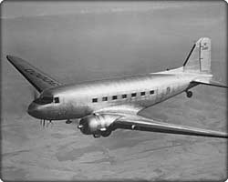With all the DC-1 advancements, only one was produced because the company improved the design to increase the number of passengers from 12 to 14 and created twenty five   
DC-2s. In 1936 Douglas produced the DC-3, which is the first plane that made air travel popular and profitable. As a result, by 1939, 90% of the airplanes were either DC-2s or DC-3s.

*Boeing DC-3*

*(*[*http://www.boeing.com/assets/images/history/mdc/images/D4E-535453\_n.jpg*](http://www.boeing.com/assets/images/history/mdc/images/D4E-535453_n.jpg)*)*

The Boeing 247, DC-2 and DC-3 made air travel popular and safe, but they had a major disadvantage. They could not go above 10,000 feet because there is insufficient air to breathe above that level. People become dizzy and would lose consciousness above that altitude. The industry wanted to be able to fly higher to avoid the rough weather at lower altitudes. Also with reduced air resistance at higher altitudes, they could fly faster and farther. The answer to these problems was solved by Boeing in 1938 by creating the Stratoliner, which was the first pressurized airplane. The pressurized cabin allowed the Stratoliner to fly to 20,000 feet carrying 5 crew and 33 passengers.

With this new industry came the need for regulations and agencies to oversee them. In 1938 the Civil Aeronautics Act created the Civil Aeronautics Board. This provided one agency to govern the airline industry. Its major functions were to determine airlines routes and to regulate prices for passenger fares. Since the airfares were regulated, the airlines competed for business by the services they offered. In 1958 the Federal Aviation Act was passed by Congress after two airplanes collided over the Grand Canyon. This legislation created the Federal Aviation Administration, which is responsible for managing all the safety issues, including air traffic control, certification of aircraft designs, airline training and maintenance programs. In the mid-1970s the need for deregulation was realized. Congress passed the Airline Deregulation Act of 1978, creating free market competition for air fares, and which disbanded the Civil Aeronautics Board shortly thereafter.

In recent history there have been setbacks to the growth of the airline industry. In 1981 the air traffic controllers went on strike. In 2001 the economic downturn decreased air travel at the same time labor and fuel costs were increasing. Then the 9/11 incidents further crippled the air industry. The industry did not really become profitable again until 2006.

**More on misconceptions about air travel**

There are numerous myths and misconceptions about air travel. Let’s look at a few others, besides those discussed in the *ChemMatters* article.

**Can lightning strikes cause an airplane to crash?** This is very unlikely. The last plane to crash in the United States due to lightning was in 1967. A bolt of lightning hit the fuel tank causing an explosion. Since then much has been learned, and the protection techniques are much improved. Airplanes actually get struck once a year on the average. Sometimes airplanes actually cause the lightning as they fly through charged regions of clouds. This lightning goes from the plane to the air and rarely causes any damage. Since 1930, engineers have worked to make planes safer to fly through lightning strikes.

And they do it by basically making sure there's a conductive path so that the lightning runs around the skin of the aircraft. It is dissipated out safely through points that have static wicks [antenna-like devices on wingtips] and so on, things that help the electricity flow around the aircraft and back out to the atmosphere.

(<http://www.cnn.com/2010/TRAVEL/08/17/planes.lightning.strikes/>)

Lightning could also affect the electronics and computers on board, so special care is taken to provide sufficient shielding, grounding and surge suppression to protect this equipment from the effects of the lightning. Likewise around the fuel tank and the fuel system there are static discharge precautions and grounding precautions to prevent sparks anywhere near the fuel. Also new fuels produce less explosive vapors and are therefore safer.

**Do airplanes dump human waste into the air?** No, all human waste is flushed to a holding tank and emptied when the plane lands. The pilot has no controls that would release the waste. The only lever to open the tank is on the outside of the plane. People routinely report that they have seen or been hit by “blue ice” which they believe is human waste mixed with the blue chemical water in the toilet and then frozen at high altitudes. The Federal Aviation Administration investigates these reports and almost always finds that it is bird droppings. There is a reason people still talk and report blue ice. The blue coloring was due to the deodorizing liquid which is also used in Port-a-Johns. Until the 1980s airplanes used electric pumps to flush away the waste and circulate fresh liquid into the bowl. Besides having to carry hundreds of gallons of deodorizing fluid, which increased fuel costs and reduced the number of passengers that could be carried, these systems tended to leak. The leaks would escape to the outside of the plane and freeze. As the plane dropped to land the “blue ice” would begin to melt and fall from the airplane. Since 1980 the design of the toilet on the airplane has changed and the blue deodorizer is no longer needed. James Kemper invented the vacuum toilet that is used today on airplanes.

Vacuum toilets rely on [strong suction and slick walls](http://dsc.discovery.com/tv-shows/mythbusters/videos/airplane-toilet-tour.htm) to pull waste away using just a fraction of a gallon of water. Pressing the flush button opens a valve in the bottom of the bowl, exposing the contents to a pneumatic vacuum. That vac sucks the load down the plane's sewer line into a 200-gallon holding tank—vapors and all. A Teflon-like non-stick coating around the inside of the bowl assists in the transfer. Then, waste remains in the tank for the duration of the flight, and it's vacuumed out by crews on the ground. An exterior latch on the holding tank ensures that pilots don't accidentally drop a load in mid-air.

(<http://gizmodo.com/5953877/what-happens-when-you-flush-a-toilet-on-an-airplane>)

**Since the toilets now operate using a strong vacuum system is it possible to get stuck on the toilet?** In theory it is possible, but your body would have to make a perfect seal with the toilet. This is nearly impossible with the size and shape of the modern airplane toilet.

**Can cell phones bring down a plane?** There is no evidence that the electromagnetic interference from small electronic devices like cell phones have ever brought down a plane or contributed to an accident. It was shown at the Boeing’s Electromagnetic Interference Lab in Seattle that a laptop’s electrical emission could interfere with the Visual Flight Rules, VFR, radios. This would not bring down a plane but the interference could cause more work for the pilots during critical times in the flight, such as take-off and landing. The pilot’s attention could be distracted lowering the level of safety. According to a CNN report:

Cell phones and laptops with wireless network capabilities -- devices that transmit signals -- fall into a category of their own when in transmit mode. Those transmissions are banned by both the FAA, because of potential airplane interference, and the Federal Communications Commission, because of potential interference with wireless networks on the ground. And for that reason, the government industry committee reviewing portable electronic usage will not consider the airborne use of cell phones for voice communications during flight.

(<http://www.cnn.com/2013/09/23/travel/cell-phones-devices-on-airplanes/>)

The rules governing portable electronic devices (PEDs) are constantly being tested and evaluated. In October 2013 the Federal Aviation Administration announced that airplanes could safely expand the use of PEDs, and it sent guidelines to the airline industry.

Passengers will eventually be able to read e-books, play games, and watch videos on their devices during all phases of flight, with very limited exceptions. Electronic items, books and magazines, must be held or put in the seat back pocket during the actual takeoff and landing roll. Cell phones should be in airplane mode or with cellular service disabled – i.e., no signal bars displayed—and cannot be used for voice communications based on FCC regulations that prohibit any airborne calls using cell phones. If your air carrier provides Wi-Fi service during flight, you may use those services. You can also continue to use short-range Bluetooth accessories, like wireless keyboards.

<http://www.faa.gov/news/press_releases/news_story.cfm?newsId=15254>

The use of cell phones and laptops during take-off and landing potentially create other problems. If passengers are using cell phones during take-off, will they pay attention to the safety instructions? Laptops in use during take-off and landing could become flying projectiles if severe turbulence occurs.

**More on** **atmospheric pressure and altitude and the effects on humans**

Pressure is defined as force per unit area. Atmospheric pressure is caused by the force of the air molecules exerted on Earth as gravity pulls it to the surface. The more air above you, the greater the pressure. Typically, at sea level there is the greatest amount of air above so the pressure is the greatest. As the altitude increases the column of air above decreases, so the pressure decreases.

Air pressure is measured using a barometer. There are two basic types of barometers, a mercury barometer and an aneroid barometer.

A mercurial barometer has a section of mercury exposed to the atmosphere. The atmosphere pushes downward on the mercury. If there is an increase in pressure, it forces the mercury to rise inside the glass tube and a higher measurement is shown. If atmospheric pressure lessens, downward force on the mercury lessens and the height of the mercury inside the tube lowers. A lower measurement would be shown. This type of instrument can be used in a lab or a weather station, but is not easy to move!

An aneroid barometer can be used in place of a mercury barometer. It is easier to move and is often easier to read. This instrument contains sealed wafers that shrink or spread out depending on changes of atmospheric pressure. If atmospheric pressure is higher, the wafers will be squished together. If atmospheric pressure lessens, it allows the wafers to grow bigger. The changes in the wafers move a mechanical arm that shows higher or lower air pressure.

(<http://www.windows2universe.org/earth/Atmosphere/measuring_press.html>)

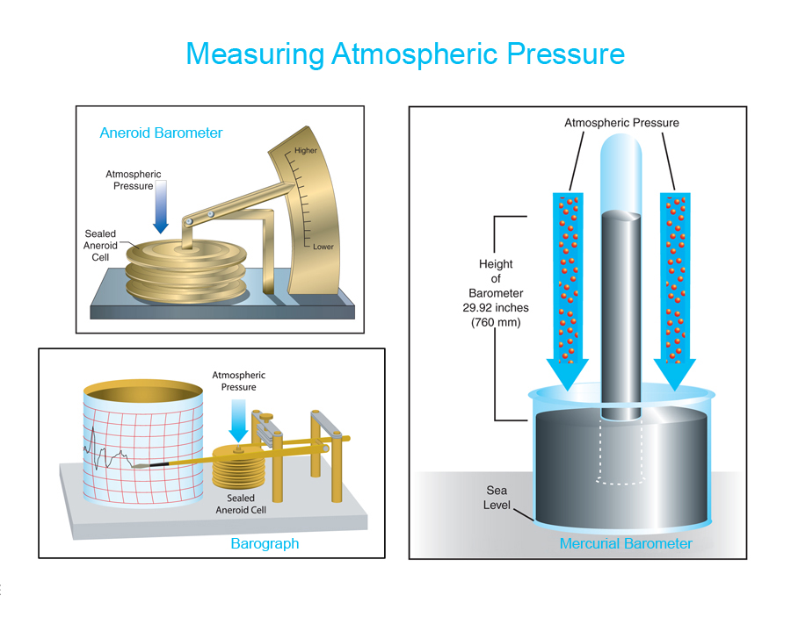

*(*[*http://www.windows2universe.org/earth/images/measuring\_press\_big.jpg*](http://www.windows2universe.org/earth/images/measuring_press_big.jpg)*)*

There are many units used to measure atmospheric pressure. The SI unit for pressure is the pascal. The table below provides a list of atmospheric pressure units and their relationship to each other.

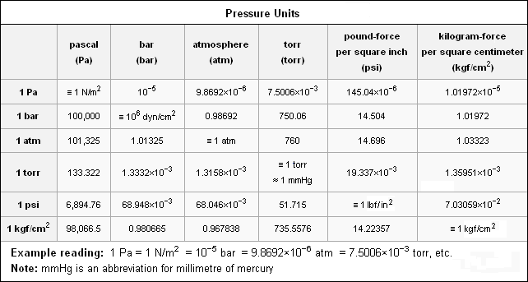

*(*[*http://static.trunity.net/files/185301\_185400/185312/pressurechart.png*](http://static.trunity.net/files/185301_185400/185312/pressurechart.png)*)*

As the altitude increases the number of air molecules decreases, people say the “air is thinner”, it becomes harder to breathe. Although the amount of air decreases, the percentage of oxygen and nitrogen molecules remain the same. With fewer air molecules these are fewer oxygen molecules—and they are further apart—so there is less oxygen to breathe. The reduced amount of oxygen to breathe can have many effects on the human body.

One of the most common effects is altitude sickness or mountain sickness. Not everyone is affected by this and there are no indications about who will be affected. This most commonly occurs at 8,000 ft. (2,441 meters or 1.5 miles) above sea level. At this height the pressure is only 77 kPa (574 mm or 0.76 atm) and there is only 76% of the oxygen available at sea level. The initial symptoms of altitude sickness are nonspecific and are similar to the flu or a hangover. The symptoms may include fatigue, dizziness, headache, nausea and swelling of extremities. The cause is described by the report from Princeton University.

In order to properly oxygenate the body, your breathing rate (even while at rest) has to increase. This extra ventilation increases the oxygen content in the blood, but not to sea level concentrations. Since the amount of oxygen required for activity is the same, the body must adjust to having less oxygen. In addition, for reasons not entirely understood, high altitude and lower air pressure causes fluid to leak from the capillaries which can cause fluid build-up in both the lungs and the brain. Continuing to higher altitudes without proper acclimatization can lead to potentially serious, even life-threatening illnesses.

(<http://www.princeton.edu/~oa/safety/altitude.html>)

The best treatment for attitude sickness is to return to a lower altitude. If not treated it can become life threatening.

At high altitudes and low pressure, humans also experience physical and psychological effects. The reduction in the amount of oxygen one is able to breathe reduces the amount of oxygen to muscles and the brain. Regardless of one’s physical fitness, the level of physical activity one can maintain is severely reduced at high altitudes. Likewise mental abilities are diminished, which most notably include decreased perception, memory, judgment, and attention.

High altitudes with diminished oxygen consumption may also result in sleep difficulties. The low oxygen directly affects the sleep center of the brain. Frequent awakenings, a light sleep and less total time of sleep are the main problems, and these usually improve with acclimatization after a few nights. Some persons, however, will have trouble sleeping despite acclimatization.

(<http://www.altitudemedicine.org/index.php/altitude-medicine/altitude-physiology/what-to-expect-when-you-come-to-altitude>)

The taste of food at high altitude and low pressure, like on an airplane, is also affected. Airlines have dealt with complaints of the lack of taste in their food in flight. People have always complained about airline food. It is not totally the airline’s fault, for food is less savory at 30,000 feet. In flight, not only does the pressure decrease but also the humidity decreases. Both of these changes reduce taste bud sensitivity. The taste of saltiness and sweetness is actually reduced by 30%. There is an additional effect. Flavor is a combination of both taste and smell.

“When you put something in your mouth, the vapors from this pass through the nasopharynx to reach the olfactory receptors high in the nose,” explains Dr. Tom Finger, professor at the University of Colorado School of Medicine and co-director of the Rocky Mountain Taste and Smell Center.

In addition to reduced taste bud sensitivity, cabin pressurization causes our mucus membranes to swell, blocking this pathway (remember the last stuffy nose you had and how difficult it was to enjoy your chicken noodle soup?). Cabin pressure also decreases the volatility of odor molecules, or their ability to vaporize and enter the nose.

(<http://www.nbcnews.com/health/body-odd/one-reason-airline-food-so-bad-your-own-tastebuds-f6C10823522>)

The combination of these effects makes gourmet food at sea level taste very bland on the airplane.

**More on Henry’s Law and Boyles Law**

**William Henry** was born in Manchester, England in 1775. As a physician and a chemist he developed what is known as Henry’s Law in 1803. The law states that at a constant temperature, the amount of a given gas that dissolves in a given type and volume of liquid is directly proportional to the partial pressure of that gas in equilibrium with that liquid. The mathematical relationship can be stated in a variety of ways.

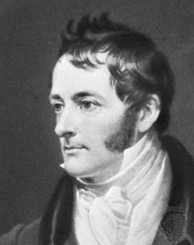

*(*[*http://upload.wikimedia.org/wikipedia/commons/e/ef/William\_Henry.jpg*](http://upload.wikimedia.org/wikipedia/commons/e/ef/William_Henry.jpg)*)*

One common expression is given as: C = kHP where C is the concentration of the dissolved gas in the liquid, kH is the temperature- dependent constant, and P is the partial pressure of the gas above the solution. Others sources use the expression P = kHC (the kH is different, see below). Both forms of the law express the concept that the concentration of a gas in a liquid is directly proportional to the partial pressure of the gas above the surface of the liquid. In other words as the pressure increases the amount of gas dissolved in the liquid increases and vice versa. The difference in the forms of the equation will be the value and the units of kH.

The unit of kH is expressed in a number of different units, depending upon the units of concentration and pressure. Henry’s law is obeyed most accurately for dilute solutions and for gases that do not react with the liquid.



*(Graham, T. Unusual Sunken Treasure.* ChemMatters***2006****,* 24 *(4), pp 11*–*13)*

An application of Henry’s law is seen in the carbonation of soft drinks:

This is how soft drinks are carbonated. At the bottling plant, the beverage is placed in the can or bottle under high pressures of carbon dioxide. These high pressures force the carbon dioxide to dissolve in the liquid. When you “pop the top”, the pressure decreases and gas begins to leave the solution, forming bubbles—fizz. Eventually, most of the carbon dioxide leaves the solution, and the drink is flat.

(Kimbrough, D. Noisy Knuckles and Henry’s Law. *ChemMatters* **2000**, *18* (4), pp 12–13)

Understanding Henry’s law is critical in scuba diving. As a diver goes deeper into the ocean, the external pressure increases and he inhales more deeply to equalize the pressure. This results in more nitrogen dissolving in his blood. If the diver surfaces too rapidly, which causes the pressure to decrease rapidly, the nitrogen will come out of solution. These gas bubbles in the bloodstream block capillaries and prevent oxygen from getting to the body tissues. This is painful and causes a dangerous condition called the “bends”, which can be fatal.

**Robert Boyle** was born in Munster, Ireland in 1627. He was committed to the New Philosophy which valued observation and experimentation as much as logical thinking. Boyle’s prime interest was in chemistry, but his first published work, *New Experiments Physico-Mechanical Touching the Spring of the Air and Its Effects*, dealt with the physical nature of air. The second edition of this work, published in 1662, described the relationship between pressure and volume of a gas that we now know as Boyle’s law.

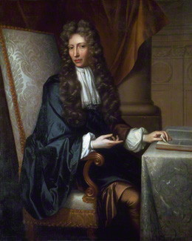

*(*[*http://images.npg.org.uk/264\_325/2/8/mw00728.jpg*](http://images.npg.org.uk/264_325/2/8/mw00728.jpg)*)*

As we know, Boyle’s law states that, for a sample of gas at constant temperature, the pressure exerted by the gas is inversely proportional to its volume. Another way of stating it is that the product of the pressure of the gas and its volume is constant. P = k/V or PV = k, where P is the pressure of the gas, V is the volume, and k is the constant for a particular gas.

Divers also have to be familiar with Boyle’s law since within the body there is air, such as in the lungs, which can be pressurized:

If divers descend without scuba gear, the volume of these body cavities decreases as the surrounding water pressure becomes greater. However, this effect is not experienced by divers using scuba gear because the regulator on the air tanks delivers air at the same pressure as the surroundings. But if divers must make emergency ascents from this depth, they must remember to breathe out steadily as they return to the surface. If they don’t, the pressure of the air in their lungs will cause their lungs to expand, causing rupturing of lung tissue.

(Belleman, M. Scuba: The Chemistry of an Adventure. *ChemMatters* **2001**, *19* (1),   
pp 7– 9)

Other examples of the application of Boyle’s Law are the use of a syringe. When you pull back on the plunger the volume inside the syringe increases, which decreases the pressure causing the liquid to be drawn into the syringe. You will experience Boyle’s Law if you have ever opened a plastic water bottle to take a drink on an airplane at high altitude and then closed it. When you land and return to normal atmospheric pressure the bottle will appear slightly crushed. Likewise at high altitude a sealed bag of peanuts or chips will appear greatly expanded. Let’s not forget that the popping of ears with a change in altitude, and as a result a change in pressure, is also an example of Boyle’s law.

**More on the ear and ear popping**

The ear is an amazing structure and it is not just for hearing. It is also responsible for giving us a sense of position and balance. The ear consists of three sections; outer, middle and inner ear.

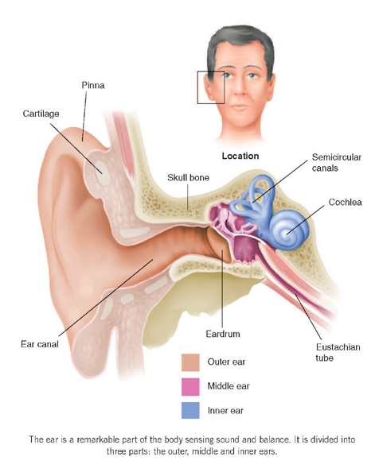

<http://www.familydoctor.co.uk/wp-content/uploads/2013/10/ear-overview.jpg>

**The outer ear** includes the ear lobe and the pinna. The pinna is made of ridge cartilage covered with skin. It funnels sound through the ear canal to the ear drum, the tympanic membrane. The ear drum separates the outer ear from the inner ear.

**The middle ear** is filled with air. As sound is funneled into the ear canal, it causes the ear drum to vibrate. The vibration is transmitted to the three small bones in the middle ear. These bones are called the ossicles and include the malleus (hammer), incus (anvil), and stapes (stirrup). The ossicles amplify the vibration and transmit it to the oval window which separates the middle ear from the inner ear. Also within the middle ear is the Eustachian tube, which connects the middle ear to the back of the nose and throat. It allows air in and out of the middle ear so that the air pressure on either side of the ear drum is equal and keeps the ear drum from bulging or retracting. If the ear drum is stressed then it will not transmit sounds as well and will cause pain. The Eustachian tube also allows fluid to drain from the middle ear.

**The inner ear** is composed of two major structures, the cochlea and the vestibular system. The cochlea is mainly responsible for hearing while the vestibular system is involved in maintaining balance.

.

*(*[*http://www.familydoctor.co.uk/wp-content/uploads/2013/10/inner-ear.jpg*](http://www.familydoctor.co.uk/wp-content/uploads/2013/10/inner-ear.jpg)*)*

*(*[*http://www.familydoctor.co.uk/wp-content/uploads/2013/10/Inner-ear-sound.jpg*](http://www.familydoctor.co.uk/wp-content/uploads/2013/10/Inner-ear-sound.jpg)*)*

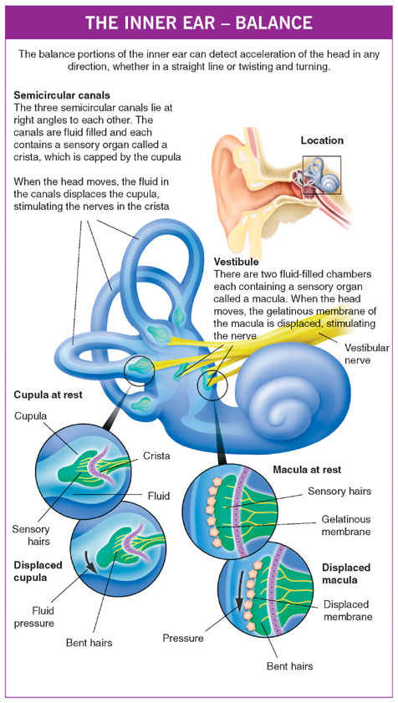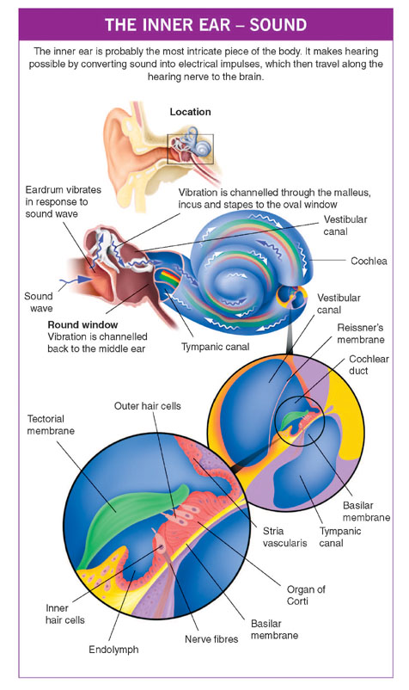

Ears pop with rapid changes in air pressure, such as when flying or scuba diving. This causes a precipitous rush of air through the Eustachian tube, causing a popping sensation. This adjustment in the middle ear is necessary to keep the eardrum vibrating normally. In an airplane it is easier for your ears to adjust during take-off than landing. During take-off the external pressure is dropping so the air in the middle ear is rushing out. During landing the external air pressure is increasing and air must go into the inner ear to balance the pressure.

But it's a lot easier to let air out of a smaller space and into a bigger space than vice versa. Think of the balloon …: inflating a balloon takes more work than letting the air out. So balancing the air pressure in your ears while you're landing usually takes more effort on your part.

(<http://sciencenetlinks.com/science-news/science-updates/popping-ears/>)

If you are flying with a cold, sinus infection or allergies, your Eustachian tube could be blocked, creating problems.

The Eustachian tube can be blocked, or obstructed, for a variety of reasons. When that occurs, the middle ear pressure cannot be equalized. The air already there is absorbed and a vacuum occurs, sucking the eardrum inward and stretching it. Such an eardrum cannot vibrate naturally, so sounds are muffled or blocked, and the stretching can be painful. If the tube remains blocked, fluid (like blood serum) will seep into the area from the membranes in an attempt to overcome the vacuum. This is called fluid in the ear, serous otitis or aero-otitis. Uncommon problems include developing a hole in the ear drum, hearing loss and dizziness.

(<http://www.entnet.org/content/ears-and-altitude>)

For that reason it is recommended to avoid air travel if possible when one has a cold or sinus infection.

**More on** **Plexiglas™**

Plexiglas™ is a synthetic polymer of methyl methacrylate. It is a thermoplastic, meaning it becomes pliable above a specific temperature and then hardens again when cooled. Plexigas™ is a trade name owned by Rohm and Haas Company. It is also known as Lucite™ and Acrylite™.

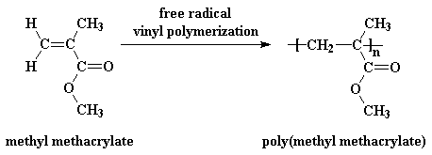

(<http://www.pslc.ws/macrog/kidsmac/images/pmma02.gif>)

Plexiglas™ is stronger and more shatter-resistant than glass. It is less dense than glass so it is lighter weight, which makes it easier to handle and reduces shipping and fuel costs. It is more transparent and less reflective than glass. Where thick windows are needed, such as in an aquarium or airplane, Plexiglas™ is the best choice because of its strength and its transparency. Plexiglas can be as thick as 13 inches and remain clear, whereas glass that thick would not.

# Connections to Chemistry Concepts

**(for correlation to course curriculum)**

1. **Risk-Benefit Analysis**—This article compares the risk of traveling by air to that of driving in a car. This provides the opportunity to discuss the importance of analyzing and comparing risks and benefits of a particular activity.
2. **Air pressure—**Air pressure is explained in this article. It explains how and why it changes with altitude. The article also discusses how air pressure affects your breathing and your ears.
3. **Force**—An understanding of force is gained in the discussion of the pressure difference between the external pressure and that of the cabin. It explains how to determine the force needed to open the airplane door while in flight.
4. **Henry’s Law**—Henry’s Law is one of the reasons carbonated beverages go flat faster on an airplane.
5. **Boyle’s Law**—Boyle’s Law is not stated by name in the article, but it is the reason the carbon dioxide bubbles in a carbonated beverage grow larger on an airplane.

# Possible Student Misconceptions

**(to aid teacher in addressing misconceptions)**

1. **“The oxygen masks are just there to get you high and calm you down.”** *This misconception was probably a result of a statement Brad Pitt made in the movie “Fight Club”. If the airplane does become depressurized you need to wear the oxygen mask. If the cabin is not pressurized then the air at high altitudes is too thin and there is not enough oxygen for your body to function normally. Without the oxygen mask, and if the airplane depressurizes, one would lose consciousness very quickly. Breathing pure oxygen does not make one inebriated.*
2. **“Air on an airplane is full of germs.”** *Studies show the air on a crowded airplane has less germs that most crowded areas. The air on an airplane is a mixture of fresh air and recirculated air. The fresh air comes off the engine compressors where it is cooled and mixed with the recirculated air. Half of the circulated air is vented and the other half is sent through filters, which are “hospital quality” and remove 94-99.9% of the airborne microbes. There is a total changeover of air every two to three minutes. So the air is not full of germs, but we cannot say that about the tray tables, arm rests and seat belts.*
3. **See also “More on misconceptions about air travel”.**

# Anticipating Student Questions

**(answers to questions students might ask in class)**

1. **“Why is there a little hole in each window on the airplane?”** *Many airplane windows have a small hole, less than 2 millimeters in diameter, in them. This hole is only in the innermost layer of the window and is designed to allow cabin pressure to push against the outer layer of the window, which is stronger than the inner layer.*
2. **“What is jet lag?”** *Jet lag is a temporary sleep disorder caused by travelling long distances quickly on an airplane. This disrupts one’s circadian rhythms, one’s internal clock, which tells the body when to go to sleep and when to wake up. The severity of the sleep disorder is worse the more time zones crossed. The symptoms include disturbed sleep, waking up early, daytime fatigue, difficulty in concentrating, constipation or diarrhea, and a general unwell feeling.*

## In-Class Activities

**(lesson ideas, including labs & demonstrations)**

1. An investigation of Henry’s law using a syringe, a carbonated beverage, and methyl red can be found at <http://chemmovies.unl.edu/chemistry/smallscale/SS038.html>. This includes the materials needed, procedure, time required and expected results. There are also short movie clips(less than a minute) to aid in the set up. A YouTube video of a similar investigation can be seen at <https://www.youtube.com/watch?v=gUfhvbnBWs0>. This video (2:13) is short and well done.
2. A very simple investigation of Boyle’s lab with minimal equipment is demonstrated in this YouTube video: <https://www.youtube.com/watch?v=vSFVMJQ4J7U>. This video (9:07) is designed to give the teacher instructions on how to set up and perform the investigation for their classes.
3. There are many good simulations available to demonstrate Boyle’s law. With these the students could collect and graph data and determine the relationship between pressure and volume. This could be assigned as an out of class activity as well. Three such sites are listed below:

<http://phet.colorado.edu/en/simulation/gas-properties>,

<http://group.chem.iastate.edu/Greenbowe/sections/projectfolder/flashfiles/gaslaw/boyles_law_graph.html>, and

<http://www.uccs.edu/vgcl/gas-laws/experiment-1-boyles-law.html>.

1. An excellent way to demonstrate the effect of air pressure is the collapsing soft drink can demonstration. In this demonstration a partial vacuum is produced by the rapid condensation of steam within in the can. The external air pressure causes the can to collapse. There are many references and videos available online. Here two references that are easy to follow:

<http://scifun.chem.wisc.edu/homeexpts/COLLAPSE.html> and

<http://weirdsciencekids.com/collapsingcan.html>.

1. An excellent series of experiments involving properties of gases, especially the properties of air pressure can be found in the investigation called “Properties of Gases” in *Chemistry in the Community* textbook produced by the American Chemical Society. This series of experiments, set up as 9 different lab stations, can be viewed in the video (4:36) online at <http://bcs.whfreeman.com/chemcom6e/#665402__762232__>.
2. *The Safest Journey* is an activity that analyzes the risk and benefits for various modes of travel. This is an activity in the textbook *Chemistry in the Community*. American Chemical Society. *Chemistry in the Community*, 6th ed., W. H. Freeman and Company/BFW: New York, 2012; pp 670-671. It can also be found online at <http://goo.gl/vrLmU5>.
3. “Getting a Lift” is a fun activity that investigates air pressure using straws, a plastic garbage bag and a piece of plywood. It can be found at *ChemMatters* 1983, 1 (*1*), pp 13.

# Out-of-class Activities and Projects

**(student research, class projects)**

1. To demonstrate Boyle’s Law, students could make Cartesian Divers as an out-of-class project. There are numerous Web sites that provide instruction for making them. The following Web sites provide good instructions and explanations:

<http://chemed.chem.purdue.edu/demos/demosheets/1.2.html>,

<http://www.usc.edu/org/cosee-west/MidwaterRealm/11CartesianDiver.pdf> and

<https://www.youtube.com/watch?v=s5eIRjmor1w>.

1. Students could be assigned to watch a portion of a movie with a plane crash or disaster. They could then evaluate the movie for the science content and validity. The two Web sites listed below provide some examples of clips from movies involving airplane crashes.

<http://www.shortlist.com/entertainment/films/most-terrifying-movie-plane-crashes> and

<https://www.youtube.com/watch?v=OOrt2yXcGZk>.

1. Students could research ways in which the effects of jet lag could be minimized.
2. Students could create a barometer by following the instructions given in the following video: <https://www.youtube.com/watch?v=jmQ8FWnM0fA>.

# References

**(non-Web-based information sources)**



**30 Years of *ChemMatters***

Available Now!

**The references below can be found on the *ChemMatters* 30-year DVD (which includes all articles published during the years 1983 through April 2013 and all available Teacher’s Guides, beginning February 1990). The DVD is available from the American Chemical Society for $42 (or $135 for a site/school license) at this site:** [http://ww.acs.org/chemmatters](http://www.acs.org/chemmatters)**. Scroll about half way down the page and click on the *ChemMatters* DVD image at the right of the screen to order or to get more information.**

**Selected articles and the complete set of Teacher’s Guides for all issues from the past three years are available free online on the same Web site, above. Simply access the link and click on the “Past Issues” button directly below the “M” in the *ChemMatters* logo at the top of the Web page.**

Gas Laws and Scuba Diving. *ChemMatters* **1983**, *1* (1), pp 4–6. This is an old article but contains a well written explanation of pressure, Boyle’s Law and Henry’s Law in context with scuba diving.

Kimbrough, D. Noisy Knuckles and Henry’s Law. *ChemMatters* **2000**, *18* (4), pp 12–13. Kimbrough explains Henry’s Law and relates it to the cracking of joints as well as relating it to the need to understand Henry’s Law if scuba diving.

Graham, T. Unusual Sunken Treasure. *ChemMatters* **2006**, *24* (4), pp 11–13. Both Henry’s Law and Boyle’s Law are used to explain the difficulties in recovering bottles of champagne from a ship wrecked in 1916.

# Web Sites for Additional Information

**(Web-based information sources)**

**More sites on** **the history of the airline industry**

This *U.S.A. Today* article provides a brief overview of the history of the airline industry: <http://traveltips.usatoday.com/history-airline-industry-100074.html>.

The following Web sites provide extensive information about the history of the airline industry:

* <http://www.avjobs.com/history/>,
* <http://www.ibtimes.com/how-airline-industry-has-evolved-100-years-commercial-air-travel-1524238>, and
* <http://james-a-watkins.hubpages.com/hub/A-History-of-Commercial-Airliners>.

The story of the first commercial airline flight is described in this article: <http://www.firstflightcentennial.org/the-first-commercial-flight/>.

This Web site has an interactive timeline describing the history of air travel: <http://www.timetoast.com/timelines/90215>.

**More sites on** **misconceptions about air travel**

An interactive quiz about the facts and myths of airplane travel can be found at this Web site. (<http://science.howstuffworks.com/transport/flight/modern/airplane-myths-and-facts-quiz.htm>)

Ten myths commonly heard about airplane travel are briefly discussed here: <http://www.businessinsider.com/10-airplane-myths-debunked-2013-9>.

Facts about airplane travel are discussed from a pilot’s perspective. (<http://www.skyscanner.net/news/secret-pilot-21-air-travel-truths-revealed>)

Myths about airplanes that come from movies are discussed in this article. It also includes some video clips from movies. (<http://www.cracked.com/article_15421_5-myths-about-flying-everyone-believes-thanks-to-movies.html>)

This *U.S. News and World Report* discusses the use of cell phones during flight: <http://www.usnews.com/opinion/articles/2013/12/12/the-fcc-should-allow-cell-phones-on-planes>.

More myths and facts about airplane and air travel can be found at these two Web sites:

* <http://www.boston.com/community/blogs/askthepilot/2013/03/the_five_most_annoying_myths_a.html> and
* <http://travel.cnn.com/explorations/life/flight-mysteries-explained-085800>.

An explanation of the effects of a lightning strike on an airplane is given at <http://www.scientificamerican.com/article/what-happens-when-lightni/>.

Information about the oxygen and oxygen masks used on airplanes is given in this article: <http://scaredflightless.com/2012/08/06/the-truth-and-myths-about-oxygen-masks-on-airplanes/>.

**More sites on** **atmospheric pressure, altitude and the effects on humans**

The following Web sites give clear, basic explanations of atmospheric pressure:

* <http://usatoday30.usatoday.com/weather/wbarocx.htm>,
* <http://education.nationalgeographic.com/education/encyclopedia/atmospheric-pressure/?ar_a=1>, and
* <http://kids.earth.nasa.gov/archive/air_pressure/>.

A great interactive Web site that calculates the air pressure and oxygen levels at various altitudes can be found here: <http://www.altitude.org/air_pressure.php>.

A table of atmospheric pressure at various altitudes is given at <https://www.avs.org/AVS/files/c7/c7edaedb-95b2-438f-adfb-36de54f87b9e.pdf>.

The physiological effects of high altitudes are describes in this article: <http://adventure.howstuffworks.com/outdoor-activities/climbing/altitude-sickness1.htm>.

The U.S. Army medical department briefly describes some altitude effects on the human body here: <http://phc.amedd.army.mil/topics/discond/ai/Pages/AltitudeEffects.aspx>.

This extensive article from Princeton University thoroughly explains altitude sickness, its prevention and acclimation: <http://www.princeton.edu/~oa/safety/altitude.html>.

The following two videos provide information about atmospheric pressure and include demonstrations of the effects of air pressure. They are both short and could easily be shown to a class. (<https://www.youtube.com/watch?v=xJHJsA7bYGc> and

<https://www.youtube.com/watch?v=jmQ8FWnM0fA>)

**More sites on Henry’s Law and Boyle’s Law**

A brief but interesting biography of William Henry can be found at <http://www.thornber.net/cheshire/ideasmen/henry.html#_ftn7>.

William Henry’s original paper, “Experiments on the Quantity of Gases Absorbed by Water, at Different Temperatures, and at Different Pressures”, can be found at this Web site: <http://rstl.royalsocietypublishing.org/content/93/29.full.pdf+html>.

This site contains a very basic description of Henry’s Law, as well as some sample calculations: <http://chemwiki.ucdavis.edu/Physical_Chemistry/Physical_Properties_of_Matter/Solutions_and_Mixtures/Ideal_Solutions/Dissolving_Gases_In_Liquids%2C_Henry's_Law>.

A Kahn video gives a nice explanation of Henry’s law: <https://www.khanacademy.org/science/health-and-medicine/respiratory-system/gas_exchange/v/henry-s-law>.

The Chemical Heritage Foundation provides this biography of Robert Boyle: <http://www.chemheritage.org/discover/online-resources/chemistry-in-history/themes/early-chemistry-and-gases/boyle.aspx>.

A brief history of Robert Boyle, a definition of Boyle’s Law and some real world examples of Boyle’s Law are given at <http://chemteacher.chemeddl.org/services/chemteacher/index.php?option=com_content&view=article&id=1>.

More real world example of Boyle’s Law are given at <http://hubpages.com/hub/Examples-of-Boyles-Law>.

The actual data Robert Boyle collected as well as a brief description of his experiment can be found at <http://www.chemteam.info/GasLaw/Gas-Boyle-Data.html>.

The “Soda Pop Geyser” is demonstrated in this video by Lee Marek. It is a demonstration of both Henry’s Law and Boyle’s Law. (<http://www2.chem.uic.edu/marek/cgi-bin/vid7b.cgi>)

**More sites on the structure of the ear and the popping of the ear]**

The anatomy of the ear and its function are described well in this Web site: <http://www.familydoctor.co.uk/unassigned-articles/the-structure-of-the-ear/>.

The following three articles explain why ears pop and how to minimize the effects from it:

* <http://www.entnet.org/content/ears-and-altitude>,
* <http://www.patient.co.uk/health/ears-and-flying>, and
* <http://gizmodo.com/why-your-ears-pop-and-what-to-do-if-they-dont-505598950>.

**More sites on** **Plexiglas™**

This Web site gives a brief explanation of poly(methyl methacrylate) and some of its uses: <http://www.pslc.ws/macrog/kidsmac/pmma.htm>.

An extensive discussion of Plexiglas™ can be found at <http://en.wikipedia.org/wiki/Poly%28methyl_methacrylate%29>.

Some of the advantages of using Plexiglas™ instead of glass can be found at <http://www.ehow.com/about_6690313_acrylic-windows-vs_-glass-windows.html>.

# More Web Sites on Teacher Information and Lesson Plans

**(sites geared specifically to teachers)**

The *ChemSource* module on gases has a wealth of teacher information dealing with gas laws and air pressure. It includes laboratory activities, demonstrations, discussion topics, and relevancy to the modern world. Hubert, J., Miller, J., Sherman, M. “Gases.” In *SourceBook*, Version 3.0, edited by Orna, M.V.; Smith, P.J.V. ChemSource, Inc.: New Rochelle, NY, 2010. (<http://dwb.unl.edu/ChemSource/SourceBook/117GASS.pdf>)