logo_chemmatters[1]

**February 2015 Teacher's Guide for**

***From Liquid to Foam: How Egg Whites Change Texture***

**Table of Contents**

[About the Guide 2](#_Toc410167073)

[Student Questions 3](#_Toc410167074)

[Answers to Student Questions 4](#_Toc410167075)

[Anticipation Guide 5](#_Toc410167076)

[Reading Strategies 6](#_Toc410167077)

[Background Information 8](#_Toc410167078)

[Connections to Chemistry Concepts 20](#_Toc410167079)

[Possible Student Misconceptions 21](#_Toc410167080)

[Anticipating Student Questions 21](#_Toc410167081)

[In-Class Activities 21](#_Toc410167082)

[Out-of-class Activities and Projects 22](#_Toc410167083)

[References 23](#_Toc410167084)

[Web Sites for Additional Information 24](#_Toc410167085)

# About the Guide

Teacher’s Guide editors William Bleam, Regis Goode, Donald McKinney, Barbara Sitzman and Ronald Tempest created the Teacher’s Guide article material. E-mail: [bbleam@verizon.net](mailto:bbleam@verizon.net)

Susan Cooper prepared the anticipation and reading guides.

Patrice Pages, *ChemMatters* editor, coordinated production and prepared the Microsoft Word and PDF versions of the Teacher’s Guide. E-mail: [chemmatters@acs.org](mailto:chemmatters@acs.org)

Articles from past issues of *ChemMatters* can be accessed from a DVD that is available from the American Chemical Society for $42. The DVD contains the entire 30-year publication of *ChemMatters* issues, from February 1983 to April 2013.

The *ChemMatters* DVD also includes Article, Title and Keyword Indexes that covers all issues from February 1983 to April 2013.

The *ChemMatters* DVD can be purchased by calling 1-800-227-5558.

Purchase information can be found online at [www.acs.org/chemmatters](http://chemistry.org/chemmatters/cd3.html).

# Student Questions

* 1. Name three food items that the article says require a beaten egg white foam.
  2. What is the chemical composition of egg whites?
  3. Proteins are made up of amino acids. How many amino acids exist naturally?
  4. What part of amino acid structure makes each amino acid unique?
  5. What does the term “hydrophilic” refer to?
  6. When proteins fold, where are the hydrophobic amino acids located?
  7. When egg whites are beaten, what happens to the proteins?
  8. What is the primary purpose of beating egg whites in a recipe like the angel food cake described in the article?
  9. Name the scientists who first showed by experimentation that trace amounts of copper stabilized egg white foam.
  10. What protein in egg white forms a stabilizing complex with copper?
  11. What is the name of the most common covalent bond that forms between amino acids containing sulfur-hydrogen side groups?

# Answers to Student Questions

* + 1. **Name three food items that the article says require a beaten egg white foam.**

*There are many food items that require egg white foam in reality, but the article identifies chocolate soufflé, meringue cookies and angel food cake.*

* + 1. **What is the chemical composition of egg whites?**

*Egg whites are 10% protein and 90% water.*

* + 1. **Proteins are made up of amino acids. How many amino acids exist naturally?**

*There are 20 naturally-occurring amino acids.*

* + 1. **What part of amino acid structure makes each amino acid unique?**

*Each amino acid has a chemical side chain attached to the backbone of the molecule and every side chain is different.*

* + 1. **What does the term “hydrophilic” refer to?**

*Hydrophilic refers to substances that are attracted to water. The opposite is hydrophobic.*

* + 1. **When proteins fold, where are the hydrophobic amino acids located?**

*Hydrophobic amino acids are generally located in the interior of the protein creating a hydrophobic core, with the hydrophilic amino acids on the outside.*

* + 1. **When egg whites are beaten, what happens to the proteins?**

*When egg white proteins are whipped they partially unravel and their hydrophobic regions are exposed to air. As a result, the tiny air bubbles formed by the eggbeater are soon coated with unraveled proteins.*

* + 1. **What is the primary purpose of beating egg whites in a recipe like the angel food cake described in the article?**

*The primary purpose in beating the egg white is to create air bubbles in the cake. The air bubbles form when egg whites are whipped. Proteins help stabilize these bubbles in a foam structure. The protein in the egg whites simply holds the air bubbles in place.*

* + 1. **Name the scientists who first showed by experimentation that trace amounts of copper stabilized egg white foam.**

*The article names three people that showed by experiment that trace amounts of copper stabilize egg white foam—Harold McGee, a science writer, Sharon Long and Winslow Briggs, both Stanford biologists.*

* + 1. **Which protein in egg white forms a stabilizing complex with copper?**

*The article identifies conalbumin as the egg white protein that bonds with copper to form a complex that stabilizes the foam.*

* + 1. **What is the name of the most common covalent bond that forms between amino acids containing sulfur-hydrogen side groups?**

*The most common covalent bond between amino acids with H-S groups is the* disulfide *bond.*

# Anticipation Guide

Anticipation guides help engage students by activating prior knowledge and stimulating student interest before reading. If class time permits, discuss students’ responses to each statement before reading each article. As they read, students should look for evidence supporting or refuting their initial responses.

**Directions:**  *Before reading*, in the first column, write “A” or “D,” indicating your agreement or disagreement with each statement. As you read, compare your opinions with information from the article. In the space under each statement, cite information from the article that supports or refutes your original ideas.

|  |  |  |
| --- | --- | --- |
| **Me** | **Text** | **Statement** |
|  |  | 1. The soft, light texture of meringue cookies, chocolate soufflé, and angel food cake is due to fat. |
|  |  | 1. Egg whites are mostly protein. |
|  |  | 1. Whipping egg whites causes proteins to unfold and stretch out. |
|  |  | 1. All amino acids are hydrophilic, meaning they are attracted to water molecules. |
|  |  | 1. Adding flour or sugar helps stabilize egg white foam. |
|  |  | 1. Copper bowls have been used to whip egg whites for at least 250 years. |
|  |  | 1. Copper is highly toxic. |
|  |  | 1. Whipped egg whites form just as quickly in glass bowls as copper bowls. |
|  |  | 1. Julia Child, the famous chef, used copper bowls and copper pans. |
|  |  | 1. During baking, air bubbles in angel food cake batter grow to three or four times their room-temperature size. |

# Reading Strategies

These graphic organizers are provided to help students locate and analyze information from the articles. Student understanding will be enhanced when they explore and evaluate the information themselves, with input from the teacher if students are struggling. Encourage students to use their own words and avoid copying entire sentences from the articles. The use of bullets helps them do this. If you use these reading and writing strategies to evaluate student performance, you may want to develop a grading rubric such as the one below.

|  |  |  |
| --- | --- | --- |
| **Score** | **Description** | **Evidence** |
| 4 | Excellent | Complete; details provided; demonstrates deep understanding. |
| 3 | Good | Complete; few details provided; demonstrates some understanding. |
| 2 | Fair | Incomplete; few details provided; some misconceptions evident. |
| 1 | Poor | Very incomplete; no details provided; many misconceptions evident. |
| 0 | Not acceptable | So incomplete that no judgment can be made about student understanding |

***Teaching Strategies:***

1. Links to **Common Core Standards for Reading**:\
   1. ELA-Literacy.RST.9-10.5: Analyze the structure of the relationships among concepts in a text, including relationships among key terms (e.g., force, friction, reaction force, energy).
   2. ELA-Literacy.RST.11-12.4: Determine the meaning of symbols, key terms, and other domain-specific words and phrases as they are used in a specific scientific or technical context relevant to grades 11-12 texts and topics.
2. Links to **Common Core Standards for Writing**:
   1. ELA-Literacy.WHST.9-10.2F: Provide a concluding statement or section that follows from and supports the information or explanation presented (e.g., articulating implications or the significance of the topic).
   2. ELA-Literacy.WHST.11-12.1E: Provide a concluding statement or section that follows from or supports the argument presented.
3. **Vocabulary** and **concepts** that are reinforced in this issue:
   1. Skepticism
   2. Amino acid
   3. Protein
   4. Enzyme
   5. Organic molecular structures
   6. Polymer
4. To help students engage with the text, ask students which article engaged them most and why, or what **questions** they still have about the articles. The Background Information in the *ChemMatters* Teacher’s Guide has suggestions for further research.

**Directions**: As you read the article, complete the graphic organizer below to describe each chemical involved in creating a stable egg white foam.

|  |  |  |
| --- | --- | --- |
| **Chemical** | **What is it?** | **How it helps create stable egg white foam, and precautions (if any) to take when using.** |
| Protein |  |  |
| Amino acid |  |  |
| Cream of tartar *or* lemon juice |  |  |
| Copper bowl |  |  |
| Iron (III) chloride |  |  |
| Conalbumin |  |  |
| Disulfide bond |  |  |

**On the back of this paper, use your knowledge of chemistry to write three steps you would take to create stable egg white foam for an angel food cake or meringue.**

# Background Information

**(teacher information)**

**More on** **egg chemistry**

Before we delve into egg whites it might be helpful to describe the overall makeup of a chicken egg. If we look at an egg in cross section, we would see the familiar three parts—the shell, the egg white and the yolk. They are the parts that we refer to for purposes of nutrition. But we also see other component parts that play an important role as shown in the diagram below.

A chicken egg is composed of the following substances by percent:

Water – 76.15

Protein – 12.56

Lipids – 9.51

Ash – 1.06

Carbohydrate – 0.73

Cholesterol – 0.372

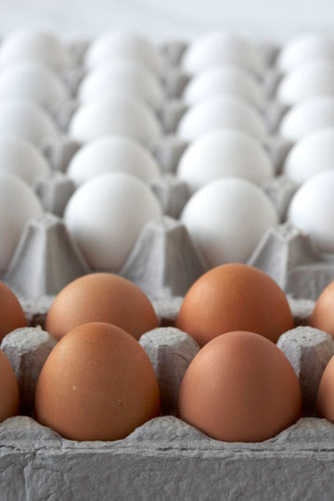The outer shell is made of calcium carbonate, CaCO3, and forms a rigid, semi-permeable membrane around the other components. The shell has thousands of tiny pores that allow air and water to pass through. When an egg is first laid there is a thin outer shell called the cuticle that helps to keep bacteria out of the egg. However, the cuticle is usually missing from eggs we purchase because it is washed away when eggs are processed for sale. Your students will likely know that egg shells vary in color, including white, cream, brown, blue or green. The color depends entirely on the breed of the laying hen. All eggs begin as white. As the egg moves through the hen’s oviduct chemicals are deposited on the shell to create color. In brown eggs, for example, the pigment is protoporphyrin, and in blue eggs the pigment is oocyanin.

*(*[*http://www.incredibleegg.org/egg-facts/eggcyclopedia/c/color*](http://www.incredibleegg.org/egg-facts/eggcyclopedia/c/color)*)*

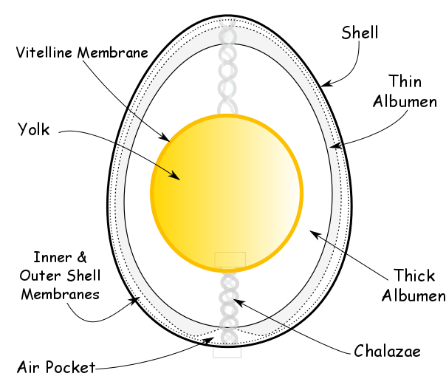

*(*[*http://davidstable.com/2012/12/eggs-101-the-basics/*](http://davidstable.com/2012/12/eggs-101-the-basics/)*)*

Inside the outer shell are two thin membranes, outer and inner, which act as barriers to bacteria. Freshly laid eggs have a temperature of about 41 oC, but they quickly cool and, as they do, the membranes shrink, the inner membrane more so than the outer. As a result, an air pocket forms between the two, usually at the broader end of the egg.

Inside the membranes is the albumen or egg white, which is 90% water and 10% protein. It contains no fat or cholesterol. In fact, there are two layers of albumen, the thin layer and the thick layer.

The vitteline membrane surrounds and contains the yolk, which contains 41% of the egg’s protein and 100% of its fat and cholesterol. Also in the yolk are the minerals iron and calcium, and vitamins A and D, thiamine and riboflavin. A natural emulsifier called lecithin is also contained in the yolk.

Small rope-like structures called chalazae are part of the egg whites and they anchor the yolk to the inner shell membrane to keep the yolk centered.

In the context of this article we are most interested in the albumin layer where we find the proteins that make up the foam needed for our angel food cake.

**More on** **amino acids**

Egg white is made up of albumin, a clear alkaline solution of about 10% proteins and 90% water mixed with traces of minerals (including sodium, potassium, chorine, sulfur, iron, phosphorus, calcium and magnesium), fats, vitamin and glucose. The albumin makes up about two-thirds of the weight of the egg’s contents, not including the shell. A little more than 50% of the egg’s protein is contained in the albumin. There is no cholesterol in the albumin.

So, let’s consider the basic chemistry of amino acids. As your students will likely remember from biology class, proteins are made up of amino acids, so we need to understand a little about amino acid chemistry. All amino acids have the basic structure at left. They are a combination on an amine functional group (green in the diagram) and a carboxyl functional group (yellow) with a side chain (red) attached to the central carbon atom. The composition of the side chain determines the exact nature of the amino acid. For example, if the side chain is just one hydrogen atom then the amino acid is glycine. If the side chain is a methyl group (–CH3) then the amino acid is alanine.

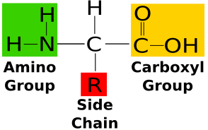

*(*[*http://education-portal.com/academy/lesson/what-are-amino-acids-definition-structure-quiz.htm*](http://education-portal.com/academy/lesson/what-are-amino-acids-definition-structure-quiz.htm)*)*

We will have more to say about the side chains later. Below is a chart of the proteins and their structures.

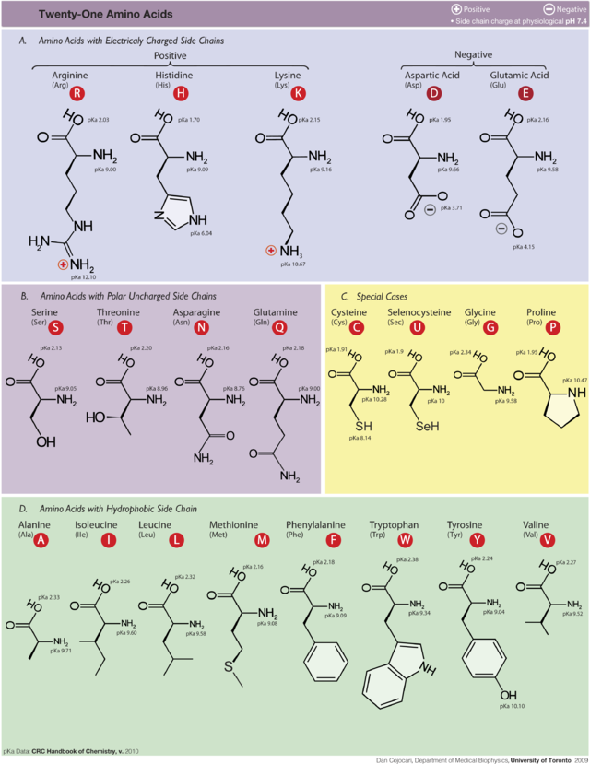

*(*[*http://en.wikipedia.org/wiki/Protein\_(nutrient)#mediaviewer/File:Amino\_acids.png*](http://en.wikipedia.org/wiki/Protein_(nutrient)#mediaviewer/File:Amino_acids.png)*)*

Amino acids combine to form proteins. Proteins are, then, polymers made up of protein units. The diagram at right shows the most common amino acid bonding mechanism. When two amino acid molecules approach each other and the carboxyl end of one collides with the amino end of the other the carboxyl unit loses a hydrogen atom and an oxygen atom, and the amino unit loses a hydrogen atom. The resulting molecule is called a dipeptide in which the two original amino acids are now linked by a covalent peptide bond (-CO-NH-) and a water molecule is also produced. The reaction is a condensation reaction.

*(*[*http://en.wikipedia.org/wiki/Peptide\_bond*](http://en.wikipedia.org/wiki/Peptide_bond)*)*

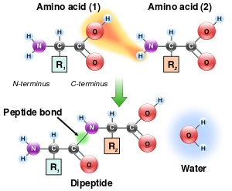

The reaction below is another way of looking at the reaction described above. The atoms shown in blue form the water molecule and the atoms shown in red are involved in the peptide bond.

*(*[*http://en.wikipedia.org/wiki/Peptide\_bond*](http://en.wikipedia.org/wiki/Peptide_bond)*)*

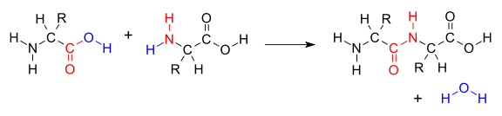

So we can think about many amino acids linking together via peptide bonds to form longer chains. Chains with molecular masses of less than 10,000 Da (Daltons) are not considered proteins but are usually referred to as oligopeptide chains. Longer protein chains may have thousands of amino acids, as noted below. In addition, the resulting protein molecules can vary greatly in size and mass. For example, keratin, a smaller protein found in human hair and nails, has a molecular mass in the 50,000-70,000 Dalton range. On the other hand, titin, the largest known protein, consists of 34,350 amino acids, with a molecular mass of approximately 3.8 million Daltons. Protein molecules are so large they are often referred to as macromolecules.

In addition to the large range in molecular size, proteins have a wide variety of properties. For example, silk is a flexible fiber, animal horn is a tough rigid solid, and the enzyme pepsin forms water soluble crystals. Given the variety of amino acid structures, there is significant diversity of proteins as illustrated by the list of proteins contained in egg white, below. It should also be no surprise that the amino acids making up proteins also vary widely in properties and function.

The list of amino acids contained in egg whites, in order of their prevalence and their general biological functions appears below. This information is adapted from <http://orthomolecular.org/nutrients/proteins.shtml>.

**Glutamic Acid** - The most common excitatory (stimulating) neurotransmitter in the central nervous system, has protective effects on the heart muscle in people with heart disease.

**Aspartic acid** - Combines with other amino acids to form compounds that absorb and remove toxins from the bloodstream.

**Leucine** - Helps with the regulation of blood-sugar levels, the growth and repair of muscle tissue (such as bones, skin and muscles), growth hormone production, and wound healing as well as energy regulation. Prevents the breakdown of muscle proteins

**Valine** - Promotes mental vigor, muscle coordination and calm emotions. Preventing muscle loss at high altitudes.

**Lysine** - Helps with the building of muscle protein, assists in fighting herpes and cold sores. It is required for growth and bone development in children, assists in calcium absorption and maintaining the correct nitrogen balance in the body and maintaining lean body mass.

**Serine** - Required for the metabolism of fat, tissue growth and the immune system as it assists in the production of immunoglobulins and antibodies.

**Alanine** - Vital for the production of protein, essential for proper function of the central nervous system and helps form neurotransmitters. An important source of energy for muscle tissue, the brain and central nervous system; strengthens the immune system by producing antibodies; helps in the metabolism of sugars and organic acids

**Phenylalanine** - Influences certain chemicals in the brain that relate to pain sensation. Helpful for some people with Parkinson’s disease and has been used to treat chronic pain. It is used in elevating the mood since it is so closely involved with the nervous system. It helps with memory and learning. It has been used as an appetite suppressant

**Isoleucine** - Helps preventing muscle protein breakdown during exercise, preventing muscle loss at high altitudes and prolonging endurance performance in the heat.

**Tyrosine** - Helps in suppressing the appetite and reducing body fat, production of skin and hair pigment, the proper functioning of the thyroid as well as the pituitary and adrenal gland

**Arginine** - Vital for the production of protein. Only the L form of amino acids are constituents of protein. Arginine crosses the blood-brain barrier, is a precursor for nitric oxide and is a responsible for the secretion of hormones such as growth hormone, glucagon and insulin. Assists in wound healing, helps remove excess ammonia from the body, stimulates immune function, and promotes secretion of several hormones, including glucagon, insulin, and growth hormone.

**Threonine** - Important for the formation of many proteins and tooth enamel, collagen, and elastrin. It metabolizes fat and prevents the buildup of fat in the liver, and is useful with intestinal disorders, and indigestion. Antiulcer.

**Proline** - Helps strengthen cardiac muscle, improves skin texture and aids collagen formation and helps contain the loss of collagen during aging.

**Glycine** - Inhibits neurotransmitter signals in the central nervous system.

**Methionine** - Supplies sulfur and other compounds required by the body for normal metabolism and growth. Improves memory recall in people with AIDS-related nervous system degeneration

**Histidine** - Neurotransmitter, stimulant of gastric secretion, vasodilator, and blood pressure regulator.

**Cystine** - Strengthens the protective lining of the stomach and intestines, which may help prevent damage caused by aspirin and similar drugs. Functions as an antioxidant and is a powerful aid to the body in protecting against radiation and pollution

**Tryptophan** - Essential for the production of the B vitamin, niacin, which is vital for the brain to manufacture the key neurotransmitter, serotonin. It enhances the release of growth hormones, and suppresses the appetite.

In summary, the amino acids listed above combine in long chains to form protein molecules. In the next section we will provide additional information on proteins.

**More on** **proteins**

The article suggests that the structure of protein molecules is the most important factor in creating foamy egg whites when baking angel food cake, meringues or soufflés. Let’s dig a little deeper into protein chemistry to see how this works.

Proteins are often described as the “workhorses” of cells. They are present in every cell in the body. They serve many different functions in organisms. They provide structure to the body in skin, cartilage, muscles, tendons and ligaments. As enzymes, hormones, antibodies, and globulins they regulate body chemistry. They serve as transport agents in the form of hemoglobin, myoglobin and various lipoproteins. Protein based antibiotics and vaccines help to fight disease, and we warm and protect our bodies with clothing that is often protein-based (e.g. wool, silk and leather).

One of the difficulties in describing protein chemical structure is that proteins are very large molecules, as noted above. For example, actin is a protein that is important for cell functioning. Its mass is about 42 kDa (12 Da is the mass of a single carbon atom). Remember that proteins are long polymers of amino acid monomers. How would that chain be represented? One way is to use the FASTA format, which is a text-based method of representing peptide sequences. Each amino acid is given a single letter abbreviation. For example, here are a few amino acids and their abbreviations:

**Amino Acid Code**

Alanine A

Aspartic acid D

Glycine G

Lysine K

Leucine L

Valine V

Tryptophan W

For a complete set of amino acid codes see <http://en.wikipedia.org/wiki/FASTA_form>. A protein’s structure is represented by arranging the letter abbreviations in order of the amino acids in the protein. So an example sequence might look like this:

... GKAAVDPADRCKEV .... Each letter represents an amino acid linked together by a peptide bond. This sequence is called the primary protein structure. Note that the FASTA format for an actual protein would be much longer, as indicated by the ellipses, above.

In addition to primary structures, proteins also have secondary, tertiary and in some cases quaternary structures. The secondary structure describes sub-structures of the long polymer chain that are arranged into either a helix or a sheet-like arrangement (see diagrams below). These two secondary characteristics are the result of intermolecular bonds between atoms *in the protein skeleton itself*. A note about the term “intermolecular” as it applies to macromolecules like proteins—the language is a little misleading. We usually refer to bonds like hydrogen bonds as “intermolecular” but in the case of large molecules this kind of bonding can occur between adjacent sections of the molecule, making the bonds “intra-molecular.” However, we will continue to use the conventional language.

The primary bonding of this type is hydrogen bonding, which occurs between the amide hydrogen with its partial positive charge and a non-bonding electron pair from the oxygen in the carboxyl group. In the helix structure (diagram below, left) the hydrogen atoms and the oxygen atoms face each other along the helix and the resulting hydrogen bonds hold the helix in place. In the sheet form (diagram below, right) the hydrogen atoms align alongside the oxygen atoms as the long chain doubles on itself in a single plane. As the article suggests, in a special case of intermolecular bonding in cysteine, which contains sulfur, the amino acids are bonded to each other secondarily by sulfur-sulfur bonds called disulfide bridges.

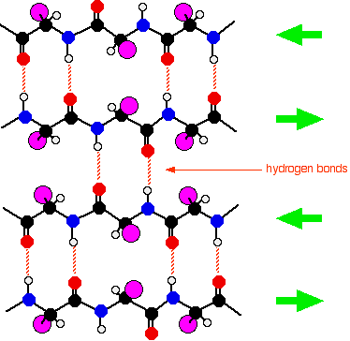

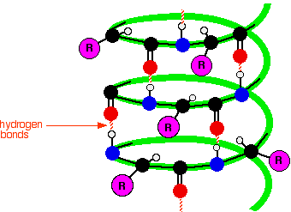

Helix secondary structure

Sheet secondary structure

*(*[*http://www.chemguide.co.uk/organicprops/aminoacids/proteinstruct.html*](http://www.chemguide.co.uk/organicprops/aminoacids/proteinstruct.html)*)*

The tertiary structure involves the way an entire polymer chain, including the helices and sheets, folds into itself to give the molecule its three-dimensional shape. Protein molecules fold into three-dimensional shapes due to intermolecular forces *between the amino acid side chains*. Many of the side chains contain units in which the hydrogen atoms set up hydrogen bonds with adjacent oxygen atoms. In the case of longer alkyl side chains temporary van der Waals dipoles can also be established, resulting in forces strong enough to hold the folded molecule in place. In some proteins there are also ionic interactions. Amino acids like aspartic acid and glutamic acid have an extra –COOH group. Other amino acids like lysine have an extra –NH2 group. If those two amino acids, each part of the same protein, were near each other in the overall structure, the –COOH could lose its H+ to the –NH2, forming a positive and a negative ion (the pair are called zwitterions), creating an ionic bond. In many proteins the tertiary structure is the final shape of the molecule.

Some proteins, however, develop a quaternary structure. These structures result from the interactions of two or more protein chains and are the result of complex intermolecular attractions. There are two general shapes into which protein molecules fold. They are globular shapes and fibrous shapes. Globular folding produces a general spherical shape. Examples of globular proteins are insulin, hemoglobin, and most enzymes. Fibrous folding presents itself as a long filamentous structure. Good examples here are keratin, mysin and actin (muscle-related proteins).

In summary, protein molecules are long polymers of amino acid monomers. Sections of the polymer take on either a helical or pleated shape and the entire backbone molecule folds itself into a general three-dimensional shape. It is important to note that the amino acid backbone also has side chains described above. As the article note, these side chains play a role in creating the protein foam for the angel food cake in question.

**More on** **egg white foam**

This article is primarily about how to create a stable foam in baking cakes, soufflés and meringues. And the article identifies beaten egg whites as the best vehicle to accomplish this feat. The foam itself is simply small air bubbles incorporated into the egg white in the whipping process. The stabilization of the foam is achieved by the egg whites. The process is summarized by the American Egg Board:

When air is incorporated into a liquid or viscous solution, the solution entraps the air bubbles, forming a foam. If the foam is stabilized by proteins, it leavens a food, increasing its height and reducing its density. The viscosity of all egg products is ideal for incorporating air cells during the whipping or beating process. As whipping or beating progresses, air bubbles decrease in size and increase in number, all the time surrounded by egg proteins. Liquid egg products have low air-liquid interfacial tension; thus, when eggs are beaten or whipped, the proteins denature, or simply, they unfold. This exposes two oppositely charged ends of the protein molecule: the hydrophobic, or water-hating end, and the hydrophilic, or water-loving ends. The proteins align themselves between the air and water, securing the air bubbles with their hydrophilic chains pointing into the water and dangling their hydrophobic chains in the air. During baking, these proteins bond with each other, forming a delicate, yet reinforced network.

Egg whites do this much better than yolks because of the unique proteins found in whites. In fact, even though the term foam technically refers to any system where there are entrapped air bubbles, in the food industry, when discussing egg products, the term tends to be exclusive to egg whites foams. This is because egg whites, unlike any other natural food ingredient, are able to create the largest possible food foam, a foam six to eight times greater in volume than unwhipped, non-aerated liquid egg white.

Whole eggs and egg yolks can also increase the volume of foods, including certain baked goods and dairy desserts such as ice cream and custard, but just not as much as egg whites alone. Visually, whipped yolks may double or triple in volume, while whipped whole eggs produce less volume than either yolks or whites whipped separately. They are also less thick than yolks alone.

There are four powerhouse proteins in egg whites that are barely present in yolks. Ovalbumin, which is about 54% of the white’s protein content, coagulates when heated, forming a solid framework around entrapped air that enables the wall structure to resist collapse. Ovalbumin does not unfold much when the egg is beaten, but without it, the foam would collapse when baked. Simply, ovalbumin allows a liquid foam to solidify. The highly elastic conalbumin, which is about 12% of the white’s protein content, together with two other proteins — ovomucin and globulins — both present in quite small amounts, stabilizes the foam at room temperature.

(<http://www.aeb.org/food-manufacturers/functional-properties/39-functional-properties/207-aeration-foaming-structure>)

As we think about the stability needed to create that angel food cake in the article we should focus on the side chains in amino acid molecules. These side chains can range from a single hydrogen atom in glycine, to a methyl group in alanine to more complex side chains like those in tryptophan or tyrosine (see structures below). Intermolecular forces in amino acid side chains actually hold the overall protein in its normal conformation. They also determine where the bends and folds are in the overall structure and shape of the complete molecule. And these side chains are “sticking out” on the exterior of the protein molecule and, therefore, are involved in bonding interactions of that protein.

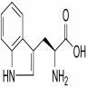

*(*[*http://commons.wikimedia.org/wiki/File:Tryptophan\_simple.png*](http://commons.wikimedia.org/wiki/File:Tryptophan_simple.png)*)*

Tryptophan

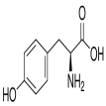

*(*[*http://www.mpbio.com/product.php?pid=02194759&country=223*](http://www.mpbio.com/product.php?pid=02194759&country=223)*)*

Tyrosine

The article emphasizes that in order to create a stable foam from egg whites there must be a balance between protein, air and water. This stability is the result of interactions on the part of the *side chains* of the amino acids that make up the egg white protein. Based on the nature of these side chains, some amino acids are attracted to water and some are not. That is, some are hydrophilic (attracted to water) and some are hydrophobic (not attracted to water). The proteins act like a surfactant, creating an interface between the water in the protein and the air bubbles that have been incorporated into the egg white. Hydrophilic amino acids have side chains that are either charged or polar, which means that they easily interact with the polar water molecule. The side chains in hydrophobic amino acid side chains are non-polar and neutral and do not interact with water, but do interact with air. The protein also serves as a framework that encapsulates the air bubbles.

Now, most protein molecules in their normal configuration have a hydrophobic core and a polar hydrophilic surface in contact with the environment. While hydrophobic amino acid residues make up the core, polar and charged amino acids cover the surface of the folded molecule. When the egg white is whipped to create foam, the whipping process causes the protein molecules to unfold (the process is called denaturing) exposing the hydrophobic parts of the molecule as well as the hydrophilic parts. The whipping process also causes the molecules to collide at a faster rate and the result is that intermolecular bonds that give the molecule its folded shape are broken. The hydrophilic sections of the protein are attracted to water and the hydrophobic sections, especially in the protein ovomucin, are attracted to the air bubbles created by the whipping process. New bonds are formed between protein molecules, especially the protein ovalbumin which coagulates during the baking process to stabilize the foam to create the light and airy angel food which may have a volume six to eight times that of the original liquid albumin.

However, as the article notes, these side chain bonds are relatively weak and any disruptions may cause the protein framework to collapse. What are the bonds that hold the foam in place? Some bonds are, in fact, ionic in nature. The charged amino acid side chains do form ionic bonds, which in this context are called salt bridges. All of the polar side chains form hydrogen bonds with water. The non-polar side chains interact with each other and the air bubbles via van der Waals forces. And in the side chains that contain sulfur the sulfur-sulfur bonding creates covalent sulfur bridges, mentioned earlier. The polar side chains form hydrogen bonds with the water present in the foam as well. See below for more on these bonds.

In the case of these side chains in amino acids (and, therefore, proteins) polarity is a critical factor. Determining polarity in organic compounds like proteins is a little more complex than doing so in inorganic compounds, but the same basic rules apply. This will be a good opportunity to either preview or review molecular polarity basics with students. Essentially you should remind students about comparing the electronegativity of individual atoms, about finding the degree of polarity of individual bonds and about polarity of groups of atoms, either whole molecules or parts of molecules in the case of amino acid side chains. You can consult your textbook for background here.

The proteins that make up albumin include the following with the percent and a very brief description of each:

Ovalbumin - 54%

Its biological role is uncertain but it is thought to be a storage protein, supplying amino acids and metal ions to biological processes. Made up of 385 individual amino acids

Ovotransferrin (also known as conalbumin) - 12%

It is a heat shock protein that is supplied to the skin to provide protection against cold stress. It also acts as an antimicrobial agent and has role in cell maturation by transporting essential nutrients to developing embryos. Made up of 700 amino acids.

Ovomucoid - 11%

It is a trypsin inhibitor, which means it blocks digestive enzymes. It is a glycoprotein comprising 186 amino acids. Ovomucoid has antibacterial activity resulting from its ability to inhibit bacterial enzymes involved in microbial growth.

Ovoglobulin G2 - 4%

This protein is important for the foaming property of egg whites that is described in the article.

Ovoglobulin G3 - 4%

Same as Ovoglobulin G2

Ovomucin - 3.5%

This protein has a soluble component and an insoluble component. The gel-like insoluble component makes up a large portion of egg white. It supports the density and general makeup of egg white.

Lysozyme - 3.4%

It acts as an anti-bacterial agent. It is made up of 129 amino acid units.

Ovoinhibitor - 1.5%

Like ovomucoid, this protein is a trypsin inhibitor.

Ovoglycoprotein - 1%

Its function in egg white is still unclear. It is an acidic glycoprotein.

Flavoprotein - 0.8%

It binds the vitamin B that is stored in egg whites.

The other minor proteins in egg white include ovomacroglobulin, avidin and cystatin.

To summarize, the foam that produces a good angel food cake is the result of air bubbles being introduced into the egg white, proteins partially unfolding and trapping the air bubbles within the water phase and intermolecular bonds holding the unfolded protein in place.

**More on** **intermolecular forces in proteins**

The material below has been adapted from the April 2005 Teacher’s Guide for the ChemMatters article, “The Amazing Drinking Bird.”

There are three types of intermolecular forces. They are (in order of increasing strength) London dispersion forces, dipole-dipole interactions, and hydrogen bonds. The relative energies of intermolecular forces are much less than covalent or ionic bonding energies. The following chart gives an approximation of the relative strengths in kJ/mol:

Covalent bonds 100–1000

Hydrogen bonds 10–40

Dipole-dipole 0.1–10

London forces 0.1–10

While covalent bond energies range from 150 to 800 kJ/mol, the energy required to overcome intermolecular attractions is usually less than 40 kJ/mol. For example, it takes 464 kJ/mol to break the H–O bonds *within* a water molecule and only 41 kJ/mol to break the bonds *between* water molecules.

London dispersion forces (one of the three forces that are, in aggregate, known as van der Waals forces) arise from instantaneous charges that arise in non-polar molecules involving atoms with larger numbers of electrons. Dipole-dipole interactions (the second type of van der Waals forces) are electrostatic forces created by the partial positive and negative charges within neighboring molecules that exhibit some degree of polarity.

Hydrogen bonds are the best known of the three and are the attractions between a polar covalently bonded hydrogen atom in one molecule and an electronegative atom with one (or more) nonbonding pair(s) of valence electrons in a neighboring molecule. Hydrogen bonding occurs most often in covalently bonded molecules involving nitrogen, oxygen, fluorine and chlorine. In proteins this occurs often between two alcohols, an alcohol and an acid, two acids, or an alcohol and an amine or amide.

**More on** **copper bowls and egg whites**

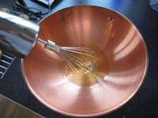The article issues a caution about the fragility of egg white foam and suggests several remedies. The oft-cited remedy is the use of a copper bowl in which to whip the egg whites. The article cites research into why copper increases the stability of stiff egg white foam. It suggests that in the whipping process copper ions are released from the bowl, perhaps due to the acidic nature of some amino acid side chains in proteins, and these ions form ligands with conalbumin (ovotransferrin) protein in egg whites. The complex stabilizes the foam. The reaction is similar to the reaction in the biuret test for protein.

In addition, copper also reacts with sulfur in proteins. The logic here is that egg white proteins contain the amino acid cysteine, which contains a sulfur-hydrogen combination in its side chain (this sulfur when combined with hydrogen is the cause of the “rotten egg” smell when eggs go bad). The sulfur-hydrogen bond is an active site in the molecule and the hydrogen is easily lost. If one cysteine molecule loses a hydrogen and a second molecule does also, the two sulfur atoms can form a disulfide bond, as illustrated in the article. The net effect of this is that protein molecules link together excessively, making the foam grainy and sticky. However, when copper reacts with sulfur in protein it prevents the formation of sulfide bridges and limits the protein coagulation.

In his book *On Food and Cooking: The Science and Lore of the Kitchen*, Harold McGee says this about copper bowls and egg whites:

Long before anyone knew about egg proteins or their chemical bonds, cooks had come up with a way of controlling them. The French tradition has long specified the use of copper utensils for making egg foams. One early trace of this tradition is a 1771 illustration in the French *Encyclopédie* that shows a boy in a pastry kitchen working with a straw wisk [sic] and what the accompanying key identified as “a copper bowl for beating egg whites.” pp. 102-103

See illustration below, which was scanned from McGee’s book.

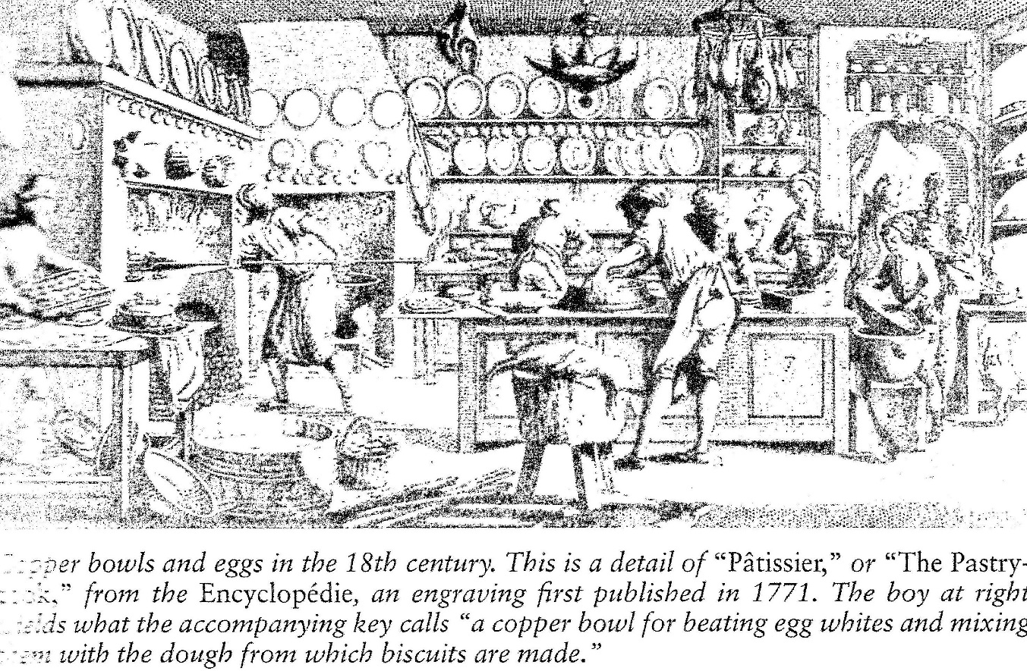

The more modern approach to stabilizing foam is to add an acidifying agent like cream of tartar, potassium bitartrate ([K](http://en.wikipedia.org/wiki/Potassium)[C4](http://en.wikipedia.org/wiki/Carbon)H5[O6](http://en.wikipedia.org/wiki/Oxygen)). Adding an acid—more specifically adding hydrogen ions to the mixture prevents cysteine from losing its own hydrogen ions and stabilizes the foam.

# Connections to Chemistry Concepts

**(for correlation to course curriculum)**

1. **Biochemistry—**Topics like proteins require that we look at the chemistry of a biological system like a chicken egg. Much of the study of biology today is actually biochemistry.
2. **Organic chemistry—**Most of the substances described in the article are organic compounds. Students need to understand organic nomenclature, organic structures, organic reactions, etc. in order to fully understand the content of this article.
3. **Polymers—**The article provides an opportunity for you to delve into polymers since proteins are natural polymers.
4. **Intermolecular forces**—Much of the protein structure depends on intermolecular forces, and this is a good chance to show why and how these forces are so important in explaining many of the changes we observe in chemistry.
5. **Bonding**—Bonding is not emphasized in the article, but in explaining amino acid and protein chemistry you can review covalent bonding as well as ionic bonding (to a limited extent).
6. **Acid/bases**—Acid theory, pH and the nature of organic acids are an integral part of this article.
7. **Polarity—**You will need to review polarity and polar molecules in order for your students to understand why the hydrophilic and hydrophobic nature of proteins is so important in this article.

# Possible Student Misconceptions

**(to aid teacher in addressing misconceptions)**

1. **“All polymers are man-made.”** *While many people may believe that because of all the publicity and the impact than modern plastics have had on our lives, there are important natural polymer as well. Examples of synthetic polymers include nylon, polyester, polyethylene and Teflon. Natural polymers include proteins, wool, silk, DNA and cellulose.*

# Anticipating Student Questions

**(answers to questions students might ask in class)**

1. **“The article says that proteins are ‘chains of molecules called amino acids.’ Does that mean that proteins are polymers?”** *Yes, proteins are very large natural polymers made up of amino acid monomers linked by peptide bonds.*
2. **“Is protein folding and unfolding a chemical change?”** *The folding/unfolding process is a physical change in form only. The protein molecule remains unchanged chemically.*
3. **“The article talks about hydrophilic amino acids that are attracted to water. Where does the water come from? Is it added to the egg whites as part of the recipe?”** *No, there is no need to add water to egg whites. Egg whites are 90% water to begin with.*

## In-Class Activities

**(lesson ideas, including labs & demonstrations)**

1. You can have students study eggs and osmosis using the procedure found here. (<http://everydaylife.globalpost.com/egg-osmosis-experiments-distilled-water-salt-water-32546.html>)
2. Students can observe the reaction of an egg shell with vinegar in this lab activity: <http://www.exploratorium.edu/cooking/eggs/activity-naked.html>.
3. Students can do a back titration to determine the mass of calcium carbonate in an egg shell. (<http://www.thinkib.net/chemistry/page/3117/caco3-in-egg-shells>)
4. Students learn to do tests for proteins in this lab activity and use their knowledge to solve a mystery. (<http://www.lessonplansinc.com/science.php?/biology/detail/macromolecule_mystery_lab>)
5. Students use the amino acid sequence for the protein villin in this activity: <http://web.stanford.edu/group/cpima/education/highschool.htm>.
6. This site has a series of activities including one on egg white foam: <http://www.uen.org/Lessonplan/preview.cgi?LPid=1178>.
7. Students can perform the test for proteins using this procedure: <http://www.ruf.rice.edu/~bioslabs/methods/protein/biuret.html>, or this one: <http://www.cfep.uci.edu/cspi/docs/lessons_secondary/You%20Are%20What%20You%20Eat.pdf>.
8. This activity enables students to model the structure of proteins, including tertiary structure. (<http://www.scienceteacherprogram.org/biology/SGallagher10.html>)
9. This activity allows students to create models of proteins that illustrate varying functions that proteins serve in the body. The activity also has an unusual inter-personal component. (<http://www.scienceteacherprogram.org/pdf/GiftOfProtein.pdf>)
10. By doing this very detailed lab simulation of protein structure, students will learn the factors that cause proteins to fold. (<http://www.scienceteacherprogram.org/biology/Granberry05.html>)
11. Students can do this series of lab activities to learn more about intermolecular forces” <http://www.physics.purdue.edu/psas/docs/Intermolecular%20Forces%20Lesson%20Plan.pdf>.
12. You might try to replicate the research that discovered that copper bowls helped to stabilize egg white foam. Students can design one or more experiments using bowls made of different materials and actually try to create the best foam.

# Out-of-class Activities and Projects

**(student research, class projects)**

1. You can assign individual students or teams of students to do research on one of the amino acids and include requirements like formula, structure, description, occurrence, uses, etc. If students construct 3D models using a uniform system for all students, students can bring their models to class and you can have students group the structures in varying ways.
2. Assign students to bring in recipes that include significant sources of proteins or protein foams. Although food in the laboratory is not a good idea, you might encourage students to bring in treats like angel food cake or meringue cookies after reading the article. A class can prepare a book of recipes to be distributed within the class or to parents.

# References

**(non-Web-based information sources)**



**30 Years of *ChemMatters***

Available Now!

**The references below can be found on the *ChemMatters* 30-year DVD (which includes all articles published during the years 1983 through April 2013 and all available Teacher’s Guides, beginning February 1990). The DVD is available from the American Chemical Society for $42 (or $135 for a site/school license) at this site:** [http://ww.acs.org/chemmatters](http://www.acs.org/chemmatters)**. Scroll about half way down the page and click on the *ChemMatters* DVD image at the right of the screen to order or to get more information.**

**Selected articles and the complete set of Teacher’s Guides for all issues from the past three years are available free online on the same Web site, above. Simply access the link and click on the “Past Issues” button directly below the “M” in the *ChemMatters* logo at the top of the Web page.**

Grosser, A. Egg Cookery, *ChemMatters* **1984**, *2* (4), pp 4–8. In a very simplistic way the author of this article describes the chemical structure of a chicken egg and the effect of various methods of cooking on the egg.

Baxter, R. Permanent Waves, *ChemMatters* **1993**, *11* (2), pp 8–11. Although this article is about waving hair, the chemistry of protein is featured, including the interaction of protein with water.

Vos, S. Linus Pauling: American Hero, *ChemMatters* **2007**, *25* (3), pp 7–10. Linus Pauling is credited with seminal work on the structure of proteins and so this article includes a large section on his contributions to the weak bonds—like hydrogen bonds—that give proteins their shape.

Nolte, B. Hold the Meat! Meat-free Food Takes a Seat at the Table, *ChemMatters* **2011**, *29* (4), pp 9–11. This article contains an introductory section on amino acids and protein structures that may help students better understand proteins.

Hill, M. Attack of the Gluten, *ChemMatters* **2012**, *30* (1), pp 9–11. Included in this article is a section on the proteins gliadin and glutenin, the proteins making up gluten. These proteins give baked products like bread their structure in a way that is similar to the proteins in egg whites that are beaten.

# Web Sites for Additional Information

**(Web-based information sources)**

**More sites on** **eggs**

The trade association The American Egg Board supplies a lot of information about eggs. (<http://www.aeb.org/>)

This Exploratorium activity details the anatomy of a chicken egg: <https://www.exploratorium.edu/cooking/eggs/eggcomposition.html>.

National Pasteurized Eggs sponsors this site which includes a short basic course on egg chemistry: <http://www.safeeggs.com/foodservice/resources/free-ce/protein-nutrition-egg-chemistry>.

**More sites on amino acids**

The reliable *Chemguide* from the U.K. summarizes the properties of amino acids and links the page to another page on proteins. (<http://www.chemguide.co.uk/organicprops/aminoacids/background.html>)

If you want to read details about amino acids and their structures, try “The Biology Project” at the University of Arizona. Be sure to check the links on the left. (<http://www.biology.arizona.edu/biochemistry/problem_sets/aa/aa.html>)

Michigan State University’s department of chemistry gives amino acid structures and a brief background summary. (<https://www2.chemistry.msu.edu/faculty/reusch/virttxtjml/proteins.htm>)

Have a look at the amino acid pages in the *Virtual Chembook* from Elmhurst College. See the links at the top of the page. (<http://www.elmhurst.edu/~chm/vchembook/560aminoacids.html>)

The *Hyperphyics Textbook* at Georgia State University has a section on amino acids with a nice visual of peptide bonding. (<http://hyperphysics.phy-astr.gsu.edu/hbase/organic/amino.html>)

This page from New York University has multiple representations of all amino acid structures: <http://www.nyu.edu/pages/mathmol/library/life/life1.html>.

Purdue University’s amino acid page includes information on the synthesis of proteins and a section on acid/base amino acid chemistry. (<http://chemed.chem.purdue.edu/genchem/topicreview/bp/1biochem/amino2.html>)

**More sites on proteins**

This site from Lund University in Sweden has eight pages of details about proteins. **(**<http://www.proteinstructures.com/Structure/Structure/amino-acids.html>)

The Concord Consortium site highlights the hydrophobic/hydrophilic nature of proteins: <http://staff.concord.org/~btinker/workbench_web/unitV/mol_water_bg.html>. This site is rich in resources. Bookmark it.

Here’s the *Chemguide page* on proteins. It offers good explanations of secondary and tertiary structures. (<http://www.chemguide.co.uk/organicprops/aminoacids/proteinstruct.html>)

The U.K.’s Royal Society of Chemistry has a nice overview of protein chemistry: <http://www.rsc.org/Education/Teachers/Resources/cfb/proteins.htm>.

BiodotEdu from CUNY Brooklyn has good visuals as part of a complete but simple review of proteins. (<http://www.brooklyn.cuny.edu/bc/ahp/LAD/C4b/C4b_proteinShape.html>)

**More sites on** **egg white foam**

San Francisco’s Exploratorium has a section on cooking and it includes a page on eggs. Be sure to click on “Why do egg whites foam?” (<http://www.exploratorium.edu/cooking/eggs/recipe-pavlova.html>)

This site, related to the food industry, gives a very nice explanation of the factors involved in preparing egg white foam: <http://www.preparedfoods.com/articles/112210-creating-egg-white-foams>.

The American Egg Board gives its take on preparing egg white foam here: <http://www.aeb.org/food-manufacturers/functional-properties/39-functional-properties/207-aeration-foaming-structure>.

**More sites on** **intermolecular forces**

Another page from Purdue University, this one contains information on the unique characteristics of each intermolecular force: <http://chemed.chem.purdue.edu/genchem/topicreview/bp/intermol/intermol.html>.

This page from Penn State reviews intermolecular forces: <http://chemistry.bd.psu.edu/jircitano/IMforces.html>.

UC Davis provides an interesting look at intermolecular forces with good visuals. (<http://chemwiki.ucdavis.edu/Physical_Chemistry/Physical_Properties_of_Matter/Atomic_and_Molecular_Properties/Intermolecular_Forces>)