April/May 2017 Teacher's Guide

Background Information

for

Genetically Modified Foods: Are They Safe to Eat?

Table of Contents

About the Guide 2
Background Information 3
References 27
Web Sites for Additional Information 28
General Web References 35

About the Guide

Teacher’s Guide team leader William Bleam and editors Pamela Diaz, Regis Goode, Diane Krone, Steve Long and Barbara Sitzman created the Teacher’s Guide article material.
E-mail: bbleam@verizon.net

Susan Cooper prepared the anticipation and reading guides.

Patrice Pages, ChemMatters editor, coordinated production and prepared the Microsoft Word and PDF versions of the Teacher’s Guide.
E-mail: chemmatters@acs.org

Articles from past issues of ChemMatters and related Teacher’s Guides can be accessed from a DVD that is available from the American Chemical Society for $42. The DVD contains the entire 30-year publication of ChemMatters issues, from February 1983 to April 2013, along with all the related Teacher’s Guides since they were first created with the February 1990 issue of ChemMatters.

The DVD also includes Article, Title, and Keyword Indexes that cover all issues from February 1983 to April 2013. A search function (similar to a Google search of keywords) is also available on the DVD.

The ChemMatters DVD can be purchased by calling 1-800-227-5558. Purchase information can also be found online at http://tinyurl.com/o37s9x2.

Background Information
(teacher information)
GMO Terminology

The term GMO refers to genetically modified organisms. It is a generic term used for any type of organism that has had its DNA altered in some fashion. It is the term used in the “Genetically Modified Foods: Are they Safe to Eat” Wendel article to refer to plants with altered genetic material (DNA). The World Health Organization (WHO) defines GMOs as "organisms (i.e., plants, animals or microorganisms) in which the genetic material (DNA) has been altered in a way that does not occur naturally by mating and/or natural recombination." (http://www.who.int/foodsafety/areas_work/food-technology/faq-genetically-modified-food/en/)

There are many other terms used globally to describe GMOs. The WHO also states that “modern biotechnology”, “gene technology”, “recombinant DNA”, and “genetic engineering (GE)” are other terms for GMOs. The term “transgenic organism” is another synonym for GMO because it describes the genes of one species which are modified or transplanted into another species. This is genetic engineering or recombinant DNA at work.

While the Wendel article consistently uses the term GMO, the references and background information below may use any combination of the synonyms described here. The terminology used in this Teacher's Guide follows the terminology used in the articles cited or as the author or source of the information used.

A History of genetically modified organisms (GMOs)

By the WHO definition above, organisms made by selective breeding or provided with hormone supplements or antibiotics are technically not GMOs. Even though animals may eat feed containing genetically engineered crops, the organisms themselves are not considered GMOs. So, when and how did GMOs begin?

Humans have altered the genetics of organisms (the focus of this Teachers Guide, like the Wendel article, is on plants) by the use of selective breeding for over 30,000 years. Mankind's desire to improve food crops and other useful plants prompted people to develop and use selective breeding techniques. However, the beginning of genetically engineered (GE) organisms through recombinant DNA techniques started with Herbert Boyer (University of California, San Francisco) and Stanley Cohen (Stanford University), based on the work of Paul Berg's (Stanford University) 1980 Nobel Award-winning gene-splicing experiments.

The first success of the Boyer-Cohen collaboration occurred in spring 1973 and involved one of Cohen’s plasmids, pSC101. Plasmids were already known to transfer drug resistance among bacteria, and this one could make E. coli resistant to the antibiotic tetracycline. The plasmid pSC101 was cleaved by EcoRI at only one site, leaving intact the plasmid’s ability to replicate. When the linearized pSC101 DNA was mixed with other DNA that had been cleaved by the same enzyme, the complementary ends of fragments from both sources of DNA joined together into new loops. Treatment with another enzyme closed the still-visible nicks in the DNA loops, which were then introduced into calcium chloride–treated bacteria. The bacteria were spread on a culture containing tetracycline, and only the bacteria with the rDNA plasmids survived.

(https://www.chemheritage.org/historical-profile/herbert-w-boyer-and-stanley-n-cohen)

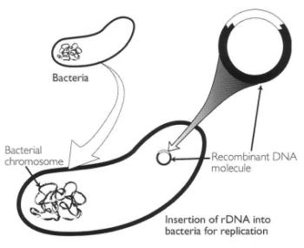
Boyer and Cohen continued their experimentation and soon proved that genetic material could be transferred between different species (Staphylococcus plasmid inserted into an E. coli plasmid). The commercial applications of the pioneering gene-splicing work of Boyer and Cohen became apparent, and soon companies like Genentech (1976) were founded to capitalize on this new technique. Eli Lilly and Company signed a joint-venture agreement with Genentech, and in 1982 Humulin (a recombinant DNA human insulin) was approved by the Federal Drug Administration. (https://www.chemheritage.org/historical-profile/herbert-w-boyer-and-stanley-n-cohen)
The insertion of recombinant DNA so that the foreign DNA will replicate naturally, as pioneered by Herbert Boyer and Stanley Cohen

(https://www.chemheritage.org/historical-profile/herbert-w-boyer-and-stanley-n-cohen)

The graphic below shows a timeline of the history of GMO development, including plants and animals from about 30,000 years ago. Humans began with the domestication and selective breeding of wolves and may have applied that knowledge to crops and, ultimately, to the current manipulation of DNA resulting in the ability to rapidly influence an organism's traits.

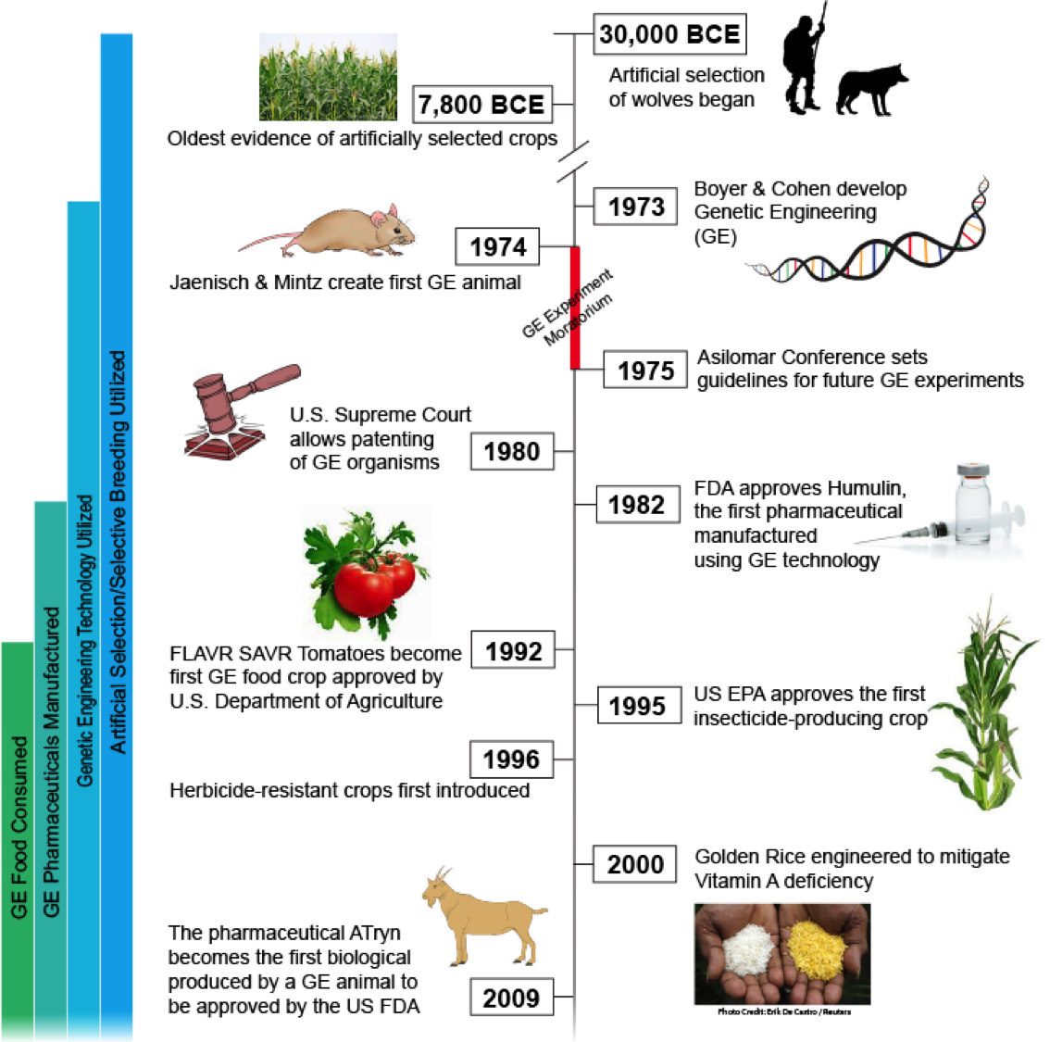

A brief timeline of GMO development

(http://sitn.hms.harvard.edu/flash/2015/from-corgis-to-corn-a-brief-look-at-the-long-history-of-gmo-technology/)

An important piece of the development of GMOs was the 1980 U.S. Supreme Court ruling (https://supreme.justia.com/cases/federal/us/447/303/case.html) that allowed General Electric scientists to patent a bacterium that was genetically engineered to break down crude oil from environmental oil spills. This critical ruling gave protection to the large investments that companies were making to design GMOs, and it was a huge incentive for universities and companies to develop new GMO techniques and additional organisms.

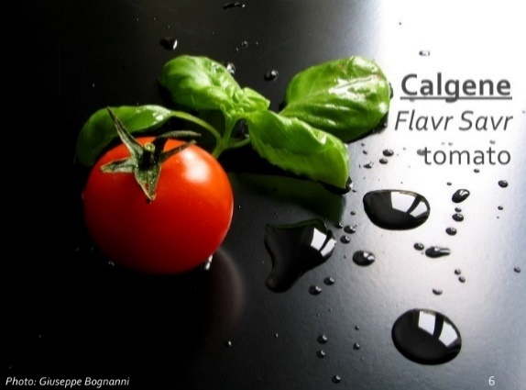
Foods have been the focus of much of the controversy surrounding GMOs. Tomatoes were the first field crop food to receive genetic engineering. After many years of research, including health and environmental studies, Calgene, Inc. (a California biotechnology company) was granted a license in 1994 to sell the genetically engineered tomato, Flavr Savr (CGN-89564-2). The Flavr Savr tomato was designed to ripen slowly to prevent damage in shipping from ripening and softening, while still retaining the tomato's red color and natural flavor. (http://calag.ucanr.edu/Archive/?article=ca.v054n04p6)
The Flavr Savr tomato

(http://www.slideshare.net/enfresdezh/genetically-modified-food)

The FDA did not require special labeling of these GMO tomatoes because FDA scientists determined that there was no health risk from consuming them, and the GMO tomatoes had the same flavor and characteristics of conventional tomatoes. The Flavr Savr tomato did not perform as well as Calgene expected, even with additional improvements to the original design, and production of the tomato ceased in 1997. Calgene was acquired by the Monsanto Company in 1996, partly due to the unprofitability related to Calgene's inexperience in growing and shipping tomatoes.

In 1995, the first genetically-altered pesticide-producing crop plants, corn and potatoes, were approved by the EPA. A piece of Bacillus thuringiensis (Bt) DNA was embedded in the DNA of the corn and potato plants. Bt is a bacterium that grows naturally in soils and produces a natural insecticide. Therefore, the EPA believed that the Bt genetic modification would not be harmful to either public health or the environment. By using the GE plant, the need for conventional pesticides was reduced. The Bt gene in the corn allowed it to resist the European corn borer, corn rootworm, and moth-like insects, while the Bt in the potato offered resistance to the Colorado potato beetle. In 1995, the GMO corn was allowed to be planted on 9,725 acres in nine states and territories, and the potato to be planted on 8,186 acres in 12 states. The Union of Concerned Scientists was critical of the EPA's decision, believing that the GMO plants producing their own pesticides could lead to the development of insects with resistance to the pesticides. Today, approximately 80% of the corn planted in the US has the Bt genetic modification. (http://www.nytimes.com/1995/04/11/us/epa-approves-three-genetically-altered-crops.html)

In 1996, the soybean was the first herbicide-resistant (also called herbicide tolerant, HT) plant. This GMO soybean was produced by the Monsanto Company, which produces the herbicide Roundup. Other crop plants (corn and sugar beets) may have a gene for herbicide resistance (typically glyphosate, called Roundup Ready). Many plants now have both the Bt and the herbicide resistant (called stacked) genetic modifications. Since 1996, the proliferation of GMO plants has steadily increased, but the trend may be slowing as the graph below shows. For an Excel data file on the percentage of Bt and HT crops planted in the US since 1996, see https://www.ers.usda.gov/media/8725/extent-of-adoption-1996-2016.xlsx.

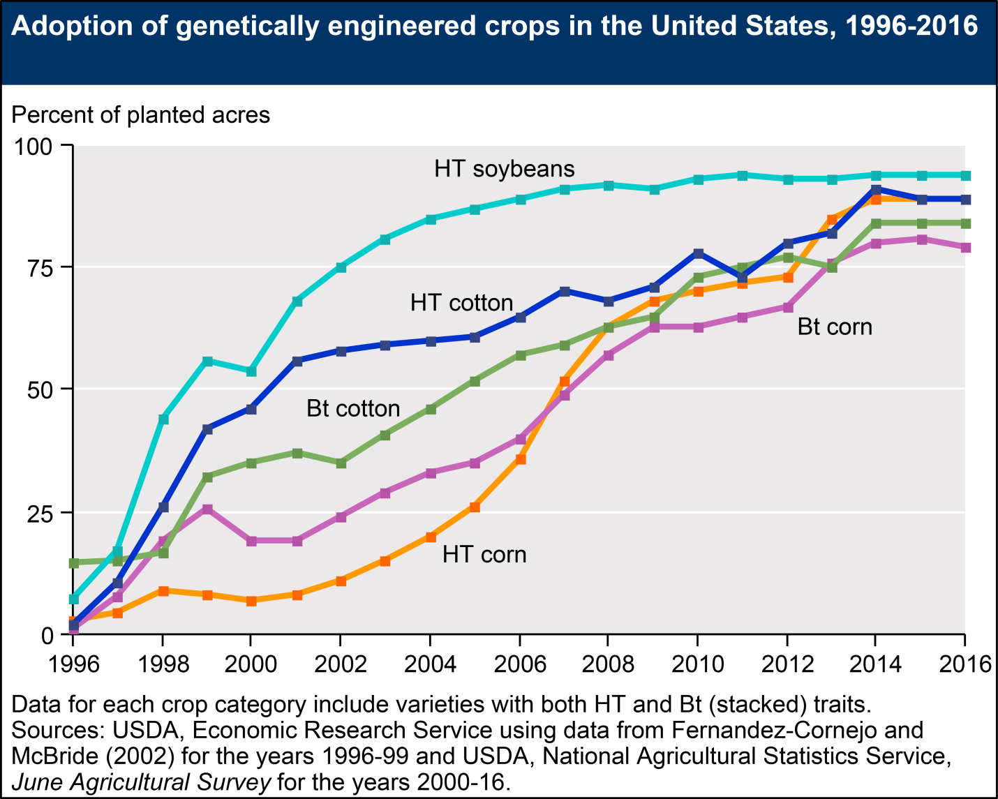

USDA graph of GE crops in the US from 1996–2016

(https://www.ers.usda.gov/data-products/adoption-of-genetically-engineered-crops-in-the-us/recent-trends-in-ge-adoption.aspx)

How GMOs are created

Simply, to create a new GMO, scientists find a trait in an organism that is of use, isolate or remove the DNA for the trait from the donor organism, insert the DNA for the useful trait into the desired (host) organism, and then grow or propagate the modified organism. Easy? Not really! The techniques that mankind has used to alter organisms have improved over the last 100 years, from selective breeding, to gene insertion from one organism to another, to the current practices of editing genomes. These newer techniques require genetic engineering skills and sophisticated equipment, and are not necessarily simple and easy, but they are becoming easier with automation.

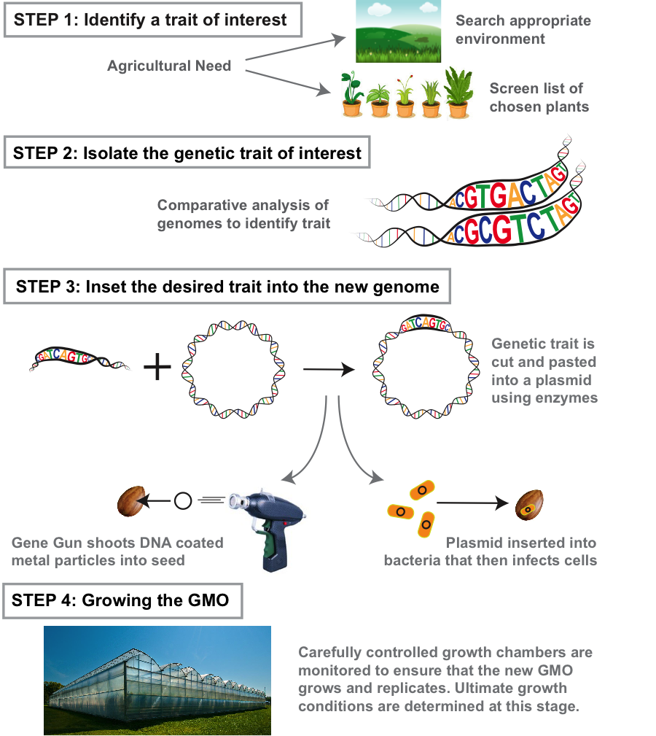

A pictorial of the process of genetic engineering to produce a GMO

(http://sitn.hms.harvard.edu/flash/2015/how-to-make-a-gmo/)

In the first step, scientists seek useful traits and often find them in nature. For example, to enable a plant to have heat- or drought-tolerance, scientists might look in hot or arid places for plants that naturally grow successfully in those environments.

Secondly, scientists must analyze and identify the part of the DNA in the plant responsible for the desired trait. To do this, scientists will analyze the genomes of the plant with the useful trait, comparing them with genomes of the same species of plant without the useful trait. Comparing the genomes of the plants, they may be able to identify the specific gene conveying the desired trait. If this comparison does not provide the needed genetic information, scientists may delete parts of the genome in the desired plant until the trait is lost. An analogy of this might be a person with a food allergy eliminating specific foods from his/her diet until the allergy symptoms cease—identification by elimination. Researchers have developed methods to expedite this identification process, but it can still be a lengthy procedure.

In the third step, a common procedure is to use enzymes to cut out strands of the desired DNA from the donor plant Often, this DNA is more easily inserted into a bacterium plasmid (a round molecule of DNA) than directly into the host plant's DNA. A common bacterium used for this implant procedure is Agrobacterium tumefaciens, a natural soil bacterium. The desired DNA is pasted into the A. tumefaciens DNA plasmid, and then the bacterium is treated so it will accept the modified plasmid. The A. tumefaciens bacterium (containing the modified plasmid) naturally invades seeds and plants, so it inserts its modified DNA into the desired plant-much like a Trojan horse—completing the transfer process. In another technique, some biotech companies use "gene guns" (see graphic) to shoot specially coated pieces of metal coated with the desired DNA into the host plant to transfer the trait of interest.

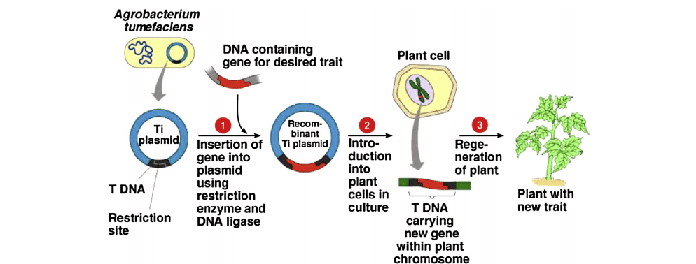

Diagram of A. tumefaciens-mediated transformation (step 3 above)

(https://www.researchgate.net/publication/259139407_Transgenic_plants_Types_benefits_public_concerns_and_future)

The last step involves growing the new GMO. However, the genotype of the newly modified plant must first be checked to assure that the modified plant carries the gene of interest. Once the GMO plant is certified to contain the desired gene and trait, it is propagated. Researchers and biotech companies spend large sums of money in special climate-controlled facilities to keep these genetically engineered plants alive and to reproduce them in large quantities. Some propagation techniques are automated and done by machine, but some require checking on the plants by hand. (http://sitn.hms.harvard.edu/flash/2015/how-to-make-a-gmo/)

The table below summarizes the genetically engineered food crops from the Food and Drug Administration (FDA). The table shows the crop, the source of the inserted gene trait, and the characteristics of the desired trait.
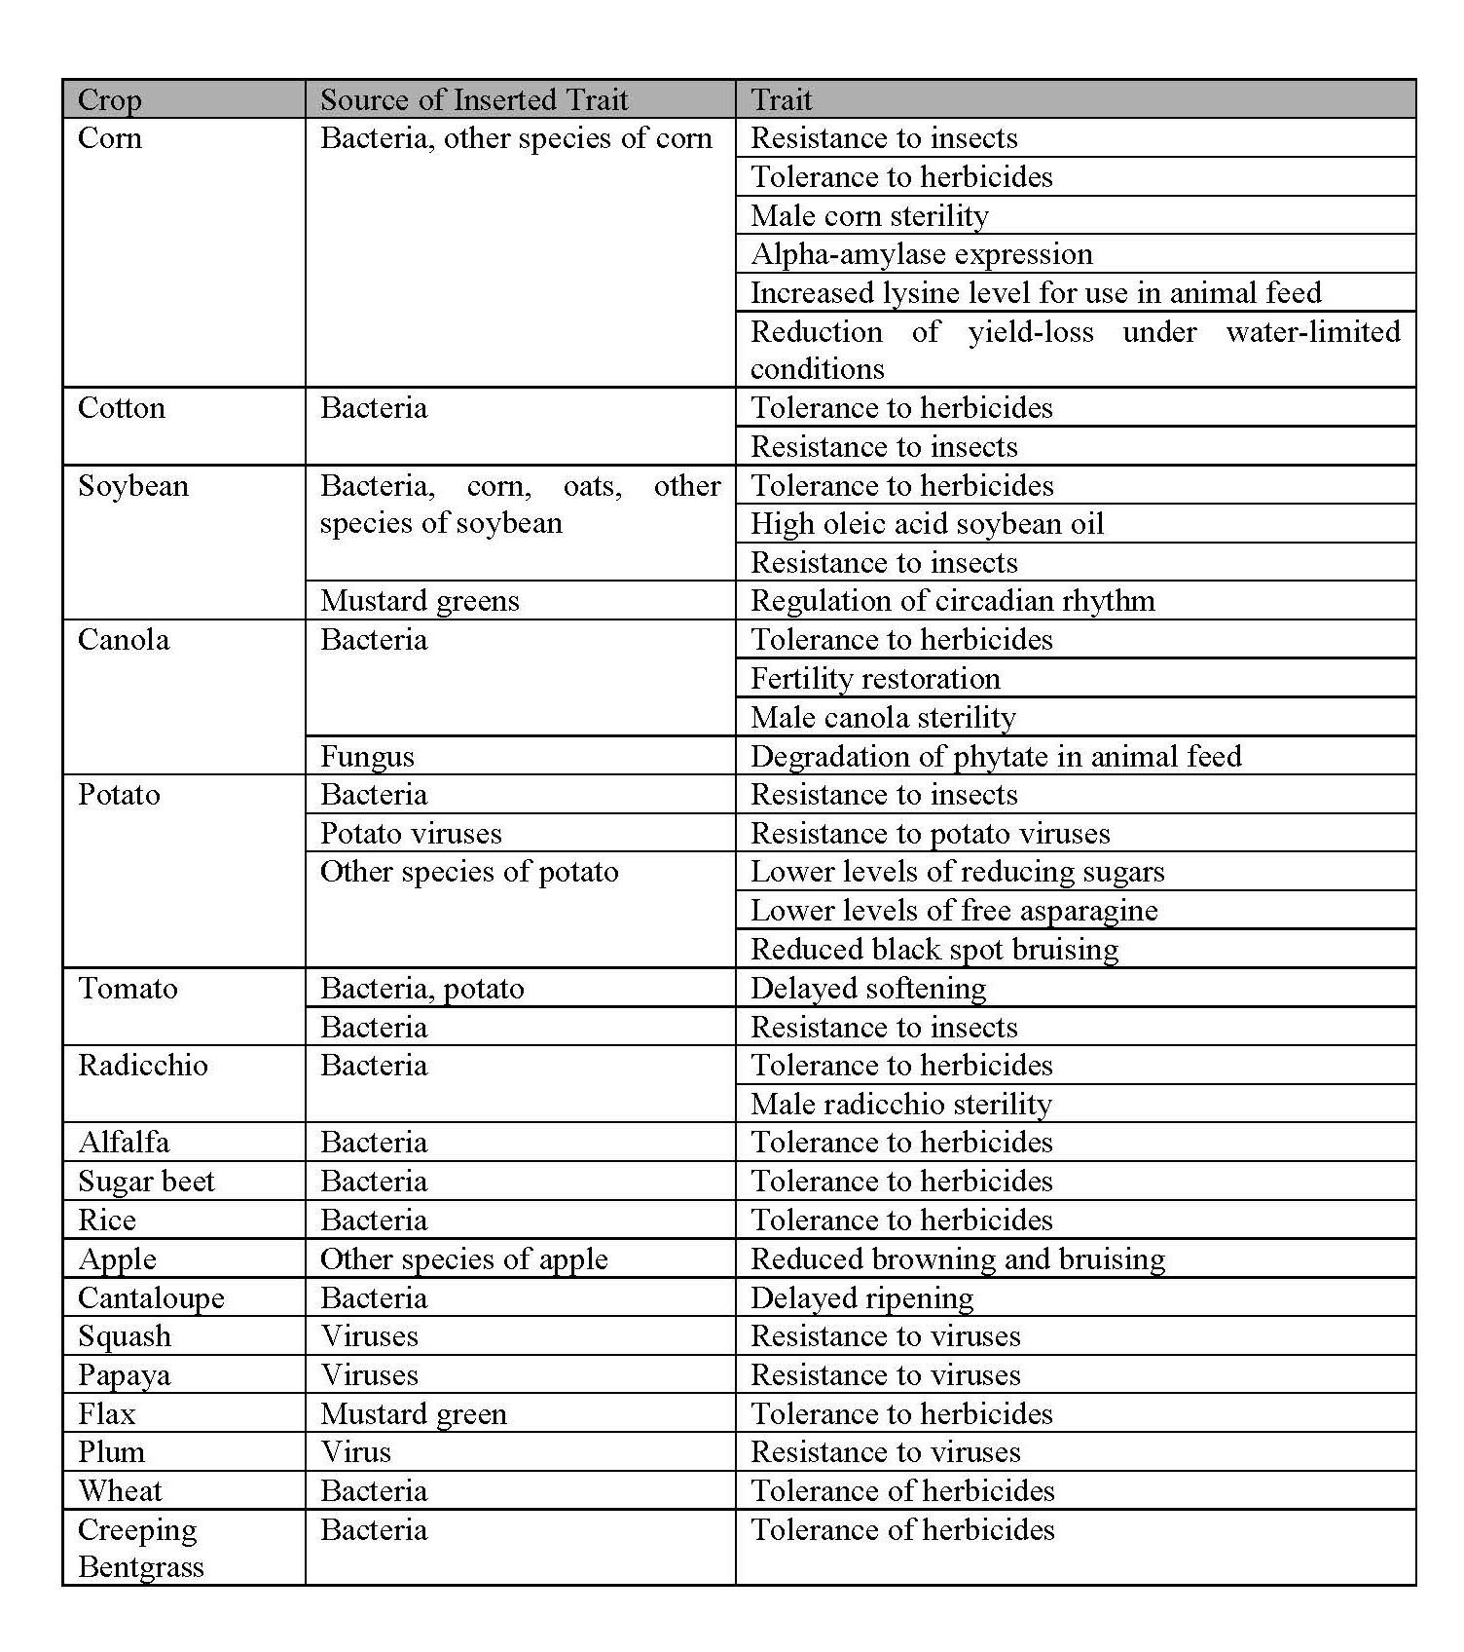
Summary of the FDA’s Inventory of Completed Biotechnology Consultations on
Genetically Engineered Foods as of June 30th, 2015. Crops listed in order of
relative abundance of genetically engineered crop consultations

(http://sitn.hms.harvard.edu/flash/2015/how-to-make-a-gmo/)
Bacillus thuringiensis (Bt)

Bacillus thuringiensis (Bt) is a common soil bacterium. It has natural insecticidal qualities which have made it valuable in GMO plants. Bt has been accepted and widely used as a pesticide for applications on natural and organic crops. However, its use in genetically engineered (GMO) applications has been more controversial. The Food and Agriculture Organization of the United Nations (FAO) "estimates that between 20 and 40 percent of global crop yields are reduced each year due to the damage wrought by plant pests and diseases." (http://www.fao.org/news/story/en/item/280489/icode/) In addition, the U.S. Environmental Protection Agency (EPA) estimates that for 2007, there were 1.13 billion pounds of pesticides (herbicides, insecticides, fungicides, etc.) applied to crops in the United States, and that 5.2 billion pounds of these chemical were used worldwide at a cost of 35 billion dollars (https://www.epa.gov/sites/production/files/2015-10/documents/market_estimates2007.pdf).

By using genetic engineering and transgenic plants (plants made with genetic engineering containing DNA from more than one organism) or GMO plants containing Bt, farmers are able to reduce the use of pesticides while maintaining, or improving, crop yields. Since the 1990s, corn and cotton containing Bt genes have become the primary varieties that are planted in the U.S.

Bt is commonly found in many soils, from deserts to tundra. It was first isolated in 1901 by Ishiwata Shigetane while studying a disease that killed silkworms, sotto (sudden-collapse) disease. In 1911, Ernst Berliner noted that Bt was toxic to specific insect larvae but not to others. In 1920, Bt began to be used as a natural pesticide on corn crops, and France began making the product, Sporine, in 1938 to kill flour moths. Scientists knew at this time that Bt was toxic to moth (lepidopteran) larvae. However, it was easily washed away by rain and it degraded under sunlight. In 1956, Hannay, Fritz-James, and Angus discovered the parasporal crystal in Bt that was the primary insecticide. By 1958, the U.S. EPA had registered Bt as a commercial pesticide.

Before 1977, the 13 known strains of Bt were understood to be toxic only to specific species of lepidopteran larvae. But in 1977, subspecies of Bt were identified that were toxic to certain flies (dipteran); and in 1983, Bt strains toxic to beetle (coleopteran) species were found. Today, thousands of strains of Bt are known, and many of them have genes that produce unique pesticide toxins. The use of Bt as a pesticide increased dramatically in the 1980s, as insects became increasingly resistant to some conventional pesticides. (http://www.bt.ucsd.edu/bt_history.html)

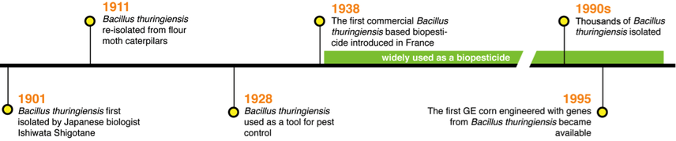

Brief timeline of Bt development and usage

(http://sitn.hms.harvard.edu/flash/2015/insecticidal-plants/)

In order for Bt to be toxic, it must be eaten by the insect. Because different strains of Bt produce toxins that bind to specific receptors in the insects' stomachs, beneficial insects are not killed, but farmers must carefully match the strain of Bt with the identified pest species.

The Bt toxin dissolve in the high pH insect gut and become active. The toxins then attack the gut cells of the insect, punching holes in the lining. The Bt spores spills out of the gut and germinate in the insect causing death within a couple days. Even though the toxin does not kill the insect immediately, treated plant parts will not be damaged because the insect stops feeding within hours. Bt spores do not spread to other insects or cause disease outbreaks on their own.

(http://www.bt.ucsd.edu/how_bt_work.html)

Bacillus thuringiensis has been demonstrated to be safe for use in the environment and with humans and other mammals. The EPA has exempted Bt from food residue tolerances, groundwater restrictions, endangered species labeling, and special review requirements.

In 2001, the US Environmental Protection Agency (EPA; Washington, DC, USA) reassessed the four still registered, but expiring, Bt crops that had been accepted for agricultural use in the preceding six years (from 1995 to October 2001). The Bt crop reassessment approvals included provisions to prevent gene flow from Bt cotton to weedy relatives, increase research data on potential environmental effects and strengthen insect resistance management.

From this reassessment, the EPA has determined that Bt corn and Bt cotton do not pose unreasonable risks to human health or to the environment.

Bt plant-incorporated protectants are proteins. Commonly found in the diet, proteins present little risk, except for a few well described cases (such as food allergens, acute toxins and antinutrients). In addition, for the majority of Bt proteins currently registered, the source bacterium has been a registered microbial pesticide previously approved for use on food crops without specific restrictions. Because of their use as microbial pesticides, a long history of safe use is associated with many proteins found in these Bt products.

(https://www.epa.gov/sites/production/files/2015-08/documents/are_bt_crops_safe.pdf)

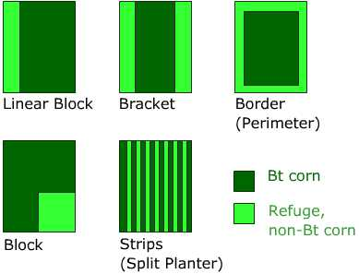
The EPA requires farmers to plant refuge areas (non-GMO plants) in the fields along with the Bt crops. This allows insects that may develop resistance to the Bt toxins to have a chance to mate with insects without the resistance. Genetically, the Bt resistance is a recessive trait, so the resistance will not be passed to the offspring. For Bt corn, famers must plant at least 20% of their acreage in non-Bt corn.
Patterns of planting refuge crops

"Bt crops are planted with alternating rows of regular
non-Bt crops. The insects that have developed resistance
to Bt have more chances of mating with an insect
that has not developed resistance to Bt. By the
laws of genetics, the progenies produced will be
insects that are not resistant to Bt."

(http://www.bt.ucsd.edu/crop_refuge.html)
(http://www.bt.ucsd.edu/crop_refuge.html)

As with every other pesticide (and herbicide) developed and used throughout history, evolution selects for resistance to these controls. China almost exclusively plants Bt cotton; but China does not require refuge crop areas to be planted along with the Bt cotton. Instead, China relies on the assumption that insect pests feed on a variety of crop plants that will naturally dilute he resistant genes that may develop by natural breeding processes. A study of this practice is now returning results. (http://www.nature.com/nbt/journal/v33/n2/full/nbt.3100.html; please note that this is an abstract only; full access requires a subscription or a fee to read the entire article)

A summary of the study from a different source states that:

Population genetics suggests that, in the absence of refuges, the starting percentage of resistant insects (just under one percent in 2010) would have produced a 98 percent resistant population by the end of the study. If the remaining crops were fully effective as refuges for non-resistant animals, however, the percentage would only be expected to reach 1.1 percent.

The results, however, were somewhere in between. By 2013, resistance had risen to 5.5 percent. Thus, the other crops are functioning as refuges, though with an efficiency the researchers calculate as roughly half that of non-GMO cotton.

That's the good news. Part of the bad news is that, over the study period, there was a shift in how the resistance was inherited. At the start, the majority (63 percent) of the animals had resistance that was recessive, meaning the animals needed to inherit two copies of the resistance gene in order to safely eat Bt crops. By the end of the study, 84 percent of the animals had resistance that could be inherited in a dominant fashion, meaning that only a single copy of the resistance gene would be needed. Worse still, the dominant alleles do not seem to cause any other health issues for the insects that carry them.

This will allow the resistance to spread much more rapidly in the future. In fact, plugging the data back into population biology models suggests that over half the insect pests will be resistant by 2017.

The authors also note that it could be worse. China only really uses Bt cotton; Brazil uses that plus corn and soybeans and also doesn't pursue a refuge policy.

There is some hope on the way. As noted above, commercial versions of crops that have two different Bt proteins are already available, and the authors of the paper note that a version carrying a third insecticide is in development. Unfortunately, by the time these arrive on the scene in China, they may be facing insects that already shrug off one of the toxins.

(https://arstechnica.com/science/2014/12/gmo-free-crop-refuges-limit-bugs-ability-to-develop-resistance/)

So, it is possible that poor agricultural techniques may allow insect pests to develop a dominant gene for resistance to the Bt protein that acts as a natural insecticide in many crop plants. When—not if—this occurs, scientists will be challenged to continue research to develop new pesticides or GMOs with new genes for which the insect pests have not developed resistance.

The Safety of GMO Plants and Foods

Some consumers question the safety of GMO foods. There are numerous rumors concerning GMOs, and foods produced from GMOs. The safety concerns generally involve environmental safety and consumer health safety. The U.S. Food and Drug Administration (FDA) states that "FDA regulates the safety of food for humans and animals, including foods produced from genetically engineered (GE) plants. Foods from GE plants must meet the same food safety requirements as foods derived from traditionally bred plants." (http://www.fda.gov/Food/IngredientsPackagingLabeling/GEPlants/default.htm)

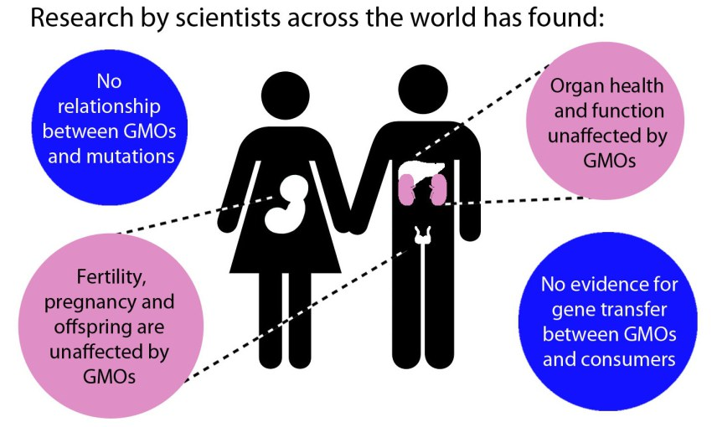
One problem associated with assessing risks and benefits of any situation is obtaining reliable and accurate information. The Internet is filled with blogs, Web sites, and "officials" offering "facts" and misrepresentations rather than scientific evidence and conclusions.
Results of scientific research concerning
safety of GMOs on human health

(http://sitn.hms.harvard.edu/flash/2015/will-gmos-hurt-my-body/)

Though knowing who to trust and what to believe regarding this topic is an ongoing battle, major health groups, including the American Medical Association and World Health Organization, have concluded from the research of independent groups worldwide that genetically modified foods are safe for consumers [Tamar Haspel. “Genetically modified foods: What is and isn’t true”. Washington Post. October 15, 2013]. Regarding toxicity, this includes any dangers related to organ health, mutations, pregnancy and offspring, and potential for transfer of genes to the consumer.

(http://sitn.hms.harvard.edu/flash/2015/will-gmos-hurt-my-body/)

To determine if GMO crops or foods are safe, numerous studies and tests are conducted to ensure that the GMO plant or food has the same nutrition as conventionally grown items. The U.S. FDA has regulations and protocols that plant developers must follow before the modified plant or food is approved for human use.

Evaluating the safety of food from a genetically engineered plant is a comprehensive process that includes several steps. Generally, the developer identifies the distinguishing attributes of new genetic traits and assesses whether any new material that a person consumed in food made from the genetically engineered plants could be toxic or allergenic. The developer also compares the levels of nutrients in the new genetically engineered plant to traditionally bred plants. This typically includes such nutrients as fiber, protein, fat, vitamins, and minerals. The developer includes this information in a safety assessment, which FDA’s Biotechnology Evaluation Team then evaluates for safety and compliance with the law.

FDA teams of scientists knowledgeable in genetic engineering, toxicology, chemistry, nutrition, and other scientific areas as needed carefully evaluate the safety assessments taking into account relevant data and information.

FDA considers a consultation to be complete only when its team of scientists are satisfied with the developer’s safety assessment and have no further questions regarding safety or regulatory issues.

(http://www.fda.gov/Food/IngredientsPackagingLabeling/GEPlants/ucm346030.htm)

One anti-GMO group, the Institute for Responsible Technology (IRT), reports that rats fed a diet of GMO potatoes developed precancerous cell growth in many internal organs within ten days of eating the modified potatoes (http://responsibletechnology.org/irtnew/docs/119.pdf). However, efforts to scientifically replicate and verify the IRT report of precancerous cells from eating GMO potatoes (or other GMO foods) have been unsuccessful.

Scientists across the U.S. and the rest of the world have sought to rigorously test the assertions of the IRT and others to uncover any possible toxicity caused by GMOs. To this end, many different types of modifications in various crops have been tested, and the studies have found no evidence that GMOs cause organ toxicity or other adverse health effects.

In order to see if this GMO potato would have adverse effects on consumer health like those claimed by the IRT, a group of scientists at the National Institute of Toxicological Research in Seoul, Korea fed rats diets containing either GMO potato or non-GMO potato. [G. S. Rhee, D. H. Cho, Y. H. Won, J. H. Seok, S. S. Kim, S. J. Kwack, R. Da Lee, S. Y. Chae, J. W. Kim, B. M. Lee, K. L. Park, and K. S. Choi, “Multigeneration reproductive and developmental toxicity study of bar gene inserted into genetically modified potato on rats.,” J. Toxicol. Environ. Health. A, vol. 68, no. 23–24, pp. 2263–2276, 2005]

For each diet, they tracked male and female rats. To carefully analyze the rats’ health, a histopathological examination of tissues and organs was conducted after the rats died. Histopathology is the examination of organs for disease at the microscopic level (think pathologist doing a biopsy). Histopathological examinations of the reproductive organs, liver, kidneys, and spleen showed no differences between GMO-eating and non-GMO-eating animals.

(http://sitn.hms.harvard.edu/flash/2015/will-gmos-hurt-my-body/)

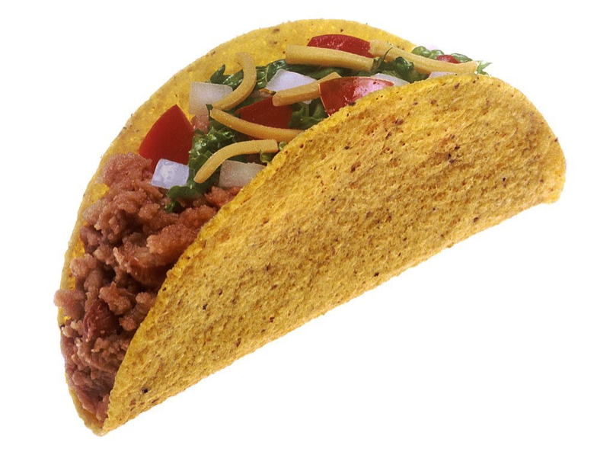
Some consumers are concerned about the potential of GMO foods to cause allergic reactions. As stated above, the FDA closely examines GMO foods for nutritional content and only approves those passing rigorous testing. In 2000, Grace Booth suffered a severe allergic reaction within minutes of eating a corn product (e.g., taco or enchilada) at Taco Bell. Booth ruled out other possible causes, and determined that her near-death experience must be due to the corn product. Earlier in 2000, the consumer watch group Genetically Engineered Food Alert discovered that some Taco Bell products were made from StarLink GMO corn containing a Bacillus thuringiensis toxin (Cry9C).
No allergies from the GMO corn in this taco!

(http://sitn.hms.harvard.edu/flash/2015/allergies-and-gmos/)

The StarLink corn had only been approved by the FDA for animal consumption because it had not been thoroughly tested for human use. Several days after Booth ate at Taco Bell, she learned of a nationwide recall of corn products from Taco Bell because the corn may have been contaminated with StarLink GMO corn. However, after an eight-month investigation by the FDA and the Centers for Disease Control and Prevention (CDC), they concluded that Booth's (and 27 other people's) allergic reaction was not due to the StarLink GMO corn. "In a letter from the Centers for Disease Control and Prevention (CDC), Booth and all the others tested were told their blood ‘… did not react to this specific [StarLink] protein.'" (http://www.cbsnews.com/news/genetically-modified-foods-hidden-allergies/)

Because of the potential for mild or even deadly food allergies, U.S. and international groups require thorough testing of GMO foods before their release to the public.

According to the international principles of food safety (FAO/WHO) [Food and Agriculture Organization/World Health Organization], before any GMO food gets market approval, the structure of the introduced protein should be compared to all known allergens. Potential allergenicity is then further analyzed with comprehensive experiments. Additionally, as part of post-marketing monitoring, randomly sampled consumers are examined to detect previously unidentified allergenicity. Currently, around 30 GMO crops have received approval in the US, and most of our corn, soybeans, and cotton are GMO crops. To date, no allergens have been found in GMO products approved for human consumption.

(http://sitn.hms.harvard.edu/flash/2015/allergies-and-gmos/)

In addition to human health issues, some people are concerned that GMOs may have a negative impact on the environment. A concern among some people is the presence of, or transfer of, modified genes into traditional (non-GMO) organisms of the same or different species. This gene flow or transgenic transfer might involve Bt resistance developing in a farmer's organic (non GMO) corn which is planted near GMO corn fields. Or, it may involve the Bt gene transferring to non-targeted native plants, or other insects developing resistance to the Bt gene. Possible strategies to limit gene flow include: engineering GMO crops to reproduce at different times than non-GMO crops, separating by distance between GMO and non-GMO crops genetically manipulating GMOs to be sterile, and re-engineering the Bt gene into chloroplasts rather than DNA so the Bt gene is not sexually reproduced. (http://www.fao.org/biotech/logs/c7/summary.htm)

According to the Food and Agriculture Organization of the WHO:

The environmental impacts of introduced GMOs can be either ecological or genetic and may include:
- unintended effects on the dynamics of populations in the receiving environment as a result of impacts on non-target species, which may occur directly by predation or competition, or indirectly by changes in land use or farming practices;
- unintended effects on biogeochemistry, especially through impacts on soil microbial populations that regulate the flow of nitrogen, phosphorus and other essential elements;
- the transfer of inserted genetic material to other domesticated or native populations, generally known as gene flow, through pollination, mixed matings, dispersal or microbial transfer.
(http://www.fao.org/docrep/003/X9602E/x9602e07.htm)

The USDA is also tasked with studying and regulating GMOs to prevent unintended negative environmental impacts. The agricultural practices that farmers use when growing GMOs is studied and regulated.

Other potential risks considered in the assessment of genetically engineered organisms include any environmental effects on birds, mammals, insects, worms, and other organisms, especially in the case of insect or disease resistance traits. This is why the USDA's Animal and Plant Health Inspection Service (APHIS) and the EPA review any environmental impacts of such pest-resistant biotechnology derived crops prior to approval of field-testing and commercial release. Testing on many types of organisms such as honeybees, other beneficial insects, earthworms, and fish is performed to ensure that there are no unintended consequences associated with these crops.

USDA researchers monitor for potential environmental problems such as insect pests becoming resistant to Bt, a substance that certain crops, such as corn and cotton, have been genetically engineered to produce to protect against insect damage. In addition, in partnership with the Agricultural Research Service (ARS) and the Forest Service, the Cooperative States Research, the National Institute of Food and Agriculture (NIFA) administers the Biotechnology Risk Assessment Research Grants Program (BRAG) which develops science-based information regarding the safety of introducing genetically engineered plants, animals, and microorganisms.

(https://www.usda.gov/wps/portal/usda/usdahome?navid=AGRICULTURE&contentid=BiotechnologyFAQs.xml)

A comprehensive 2010 report from the prestigious National Research Council (NRC) assessed the environmental, economic, and social impacts of the genetic engineering of crops in the U.S. This important study and summary looks at genetic engineering from 1996 through 2009. The report detailed effects of GE crops with respect to pesticide use and crop tillage, the effects of Bt-modified plants on the environment, glyphosate use, and gene flow between species of corn and soybean. The risks associated with GE crops was also addressed.

The evidence shows that the planting of GE crops has largely resulted in less adverse or equivalent effects on the farm environment compared with the conventional non-GE systems that GE crops replaced. A key improvement has been the change to pesticide regimens that apply less pesticide or that use pesticides with lower toxicity to the environment but that have more consistent efficacy than conventional pesticide regimens used on non-GE versions of the crops.

At least one potential environmental risk associated with the first phase of GE crops has surfaced: Some adopters of GE crops rely heavily on a single pesticide to control targeted pests, and this leads to a buildup of pest resistance regardless of whether GE crops or non-GE crops are involved. The governmental regulation of GE Bt crops through refuge requirements seems to have proved effective in delaying buildup of insect resistance with two reported exceptions, which have not had major consequences in the United States. Grower decisions to use repeated applications of particular herbicides to some HR crops have led, in some documented cases, to evolved herbicide-resistance problems and shifts in the weed community. In contrast with Bt-crop refuge requirements, no public or private mechanisms for delaying weed resistance have been extensively implemented. … The newest HR varieties likely will have tolerance to more than one herbicide, and this would allow easier herbicide rotation or mixing, and, in theory, help to improve the durability of herbicide effectiveness. These new stacked varieties will be one more tool to help manage the evolution of weed as well as insect resistance.

The potential for gene flow via cross-pollination between current major GE crops and wild or weedy relatives is limited to cotton in small spatial scales in the United States because the other major GE crops have no native relatives. How this changes in the future will depend on what GE crops are commercialized, whether related species with which they are capable of interbreeding are present, and the consequences of such interbreeding for weed management. Gene flow (i.e., the adventitious presence) of legal GE traits in non-GE crops and derived products remains a serious concern for farmers whose market access depends on adhering to strict non-GE standards.

The literature reviewed in this report indicates that a majority of U.S. farmers who grow soybean, corn, or cotton have generally found GE varieties with herbicide-resistance and insect-resistance traits advantageous because of their superior efficacy in pest control; their concomitant economic, environmental, and presumed personal health advantages; or their convenience. The extent of the benefits varies among locations, crops, and specific genetic-engineering technologies.

After some early evidence of yield disadvantages for some GE varieties in the United States, studies have now shown either a moderate boost in yields of some crops or a neutral yield effect. Some emerging evidence suggests that the attractiveness of genetic-engineering technology for soybean, cotton, and corn has increased the global acreage planted to these crops over what would have been planted otherwise and thereby increased global commodity supplies (World Bank, 2007; Brookes and Barfoot, 2009).

The historic social repercussions of introducing new technologies in agriculture, such as mechanization and the widespread planting of hybrid corn, have been studied extensively, and the results of the studies provide a basis for understanding the general effects of introducing GE varieties of crops. Despite the salience of those effects, however, there has been little investigation of farm-level and community-level social impacts of GE crops. The new seed technologies raise important potential social issues about farm structure, the input and seed choices available to farmers, and the genetic diversity of seeds. Among the known social facts associated with the dissemination of GE crops are the continued consolidation of the seed industry and its integration with the chemical industry. Another is the change in relationships between farmers and their seed suppliers.

(https://www.nap.edu/catalog/12804/the-impact-of-genetically-engineered-crops-on-farm-sustainability-in-the-united-states)

The same NRC report summarized five challenges facing GE crops. They are:
- the possibility of a lack of competition among large companies producing GE seeds and limited options for farmers not using GE seeds
- monitoring the environmental impacts and health of soils, water, and air as herbicide-resistant and insect-resistant crops increase in acreage
- developing of "minor crops" like fruits and vegetables lag in GE development as do some traits like drought resistance and nutrient absorption; the presence of transgenic genetic material in traditional (non-GE) crops
- market restrictions from some countries or companies may slow the sale or importation of GE crops.

Hydrogen bonding

An important intermolecular attraction that is critical in the structure of the DNA double helix is the hydrogen bond (a type of van der Waals force). In reality, hydrogen bonds are a special case of dipole forces where the hydrogen atom of one molecule is attracted to the electronegative atom of another molecule, typically nitrogen, oxygen, or fluorine. The hydrogen atom acquires a slight positive charge due to unequal electron distribution, while the other atom—with one or more unshared electron pairs—has a negative charge. The resulting electrostatic attraction forms the hydrogen bond.

Hydrogen bonding is considered a special case of dipole force because the strength of attraction between the affected atoms is stronger than typical dipole forces. Yet, hydrogen bonds are usually considered to be a weak attractive force and are only about one-tenth of the strength of a typical covalent bond. The strength of hydrogen bonds is often broken into three categories. The majority of hydrogen bonds fall into the weak classification, with bond strengths of 0–4 kcal/mol. The moderate range includes the bonds with 5–14 kcal/mol. The very strong hydrogen bonds are those with 15–40 kcal/mol bond strength. (Ansyln, E.; Dougherty, D. Modern Physical Organic Chemistry; University Science Books: Sausalito, California, 2005; p 171)

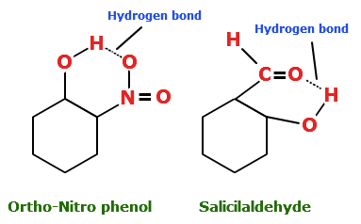
There are two types of hydrogen bonds, intramolecular and intermolecular. In the intramolecular type, the hydrogen bonds occur within a molecule. The functional groups within the molecule are capable of forming electropositive hydrogen atoms and electronegative atoms, such as the oxygen in a hydroxyl group or the nitrogen in an amine group. An example of this intramolecular hydrogen bonding occurs in ortho-nitrophenol between the –NO₂ and the –OH groups seen at right.
Ortho-nitrophenol Salicylaldehyde

Intramolecular hydrogen bonding within
a) ortho-nitrophenol and b) salicylaldehyde

(http://chemistry.tutorvista.com/physical-chemistry/hydrogen-bonding.html)

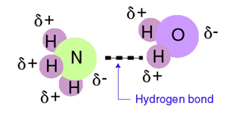
The intermolecular hydrogen bonding takes place between separate, adjacent molecules. This is by far the most typical type of hydrogen bonding. The molecules may be the same (as in water), or they may be different (as in ammonia and water, or adenine and thymine) (see structures at left). As long as there is a lone pair of electrons (e.g., from the nitrogen in ammonia) to act as an electron donor for the electropositive hydrogen (e.g., from the water molecule), the molecules can interact to form the intermolecular hydrogen bond.
Intermolecular hydrogen bonding
between ammonia and water

(http://www.slideshare.net/pedagogics/2012-topic-43-intermolecular-forces-and-physical-properties)
●
●

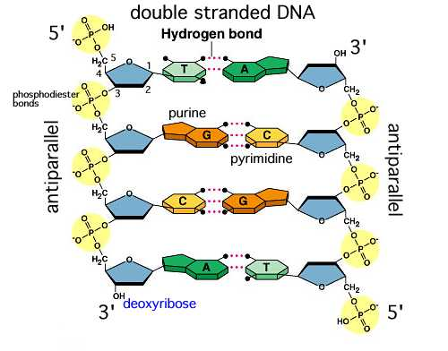
Hydrogen bonds are often discussed with respect to the properties of water, but in the context of the Wendel article, the focus is on the attraction between base-pairs in the DNA helix. The five nitrogen-containing bases found in RNA and DNA (adenine, guanine, cytosine, thymine, and uracil) are structurally all planar molecules; they are relatively flat and rigid. The nitrogen atoms in one base pair are geometrically situated so that they attract hydrogen atoms in the compatible base. So structurally, adenine pairs with thymine (in DNA) or uracil (In RNA), and cytosine pairs with guanine, due to the location of the electronegative nitrogen and the electropositive hydrogen atoms. There are only two hydrogen bonds formed between each adenine-thymine base pair, and there are three hydrogen bonds formed between the cytosine-guanine base pair. These hydrogen bonds are of sufficient strength to hold the double strands of nucleic material in either RNA or DNA, and yet weak enough to separate and not break the genetic strands and allow these genetic strands to separate during transcription or replication.
Hydrogen bond
Hydrogen bonding between DNA strands

(http://academic.brooklyn.cuny.edu/biology/bio4fv/page/molecular%20biology/dna-structure.html)

While hydrogen bonds are typically thought of as weak interactions, they are of utmost importance in understanding the bonding, structure, and behavior of RNA and DNA, as well as that of water. Individually, hydrogen bonds may be weaker than traditional covalent or ionic bonds, but their collective effect is powerful. Water has the densest concentration of hydrogen bonds of common substances, but their effect can be significant in many important materials, including DNA and proteins.

Proteins and hydrolysis reactions (digestion)

The GMO foods that people consume contain proteins made by the genetically modified plants. Some individuals are concerned with possible adverse reactions, such as allergies, in people who eat these foods. The allergens in foods are typically proteins. Currently, about 30 GMO crops have received approval for use in the U.S., and no allergens for human consumption have been identified in GMO crop foods. (http://sitn.hms.harvard.edu/flash/2015/allergies-and-gmos/). To allay the fear of GMO food allergens, it is necessary to understand the structure of proteins (both conventional and genetically modified) and the digestion of proteins in the stomach.

Proteins are polypeptides (i.e., long strands of amino acids joined by peptide bonds). They occur naturally in plants and animals, and some proteins function as biological catalysts, or enzymes. There are 20 common amino acids that are used as the building blocks for all proteins on earth, and these amino acids are identical, regardless of whether they come from a plant, or animal—or human—or from a traditional or a GE food protein.

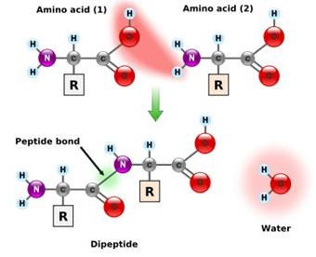
The amino acids comprising proteins each contain two functional groups, carboxyl
(–COOH) and amino (–NH₂). Two amino acids can undergo a condensation reaction and form a peptide bond between them (diagram at right). The –OH group is removed from the carboxylic acid end of one amino acid, and the H⁺ ion is removed from the amine end of the second amino acid molecule, forming the water molecule.
Condensation reaction between two amino acids

(http://27.109.7.67:1111/econtent/basic-chemistry-III/peptide-proteins.php)

When proteins are chewed and swallowed, they enter the stomach where pepsin, a protein enzyme (protease), is produced to begin the breakdown (digestion) of the proteins. The process of protein digestion continues in the small intestine where more enzymes, trypsin and chymotrypsin, from the pancreas are released, along with other peptidases (peptide enzymes) from the pancreas and small intestine. The action of these protein enzymes break the large protein molecules into smaller and smaller peptides—ultimately into the same amino acids from which the proteins were formed. Regardless of whether the protein was produced in a conventional plant or in a GMO plant, the protein structure and the digestive process render the ingested protein into the identical 20 amino acid molecules.

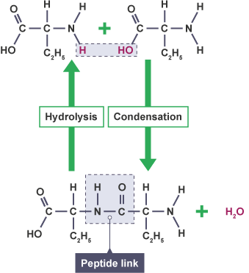
The chemical reaction involved in the digestion of the proteins is a hydrolysis reaction. Hydrolysis is the reverse reaction of the condensation reaction that chemically combined the amino acids into peptides and proteins in the first place. By inserting a water molecule—in the form of a) a hydroxyl group added to a carboxyl group on one amino acid, and b) a hydrogen ion added to an amine group on the other amino acid—the peptide bond is broken and the amino acids are returned to their free form. Therefore, regardless of the origin of the protein (GMO or conventional food), the digestive process is identical and produces the same 20 amino acids, which are indistinguishable from the GMO or conventional food.
Condensation and hydrolysis in peptides are the same process in reverse

(http://a.files.bbci.co.uk/bam/live/content/zsbvcdm/large)

Golden Rice

A leading cause of blindness and related deaths of small children is vitamin A deficiency (VAD). It is estimated that in countries where rice is the primary food crop, as well as other countries throughout the world, 250 million preschool children are affected by VAD. Deaths among these children under the age of five could be reduced by one-third if they had an adequate dietary intake of vitamin A.

“This world map [below] from «Sight and Life» shows the impressive spread of clinical and subclinical VAD: brown, clinical; red, acute subclinical; orange, subclinical.”
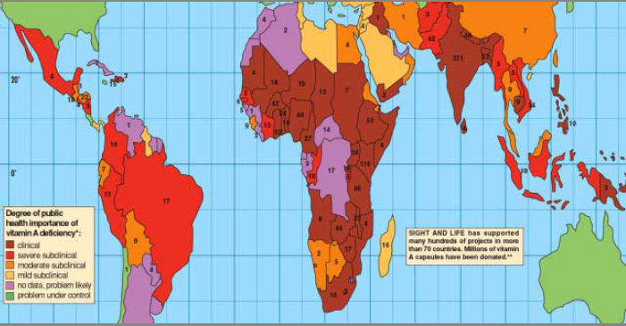
Global occurrence of vitamin A Deficiency (VAD)

(http://www.goldenrice.org/Content2-How/how5_health.php)

“All developing countries are affected by multiple micronutrient deficiencies. In the case of vitamin A the most affected regions are Africa and SE Asia.” (http://www.goldenrice.org/Content2-How/how5_health.php)

Golden rice is a genetically engineered (GE) food designed to prevent the malnutrition associated with childhood blindness and deaths due to VAD. The addition of two genes in rice to produce beta-carotene (a precursor of vitamin A) can supply the needed vitamin A and reduce or eliminate VAD.

Golden Rice technology is based on the simple principle that rice plants possess the whole machinery to synthesise β-carotene, and while this machinery is fully active in leaves, parts of it are turned off in the grain. By adding only two genes, a plant phytoene synthase (psy) and a bacterial phytoene desaturase (crt I), the pathway is turned back on and β-carotene consequently accumulates in the grain.

(http://www.goldenrice.org/Content2-How/how1_sci.php)

As mentioned previously, in 1973, Herbert Boyer (University of California San Francisco) and Stanley Cohen (Stanford University) achieved the first genetically engineered organism. By the early 1990s, sufficient data had been accumulated to encourage Peter Beyer (Professor, Centre for Applied Biosciences, Univ. of Freiburg, Germany) and Ingo Potrykus (Professor Emeritus, Institute for Plant Sciences, Switzerland) to collaborate and defeat VAD. Through their GMO work, rice expressing the beta-carotene gene, Golden Rice, was achieved in 1999, and the event was published in 2000. Further research and modification has produced improved versions of the Golden Rice.

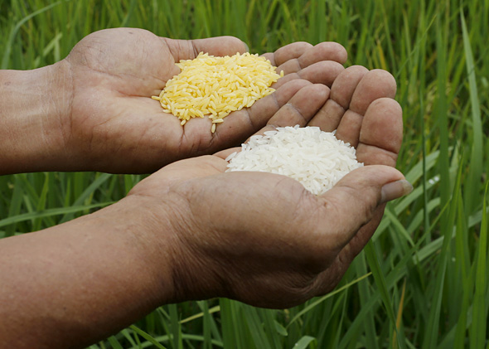
With the backing of Peter Raven of the Missouri Botanical Garden in Saint Louis, Missouri, the US popular media and scientific press widely promoted the creation of Golden Rice. The resulting paper in 2000, “Engineering the Provitamin A (beta-Carotene) Biosynthetic Pathway into (Carotenoid-Free) Rice Endosperm,” had greater than 1300 citations as of 2013. Since the initial experiments with rice, scientists have engineered other crops, including maize and potato, to produce beta-carotene using different biochemical pathways.
Golden rice and traditional white rice

(http://www.slate.com/articles/health_and_science/new_scientist/2013/10/golden_rice_inventor_ingo_potrykus_greenpeace_and_others_wicked_for_opposition.html)
(https://embryo.asu.edu/pages/golden-rice)

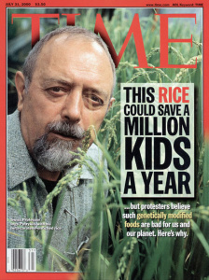
The opposition to Golden Rice was almost immediate from its invention. Greenpeace International states that "GE 'Golden' rice is a proposed but not practically viable crop solution that has never been brought to market. It is also environmentally irresponsible and could compromise food, nutrition and financial security."
The cover of Time magazine from July 31, 2000

(http://content.time.com/time/magazine/0,9263,7601000731,00.html)
(http://www.greenpeace.org/international/en/campaigns/agriculture/problem/Greenpeace-and-Golden-Rice/)

Greenpeace opposes the release of any GE crops. They believe Golden Rice does not supply sufficient vitamin A to combat VAD, and that the money spent in the development of Golden Rice could have been used on more practical VAD solutions. With this early and consistent opposition, Golden Rice has faced an uphill battle.

There was an insufficient amount of research data at that time to prove that Golden Rice and its improved successors could meet the dietary requirements of growing children. Ingo Potrykus (Golden Rice Board and Network) continues to fight for Golden Rice. In 2012, Tufts University published a research study validating the efficacy of Golden Rice to supply the necessary vitamin A, but the research was contested due to improper protocols. In an interview, Ingo Potrykus responded with this:

It was a long experiment by a group at Tufts University with colleagues from China. The outcome was fantastic. It was basically as good as it could be, with each pair of beta-carotene molecules in the rice being converted in the body to one molecule of vitamin A, the theoretical maximum. This is four times better than the conversion from spinach, which took between 7 and 8 molecules of beta-carotene to make each molecule of vitamin A.

Tufts has recently come out with a statement after studying what happened. It seems that the researchers didn't fully inform the participants in the trial that their children would be eating something that had been genetically modified, and that's been used by Greenpeace to turn everything upside down. But the important message from the Tufts report is that despite the procedural irregularities, the scientific data from the experiment stands firm and valid, that a single serving of rice provides 60 per cent of the recommended intake [of Vitamin A] for children.

(http://www.goldenrice.org/PDFs/New_Scientist_interview.pdf)

Unfortunately, as of 2013, no countries commercially grow this life-changing crop. "Golden Rice is a technology that intersects scientific and ethical debates that extend beyond a grain of rice." (https://embryo.asu.edu/pages/golden-rice) The ability to reduce or end VAD-related blindness in approximately 500,000 children each year, and to reduced childhood deaths associated with VAD malnutrition is mired in controversy and public relations nightmares.

As of 2013, tests of Golden Rice remained in field trials. IRRI [the International Rice Research Institute], partnered with Helen Keller International, plans to introduce Golden Rice in Bangladesh and in the Philippines by crossing it with local, high-yielding rice varieties. While IRRI has participated in the Golden Rice project nearly since its invention, Helen Keller International, headquartered in New York, New York, joined the project in 2011 to support the public health benefits of vitamin A, which can prevent blindness. In the US, the Rockefeller Foundation, the United States Agency for International Development, and the Bill & Melinda Gates Foundation supported the Golden Rice project at IRRI. The Bill & Melinda Gates Foundation, headquartered in Seattle, Washington, became a supporter of the Golden Rice project in 2011. Furthermore, the government of Bangladesh approved field trials of Golden Rice, and in 2012 estimated that varieties would be available for consumption by 2015.
A child with blindness related to VAD

(http://www.goldenrice.org/Content3-Why/why.php)
(https://embryo.asu.edu/pages/golden-rice)

References
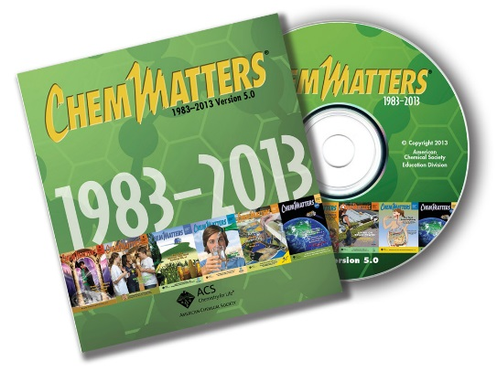
(non-Web-based information sources)
The references below can be found on the ChemMatters 30-year DVD, which includes all articles
published from the magazine’s inception in October 1983 through April 2013; all available Teacher’s Guides, beginning February 1990; and 12 ChemMatters videos. The DVD is available from the American Chemical Society for $42 (or $135 for a site/school license) at this site: http://ww.acs.org/chemmatters. Click on the “Teacher’s Guide” tab to the left, directly under the “ChemMatters Online" logo and, on the new page, click on “Get the past 30 Years of ChemMatters on DVD!” (the icon on the right of the screen).

Selected articles and the complete set of
Teacher’s Guides for all issues from the past three
years are available free online at the same Web site, above. Click on the “Issues” tab just below the logo, “ChemMatters Online”.
30 Years of ChemMatters !
Available Now!

"Corn: The A'maiz'ing Grain" is an interesting article that supports the Wendel article. The history and importance of corn in mankind's existence is explored. Also, the subsection of the article, “Genetically modified corn–isn't that frankenfood?” discusses GE or transgenic corn and the controversy surrounding it. (Haines, G. Corn: The A"maiz"ing Grain. ChemMatters, 2006, 24 (4), pp 4–7)

The December 2006 Teacher's Guide for "Corn: The A'maiz'ing Grain" (see above) directs readers to material on GMOs in the “Web sites for Additional Information” section. Over one dozen links include questions answered by the World Health Organization, Roundup Ready® Soybeans, and GE techniques.

The use of DNA vaccines, where an engineered plasmid containing an antigen is injected into the body, has similarities to the genetic engineering of plants. A section of "Promising New Vaccines" describes the DNA vaccination. (Boughton, B. Promising New Vaccines. ChemMatters, 2009, 27 (1), pp 16–17)

A useful graphic of DNA showing the hydrogen bonds between the double nucleotide strands and a brief description of polymers associated with an artificial pancreas might be of interest to some students. (Karabin, S. Changing the Course of Diabetes. ChemMatters, 2011, 29 (4), pp 12–13)

The Open for Discussion department in a previous issue of ChemMatters includes a brief dialog about genetically modified and certified organic foods. A chart of beneficial and uncertain effects of GM foods is presented. (Sitzman, B., Goode, R. Labels and Logos: "Genetically Modified" and "Certified Organic". ChemMatters, 2013, 31 (4), p 5)

A sidebar, How Mussels' Bioglue Works, in the article, "Stuck on You", briefly describes hydrogen bonds and London dispersion forces in protein structure. A diagram indicating hydrogen bonds in mussel proteins helping them to attach to various surfaces is depicted in the sidebar. (Anger, M. Stuck on You. ChemMatters, 2016, 34 (1), pp 8–10)
____________________

This article from The Journal of Chemical Education targets elementary and middle school science students, but the ability to have a physical demonstration model of DNA constructed from building blocks and magnets might useful to high school students, too. The article includes a link to JCE Online for construction videos and templates. (Cox, J. A Unique Demonstration Model of DNA. J. Chem. Educ., 2006, 83 (9), pp 1319–1321; http://pubs.acs.org/doi/pdf/10.1021/ed083p1319; note that this link is a brief abstract only, the full article is only available to American Chemical Society members or subscribers to the journal.)

Two simple models of DNA are described in this Journal of Chemical Education article. One model uses a paper ribbon (template supplied online) and a yo-yo model shows the compact form of the supercoiling in DNA. Two short movies are also available to support the article and activity which are suitable for high school students. (Van Horn, J. DNA Structure and Supercoiling: Ribbons and a Yo-Yo Model. J. Chem. Educ., 2011, 88 (9), pp 1264–1267; http://pubs.acs.org/doi/abs/10.1021/ed100887p; note that this link is a brief abstract only, the full article is only available to American Chemical Society members or subscribers to the journal.)

Web Sites for Additional Information
(Web-based information sources)
GMO foods

A special edition blog in August 2015 from Harvard University, GMOs and Our Food, contained an introduction and 15 well-researched and well-written articles related to GMOs (several are referenced in this Teacher's Guide). The articles are:
- How to make a GMO
- A History of GMOs
- GMOs and Natural Genetic Diversity
- The Technology and Safety of BT Crops
- RoundupReady Crops and the environment
- The Allergenic Effects of GMOs
- Pesticides and Our Food
- Will GMOs Harm our Organs
- Acquiring GMO Patents
- GMOs and Farming Culture
- How GMOs Are Regulated
- Feeding the World with GMOs
- Can GMOs Combat Malnutrition
- Genome Engineering: An Interview with Dr. Dan Voytas
- New Technology in GMOs: Epigenetics & RNAi
(http://sitn.hms.harvard.edu/signal-to-noise-special-edition-gmos-and-our-food/)

Live Science presents "GMOs: Facts about Genetically Modified Food" on their Web site. The safety, politics, and labeling of GMOs is discussed. (http://www.livescience.com/40895-gmo-facts.html)

"The Truth about Genetically Modified Food" is an informative article from the September 1, 2013 issue of Scientific American. Research suggests that GMOs are safe to eat and can help feed millions of hungry people in the world. The risks and benefits are examined in this dependable publication. (https://www.scientificamerican.com/article/the-truth-about-genetically-modified-food/)
Scientific American's November 29, 2013 article, "Study Linking Genetically Modified Corn to Rat Tumors is Retracted", reports on a 2012 article published in the journal Food and Chemical Toxicology (FCT) that was retracted due to scientists’ scorn of the weak evidence used in the FCT article. The journal retracted the article when the authors refused to do so, in spite of near-universal disapproval by other scientists. (https://www.scientificamerican.com/article/study-linking-genetically-modified-corn-to-cancer/)

This site has a brief article on GMO foods, but it has a great diagram in the style of a basketball playoff bracket pitting GMO versus organic. (https://sites.jmu.edu/gbio103/how-and-why-do-humans-produce-organic-and-genetically-modified-food-march-madness/)

The Journal of the Royal Society of Medicine weighs in on the debate with "Genetically Modified Plants and Human Health". The article gives an overview of plant genetic engineering and addresses food safety, the environment, gene transfer, and public opinion. (https://www.ncbi.nlm.nih.gov/pmc/articles/PMC2408621/)

"Genetically Modified Organisms (GMOs): Transgenic Crops and Recombinant DNA" asks the question, "If you could save lives by producing vaccines in transgenic bananas, would you? In the debate over large-scale commercialization and use of GMOs, where should we draw the line?" The Web article has a chart of examples of GMOs resulting from agriculture, a history of international regulations for GMO research and development, and their take on risks and controversies. (http://www.nature.com/scitable/topicpage/genetically-modified-organisms-gmos-transgenic-crops-and-732)

This 2016 article from the New York Times, "Acreage for Genetically Modified Crops Declined in 2015", reports on the slight decline in acres of GMO crops planted in the world. Three-quarters of all GMO crops in the world are planted in the U.S., Brazil, and Argentina. A bar graph shows the acreage of GMO crops since 1996. (https://www.nytimes.com/2016/04/13/business/acreage-for-genetically-modified-crops-declined-in-2015.html?_r=1)

This USDA Web site has Excel data sheets showing genetically engineered varieties of corn, cotton, and soybeans aggregated by state and for the United States for the years 2000– 2016. (https://www.ers.usda.gov/data-products/adoption-of-genetically-engineered-crops-in-the-us.aspx)

Another USDA Web page, "Recent Trends in GE Adoption", gives a line graph of genetically engineered crops in the United States by percent of planted acres from 1996–2016. (https://www.ers.usda.gov/data-products/adoption-of-genetically-engineered-crops-in-the-us/recent-trends-in-ge-adoption/)

The World Health Organization's Web site provides questions and answers to 19 "Frequently Asked Questions on Genetically Modified Foods" at http://www.who.int/foodsafety/areas_work/food-technology/faq-genetically-modified-food/en/.

The U.S, Food and Drug Administration's Web site has a volume of information and resources on GMOs. This site gives details on voluntary labeling of GMO foods with sections on background information, general principles and guidance, and extended references. (http://www.fda.gov/Food/GuidanceRegulation/GuidanceDocumentsRegulatoryInformation/LabelingNutrition/ucm059098.htm)

The Center for Environmental Risk Assessment's Web page focuses on GE organisms used in agriculture and foods. A link on their page (GM Crop database) allows readers to search their database for crop plants, traits, inserted genes, type of approval, country, developer, and year. The database includes GMOs as well as plants with novel traits developed through conventional plant breeding. The site also includes e-learning courses after registration. (http://www.cera-gmc.org/)

Genetically Modified Foods are discussed at the Learn Genetics site. The creation of an insect-resistant tomato plant is explained with a simple diagram. (http://learn.genetics.utah.edu/content/science/gmfoods/)

Other GMO information

A report summary of "Pesticide Use in U.S. Agriculture: 21 Selected Crops, 1960–2008" gives an overview of pesticide use in the U.S. It states that pesticide use largely increased from 1960 through 1981 due to increased acreage of crops planted. However, after 1980, the trend has been decreasing slightly, partly due to GMO crops requiring less pesticide use. The full report is available on the site through a link. (https://www.ers.usda.gov/webdocs/publications/eib124/46736_eib124_summary.pdf?v=41830)

The U.S. Environmental Protection Agency provides a comprehensive Web site on "Introduction to Biotechnology Regulation for Pesticides". The site has an overview of biopesticides and biotechnology pesticide products, registration for plant-incorporated protectants, gene flow assessment, ecological assessment processes, environmental fate, and insect resistance in Bt crops. (https://www.epa.gov/regulation-biotechnology-under-tsca-and-fifra/introduction-biotechnology-regulation-pesticides)

The National Academies of Sciences, Engineering, and Medicine has published a book, Genetically Engineered Crops: Experiences and Prospects, looking at the debate surrounding GE crops and possible adverse effects on human health, the environment, and ethics. It delves into the complexities of emerging GE technologies. The book can be purchased on the Web site, but it is also available on the National Academies Press site as a free PDF download. (https://www.nap.edu/catalog/23395/genetically-engineered-crops-experiences-and-prospects)

Another book from the National Academies, The Impact of Genetically Engineered Crops on Farm Sustainability in the United States, looks at the challenges in farming that may come with excessive reliance on a single technology for our crops. The reduction in diversity of farming practices may also have adverse effect on the potential economic and environmental gains from using GE crops. The book is available for purchase on the Web site but is also available on the site as a free PDF download. (https://www.nap.edu/catalog/12804/the-impact-of-genetically-engineered-crops-on-farm-sustainability-in-the-united-states

An exhaustive Web site centered on GMOs includes links to characteristics, environment, exposure, methods of monitoring, harmful effects, and more. (http://enhs.umn.edu/current/5103/gm/character.html)

The U.S. Department of Agriculture (USDA) has a part of its Web site devoted to Biotechnology Regulatory Services. This site has additional links to regulations, permits, compliance, and a biotechnology quality system. (https://www.aphis.usda.gov/aphis/ourfocus/biotechnology)

Stanford University's The Tech Museum of Innovation has a Web page devoted to GMO foods, where people have posed eight questions that have been answered by geneticists. (http://genetics.thetech.org/genetic-categories/genetically-modified-foods)

Popular Science published an article in 2014, "GMO Facts: 10 Common GMO Claims Debunked". It can be read at http://www.popsci.com/article/science/core-truths-10-common-gmo-claims-debunked?dom=PSC&loc=slider&lnk=2&con=core-truths-10-common-gmo-claims-debunked.

Another Popular Science article explores "The Pros and Cons of Herbicide-Tolerant GMOs", and this article is located at http://www.popsci.com/blog-network/our-modern-plagues/pros-and-cons-herbicide-tolerant-gmos.

The Howard Hughes Medical Institute has a tutorial on "How to Make a Transgenic Plant". The concise explanations are accompanied by graphics. (http://www.unc.edu/depts/our/hhmi/hhmi-ft_learning_modules/plantmodule/transgenicplants.html)

A Web page of FAQs related to transgenic (GMO) plants with links and additional resources can be read at http://cls.casa.colostate.edu/transgeniccrops/faqpopup.html.

Authors from India explain transgenic (GMO) plants and discuss the types, benefits, public concerns, and future of GMOs in an article at https://www.researchgate.net/publication/259139407_Transgenic_plants_Types_benefits_public_concerns_and_future. Please note that the site may request readers to register, but the document will download without registration after a few seconds.

An overview of the plant genetic engineering process is explained with images at http://agbiosafety.unl.edu/education/summary.htm. There are additional links on the page for related topics such as gene cloning and DNA extraction.

Non-GMOs

The Non-GMO Project has a Web page with their list of GMO facts and links to more of their resources. (https://www.nongmoproject.org/gmo-facts/)

An organization claiming to be, "The most comprehensive source of GMO health information on the Web", the Institute for Responsible Technology, provides their perhaps biased view of GMOs. One link on the site connects to health risks associated with GMOs, along with references and studies that have not been supported by other scientific research. (http://responsibletechnology.org/gmo-education/)

This 2001 article in The Washington Post reports on the biotech corn, Starlink, which is claimed to have produced allergic responses in people. Starlink was approved for use in animal feed, but not in human food. However, some corn products were found to contain small amounts of the Starlink corn. (https://www.washingtonpost.com/archive/politics/2001/03/19/biotech-corn-is-test-case-for-industry/57734822-b8c1-4215-af91-b12267d06dcb/?utm_term=.3ee89381e98b)

DNA animations on this site provide videos illustrating many of the complex biochemical processes involving DNA. Subheadings on the page include animations relevant to the Wendel article, such as "Recombinant DNA Technology", "Gene Expression of a Secreted Protein", and "Polymerase Chain Reaction", to list only a few. (http://bio-alive.com/animations/DNA.htm)

Bacillus thuringiensis (Bt)

This site provides a complete look at Bt-modified crops. Links include a history of Bt, how it works, and its safety. Additional links guide readers to related topics on GMOs, Bt cotton, Bt corn, and crop refuges. (http://www.bt.ucsd.edu/bt_crop.html)

For more information on "Bt-Corn: What It Is and How It Works" see https://entomology.ca.uky.edu/ef130.

Monsanto is a major producer of GM seeds. The company’s general Web site has information about their products. For information on insect resistance to Bt corn and cotton crops, see http://www.monsanto.com/newsviews/pages/insect-resistance-to-gmo-and-bt-crops.aspx.

The U.S. Environmental Protection Agency performed an analysis of Bt crops and concluded that they posed "no significant risk to the environment or to human health." To read an article published in the September 2003 issue of Nature Biotechnology, see https://www.epa.gov/sites/production/files/2015-08/documents/are_bt_crops_safe.pdf.

Hydrogen bonding

For more information on hydrogen bonding, including graphs, diagrams, and links to other intermolecular forces, see http://www.chemguide.co.uk/atoms/bonding/hbond.html.

This Web site is similar to the one above, but it has a more extensive set of diagrams, explanations, and tables. Included are sections on properties and effects of hydrogen bonds, viscosity, hydrogen bonding in nature, and factors preventing hydrogen bonding. (https://chem.libretexts.org/Core/Physical_and_Theoretical_Chemistry/Physical_Properties_of_Matter/Atomic_and_Molecular_Properties/Intermolecular_Forces/Specific_Interactions/Hydrogen_Bonding)

This site has a short description of hydrogen bonds, but it also provides a brief animation of H₂O and ONF with their hydrogen bonds. (https://www.chem.purdue.edu/gchelp/liquids/hbond.html)

A scholarly discussion of hydrogen bonds—with an introduction, history, classification and terminology, and a wide collection of analytical data—is located at http://evans.rc.fas.harvard.edu/pdf/smnr_2009_Kwan_Eugene.pdf.

The Journal of Chemical Information and Modeling published an article, "Characterizing the Strength of Individual Hydrogen Bonds in DNA Base Pairs", that complements the Wendel article. (http://pubs.acs.org/doi/pdf/10.1021/ci100288h) Please note that this link is a brief abstract only, the full article is only available to subscribers to the journal.

The Journal of Biological Chemistry published this article, "Strength of the C^{α} H··O Hydrogen Bond of Amino Acid Residues", explaining that the peptide group traditionally has not been believed to form hydrogen bonds, but under certain circumstances there may be evidence that it does. (http://www.jbc.org/content/276/13/9832.full)

"The Quantum Nature of the Hydrogen Bond" is explained in this technical article. (http://www.pnas.org/content/108/16/6369.full)

This college-level explanation of hydrogen bonding has a focus on proteins. It provides six rules summarizing of hydrogen bonding. (http://www.bio.brandeis.edu/classes/biochem104/hydrogen_bonds.pdf)

A thorough explanation of hydrogen bonding in water is explained in "Water's Hydrogen Bond Strength". This 20-page paper (including extensive additional references) covers an introduction, consequences, effects, and tables summarizing data. Although no date is given for the article, the most recent reference included is from 2007. (https://arxiv.org/ftp/arxiv/papers/0706/0706.1355.pdf)

Golden Rice

The Golden Rice Project has a bountiful Web site describing the organization, the Golden Rice Project, why Golden Rice is important, the science and environmental aspects, and an information center. (http://www.goldenrice.org/)

National Public Radio shares information about Golden Rice and the surrounding controversy at http://www.npr.org/sections/thesalt/2013/03/07/173611461/in-a-grain-of-golden-rice-a-world-of-controversy-over-gmo-foods.

"Genetically Modified Golden Rice Falls Short on Lifesaving Promises" explains a study stating that that GMO activists are not to blame for the slow introduction of Golden Rice, and the scientific challenges affecting the rice. (https://source.wustl.edu/2016/06/genetically-modified-golden-rice-falls-short-lifesaving-promises/)

The New York Times published an article detailing the challenges facing Golden Rice and the vandalism in the Philippines and other sites where the rice has an opportunity to affect the lives of millions. (http://www.nytimes.com/2013/08/25/sunday-review/golden-rice-lifesaver.html)

Stanford University's The Tech Museum of Innovation has a page on Golden Rice in its "Ask a Geneticist" column. (http://genetics.thetech.org/ask/ask334)

A history of Golden Rice and its development by Ingo Potrykus was printed in a 2000 New York Times article. The information gives a background for a perspective on how far Golden Rice has—or has not—advanced to today. (http://www.nytimes.com/2000/11/21/science/scientist-at-work-ingo-potrykus-golden-rice-in-a-grenade-proof-greenhouse.html)

One of Time magazine's cover stories in 2000 was on Golden Rice and Ingo Potrykus. The cover stated, "This rice could save a million kids a year." Read the article at http://content.time.com/time/magazine/article/0,9171,997586,00.html.

"Is Opposition to Golden Rice Wicked?" is the question that New Scientist seeks to answer. The article states that, "One of the cleverest tricks of the anti-GMO movement is to link GMOs so closely to Monsanto." Read more at http://www.slate.com/articles/health_and_science/new_scientist/2013/10/golden_rice_inventor_ingo_potrykus_greenpeace_and_others_wicked_for_opposition.html.

This link is another general information article on Golden Rice found at The Embryo Project Encyclopedia. (https://embryo.asu.edu/pages/golden-rice)

For more information on vitamin A eye deficiency (VAD), including pictures of eye diseases related to VAD see https://www.ncbi.nlm.nih.gov/pmc/articles/PMC3936686/.

Hydrolysis (digestion) and proteins

A straightforward explanation of the chemical process of hydrolysis is found at http://www.chemistryexplained.com/Hy-Kr/Hydrolysis.html.

The Wendel article addresses digestion (hydrolysis) of proteins. This site specifically explain the hydrolysis of proteins in simple terms with an example. (http://www.chemguide.co.uk/organicprops/aminoacids/proteinhydrolysis.html)

A much deeper, collegiate explanation of "Proteases: Hydrolysis of Peptide Bonds: Specificity and Mechanism" is located at http://www.uta.edu/faculty/sawasthi/Enzymology-4351-5324/Class%20Syllabus%20Enzymology/Proteases.pdf.

This site also provides a scholarly look at proteins, peptides, and amino acids. Reactions of α-amino acids and synthesis of α-amino acids is explained with chemical structures and equations. (https://www2.chemistry.msu.edu/faculty/reusch/virttxtjml/proteins.htm)

Protein degradation by enzymes is explained in technical terminology, with a few reactions and images for support, at https://www.rpi.edu/dept/bcbp/molbiochem/MBWeb/mb2/part1/protease.htm.

The chemistry of the protein building blocks, amino acids, is offered at The Biology Project Web site. There are links to additional pages with more details on the amino acids, plus a self-test. (http://www.biology.arizona.edu/biochemistry/problem_sets/aa/aa.html)

The Royal Society of Chemistry provides a Web page on proteins. It covers their importance, the amino acids, peptide bond formation, structures, and a test of your knowledge. (http://www.rsc.org/Education/Teachers/Resources/cfb/proteins.htm)

An overview of protein digestion in the human body is posted by a British teacher. Descriptions with graphics to help with understanding is found at https://pmgbiology.com/2016/02/14/digestion-of-proteins-a-understanding-for-igcse-biology-2-29/.

This site provides information on protein digestion in the body, along with a nice flow diagram of the process. (http://pharmaxchange.info/press/2013/07/digestion-of-dietary-proteins-in-the-gastro-intestinal-tract-gi-tract/)

General Web References
(Web information not solely related to article topic)
Bio-Alive is a vast collection of instructional materials including lectures, seminars, animations, tutorials, labs, and games—virtually everything—for the life sciences. (http://bio-alive.com/index.htm)

Science in the News (http://sitn.hms.harvard.edu/) is published online by Harvard University, The Graduate School of Arts and Sciences. This is an excellent resource for scientific articles. Web readers can view information on various branches of science, the environment, public health, and art. Podcasts, seminars, and other presentations are available.

