

**April/May 2017 Teacher's Guide**

**Background Information**

**for**

***Recycling Plastic Bags***

**Table of Contents**

About the Guide 2

Background Information 3

References 41

Web Sites for Additional Information 42

General Web References 46

# 

# About the Guide

Teacher’s Guide team leader William Bleam and editors Pamela Diaz, Regis Goode, Diane Krone, Steve Long and Barbara Sitzman created the Teacher’s Guide article material.   
E-mail: [bbleam@verizon.net](mailto:bbleam@verizon.net)

Susan Cooper prepared the anticipation and reading guides.

Patrice Pages, *ChemMatters* editor, coordinated production and prepared the Microsoft Word and PDF versions of the Teacher’s Guide.

E-mail: [chemmatters@acs.org](mailto:chemmatters@acs.org)

Articles from past issues of *ChemMatters* and related Teacher’s Guides can be accessed from a DVD that is available from the American Chemical Society for $42. The DVD contains the entire 30-year publication of *ChemMatters* issues, from February 1983 to April 2013, along with all the related Teacher’s Guides since they were first created with the February 1990 issue of *ChemMatters*.

The DVD also includes Article, Title, and Keyword Indexes that cover all issues from February 1983 to April 2013. A search function (similar to a Google search of keywords) is also available on the DVD.

The *ChemMatters* DVD can be purchased by calling 1-800-227-5558. Purchase information can also be found online at <http://tinyurl.com/o37s9x2>.

# Background Information

**(teacher information)**

**History of plastic grocery bags**

Polyethylene’s discovery was serendipitous! In 1933, R. O. Gibson and E. W. Fawcett were autoclaving a mixture of ethylene and benzaldehyde in their research laboratory at the Imperial Chemical Industries (Great Britain). A leak caused pressure loss in the container and, to their amazement, a white, waxy solid appeared! Later their studies revealed that the loss of pressure was due to polymerization, not the leak. Patents were issued for this process in 1936. (<https://www.globalplasticsheeting.com/our-blog-resource-library/bid/23095/The-History-of-Polyethylene>)

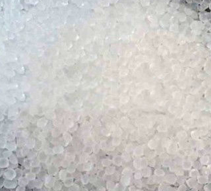

*Polyethylene, (C2H4)n*

*(*[*https://www.globalplasticsheeting.com/our-blog-resource-library/bid/23095/The-History-of-Polyethylene*](https://www.globalplasticsheeting.com/our-blog-resource-library/bid/23095/The-History-of-Polyethylene)*)*

High density polyethylene (HDPE) was produced in 1953 by Karl Ziegler of the Kaiser Wilhelm Institute in Germany. Ziegler continued his investigations and received the 1963 Nobel Prize for Chemistry for his work on multi-membered ring systems. HDPE was first used for piping. Today, much water and waste material runs through HDPE pipes.

In the 1950s, records show various patent applications for technologies designed to produce plastic grocery bags. Unlike bags today, the first were constructed as composites that required a secondary process to attach the separate handles.

*Early PE grocery bags (1950s) with separate handles sewn in at the top*

*(*[*http://www.papermart.com/Images/Item/jpg_giftbag/77040-index-matte-loop-handle-bag.jpg?rnd=1*](http://www.papermart.com/Images/Item/jpg_giftbag/77040-index-matte-loop-handle-bag.jpg?rnd=1)*)*

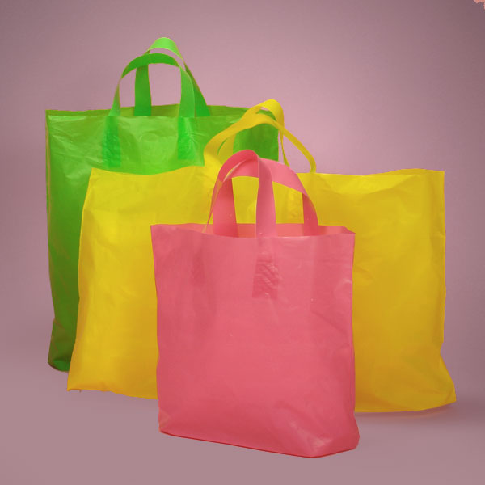

In the early 1960s, Swedish engineer Sten Gustaf Thulin was credited with designing a method to produce a simple, strong bag that could be cut from a flat tube of plastic. This type of grocery sack was later known as the “T-shirt” style.) Thulin’s process was patented worldwide in 1962 by Celloplast, a Swedish packaging company (see photo of new bag on next page). The invention claimed to “revolutionize” grocery shopping, because the capacity of these plastic bags far exceeded that of paper grocery sacks. (<http://www.oxfordcollege.ac/news/environmental-studies-the-common-plastic-bag/>)

With worldwide patents for their technology, Celloplast quickly built manufacturing plants in Europe and the U.S., monopolizing the grocery bag industry until 1977. At this time, the petroleum giant Mobil overturned Celloplast’s U.S. patents and our manufacturers took over the plastic grocery bag market. Relevant information is “selected” from the eBook, “Fifty Bags That Changed the World: Design Museum Fifty”.

(<https://books.google.com/books?id=10MYAwAAQBAJ&pg=PT43&lpg=PT43&dq=How+did+Mobil+overturn+Celloplast's+US+patent+for+grocery+bags+in+1977?&source=bl&ots=oH5Scesdj5&sig=IzOJkobQBcsANDSSoXNxw0fmTxc&hl=en&sa=X&ved=0ahUKEwjVqNbqq8rRAhUQ6mMKHZP_BFsQ6AEIITAB#v=onepage&q=How%20did%20Mobil%20overturn%20Celloplast's%20US%20patent%20for%20grocery%20bags%20in%201977%3F&f=false>)

*Modern style of grocery sack   
(“T-shirt” style, by Celloplast)*

*(*[*http://www.theatlantic.com/technology/archive/2014/10/how-the-plastic-bag-became-so-popular/381065/*](http://www.theatlantic.com/technology/archive/2014/10/how-the-plastic-bag-became-so-popular/381065/)*)*

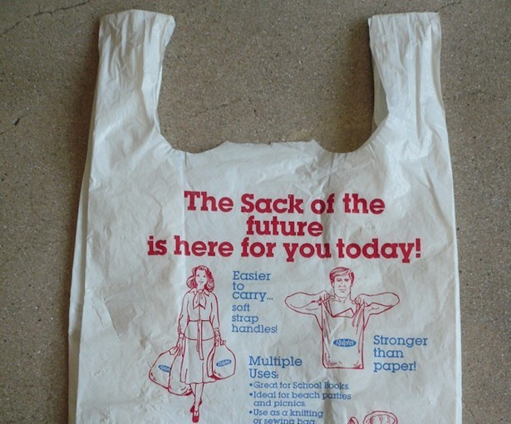

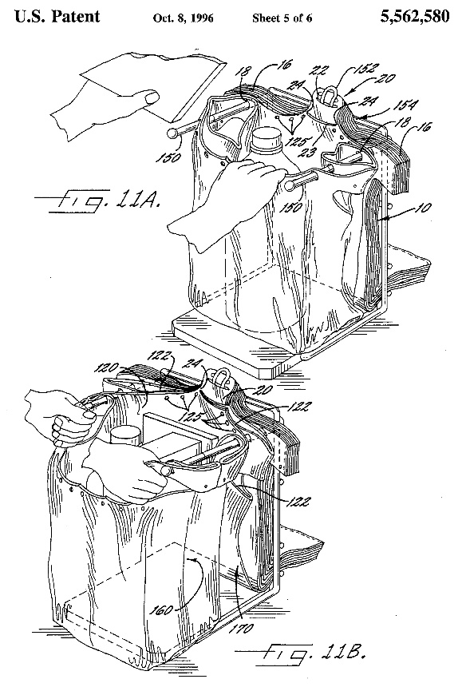 In 1982, Mobil’s single-use plastic bags were introduced to U.S. supermarkets by grocery giants Kroger and Safeway as “the stronger, lighter and less bulky alternative” to paper bags. Advertised as a more convenient design with handles on each side, they quickly came into full production in the U.S. By 1996, U.S. customers chose plastic four out of five times over paper for their groceries. (<https://www.plastech.biz/forum-plastech/About-Plastic-Grocery-Bags-7546>)

In 1992, Sonoco Products Company was awarded a U.S. patent for a “Self-opening polyethylene bag stack”. This invention (seen at right) is a great time-saver. It allows the checker or customer at a self-checkout counter to simply pull one plastic bag from a stack mounted on a holder. When pulled off the stack, the bag self-opens and is immediately ready to be loaded with groceries or other purchases. (<http://www.google.ch/patents/US5562580>)

*The self-opening polyethylene bag stack*

*(*[*http://www.google.ch/patents/US5562580*](http://www.google.ch/patents/US5562580)*)*

**History of polymer discovery**

The Age of Polymers is credited to Leo Hendrick Baekeland, the Belgian-born American inventor and chemist who produced bakelite from phenol and formaldehyde in 1907. This was the world’s first synthetic thermoset plastic. Once molded it would retain its shape through heating and exposure to many solvents. Bakelite had many uses, such as telephone casings, kitchenware, jewelry and nonconducting insulators. (<http://www.innovateus.net/content/bakelite>)

Before the 1920s, chemists thought that the molecular weight of a molecule could not exceed 5000 grams and its size could not exceed that of a unit cell. (Note: A unit cell is defined as the smallest group of particles that repeats itself in the pattern of a solid.)

In 1920 Hermann Staudinger, an organic chemistry professor in Zurich, was studying natural rubber. His research data questioned the assumption of limits on the size and weight of molecules. While earlier chemists had found high molecular weights, they surmised that their values were due to measuring the mass of many small molecules bound together in colloid suspensions. Staudinger proposed the existence of heavy macromolecules consisting of 10,000 or more atoms. Moreover, he postulated that these macromolecules were composed of small molecules linked together by covalent bonds. He called these polymers; *poly* indicates “many” and *mers* means “parts”. Professor Staudinger received the 1953 [Nobel Prize in Chemistry](https://en.wikipedia.org/wiki/Nobel_Prize_in_Chemistry) for his discoveries in the field of macromolecular chemistry.

Staudinger’s paper on his natural rubber research cited two reasons to justify the existence of compounds (polymers) with high molecular weights. First, those who questioned the existence of these compounds attributed the mass of natural rubber to collections of small double bonded molecules tied together into molecular collections by their “partial valences”. Staudinger suggested that if this was true, hydrogenation would remove the double bonds and the aggregates of small molecules would break into pieces. (Note: Hydrogenation means saturated with respect to hydrogen, meaning that each carbon in the hydrocarbon molecule is bonded to as many hydrogen atoms as possible forming singular carbon-carbon bonds.) Staudinger’s experiments showed that when hydrogenated, rubber does not break apart. Rubber has a high molecular weight whether or not it is hydrogenated. (<https://www.acs.org/content/acs/en/education/whatischemistry/landmarks/staudingerpolymerscience.html>)

To further confront those who disbelieved the existence of polymers, Staudinger measured the viscosity of rubber to confirm that it did not change during chemical modification of the polymer. The following is an excerpt from the original abstract of Staudinger’s paper published in *Transactions of the Faraday Society*:

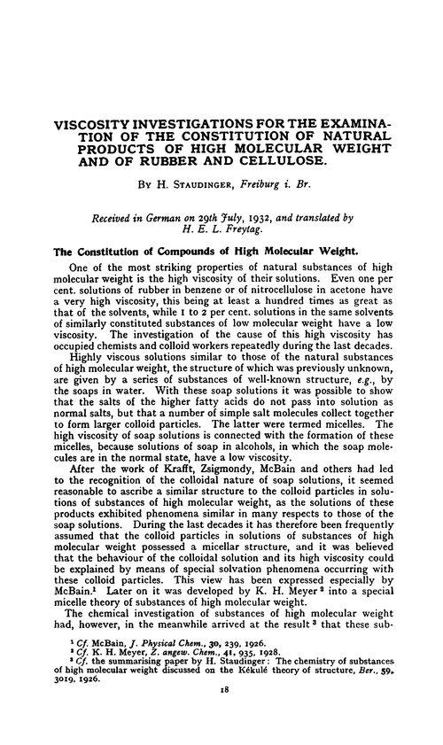

*(*[*http://pubs.rsc.org/en/Content/ArticleLanding/TF/1933/TF9332900018#!divAbstract*](http://pubs.rsc.org/en/Content/ArticleLanding/TF/1933/TF9332900018#!divAbstract)*)*

Staudinger’s primary polymer research was on natural rubber, a polymer composed of isoprene (2-methyl-1,3-butadiene) monomers. The structural formulas pictured below show two chains of isoprene; each chain contains two units. When the chains are vulcanized, sulfur (S) is added to form a cross link between the isoprene chains. This increases the durability of the rubber. (Cross linking is responsible for the low density in one form of polyethylene. See further explanation in this Teacher’s Guide.)

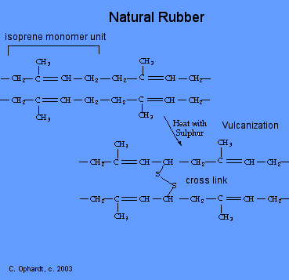

*The isoprene monomer, polymerization and vulcanization of rubber*

*(*[*http://chemistry.elmhurst.edu/vchembook/403rubber.html*](http://chemistry.elmhurst.edu/vchembook/403rubber.html)*)*

**Chemistry of polyethylene**

Polyethylene is a hydrocarbon molecule derived from hydrogen- and carbon-containing molecules of ethene. The polymer consists of long chains of single-covalently-bonded carbon atoms, where each carbon is also covalently bonded to two hydrogen atoms. Each terminal carbon has three attached hydrogen atoms so the molecule is said to be saturated with hydrogen. As shown in the “Recycling Plastic Bags” article by De Antonis, this simple form of polyethylene is formed by ethene molecules linked together by single covalent bonds between the carbon atoms. Three primary forms of polyethylene are used for plastic bags: high density (HDPE), low density (LDPE), and linear low density (LLDPE).

Physical characteristics of the polyethylene forms differ, due to the arrangement of atoms in their monomers. Their structure affects tensile strength (resistance to breaking under stress) and crystallinity (orderly structure within their atoms). In addition, manufacturing processes differ for different structural arrangements. HDPE and LLDPE can be produced by the Ziegler-Natta vinyl polymerization method; LDPE is formed by free-radical polymerization. (<http://pubs.acs.org/cen/whatstuff/stuff/8238plasticbags.html>)

**High density polyethylene (HDPE)**

The almost branch-free carbon chains in HDPE lie linearly and pack tightly together, due to their orderly crystalline structure, and the strength of their intermolecular forces (IMFs). This close packing gives a high density of approximately 0.940-0.965 g cm–3. The closeness of chains promotes strong IMFs. Thus, the tensile strength, and chemical and heat resistance of HDPE are greater than that found in other polyethylene forms. The melting point is also higher, approximately 120–130 oC. This form is a good choice for grocery bags, milk jugs, gas and water pipes, car parts, and food containers.

In the illustration below, HDPE is pictured in three ways:

1. The organic shorthand “linear” that is shown as a wavy line to depict nonlinear bond angles between the atoms (even though this is considered a linear structure of single bonded carbons covalently bonded in a continuous line).
2. The “molecular structure”, a ball and stick diagram, showing approximate bond angles.
3. The symbolic “chemical structure” where brackets indicate that there can be any number of CH2 units in the molecule.

*High density polyethylene (HDPE)*

*(*[*https://www.britannica.com/science/high-density-polyethylene*](https://www.britannica.com/science/high-density-polyethylene)*)*

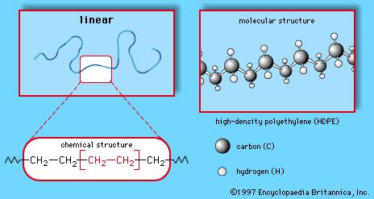

**Low density polyethylene (LDPE)**

As the name implies, the density of LDPE (< 0.930 g cm–3) is less than that of HDPE. This is caused by the atomic rearrangement of branching. When a structural isomer of the monomer is not a linear chain, the resulting polymer will contain one or more branches. These branches prevent (physically interfere with) a close-packing of the polymer chains, decreasing the IMFs between chains and the density. The weaker IMFs explain the lower melting point of approximately 110 oC and the softer, more flexible, but weaker properties of the branched polymer. LDPE is used for thin clothes bags from dry cleaners, food packaging films and electrical cable insulation. (<http://www.essentialchemicalindustry.org/polymers/polyethene.html>)

The illustration below shows branched polyethylene with an ethane group (two carbons) and a propane group (three carbons) attached to the linear chain. The presence of these branches prevents close packing of molecules, decreasing the polymer’s density.

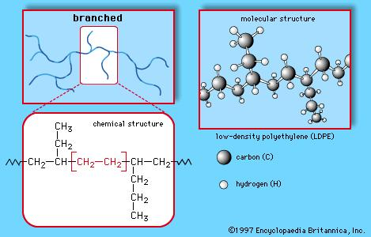

*Low density polyethylene (LDPE)*

*(*[*https://www.britannica.com/science/high-density-polyethylene*](https://www.britannica.com/science/high-density-polyethylene)*)*

**Linear low density polyethylene (LLDPE)**

The density of LLDPE is approximately 0.915–0.940 g cm–3. Although it is composed of linear polyethylene chains, each has many small branches that prevent strong IMFs between the polymer chains. Both the chains and branches of LLDPE are shorter than those of LDPE. These shorter branches increase the ability of molecular chains to slide back and forth against each other without getting tangled. This produces a strong, impact resistant polymer. LLDPE is used for very thin crack resistant film such as plastic and stretch wraps and also for thick, glossy shopping bags. (<http://www.essentialchemicalindustry.org/polymers/polyethene.html>)

The table below summarizes the industrial processes used to manufacture products from the three major forms of PE, with examples of the general type of product that results from each process. Note that, while some of the products are similar, those from HDPE are firmer, solid structures, while LDPE (with weaker IMFs, as explained above) is used to create more flexible products, like squeezable bottles.

|  |  |  |  |
| --- | --- | --- | --- |
| **A comparison of the uses for the various types of polyethylene** | | | |
| **Process** | **HDPE** | **LDPE** | **LLDPE** |
| Making film | Food packaging Shopping bags | Cling film Milk carton lining | Stretch film |
| *Injection  molding | Dustbins Crates | Buckets Bowls | Food boxes |
| **Blow molding | Detergent bottles Drums | Squeezable bottles |  |
| ***Extrusion | Water pipes | Flexible water pipes Cable jacketing | Cable coating |

*(*[*http://www.essentialchemicalindustry.org/polymers/polyethene.html*](http://www.essentialchemicalindustry.org/polymers/polyethene.html)*)*

*\*Injection molding produces a part that is solid, such as a reusable coffee cup.  
**Blow molding produces hollow parts, such as water bottles.  
(*[*http://moldedparts.com/2015/04/difference-between-injection-molding-and-blow-molding/*](http://moldedparts.com/2015/04/difference-between-injection-molding-and-blow-molding/)*)  
***Extrusion machines force polyethylene through a die to make hoses, drinking straws and pipes. (*[*http://www.extrusionscrews.com/ExtrusionMoluding.php*](http://www.extrusionscrews.com/ExtrusionMoluding.php)*)*

**Chemistry of polyethylene production**

Ethene (or ethylene) is produced by steam cracking hydrocarbons such as ethane, propane, naphtha, and gas oil. In addition, a Brazilian plant obtains ethene from sugar cane bioethanol. Production methods for the forms of polyethylene differ. Yet, many industrial plants are able to produce various forms of polyethylene and even switch production from one form to another on short notice.

*Cracking of ethane*

*(*[*http://education.afpm.org/petrochemicals/what-is-a-cracker-and-why-should-i-care/*](http://education.afpm.org/petrochemicals/what-is-a-cracker-and-why-should-i-care/)*)*

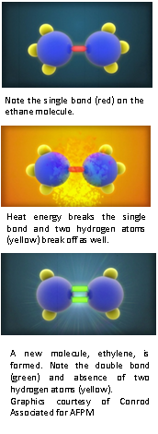

Unlike crude oil, ethane (gasous at room temperature)   
is difficult and expensive to ship. The IMFs between ethane molecules are very weak, thus its boiling point is very low,   
–89 oC. Therefore it is gaseous at room temperatures. This creates safety concerns for shipping due to its flammability. Therefore, U.S. steam cracking facilities are usually located   
near supplies (oil refineries and shale oil deposits).

Converting a single bond to a double bond between two carbon atoms requires a great deal of energy. Ethane crackers are fed a mixture of ethane with a little propane and heated to 816 oC. At this temperature, the single bond is weakened and two hydrogen atoms are released to form a stronger H-H bond, the H2 molecule. This process is shown in the three illustrations at right. Lacking two hydrogen atoms, the new molecule is stabilized with a double covalent bond between the carbon atoms. The new ethene (ethylene) molecules are cooled below their boiling point, then distilled from the mixture with other hydrocarbons. This process yields about 80% ethene that can be polymerized to form plastic bags. (<http://education.afpm.org/petrochemicals/what-is-a-cracker-and-why-should-i-care/>)

**Ethane to ethene**

As described above, the traditional steam cracking method to produce ethene by removing hydrogen atoms (dehydrogenation) from ethane molecules requires extremely high temperatures, a very expensive process. Estimations suggest that approximately 70% of the cost of ethylene production comes from the traditional steam cracking process. To reduce this cost, researchers have been working with catalytic production methods that reduce the high cracking temperature requirements.

To accomplish this, scientists are using oxidative dehydrogenation production procedures. Auto-thermal oxidative dehydrogenation (ODH) is a catalytic procedure that successfully converts ethane to ethylene at only 300 oC, suggesting an energy/cost saving alternative to steam cracking. In the experiment below, several oxidized nickel based catalysts were used. A general catalyst formula is Ni-Me-O where Me represents a metal as shown below. The graph shows the selectivity of ethylene to the various catalysts as a function of the amount of ethane converted to ethylene. Note that, in the study, the titanium (Ti) and tungsten (W) catalysts exhibited the highest selectivity to ethylene. (<https://www.researchgate.net/figure/259996696_fig10_Fig-10-Selectivity-to-ethylene-as-a-function-of-ethane-conversion-obtained-over-nickel>)

Fig. 10. Selectivity to ethylene as a function of ethane conversion, obtained over nickel oxide-based catalysts in ethane ODH performed in the presence of 10% O 2 and 10% O 2 at 330 ◦ C. 
                

*(*[*https://www.researchgate.net/figure/259996696_fig10_Fig-10-Selectivity-to-ethylene-as-a-function-of-ethane-conversion-obtained-over-nickel*](https://www.researchgate.net/figure/259996696_fig10_Fig-10-Selectivity-to-ethylene-as-a-function-of-ethane-conversion-obtained-over-nickel)*)*

As shown by the chemical reaction in the De Antonis article, hydrogen gas is the by-product of dehydrogenation. Researchers recognized the need to remove the hydrogen for safety and to improve production by favoring ethylene (according to Le Châtelier’s Principle), the major product. In the ODH process, oxygen gas and ethane are simultaneously fed into a converter in the presence of a Ni-Me-O catalyst. The addition of oxygen to the reaction (oxidative dehydrogenation) not only oxidizes the hydrogen to less active water, but it re-oxidizes the oxygen-deprived catalyst. Research continues to investigate procedures to reduce the greenhouse gases of CO2 and NOx emitted during refining processes. (<http://onlinelibrary.wiley.com/doi/10.1002/ente.201600074/full>)

While steam cracking remains the major industrial process for producing ethylene, the procedure is very costly. The reaction is highly endothermic, so a large amount of fuel is needed to maintain cracker temperatures at 700–1000 oC. Initially, a large capital outlay is required for construction and then for continued maintenance of the huge furnaces. Also, to obtain a high yield, the pressure must be kept as low as possible. This requires diluting the steam as needed.

Alternatively, there are several important advantages to using ODH procedures. The capital investment is less, machinery is more compact, and less energy is required because it operates at lower temperatures. Some of this work is still in the experimental design stage using bench scale units. Scientists are working to perfect reactor design and determine the best catalysts, ones that are stable, long lasting and result in a high selectivity for ethylene. (<http://about.elsevier.com/pdf/chemeng-vsi/52_Basini.pdf> and <http://www.google.com/patents/US20100256432>)

**Production of HDPE and LLDPE**

Both production methods described below are addition reactions (ethene monomers are added to form polyethylene polymers). Manufacturing a mixture of LDPE branched polymers is relatively easy because this can be done under very high pressures and temperatures. However, until the 1950s, scientists were unable to produce unbranched polymer chains. Extreme temperatures and pressures would not yield a highly crystallized unbranched form of polyethylene. Scientists Karl Ziegler and Giulio Natta independently searched for a catalyst that would work at the lower temperatures and pressures needed to reduce the possibility of branching.

The Ziegler-Natta catalyst will produce HDPE at approximately 50–75 oC and a pressure slightly above atmospheric. This process employs a titanium chloride catalyst, TiCl3 or TiCl4 with an aluminum co-catalyst, Al(C2H5)2Cl (IUPAC name: chlorodiethylalumane). Below are diagrams to illustrate the mechanism involved in this catalysis. Propylene is the feedstock hydrocarbon.

In the chemical equation below, titanium has two empty orbitals represented by empty boxes. The aluminum co-catalyst will donate one of its ethyl groups to fill one empty orbital. The fuzzy lines represent coordination between the catalysts (π bonding), not covalent bonds.

**Coordination polymerization**

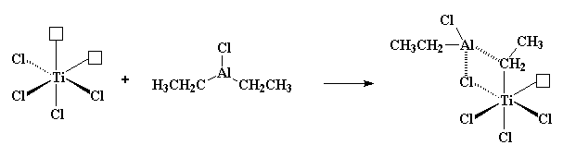

*Titanium chloride Aluminum co-catalyst Coordination complex*

*(*[*http://pslc.ws/macrog/ziegler.htm*](http://pslc.ws/macrog/ziegler.htm)*)*

When propylene is introduced, the two electrons in its π orbital fill the remaining empty titanium orbital, breaking the double bond in the propylene. The red arrows show electrons shifting positions. With a bit of molecular as well as electron rearrangement, the beginning of HDPE can be seen in blue.

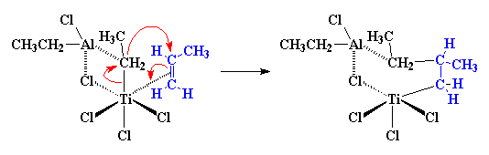

*(*[*http://pslc.ws/macrog/ziegler.htm*](http://pslc.ws/macrog/ziegler.htm)*)*

When another propylene molecule is introduced, the polymerization continues as seen by the lengthening blue carbon chain below.

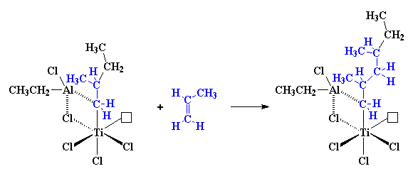

*(*[*http://pslc.ws/macrog/ziegler.htm*](http://pslc.ws/macrog/ziegler.htm)*)*

A vanadium catalyst (VCl4) with the same aluminum co-catalyst works basically the same way (although it has only one empty orbital). (<http://pslc.ws/macrog/ziegler.htm>)

In 1964, Philips Petroleum researchers sought to improve on the Ziegler-Natta process that required removal of the very active catalyst during the extraction process. The Phillips process required a temperature of approximately 300 oC, and standard pressure. To avoid the necessity of removing the Ziegler-Natta catalyst, the Phillips catalyst was bound to the large surface area of a silica gel. Here it remained in place during the complete manufacturing process. The catalyst is chromium trioxide, CrO3. Today, approximately half of the world’s HDPE is produced by the Phillips process.

Hexavalent chromium (as in the CrO3 catalyst, also called chromium-6) is an excellent anticorrosion agent when electroplated onto metal parts as a protective surface coating. Unfortunately, it is also a proven carcinogen, particularly when inhaled where it causes lung irritation leading to lung cancer. As of September 21, 2017, the use of hexavalent chromium will be banned in the European Union (EU), except for some military uses. Bans are also being considered in many other countries. (<http://nomorehex.org/LEGISLATION/EU-MANDATE>)

The U.S. federal government has a “suggested limit” of 100 parts per billion (ppb) in drinking water; the state of California’s has a “set limit” of 10 ppb with a suggested health limit of .02 ppb. The “Erin Brockovich” movie presented a chromium-6 contamination of 18.8 ppm by the Pacific Gas and Electric Company in Hinkley, California. Wells in the California city of Banning (100 miles from Hinkley) now exceed the California limit. But in this case, the source is natural. Chromium-6 seeps into water supplies from minerals in local rock formations. Water filtration and reverse osmosis procedures to remove this carcinogen are extremely expensive. (<http://www.pe.com/articles/water-776921-chromium-wells.html>)

Worldwide replacement of chromium catalysts is becoming increasingly important. Fortunately, current improvements in polymer production focus on a metallocene, such as a metallocene/methylaluminoxane (MAO) as the catalyst for addition polymerization. A metallocene is a compound composed of two cyclopentadienyl anions, (C5H5)–. The anions bind to the central metal “M” that has a +2 oxidation state, M2+,to form the compound, M(C5H5)2. These new catalysts have very well defined structures that allow for the specificity needed for HDPE polymer production. (<http://repository.um.edu.my/93175/1/materials-07-05069.pdf>)

Illustrations below show the generic version (on the left) and the specific structure of metallocene when M = Fe (the iron cation) in the middle. Shown on the right: “Cyclopenta-” means a five carbon ring; “–diene” means that the ring contains two double bonds. As seen on the left and middle, two cyclopentadienyl anions “sandwich” the metal cation.

*Metallocene*

*(*[*https://en.wikipedia.org/wiki/Metallocene*](https://en.wikipedia.org/wiki/Metallocene)*)*

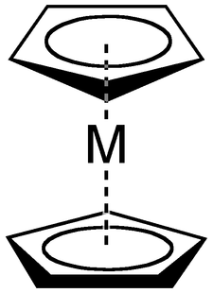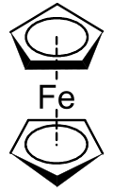

*Ferrocene*

*(*[*https://en.wikipedia.org/wiki/Cyclopentadiene*](https://en.wikipedia.org/wiki/Cyclopentadiene)*)*

*Cyclopentadiene*

*(*[*https://en.wikipedia.org/wiki/Ferrocene*](https://en.wikipedia.org/wiki/Ferrocene)*)*



Since M represents any suitable metal, the mechanism below uses a metallocene containing zirconium (M = Zr, zirconium), and the illustration shows the “metal pancake” at work, breaking the double bond in propylene and rearranging the complex to begin a chain of single bonded carbons (in blue). The pink arrows show shifting electrons during the bond breaking. The catalyst continues to break double bonds and adds more carbon atoms to the HDPE chain.

(<http://www.pslc.ws/macrog/mcene.htm>)

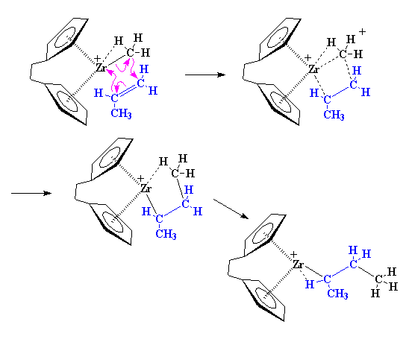

*The mechanism of a metallocene catalyst producing polypropylene from the propylene monomer.*

*(*[*http://www.pslc.ws/macrog/mcene.htm*](http://www.pslc.ws/macrog/mcene.htm)*)*

As shown in the processes above, pure ethene or propene are the monomers of HDPE. If the production target is LLDPE, pure ethene is mixed with a small amount of another alkene such as but-1-ene, hex-1-ene, or oct-1-ene. The -1-ene means that one double bond is located between the first and second carbons.

**Production of LDPE**

A free-radical polymerization process is used to produce branched polyethylenes. This process requires an “initiator molecule”, an organic peroxide that supplies oxygen, such as benzoyl peroxide.

The initiator, a benzoyl peroxide molecule, breaks down into two free radicals (note the dots that represent unpaired oxygen atoms on the free radical products below).  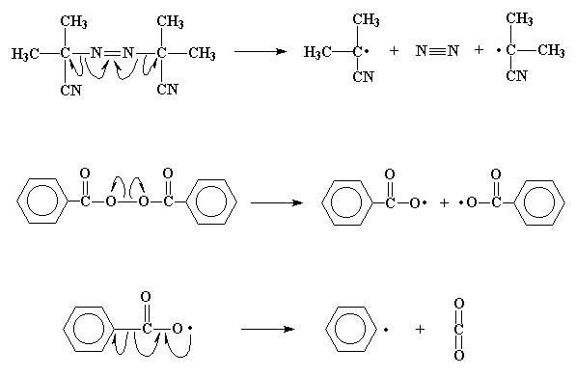

*Benzoyl peroxide molecule Free radicals*

*(*[*http://pslc.ws/macrog/radical.htm*](http://pslc.ws/macrog/radical.htm)*)*

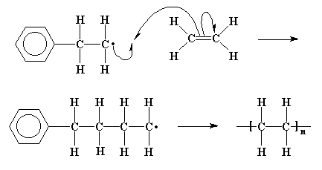 At right: To gain an electron, the benzene free radical attacks the double bond of ethene by grabbing an electron. This produces a free radical with single bonded carbon atoms. In its quest for electrons, the free radical continues to attack more ethene molecules causing more additions to the single bonded polyethylene chain. The chain will terminate at the point when two radicals join together.

(<http://pslc.ws/macrog/radical.htm>)

*Polyethylene polymer chain forming*

*(*[*http://pslc.ws/macrog/radical.htm*](http://pslc.ws/macrog/radical.htm)*)*

This process requires a temperature of 420–570 K and pressures between 1000 and 3000 atmospheres. As seen in the chemical equation below, the reaction is exothermic.

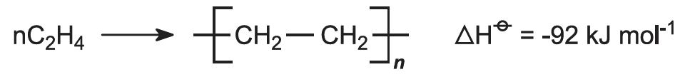

Note: The superscripted theta symbol following the ΔH (enthalpy for the reaction) indicates that this is a “state function”, meaning that it has been carried out under standard conditions. This is often written as ΔH*f*o.) (<http://www.essentialchemicalindustry.org/polymers/polyethene.html>)

**Other plastics**

All plastics are polymers, and the triangle codes for recyclable plastics indicate the type of resin used in their manufacture. Chasing-arrow symbols are mentioned in the De Antonis article. The ASTM International Resin Identification Coding System (RIC) was developed in 1988 by the American Society for Testing and Materials (ASTM). In 2001 ASTM became an international organization. With a membership of 140 countries, ASTM International is the standards organization that produces technical standards for many products and materials.

In June 2013, the chasing-arrows were replaced by solid triangles because people often erroneously connected the numbers with recycling. To avoid consumer confusion, ASTM released a statement regarding the new symbol designation “… helps bring focus back to the system’s core mission: resin identification and quality control prior to recycling.” (<http://www.plasticsnews.com/article/20130611/NEWS/130619978/say-so-long-to-recycling-code-arrows>)

**June 2013 ASTM Resin Identification Codes**

|  |
| --- |
| **Some Common Uses** |
| Soft drink, water, shampoo, cooking oil and mouthwash bottles  Peanut butter jars |
| Milk, water and juice jugs  Detergent bottles  Yogurt and margarine tubs  Grocery bags |
| Clear food packaging  Shampoo bottles  Water pipes  Electrical Insulation |
| Bread bags  Frozen food bags  Squeezable bottles (mustard, honey) |
| Ketchup bottles  Yogurt and margarine tubs  Drinking straws  Battery cases |
| Meat trays  Egg cartons  Cups and plates  Spoons, knives forks |
| Everything else!  Ketchup containers  3 and 5 gallon water bottles  Some juice bottles, etc. |

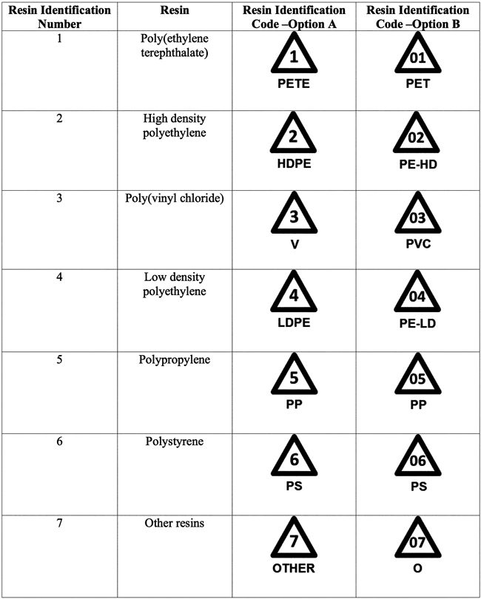

*(*[*http://www.plasticsnews.com/article/20130611/NEWS/130619978/say-so-long-to-recycling-code-arrows*](http://www.plasticsnews.com/article/20130611/NEWS/130619978/say-so-long-to-recycling-code-arrows)*)*

*Source for last column: (*[*https://www.containerandpackaging.com/blog/2009/06/what-are-the-7-main-plastic-resin-types/*](https://www.containerandpackaging.com/blog/2009/06/what-are-the-7-main-plastic-resin-types/)*)*

**Polymer chemistry, by resin numbers**

The seven resin code numbers are listed below, along with the monomer structure and some basic chemical properties for each. Common uses for each resin (based on their characteristic properties) are listed in the table above.

**Resin #1: Polyethylene terephthalate**

The hardness, stiffness, and strength characteristics of the polyethylene terephthalate (PETE or PET) polymer make it a good choice for soda bottles. PET is a polyester, made of ester linkages between the ethylene terephthalate monomers. (In the diagrams below, the ester linkage of the terephthalate is shown on the left, and the ethylene group is on the right.)

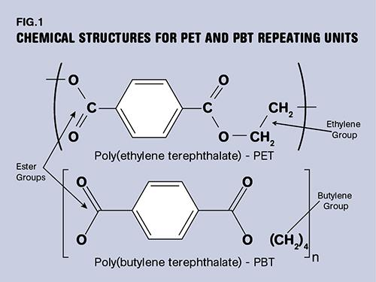

*Polyethylene terephthalate (PET)*

*IUPAC:* Poly(ethyl benzene-1,4-dicarboxylate)

*(*[*http://www.ptonline.com/columns/pbt-and-pet-polyester-the-difference-crystallinity-makes)*](http://www.ptonline.com/columns/pbt-and-pet-polyester-the-difference-crystallinity-makes))

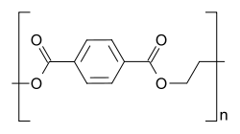

*Ethylene terephthalate monomer*

*(*[*https://en.wikipedia.org/wiki/Polyethylene_terephthalate*](https://en.wikipedia.org/wiki/Polyethylene_terephthalate)*)*

**Resin #2: High density polyethylene**

High density polyethylene (HDPE) was discussed in the polyethylene section (above) of this Teacher’s Guide. The ethene monomer and the linear and structural molecular formulas are shown below:

*High density polyethylene (HDPE)*

*(*[*https://www.britannica.com/science/high-density-polyethylene*](https://www.britannica.com/science/high-density-polyethylene)*)*



*Ethene monomer*

*(*[*http://www.chm.bris.ac.uk/motm/ethene/ethene.gif*](http://www.chm.bris.ac.uk/motm/ethene/ethene.gif)*)*

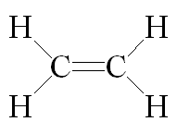

**Resin #3: Polyvinylchloride (PVC):**

Polyvinylchloride (PVC) isa strong, rigid solid. The monomer shown on the left below has a chloride (Cl) atom bonded to only one carbon atom. The illustration on the right shows that when chloroethene polymerizes, every other (alternating) carbon atom on the chain is bonded to a Cl atom.

The illustration below is two dimensional showing all the chlorine atoms on one side. Since the PVC backbone is composed of single carbon to carbon bonds, individual chlorine atoms can frequently rotate to positions forward, above or behind the backbone shown in the image. This spatial arrangement is called tacticity (further discussion of tacticity is given below this section of the Teacher’s Guide). The flexibility of the PVC chain leads to arrangements where chlorine atoms alternate between sides on the backbone, leading to IMF attraction between polymer chains. This packing creates a polymer that is somewhat crystalline. (<http://www.informit.com/articles/article.aspx?p=2235827&seqNum=2>)

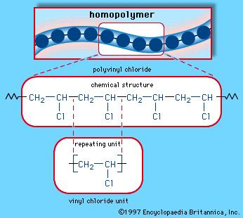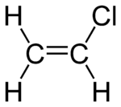

*Chloroethene monomer*

*(*[*https://en.wikipedia.org/wiki/Vinyl_chloride*](https://en.wikipedia.org/wiki/Vinyl_chloride)*)*

*Polyvinylchloride, IUPAC: Poly(1-chloroethene)*

*(*[*https://www.britannica.com/science/polyvinyl-chloride*](https://www.britannica.com/science/polyvinyl-chloride)*)*

**Resin #4: Low density polyethylene (LDPE)**

Low density polyethylene (LDPE) wasdiscussed in the polyethylene section (above) in this Teacher’s Guide. LDPE has the same ethene monomer as HDPE. This resin is composed of branched polyethylene. The branches prevent the linear carbon chains from packing closely, so the density is less than that of HDPE. The monomer is shown below.

*Ethene monomer*

*(*[*http://www.chm.bris.ac.uk/motm/ethene/ethene.gif*](http://www.chm.bris.ac.uk/motm/ethene/ethene.gif)*)*



*Low density polyethylene*

*(*[*https://media1.britannica.com/eb-media/67/1667-004-3A9A7896.jpg*](https://media1.britannica.com/eb-media/67/1667-004-3A9A7896.jpg)*)*

**Resin #5: Polypropylene (PP)**

Propylene, the monomer for polypropylene (PP), is shown at right. In addition to its production from fossil fuels, propylene is a by-product of natural vegetative fermentation. Note that one methyl group replaces a hydrogen atom on the three-carbon hydrocarbon monomer. PP displays many properties similar to PE, but the methyl group increases steric hindrance, making the polymer chains less flexible, and reducing the IMFs between them. Therefore, the melting point is lower, and the molecules are more susceptible to oxidation.

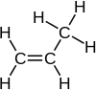

*Propylene monomer (IUPAC: Propene)*

*(*[*https://en.wikipedia.org/wiki/Propene*](https://en.wikipedia.org/wiki/Propene)*)*

PP can be prepared in all three tactic (spatial) forms by changing the conditions of polymerization. See more on tacticity in the section below “Resin 7”. The major commercial form, isotactic, is prepared at low temperatures and pressures using Ziegler-Natta catalysts. Syndiotactic PP is produced using a metallocene catalyst. This form has low crystallinity and a lower melting point (130 oC) than the isotactic form (160 oC), becomes brittle at 0 oC and, in the past, seemed to have little value. However scientists have found that it can be rolled into sheets that serve as excellent power insulators. And since this form does not cross-link, it is recyclable. The atactic form is sticky, lacks definite structure and has little commercial value. (<http://www.informit.com/articles/article.aspx?p=2235827&seqNum=2>)

The spatial arrangement of each tactic form of PP is shown below with a brief description of the physical characteristics in the column on the right.

In the isotactic form the methyl groups line up on one side of the polymer to form a hard, strong solid.

In the syndiotactic form the arrangement of methyl groups is also regular. So it forms a crystalline structure.

The methyl groups are randomly attached in the atactic form. Thus, it cannot crystallize leaving the solid soft and elastic like rubber.

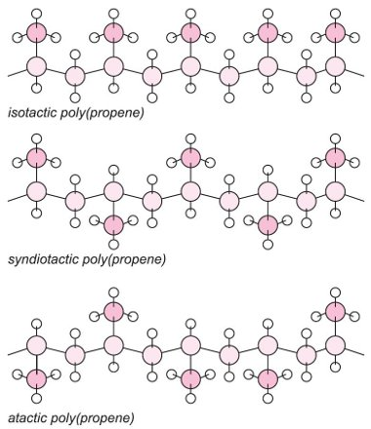

*(*[*http://www.essentialchemicalindustry.org/polymers/polypropene.html*](http://www.essentialchemicalindustry.org/polymers/polypropene.html)*)*

**Resin #6: Polystyrene (PS)**

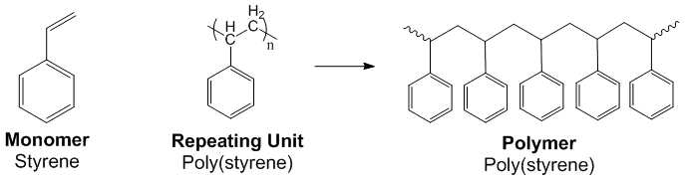 Styrene (C8H8), shown on the left in the image below, is the precursor monomer for polystyrene. The IUPAC name for styrene is ethylbenzene. The repeat unit, derived from the styrene monomer, is shown in the center, and one of the conformational forms of the polymer is shown at right.

*Polystyrene—its monomer, repeat unit and polymeric forms*

*(*[*http://www.chemtube3d.com/polymer/images/polystyrene.gif*](http://www.chemtube3d.com/polymer/images/polystyrene.gif)*)*

Polystyrene (PS) is a hard, rigid, clear, solid polymer that is soluble in organic solvents. PS can be softened and molded when heated. During heating, the strong IMFs between the long PS chains are weakened, so the attached phenyl groups can more easily rotate around the single bonds between the backbone carbons. As the geometric arrangement (conformation) changes, the chains can slide past each other. Although the IMFs are considered strong, they are much weaker than the covalent bonds holding the background carbon chains intact. As the temperature increases, the relaxation of the IMFs increases the chain flexibility.

Similar to the ordered, syndiotactic form for PP, above, in the **syndiotactic** spatial form of **PS** (on the left of the diagram on the next page), the benzene rings are ordered, and strong IMFs hold chains tightly to each other, to form nicely packed crystalline structures. (Note that additional information on tacticity follows in the next section of this Teacher’s Guide.) This regularly arranged crystalline structure (syndiotactic) is resistant to moisture, chemical corrosion, and heat. Its electrical stability leads to its use as electronic components for hybrid vehicles. (<http://www.idemitsu.com/products/petrochemicals/engineering/polystyrene.html>)

Preparation of the syndiotactic form involves stereospecific metallocene catalysis performed at lower temperatures. There, size of the alternating phenyl rings causes strong steric hindrance (repulsion) that prevents rotation about the single covalent carbon-carbon bonds on the backbone of the polymer. This increases the rigidity of the polymer. Thin transparent films of syndiotactic PS are used as “windows” in envelopes and packages of bacon. (<http://polymerdatabase.com/polymer%20physics/Tacticity.html>)

**Atactic PS** (in the center of the diagram below) is the most commonly used spatial form often referred to as “General Purpose” PS. The random nature of this irregular, amorphous form produces a highly transparent material. It is clear, hard, brittle—and cheap. These characteristics, especially transparency, lead to many medical applications.

Catalysts are not used in the atactic PS production process, but the temperature is adjusted to slowly increase from 150 oC to 200 oC. Due to the large benzene rings, PS cannot be packed closely into crystals, so the material is transparent. (This may be a bit counterintuitive, but a crystalline polymer is not transparent.) In addition, the rings restrict rotation around the carbon-carbon covalent bonds in the backbone chain, increasing rigidity. Atactic PS forms transparent, stiff and fragile products. The material is inexpensive and easily colored, making it a choice for cheap, disposable plastic cutlery. (<http://www.tudosobreplasticos.com/en/materiais/poliestireno.asp>)

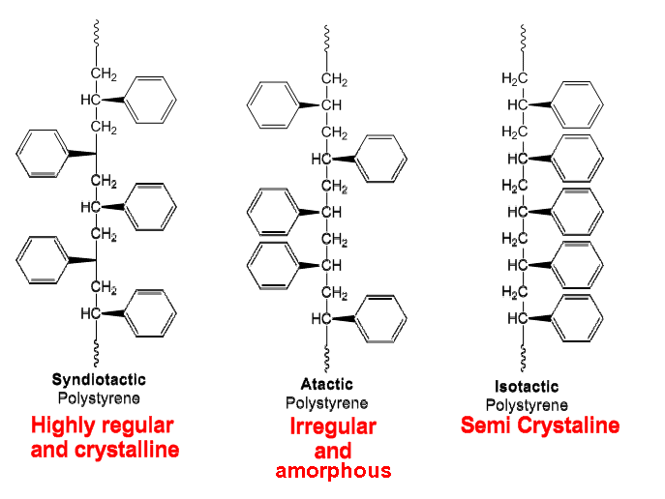 The **isotactic** form of **PS** (on the right, below) is not a favored PS conformation. While the methyl groups of PP are small enough to be accommodated in a head-to-tail configuration on one side of the carbon backbone (isotactic spatial form), the bulkiness and, thus, the steric hindrance of the large phenyl groups resists formation of this structure.

*Three spatial forms (tacticity) of polystyrene*

*(*[*http://www.chemtube3d.com/polymer/images/polystyrene.gif*](http://www.chemtube3d.com/polymer/images/polystyrene.gif)*)*

In November 2011, *Polymer Chemistry* published a report of a collaboration between researchers from Chinese universities and the University of Southern California. Using a butyllithium catalyst and hexane solvents, the chemists were able to produce an isotactic-rich PS mixture that polymerized at –30 oC. (<https://www.deepdyve.com/lp/elsevier/synthesis-of-isotactic-polystyrene-in-hydrocarbons-by-initiation-with-FzolbUgsqQ>)

A more recent study by Chinese researchers (*Polymer Chemistry* (*4*) 2013, pp 954–960) describes a procedure using a highly specific MAO catalyst. The isotactic PS product increasingly crystallizes over time. Perhaps in the future, this may lead to commercial value. (<http://pubs.rsc.org/en/Content/ArticleLanding/2013/PY/c2py20814h#!divAbstract>)

**Resin #7: Other resins**

This is “other” resins—those which do not fit in codes 1–6. Code 7 may also indicate that the material has been formed by a combination of resins, or layers of different resins, increasing the complexity and expense of sorting and recycling. Some examples of resin code #7 are: materials made with acrylic, nylon, polylactic acid (biodegradable), or polyurethane; ketchup bottles and some citrus juice bottles; Plexiglas; and plastic lumber.

**Structure of polymer chains**

Polymer chains can differ in their geometric arrangements (configurations) and stereochemical arrangements (conformations), as well as in their spatial arrangements (tacticity). Polymeric properties are highly dependent upon the specifics of the chain structure, as discussed in the section on polymer chemistry by their resin numbers.

**Configuration**

Configuration indicates the stereochemical arrangement of atoms. The two images shown at right have chiral carbons (central carbons covalently bonded to four different groups). These molecules are stereo isomers of each other because their atoms do not have the same stereochemical arrangement. Thus, covalent bonds must be broken to alter their structure. The molecules below are stereoisomers, non-superimposable mirror images of each other.

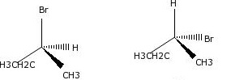

*Stereoisomers of 2-bromobutane*

(<http://worldofbiochemistry.blogspot.com/2012/09/conformation-vs-configuration.html>)

Another example of configurational isomers is the way some monomers join when they are forming polymers. Monomers can be linked by placement in the same order (head to tail) to produce a polymer chain, or they can be linked head to head or tail to tail as shown below. These different configurations can only be changed by breaking covalent bonds. These three arrangements will result in very different properties for the three stereoisomers.

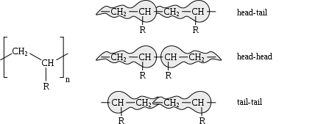

*Three different configurational structures for a polymer*

*Joël Gubler alias* [*Talos*](https://commons.wikimedia.org/w/index.php?title=User:Talos&action=edit&redlink=1)

*(*[*https://en.wikipedia.org/wiki/Tacticity*](https://en.wikipedia.org/wiki/Tacticity)*)*

**Conformation**

Conformation describes the geometric arrangements of the groups attached to the carbon chain backbone. No bonds are broken because rotation around carbon-carbon single bonds is easy and can be frequent. Three conformations (rotations) are shown below. For long flexible polymer chains, many conformations are possible. Note that these three are just temporary so the arrangements are not considered structural isomers of each other. In general, the conformation with the lowest energy level is favored.

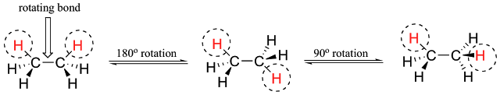

(<http://worldofbiochemistry.blogspot.com/2012/09/conformation-vs-configuration.html>)

The organic shorthand (images at right) shows the flexibility of conformation in a macromolecule. When exposed to heating (thermal motion) or solvents (bond weakening), the molecules rotate around the single backbone carbon-carbon bonds.



*Conformational changes in a macromolecule*

(<http://www.e13.physik.tu-muenchen.de/Muellerb/Uebung/chapter03.pdf>)

**Tacticity**

Resin numbers three (PVC), five (PP) and six (PS) have groups (other than hydrogen atoms) attached to their long carbon chains. In the PVC monomer, one hydrogen atom is replaced by a chlorine atom; in PP, one hydrogen is replaced by a methyl group (─CH3); and PS has a phenyl group (─C6H5) replacing one hydrogen atom. These groups can have different spatial arrangements, known as tacticity. The group arrangement helps to determine the properties of a polymer. There are three basic types of tacticity.

In the images at right, “R” stands for any attached group. The dashed line means that the atom (or “R” group of atoms) extends backwards from the two dimensional plane; the wedged line indicates a forward protrusion. Note that in the isotactic image, the orientation is the same for all groups; in the syndiotactic arrangement, the “H” and the “R” alternate between dash and wedge in each section of the polymer. The third possibility, atactic (or not tactic) is a scattered, random arrangement of the groups along the backbone.

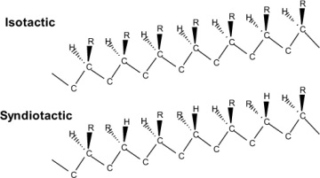

*Tacticity in a polymer molecule*

*(*[*http://www.informit.com/articles/article.aspx?p=2235827&seqNum=2*](http://www.informit.com/articles/article.aspx?p=2235827&seqNum=2)*)*

The tacticity of the polymer depends upon the temperature and the solvents used in the polymerization process. Many properties of polymers, including thermal and mechanical behavior, as well as flexibility, and transparency/opaqueness are determined by the tacticity of the polymer chain. Most isotactic and syndiotactic polymers pack closely enough to be at least partially crystalline (translucent to opaque), while atactic polymers lack crystallinity, because their structures are disordered. Atactic polymers are amorphous and, usually, transparent. (<http://www.informit.com/articles/article.aspx?p=2235827&seqNum=2>)

**Collecting and recycling PE grocery bags**

In the U.S., recycling is usually a community decision, so this can vary by state, county and municipality. Recycling bins may take all recyclables in one container (single-stream recycling), or they may require separation into slots or separate bins for bottles and cans, paper goods, plastic, magazines and newspapers (multi-stream recycling).

**Single-stream recycling**

This is done simply at home. All recyclables are dumped into one bin and left on the curb for pickup. This easy method, where the entire bin is emptied into one municipal truck, ensures that more recyclables will be collected, rather than driven directly to the landfill. The trash recyclables are taken to a materials recovery facility, where they are placed on conveyor belts and run through screens, magnets and lasers for separation.

This *Popular Science* diagram represents the recycling steps taken by the separator in Willimantic, Connecticut:

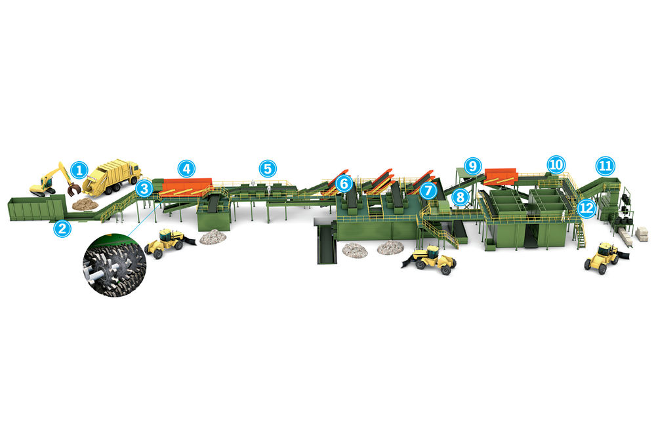

*Recycling via a single-stream separator*

*(*[*http://www.popsci.com/technology/article/2013-07/how-it-works-recycling-machines-separate-junk-type*](http://www.popsci.com/technology/article/2013-07/how-it-works-recycling-machines-separate-junk-type)*)*

Recycling steps numbered in the diagram above:

1. **Tipping Floor:** Truck dumps material on the floor and any oversized or overweight items are removed
2. **Drum Feeder:** Claw grabs a bunch of material and places it in a spinning drum for even distribution on the conveyor belt.
3. **Initial Sorter:** Worker removes plastic bags, coat hangers and other items that could jam or not fit the sorter.
4. **Large Star Screens:** Corrugated cardboard is lifted out and small items fall through to another belt below.
5. **Second Sorters:** Workers remove smaller contaminants (like people’s wallets).
6. **Medium Star Screens:** Paper is lifted out, leaving glass, plastic and metals to fall through the screens.
7. **Glass sorter:** Glass is heavier than plastic and aluminum so it falls through to a bin where a conveyor belt takes it to another facility area to be ground into fine sand and shipped to a glass recycler.
8. **Magnetic Metal Sorter:** A strong magnet passes over conveyor belt, attracting and removing metals.
9. **Eddy Current Separator:** Electrons of aluminum are induced to create a magnetic field (eddy field) that pushes aluminum off the primary conveyor belt and onto another belt.
10. **Infrared Lasers:** These separate plastic by types. Puffs of air separate recyclable from nonrecyclable plastics and send them into separate bins.
11. **Baler:** Recyclable material is tied into separate bales of paper, plastic, cardboard or metal. Each bale is 5 by 4 by 3 feet and weighs one ton.
12. **Landfill:** All the rest, including Happy Meal toys, shoes and jar lids go to the landfill.

(<http://www.popsci.com/technology/article/2013-07/how-it-works-recycling-machines-separate-junk-type>)

**Multi stream recycling**

The collection bin on the left below is the home curbside version, where all recyclables go into one container (single-stream). In the middle is the type that asks consumers to separate their trash (multi-stream). These are often found in places such as offices, airports and universities. Purchasers can choose a combination of three shapes for holes. The one below shows a round hole just the size of an aluminum can or 500 mL plastic drink bottle, a slotted hole on a diagonal for papers and magazines, and a rectangular shape for miscellaneous trash. Purchase comes with standard labels for holes.

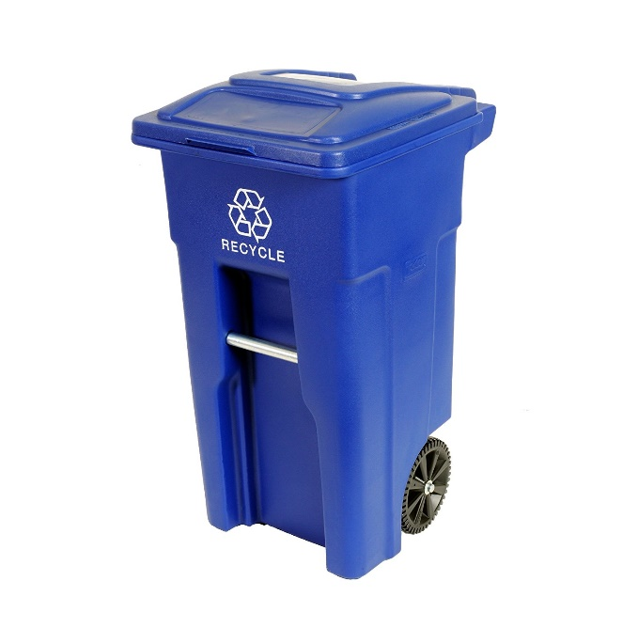

[http://www.wastewiseproductsinc.com/wp-content/thumbgen_cache/42f580cdb93d27e7047dc198c6be65ed.gif](http://www.wastewiseproductsinc.com/wp-content/uploads/2016/03/Aristata-Cans-and-Bottles-Label.gif)[http://www.wastewiseproductsinc.com/wp-content/thumbgen_cache/d8aac10917d561643d15181a616acf52.gif](http://www.wastewiseproductsinc.com/wp-content/uploads/2016/03/Aristata-Compost-Label.gif)

[http://www.wastewiseproductsinc.com/wp-content/thumbgen_cache/722a08b9d53ba85b292dee6bbc69ab8e.gif](http://www.wastewiseproductsinc.com/wp-content/uploads/2016/03/Aristata-Mixed-Recyclables-Label.gif)[http://www.wastewiseproductsinc.com/wp-content/thumbgen_cache/4e720fedf4638a327dc1e6d3e45184e7.gif](http://www.wastewiseproductsinc.com/wp-content/uploads/2016/03/Aristata-Organics-Label.gif)

[http://www.wastewiseproductsinc.com/wp-content/thumbgen_cache/10d546e03e4107aea4aa9d72da9258e6.gif](http://www.wastewiseproductsinc.com/wp-content/uploads/2016/03/Aristata-Paper-Label.gif)

[http://www.wastewiseproductsinc.com/wp-content/thumbgen_cache/24f867e8ed9cf2e822af66ba2868cb12.gif](http://www.wastewiseproductsinc.com/wp-content/uploads/2016/03/Aristata-Trash-Only-Label.gif)

[http://www.wastewiseproductsinc.com/wp-content/thumbgen_cache/6d8a45a0d5dbb7a008b52c2682a3e7e3.gif](http://www.wastewiseproductsinc.com/wp-content/uploads/2016/03/Aristata-Waste-Only-Label.gif)

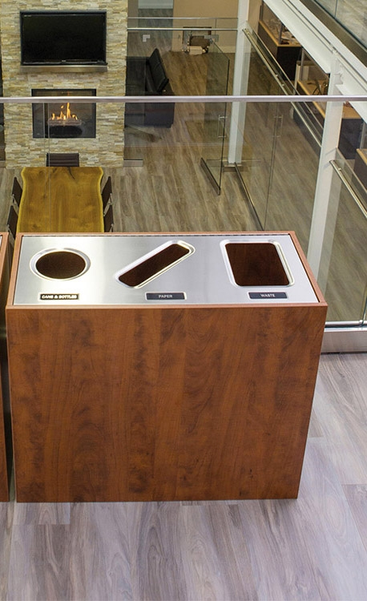

Single-Stream Multi-Stream Standard Labels

*Bin on Left: (*<https://www.google.com/?gws_rd=ssl#q=Amazon+curbside+recycling+bins+for+home>)

*Center bin & labels:* (<http://www.wastewiseproductsinc.com/recycling-bin/aristata-tier-iii-mid-summer-flame-triple-stream/>)

**Plastic bag recycling**

Whatever the collection mechanism, thin plastic polyethylene films (resin numbers 2 and 4), such as grocery bags, plastic wrap, dry cleaning bags, wrap around rolls of paper towels, etc., cannot be easily separated from other waste and simply recycled into new bags. Since these films require a different processing system, separate collection is the most effective means of preparing the resin for recycling. (<https://www.plasticsmakeitpossible.com/plastics-recycling/how-to-recycle/at-home/can-i-recycle-plastic-bags-in-the-recycling-bin/>)

In 1990, supermarkets began placing bins like the one shown at right (from a grocery store in Wayne, Nebraska) for only resin #2 and #4 recyclable film at grocery stores. By 1992 approximately one half of all U.S. supermarkets had these collection programs. The label at far right is used by manufacturers that follow the Association of Postconsumer Plastics Recyclers “Design for Recyclability Guidelines”.

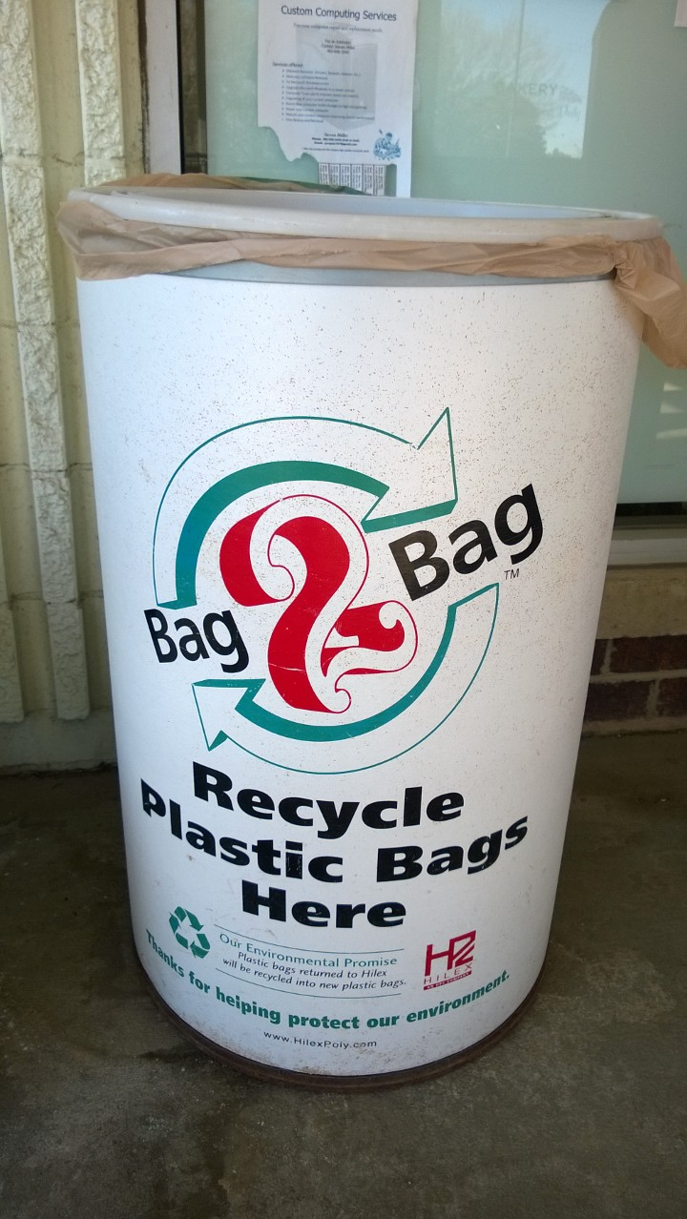

*Store drop-off bin, Wayne, Nebraska*

*(*[*http://www.cityofwayne.org/index.aspx?NID=622*](http://www.cityofwayne.org/index.aspx?NID=622)*)*

*PE film   
recycling label*

*(*[*http://www.plasticfilmrecycling.org/*](http://www.plasticfilmrecycling.org/))

(<http://www.plasticfilmrecycling.org/>)

The Novolex Bag-2-Bag® program shown in the De Antonis article has prepared these guidelines for consumer/recyclers:

**Please Recycle These In Bag-2-Bag®**

* Plastic retail bags
* Produce bags
* News Paper Bags
* Dry Cleaning Bags
* Cereal Box liners
* Paper towel and toilet paper wrap
* Over wrap on cases of soda or canned vegetables
* Sealed air pouches in mailed packages
* Ziploc and other zipper style bags—please remove zippers prior to recycling
* **Please Do Not Recycle These In Bag-2-Bag®**
* Salad and other pre-prepared vegetable bags
* Frozen vegetable bags
* Pet food bags
* PVC or PVDC (Saran) films (meat wrap is PVC)
* Polystyrene, polyurethane foamed, polypropylene
* PETE trays
* Plastic bottles
* Hazardous materials, medical wastes, or packages of these products
* Metal

(<http://novolex.com/sustainability/bag-2-bag>)

The Waste and Resources Action Programme (WRAP) began in Great Britain in 2002. [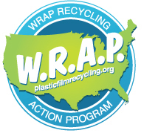](http://www.plasticfilmrecycling.org/wrap/wrap-1.html)In November 2016, American Chemistry Council (ACC) Plastics Division announced their collaboration with the U.S. Environmental Protection Agency (EPA) to promote sustainable management practices for plastics materials. Their goal is to educate the public in an effort to increase the amount of PE thin film that is collected. A system of special Store Drop-Off bins for plastic grocery bags and other clean thin wrap has been introduced and collection continues to increase. (<http://www.plasticfilmrecycling.org/>)

*(*[*http://www.plasticfilmrecycling.org/*](http://www.plasticfilmrecycling.org/)*)*

The Procter and Gamble Company (P&G) has joined the ACC’s Flexible Film Recycling Group to design programs to encourage local recycling programs. P&G’s Research and Development (R&D) manager Stephen Sikra explains the high demand for recycled PE film, “I see it as very strong with many uses, including durable goods such as composite lumber for decks, fencing, building and garden products, crates, and piping, and for flexible applications, including new film packaging and plastic bags.” (<https://www.packworld.com/sustainability/recycling/pg-puts-focus-pe-film-recycling>)

**Processing recycled PE bags and films**

The largest used grocery bag collection system is the one mentioned in the De Antonis article, the Novolex Bag-2-Bag® program. Novolex has more than 30,000 U.S. pick-up locations. Its processing plant is advertised as the “world’s largest closed-loop plastic bag recycling plant”. Closed-loop means that Novolex collects bags from store drop-off bins and trucks them to their Indiana plant for processing into PE pellets that become the raw material for in-house production of new (recycled) grocery bags, thus closing the loop.

White grocery bags are manufactured from virgin resin. If material is available, Novolex has the capability to manufacture bags with 100% recycled PE. In 2014, their average was 30% recycled per bag (some bags contained 50% recovered material). As more people return thin films to recovery bins, Novolex predicts that the percent of virgin PE needed will decrease. When recycled films of various colors are mixed (like mixing food colors) and heated, the product pellets are white to grey depending upon the percentage of recycled material used, as shown in the graph at right.

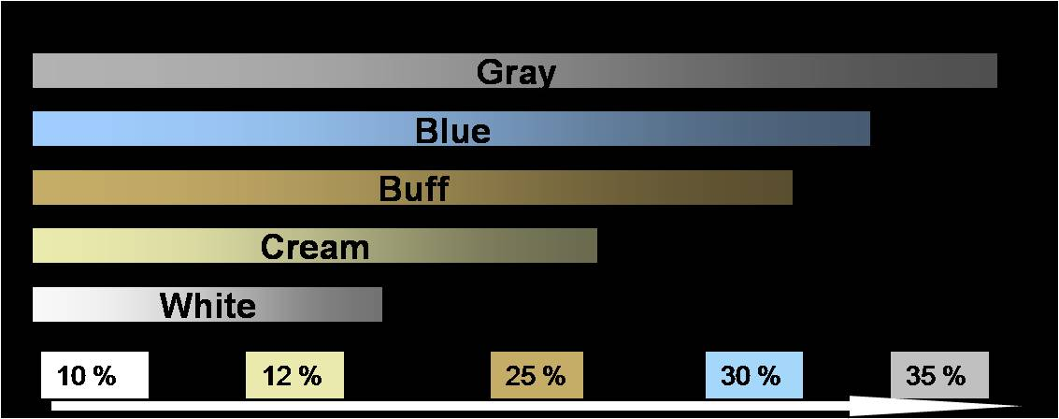

*Percent recycled content in recycled PE pellets*

*(*[*http://novolex.com/sustainability/gray-is-the-new-green*](http://novolex.com/sustainability/gray-is-the-new-green)*)*

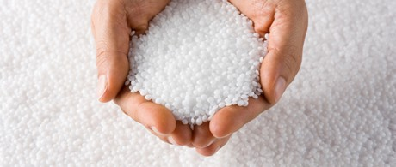 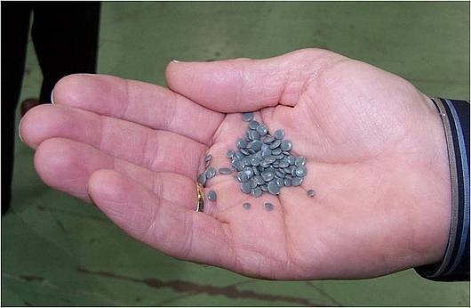

*White virgin PE pellets Novolex recycled PE pellets*

*(*[*http://novolex.com/sustainability/recycling-plant*](http://novolex.com/sustainability/recycling-plant)*)*

*(*[*https://www.containerandpackaging.com/blog/2009/06/what-are-the-7-main-plastic-resin-types/*](https://www.containerandpackaging.com/blog/2009/06/what-are-the-7-main-plastic-resin-types/)*)*

**Novolex process**

Every day, the Bag-2-Bag® program processes approximately 80,000 pounds of plastic. The Indiana plant has two basic lines, a “dry line” for clean plastic tailings, such as the cutouts from bag handles from their own and other manufacturing plants. There is also a “wet line” to wash recycled grocery bags. A shredder breaks down the material to allow the contaminants such as grocery receipts (forgotten in bags) to sink to the bottom for removal, while the bits of PE rise to the top of the bath. After a final grinding and washing, the material is pressed to remove rinse water and thoroughly dried, because just one drop of water can ruin the entire batch. See descriptions of the Novolex industrial procedures below:

1. Dry material from both lines is put through a grinder, reduced to PE flakes and melted into a liquid which is then formed into feedstock pellets.
2. Pellets from the Novolex process are combined with recycled and new (virgin) pellets purchased from suppliers. The exact mixture is determined by individual customer specifications. The picture shows the resin mixture **on a conveyor belt** being fed into blowers (white structure shown in the top right corner of the picture) where the pellets are blown and extruded into a thin film.
3. Film is rolled and then sent to the bag making machines where it is stamped with logos, cut into bags, sealed at the bottom and handles are pressed out.

(<http://novolex.com/news-updates/thats-a-wrap>)

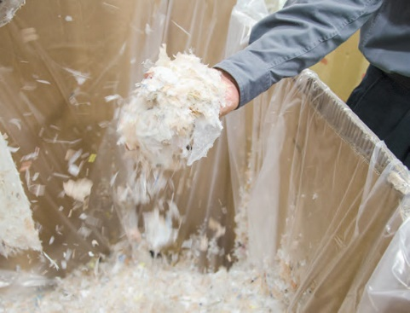 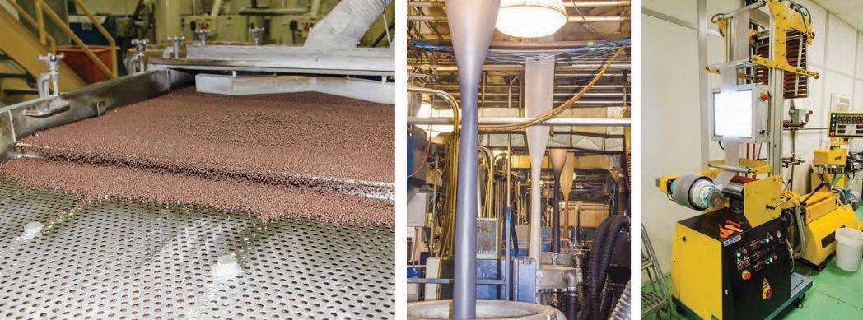 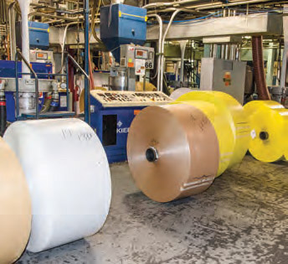

*(a) Dry, ground, flaked recycled PE (b) Mixing and extrusion (c) Rolls of recycled PE film*

*(*[*http://novolex.com/news-updates/thats-a-wrap*](http://novolex.com/news-updates/thats-a-wrap)*)*

Novolex constantly monitors both their own products and the resin pellets that they purchase from other suppliers, to ensure quality and to avoid threats to their machinery and to their customers. The national non-profit Healthy Building Network promotes the use of environmentally friendly and sustainable building materials. They have produced a series of reports on “Optimizing Recycling”. In collaboration with the Stop-Waste program of Alameda County, a report was prepared to identify problems with recycled polyethylene. This report suggests that if the bags may be recycled, manufacturers should not use potentially harmful additives in their bags made from virgin pellets. In addition, PE material should be screened and rejected when necessary before recycling.

Degradation additives are used to reduce public concern about litter and bags in landfills. These chemicals actually fail to decompose PE; they simply break the plastic into tiny pieces. Recycled bags made from pellets containing these additives may lack the strength to hold a heavy grocery load.

Some grocery bag processers depend upon metal catalysts to speed polymerizing reactions. Microbes decompose the catalysts but leave the metal behind to contaminate landfills and/or recycled bags. The Alameda County project found high levels of cobalt (listed as a California Proposition 65 carcinogen) in a food waste bag that had been manufactured using a cobalt catalyst. Some recyclables collected in single-stream bins contain more than one type of resin. For example, an HDPE bottle may have a PVC banded label that later becomes an impurity in the recycled product. In addition, there may be contaminants left in recycled plastic containers that once held pesticides, antifreeze or detergent. (<http://healthybuilding.net/uploads/files/optimizing-recycling-pe-report.pdf>)

**Environmental concerns**

Plastic grocery bags have only been around for about 50 years, so the claims of 500 to 1000 year life spans are vague estimates. Life spans for landfill items are estimated by tests for the length of decomposition time. When a PE garbage bag and other organic waste, such as a banana peel and newspaper, are mixed with compost rich in microorganisms, carbon dioxide is released as microbes decompose the peel and paper. Measuring the gas indicates the life span of these organic materials. When only the intact grocery bag is left, no carbon dioxide is expelled because soil microbes do not feed on plastic. PE will gradually degrade from exposure to the sun’s ultraviolet (UV) rays; however, the chains just break into small pieces that swirl about in ocean currents. Thus, the bag may be considered “decomposed”, but the plastic remains in the water. (<http://www.slate.com/articles/news_and_politics/explainer/2007/06/will_my_plastic_bag_still_be_here_in_2507.html>)

Grocery bags end up almost everywhere. For several miles outside Trelew, Argentina, the shrubs are decorated with PE bags of all colors. The lightweight film is picked up in the city by constant Patagonian winds and flown for miles, to rest on every twig and bush. And many finally come to rest in lakes, rivers and oceans. They last hundreds of years in landfills, block storm drains, and litter hiking trails. The most serious concern is the danger to marine animals that may become enmeshed and choked by them, or perceive them as food. Bits of PE settled in the stomachs of fish and seabirds satisfy their hunger; meanwhile they starve to death. (<http://grist.org/climate-energy/are-plastic-bag-bans-good-for-the-climate/>)

*A sea turtle seen feeding on a PE plastic bag*

*(*[*http://www.ecowatch.com/silent-killers-the-danger-of-plastic-bags-to-marine-life-1881783599.html*](http://www.ecowatch.com/silent-killers-the-danger-of-plastic-bags-to-marine-life-1881783599.html)*)*

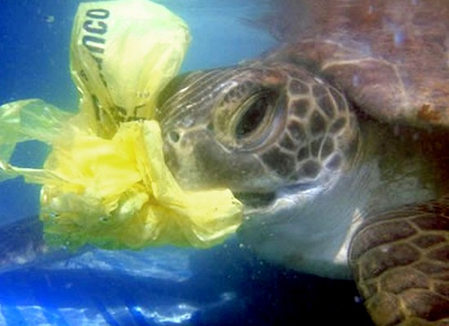

*BBC News* (June 2016) reported, “Fish eat plastic like teens eat fast food”. This article was based on a Swedish study of perch larvae exposed to ocean water containing a mixture of micro pieces of plastic and natural food (plankton). The fish showed a definite preference for the plastic. When deliberately exposed

to a diet of plastic, the normal hatch rate was reduced. Dr. Oona Lonnstedt, Uppsala University, said that those that did hatch were "smaller, slower, and more stupid" causing them to be much more susceptible to predation.

(<http://www.bbc.com/news/science-environment-36435288>)

*Damselfish larva with Ingested Plastic Particles*

*Oona Lonnsted (*[*http://www.bbc.com/news/science-environment-36435288*](http://www.bbc.com/news/science-environment-36435288)*)*

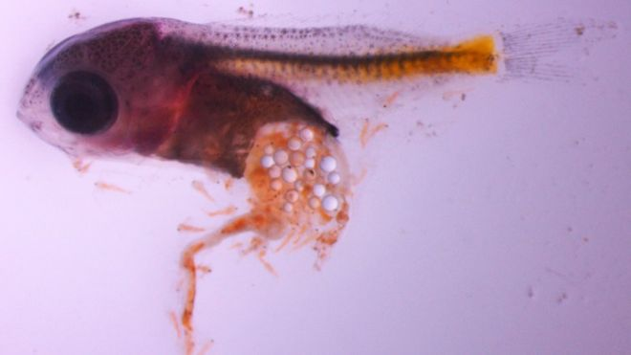

Carey Morishige, Pacific Islands Regional Coordinator for the Marine Debris Program of the National Oceanic and Atmospheric Administration (NOAA), discussed two myths about ocean “Garbage Patches”.

1. Garbage Patches of empty bottles and yogurt cups do not exist. Patches are simply areas of large concentrations of microscopic plastic material. These include flecks of plastic from disintegrating PE garbage bags and other plastic items; microfibers from synthetic clothing, such as fleece jackets; and microbeads from cosmetic scrubs and household cleaners. Morishige describes these as, “like flecks of pepper floating throughout a bowl of soup”. The De Antonis article describes the circular motion of ocean currents or gyres that pull the material together.
2. Aside from the Great Pacific Garbage Patch, there are actually many places in various parts of the ocean where the wind and ocean currents bring together tiny particles of ocean debris.

(<http://response.restoration.noaa.gov/about/media/how-big-great-pacific-garbage-patch-science-vs-myth.html>)

The plastic microscopic material found in oceans and waterways is defined as plastic microfibers less than five millimeters in length and microbeads less than five millimeters in diameter. The Bren School of Environmental Science and Management at the University of California, Santa Barbara studied plastic pollution in the waste water effluent at water treatment plants. The student team found that 85% of the microplastic in the water was in the form of microfibers and 13% was microbeads and other plastic fragments. (<http://www.esm.ucsb.edu/research/2016Group_Projects/documents/PataPlastFinalReport.pdf>)

Abigail Barrows, chief investigator for the Global Microplastics Initiative, tested ocean water samples. She found that almost all samples contained microplastic debris. From 426  
one-liter samples from around the world, 94% contained microplastics, and 84% of those were microfibers. Several major companies, including Patagonia, are concerned enough to consider redesigning their fabrics to reduce the amount of fibers lost during washing. In a single machine washing, a new fleece jacket loses about 2.7g of fibers to the waste water. (<https://www.outsideonline.com/1998166/plastics>)

The map below from the NOAA Web site shows places where tiny bits of plastic congregate in the Pacific Ocean. The swirls on the map indicate the ocean currents responsible for concentrating these micro- and submicroscopic particles. Some think that in these areas larger debris may have settled on the ocean floor. Note: This map is essentially the same as the one in the De Antonis article.

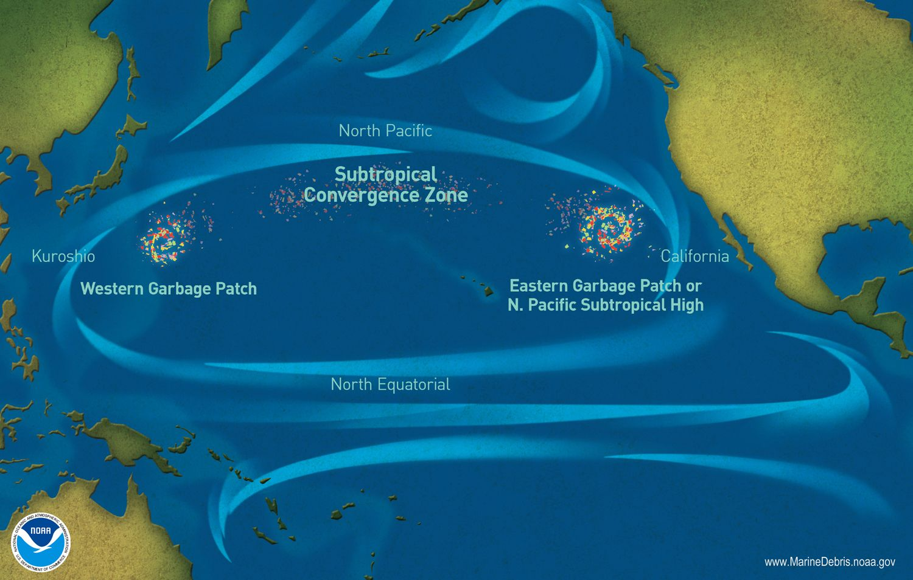

*Marine decay locations in the North Pacific Ocean*

*(*[*http://www.nationalgeographic.org/encyclopedia/great-pacific-garbage-patch/*](http://www.nationalgeographic.org/encyclopedia/great-pacific-garbage-patch/)*)*

**Possible solutions**

In an effort to reduce ocean plastic litter, the Global Plastics Association, an organization supported by international plastics makers, says, “… plastics should be responsibly used, reused, recycled and finally recovered for their energy value”. (<https://www.marinelittersolutions.com/about-us/joint-declaration/>)

To promote this effort they have planned 260 marine litter solutions and 69 organizations in 35 countries have signed a pledge to:

1. Contribute to solutions by working in public-private partnerships aimed at preventing marine debris.

2. Work with the scientific community and researchers to better understand and evaluate the scope, origins and impact of and solutions to marine litter.

3. Promote comprehensive science-based policies and enforcement of existing laws to prevent marine litter.

4. Help spread knowledge regarding eco-efficient waste management systems and practices, particularly in communities and countries that border our oceans and watersheds.

5. Enhance opportunities to recover plastic products for recycling and energy recovery.

6. Steward the transport and distribution of plastic resin pellets and products from supplier to customer to prevent product loss and encourage our customers to do the same.

(<https://www.marinelittersolutions.com/wp-content/uploads/2016/11/MLS-Declaration-2016_V3-0002.pdf>)

In addition to recycling thin PE bags, possible solutions to the plastic litter problems described in De Antonis article include ways to decompose the material, ban the sale of PE bags, and substitute reusable bags.

**Biodegradable bags**

The abbreviated diagram below shows the triangle of formation for PLA by a condensation (removal of water) reaction between lactic acid and lactide (two green arrows point toward the product PLA). A description of the three reactions follows:

*Formation of Biodegradable PLA Pellets*

*(*[*http://pubs.acs.org/doi/abs/10.1021/bm101302t*](http://pubs.acs.org/doi/abs/10.1021/bm101302t)*)*

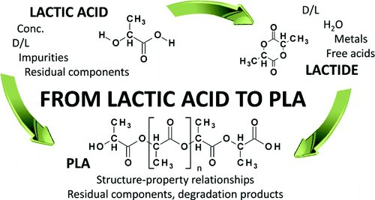

Lactic Acid: Bacterial fermentation of various plant starches yields both D- and L- stereoisomers of lactic acid, along with other impurities and residual components.

Lactide: Polycondensation of lactic acid produces ringed D- and L- stereoisomers of lactide (note the green arrow from lactic acid to lactide). Metallic compounds of Sn, Zn, Al, Sb and others catalyze this reaction. Note that the metal (impurity) is shown with the lactide structure and water (H2O), the byproduct of condensation.

PLA: The final product is produced from reactants that both contain impurities, and are of inconsistent quality. This means that the composition of PLA resin beads is not consistent. So, PLA grocery bags differ in texture and strength from batch to batch. These are (perhaps costly) problems that need to be addressed for this process to become sustainable. (<http://pubs.rsc.org/en/content/chapterhtml/2014/bk9781849738798-00001?isbn=978-1-84973-879-8#sect258>)

Biodegradable grocery bags are a possible solution to the landfill/litter problems. Completely degradable bags can be manufactured from tapioca, wheat, corn, and potato starches. The starch is fermented to lactic acid and then polymerized to form pellets of polylactide (PLA), a biodegradable plastic. These organic pellets are melted and processed to form biodegradable thin films.

This process is considered “carbon neutral”, because the polymer is produced by the fermentation of dextrose (a simple sugar) that is obtained from carbon-absorbing plants. PLA is considered “green”, because it is not produced from fossil fuels. Estimates show that its production requires 65% less energy and releases 68% fewer greenhouse gases than the production of resin #1, polyethylene terephthalate (PET).

Although PLA will biodegrade into carbon dioxide and water, this will happen extremely slowly in backyard compost bins, and even more slowly (100–1,000 years) in dark landfills packed tightly with wastes that allow little oxygen penetration. In carefully controlled industrial processes where digestive microbes are added while the temperature is kept at a constant   
60 °C, biodegradation may occur within three months.

There are other problems that limit the use of PLA for grocery bags. Bioplastic is weaker than HDPE, has a limited shelf life, melts at 173–178 °C, and may fall apart when filled with wet leaves. In addition, it must be collected separately and sent to one of the few U.S. composting facilities (not to recycling plants). (<http://www.smithsonianmag.com/science-nature/corn-plastic-to-the-rescue-126404720/?c=y&page=2>)

**Photodegradable/oxodegradable bags**

HDPE grocery bags can also be decomposed by blending a UV oxidative additive into the resin. A metal salt such as ferric stearate or Iron(III) stearate, Fe(C17H34COOH)3, is often used. Note that the stearate is the salt of the organic compound stearic acid, which contains a carbonyl (C=O) organic acid group. See the structural diagram below. (<http://onlinelibrary.wiley.com/wol1/doi/10.1002/pi.4990280107/abstract>)

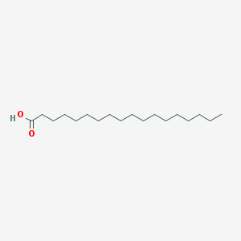

*Stearic acid or octadecanoic acid: CH3(CH2)16COOH*

*(*[*https://pubchem.ncbi.nlm.nih.gov/compound/stearic_acid#section=2D-Structure*](https://pubchem.ncbi.nlm.nih.gov/compound/stearic_acid#section=2D-Structure)*)*

When the bag is discarded, those special oxidative additives cause the polymer chains to break down into oxygenated short chain molecules when exposed to UV light rays. Unlike the long hydrocarbon chains of HDPE molecules, the smaller segments contain the oxygen needed for biodegradation by soil microorganisms. In the open environment, photodegradable bags will decompose in 2 to 18 months; in a landfill, the process may take 6 months to 5 years. (<http://www.packagingknowledge.com/degradable_biodegradable_bags.asp>)

The major objection to photodegradable grocery bags is the reluctance of consumers accustomed to cheap HDPE bags to switch to more expensive, but still considered “throwaway”, bags.

The Bag-2-Bag® program by Novolex is the best way to recycle single-use grocery bags. This link takes you to a complete description of the program, including what can be placed in the supermarket bins. (<http://novolex.com/sustainability/bag-2-bag>) Enter your Zip code on this site for the location of the nearest supermarket Bag-2-Bag® drop off bin. (<http://www.plasticfilmrecycling.org/s01/s01dropoff.html>)

**Reusable bags**

Reusable bags are usually considered better for the environment and sea life than   
thin-filmed HDPE, but they must be used multiple times to justify their expense, in terms of the cost of manufacturing and the cost to the environment. It is estimated that to achieve the greatest environmental benefits, one must use a PP reusable bag 100 times and a cotton reusable bag 131 times. The last estimate is from a 2011 study done by the United Kingdom (U.K.) Environmental Agency. (<http://www.marketwatch.com/story/are-reusable-bags-worse-for-environment-than-plastic-2014-01-09>)

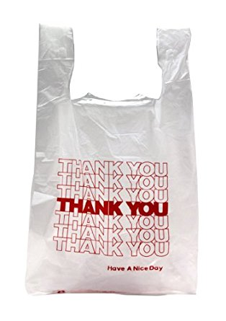 [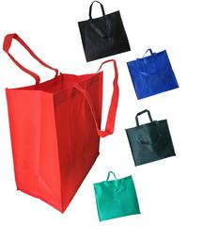](https://totebagfactory.com/collections/reusable-grocery-shopping-bags/products/cheap-jumbo-tote-bags) [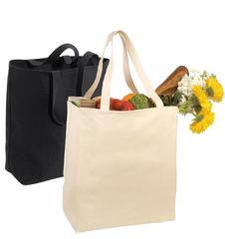](https://totebagfactory.com/collections/reusable-grocery-shopping-bags/products/wholesale-grocery-tote-bag-over-the-shoulder)

*PE Single Use   
Grocery Bag*

*(*[*https://www.amazon.com/Thank-You-T-Shirt-Plastic-Shopping/dp/B00FZQZJGE*](https://www.amazon.com/Thank-You-T-Shirt-Plastic-Shopping/dp/B00FZQZJGE)*)*

*PP Grocery Bag*

*(*[*https://totebagfactory.com/collections/reusable-grocery-shopping-bags*](https://totebagfactory.com/collections/reusable-grocery-shopping-bags)*)*

*Cotton Grocery Bag*

*(*[*https://totebagfactory.com/collections/reusable-grocery-shopping-bags*](https://totebagfactory.com/collections/reusable-grocery-shopping-bags)*)*

In 2010, as customers in California began to switch to reusable bags, Loma Linda University (Loma Linda, California) and the University of Arizona published a joint food safety research report, “Assessment of the Potential for Cross Contamination of Food Products by Reusable Shopping Bags”. They found that people are seldom aware that bags should be washed to avoid the growth of harmful bacteria and molds in a grocery bag. The research concluded that reusable grocery bags can harbor dangerous foodborne bacteria that may impact public health safety.

The report recommends that when using reusable bag customers should:

1. separate raw foods from other food products,
2. use bags only for grocery store items, not for dirty clothes or other nonfood items.
3. avoid storing bags in car trunks where high temperatures encourage bacterial growth.

(<http://www.foodsafetynews.com/2010/06/reusable-shopping-bags-and-food-safety/#.WJjRXXkzVy0>)

Several manufacturers are producing reusable shopping bags treated with AP-360, an antibacterial agent. The U.S. EPA says that this material, obtained from the chitin of discarded crustacean cells, is non-allergenic and safe for humans. The Soulard apparel company has been using AP-360 to eliminate odor-causing bacteria in the golf shirts it manufactures for Wilson Sporting Goods. They plan to spray reusable grocery shopping bags with AP-360 that should last through at least 5 washings. AP-360 is antibacterial and should eliminate deadly *E. coli* and campylobacter bacteria often found in raw chicken. Washing is still needed to kill mold and dangerous viruses. (<http://www.stltoday.com/business/local/soulard-company-sees-future-in-reusable-shopping-bags/article_593165dc-69d3-5e67-8123-73c5c28324a0.html>)

**Bag bans**

Many countries and U.S. municipalities began to question the rationale for using cheap, single-use PE grocery bags. Not only does their manufacture consume fossil fuels but, as debris, they litter and harm wildlife. Long before the U.S. considered limiting their use, many other countries, including the European Union (E.U.), China, India, and many others, began to ban or tax their use. San Francisco became the first U.S. city to ban these bags in 2007. Many U.S. cities (particularly in California) followed.

A 95% reduction in plastic bag litter followed a 2002 bag tax in Ireland. *Scientific American* magazine reported that the 2011 ban in San Jose, California resulted in a plastic litter reduction of “approximately 89% in the storm drain system, 60% in the creeks and rivers, and 59% in City streets and neighborhoods.” (<https://www.scientificamerican.com/article/do-plastic-bag-bans-work/>)

In many countries of the world, there has been a **phase-out of lightweight plastic bags**. Single-use plastic shopping bags, commonly made from high-density polyethylene (HDPE) plastic, have traditionally been given free to customers by stores when purchasing goods—a popular method considered a strong, cheap, and hygienic way of transporting items. Problems associated with plastic bags include use of non-renewable resources (such as crude oil, gas and coal), disposal, and environmental impacts.

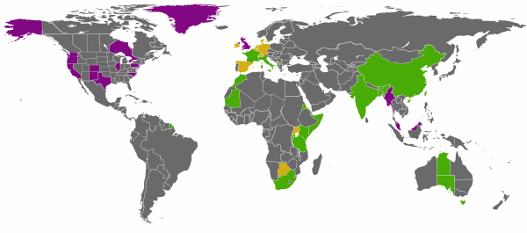

*Phase out of lightweight plastic bags around the world*

Plastic bags banned;

A tax on some plastic bags;

Partial tax or ban (municipal or regional levels)

*(*[*https://en.wikipedia.org/wiki/Phase-out_of_lightweight_plastic_bags*](https://en.wikipedia.org/wiki/Phase-out_of_lightweight_plastic_bags)*)*

Governments all over the world have taken action to ban the sale of lightweight bags, charge customers for lightweight bags, and/or generate taxes from the stores who sell them. The Bangladesh government was the first to do so in 2002, imposing a total ban on the bag. Such a ban has also been applied in countries such as Rwanda, China, Taiwan and Macedonia. Some countries in Western Europe impose a fee per bag. Bans, partial bans, and fees have been enacted by some local jurisdictions in North America, Australia and the United Kingdom.

In November 2016, California became the first state to enact a statewide ban. Supermarket parking lots post signs, “Remember your Reusable Bags”. Customers can purchase a paper bag for ten cents. The statewide ban was preceded by over a hundred local laws. These will remain, and all supersede the statewide legislation. (<http://www.npr.org/sections/thetwo-way/2014/09/30/352774915/ban-on-single-use-plastic-bags-is-enacted-in-california>)

*Monterey, California  
Whole Foods Parking Lot*

*(*[*http://lolako.com/tag/signs-remember-to-bring-reusable-bags/*](http://lolako.com/tag/signs-remember-to-bring-reusable-bags/)*)*

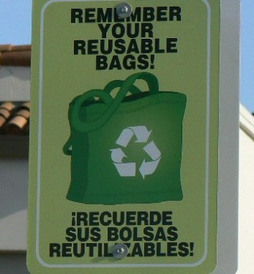

# References

**(non-Web-based information sources)**

**The references below can be found on the *ChemMatters* 30-year DVD, which includes all articles   
published from the magazine’s inception in October 1983 through April 2013; all available Teacher’s Guides, beginning February 1990; and 12 *ChemMatters* videos. The DVD is available from the American Chemical Society for $42 (or $135 for a site/school license) at this site:** [**http://ww.acs.org/chemmatters**](http://www.acs.org/chemmatters)**. Click on the “Teacher’s Guide” tab to the left, directly under the “*ChemMatters Online"* logo and, on the new page, click on “Get the past 30 Years of *ChemMatters* on DVD!” (the icon on the right of the screen).**

**Selected articles and the complete set of   
Teacher’s Guides for all issues from the past three   
years are available free online at the same Web site, above. Click on the “Issues” tab just below the logo, *“ChemMatters Online”*.**

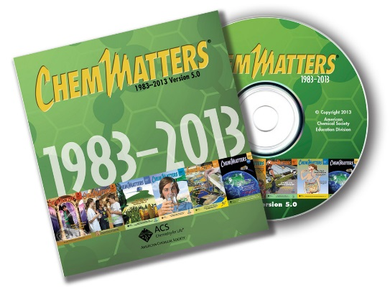

***30* Years of *ChemMatters !***

Available Now!

This article shows how biodegradable bags made of polyethylene (non-biodegradable) with inserted starch molecules (biodegradable), can be broken down into small molecules by bacteria that digest the starch. Degrading experiments that can be done in or outside class are included. (Downey, C. Biodegradable Bags. *ChemMatters*, 1991, *9* (3), pp 4–6)

The Classroom Guide for the October 1991 *ChemMatters* article above, “Biodegradable bags”, compares the volumes and weight of paper and plastic grocery bags. While the information about the difficulty of sorting and recycling different plastics is dated, details about the characteristic properties of various resins is relevant today.

Addition and condensation polymerization are discussed with structural diagrams showing two monosaccharides forming a disaccharide by condensation polymerization. The production of food wrappers includes PE sandwich bags and edible food wraps. (Mahoney, M. Edible Wraps. *ChemMatters*, 2003, *21* (2), pp 14–16)

This article discusses environmental concerns involved in the production of petroleum plastics, including the release of carbon dioxide and its contribution to global warming. Information about the production of bioplastics and their composting is accompanied by a student activity with instructions on how to produce a bioplastic from cornstarch. (Washam, C. Plastics Go Green. *ChemMatters*, 2010, *28* (2), pp 10–12)

The focus of this article is the recycling of petroleum plastics by physical and chemical processes. A detail of the chemistry involved includes relevant chemical equations. The industrial process of recycling and inherent problems of handling mixed resins, plus the importance of the recycling industry in India are discussed. (Husband, T. Recycling to Survive. *ChemMatters*, 2011, *29* (1), pp 5–7)

The Teacher’s Guide for the February 2011 *ChemMatters* article, “Recycling to Survive”, provides information on recycling of various plastic resins and distinguishes between thermoplastics and thermosets. A table comparing the properties of these two basic types of plastics is included.

This article presents natural (biological) polymerization, while discussing diabetes and the development of an artificial kidney. Structural formulas for DNA show the repeating units. Since many students know or are related to a diabetic, this article will introduce the biochemistry of polymers involved in both the illness and possible treatments. (Karabin, S. Changing the Course of Diabetes. *ChemMatters*, 2011, *29* (4), pp 12–13)

The Teacher’s Guide for the December 2011 *ChemMatters* article, “Changing the course of Diabetes”, presents a wealth of information about the polymerization process. Structural diagrams for monomers and for polymerization reactions are accompanied by explanations. Material includes natural organic polymers as well as synthetic polymers.

# Web Sites for Additional Information

**(Web-based information sources)**

**History of plastic grocery bags**

This paper, “Polyethylene: Discovery and Growth”, details the laboratory work that led to the discovery of polyethylene and eventually to low and high density polyethylenes. (<https://www.researchgate.net/publication/228813221_Polyethylene_discovery_and_growth>)

In contrast to the scientific paper above, the British Royal Society of Chemistry (RSC) has published “Plastic Fantastic”, the story of the discovery of polyethylene plus the later efforts to repeat the experiment. This true tale includes interesting experimental details. RSC gives permission to copy and share with your students. (<http://www.rsc.org/images/InfoChem_Jan2005_Plastic_fantastic_tcm18-217681.pdf>)

**History of polymer discovery**

Leo Hendrick Baekeland (1863–1944) developed the first durable plastic (Bakelite) from phenol and formaldehyde. His invention is said to have begun the “Age of Polymers” for the world. His biography and work on the first synthetic thermoset plastic is well described in this article. (Note: Once molded, thermoset plastics keep their shape during heating or exposure to many solvents.) (<https://www.acs.org/content/acs/en/education/whatischemistry/landmarks/bakelite.html>)

Section 1.1: “Historical Overview on the Origin of Polymer Science and Synthesis of Polyamidesand Polyesters” of the book *Biodegradable Polyesters: Synthesis, Properties, Applications* by Chi Zhang describes the opposition to crediting Staudinger with the discovery of high molecular weight compounds. The book details Zhang’s research and the scientific evidence that he used to verify the existence of polymers. (<https://application.wiley-vch.de/books/sample/3527330860_c01.pdf>)

**Chemistry of polyethylene**

This site contains a fairly complete table of the physical and chemical properties of LDPE and HDPE. The values and descriptions are in two side-by-side columns for easy comparison. (<http://www.ausetute.com.au/polythen.html>)

In this article, the various polyethylenes are listed, with a discussion about the difference between them. The material is easy to read and use as a quick guide.

(<http://www.usplastic.com/knowledgebase/article.aspx?contentkey=508>)

**Chemistry of polyethylene production**

Braskem, a major Brazilian ethanol producer, is becoming a leader in the production of bio-based ethene from sugar cane, for use in the production of polyethylene. The ethanol is dehydrated and heated with either concentrated sulfuric acid or a catalyst to crack the material and yield ethene molecules. This article in *Ethanol Producer* magazine discusses other Brazilian projects and provides their own market analysis of the Braskem project. (<http://www.ethanolproducer.com/articles/8617/feeding-the-chemical-market>)

Karl Ziegler was determined to make HDPE at atmospheric pressure. He succeeded, but questions still remain about the mechanism of his catalytic conversion, such as: “Where is the active site located?” This article contains clear diagrams along with suggested explanations. (<http://wwwcourses.sens.buffalo.edu/ce435/Polyethylene/CE435Kevin.htm>)

New metallocene/methylaluminoxane (MAO) catalysts must be very specific in structure to produce polymers with the correct stereo characteristics to work well with co-polymers in the production of long-lasting materials. This paper, “The Influence of Ziegler-Natta and Metallocene Catalysts on Polyolefin Structure, Properties, and Processing Ability” published in the journal *Materials* discusses the history of catalysis in the polymer industry, proposed catalytic mechanisms, and world use. There is open-access to the entire paper. (<http://repository.um.edu.my/93175/1/materials-07-05069.pdf>)

**Polymer chemistry by resin numbers**

The American Chemistry Council (ACC) has prepared an excellent, comprehensive table by resin numbers, “Plastic Packaging Resins”. This table includes the following information for each number: Descriptions, Properties, Product Applications and Products made with Recycled Content. This might provide an excellent reference for student projects. (<https://plastics.americanchemistry.com/Plastic-Resin-Codes-PDF/>)

In addition to some technical information about polymerization, this site has a nice table of some “Common Addition Polymers” that includes structural formulas for the monomers, properties and uses. This chart contains many polymers not listed on the RIC 1-6 codes. (<https://www2.chemistry.msu.edu/faculty/reusch/virttxtjml/polymers.htm>)

**Collection and recycling PE bags**

This *Smithsonian* magazine article discusses the problems that occur when PE films and garbage bags enter single-stream recycling processes. They clog recycling machinery, contaminate bales of recyclables and are wind driven from landfills to waterways. (<http://www.smithsonianmag.com/science-nature/recycling-you-may-be-doing-it-wrong-180951192/>)

In January 2016 the “2014 National Postconsumer Plastic Bag & Film Recycling Report” was prepared for the ACC. Postconsumer refers to materials that have undergone their intended use and have been discarded or sent for recycling. The report includes nice graphs of the amount and types of thin film recovered and recommendations for increasing the recovery of recyclable thin PE film. **(**<https://plastics.americanchemistry.com/Education-Resources/Publications/2014-National-Postconsumer-Plastic-Bag-Film-Recycling-Report.pdf>)

The single-stream collection process for Boulder County, Colorado is discussed on this Web site. To encourage people to recycle, they stress the ease of collection when following the county procedures. This includes a description of the items that are recyclable by the process used. They also have a list of frequently asked questions (FAQs) about the process. (<http://www.ecocycle.org/recycle-compost-reuse>)

A detailed presentation of the U.S. collaborations and goals of the WRAP (Waste and Resources Action Programme) is presented here. This site includes descriptions of thin film materials that can be placed in store drop-off bins. The benefits of this sustainable program include: decrease in disposal rates, reduction of environmental impacts and methods to increase stakeholder capacity. (<https://www.americanchemistry.com/Media/PressReleasesTranscripts/ACC-news-releases/US-EPA-and-ACC-Partner-to-Promote-Sustainable-Materials-Management.html>)

This site describes the WRAP program for recycling thin film. A map of U.S. WRAP sites is shown. (<http://www.plasticfilmrecycling.org/wrap/wrap-1.html>)

The “Sustainable Businesses” site discusses the benefits and drawbacks of dual-stream recycling. In addition, the article provides a comparison of the single and dual-stream processes. (<https://www.thebalance.com/dual-stream-recycling-2877730>)

The Novolex Web site discusses how they maintain quality and make a profit by collecting at grocery stores and selling recycled bags. They also work on educating the public about the importance of the specialized collection/recycle program. (<http://novolex.com/news-updates/thats-a-wrap>)

**Environmental concerns**

This site discusses concerns about toxic chemicals that can be absorbed by plastic ocean debris, and their effect on human health. At the end of the article, seven references for more information are given, with easy access by a “click” on the name of the topic. (<http://serc.carleton.edu/NAGTWorkshops/health/case_studies/plastics.html>)

An article published in the journal *Science* describes studies on baby perch that demonstrate a preference for a diet of plastic over natural plankton. Airborne microplastic fibers may also contribute to air pollution and respiratory diseases in humans. This site contains details of the study: (<http://www.independent.co.uk/news/science/fish-microplastic-microbeads-perch-pike-food-marine-pollution-a7063161.html>)

**Possible solutions**

**Biodegradable bags**

As reported in *Smithsonian* Magazine, Blair, Nebraska’s Nature Works is the largest lactic acid production plant in the world. In 2008 Wal-Mart decided to counter criticism about the company’s environmental irresponsibility. They began “moving toward zero waste” by using PLA containers. (<http://www.smithsonianmag.com/science-nature/corn-plastic-to-the-rescue-126404720/>)

**Photodegradable/oxodegradable bags**

The city of Portland, Oregon requested a study by the Pacific Northwest Pollution Prevention Resource Center of the benefits and drawbacks of oxo-degradable bags. They provided thorough answers to questions from the city. This, for example, led to correction of manufacturers’ promotions that advertise an 18- to 24-month decomposition time for the bags. The estimation of a very short decomposition time period relied on a microbe-rich, hot and arid environment. These conditions are not present in rainy Portland. (<http://pprc.org/index.php/2012/p2-rapid/oxo-degradable-bags/>)

A paper published in the July 2016 issue of *Materials Research* discusses work and cites research data on the “Effect of Metal Acetylacetonates on the Photooxidative Destruction of High Density Polyethylene” used as photodestructing additives to HDPE resins. Scientists used the pro-oxidants cobalt(III) acetylacetonate and manganese(II) acetylacetonate. The acetonate anion, CH3COCHCOCH− contains the oxygen required for aerobic biodegradation following exposure to UV radiation. (<http://www.scielo.br/scielo.php?script=sci_arttext&pid=S1516-14392016000400901>)

**Reusable bags**

There have been several news reports of human poisoning from bacteria, mold and viruses growing in reusable grocery bags. This news article describes a Noro virus outbreak among middle school soccer players in the state of Washington that was linked to a dirty reusable grocery bag. (<http://www.theblaze.com/news/2012/05/09/scientists-link-stomach-flu-outbreak-to-reusable-shopping-bag/>)

**Bag bans**

This site provides a complete list of worldwide bans of HDPE single-use grocery bags. The list can be accessed by country or state. For example if you “click” on U.S. a list will show the legislation for each municipality or territory with the effective date and details of implementation. The list also includes all foreign countries that have issued bans. (<https://en.wikipedia.org/wiki/Phase-out_of_lightweight_plastic_bags#United_States>)

This site contains a U.S. map which allows you to just plug in your state or zip code and grocery bag regulations will be shown. (<http://novolex.com/bag-legislation>)

# General Web References

**(Web information not solely related to article topic)**

The “Polymer Properties Data Base” is a fairly extensive information trove about polymers and their properties. If you want to know the basics about polymers, this should give it to you. The site is arranged according to polymer chemistry and polymer physics. The data is alphabetized by polymer topics and key words. For example, a click on “A” reaches a list of choices that include adhesion forces, apparent viscosity and the Arrhenius Equation. The database was composed as an introduction (less detailed than textbooks) to the physical structure and properties of polymers. It is easy to use and provides an excellent source of reference for polymer topics. ([http://polymerdatabase.com/polymer%20physics/pp%20index.html](https://urldefense.proofpoint.com/v2/url?u=http-3A__polymerdatabase.com_polymer-2520physics_pp-2520index.html&d=DwMFaQ&c=clK7kQUTWtAVEOVIgvi0NU5BOUHhpN0H8p7CSfnc_gI&r=J66GWfxfhh2EUCH5xnkQjA&m=x1_JoHokj0kica-kL_lbprUJYEBBeQFpOSLWeuXi04U&s=PG9-hoYnw8RiEzOcBUdRCSemgY6nM8ad501FhdAvHko&e=))