

**December 2016/January 2017 Teacher's Guide**

**Background Information**

**for**

***Clearing the Way to Acne-Free Days***

**Table of Contents**

About the Guide 2

Background Information 3

References 19

Web Sites for Additional Information 20

# About the Guide

Teacher’s Guide team leader William Bleam and editors Pamela Diaz, Regis Goode, Diane Krone, Steve Long and Barbara Sitzman created the Teacher’s Guide article material.   
E-mail: [bbleam@verizon.net](mailto:bbleam@verizon.net)

Susan Cooper prepared the anticipation and reading guides.

Patrice Pages, *ChemMatters* editor, coordinated production and prepared the Microsoft Word and PDF versions of the Teacher’s Guide.

E-mail: [chemmatters@acs.org](mailto:chemmatters@acs.org)

Articles from past issues of *ChemMatters* and related Teacher’s Guides can be accessed from a DVD that is available from the American Chemical Society for $42. The DVD contains the entire 30-year publication of *ChemMatters* issues, from February 1983 to April 2013, along with all the related Teacher’s Guides since they were first created with the February 1990 issue of *ChemMatters*.

The DVD also includes Article, Title, and Keyword Indexes that cover all issues from February 1983 to April 2013. A search function (similar to a Google search of keywords) is also available on the DVD.

The *ChemMatters* DVD can be purchased by calling 1-800-227-5558. Purchase information can also be found online at <http://tinyurl.com/o37s9x2>.

# Background Information

**(teacher information)**

**Skin** **anatomy**

The skin is the largest organ in the human body, with a total area of about 20 square feet. Skin provides protection for the interior organs of the body, as well as insulation and protection from the elements. Skin regulates body temperature, stores water and fat, facilitates the sensations of touch, heat, and cold, and synthesizes vitamin D. Skin has three main layers.

1. The **epidermis** is the outermost layer of skin. It is made up primarily of keratinocytes, melanocytes (responsible for skin color), Langerhans cells (involved in the immune system), and Merkel cells (sensory cells). The epidermis does not contain blood vessels and is nourished by diffusion. The epidermis is subdivided into five layers.
2. stratum corneum: consists of 15–20 layers of dead keratinocytes which are constantly being shed.
3. Stratum lucidum: 3–5 layers of dead keratinocytes that appear clear under a microscope.
4. Stratum granulosum: layer of viable cells that secretes lipids and proteins into the extracellular space. These secretions result in the hydrophobic lipid envelope responsible for the skin’s barrier properties. Cell death occurs after excretion.
5. Stratum spinosum: layer of young cells that synthesize keratin.
6. Stratum basal: continuous layer, one cell thick, of basal stem cells.

It takes fourteen days for a cell to migrate from the basal layer to the top of the stratum corneum.

1. Beneath the epidermis lies the **dermis** layer**.** It consists of epithelial tissue that cushions the body from stress and strain and is tightly connected to the epidermis by a basement membrane. The dermis contains the hair follicles, blood vessels, lymph vessels, sweat glands, sebaceous glands, and apocrine glands (secretory). It also envelopes nerve endings that provide the sense of touch and heat. (Tattoo ink is held in the dermis.)

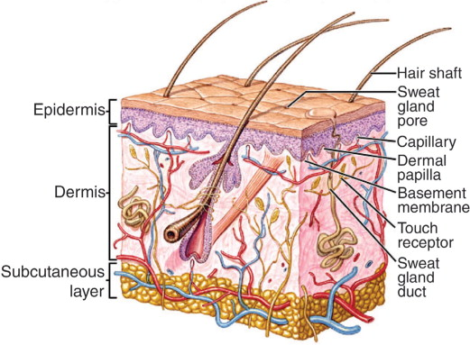

*Structure of the human skin*

*(*[*http://www.sciencedirect.com/science/article/pii/S1369702108700877*](http://www.sciencedirect.com/science/article/pii/S1369702108700877)*)*

1. Below the dermis is the **subcutaneous layer** sometimes referred to as the **hypodermis**. It consists of a layer of fat cells and collagen which provide insulation and cushioning. Its purpose is to attach the skin to bone and muscle as well as supply the dermis with blood vessels and nerves. 50% of the body’s fat is in this layer.

An interactive diagram showing physical changes in skin to regulate body temperature when the environmental temperature changes, as well as one that shows the migration of the epidermis cells migrating through the five layers can be found at the following web site: <http://www.abpischools.org.uk/page/modules/skin/skin3.cfm?coSiteNavigation_allTopic=1>.

The sebaceous glands in the dermis open into a hair follicle as part of the pilosebaceous unit. These units are distributed over the entire skin surface with the exception of the palms, and the soles of the feet. They are most populous and most productive on the scalp and face, and are largest on the forehead, nose, and upper part of the back and chest. The secretions of the sebaceous glands contain a varying mixture of lipids. The major components are triglycerides, wax esters, squalene, cholesterol esters, and cholesterol. The triglycerides are broken down by bacterial lipase producing the free fatty acids that complete the mixture.

Although sebaceous glands are apparent readily in sections of tissue of newborn skin, they regress soon afterwards and remain small throughout childhood. If, before age 8, sebaceous glands enlarge and become increasingly productive, it may be inferred that puberty has arrived early: a cause for that should be sought. Maturation of sebaceous glands continues throughout adolescence and remains relatively unchanged until many years later, decreasing after menopause in women and after andropause in men. The quantity of sebum diminishes as aging advances, but, curiously, sebaceous glands do not become noticeably smaller as the turnover of mature sebocytes decreases.

(<http://www.derm101.com/inflammatory/embryologic-histologic-and-anatomic-aspects/sebaceous-units/>)

**Causes of** **acne**

*Acne vulgaris* is the most common skin condition in the U.S., affecting up to 50 million Americans annually—who, collectively, spend over three billion dollars for treatment of acne. Essentially, acne is a chronic disease involving the blockage and/or inflammation of the pilosebaceous unit of the skin. It can present as noninflammatory lesions, inflammatory lesions, or a mixture of both, affecting mostly the face but also the back and chest.

Genetics is a key factor in the development of acne but there are other factors that are involved as well, if not more important.

Under the influence of androgens, usually around puberty, the sebaceous glands enlarge and produce excess sebum. At the same time, keratinocytes in the sebaceous duct proliferate and cause blockage. These events lead to comedone formation. As a secondary even, *Propionibacterium acnes* colonize the comedones, causing inflammation, which leads to papules and pustules.

(<http://ep.bmj.com/content/90/4/ep98.full>)

When acne develops, it can present as a variety of different types of lesions. In the mildest form of acne the comedones are whiteheads and/or blackheads without inflammation. When the comedones become inflamed, they appear as pink bumps that can be tender to the touch. The walls of the pilosebaceous unit are being torn open. These are referred to as papules. Papules that are topped with yellow creamy liquid that is seeping outside the boundary of the hair follicle are referred to as pustules or the dreaded zit. From here, the lesion progresses to nodules or cysts, which are firm and reside deep within the skin. Both nodular and cystic acne result in scarring. Below, the different lesions and stages of acne are illustrated.

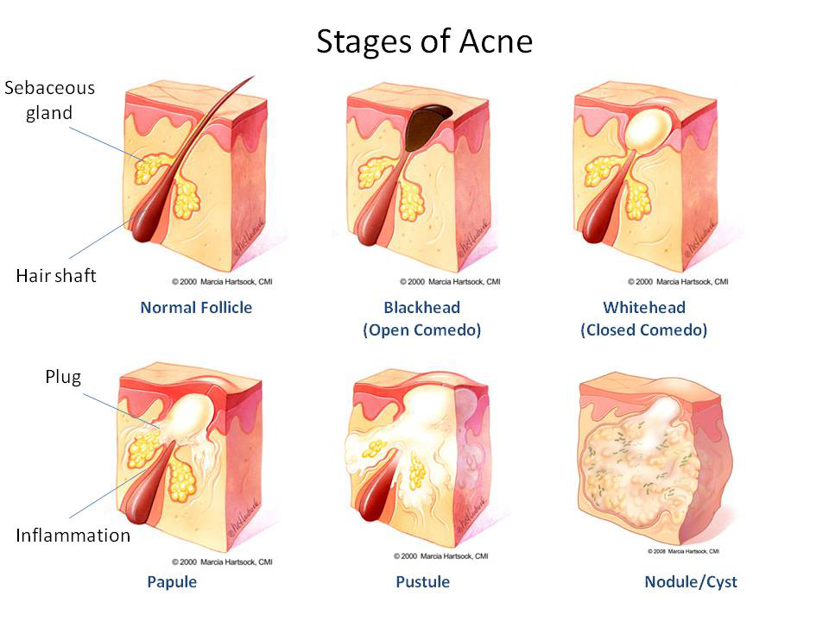

*(*[*https://auroraforeveryone.wordpress.com/2015/07/08/acne/*](https://auroraforeveryone.wordpress.com/2015/07/08/acne/)*)*

Photographs of the various stages of acne can be found at <https://medlineplus.gov/ency/article/003236.htm>.

***Propionibacterium acnes***

The bacteria that colonize in the sebum from the sebaceous gland are *Propionibacterium acnes*. It is considered part of the normal flora of the skin.

*Propionibacterium* species are nonsporulating, gram-positive anaerobic bacilli that are considered commensal bacteria on the skin. They are usually nonpathogenic and are common contaminants of blood and body fluid cultures. These species are slow-growing and require at least 6 days for growth in culture.

*Propionibacterium* species belong to the genera of coryneforms and are the best studied because of their association with acne vulgaris. Propionibacterium species, however, can also cause numerous other types of infections, including endocarditis, postoperative shoulder infections, and neurosurgical shunt infections. …

*Propionibacterium acnes* is found briefly on the skin of neonates, but true colonization begins during the 1-3 years prior to sexual maturity. During this time, numbers of *P. acnes* rise from fewer than 10/cm2 to about 106/cm2, chiefly on the face and upper thorax. *P. acnes* grow in the lipid-rich microenvironment of the hair follicle. In acne vulgaris, *P. acnes* produce inflammatory mediators that result in acne papules, pustules, and nodulocystic lesions.

(<http://emedicine.medscape.com/article/226337-overview>)

Recent research with *P. acnes* has revealed different strains of the bacteria, which may help explain why some people suffer from acne and others do not. Researchers Dr. Huiying Li and Dr. George Weinstock at the Washington School of Medicine, looking for differences in bacterial strains in acne sufferers and people with clear skin, took bacterial samples from the noses of 49 acne sufferers and 52 people with clear skin. After sequencing the genomes of 66 different strains of *P. acnes* they found a difference in the bacteria between the two groups of people.

They identified two unique strains of *P. acnes* found in 20 percent of the participants with pimples that were close to non-existent among those with healthy skin. In addition, another strain of *P. acnes* was commonly found among the volunteers with healthy skin, yet quite rare in participants with acne.

The researchers believe that this "good" strain has a natural defense mechanism that targets and eliminates attackers that try and infect the cell. The finding should help in the development of future acne treatments. The researchers believe that by increasing the body's concentrations of the friendly *P. acnes* strain - through the use of a cream or lotion - acne severity could be reduced.

(<http://www.medicalnewstoday.com/articles/257040.php>)

These findings support the research that is being done with probiotics and acne that will be discussed in a separate segment in this teacher’s guide.

**Acne treatments**

Acne can be treated in a number of different ways, depending on the stage or severity of the acne. Treatments center on the four major causes of acne:

1. excess androgens that lead to
2. increased sebum production that enhances the
3. colonization of bacteria that trigger an immune response which results in
4. inflammation

Antibiotics address the bacteria, anti-androgenic drugs ultimately decrease sebum production, and anti-inflammatory drugs reduce the redness and swelling of the acne lesions. The following is the recommended treatment protocol for the different types/stages of acne.

* Comedonal acne - Topical retinoids or benzoyl peroxide; fixed-dose combinations adapalene–benzoyl peroxide and clindamycin–benzoyl peroxide; or the combination of clindamycin 1.2% and tretinoin 0.025% (as a gel); and, for women, consider combined oral contraceptives
* Localized mild-to-moderate papulopustular acne - Benzoyl peroxide as monotherapy; topical retinoids as monotherapy; the fixed-dose combination of clindamycin 1% and benzoyl peroxide 5% and the fixed-dose combination of adapalene 0.1% and benzoyl peroxide 2.5% (as gels); or the combination of clindamycin 1.2% and tretinoin 0.025% gel
* More extensive moderate papulopustular acne - Addition of systemic antibiotics to the topical medications above, as recommended for mild-to-moderate papulopustular acne
* More extensive moderate papulopustular acne in women - Addition of combined oral contraceptives to the topical medications above, as recommended for mild-to-moderate papulopustular acne
* Severe acne - Oral isotretinoin or systemic antibiotics in combination with benzoyl peroxide, with or without topical retinoids
* Oral isotretinoin - Should only be prescribed by physicians with experience in prescribing and monitoring the drug; strict pregnancy precautions must be followed.

(h[ttp://emedicine.medscape.com/article/1069804-guidelines](http://emedicine.medscape.com/article/1069804-guidelines))

Acne has four main pathogenic mechanisms; hyperkeratosis, androgen mediated increased sebum production, *P. acnes* colonization on the accumulated sebum, and an immune mediated inflammatory reaction against *P. acnes*.

The graphic below illustrates the action of the various acne medications on these four mechanisms.

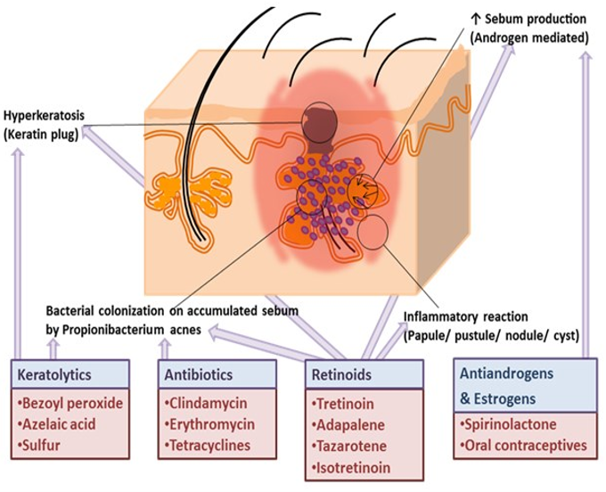

*Pathogenesis of acne vulgaris and mechanism of action  
of drugs used in this condition*

*(*[*http://www.scopemed.org/fulltextpdf.php?mno=165508*](http://www.scopemed.org/fulltextpdf.php?mno=165508)*)*

**Benzoyl peroxide**

Benzoyl peroxide has been in use for the treatment of acne since the 1930s, and it is still the most recommended drug for the initial treatment of acne. It is on the World Health Organization’s “List of Essential Medicines”, the most important medicines needed in a basic health care system. In a study of a comparison of five treatments for acne reported in the December 2004 issue of *The Lancet*, benzoyl peroxide alone outperformed many of the antibiotics (see graph, below). Results were even better when benzoyl peroxide was paired with an antibiotic such as clindamycin. Benzoyl peroxide with an antibiotic helps kill bacteria before antibiotic resistance is acquired.

(<https://www.ncbi.nlm.nih.gov/pubmed/15610805?dopt=Abstract>)

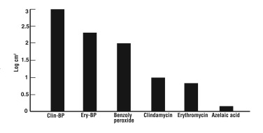

*Comparison of reduction of* P. acnes *with different topical therapies*

([*https://www.ncbi.nlm.nih.gov/pmc/articles/PMC3366450/*](https://www.ncbi.nlm.nih.gov/pmc/articles/PMC3366450/))

Benzoyl peroxide, (C6H5CO)2O2, is two benzoyl groups bridged by a peroxide link. The peroxide link is not stable and, when the molecule comes in contact with the skin, it readily undergoes homolysis (symmetrical fission), forming two free radicals with each benzoyl group receiving an oxygen atom with an unpaired electron. The benzoyl free radicals are even more reactive than the peroxide, so much so that they combine with the relatively inert keratin and erode the stratum corneum. This is why some people’s skin looks sunburned when they start using benzoyl peroxide. Benzoyl peroxide is usually present in concentrations of 2.5%, 5%, or 10%. Increasing the concentration has not proven to be any more effective against acne; it just irritates the skin more.

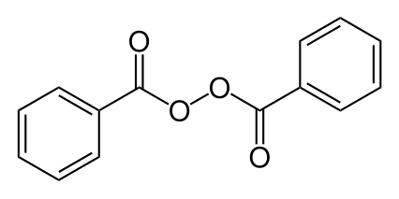

*Benzoyl peroxide*

*(*[*https://en.wikipedia.org/wiki/Benzoyl_peroxide*](https://en.wikipedia.org/wiki/Benzoyl_peroxide)*)*

Benzoyl peroxide is also present in some teeth whitening products, as it has bleaching properties as well. So, one needs to be careful not to spill any on his/her clothes while washing one’s face with it.

**Salicylic acid**

Salicylic acid, C6H4(OH)COOH, is an organic compound derived from the bark of the

willow tree. It has been used in medicines since ancient times, though it wasn’t extracted in pure form until the 1800s. Like benzoyl peroxide, it, too, is on the World Health Organization’s “List of Essential Medicines”. An interesting history of this compound is relayed below. See any familiar names?

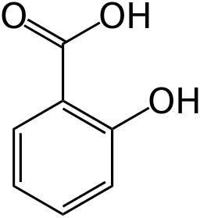

*Salicylic Acid*

*(*[*https://en.wikipedia.org/wiki/Salicylic_acid*](https://en.wikipedia.org/wiki/Salicylic_acid)*)*

The active extract of the bark, called salicin, after the Latin name for the white willow (Salix alba), was isolated and named by the German chemist Johann Andreas Buchner in 1828. A larger amount of the substance was isolated in 1829 by Henri Leroux, a French pharmacist. Raffaele Piria, and Italian chemist, was able to convert the substance into a sugar and a second component, which on oxidation becomes salicylic acid. Salicylic acid was also isolated from the herb meadowsweet (*Filipendula* ulmaria), formerly classified as (*Spiraea ulmaria)* by German researchers in 1839. While their extract was somewhat effective, it also caused digestive problems such as gastric irritation, bleeding, diarrhea and even death when consumed in high doses.

(<https://en.wikipedia.org/wiki/Salicylic_acid>)

Salicylic acid is classified as a beta hydroxy acid (BHA), as the hydroxyl group (–OH) is attached to the second carbon from the carboxylic acid group (–COOH). By contrast, alpha hydroxy acids have a hydroxyl group bonded to the carbon adjacent to the carboxyl group. (Alpha hydroxy acids, AHAs, are also used in treating acne, but they are used more in chemical peels. They are water soluble and do not dissolve in the sebum lipids. They can only exfoliate surface cells.)

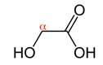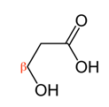

*α- and β-hydroxy acids*

*(*[*https://en.wikipedia.org/wiki/Alpha_hydroxy_acid*](https://en.wikipedia.org/wiki/Alpha_hydroxy_acid)*)*

Salicylic acid is lipophilic and poorly soluble in water. The molecule can dissolve in the sebum of the follicle and cause the exfoliation of the keratin cells blocking the follicle, thus keeping the pores clear. Keeping the pores clear is the first step in controlling many types of blemishes. Because it can dissolve in the sebum, salicylic acid is a useful carrier for other compounds that treat acne. Salicylic acid is a rather large molecule, and its movement through the dermis is limited. In contrast to other acne treatments such as benzoyl peroxide, salicylic acid does not seem to be as harsh on the skin.

Salicylic acid is available in several over the counter (OTC) products. The concentration may vary, but is usually between 0.2% and 2%. Side effects from salicylic acid washes are skin dryness, peeling, and flaking. Concentrations of 20%–30% are used in chemical peels and are not available over the counter. Concentrations this high are used by a dermatologist or cosmetologist.

**Antibiotic treatment**

Antibiotics are often used in the treatment of all types of acne. When they are combined with benzoyl peroxide or salicylic acid in topical applications, their effectiveness increases. The use of benzoyl peroxide with its antibiotic properties is especially helpful in preventing the development of antibiotic-resistant strains of bacteria. This is the primary concern of using systemic antibiotics against acne, since they are used for an extended period of time. Systemic antibiotics should be accompanied by a skin cleanser containing benzoyl peroxide to help prevent resistant strains of bacteria from emerging. Below is an excerpt from Medscape about the antibiotics used to treat acne.

Systemic antibiotics are a mainstay in the treatment of moderate-to-severe inflammatory acne vulgaris. These agents have anti-inflammatory properties, and they are effective against P acnes. The tetracycline group of antibiotics is commonly prescribed for acne. The more lipophilic antibiotics, such as doxycycline and minocycline, are generally more effective than tetracycline.

Greater efficacy may also be due to less P acnes resistance to minocycline. However, P acnes resistance is becoming more common with all classes of antibiotics currently used to treat acne vulgaris. P acnes resistance to erythromycin has greatly reduced its usefulness in the treatment of acne. Sub antimicrobial therapy or concurrent treatment with topical benzoyl peroxide may reduce the emergence of resistant strains.

Oral antibiotic use can lead to vaginal candidiasis; doxycycline can be associated with photosensitivity; and minocycline has been linked to pigment deposition of the skin, mucus membranes, and teeth.

The emergence of antibiotic-resistant bacteria, other than P acnes is a contentious debate. An early study by Miller et al found increased skin carriage of coagulase-negative staphylococci in not only acne patients with prolonged use of antibiotics but also in their close contacts.On the contrary, a study by Fanelli et al found that Staphylococcus aureus remained sensitive to tetracycline even after prolonged use of that antibiotic for acne. This has significant ramifications when considering efforts to control the spread of methicillin-resistant S aureus (MRSA), because tetracycline group antibiotics are currently one of the primary options for outpatient treatment of MRSA infection.

Other antibiotics, including trimethoprim alone or in combination with sulfamethoxazole, and azithromycin, reportedly are helpful.

(<http://emedicine.medscape.com/article/1069804-treatment>)

**Retinoids**

Retinoids are derivatives of Vitamin A that are frequently used in acne treatments. Retinol, being an example of one of the mildest retinoids, is present in many over the counter (OTC) creams and moisturizers. In topical creams or gels, retinoids are among the most commonly prescribed drugs for acne treatment. Often a mild retinoid, combined with benzoyl peroxide for its antibiotic properties, is the first line of defense for most types of acne. Retinoids are also a popular ingredient in “wrinkle reducing creams” for their ability to also stimulate collagen formation.

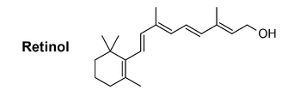

*(*[*https://en.wikipedia.org/wiki/Retinoid*](https://en.wikipedia.org/wiki/Retinoid)*)*

Scientists think retinoids work by binding to specific retinoic acid receptors (RARs) in your skin and activating them. The activation of these receptors results in collagen production and/or skin desquamation, etc. Different receptors do different things when they are activated. Therefore, retinoids improve the way your skin sheds and renews itself by binding to and activating these RARs.

(<http://www.skinacea.com/retinoids/what-are-retinoids.html#.WBVfCPorLDc>)

Some retinoids are natural, while others have been synthesized. The synthetic retinoids have been designed to react only with certain RARs to improve the specificity of the response to the retinoid. Natural retinoids tend to break down immediately, sometimes becoming toxic when exposed to sunlight. Synthetic retinoids remain stable in sunlight, but all retinoids make your skin more sensitive to sunlight, since they thin the stratum corneum. Natural retinoids can be converted into one another, as indicated in the reactions below.

Retinyl palmitate 🡪 Retinol 🡪 Retinaldehyde 🡪 Tretinoin (retinoic acid)

Retinyl palmitate is the weakest natural retinoid, and tretinoin or retinoic acid is the strongest. For the synthetic retinoids, adapalene is the weakest while isotretinoin is the strongest. The synthetic retinoids do not follow the same conversion pattern as seen in the natural retinoids.

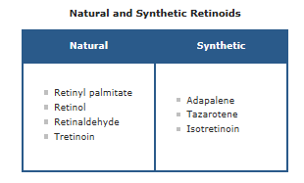

([*http://www.skinacea.com/retinoids/types-of-retinoids.html#.WBVFcforLDc*](http://www.skinacea.com/retinoids/types-of-retinoids.html#.WBVFcforLDc))

Isotretinoin is the only retinoid that is prescribed to be taken internally. It is one of the most effective treatments available, but it is only used for severe cases of acne. Isotretinoin causes normalization of epidermal cells in the follicles, depresses sebum production by 70%, acts as an anti-inflammatory, and reduces the presence of *P. acnes*. Roche developed the drug for cancer treatment. It did not work well for that, but it was noticed that it did clear up acne. However, the wonder drug for acne was found to have some serious side effects. It causes birth defects in the babies of mothers taking isotretinoin, it may heighten feelings of depression and suicidal thoughts, it may cause some bowel disorders, and it causes abnormal healing.

Despite all this, it is the only drug that seemed to help some patients, so doctors and drug companies fought to keep the drug available. Today all patients treated with isotretinoin must adhere to the iPLEDGE risk management program. In the iPLEDGE program, patients must be educated about the drug’s side effects and sign multiple contracts agreeing to adhere to strict guidelines if they want to take this drug. Young women who may become pregnant are encouraged to be vigilant with birth control while they are taking the drug. Roche, who marketed the drug under the name Accutane, stopped producing it when the patent expired and other companies could manufacturer it. They claimed too many lawsuits made the drug too unattractive to continue their involvement with it. Wikipedia presents the interesting history of this drug here: <https://en.wikipedia.org/wiki/Isotretinoin>.

**Hormone treatments**

Outside the dermatology community it is a little known fact that the skin has its own endocrine system and that testosterone can be synthesized by dermal structures like the sebaceous glands. In an article from the *Journal of Clinical and Aesthetic Dermatology*, this relationship is explained in the section on hormonal pathogenesis of acne.

Sebum production plays a vital role in acne formation. The pilosebaceous unit has four distinct components: the hair follicle, the keratinized follicular infundibulum, the sebaceous gland, and the sebaceous duct that connects the gland to the infundibulum. The number, size, and activity of sebaceous glands may be inherited. While the number of sebaceous glands remains stable throughout life, the size increases with age.[8](https://www.ncbi.nlm.nih.gov/pmc/articles/PMC2923944/#B8) Human sebum contains unique fatty acids that support the growth of P. acnes, a unique colonizer of human skin.[9](https://www.ncbi.nlm.nih.gov/pmc/articles/PMC2923944/#B9)Androgens stimulate sebum production and research has demonstrated the intracrine nature of this relationship. Intracrine secretion involves the synthesis of active androgens in peripheral organs, such as the skin, where the androgens exert their action in the same cells where synthesis takes place without release into the general circulation.[10](https://www.ncbi.nlm.nih.gov/pmc/articles/PMC2923944/#B10) In-vivo studies show that sebaceous glands can act as independent endocrine organs, responding to changes in androgens in a similar manner as the hypothalamus-pituitary-adrenal axis. This intracrine function is regulated by corticotrophin-releasing hormone (CRH), its binding protein, and corticotrophin receptors.[5](https://www.ncbi.nlm.nih.gov/pmc/articles/PMC2923944/#B5),[11](https://www.ncbi.nlm.nih.gov/pmc/articles/PMC2923944/" \l "B11) Since CRH levels change during stress and CRH regulates sebaceous gland function, this may explain the relationship between stress and inflammatory skin disorders such as acne.[5](https://www.ncbi.nlm.nih.gov/pmc/articles/PMC2923944/#B5)

(<https://www.ncbi.nlm.nih.gov/pmc/articles/PMC2923944/>)

While a significant portion of circulating androgens is produced by the adrenal gland and the testes or ovaries, a large portion is also synthesized by the sebaceous glands and other skin structures. The enzymes required for the conversion of inactive adrenal gland testosterone precursors into testosterone are present in the structures of the skin. Once the testosterone is synthesized, it can be converted into the more potent dihydrotestosterone (DHT) by the enzyme 5-α reductase (also found in the sebaceous glands) or converted into estradiol by the enzyme aromatase.

Estrogen suppresses sebum production while testosterone increases it. Also, when estrogen is metabolized in the liver sex hormone-binding globulin is produced, which has a high affinity for testosterone and will bind to it preferentially over estrogen. This decreases the circulating androgen levels through yet another pathway.

Use of hormones in the treatment of acne came to the forefront in the early 1990s.

Some hormonal therapies may be effective in the treatment of acne vulgaris. Estrogen can be used to decrease sebum production. Additionally, it reduces ovarian production of androgens by suppressing gonadotrophin release.Oral contraceptives also increase hepatic synthesis of sex hormone–binding globulin, resulting in an overall decrease in circulating free testosterone. Combination birth control pills have shown efficacy in the treatment of acne vulgaris.

(<http://emedicine.medscape.com/article/1069804-treatment>)

In the United States, there are three oral combination contraceptive pills approved for the treatment of acne in women. These include ethinyl estradiol and norgestimate, norethindrone acetate and ethinyl estradiol, and ethinyl estradiol/drosperinone. Drosperinone is a form of spironolactone which is discussed next.

**Spironolactone**

As mentioned in the Mork *ChemMatters* article, spironolactone is primarily used to reduce fluid build-up in the body of those with kidney disease or heart problems. It is a selective diuretic in that water, sodium, and chloride are excreted, but potassium is retained. It is an antagonist of the androgen receptor, as well as an inhibitor of androgen production. Due to its anti-androgen effects it began to be used “off label” in women with hormonal acne in the 1980s. (Off label is the term used when a drug is prescribed to treat a condition for which it was not originally designed to treat.)

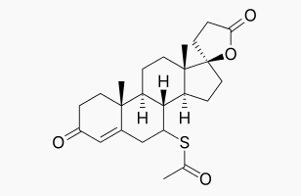

*Spironolactone*

*(*[*https://en.wikipedia.org/wiki/Spirolactone*](https://en.wikipedia.org/wiki/Spirolactone)*)*

Spironolactone is a synthetic steroidal androgen receptor blocker, which has been used for more than 30 years for the treatment of acne and hirsutism. It is also used to treat noncutaneous disorders, such as hypertension and congestive heart failure. In these disorders, it acts as an aldosterone antagonist and competes with aldosterone receptors in the kidney to produce diuresis, reduction in blood pressure, and potassium retention. The anti-androgenic effects are achieved through several mechanisms: 1) competition with testosterone and DHT for androgen receptors, thereby decreasing androgen-stimulated sebum production; 2) inhibition of androgen synthesis decreasing type 2 17B-HSD, thereby halting the conversion of androstenedione to testosterone; 3) inhibition of 5α-reductase, thus halting the conversion of testosterone to DHT; and 4) increasing the level of SHBG.[6](https://www.ncbi.nlm.nih.gov/pmc/articles/PMC2923944/#B6),[8](https://www.ncbi.nlm.nih.gov/pmc/articles/PMC2923944/" \l "B8),[24](https://www.ncbi.nlm.nih.gov/pmc/articles/PMC2923944/#B24)

(<https://www.ncbi.nlm.nih.gov/pmc/articles/PMC2923944/>)

Women taking spironolactone must avoid getting pregnant, as the drug causes feminization of the male fetus. In men, spironolactone causes loss in muscle mass, loss of energy, decreased body hair growth, and feminization of the nipples. Therefore it is not used as much to treat acne in males, but it is used to aid in the feminization of transgender men. It essentially depresses the testosterone levels to that of a female.

**Light and laser therapy**

There continues to be research and development on the use of light and lasers to treat acne. These methodologies have the advantage of decreasing the use of systemic medicines to treat the problems of the skin. While lasers have primarily been used in the past to remediate acne scarring they are moving into a more proactive role in preventing that scarring.

There are two main mechanisms that laser/light treatments may help acne: firstly, by destroying *Propionibacterium acnes* through photodynamic therapy reaction and secondly, by destroying the sebaceous glands/entire pilosebaceous unit. These therapies work best when combined with traditional therapies. Photodynamic therapy is the treatment of skin with aminolevulinic acid followed by photo activation of the compound. It has been shown to help treat acne. Rarely, photodynamic therapy has been associated with a painful pustular reaction, though most patients tolerate it well.

Red and blue light therapy is also used to treat acne, with the most recent advances being portable handy devices that allow the patient to deliver the light therapy at home. There have been many studies showing early promise, with improvements in the 50-75% range. However, it is difficult to decide where lasers/lights will eventually fit in the overall management of acne as very few comparative studies have been made with conventional medical treatment.

(<http://www.scopemed.org/fulltextpdf.php?mno=165508>)

An interesting study with laser therapy and gold nanoparticles is described in the June 2016 issue of *Seminars in Cutaneous Medicine and Surgery*. Whether you are a fan of James Bond in “Goldfinger” or are a “Star Wars” aficionado, this therapy brings science fiction to life.

The use of topically applied gold nanoparticles combined with a laser application is also being investigated for treatment of acne. When exposed to laser light at 800 nm, gold nanoparticles selectively absorb light and subsequently produce heat. After topical application, these light-absorbing nanoparticles penetrate down the pilosebaceous unit with the assistance of a massage tool. Subsequent laser application to the skin causes light absorption by the gold nanoparticles, generation of heat, and selective destruction of the pilosebaceous unit. Results of a study showed a significant reduction in inflammatory lesions when topically applied gold nanoparticles were followed by the application of a 800 nm diode laser utilizing 3 treatments at one week intervals. Further studies are needed; but initial results are encouraging for this new treatment approach.

Hand-held home devices as well as in-office vacuum-assisted laser and light devices are available and represent alternatives for patients looking for nontraditional therapies.

(<http://www.scmsjournal.com/articles/view_pdf/what-s-new-in-acne-and-rosacea>)

**Acne and diet**

For decades in the early 20th Century, doctors and medical texts warned acne prone people to avoid chocolate. This advice was put to the test with two studies in 1969 and 1971. Both studies showed no correlation with chocolate intake and acne. However, these studies were small, uncontrolled, short duration, subjective, included very short follow up, and employed inadequate statistical analysis. They also did not account for the sugar or dairy content of chocolate being ingested. Despite the severe design limitations inherent in these chocolate-specific studies, not only did the dermatology community dismiss the possible chocolate/acne correlation, but also sent out the message that diet and acne are not related. This massive overstating of flawed evidence is an historic and staggering error of the entire dermatology community. However, as time has moved on, modern scientists are putting diet, and along with it, chocolate, back under consideration.

(<http://www.acne.org/diet.html>)

Some of the most interesting research into the treatment of acne concerns diet. As stated in the quote above, poorly designed studies led to dismissal of the role of diet in the development and prognosis of acne. Research into non-Western diets and the health of the people with those diets revealed that some cultures do not suffer from acne like those on

Western diets do. Research that has focused on the ratio of omega-6 to omega-3 fatty acids in the diet reveals the impact that the omega fatty acid ratio plays in the body’s inflammatory responses. The ratio in a typical Western diet can be 10:1 to 20:1, versus a 3:1 to 2:1 in a non-Western diet of primitive, non-industrialized populations. The omega-6 fatty acids are thought to induce inflammatory responses, which correlate with the development of inflammatory acne, while high levels of omega-3 fatty acids are associated with decreases in inflammatory factors. Some studies demonstrate that eating a diet rich in fish and seafood results in lower rates of inflammatory disease.

In general our Western diet is not only deprived of omega- 3s but is also a diet rich in refined carbohydrates. It has been reported that people living in the Kitavan Islands (off the coast of Papua New Guinea) and the Aché hunter-gathers of Paraguay do not suffer from acne and this is associated with their low glycemic diet, consisting mainly of fresh fruits, vegetables, and lean proteins. This conclusion is in agreement with recent studies on low-glycemic diets …

(<https://www.ncbi.nlm.nih.gov/pmc/articles/PMC2836431/>)

Research conducted by a team of Australian scientists set out to determine whether a low-glycemic-load diet could improve acne lesion counts in young males. Forty three males, ages 15–25 years old were randomly assigned to either the diet intervention group or to a control group. They were followed for 12 weeks. Dermatologists assessed the number of acne lesions every four weeks, documenting their counts with photographs. Since a high-glycemic-index diet had been implicated to cause hyperinsulinemia, insulin sensitivity was also measured every four weeks. After 12 weeks, participants on the low-glycemic-load diet experienced greater reductions in total lesion counts and inflammatory lesions, compared to those on the control diet. This group also experienced an increase in insulin sensitivity. Because most of this group also lost weight, the scientists were not able to statistically prove that the loss in weight was not a factor in the groups’ increased insulin sensitivity.

The authors speculate that the frequent consumption of high-glycemic-index carbohydrates may repeatedly expose adolescents to acute hyperinsulinemia. Hyperinsulinemia has been implicated in acne pathophysiology because of its association with increased androgen bioavailability and free concentrations of insulin-like growth factor 1 (IGF-1). Therefore, we hypothesized that low-glycemic-load dietary interventions may have a therapeutic effect on acne based on the beneficial endocrine effects of these diets. Consequently, the aim of this preliminary study was to investigate the efficacy of a low-glycemic-diet in reducing the severity of acne symptoms.

(<http://ajcn.nutrition.org/content/86/1/107.long>)

You can find more information about the study referenced above in the “Activities” section of this Teacher’s Guide.

Like chocolate, milk is another food that is rumored to aggravate acne. In 2012, scientists conducted a study to investigate the effect of a single food item, milk and ice cream, on acne vulgaris. The milk and ice cream represented a higher glycemic load diet. In this study, the participants merely had to complete a questionnaire enquiring into the respondent’s family history and dietary patterns. Those with acne had a significantly higher dietary glycemic load, compared to the controls. The frequency of milk and ice cream consumption was also greater in this group. (<https://bmcdermatol.biomedcentral.com/articles/10.1186/1471-5945-12-13>)

**Probiotics**

Probiotics are everywhere today in the news and at the market. As far as acne goes, probiotics may be the next big thing in treatment. Whether as live cultures found in some yogurts, or as daily supplements, or mixed in with a facial cream, there is a variety of different thoughts as to how this might work. In persons with acne, the living microorganisms on the skin are recognized as foreign by the body’s immune system. The immune system is activated to destroy the foreigner, resulting in inflammation, redness, or bumps. The idea behind probiotic creams is that the bacteria in them would prevent the skin cells from detecting the *P. acnes* and thus stop the immune response before it begins. This is referred to as “bacterial interference.” Another thought is that the probiotic bacteria may be able to kill the disease-causing bacteria.

Probiotics added to the diet may enhance acne treatments by affecting the “gut-brain-skin axis”. “The probiotics will line the gut and create a healthy, sealed barrier that prevents inflammation that can trigger acne or rosacea”.

A few international studies have shown a correlation between oral probiotic use and improvement in acne, including:

* A recent Korean study of 56 acne patients found that drinking a Lactobacillus-fermented dairy beverage effectively reduced their total acne lesion count and decreased oil production over 12 weeks.
* In an Italian study, half of patients were administered an oral probiotic supplement in addition to their standard acne and rosacea treatment.   
  The other half of patients did not receive the probiotic supplement. The probiotic group experienced better clearing of acne and rosacea symptoms.

(<https://www.aad.org/media/news-releases/could-probiotics-be-the-next-big-thing-in-acne-and-rosacea-treatments>)

Note: Rosacea mentioned in the quote above is a skin condition that usually affects adults around mid-life. One type of rosacea looks like papulopustular acne though it may have different triggers from acne vulgaris.

# References

**(non-Web-based information sources)**

**The references below can be found on the *ChemMatters* 30-year DVD, which includes all articles   
published from the magazine’s inception in October 1983 through April 2013; all available Teacher’s Guides, beginning February 1990; and 12 *ChemMatters* videos. The DVD is available from the American Chemical Society for $42 (or $135 for a site/school license) at this site:** [**http://ww.acs.org/chemmatters**](http://www.acs.org/chemmatters)**. Click on the “Teacher’s Guide” tab to the left, directly under the “*ChemMatters Online"* logo and, on the new page, click on “Get the past 30 Years of *ChemMatters* on DVD!” (the icon on the right of the screen).**

**Selected articles and the complete set of   
Teacher’s Guides for all issues from the past three   
years are available free online at the same Web site, above. Click on the “Issues” tab just below the logo, *“ChemMatters Online”*.**



***30* Years of *ChemMatters !***

Available Now!

Author Smith discusses the function of the skin, why we need moisturizers and cleansers, cleansing creams, soap and cold cream, as well as the simple causes of acne. The action of benzoyl peroxide is explained in terms of free radical reactions. (Smith, W. Skin Deep. *ChemMatters*, 1987, *5* (4), pp 4–7)

Author Baxter spends little time discussing the cause of zits, and she gets right to the cures, including recent developments with vitamin A and lasers. She mentions Accutane which was the formula for isotretinoin manufactured by Roche. Roche no longer markets this drug. (Baxter, R. Battling Zits! *ChemMatters*, 2005, *23* (2), pp 4–6)

The Teacher’s Guide for the April 2005 *ChemMatters* article above contains additional information about acne treatments Accutane and the alpha- and beta-hydroxy acids. There is also a discussion of the term “like dissolves like” in terms of entropy and enthalpy.

Soaps, skin cleansers, body odor, bad breath, acne and flatulence are the subjects of this article. (Rohrig B. Demystifying Gross Stuff. *ChemMatters,* 2011, *29* (3) pp 12–14)

The evolution of skin color and its respective chemistry is discussed in this issue of *ChemMatters*. (Harper, K. Skin Color: A Question of Chemistry. *ChemMatters*, 2014, *32* (2), pp 12–14)

The Teacher’s Guide to the April 2014 *ChemMatters* issue above contains more information on the anatomy of skin and its functions. The guide also contains a discussion of recent developments in artificial skin.

# Web Sites for Additional Information

**(Web-based information sources)**

**Skin**

For a good, labeled cross section of the skin that could be projected on a smart or Promethean board, use this Wikipedia drawing: <https://en.wikipedia.org/wiki/Human_skin#/media/File:Skin.png>.

**Acne**

Photographs of the various stages of acne can be found at the MedlinePlus Web site. These could be made into power point slide or projected as they are. (<https://medlineplus.gov/ency/article/003236.htm>)

Medline’s home page for acne includes an index for the information contained in this teacher’s guide, ranging from basic description to treatments and research. There is lots of information in Spanish, if you have students who need lessons in Spanish. (<http://medlineplus.gov/acne.html>)

In this article published by the American Academy of Dermatology the information is presented in easy to read bullet points. Some statistical information concerning incidence of acne and cost is located here, also. (<https://www.aad.org/media/stats/conditions>)

Lots of basic information about acne can be found at this site. An easy-to-access menu helps locate the different topics. There are translation options at the top of the page, which make reading possible in several different languages. (<http://emedicine.medscape.com/article/1069804-overview>)

This site contains information about Propionibacterium species and the infections they cause: <http://emedicine.medscape.com/article/226337-overview>.

**Acne treatment**

The *Journal of Clinical and Aesthetic Dermatology* is the source of the article found at this link. It contains extensive information about over-the-counter (OTC) treatments for acne. A comparison of the effectiveness of benzoyl peroxide, compared with antibiotics, is presented with nice graphs. This would be a good site to use to get some discussion going on designing an experiment that answers some of the questions about the performance of many of the products discussed. (<https://www.ncbi.nlm.nih.gov/pmc/articles/PMC3366450/>)

What’s new and what’s still true is the theme of this 2015 article about the current status of many acne treatments. The segment on what’s new is very informative. (<http://www.scopemed.org/fulltextpdf.php?mno=165508>)

Some more information on the chemistry of salicylic acid and how it works in acne treatments can be found at this Web site: <http://www.kaviskin.com/info/salicylicacid.html>.

Descriptions of several treatment options for acne are located at this Web site: <http://emedicine.medscape.com/article/1069804-treatment>.

Considerable information on how salicylic acid works, compared to benzoyl peroxide, can be found here. The benzoyl peroxide information and a guide for choosing acne treatments are on other tabs at this site. (<https://www.verywell.com/salicylic-acid-15632>)

A comprehensive table of acne treatments can be found here. The amount of information is staggering, as each entry is a link to the names of the commercial products containing that compound. (<http://www.skinacea.com/acne/acne-treatment-list.html#.WBVdDvorLDc>)

“Evidence based update on the management of acne” is the title of this report. Treatment of acne is presented through several case studies, each for acne in a different stage. (<http://ep.bmj.com/content/90/4/ep98.full#content-block>)

**Diet and acne**

An article about recent acne research exploring the use of probiotics to enhance the treatment of acne can be found here: <https://www.aad.org/media/news-releases/could-probiotics-be-the-next-big-thing-in-acne-and-rosacea-treatments>.

The relationship between acne and diet is the topic of this extensive review of the literature for recent research studies. (<https://www.ncbi.nlm.nih.gov/pmc/articles/PMC2836431/>)

The research paper “A low-glycemic-load diet improves symptoms in acne vulgaris patients” can be found here as it appears in the *American Journal of Clinical Nutrition*. This is a landmark study. There are charts and pictures that have links to PowerPoint slides for use in presentations. This article would be good to use in a discussion on experimental design. (<http://ajcn.nutrition.org/content/86/1/107.long>)

“High glycemic load diet, milk and ice cream consumption are related to acne vulgaris in Malaysian young adults: a case control study” is the name of the research report that can be found at this site:

<https://bmcdermatol.biomedcentral.com/articles/10.1186/1471-5945-12-13>.

The history of the debate about chocolate’s effect on acne can be found at this Web site, as well as the research into several other diet claims concerning acne. (<http://www.acne.org/diet.html>)

A low glycemic load diet is discussed on this web site: <http://www.mayoclinic.org/healthy-lifestyle/nutrition-and-healthy-eating/in-depth/glycemic-index-diet/art-20048478>.

**Retinoids**

Wikipedia has a very good section on the history of isotretinoin. This highly restricted drug has had many confrontations with the FDA and legislature in order to remain available for doctors to prescribe it. (<https://en.wikipedia.org/wiki/Isotretinoin>)

For a list of commercial retinoid creams, listed from mildest to strongest, and the pros and cons of each, visit the following web site: <http://www.skinacea.com/retinoids/types-of-retinoids.html#.WBVFcforLDc>.

A discussion of natural retinoids versus synthetic retinoids is covered in depth here: <http://www.skinacea.com/retinoids/natural-vs-synthetic-retinoids.html#WBUygoWcGWw>.

Downloads from the FDA for the iPLEDGE program for those who want to take isotretinoin can be found on this site. The brightly colored yellow and black contracts and patient agreements are located further in the packet. This is the most recent document published in 2012. Others on the Web are shorter but are not up to date. (<http://www.fda.gov/downloads/drugs/drugsafety/postmarketdrugsafetyinformationforpatientsandproviders/ucm234639.pdf>)

**Hormone treatments and** **spironolactone**

A recent article reviews patient studies and research that have been reported for spironolactone as it is used for the treatment of acne. The results of several studies are used to support the use of spironolactone. (<http://www.medpagetoday.com/meetingcoverage/aad/53310>)

The scholarly article “Hormonal Treatment of Acne in Women” that occurred in the December 2009 issue of the *Journal of Clinical and Aesthetic Dermatology* provides a thorough explanation of the hormonal pathogenicity of acne. The authors explain the biochemical pathways involved in the production of androgens in the skin. Treatment of acne with oral contraceptives and spironolactone is explained. If you are teaching an upper level chemistry class and are covering a unit on biochemistry, this would be an excellent article to assign as outside reading. (<https://www.ncbi.nlm.nih.gov/pmc/articles/PMC2923944/>)

General information about spironolactone and its formula and that of its derivative can be found here: <https://en.wikipedia.org/wiki/spironolactone>.

**Acne research**

“Strain of acne-causing bacteria found to actually preserve the skin” is the title of the article featured at this medical news site. Reports about a study that compared the *P. acnes* strains found on people with acne to those found on people without acne revealed strains of *P. acnes* on the acne-free participants that were not present on the participants with acne. (<http://www.medicalnewstoday.com/articles/257040.php>)

**Laser treatments**

The results of a study done to compare laser treatments with salicylic acid peels can be found at this Web site. The study treated half of the face of participants with lasers and then applied salicylic acid peels to the entire face for a comparison of the efficacy of laser therapy. (<https://www.ncbi.nlm.nih.gov/pmc/articles/PMC4688384/>)