December 2016/January 2017 Teacher's Guide

Background Information

for

Piping Hot, Ice Cold… Thanks to Chemistry

Table of Contents

About the Guide 2
Background Information 3
References 19
Web Sites for Additional Information 20

About the Guide

Teacher’s Guide team leader William Bleam and editors Pamela Diaz, Regis Goode, Diane Krone, Steve Long and Barbara Sitzman created the Teacher’s Guide article material.
E-mail: bbleam@verizon.net

Susan Cooper prepared the anticipation and reading guides.

Patrice Pages, ChemMatters editor, coordinated production and prepared the Microsoft Word and PDF versions of the Teacher’s Guide.
E-mail: chemmatters@acs.org

Articles from past issues of ChemMatters and related Teacher’s Guides can be accessed from a DVD that is available from the American Chemical Society for $42. The DVD contains the entire 30-year publication of ChemMatters issues, from February 1983 to April 2013, along with all the related Teacher’s Guides since they were first created with the February 1990 issue of ChemMatters.

The DVD also includes Article, Title, and Keyword Indexes that cover all issues from February 1983 to April 2013. A search function (similar to a Google search of keywords) is also available on the DVD.

The ChemMatters DVD can be purchased by calling 1-800-227-5558. Purchase information can also be found online at http://tinyurl.com/o37s9x2.

Background Information
(teacher information)
The history of self-heating cans

In 1897, during his career as a Russian military engineer, Yevgeny Stephanovich Fedorov invented the first self-heating can. His tin was designed to heat corned beef for some Russian troops during World War I. (http://ifood.tv/equipment/self-heating-can/about)

Production of Fedorov’s cans ceased after the war, but the self-heating idea returned to favor in the 1900s when it was reintroduced for explorers and mountaineers. Hiram Bingham used self-heating cans produced by Silver’s and the Grace Brothers firms during his travels in Peru from 1909 to 1915. (http://kansas-city-star-ball1111.blogspot.com/search?q=self-heating+cans)

Alan R. Hawley, an early American aviator, piloted “America II” to win the national balloon race of 1910. During his flight, he carried “… three cans of soup, self-heating with lime”. Lime, commonly called quicklime, is calcium oxide (CaO). Its reaction with water is extremely exothermic. The equation is written here:

CaO + H₂O Ca(OH)₂ + energy

In 1941, the New York Times “News of Food” column reported that self-heating food was on the shelves of a Manhattan Department store: cups of coffee, spaghetti and baked beans were sold. Customers thought this was magic but they were disappointed in the 15 minute wait while food heated. In 1947, the same food news column reported, “Food in Self-Heating Cans Reappears”. They listed and reviewed the taste of several varieties of “HotCans”. Note: Look in the section “1940s self-heating coffee” (way down the screen) at this URL: (https://slashdot.org/story/06/05/05/075237/self-heating-coffee-cans-recalled)

American, British and Canadian troops used self-heating cans for emergency rations during World War II. The heating element in the troop rations was located in the center of the can. See photos below from 1944.
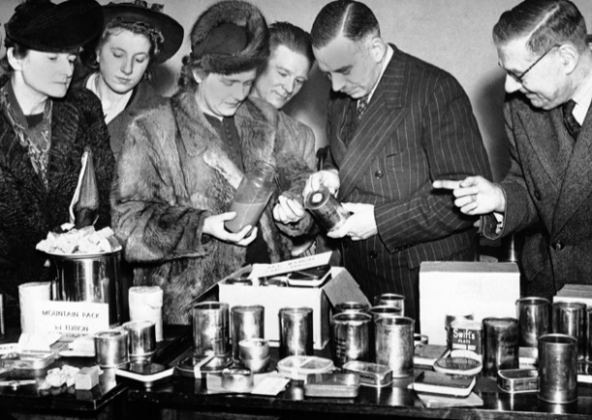
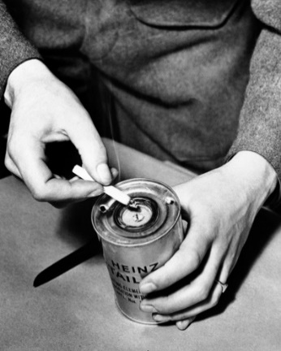
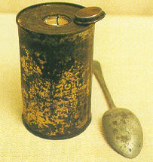
Lit by a cigarette, the soup stayed hot for four minutes.

(http://www.thejournal.ie/self-heating-soup-cans-1370166-Mar2014/)
Dr. William Clayton, adviser to the Ministry of Food, explains the simple fuse in the lid of the self-heating can.

(http://www.thejournal.ie/self-heating-soup-cans-1370166-Mar2014/)
World War II Heinz self-heating ration can with heating element open

(http://www.mreinfo.com/forums/viewtopic.php?t=3777)

After World War II, little attention (except for military use) was paid to self-heating cans, until the celebrity chef and restaurateur Wolfgang Puck introduced his self-heating coffee can: “Wolfgang Puck’s Gourmet Latte” advertised as, “It will expand the way people drink coffee.” On January 2, 2005 the latte went on shelves for $2.25 per can, less than Starbucks’ price. A Starbucks spokesman retorted, “Starbucks is about great coffee and a relaxing experience.”

Puck’s cans were produced using “OnTech” technology. This process will be discussed in the “Technology” section of this Teacher’s Guide. Meanwhile, the OnTech Corporation introduced its new 2006 self-heating hot chocolate and coffee. (http://usatoday30.usatoday.com/tech/news/techinnovations/2004-12-19-self-heat_x.htm)

Safety problems

In 1944, H.J. Heinz Company produced World War II cans for British and Canadian soldiers. These were activated by an explosive fuse ignited by a cigarette.
(http://www.mreinfo.com/forums/viewtopic.php?t=3777)

Sometimes the chemical reaction was not well controlled. One soldier reported frequent can explosions in Normandy, “showering hot soup on anyone within range”. Some accidents were caused by human error, such as failure to punch holes, resulting in a buildup of excessive internal pressure leading to explosions, or by misplacement of holes. Off the coast of Southern England, a British soldier reported:

We all punched a hole in both sides, apart from one man who punched the holes in the side of the can. The cans were really hot as the fuse went all the way down to the bottom. This man had put his soup to one side on a ledge which was level with his head.
We all had cans with the soup coming up from the top but because he’d punched holes in the side of his can the soup came out at force of the sides of the can – straight into his ears!! He had tomato soup all down his ears but unfortunately for him he became our first casualty with a badly scalded ear.

(http://www.thejournal.ie/self-heating-soup-cans-1370166-Mar2014/)

A few more problems plagued the early self-heating industry. In the early 1990s Japan’s Gekkeikan Company produced some cans without steam releasing valves. When customers complained that the bottoms fell off when the seals broke due to the build-up of pressure from the hydrogen gas (H₂) by-product, the company quickly recalled their cans. Gekkeikan still sells self-heating saki cans, but a United Kingdom (U.K.) company, Thermotic Developments Limited, hopes that Gekkeikan will consider replacing their own cans with the new, safer Thermotic product. Earlier Thermotic designs released H₂ gas through a cigarette filter in the bottom of the can. Customers soon complained that the hot steam burned wooden surfaces. Details and pictures of the Thermotic device are given in the Technology section of this guide.

Thermotic has redesigned their product. Yet, in April 2002, Lillian Beckett activated her “Nescafe Hot When You Want” self-heating coffee as she rode a London train to work. The sounds of terrorism, a “pop” followed by “hissing” and a “funny smell”, alarmed the gentleman seated opposite. (http://www.wsj.com/articles/SB101975794994901800)

Puck’s problems

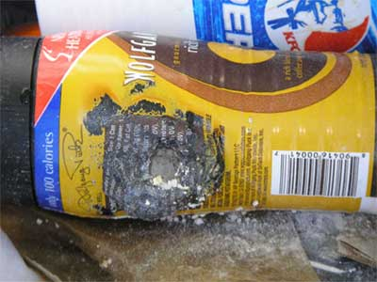
Wolfgang Puck used an OnTech design heated by quicklime and water for his cans. Unfortunately he gave Lakeside Foods, Inc. the contract to fill and seal the Puck Latte line of cans. Soon, complaints from customers and vendors arrived, describing everything from lukewarm coffee to scalding and exploding cans; even chunks of white calcium oxide were found in the coffee!
Hillside Coffee “Puckcan”

(http://www.lanceandeskimo.com/chefelf/bev_hillsidecoffee.shtml

A defective, exploded can is pictured at right:

In addition, Lakeside stated that the contents of some of its cans might be contaminated by “spoilage organisms or harmful bacteria due to seal leakage”. (http://www.bevnet.com/news/2006/06-09-2006-latte_wolfgang_recall.asp/)

The June 9, 2006 issue of the Milwaukee Business Journal reported that Lakeside cooperated with the U.S. Food and Drug Administration (FDA) to issue a recall. The Environmental Protection Agency (EPA) stated that the recall was due to leakage, not to problems with heating. The following self-heating 10 ounce cans were recalled:

Wolfgang Puck-brand Rich Caramel Latte, Rich Espresso Latte, French Vanilla Latte and Rich Mocha Latte; Decadent-brand Chai Tea Latte, Hot Chocolate and Mint Hot Chocolate; Hillside-brand Double Shot Latte, French Vanilla Latte, Hazelnut Latte and Mocha Latte; Beaumont-brand Gold French Vanilla and Gold Double Shot; Yummers Hot Chocolate; and Chef Jay's-brand Zesty Chicken, French Onion and Hearty Beef.

(http://www.bizjournals.com/milwaukee/stories/2006/06/05/daily49.html)

The questionable Puck cans were quickly removed from Kroger’s and Albertson’s as well as Sam’s Club shelves. As Puck tried to distance his name from the product, law suits ensued. See more information on the tangles of this litigation under the “Web Sites for Additional Information” section of this Teacher’s Guide.

Self-heating cans provide almost instant hot coffee without a microwave—in your car, at the beach or camping. Many of the problems with explosions, leaks and temperature regulation have been solved. Yet, there remain some disadvantages. They are expensive. While not as pricey as Starbucks, they cost quite a bit more than a cup of homemade coffee. Since the cans must include the chemical heating reactants, they are heavier and bulkier. This is probably not a problem when car camping or riding a train, but they would not be a good choice for back packing where what you pack in must be packed out (as trash).

Technology

Self-heating can technology usually involves two chemical reactants that are combined or activated by pressing the can sides or a button on the bottom of the can. There are two basic designs for self-heating cans. Some older versions placed the heating unit on the outside around an inner compartment for the edible material. These designs were more prone to excess heating of the outside and insufficient heating of the inside food. There was an increased risk of burns from leaking chemicals and squirting food.

Newer versions reduce these problems by placing the food on the outside, with the heat producing chemicals residing in an inner chamber. Some even use a foam label to insulate the outer beverage section as it heats. This also helps to maintain a warmer food temperature. In early models, a fuse was ignited to initiate the exothermic reaction. In most current designs a rod or prongs are connected to a button on the can. When the button is pushed, the membrane barrier between the chemicals is pierced thus mixing the chemicals. In other models, the barrier is broken by pulling the ring of a soda can type tab. (http://ifood.tv/equipment/self-heating-can/about)

H. J. Heinz and the Canadian firm, International Group Incorporated (IGI), designed self-heating meals in a can. These “Meals Ready to Eat” (MREs) were designed in 1938 for World War II soldiers. The food or drink was located outside the heating materials. The can consisted of a central metal tube filled with a smokeless chemical fuel that was ignited by a cordite fuse that could be lit by a cigarette. Cordite is a mixture of nitroglycerine (30–40%), guncotton (55–65%) and paraffin grease (5%). This was used by the British in the 1930s as smokeless powder propellant in rifles and guns. When cordite was combined with acetone, a colloid formed. This could be shaped into an extremely flammable cord or cordite stick. The cordite fuse worked well when it didn’t explode! When ignited, the chemical fuel produced a thermite type reaction. The thermite reaction will be explained in the “Chemistry” section of this Teacher’s Guide. (http://mysite.du.edu/~jcalvert/phys/bang.htm)

On May 1, 2001 The Guardian (UK newspaper) announced Nestle’s “Hot When You Want” coffee (see images on next page). Thermotic Developments Ltd. designed this self-heating can. Insulation materials were added for safety, to prevent burning. Potential customers are told that all they need to do was press a red bottom on the base and within three minutes their coffee would be temperature-ready for drinking. Nestle representative Deborah Tilley said, Its about enabling people to have coffee whenever and wherever they want it—on a train, on a park bench or wherever."

The exothermic calcium oxide and water reaction in the inner membrane produces a rise of 40 ºC (72 ºF) above ambient temperature in three minutes. The May introduction in England was fine, but when cold winter arrived, there was only sufficient energy for warmish, not hot coffee! Thus, production ceased in 2004. (https://www.theguardian.com/uk/2001/may/01/engineering.highereducation)
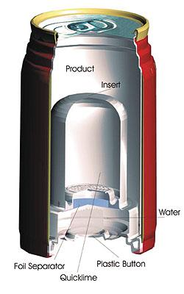
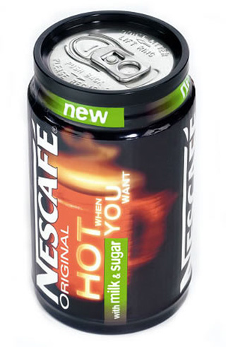
The outside and the inside of the Nestle’s “Hot When You Want” coffee can

(Outside: (https://bestinpackaging.com/2012/12/03/self-heating-packaging-containers-part-1/,
Inside: http://www.packworld.com/package-component/label/nestl%C3%A9-tests-award-winning-can)
In November 2004, the publication Packing World announced the “début” of North American self-heating beverage containers. OnTech Corporation produced containers for Hillside beverages and later for Wolfgang Puck. Heat energy was produced by a calcium oxide/water reaction. The advertisement read, “… a high-barrier self-stable cup-holder-friendly container” with a foam label and three plastic compartments. The beverage was on the outside, an inner cone holding the calcium oxide and water was located in a “puck” inside the cone. The customer removed the bottom of the package to reveal a button. When pushed, the button pierced the membrane separating the calcium oxide from the water. (http://www.packworld.com/package-type/containers/self-heating-beverage-container-debuts)

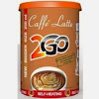
In April 2005, the Spanish company Fast Drinks began producing the “2Go” product line of self-heating beverages. Drinks were packaged in three-piece tin-plated containers that were completely recyclable. The beverage was located in the outer container; the other two containers were used to separate solid calcium hydroxide from the water. Pushing down on the can base breaks the membrane between the reactants. The heat of dissolution of calcium hydroxide increases the beverage temperature to 40 ºC (104 ºF) in three minutes and retains the beverage heat for 20 minutes. (http://www.fastdrinks2go.com/index_eng.php)
Caffe Latte 2Go

(https://www.youtube.com/user/fastdrinks2go?ob=0)

For Spanish-speaking students, the Spanish Fast Drinks 2Go (Bebidas Autocalentables) Web site contains a short video (0:56) showing self-heating can construction under the section “¿Cómo Funciona?” (http://www.fastdrinks2go.com/) This YouTube video can be reached at https://www.youtube.com/watch?v=tzVZ42NZN00.

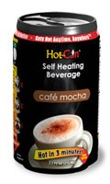
The HotCan was introduced in Malaysia, Australia and New Zealand in 2009. The containers were manufactured from aluminum coil in Malaysia. Kenneth Kolb, a U.S. medical researcher, moved to Malaysia where he saw a market for drinks with Halal certification. Halal foods are prepared in compliance with Islamic law. The following guidelines are from the USA Halal Chamber of Commerce, Inc.
The HotCan

(https://hotcaninc.wordpress.com/2011/12/19/more-self-heating-drinks-cans-to-be-launched/)

Halal foods are foods that are allowed under Islamic dietary guidelines. According to these guidelines gathered from the Qur’an, Muslim followers cannot consume the following:
- pork or pork by products
- animals that were dead prior to slaughtering
- animals not slaughtered properly or not slaughtered in the name of Allah
- blood and blood by products
- alcohol
- carnivorous animals
- birds of prey
- land animals without external ears

These prohibited foods and ingredients are called haram, meaning “forbidden” in Arabic. (http://www.ushalalcertification.com/what-is-halal.html)

Kolb saw a market for this certification in Saudi Arabia and Turkey, as well as in Malaysia and Indonesia. Hot-Cans can be purchased for four types of soup, two coffee flavors, chocolate and tea. In addition, the flavors are adjusted for the tastes of US and European customers. Kolb assumes that as demand increases his cans will be filled in Europe. His industrial vision includes, “We’re not in the business of making beverages, we’re in the business of making packaging technology.” (https://hotcaninc.wordpress.com/2011/12/19/more-self-heating-drinks-cans-to-be-launched/)

The Italian CaldoCaldo Company SRL produces “CaldoCaldo” cans that are heated by the energy released when anhydrous calcium chloride dissolves in water. Although no byproducts are created, the reaction produces less heat energy than the more commonly used chemical reaction between calcium oxide and water. This CaldoCaldo process warms the drink by only 23 ºC (41 ºF) above the ambient temperature. This works because most Mediterranean customers prefer drinks at medium warm, not hot temperatures.
https://bestinpackaging.com/2012/12/03/self-heating-packaging-containers-part-1/)

Hover over “How to Use” on this CaldoCaldo website for a short instructional animation: (http://r-and-r.ws/calcaldo.html)

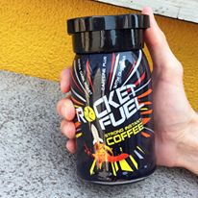
“Rocket Fuel” self-heating coffee was introduced in 2011 by the UK Food Brands Group. Sold in UK supermarkets and by Amazon UK, it features recyclable cups and contains the stimulant guarana, “designed to deliver a high octane boost”. Guarana seeds contain 2–4.5% caffeine compared to 1–2% caffeine in coffee beans. Some consider this drink a health hazard due to excess caffeine stimulation.
Guarana plant from Brazilian Amazon

(https://en.wikipedia.org/wiki/Guarana)
Rocket Fuel Coffee

(https://www.facebook.com/rocketfuelcoffee/photos)

(http://www.retailtimes.co.uk/food-brands-relaunches-rocket-fuel-self-heating-coffee-cups/)

The ScaldoPack

(http://www.scaldopack.be/technology.php)
From Belgium came the ScaldoPack in 2015, a stand-by-itself flexible pouch. Press on the red circle to activate the chemicals in the inner pocket and leave it sitting for five minutes to allow the heat to move into the outer chamber containing the drink. ScaldoPack was designed to be environmentally friendly, because container construction requires only 15 grams of material. Yet, the reaction chamber may reach 300 ºC (572 ºF), enough to melt the plastic packaging! So a temperature modulator is required to be certain that the reaction chamber does not heat above 95 ºC (203 ºF). (http://www.scaldopack.be/)
The HeatGenie™ was designed with a focus on cost reduction and reactions that do not produce odor and fumes. Researchers looked at the oxidation of common metals as high heat-generating sources. The figure below shows that the oxidation of aluminum by silicon dioxide produces over three times more energy than the calcium oxide and water reaction used in many self-heating containers. When powdered forms of aluminum and silica (SiO₂) are mixed, the silicon dioxide provides the oxygen for the oxidation of aluminum. A button on the bottom of the HeatGenie™ can is used to break the barrier between these reactants, thus activating the redox reaction. (https://bestinpackaging.com/2012/12/13/self-heating-packaging-containers-part-2/)
Cans of HeatGenie™

(http://www.heatgenie.com/)

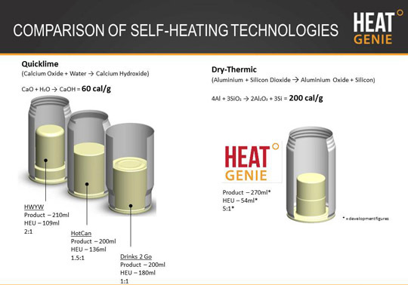

(https://bestinpackaging.com/2012/12/13/self-heating-packaging-containers-part-2/)

[Note: The formula for the calcium hydroxide product is incorrect in the quicklime equation above. It should be: Ca(OH)₂]

HEU is the acronym for Heat Exchange Unit.

The ratios represent the volume of beverage being heated, compared to the volume of heat source chemical needed (HEU) to heat that volume of beverage. HeatGenie has the highest ratio, meaning it requires the least amount of chemical to heat the beverage.
It is assumed that HWYW represents another company’s self-heating can product.

In the 1990s the U.S. Military provided the flameless ration heater (FRH), used in Meals Ready to Eat (MREs), to heat meals in the field. In this self-heating system, heat energy evolves when magnesium is oxidized by water. Water provides the oxygen, and hydrogen gas is released as a by-product. Thus, the instructions for use include this warning that emphasizes the flammability of hydrogen gas:

WARNING:
1. Vapors released by activated heater contain hydrogen, a flammable gas. Do not place an open flame in the vapor.
2. Vapors released by activated heater can displace oxygen.
3. Hot water leakage can burn and cause a cold- weather injury.
4. After heating, the heater bag and MRE pouch will be very hot. Use caution when removing MRE pouch from bag.
5. Discard heater and bag after use. Do not drink the water remaining in the bag or use it in food items.

HEATER AND ITS BYPRODUCTS ARE NOT INTENDED FOR HUMAN CONSUMPTION

(http://www.mreinfo.com/mres/flameless-ration-heater/)

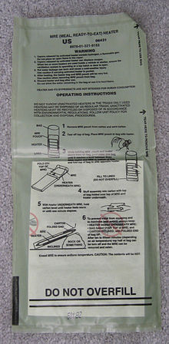
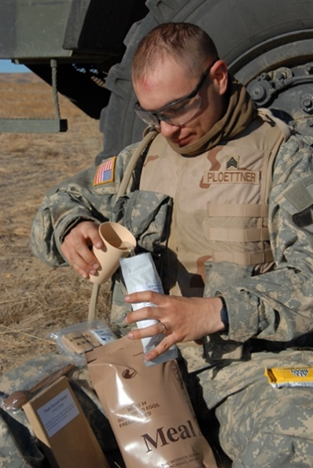

Soldier pours water into MRE meal packet

(http://www.natick.army.mil/about/pao/2007/07-04.htm)

Flameless Ration Heater used in MREs

(https://en.wikipedia.org/wiki/Flameless_ration_heater)

eCoupled technology

“Intelligent” wireless technology allows wireless power to be transferred to devices placed on a wireless powered surface. A smart phone or tablet can be used to control kitchen appliances remotely. Fulton Innovations (a U.S. company) introduced eCoupled technology at the 2011 Las Vegas Consumer Electronics Show. They demonstrated how to remotely control appliances, as well as a self-heating can, with eCoupled wireless technology. (http://metro.co.uk/2011/03/02/ecoupled-technology-brings-kitchen-appliances-powered-without-wires-642121/)

Self-heating baby food technology

In February 2013, the Dutch company Aestech announced its development of self-heating containers for babies and toddlers “on the go”. These include infant formula and semi-soft and solid baby food containers. The pictures below show Aestech baby food containers.

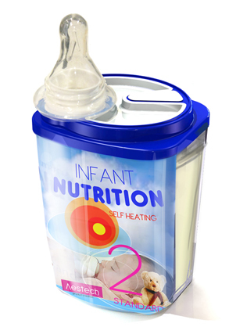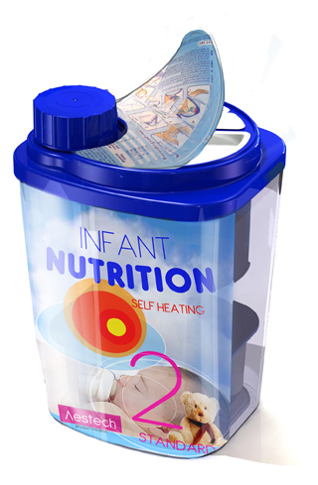

Baby Bottle with top vitamin dispenser Solid baby food

(https://bestinpackaging.com/2013/02/21/self-heating-packaging-for-baby-formula/)

With safety a major concern, the heating elements for baby food are designed to regulate temperature to prevent the melting of plastic packaging. The water compartment at the bottom of the container and the aluminum heating element of calcium oxide stand on small columns so that they are surrounded by sterile water (in a separate compartment) for the formula. The activation button pierces the seal on the formula powder, and shaking mixes the powder with the sterile water. A tube of water for the chemical reaction connects the heating element to the activation button located on the top of the bottle. (http://www.dairyreporter.com/Library/Packaging-Packing-Materials-Containers/Self-heating-packaging-for-infant-formula-emerges)

The diagram (below) from the Aestech website shows the novel four compartment construction of their baby bottles and food containers:

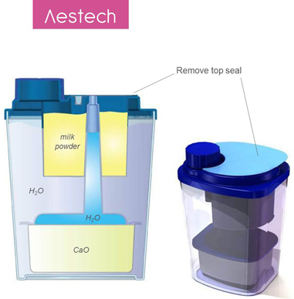
HOW IT WORKS

Heating is based on the exothermic reaction:

CaO + H₂O Ca(OH)₂

Both CaO and Ca(OH)₂ are commonly used additives in food products and are known under the *E-coding E529 and E526.

The partly transparent package shows the clear water, milk mixing, volume level and even the milk temperature: Visual conformation [sic] a parent needs to have.

(https://bestinpackaging.com/2013/02/21/self-heating-packaging-for-baby-formula/)

*The European Union (E.U.) Food Standards Agency codes acceptable food additives; the E- codes are listed in numerical order on the website for the nutrition book, Breaking the Vicious Cycle.
- E529 Calcium oxide [Acidity regulator] [Improving agent]
- E526 Calcium hydroxide [Acidity regulator] [Firming agent]
(http://www.breakingtheviciouscycle.info/knowledge_base/detail/e-codes-for-food-additives-in-europe/)

New technologies

Scientists continue to seek advanced mechanisms that will both provide safe, sufficient heat energy and maintain the proper temperature for a reasonable amount of time. Yet there are still many problems to solve. Self-propagating high-temperature synthesis (SHS) processes involve the oxidation of metals. Solid state oxidation and reduction reactions between metals and metal oxides can emit high amounts of heat energy; temperatures may exceed 1000 ºC (1832 ºF). This process is expensive and the reactions have high activation energies. In addition to the high temperatures, their by-products may be dangerous. So, safety concerns certainly must be addressed.

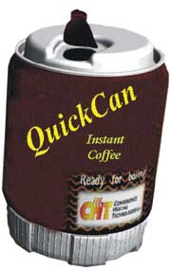
Convenience Heating Technologies, Inc. (CHT) at Hebrew University of Jerusalem is working on SHS systems to heat containers. These include mixing powdered aluminum with iron oxide (Fe₂O₃) (the standard thermite reaction). The oxidation process yields more than four times the energy produced by the commonly used calcium oxide and water reactions. (http://pubs.acs.org/subscribe/archive/ci/31/i09/html/09gluch.html)

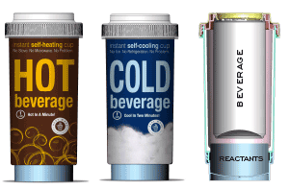
Heat Wave Technologies advertises improved packaging. Their cans are not flimsy like those of competitors. Constructed of aluminum and plastic, they are completely recyclable. Further, foam insulation keeps the beverage warm for an extended time and protects the consumer from the heat of reaction.
Heat Wave Technologies
Hot and Cold Beverage cups

(http://www.heatwavetech.com/innovation.html#)
CHT’s hot can that uses
SHS technology

(http://pubs.acs.org/subscribe/archive/ci/31/i09/html/09gluch.html)

The dissolution of anhydrous calcium chloride provides energy to heat a beverage. A 25-second video on their website shows that a beverage can be heated in 60 seconds! The technology of the company’s cold beverage cups will be discussed in the “Self-cooling cans” later in this Teacher’s Guide.

Heater Meals

Advertised as: “No stove, no water, no power, no problem”, the UK Heater Meals Company introduced meals in self-heating packages for camping and emergencies in 2007. They were introduced to the US market in 2008. The meals have a shelf life of five years and do not require refrigeration. The redox chemistry for Heater Meals (produced under the Cross & Blackwell label) as “Heater-meal Packs” is explained in the section, “Chemistry of self-heat containers” (below). (http://www.heatermeals.co.uk/)

Meal packs and meals can be purchased as a kit or separately. Amazon lists a package of one dozen heater packs for $20.48, a single meal for $10.95 and a package of one dozen complete kits (meals and heater packs) runs from $62 to $135. (https://www.amazon.com/s/ref=nb_sb_noss?url=search-alias%3Dsporting&field-keywords=heater+meal+packs)

The chemistry of Heater Meals, flameless ration heaters (FRH), is described below in the “Chemistry of self-heating container systems” section of this Teacher’s Guide. The instructions for use are located at this site: http://heatermeals.com/how-self-heating-works/.

Instructions for Heater Meal Use
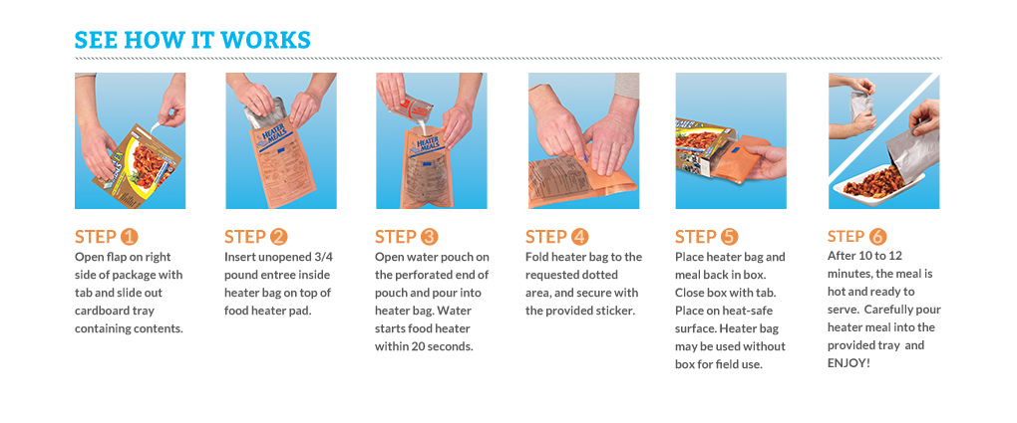
(http://heatermeals.com/wp-content/uploads/2013/07/how-self-heating-works-heatermeals.png)

Cooking—not just heating

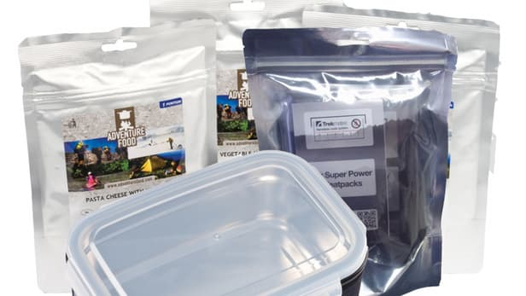
In addition to warming, as long as sufficient heat energy is available in a short-enough time interval, self-heating processes can be used to cook meals. When camping, if inclement weather makes outdoor cooking unpleasant, bringing a cooking stove within the tent could be disastrous. The tent may burn, or the occupants may die of carbon monoxide poisoning from incomplete combustion of the fuel. Trekmates advertises a camp cooking system that cooks your dinner without a campfire or stove. With safety modifications, this company has borrowed the military flameless heating system process. You can purchase a kit containing food or separate heating/cooking packets.
Trekmates

(http://newatlas.com/trekmates-flameless-stove/23366/)

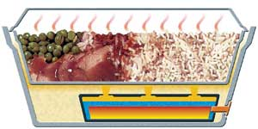
The container (illustrated at left) produced by the Convenience Heating Technologies (CHT) Company uses the SHS process described in the “Chemistry” section below. Note that the heating unit is separated and insulated from both the food and human contact. The “safety features” below are designed to protect both the customer and the food:

CHT’s self-heating food container

(http://pubs.acs.org/subscribe/archive/ci/31/i09/html/09gluch.html)

Product advantages and safety features
- A safety pin prevents the process from being initiated accidentally.
- Another safety feature alleviates the pressure that builds up as the contents of the container reach the boiling point, while retaining enough water in the container to absorb the energy produced from the exothermic reaction. The container cannot be opened until the temperature rises to 95 °C.
- The heating unit and its chemicals are encapsulated, thereby protecting the contents and the consumer.
- The can itself is insulated, which ensures that the heat remains inside the can and does not burn the consumer’s hand.
(http://pubs.acs.org/subscribe/archive/ci/31/i09/html/09gluch.html)

The chemistry of self-heating container systems

This Teacher’s Guide has discussed several different chemical processes that provide energy for self-heating containers. The amount of energy produced depends upon the type of reaction. The more highly reactive compounds produce the most energy but may also present safety concerns, such as overheating and the production of toxic or flammable products.

Exothermic chemical reactions such as neutralization (acid-base) and oxidation and reduction (redox) are used to provide the energy for self-heating containers. In addition, the dissolving process and heat of crystallization (physical changes) can also be exothermic.

Energy from exothermic physical changes

Heat energy from the dissolving process

While most of the energy used for self-heating processes evolves from chemical reactions, the dissolving process can also release energy. Anhydrous calcium chloride (CaCl₂) dissolves in water releasing enough heat energy to increase the temperature of the liquid in a “2Go” can by 40 ºC (72 ºF) in three minutes, as well as maintain an acceptable drinking temperature for 20 minutes.

When anhydrous CaCl₂ dissolves in water, the energy required to break the ionic bonds (lattice dissociation enthalpy) of CaCl₂ is +2258 kJ/mol. This is the energy required to break the hydrogen bonds between water molecules and to pull apart the crystal lattice as positive calcium ions are attracted by the partially negative oxygen atoms of water molecules and the negative chlorine ions are attracted to the partially negative hydrogen atoms of water.

Energy is released as the hydrated calcium and chloride ions form (hydration enthalpy). Each Ca²⁺ ion has a hydration enthalpy of –1650 kJ/mol, and the value for each Cl– ion is –364 kJ/mol. Since there are two Cl– ions, the total hydration energy for this reaction is
2(–364 kJ/mol) + (–1650 kJ/mol) = –2378 kJ/mol

Combing the values for lattice dissociation (positive because energy is required) and hydration (negative, energy released) the dissolution of CaCl₂ results in a ΔH of –120 kJ/mol.
(+2258 kJ/mol) + (–2378 kJ/mol) = –120 kJ/mol
lattice dissociation enthalpy + hydration enthalpy = ΔH
bond-breaking + bond-forming = ΔH

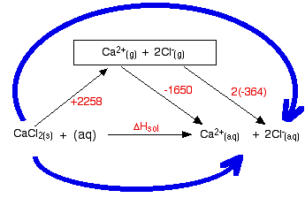
This means that 120 kJ of energy are released for each mole of CaCl₂ that is dissolved. This is the energy available to heat the liquid in a “2Go” can. To determine the total energy released to heat the food, calculate of the change in heat energy (ΔH), as shown in this diagram.

ΔH_{sol} = +2258 + [–1650 + 2 (–364)]

ΔH_{sol} = –120 kJ mol⁻¹

(http://www.chemguide.co.uk/physical/energetics/solution.html)

This technology is used by the Heat Wave Technologies Company. The hydrolysis of calcium chloride has the advantage of producing no dangerous reaction by-products, but less heat is generated than from chemical reactions. (http://www.heatwavetech.com/innovation.html#)

Energy of crystallization

A patent for a rechargeable self-heating container describes the process of obtaining heat energy from supersaturated and supercooled sodium acetate trihydrate (C₂H₃NaO₂ • 3 H₂O) solution. The solution is stabilized under its melting point of 54 ºC (129 ºF); a seed crystal activates the crystallization; and heat is released as the more stable salt is crystallized. Once
re-liquefied, the supersaturated solution can be reused. Instant heat pads provide energy by this same process. (https://www.google.si/patents/US20080251063)

Energy from exothermic chemical reactions

As presented in the “Piping Hot, Ice Cold…” Rohrig article, chemical reactions involve breaking chemical bonds (endothermic) and forming new chemical bonds (exothermic). The amount of energy released or absorbed during a chemical reaction is determined by the difference in these two values.
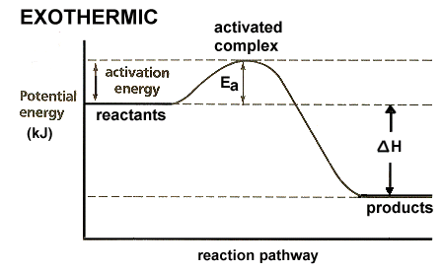
The potential energy diagram at right shows the potential energy (kJ on the y-axis) required to break the chemical bonds of the reactants (activation energy), increasing the potential energy (+kJ). Once the unstable activated complex is formed, potential energy is lost (–kJ) as the products form. As shown in the diagram, energy is lost in an exothermic reaction. This energy can be used to heat food. The amount lost (a negative value) is represented by ΔH in the diagram which shows the difference between the amount of energy required to break bonds (+ΔH) and the amount released (–ΔH) when new bonds are formed. An exothermic reaction has an overall –ΔH, showing that potential energy is lost. The horizontal (x) axis shows the reaction pathway (coordinate) representing the progress (over time) of the reaction.
(https://sites.prairiesouth.ca/legacy/chemistry//chem30/graphics/2_graphics/exo.gif)

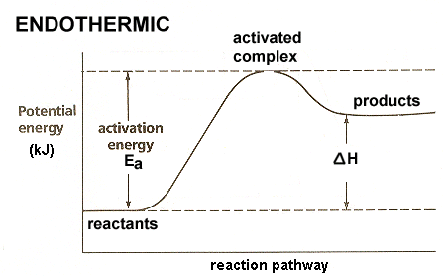
By comparison, in an endothermic reaction the potential energy of the products is greater than the reactants, as shown in the potential energy diagram at right. More energy is required to break the chemical bonds of the reactants (activation energy) than is released as the products form. The product bonds store this energy, thus the sign for the change in energy (ΔH) will be positive. This graph will represent a process that can be used for self-cooling cans, explained later in this Teacher’s Guide.

Dissolution of quicklime
(http://1.bp.blogspot.com/-z5BCMXn-xmE/TWC5XTNRM9I/AAAAAAAAAD0/rIu2CwA60U0/s1600/endo.gif)

Most self-heating technologies are designed to use the energy released by chemical reactions. The exothermic reaction between quicklime and water is the most commonly used source of energy for self-heating packaging. Commonly called quicklime or slaked lime, calcium oxide (CaO) is abundant in nature and cheap; it produces sufficient energy; and the calcium hydroxide product, Ca(OH)₂ (aq), readily combines with atmospheric carbon dioxide producing environmentally friendly products (solid calcium carbonate and water).

Calcium carbonate is chalk, or limestone, and is often found in dietary supplements as a source of calcium and as an ingredient in some antacids, such as “Tums”. An additional commercially touted benefit of this reaction is the removal of carbon dioxide (an extremely small amount) from the atmosphere, thus reducing the Green House Effect. The equation below shows that 63.7 kJ of heat are released as each mole of CaO(s) dissolves.
CaO (s) + H₂O (l) Ca(OH)₂ (aq) + 63.7 kJ (ΔH = –63.7kJ/mol CaO)
Ca(OH)₂ (aq) + CO₂ (g) CaCO₃ (s) + H₂O (l)
(https://en.wikipedia.org/wiki/Calcium_oxide)

The drawback of this “hydration method” lies in the low energy yield (shown above). To carry a sufficient quantity of the reactants, the heating unit must be fairly large and heavy. In addition, the energy released will only increase the temperature by 45 ºC (81 ºF) above the ambient temperature. Thus, this method may not heat sufficiently in cold weather; it is impossible to boil water; and the heating time is a long five minutes.

Self-propagating high-temperature synthesis (SHS)

SHS systems use the thermite reaction that occurs when dry solid, powdered metal and metal oxide are mixed to form a pure metal and a stable oxide. Note that aluminum is the more reactive metal, so it easily replaces iron. These are very exothermic redox reactions:
2 Al(s) + Fe₂O₃(s) Al₂O₃(s) + 2 Fe(s) ΔH = –847.6 kJ/mol
8 Al(s) + 3 Fe₃O₄(s) 4 Al₂O₃(s) + 9 Fe(s) ΔH = –1316.6 kJ/mol

Industrially, this process is used to weld, construct explosive devices and separate metals from their oxides. (https://www.google.si/patents/US8864924)

Convenience Heating Technologies, Inc. (CHT) at Hebrew University of Jerusalem is using these reactions to provide the energy for self-propagating high-temperature synthesis (SHS) systems to heat food containers. The thermite oxidation process yields more than four times the energy produced by the commonly used calcium oxide and water reactions.

The reaction below is used to overcome the high activation energy of the thermite reaction. When a mixture of ethylene glycol, water and a catalyst is injected into potassium permanganate (along with the powdered metal and metal oxide), the thermite reaction begins in approximately six seconds. Silica is used as a binder. The reactions may also be initiated by glycerine and potassium permanganate.
10 KMnO₄ + 4 C₂H₆O₂ → 5 Mn₂O₃ + 5 K₂CO₃ + 3 CO₂ + 12 H₂O + heat
potassium + ethylene → manganese + potassium + carbon + water + heat
permanganate glycol (III) oxide carbonate dioxide

Note that potassium permanganate oxidizes the ethylene glycol to produce the energy required to initiate the reaction between the powdered metal and a metal oxide. Food is heated in about 4 minutes and beverages are heated from 2–3 ºC (36–37 ºF) to boiling in less than 90 seconds. (http://pubs.acs.org/subscribe/archive/ci/31/i09/html/09gluch.html)

The energy source for the self-heating HeatGenie™ comes from a similar thermite reaction between powdered aluminum and silicon dioxide. The HeatGenie™ Web site boasts that this is a safe reaction between two dry, non-reactive chemicals. Aluminum is an active metal that readily reacts with an oxygen source. Silicon dioxide (also known as silica) provides the oxygen to oxidize the aluminum, and it is cheap and readily found combined in nature as quartz, a major component of sand.
4 Al (s) + 3 SiO₂ (s) 2 Al₂O₃ (s) + 3 Si (s)
(http://static1.squarespace.com/static/57572f2d59827e49522c994e/t/57b632e120099ebf80b298af/1471558371042/HTG_Specs_and_Details.pdf)

Other redox reactions

Zinc is a more reactive metal than copper, so it displaces copper in the equation below. An exothermic reaction between copper sulfate and zinc metal is safer than other reactions because no gas is produced. Yet it yields little heat energy, so a large amount of reactants is required to heat a small amount of coffee.
Zn (s) + CuSO₄ (s) ZnSO₄ (s) + Cu (s) + 60.5kJ (or ΔH = –60.5 kJ/mol Zn)
Zinc + copper zinc + copper + heat
Sulfate sulfate
(http://stationery1.blogspot.com/2009/04/self-heating-can.html)

Acid/base neutralization reactions

This patent, “Self-Heating Chemical System for Sustained Modulation of Temperature”, describes the production of heat energy from a series of exothermic reactions. It includes chemical reactions, phase changes and neutralization. The key sequence of exothermic reactions is given in the patent. The type of heat-producing reaction is given in parentheses following each equation:

- CaO + H₂O → Ca(OH)₂ (chemical reaction)
calcium + water→calcium
oxide hydroxide
- Zeolite + Water (steam) → Hydrated zeolite + Water (liquid) (phase change)
- CaO • MgO + H₂O → Ca(OH)₂ + MgO (chemical reaction)
- MgO + H₂O → Mg(OH)₂ (chemical reaction)
- 2 Ca(OH)₂ + 3 C₆H₈O₇(aq) → Ca₂(C₆H₅O₇)₃ • 4H₂O + 2H₂O (acid-base
calcium + citric → calcium + water neutralization)
hydroxide acid citrate

(http://www.google.com/patents/US20070289720)

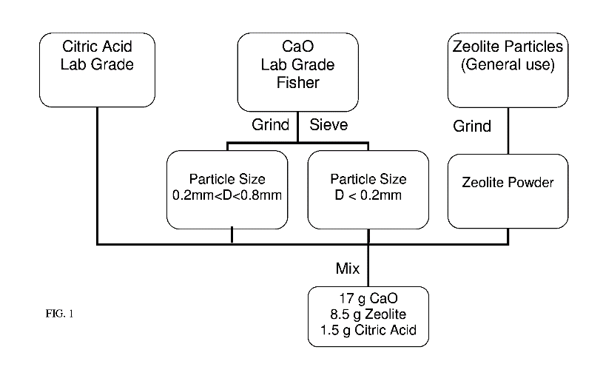
In this patented process, the exothermic neutralization reaction between calcium hydroxide (a base) and citric acid is used to provide sustained regulation of the reaction temperature and pH. As explained in the patent, a primary concern was to develop a process where the temperature was controlled to be both safe for the consumer and sustained to maintain beverage heat for a reasonable period of time. To achieve these goals researchers found that both particle size and the mass ratio of calcium oxide to zeolite to citric acid were essential. The optimum relationship between these two variables (particle size and grams used) is shown in the schematic above. (http://www.google.com/patents/US20070289720)
Schematic of the patented process

(http://www.google.com/patents/US20070289720)

Zeolites are minerals composed of hydrated aluminosilicates, that is, compounds containing silicate ions (SiO₄^{2–}), where some of the silicon has been replaced by aluminum ions. These are usually salts of sodium, potassium, calcium or barium. They occur naturally and can be produced industrially. Zeolite pellets are porous and have a large surface area. The steam from the CaO/water reaction adheres to the surface of the pellets, as it undergoes a phase change, condensing to liquid water and releasing heat energy. An excellent 54-second video shows this process: (https://www.youtube.com/watch?v=twkAfF5dWew&app=desktop)
Zeolite pellets

(https://www.sciencedaily.com/releases/2012/06/120606075319.htm)

While the reaction between calcium oxide and water (step 1 in the numbered reaction sequence above), rapidly generates much heat energy, the condensation of water on the surface of the zeolite pellets (step 2 above) produces less heat energy, more slowly. The zeolite stores this heat energy and releases it slowly and uniformly, thus promoting sustained heating and avoidance of “hot spots”.
Another patented process, “Exothermic compositions and container for heating food”, mixes a solid base with a solid acid in a neutralization process. For example, quicklime and oxalic acid yield neutral calcium oxalate monohydrate and a substantial amount of energy. To initiate the reaction, water is added to the solids. This reaction produces more energy and avoids injury and possible food contamination caused by boiling and splattering from the calcium oxide and water combination. A low weight solid acid is used, such as oxalic (H₂C₂O₄) shown in the equation below, or sulfamic (H₃NSO₃) or tartaric (C₄H₆O₆). In addition, the product is not caustic calcium hydroxide.
CaO (s) + H₂C₂O₄ (s) → CaC₂O₄ • H₂O (s) + 340 calories/gram of solid fuel
calcium + oxalic → calcium oxalate + energy
oxide acid monohydrate
(http://www.google.co.ve/patents/US5483949)

Flameless Ration Heaters

The reaction between powdered magnesium and water that is used to provide the U.S. military with hot meals was described in the Rohrig article and can be represented by:
Mg(s) + 2 H₂O(l) → Mg⁺²(aq) + 2 OH–(aq) + H₂(g) + 351 kJ

The chemical equation above shows that ΔH = –351 kJ/mol Mg. This means that the reaction is exothermic and, for each mole of Mg oxidized by the oxygen atoms of water, 351 kJ of energy is released to heat the food. (https://en.wikipedia.org/wiki/Flameless_ration_heater)

Note that, since the iron filings described in the Rohrig article are needed only to help activate the reaction but do not affect the reaction rate, iron is not considered a catalyst. (http://science.howstuffworks.com/mre4.htm)

This process is also used in Cross & Blackwell Heater-meal Packs. It involves the formation of a small electrochemical cell where the oxidation-reduction process provides the heat energy. Magnesium atoms have a lower reduction potential than iron atoms. So in the moist environment, magnesium metal atoms (powdered to provide greater surface area) release electrons to the less active iron. In the overall equation above, as the aqueous magnesium hydroxide, Mg(OH)₂ (aq), product continues to form, iron separates the magnesium and hydroxide ions, preventing the formation of solid Mg(OH)₂. Sodium chloride is also added to the water. The sodium cations (Na⁺) attract the hydroxide anions (OH–), and the chloride anions
(Cl–) attract the magnesium cations (Mg²⁺), keeping the charge neutral and further preventing the formation of solid magnesium hydroxide. (http://www.scienceinschool.org/2011/issue18/lncu)

Confined space hazard for self-heating systems

Following a flight attendant’s concern regarding the use of flameless ration heaters aboard aircraft, the Federal Aviation Administration (FAA) summarized its findings: “It is evident from the tests that the release of hydrogen gas from these MREs is of a sufficient quality to pose a significant hazard onboard a passenger aircraft.” (https://www.faa.gov/other_visit/aviation_industry/airline_operators/airline_safety/safo/all_safos/media/2006/safo06008.pdf)

Self-cooling cans

The first reports of self-cooling cans came from World War II and the Vietnam War, where military cooks blasted beer cans with carbon dioxide fire extinguishers for a quick chill. Following this, there have been many attempts to design affordable packaging that will chill the beverage, avoid giving frostbite to the drinker, and allow space for the liquid. Developing the technology and packaging for self-heating cans was much easier than for self-cooling cans. The latter came to market about 50 years after the former.

Researchers are currently investigating two basic self-cooling technologies: endothermic reactions and evaporative cooling.

Endothermic salt hydration technologies

In November 1988, The Coca Cola Company received a patent for packaging a self-cooling beverage can. In this design the beverage resides in a compartment outside the cooling materials. Within the center of the beverage can there are two containers. One contains a reacting liquid (usually water); the second contains the solid reacting chemical. These containers are separated by a membrane able to withstand the normal trauma of transportation. Yet it can be ruptured to activate the reaction by pushing a button on the bottom of the can or by simply opening the beverage compartment. An endothermic dissolution of an inorganic salt in water is responsible for cooling the beverage. The patent suggests using, “… alkali metal halides, perchlorates, ammonium salts or the like. The preferred chemical is ammonium nitrate.” (http://www.google.com/patents/US4784678)

Most endothermic reactions that hold possibilities for self-cooling have low enthalpies of reaction. For example, sodium thiosulfate pentahydrate (Na₂S₂O₃•5H₂O) is very water soluble, and its dissolution is endothermic (ΔH= +47.4 kJ/mol). This reaction is suitable for CaldoCaldo cans because the Italians are accustomed to drinks that are not extremely cold (or hot as mentioned earlier in the self-heating section of this Teacher’s Guide). The Italian CaldoCaldo Company SLR produces self-heating cans that are “powered” by the exothermic dissolution of anhydrous calcium chloride (ΔH = –120 kJ/mol).

Note the difference between the enthalpy for the exothermic reaction between a salt and water (~120 kJ/mol of heat energy released) compared to a similar (but endothermic) reaction where relatively little heat energy (47.4 kJ/mol) is removed from the beverage. The following images show the structural formula for the reactant salt, sodium thiosulfate pentahydrate, without the five water molecules.

Sodium thiosulfate
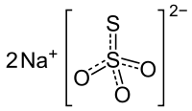
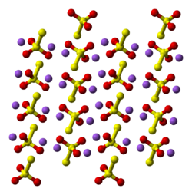

(https://en.wikipedia.org/wiki/Sodium_thiosulfate)

Note: In the ball and stick models above, each thiosulfate ion contains two sulfur atoms (yellow) and three oxygen atoms (red). There are two sodium ions (purple) for each thiosulfate ion. This image can be pictured as the dissolved salt with the ions hydrated in a water solution.

As explained in the self-heating technology section of this Teacher’s Guide, the Belgium firm Scaldo Pack SA uses a pouch within pouch within pouch system for self-heating. They use similar packaging for self-cooling. A flexible self-standing pouch is cooled by an endothermic salt hydration method. A sealed reaction chamber pouch resides within the outer beverage pouch. A liquid (water) is placed in the reaction chamber pouch, and an inner pouch containing a salt is placed in the water inside the reaction pouch. Activating the reaction is easy because the inner salt pouch is made of elastic material that breaks releasing the salt when the interior pressure increases in response to pressure exerted on the outer pouch. The temperature of 200 mL of beverage decreases by 13 ºC (23 ºF) in about three minutes. ScaldoPack uses “high nitrogen holding salts” that are biodegradable and nontoxic for people. (http://www.google.com/patents/US20130318916)

Within the outer pouch shown below, there is an inner reaction chamber (pouch) containing both water and another inner pouch that holds the salt.

ScaldoPack self-cooling beverage

(http://www.scaldopack.be/products-cold.php)

In 2003, Procter and Gamble was granted a patent for self-heating/self-cooling packaging powered by the water of hydration of salts. For self-cooling they suggested the following salts that dissolve in water endothermically,
- sodium sulfate•10H₂O
- sodium bicarbonate
- potassium perchlorate
- potassium sulfate
- potassium chloride
- potassium chromate
- urea
- vanillin
- calcium nitrate
- ammonium nitrate
- ammonium dichromate
- ammonium chloride.
(http://www.google.com/patents/US6644383)

Evaporative cooling technologies

Gas expansion is an endothermic process. Energy is required to break the intermolecular attractions between molecules in the liquid phase and additional energy is required for liquids to undergo a phase change to the gaseous state. In addition, energy is required to move gases from a crowded, concentrated situation and further separate (expand) the molecules into a larger space. The energy required to evaporate liquid water is withdrawn from the surroundings, leaving the beverage (surroundings) cooler.

In 1998 astronauts were the first people to use self-cooling cans. Their beverages were cooled by water evaporation that occurred within a compartment inside of the beverage can. The water molecules removed the heat energy needed for evaporation from the beverage. The heat energy withdrawn from the beverage and the can was used to break the hydrogen bonds between water molecules and to increase the molecular kinetic energy as the molecules moved apart (expanded) to fill the available space. (https://books.google.com/books?id=2terzJW5mb0C&pg=PA13&lpg=PA13&dq=self+cooling+cans+astronauts&source=bl&ots=4ugflXVcFs&sig=jRNxcQAAqAGAaOD8T2VAR4sWe0c&hl=en&sa=X&ved=0ahUKEwjR_NvPk8LPAhWCRyYKHRYQBtQQ6AEITDAH#v=onepage&q=self%20cooling%20cans%20astronauts&f=false)

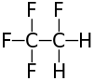
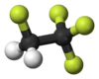
In 1992, Mitchell Joseph was testing his self-cooling design on a Pepsi Beverages Company project. He successfully used evaporation of 1,1,1,2-tetrafluoroethane, a hydrofluorocarbon compound (HFC-134a) as the coolant.
Structural formula and
ball-and-stick model
of 1,1,1,2-tetrafluororethane

(https://en.wikipedia.org/wiki/1,1,1,2-Tetrafluoroethane#Climate_change_considerations

His can cooled quickly, but at tremendous environmental expense. HFC-134a, a greenhouse gas, depletes atmospheric ozone and contributes to global warming at a rate that is 1,400 times greater than that of the more familiar carbon dioxide. A European Union (EU) ban began on the use of HFC refrigerants in car air conditioning systems in 2011 and becomes a total ban by 2017. It is estimated that the gas released from one can of HFC-134a chilled beer is equivalent to the greenhouse contribution from driving 500 miles.

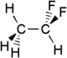
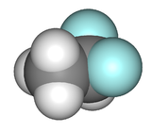
The July 1997 issue of Mother Earth reported that the Joseph Company proposed using 1,1-difluoroethane (HFC-152a) as a military beverage cooler for Individual Canteen Cups of Coffee (IC³ or “ice cube”). HFC-152a does not present as severe an atmospheric problem as HFC-134a, but it is still a greenhouse gas that has an effect 140 times greater than carbon dioxide. Note that a molecule of this hydrofluorocarbon contains only two fluorine atoms as compared to the four in HFC-134a.
Structural formula and
space-filling model
of 1,1-difluoroethane

(https://en.wikipedia.org/wiki/1,1-Difluoroethane)

The army asked for EPA advice. The EPA approved both HFC-134a and HFC-152a for closed refrigeration use only, including refrigerators and automobile air conditioners. All other uses were banned except for asthma inhalers. The director of EPA’s Stratospheric Protect Division, Drusilla Hufford said, "Unlike cooling a beer, taking a puff to recover from an asthma attack is more important. No one's ever died from the desire to have a cold beer." (http://www.motherjones.com/politics/1997/07/chill-can-packs-heat)

In 1998, Pepsi cancelled the project due to environmental concerns. Joseph left Pepsi and continued his project under his own firm, Joseph Company International. Unfortunately for Joseph, HFC-134a was illegal under the U.S. EPA regulations. It has since been totally banned from use in U.S. automobiles, beginning with the 2021 model year, and all other uses will be banned by 2018. Note that the EU bans are and will be in effect sooner than the U.S. bans.

Pepsi and Coca Cola as well as many other companies decided to terminate self-cooling projects due to concerns expressed by the EPA over the use of the ozone depleting hydrofluorocarbon (HFC-134a) gas. Cans from some of the other thousands of unsuccessful self-cooling ventures are shown in the picture below.

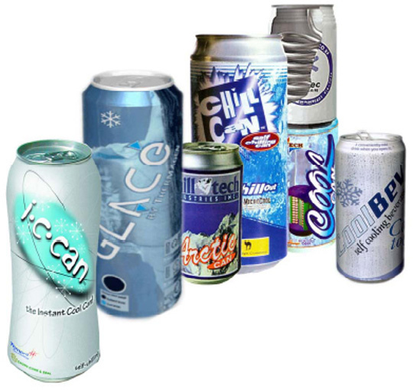
Field of opportunities or graveyard of dreams?
Photo of unsuccessful self-cooling cans

Source: Packaging Materials & Technologies Ltd

(https://bestinpackaging.com/2012/12/17/the-self-cooling-technology-and-the-future-part-3/)
On October 17, 2016, Germany’s International Broadcaster Deutsehe Welle (DW) announced that 200 countries signed an amendment to the Montreal Protocol (an international treaty to protect the ozone layer) to ban HFCs, “The super greenhouse gases”. The Greenpeace USA Organization estimates that the quantity of HFCs in the atmosphere is increasing by 10–15% per year, making them the fastest growing greenhouse gases in our atmosphere. The primary use is as a refrigerant for air conditioners. (http://www.dw.com/en/banning-the-super-greenhouse-gas/a-36044849)

The diagram below illustrates the ways in which greenhouse gases affect the atmosphere.

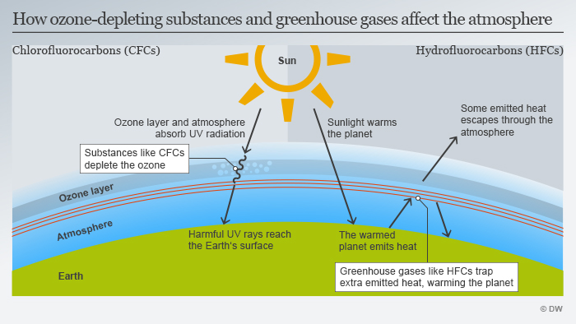
(http://www.dw.com/en/banning-the-super-greenhouse-gas/a-36044849)

Self-cooling success

Mitchell Joseph redesigned his self-cooling can to use carbon dioxide as the coolant. The Joseph Company International introduced the “ChillCan” in February 2012, proclaiming, “World's First Self-Chilling Beverage", the first patented West Coast Chill Can for an energy drink. Just push the button on the bottom of the can and the temperature of the liquid inside the can decreases by 30 ºC (54 ºF) within minutes. (http://newatlas.com/west-coast-chill-self-chilling-drink/21316/)
West Coast ChillCan
Claire Benoist

(http://www.popsci.com/gadgets/article/2012-06/first-ever-self-chilling-can)

A heat exchange unit (HEU), which, according to Joseph, contains “an organic, renewable vegetable source” is built into the system. The “green” vegetable source is activated carbon from coconut shells that acts as an atmospheric carbon dioxide absorbent system. The internal HEU is attached to a button on the bottom of the can and contains carbon dioxide gas under high pressure. When the button is pressed, the carbon dioxide gas is released using the heat energy of the surroundings to break the attractions between molecules and expand the gas as it leaves the small hole on the bottom of the can. When deprived of heat energy, the ChillCan liquid content decreases in temperature. Note the activation button on the bottom of the can shown at right. (http://www.beveragedaily.com/Processing-Packaging/Self-chilling-beverage-cans-will-take-market-by-storm-Joseph-Company-CEO)

Awards

The Joseph Company International has received many prestigious awards. These are shown on their Web site (below):
- Five chill cans were “launched” into space as part of a program with NASA.
- The company received a NASA EPA Ozone Protection Award for corporate responsibility in redesigning the self-chilling beverage can.
- The Editor’s Choice Award from the Beverage Industry was presented at the Supply Side West ’12 Exposition held in Las Vegas.
- This Best Package of 2012 award was presented to West Coast Chill Pure Energy for beverage packaging design technology.

Their Web site provides information about these and many more accolades they’ve won: http://chillcan.com/awards-and-accolades/.

Tempra technology

In competition with The Joseph Company, Tempra Technology has developed a self-cooling procedure that does not rely upon compressed gas for chilling the beverage. Rather, their beverages are cooled by the release of energy during the simple evaporation of water. Evaporation withdraws heat from the beverage as water molecules gain the energy required to break their intermolecular forces (hydrogen bonds) and undergo the liquid-to-gas phase change. This packaging is practical and requires only about 25% of the space in the can.

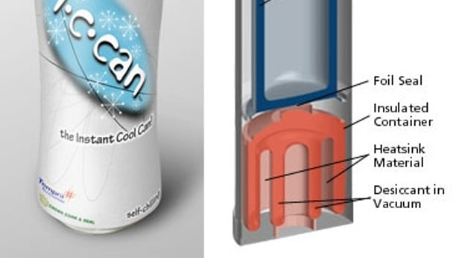
As seen in this picture, there are two compartments in the can. The upper container (wall colored blue) is the heat absorber (evaporator). It is coated with water bound in a gel layer. This container is surrounded by the beverage to be cooled.

The lower container is a heat absorber (heatsink) which is evacuated and contains both a clay drying agent and a granular desiccant (water absorber). Activation is simple, just twist the lower portion of the can at the foil seal. When the seal is broken, the vacuum is released and the water is exposed to the desiccant. The vacuum reduces the pressure below the vapor pressure of water so the liquid water molecules are free to evaporate into the gaseous state. As the water evaporates it withdraws heat energy from the beverage. The heat energy is absorbed by the heatsink material leaving a cold beverage for the consumer. This process decreases the beverage temperature by 17–22 ºC (30–40 ºF) in three minutes. (http://newatlas.com/go/3136/)
The Self-chilling can

(http://newatlas.com/go/3136/)

Some suggest that this Tempra technology could be applied to the medical field. Medication that must be refrigerated could be enclosed in similar packages for travel or use in areas where refrigeration is not available.

Invitation to join research

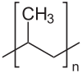
The corporate sustainability department of Kraft Foods is working to “green” their image. A few years ago in an effort to promote sustainable practices and decrease cost, Kraft reduced their Milka chocolate bar covering. They eliminated the double covering of a paper wrapper over aluminum foil by substituting a “one-layer, laminated, oriented polypropylene, (C₃H₆)_{n}, flow pack with a cold sealant”. “Oriented” refers to the process of first extruding and stretching the polymer in the direction of the machine rollers and then stretching it transversely (at right angles) to the initial stretch. The cold seal adhesive covering adheres to itself by simply pressing the pieces together, no heat is required. Converting to a single layer of covering has resulted in a 60% reduction in packaging material for Milka bars. (https://bestinpackaging.com/2010/10/19/self-cooling-chocolate-packaging-kraft-invites-people-to-join-them-in-research/)
Polypropylene (C₃H₆)_{n}
Structural formula and ball-and-stick model

(https://en.wikipedia.org/wiki/Polypropylene)
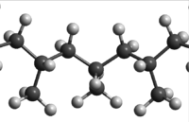

Have you ever opened a chocolate covered candy bar on a hot summer day and encountered a mass of melting chocolate? Recognizing this problem, Kraft Foods has requested the public’s help in developing self-cooling wrappers for chocolate candy bars. To prevent melting when the ambient temperature is between 24 and 40 ºC (75 and 104 ºF), the company suggests that people work on innovative approaches that may involve new insulating materials or packaging that responds to light or heat by absorbing heat energy.

Milka Bar Melted Milka Bar
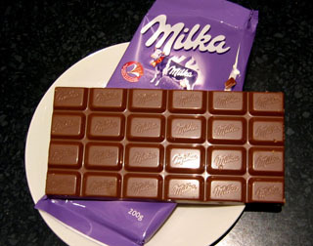
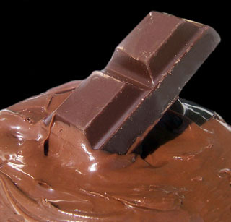

(https://bestinpackaging.com/2010/10/19/self-cooling-chocolate-packaging-kraft-invites-people-to-join-them-in-research/)

References
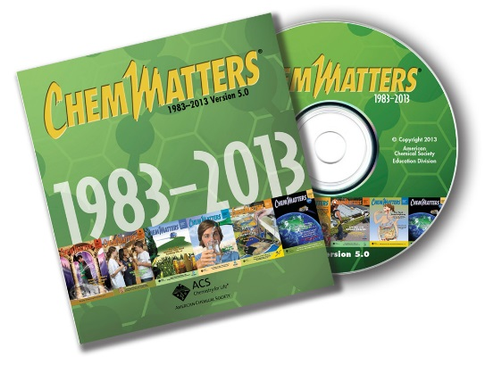
(non-Web-based information sources)
The references below can be found on the ChemMatters 30-year DVD, which includes all articles
published from the magazine’s inception in October 1983 through April 2013; all available Teacher’s Guides, beginning February 1990; and 12 ChemMatters videos. The DVD is available from the American Chemical Society for $42 (or $135 for a site/school license) at this site: http://ww.acs.org/chemmatters. Click on the “Teacher’s Guide” tab to the left, directly under the “ChemMatters Online" logo and, on the new page, click on “Get the past 30 Years of ChemMatters on DVD!” (the icon on the right of the screen).

Selected articles and the complete set of
Teacher’s Guides for all issues from the past three
years are available free online at the same Web site, above. Click on the “Issues” tab just below the logo, “ChemMatters Online”.
30 Years of ChemMatters !
Available Now!

This article describes construction and chemistry of the hot and cold packs used for sports injuries. It includes a description of the hydration of salts, including nice diagrams showing water molecules attracting both the positive and the negative ions of the salt. (Marsella, G. Hot & Cold Packs. ChemMatters, 1987, 5 (1), pp 7–11)

The construction and chemistry of Military Meals Ready to Eat (MREs) are illustrated and discussed. The meals shown were prepared for the U.S. Army fighting in Operation Desert Storm. (Scott, D.; Meadows, R. Hot Meals. ChemMatters, 1992, 10 (1), pp 12–13)

Some history, uses, and the chemistry of the thermite reaction is discussed in this article. Nice photos of explosions are included as well. (Tinnesand, M. Mighty Thermite. ChemMatters, 2002, 20 (1). pp 14–15)

The technology involved in the function of a heat pump described in this article is similar to the self-cooling process used in Tempra technology to cool a can by the expansion of a gas (water). (Becker, B. Question from the Classroom. ChemMatters, 2006, 24 (3), p 2)

Students may find this article on race cars interesting and it may present a good way to emphasize the energy behind gas expansion. The exothermicity of the expansion of gases pushes the piston in NASCAR cars. (Rohrig, B. The Science of NASCAR. ChemMatters, 2007, 25 (1), pp 4–7)
____________________

Matthews, G. Demonstrations of spontaneous endothermic reactions. Journal of Chemical Education, 1966, 43 (9), p 476. This article describes high school demonstrations of spontaneous endothermic reactions involving hydrated metal chlorides and thionyl chloride. (Note: Journal of Chemical Education articles are available free to subscribers only.) (http://pubs.acs.org/doi/abs/10.1021/ed043p476)

Web Sites for Additional Information
(Web-based information sources)
Sites on history of self-heating cans

This site contains additional information about the first self-heating cans and contains a link to more information on a Wikipedia site. (http://pages.rediff.com/self-heating-can/516130)

Sites on Puck litigation

This article, “Too Hot to Handle: Problems Boil Over for Celebrity Chef’s Self-Heating Lattes” provides details of the complicated legal process of assigning the blame for the defective cans to various entities involved. These include Puck’s branding corporation, OnTech designers, subcontracted can suppliers, supermarkets and Puck. (http://www.bevnet.com/news/2006/04-28-2006-wolfgang_puck_self_heating_cans.asp)

The New York Times, May 2, 2006 edition, ran this column, “Self- Heating Latte Cans Bring out Lawyers”. Additional details are provided with a discussion of the lawsuits that resulted from the problems with Puck’s lattes. (http://www.nytimes.com/2006/05/02/business/02puck.html?_r=0)

Sites on technology

Smithers Rapra analytical and chemical laboratories provides testing, analysis and calibration services. This publication (January 2, 2011), Section 2.1.11, page 40 “Self-heating and Self-cooling Cans (Metallic and Plastic Chambers)” contains nice diagrams of self-heating cans. There is interesting discussion on problems with can construction such as leaking seals and bleeding label inks, as well as the concern for food safety. (http://www.smithersrapra.com/SmithersRapra/media/Sample-Chapters/Food-Packaging-and-Food-Alterations.pdf)

This Web site describes the Thermotic technology behind the Nestle self-heating coffee can. Details of construction and materials, as well as information about relationships between the involved companies are discussed. (http://www.packworld.com/package-component/label/nestl%C3%A9-tests-award-winning-can)

This innovations report, “Self-Heating Cup, Or Heat In Any Weather”, the Bargan Production Group, a Moscow company, discusses how they approached the task of designing a self-heating container. In the process of producing and patenting this device, they identified the factors to consider when using a zinc/copper sulfate reaction as their energy source.
As the Russian group works on this redox reaction, they have experimented with different concentrations of the chemicals, as well as particle size. Their product requires nine minutes to reach 95 ⁰C (203 ⁰F) and the container plus water weighs 300 grams, making it inconvenient for hiking or backpacking. (http://www.innovations-report.com/html/reports/life-sciences/report-66411.html)

Recent self-heating cans are constructed with drawn and ironed (D&I) technology. D&I construction of cans is both explained and pictured in 15 steps on this UK Metal Packaging Manufacturers Association website. (http://www.mpma.org.uk/pages/data/2piecedrinkscan.pdf)

Sites on eCoupled Technology

This site provides additional information about eCoupled wireless technology with an emphasis on power efficiency. Wireless provides a much more efficient use of electrical power than the traditional kitchen with wired plug-in appliances. (http://metro.co.uk/2011/03/02/ecoupled-technology-brings-kitchen-appliances-powered-without-wires-642121/)

Sites on self-heating baby food

This information is from the Aestech website and offers a thorough explanation of their new self-heating technology, especially designed for baby formula bottles and baby food containers. Several pictures are used to describe the construction of their product. (https://bestinpackaging.com/2013/02/21/self-heating-packaging-for-baby-formula/)

Sites on the E.U. Food Standards Agency

The E.U. Food Standards Agency Web site lists the E-Codes and separates types of food additives. Calcium oxide and calcium hydroxide (used in self-heating baby food containers are listed in the “others” category and are described as:

Acid, acidity regulators, anti-caking agents, anti-foaming agents, bulking agents, carriers and carrier solvents, emulsifying salts, firming agents, flavour enhancers, flour treatment agents, foaming agents, glazing agents, humectants, modified starches, packaging gases, propellants, raising agents and sequestrants.
(https://www.food.gov.uk/science/additives/enumberlist)

Sites on flameless ration heaters (FRH)

This patent application describes the magnesium oxidation process that provides energy for military type flameless ration heaters. The heater described in this patent uses a powdered magnesium-iron alloy composed of 95% magnesium and 5% iron by weight. In this unit, when 7.5 grams of this alloy reacts with 30 mL of water, the temperature of a 230 gram meal rises by 37.8 ⁰C (68 ⁰F) in 10 minutes. A list of related U.S. patents is also provided. (https://www.google.com/patents/US5611329)

This patent lists the steps involved in generating heat from the reaction between magnesium dust and water. (https://www.google.com/patents/US4017414)

Detailed instructions and diagrams are provided for the use and activation of a flameless ration heater. (http://www.mreinfo.com/mres/flameless-ration-heater/)

The patent document on this URL provides detailed information on the technology and chemistry of FRH. (https://www.google.com/patents/US5611329)

Sites on self-heating can technologies

This patent was submitted for a self-heating can that used the energy released when anhydrous calcium chloride is dissolved in water. The patent includes diagrams, descriptions and data obtained from beverage testing. (http://www.google.com/patents/US5628304)

A New Atlas “outdoors” column describes “HotCan” technology and the use of the calcium oxide and water reaction to supply heat energy. (http://newatlas.com/hot-can-self-heating-beverages/25646/)

The Can Maker site discusses the business end of self-heating cans, including the worldwide launch and production of “HotCan” and other brands. (http://www.canmaker.com/online/malaysian-self-heating-drinks-cans-for-the-us/)

Sites on chemistry

An excellent and very thorough description of the exothermic process of calcium chloride dissolving in water and the use of the enthalpies of solution and hydration to calculate the energy produced during this process is given here: http://www.chemguide.co.uk/physical/energetics/solution.html.

Wikipedia gives a complete description of the preparation of quicklime, the modern uses and its use as a weapon in 80 BC. (https://en.wikipedia.org/wiki/Calcium_oxide)

Using graphed laboratory data, the calculation of the enthalpy of a reaction between zinc and copper sulfate solution is shown. (http://www.academia.edu/3516201/Determining_the_Enthalpy_Change_for_a_Reaction_of_Copper_Sulphate_and_Zinc_IB_Chemistry_HL_Internal_Assessment)

These are two lab examinations for determining the enthalpy for a reaction between copper sulfate and zinc. They are based on labs that students have done before. This site goes over sample calculations and includes a graph for the teacher. (https://www.scribd.com/doc/30755429/Heat-Determining-Enthalpy-Change-Lab-Assessment-Part-I-Part-2)

On the HeatGenie™ site, the section on “How it Works” discusses the chemistry, as well as the technology of construction of this self-heating can. (http://static1.squarespace.com/static/57572f2d59827e49522c994e/t/57b632e120099ebf80b298af/1471558371042/HTG_Specs_and_Details.pdf)

Sites on the thermite reaction

This Rutgers site shows the preparation and demonstration of the thermite reaction. This demonstration is banned from most high school classrooms and laboratories, but can be described and shown as a video (see the section on videos in the activities section, above). This site contains a short video, but the quality is poor. (http://cldfacility.rutgers.edu/content/thermite-reaction)

Sites on best packaging

The 10 best packaging materials are described on this site. These include packaging used for candy and other types of edible bars. (https://boschpackagingblogna.com/2013/06/28/top-10-packaging-materials-films-used-on-horizontal-flow-wrappers/)

Kraft’s sustainability program highlighting greener packaging is discussed on their corporate website. (http://www.greenerpackage.com/corporate_strategy/global_collaboration_enables_kraft_foods%E2%80%99_culture_change)

Sites on use and dangers of hydrofluorocarbons (HFCs)

The dangers and regulations of HFCs including HFC-134a (1,1,1,2-tetrafluoroethane) and HFC-152a (1,1-difluoroethane) are discussed in relationship to their use as coolants for self-cooling cans as well as for other refrigerant purposes. (http://www.motherjones.com/politics/1997/07/chill-can-packs-heat)

The European Union was far ahead of the United States in banning the use of HFCs in “environmentally safe” electric cars. The Chevy Volt, Nissan Leaf and Tesla Roadster all use HFC-134a as the refrigerant in their air conditioning systems. This article about the “dirty little secret” is a scathing report on the use of these greenhouse gases. (https://insideclimatenews.org/news/20140319/electric-cars-have-dirty-little-secret)

This paper, “Climate Change regulation and the Next Generation of Refrigerants”, prepared by Ingersol Rand Inc., provides details including graphs on the worldwide use and regulation of fluorine refrigerants, including HFC 134a. (http://www.trane.com/commercial/uploads/pdf/cso/138/refrigerants.pdf)

This is The Washington Post announcement of the October 2016 ban on HFCs. It also provides the history and teachable details, including scientific evidence on the dangers of these ozone destroying gases. (https://www.washingtonpost.com/news/energy-environment/wp/2016/07/18/this-could-do-more-to-save-the-planet-this-year-than-any-other-action/?utm_term=.b097b450ee50)

Sites on self-cooling can technology

“Mundane Utility/Real Life”, by tv/tropes, provides many interesting anecdotes about the ways that fire fighters, soldiers and pilots use equipment for “Not Intended Use” to heat, cook and cool their food. (http://tvtropes.org/pmwiki/pmwiki.php/MundaneUtility/REALLIFE#!)

This Wall Street Journal article describes the twists and turns of working to find a solution to the production of a self-cooling can by Tempra Technology of Bradenton, Florida. The company has been involved in some questionable business practices. In addition, they are challenged by the technical problems inherent in the development of suitable and affordable packaging for a self-cooling can. (http://www.wsj.com/articles/SB967764392506284518)

This July 1997 Mother Earth article, ”Chill Can Packs Heat” discusses the problems, including the EPA concerns, about early self-cooling cans that use hydrofluorocarbon gas coolants. (http://www.motherjones.com/politics/1997/07/chill-can-packs-heat)

The Orange County Register announced that an Irvine company introduced a can which chills itself—developed and sold by an Irvine (Orange County), California firm. The history of Mitchell Joseph’s design, the technology involved, and the liquid contents of the West Coast Chill Can are described. (http://www.ocregister.com/articles/chill-339616-joseph-beverage.html)

In June 2012, Popular Science Magazine carried a column on Mitchell Joseph’s carbon dioxide gas expansion technology to cool a beverage can. This article has a nice picture of the West Coast Chill Can and suggests when and where it will be available for purchase. (http://www.popsci.com/gadgets/article/2012-06/first-ever-self-chilling-can)

This site explains the Tempra technology that uses the evaporation of water by a vacuum to chill the beverage in a self-cooling can. (https://1o218khorweisean.wikispaces.com/Self+Cooling+Can)

This patent for self-cooling containers was awarded to Empire Technology Development, LLC on November 20, 2014. It lists the enthalpies for the dissolution of many salts, exothermic and endothermic, bit without regard for their toxicity. (http://www.google.tl/patents/WO2014185925A1?cl=en)

Sites on the EPA “Stratospheric Ozone Protection Award”

Awards and other honors for Mitchell Joseph’s Chill-Can are described on their Web site. This includes the EPA Stratospheric award for ozone protection. (http://chillcan.com/awards-and-accolades/)

This document is a progress report from the EPA, highlighting the achievements honored by the Stratospheric Ozone Protection Award. (https://www.epa.gov/sites/production/files/2015-07/documents/achievements_in_stratospheric_ozone_protection.pdf)

Sites on self-cooling for candy bars

This reference suggests and describes several future technologies as possibilities for self-cooling films designed to prevent the melting of Kraft Milka chocolate bars. (https://bestinpackaging.com/2010/10/19/self-cooling-chocolate-packaging-kraft-invites-people-to-join-them-in-research/)

