December 2016/January 2017 Teacher's Guide

Background Information

for

Preserving Organs: Saving Lives, Giving Hope

Table of Contents

About the Guide 2
Background Information 3
References 19
Web Sites for Additional Information 20

About the Guide

Teacher’s Guide team leader William Bleam and editors Pamela Diaz, Regis Goode, Diane Krone, Steve Long and Barbara Sitzman created the Teacher’s Guide article material.
E-mail: bbleam@verizon.net

Susan Cooper prepared the anticipation and reading guides.

Patrice Pages, ChemMatters editor, coordinated production and prepared the Microsoft Word and PDF versions of the Teacher’s Guide.
E-mail: chemmatters@acs.org

Articles from past issues of ChemMatters and related Teacher’s Guides can be accessed from a DVD that is available from the American Chemical Society for $42. The DVD contains the entire 30-year publication of ChemMatters issues, from February 1983 to April 2013, along with all the related Teacher’s Guides since they were first created with the February 1990 issue of ChemMatters.

The DVD also includes Article, Title, and Keyword Indexes that cover all issues from February 1983 to April 2013. A search function (similar to a Google search of keywords) is also available on the DVD.

The ChemMatters DVD can be purchased by calling 1-800-227-5558. Purchase information can also be found online at http://tinyurl.com/o37s9x2.

Background Information
(teacher information)
A brief history of organ transplantation

Overcoming obstacles

Can organ transplants cure a patient with a diseased organ? Are successful organ transplants even possible? These were two questions researchers had in mind when they first attempted organ transplants in animals in the early 1900’s.

The first attempts at transplantation were unsuccessful for three reasons: a) because physicians hadn‘t developed a surgical method to successfully connect the blood vessels of the donor organ to the recipients blood supply, b) they didn’t understand the immunological processes of transplant rejection, and c) they didn’t understand how to best preserve and protect donor organs while outside a living body. It took researchers and physicians more than 50 years to overcome these three obstacles to successful organ transplantation.

Dr. Alexis Carrell solved the first problem in 1902 by perfecting a vascular suturing technique that prevented blood clotting and infection. His method is still used in transplant surgeries today and he was awarded the Nobel Prize in Physiology or Medicine in 1912 for his work.

The technique is as simple as it is ingenious. The ends of the two vessels are approximated by three stitches, each placed one-third of the way around the circumference. When the stitches are retracted the vessels form a triangle, making continuous suturing possible. It also minimizes the possibility of catching the back wall of the vessel with the needle. And you don’t have to hold the edges of the vessels with a forceps, thus avoiding the risk of bruising and swelling.

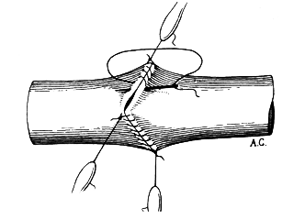
Alexis Carrel's own drawing of the triangulation technique.

(https://sterileeye.com/2008/09/25/triangulation/)

The first attempts to transplant human organs did not involve the use of immunosupressants and they all failed with death of the organ. It was around 1948 when the biologist Sir Peter Medawar discovered the need for immunosuppression in transplant surgery as he researched skin graft rejection on injured World War II soldiers. He was honored with a Nobel Prize in 1958. Following his work, and before immunosupressants were fully understood, surgeons were able to ignore the use of immunosupressants by performing transplants on identical twins. In 1954, Dr. Joseph Murray performed the first successful human kidney transplant in a patient who received a kidney from his identical twin brother. Because identical twins are genetically identical, the recipient’s immune system would not reject the donor kidney, and immunosuppressants were not needed. Besides a successful transplant, the patient was cured of his disease and survived for eight years. Dr. Murray, along with Dr. E. Donnall Thomas, received a Nobel Prize in 1990 for "organ and cell transplantation in the treatment of human disease." However, this severely limited organ transplantation. By the 1960s transplant surgeons were experimenting with immunosupressants and, in 1963, a combination of the immunosuppressant azathioprine and the steroid prednisone produced good results (i.e., the patient survived for one year—at this time, this was considered long term survival). As a result of this success, more kidney transplants were performed and, by 1965, more than 60% of kidney transplant patients had a one year survival rate. Cyclosporine, introduced in the mid-1970s, increased one-year survival rate to 85%. An understanding of the relationship between immunology and organ transplantation led to an increase in organ recipient survival rate and transplant operations. The second obstacle was overcome by 1968.

As kidney transplants became more successful, scientists and surgeons began investigating preservation methods to increase the shelf life of donor organs. They noticed that if a kidney was removed and replaced within one hour, no preservation was necessary. However, if there was a two hour lapse between removal and transplantation, often the kidney did not function properly. They also discovered that external cooling of canine kidneys used in research could be successfully stored for twelve hours. This led to the development of a cold storage method, in which a preservation solution that mimics intracellular fluids could be pumped through the blood vessels of the donor organ. By 1968, this process of organ preservation allowed donor organs at one site to be transported to recipients at another, thus increasing the number of available donor organs and removing the third obstacle to organ transplantation.

A timeline of successful organ transplants

The US Department of Health and Human Services identifies the following transplants as the first of their kind in the world. (https://optn.transplant.hrsa.gov/learn/about-transplantation/history/)

1954—First successful kidney transplant (Immunosuppressants were not needed because the recipient received a kidney from his identical twin brother)
1966—First successful pancreas/kidney transplant
1967—First successful liver transplant
1968—First isolated pancreas transplant
1968—First successful heart transplant
1981—First successful heart-lung transplant
1986—First successful double lung transplant
1989—First successful living related liver transplant
1990—First successful living related lung transplant

Current survival rate

An increased survival rate is an expected outcome of organ transplantations. The survival rate of organ recipients depends on factors such as age and gender, the general health and weight of the patient, the length of time the organ was stored before transplantation, and the patient’s response to anti-rejection medications.

Heart transplant patients can expect an average lifespan of 10 years, while only one-third of all lung transplant recipients survive 10 years. Kidney transplant recipients generally survive 10 to 12 years, and liver transplant patients have been known to survive as long as 30 years or more.

This table compares the average survival rates of heart, liver, kidney, and lung transplant patients.

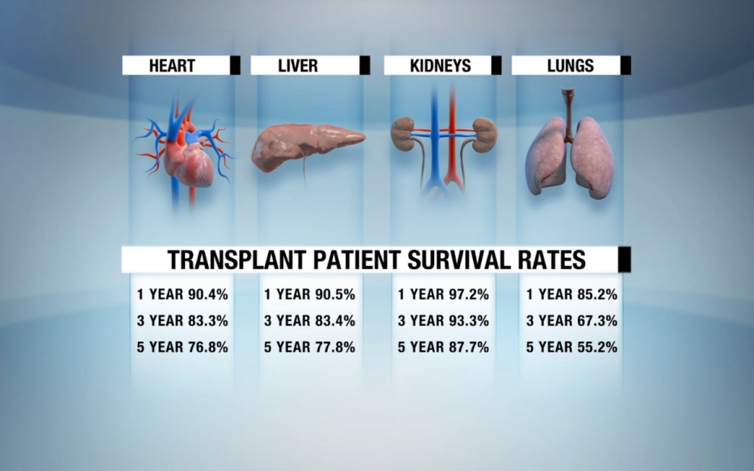

(http://america.aljazeera.com/watch/shows/techknow/blog/2014/2/4/transplant-timelineahistoryoforgandonation.html

The most common conditions causing organ failure that requires transplantation are given below:

Kidneys | Glomerular Diseases, Diabetes, and Hypertensive Nephrosclerosis
Liver | Cirrhosis due to viral hepatitis, Cirrhosis due to fatty liver, Cirrhosis due to alcohol, and Cirrhosis due to autoimmune disease
Heart | Coronary Artery Disease, Cardiomyopathy, and Congenital Heart Disease
Lung | Idiopathic Pulmonary Fibrosis, Alpha-1 Antitrypsin Deficiency, and Emphysema/COPD
Pancreas | Diabetes
(http://www.transweb.org/faq/q32.shtml)

Today, the biggest challenge with organ transplants is that the need exceeds the supply of organs. But medical technology is improving and more donors are becoming available.

Doxorubicin and anthracycline antibiotics

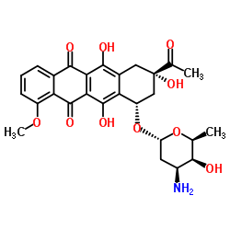
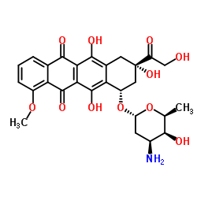
The precursor to the cancer drug doxorubicin was discovered in the 1950s, in soil samples taken from the grounds of a 13th century castle located in Andria, Italy. The soil samples contained a strain of a bacterial species called Streptomyces peucetius, which produced an antibiotic that has major anti-cancer activity. This antibiotic was named daunorubicin. However, daunorubicin was found to cause rare, but fatal, cardiomyopathy. Doxorubicin is a slightly modified form of daunorubicin that is produced by mutating the S. peucetius. This modified anthracycline antibiotic is less toxic than its precursor. Structures and IUPAC names are shown below.
Daunorubicon

(1S,3S)-3-Acetyl-3,5,12-trihydroxy-10-methoxy-6,11-dioxo-1,2,3,4,6,11-hexahydro-1-tetracenyl 3-amino-2,3,6-trideoxy-α-L-lyxo-hexopyranoside [ACD/IUPAC Name]

http://www.chemspider.com/Chemical-Structure.28163.html?rid=02835741-f337-44ec-8265-03cbe5005343
Doxorubicin

(1S,3S)-3-Glycoloyl-3,5,12-trihydroxy-10-methoxy-6,11-dioxo-1,2,3,4,6,11-hexahydro-1-tetracenyl 3-amino-2,3,6-trideoxy-α-L-lyxo-hexopyranoside [ACD/IUPAC Name]

(http://www.chemspider.com/Chemical-Structure.29400.html?rid=46821060-669b-40a5-ba92-2c65ba0cb89f)

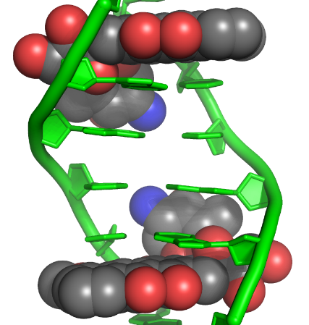
While the exact mechanisms are not fully understood, it is believed that the anticancer effect of the anthracycline antibiotics may involve their interaction with DNA. These drugs inhibit DNA and RNA synthesis of tumor cells. Doxorubicin alters chromatin structure by inserting itself between base pairs in the DNA helix. This insertion prevents DNA replication, resulting in protein synthesis inhibition.
Insertion of doxorubicin between DNA base pairs

https://upload.wikimedia.org/wikipedia/commons/e/ee/Doxorubicin%E2%80%93DNA_complex_1D12.png

Doxorubicin also inhibits topoisomerase II, an enzyme that controls the winding of DNA, by preventing the resealing of the nucleotide strand after double-strand breakage.

The series of images below shows the normal functioning of the topoisomerase enzyme and was produced from the YouTube video called “A Knotty Problem”.

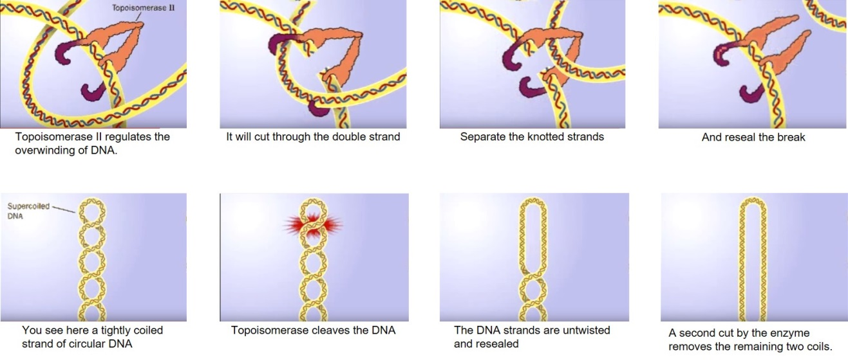

(https://www.youtube.com/watch?v=EYGrElVyHnU).

A serious side effect of doxorubicin is damage to heart muscle by the production of free radicals. Myocardial cells are less able to metabolize free radicals than are other cells. Free radicals can injure lipid structures in the myocardial cell by “stealing” electrons from the lipids. The result is impaired function of the sarcoplasmic reticulum, which regulates muscle contraction, and of the mitochondria, which supply the energy needed for muscle contractions.

Preserving (or perfusing) solutions

A perfused solution supplies an organ with a blood substitute by circulating it through the organ’s blood vessels. The article mentions that a donor’s heart is perfused with a “cold solution containing potassium and other ions.” Two questions come to mind. What is the actual composition of the perfused solution and why is it cold?

The cold solution slows metabolism and inhibits the production of byproducts that can destroy the myocardial cells. The hypothermic solution also deters bacterial growth that results in tissue spoilage.

Perfusion solutions mimic the ionic content of blood and include buffers to maintain a pH of 7.4. However, this hypothermic blood substitute disrupts the normal functioning of the cell membrane. Cell membranes are composed of a phospholipid bilayer, with some surface proteins embedded around the surface. The cold solution causes a phase transition of lipids that affects membrane stability. This results in increased permeability, which contributes to cell swelling. Therefore, perfusion solutions contain osmotic agents to draw the water out of the cells by osmosis.

The most successful organ donor solutions are HES (hydroxyethyl starch); HTK (histidine–tryptophan–ketoglutarate solution); STF (Stanford solution); UW (University of Wisconsin solution); and UW-1 (modified University of Wisconsin solution).

 | HTK | STF | UW | UW-1
Cations
Na⁺ | 15.00 | 20.00 | 30.00 | 125.00
K⁺ | 10.00 | 27.00 | 125.00 | 30.00
Mg²⁺ | 4.00 | – | 5.00 | 5.00
Ca²⁺ | 0.015 | – | – | –
Anions
Cl⁻ | 50.00 | 27.00 | – | –
HPO₄²⁻ | – | – | – | –
H₂PO₄⁻ | – | – | 25.00 | 25.00
HCO₃⁻ | – | 20.00 | – | –
SO₄²⁻ | – | – | 5.00 | 5.00
Substrates and metabolites
Glucose | – | 250.00 | – | –
Glutamate | – | – | – | –
Ketoglutarate | 1.00 | – | – | –
Tryptophan | 2.00 | – | – | –
Adenosine | – | – | 5.00 | 5.00
Metabolically inactive osmotic agents
Mannitol | 30.00 | 60.00 | – | –
d-Raffinose | – | – | 35.40 | 35.40
HES (g/l) | – | – | 50.00 | 50.00
Antioxidants
Lactobionate | – | – | 100.00 | 100.00
Allopurinol | – | – | 1.00 | 1.00
Glutathione | – | – | 3.00 | 3.00
Organic buffers
Histidine | 180.00 | – | – | –
Histidine-HCl | 18.00 | – | – | –
Others
Osmolarity | 310 | 409 | 320 | 320

All concentrations are in mmol/l.

Chemical composition of the most commonly used heart preservation solutions

(http://icvts.oxfordjournals.org/content/20/4/510/T1.expansion.html)

Preservation solution composition is constantly evolving as cost, safety, effectiveness and stability are analyzed.

Immunosuppressants

Cyclosporine is an immunosuppressant drug that is widely used to prevent organ rejection after transplant. It was initially used as an antifungal drug, but when it was discovered that cyclosporine supported skin grafts among rats, it was tested and developed as an immunosuppressant. It functions by impeding T cell activation.

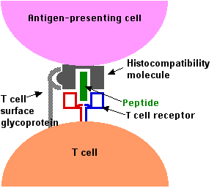
T cells are lymphocytes that form in the thymus and actively participate in the immune response. These are long-lived cells that can survive for 6 months to 10 years. T cells serve many different functions—protection against intracellular bacteria, viruses and virus infected cells, some cancer cells, and foreign tissue grafts. T cells contain receptors on their cell surfaces. The most important receptors on T cells are the receptors for antigen.
T cell receptor binding to MHC-antigen Complex

(https://www.ebi.ac.uk/interpro/potm/2005_3/Page1.htm)

When an organ is transplanted between two individuals, it causes an immune response that results in rejection and destruction of the donor organ by the organ recipient. Each animal possesses its own characteristic set of histocompatibility antigens. T cells recognize fragments of protein antigen on target cells. The peptide fragments are carried to the surface of the cell on special molecules called major histocompatibility complex (MHC) proteins.

The diagram below shows the mechanism of T cell activation. A T cell is activated when it binds to an antigen-presenting cell, or a target cell. This activates a protein called calcineurin to convert an inactive form of the nuclear factor of activated T cells, NFAT (inactive), to an active form of NFAT (active), by the process of dephosphorylation. NFAT are proteins involved in converting DNA into RNA. Cytoplasmic NFAT (active), the dephosphorylated NFAT, then moves to the nucleus of the cell. The addition of NFAT (active) to the nucleus triggers nuclear transcription, the conversion of DNA to RNA, of cytokine genes. This activates a type of cytokine cell called interleukin (IL-2) to be secreted by the cell, where it may bind to IL-2 receptors on the exterior of a T cell. IL-2 regulates T cell proliferation, or cell growth and division. Interleukins are also involved in a series of events which result in immune responses that result in the death of foreign cells.

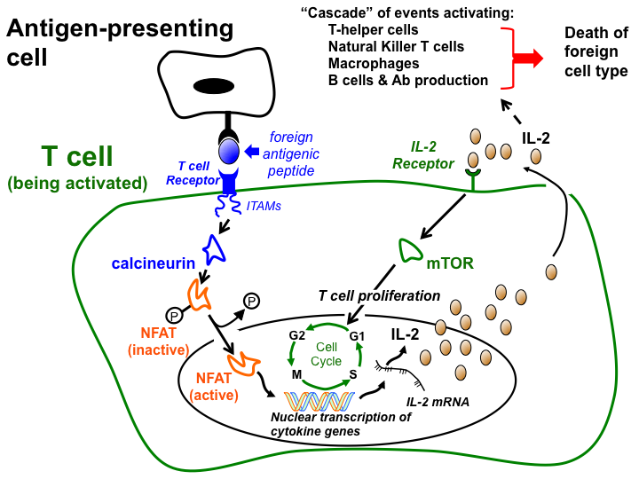

Mechanism of T cell activation

(http://tmedweb.tulane.edu/pharmwiki/doku.php/organ_transplantation?s[]=cell&s[]=activation)

The diagram labelled “The inhibition of calcineurin by cyclosporine” (below) shows how the immunosuppressant drug cyclosporine (CsA) interferes with the activity of T cells. It does this by binding to cyclophilin, (CpN) a protein that is found in all cells. This complex then bonds to the calcineurin. Because the calcineurin is tied up in this complex, it is unavailable to react with the NFAT (inactive), which is the structure labelled NF-ATc – PO₄. This in turn inhibits the production of NFAT (active), NF-ATc. With no NFAT (active) entering the nucleus, nuclear transcription and T cell activation does not occur. The outcome is immunosuppression by inhibition of interleukin.

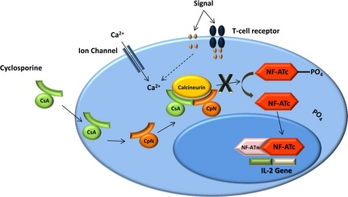

The inhibition of calcineurin by cyclosporine

(https://www.researchgate.net/profile/Cory_Langston/publication/259348441/figure/fig1/AS:267433848078355@1440772606442/Figure-2-Cyclosporine-mechanism-of-action.png)

Another immunosuppressant, tacrolimus, works in a similar manner as cyclosporine, except instead of binding to cyclophilin, it binds to a different immunophilin that is present in the cell. The most common side effects of cyclosporine include hypertension, nephrotoxicity, and vulnerability to viral infections. Test results show tacrolimus to be less toxic to the kidney than cyclosporine, but a common side effect of this drug is post-transplant insulin-dependent diabetes.

Properties of water that affect organ preservation

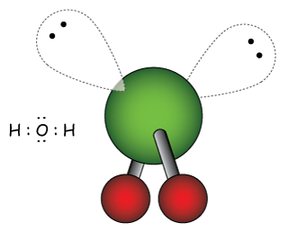
Many of the properties of water can be explained by the electronic structure of the H₂O molecule, which is tetrahedral (if you include the non-bonding pairs of electrons). The oxygen atom is covalently bonded to two hydrogen atoms. Because of the difference in electronegativities between hydrogen and oxygen, the electrons are not evenly distributed in each bond. The oxygen atom carries a partial negative charge, while the hydrogen atoms carry a slight positive charge. Additionally, the oxygen atom has two lone pairs of electrons.
The water molecule is a bent,
polar molecule

(http://www.drcruzan.com/Water.html)

Because of these lone pairs, the water molecule is bent, with a bond angle of about 104.5°. Normally, tetrahedral molecules have bond angles of 109°, but the lone pairs of electrons have larger electron clouds and stronger repulsive forces than the shared pairs of electrons, thus decreasing the H–O–H bond angle.

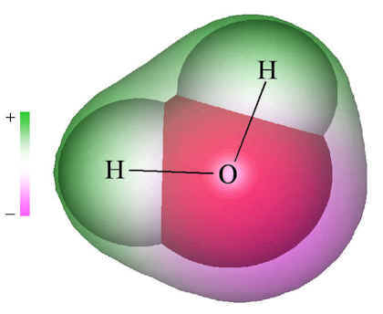
The image of the electrostatic potential of water shows the negative end of the molecule in purple and the positive end of the molecule in green.

Electrostatic potential map of water

(http://www.chm.bris.ac.uk/webprojects2001/morgan/)

Because water is a bent molecule, with each oxygen atom capable of forming two hydrogen bonds with its lone pairs of electrons, water molecules bond together in a three dimensional network. How tightly the water molecules pack together is affected by two opposing forces—hydrogen bonding, which holds the water molecules together, and the movement of molecules caused by kinetic energy.

As water freezes to ice at 0 °C, the kinetic energy of the molecules decreases and the molecules move more slowly. This allows the maximum number of hydrogen bonds to form between the water molecules and results in an ordered hexagonal structural arrangement of water molecules with large open spaces. This is shown in the diagram of ice, below left. This ordered, open arrangement accounts for the low density of ice. (This rigid structure with lots of extra open space between the solid ice molecules is responsible for the problems that freezing presents for organ preservation by freezing.)

However, as the temperature of a sample of ice increases, the kinetic energy increases, resulting in hydrogen bonds that are constantly breaking and reforming. This results in collapse of the rigid hexagonal structure and thus the liquid occupies less space than did the solid, thus increasing the density (remember, D = M/V; as volume decreases, density increases). The diagram of liquid water shows the more random arrangement of water molecules. Water is most dense at 4 °C because the two opposing forces of hydrogen bonding and kinetic motion of molecules are “in balance.” At this temperature, the water molecules are not moving very rapidly, so that more hydrogen bonds form than are broken. This allows for the tightest packing of molecules because the hexagonal structure of the solid has not yet formed, which would push the molecules farther apart. As the temperature continues to rise, kinetic energy increases, movement between molecules increases, and more hydrogen bonds break, allowing the molecules to be farther apart from one another. Thus density decreases. At 100 °C, the kinetic energy is much greater than the strength of the hydrogen bonds, and the molecules can completely separate from one another, causing vapor to form and density to decrease significantly.

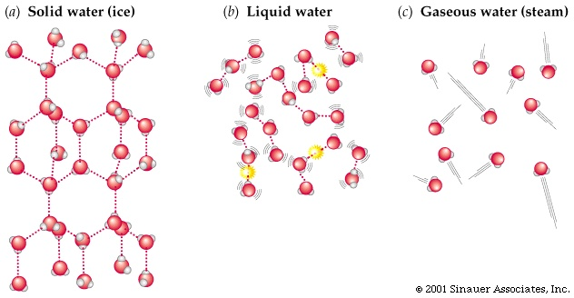

Hydrogen bonds in ice, liquid water, and steam

(http://scienceline.ucsb.edu/getkey.pprevent the formation of ice crystals hp?key=4169)

As water freezes to ice, density increases and this poses a problem in cryopreservation processes. Care must be taken to prevent the formation of large ice crystals that can form in the interstitial spaces between the cells of preserved organs, causing distortion of cells and, ultimately, their destruction.

Hydrogen bonding also accounts for an increase in the viscosity of water as temperature decreases. Viscosity is defined as a liquid’s resistance to flow. This is also a factor in cryopreservation. Viscosity is measured in milliPascal seconds (mP•s), with Pascal measuring pressure or stress. Molecules such as water that hydrogen bond tend to stick together, and their attraction to one another, or their “stickiness” for one another, causes a resistance to flow or stress. As water temperature decreases, the average speed of molecules decreases, and the average intermolecular force of hydrogen bonding increases. This increase in intermolecular forces thus causes an increase in “stickiness” and viscosity. Water is the most abundant material in living cells. At body temperature, 37 °C, water has a viscosity of 0.65 mP•s. At 0 °C, water’s viscosity increases to 1.79 mP•s.

Another property of water that concerns cryopreservation is specific heat. The specific heat is the amount of energy required to raise the temperature of one gram of a substance by one degree Celsius. Specific heat is related to a substance’s internal energy and is related to the number of degrees of freedom of its molecules. The degrees of freedom can be defined as the number of directions in which a particle can freely move. A liquid water molecule, for example, has nine degrees of freedom.

There are three translational degrees of freedom and they include the movement of water from one point in space to another along the x- axis, the y-axis, or the z-axis, or a combination of these dimensions in space.

Water has three rotational degrees of freedom around its center of mass, and they are summarized in the picture below.
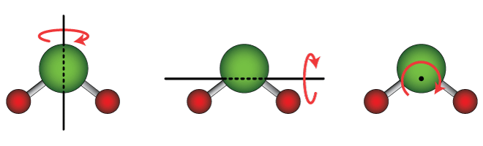
The three rotational degrees of freedom of a water molecule

(http://www.drcruzan.com/Water.html)

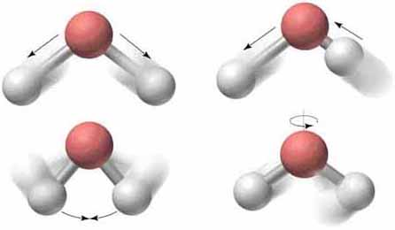
Finally, the water molecule has three vibrational degrees of freedom around its center of mass. They include symmetrical stretching, asymmetrical stretching, and symmetrical bending. The diagram below shows the three forms of vibrational motion and compares it to rotational motion.

Vibration and stretching in water molecules
Clockwise from bottom left,
vibrational bending, symmetrical stretching,
asymmetrical stretching, and rotational motion.

(http://wps.prenhall.com/wps/media/objects/3312/3392504/blb1903.html)

Because of its nine degrees of freedom of motion, water has a high heat capacity. Ice, like all solids, only has vibrational degrees of freedom because of the fixed location of the molecules in the solid. Since ice molecules only have three degrees of freedom of motion, ice has a smaller heat capacity than liquid water. Because of water’s large heat capacity, heating and cooling require large energy changes. Since the specific heat of water is about twice that of ice, it takes about twice as much energy to increase the temperature of water by one degree than it does for ice. This creates some problems for a type of organ preservation called vitrification, which requires rapid cooling and rewarming to prevent the formation of damaging ice crystals. Water’s high specific heat makes this difficult.

Cryopreservation

Cryopreservation is the process of freezing cells, tissues, organs—and even whole bodies—to temperatures of –100 °C and below. At these temperatures, all biological activities and biochemical reactions cease, so living materials can be stored for prolonged periods of time. In this process, formation of ice crystals can damage cells during the freezing process. Two common cryoprotectants are dimethyl sulfoxide (DMSO) and hydroxyethyl starch (HES).

General properties of cryoprotectants are that they:
- are water soluble
- are effective at lowering the freezing point of the liquids in and around cells
- do not precipitate out
- are non-toxic at high concentrations; some cryoprotectants are used in concentrations from 5% up to 60%
- form hydrogen bonds with water

DMSO is an example of a penetrating cryoprotectant. It is a small enough molecule to easily penetrate cell membranes, and it protects the cell from within. It is non-toxic at low concentrations and can easily penetrate cell membranes without causing damage. Its major role is to prevent ice formation within cells. DMSO is actually used in nature by some insects as an antifreeze. One of its benefits is to help keep an osmotic balance in the cell, and it delays the point when salt concentrations begin dehydrating cells.
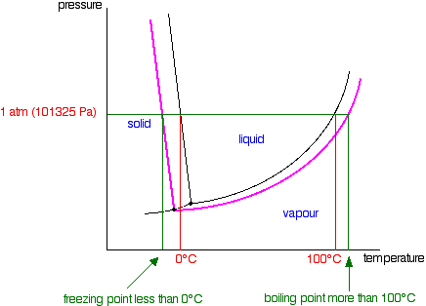
Phase Diagram

(http://chemguide.co.uk/physical/phaseeqia/raoultnonvol.html)
Dimethyl sulfoxide (DMSO) is an example of a cryoprotectant that works to lower the freezing point of water. That is, it causes a colligative freezing effect. The phase diagram can be used to explain how adding DMSO lowers the freezing point of the solution. The black, almost vertical line that separates the liquid phase from the solid phase represents an equilibrium between these two phases and can be used to find the freezing temperatures of pure water at different pressures. The point on this line at 1 atm, normal atmospheric pressure, shows us that pure water freezes at 0 °C. The pink line represents freezing temperatures of a solution. It shows that when DMSO is added to water, equilibrium has shifted and the freezing point has been lowered.

HES, hydroxyethyl starch, is a large polymer and is a non-penetrating cryoprotectant. It functions in the interstitial space outside cells. Because it doesn’t enter cells, it is less toxic than DMSO. Using HES allows for lower concentrations of penetrating cryoprotectants to be used within cells. HES also increases viscosity, which reduces the rate at which water leaves cells. As more water is withdrawn from cells, HES outside cells becomes dilute, and its viscosity decreases. This results in an increased rate of dehydration within the cell as more water molecules are able to leave the cell via osmosis. This slow dehydration is a benefit because now these cells (with less water inside) can be quickly cooled to prevent the formation of ice crystals.

The challenges in cryopreservation involve the cooling and rewarming processes, as both can cause cell damage from ice crystal formation. If water freezes inside the cell, damage occurs to the cell membrane, causing cell leakage. If water freezes outside the cell, pressure on cells caused by the expansion of ice can result in cell distortion and death. Formation of ice crystals resulting in cell damage is more likely to occur when the cooling and rewarming processes occur slowly because slow cooling and rewarming allows larger crystals of ice to form. Water’s high specific heat is responsible for the slow cooling process; since it takes so much heat to change water’s temperature, this process happens slowly. Both penetrating and non-penetrating cryoprotectants counteract this slow cooling. They affect cell concentrations so that more rapid cooling can occur. Both types of cryoprotectants also reduce the formation of ice crystals.

Supercooling

Since the demand for organ transplantation is rapidly increasing, scientists are looking for methods to keep donor organs viable for longer periods of time. The general thought is that if organs can be cooled to temperatures below freezing, metabolism slows down considerably, and organs could be preserved for days or months instead of hours. Could the process of supercooling be used to preserve organs? Let’s begin by defining “supercooling” and using water as an example to describe the process.

Chemists define supercooling as the process of cooling a liquid below its freezing point without crystallization. Water normally freezes at 0 °C, but pure water can be supercooled to
–40 °C. For water to be supercooled it needs to be extremely pure. Otherwise, nucleation initiates the formation of a crystal. In this impure system, a small number of molecules of the pure substance become arranged in a pattern characteristic of a crystalline solid, forming a site upon which additional particles are deposited as the crystal grows.

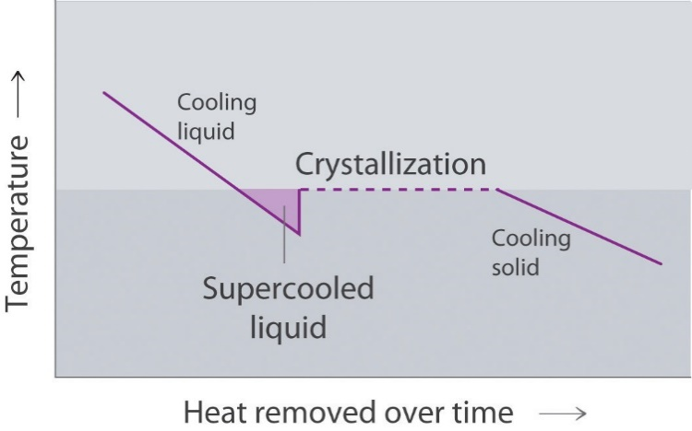
The graph at right shows the relationship between temperature and heat changes during cooling. Freezing is an exothermic process. Heat is removed from the liquid and temperature decreases, as average kinetic energy and molecular movement decreases. The liquid state remains even as the temperature is decreasing below the equilibrium freezing point. This is an unstable equilibrium and something as small as a speck of dust can disturb the equilibrium to initiate crystallization. A small amount of ice begins to form. As water freezes at the nucleation site(s), potential (bond) energy is released as heat energy into the remaining water. This heat energy is in the form of kinetic energy and is indicated by an increase in temperature. The sudden uptick in the temperature on the graph indicates that this change occurs very rapidly. Temperature increases until this system reaches 0 °C. When water reaches its normal freezing temperature of 0 °C, the remaining water freezes, albeit more slowly. As ice crystals form potential energy is released as heat energy. The graph shows that heat energy is being removed and temperature remains constant, indicating that average kinetic energy remains constant. During crystallization the system is in thermal equilibrium since the amount of heat energy produced during the phase change is equal to the heat being removed during cooling. Once all of the water has frozen, as heat continues to be removed, the temperature of the solid will decrease until it reaches equilibrium with its surroundings. This decrease in temperature indicates a decrease in the average kinetic energy of the molecules.
Cooling curve showing supercooling

(http://2012books.lardbucket.org/books/principles-of-general-chemistry-v1.0/s15-05-changes-of-state.html)

The size of the crystals formed are affected by the cooling rate. A faster cooling rate prevents large crystals, because more crystals begin forming and they don’t have time to grow. Larger crystals grow with a slower cooling rate. A faster cooling rate would be beneficial in organ preservation because the smaller crystals that form would do less damage to the living cells.

Besides water, many different solutions can be supercooled, making supercooling a possible method of organ preservation. Research with “supercooled” organs is still in its infancy but looks promising. Scientists at Massachusetts General Hospital have been experimenting with new supercooling techniques using animal livers. Supercooled organs have been stored for up to three days at temperatures of –6 °C and then transplanted into donor animals. All of the animals that received donor organs were healthy at the three month follow-up period. This method involves filling the organ with oxygen and nutrients before supercooling to keep the tissue alive. To protect the organ’s cells from cold and membrane damage, a modified glucose and polyethylene glycol solution was perfused into the cells and then supercooled to –6 °C.

Vitrification

Vitrification is a process in which solutions and water are solidified into a glasslike amorphous solid. Amorphous solids are non-crystalline solids in which the molecules are not arranged in a definite lattice pattern. Plastics, gels, and cotton candy are examples. The liquid-glass transition is a reversible process, where the material changes from a rubbery, viscous substance to a brittle glassy substance. The glass transition temperature occurs at a range of temperatures that is below the freezing temperature of the crystalline solid state of the substance. Vitrification solutions contain cryoprotective agents, carrier solution, and ice blockers.

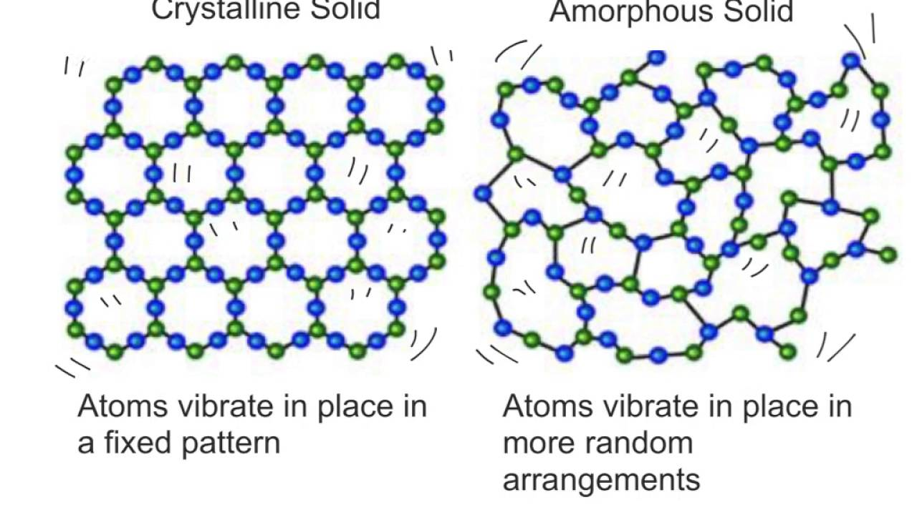
Amorphous solids produced by vitrification are less rigid than crystalline solids.

(https://www.youtube.com/watch?v=Pp_0h9Il5ko)

The cooling rate for vitrification has to be extremely fast—on the order of millions of degrees per second—to prevent nucleation and the formation of ice crystals. In cryogenics, prevention of the formation of ice crystals is extremely important for preservation of organs. So, the vitrification process employs high concentrations of cryoprotective agents before cooling. The downfall of using such concentrated solutions is that the cryoprotectants can be toxic at high concentrations. Researchers have found that using cryoprotectants that are polar and don’t chemically interact with water are best.

Adding carrier solution allows for reduced concentrations of cryoprotective agents to be used. Carrier solutions don’t work like cryoprotectants. Rather, they work to support the cell at temperatures near freezing. These are isotonic solutions that have solute concentrations to match that of their surrounding cells. These solutions contain salts, osmotic agents, and glutathione, an important antioxidant, and pH buffers. This prevents shrinking and swelling of cells. It is important for cell protection that the concentration of these solutions remain constant. Like cryoprotectants, carrier solutions have colligative effects to protect against freezing.

Ice blockers are polymers that work to prevent nucleation and the formation of ice crystals by bonding to ice crystals and contaminants that may trigger ice formation. Use of ice blockers also allows for lesser concentrations of cryoprotectants.

As the vitrification solution is cooled to its glass transition temperature, it rapidly becomes more viscous so that solidification occurs. A faster cooling rate results in a higher glass transition temperature, which causes the amorphous solid to have a lower density and higher viscosity than the crystalline solid, because the molecules don’t have time to arrange themselves in a fixed arrangement. The distance between neighboring molecules varies throughout the solid because of the random arrangement of molecules.

Once vitrification is reached, because all material is at low temperature in solid form, there is little to no metabolic activity and organs can be preserved for long periods of time.

Problems do appear during rewarming of organs. The growth of ice crystals during rewarming is called devitrification. To prevent devitrification, rewarming can take place at very rapid rates, viscous anti-nucleators, like polyvinyl, alcohol can be added to the cryopreservative, and very concentrated non-penetrating cryoprotectants can be used. Since non-penetrating cryoprotectants can be perfused from the body, they can quickly be removed, thus reducing their toxicity.

While vitrification is commonly used to preserve human egg cells and embryos, so far, the only human organ preserved by this method has been the brain. Brains of those individuals wishing to be cryopreserved, with hopes of “coming back”, are stored at a commercial company called Alcor (http://www.alcor.org). The cost for brain preservation is currently $80,000.

Vitrification research has been conducted with animal organs. Recently a rabbit kidney was vitrified, rewarmed and successfully transplanted in a living rabbit with complete functionality. So there is promise for this method of organ transplantation.

References
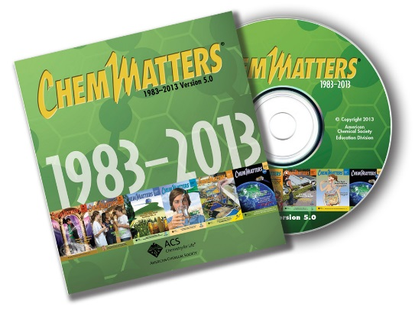
(non-Web-based information sources)
The references below can be found on the ChemMatters 30-year DVD, which includes all articles
published from the magazine’s inception in October 1983 through April 2013; all available Teacher’s Guides, beginning February 1990; and 12 ChemMatters videos. The DVD is available from the American Chemical Society for $42 (or $135 for a site/school license) at this site: http://ww.acs.org/chemmatters. Click on the “Teacher’s Guide” tab to the left, directly under the “ChemMatters Online" logo and, on the new page, click on “Get the past 30 Years of ChemMatters on DVD!” (the icon on the right of the screen).

Selected articles and the complete set of
Teacher’s Guides for all issues from the past three
years are available free online at the same Web site, above. Click on the “Issues” tab just below the logo, “ChemMatters Online”.
30 Years of ChemMatters !
Available Now!

Supercooling is discussed in this article as it relates to the use of sodium acetate trihydrate in heat packs. (Marsella, G. Hot and Cold Packs. ChemMatters, 1987 1 (4), pp 7–12)

This article describes how the shape of snowflakes are the result of two properties of water—its polarity and its shape. The article also describes the rough shape of an ice crystal. (Hazard, A. Science of Snowflakes. ChemMatters, 2009, 27 (4), pp 9–10)

Perhaps we won’t have to worry about preserving organs in the future; engineered organs may someday take the place of “natural” organs. This article discusses engineered organs. (Warner, J. Living with an Artificial Bladder. ChemMatters, 2013, 31 (1), pp 6–8)

Web Sites for Additional Information
(Web-based information sources)
Organ donors

The United Network for Organ Sharing contains data on every organ donation and transplant that has occurred in the United States since 1987.
(https://www.unos.org/data/transplant-trends)

This article discusses how using organs from donors 65 years and older is now more common than in the past. This increases the number of available organs available for transplants.
(http://www.nytimes.com/2016/08/16/health/organ-donor.html)

As more people die from drug overdose, their organs are saving the lives of individuals who would normally die waiting for a donor organ. In 2016, diseased drug users accounted for 12% of all donors in the United States. While drug users are considered high risk for diseases like HIV and hepatitis C, with new screening techniques, the risk of transplanting an infected organ is small.
(http://www.nytimes.com/2016/10/06/us/as-drug-deaths-soar-a-silver-lining-for-organ-transplant-patients.html)

This article describes how the current practice for matching donor organs with recipients is inefficient and results in many organs ending up as medical waste or in research laboratories. Researchers project that a redesigned system could add 10,000 years of life from one year’s worth of donated organs. But, is it a fair system?
(http://www.nytimes.com/2012/09/20/health/transplant-experts-blame-allocation-system-for-discarding-kidneys.html)

A kidney donor discusses the imperfections in the idea of informed consent.
(https://www.washingtonpost.com/national/health-science/at-18-years-old-he-donated-a-kidney-now-he-regrets-it/2016/09/30/cc9407d8-5ff9-11e6-8e45-477372e89d78_story.html)

The U.S. transplant system forbids payment for organs; however, there is a severe shortage of donor kidneys, and some feel that the system should re-evaluate this ban with hopes of relieving the shortage. Researchers surveyed Americans about their willingness to become living kidney donors and how being compensated would affect their thinking. The results of the survey are discussed.
(https://www.washingtonpost.com/news/to-your-health/wp/2016/03/23/what-would-happen-if-you-offered-to-pay-americans-to-donate-their-kidneys/?tid=a_inl)

Doxorubicin and anthrocycline antibiotics

This booklet, which is published by the National Historic Chemical Landmarks Subcommittee of the American Chemical Society, describes the work done by Selman Waksman and his students to detect antimicrobial agents produced by microorganisms. The source will give insight into the deliberate search for chemotherapeutic agents.
(https://www.acs.org/content/acs/en/education/whatischemistry/landmarks/selmanwaksman.html)

Organ cryopreservation

This site describes the procedure and advantages of cryopreservation. (http://www.forbes.com/sites/paulrodgers/2014/06/30/transplant-breakthrough-donor-organs-stored-for-days/#4e7b8f9e1c30)

The invention and patent application describes solutions and methods for preserving donor organs and storing them for extended periods of time before transplantation. (https://www.google.ch/patents/US7029839)

This article discusses some of the advances that are taking place in cryopreservation.
(http://www.lifezette.com/healthzette/so-youd-like-to-freeze-your-kidneys/)

Scientists are studying natural adaptation to cold by amphibians and fish to learn more about cryopreservation with the hopes for “freezing” human organs.
http://www.the-scientist.com/?articles.view/articleNo/34190/title/Icing-Organs/

Perfusion

This article gives a history of organ preservation and perfusion systems: https://www.ncbi.nlm.nih.gov/pmc/articles/PMC3088735/.

3-D organ printing

This short video shows how 3-D printing is helping to revolutionize organ repair and rebuilding. (https://www.youtube.com/watch?v=eZ6GQfXEmyM)

This video show some of the human tissue being produced by 3-D printers that could eventually replace real tissues. (http://qz.com/616185/this-3d-printer-creates-human-muscles-and-tissues-that-could-actually-replace-real-ones/)

Synthetic organs

To combat the problems of organ shortage and to decrease the chance that a patient’s body will reject it, researchers have been working to create synthetic organs from patients’ own cells. (http://www.popsci.com/scientists-grow-transplantable-hearts-with-stem-cells)

