

**February/March 2017 Teacher's Guide**

**Background Information**

**for**

***The Drive for Cleaner Emissions***

**Table of Contents**

About the Guide 2

Background Information 3

References 28

Web Sites for Additional Information 30

# 

# About the Guide

Teacher’s Guide team leader William Bleam and editors Pamela Diaz, Regis Goode, Diane Krone, Steve Long and Barbara Sitzman created the Teacher’s Guide article material.   
E-mail: [bbleam@verizon.net](mailto:bbleam@verizon.net)

Susan Cooper prepared the anticipation and reading guides.

Patrice Pages, *ChemMatters* editor, coordinated production and prepared the Microsoft Word and PDF versions of the Teacher’s Guide.

E-mail: [chemmatters@acs.org](mailto:chemmatters@acs.org)

Articles from past issues of *ChemMatters* and related Teacher’s Guides can be accessed from a DVD that is available from the American Chemical Society for $42. The DVD contains the entire 30-year publication of *ChemMatters* issues, from February 1983 to April 2013, along with all the related Teacher’s Guides since they were first created with the February 1990 issue of *ChemMatters*.

The DVD also includes Article, Title, and Keyword Indexes that cover all issues from February 1983 to April 2013. A search function (similar to a Google search of keywords) is also available on the DVD.

The *ChemMatters* DVD can be purchased by calling 1-800-227-5558. Purchase information can also be found online at <http://tinyurl.com/o37s9x2>.

# Background Information

**(teacher information)**

As mentioned in the Ulrich “The Drive for Cleaner Emissions” article, in designing automobiles, car manufacturers need to balance three fundamental car properties: engine power, engine fuel efficiency, and air pollution. This Teacher’s Guide will discuss each of these, in order.

**Engine Power**

An internal combustion engine is a heat engine that is powered by burning fuel within its cylinders. Both the gasoline engine and the diesel engine are types of internal combustion engines. The difference between them is that a gasoline engine relies on a spark to ignite a gasoline-air mixture within the cylinder, while a diesel engine uses the heat generated from compressing the diesel fuel-air mixture to ignite that very same fuel-air mixture within its cylinder.

Internal combustion engines in cars work on a four-stroke cycle. The diagram below shows cut-away views of the four strokes of a single cylinder in a gasoline engine. During the **induction** stroke (or intake stroke), the inlet valve is open and the piston moves down. This allows the cylinder to fill with an air/fuel mixture. The fuel/air ratio indicates that the mixture contains very little fuel. The stoichiometric ratio (fuel/oxygen) for the complete combustion of octane is a 2:25, or 1:12.5, mole ratio between the octane and oxygen, according to the equation for the combustion reaction:

2 C8H18 + 25 O2 16 CO2 + 18 H2O

Since air contains about 20% oxygen, the octane to air mole ratio is about 1:62.5.

During the **compression** stroke, the piston compresses the air/fuel mixture, the intake valve closes and the exhaust valve remains closed. A spark from the spark plug ignites the gas mixture during the **power** stroke and combustion occurs. The rapid expansion of the hot gases produced, water and carbon dioxide, pushes the piston down. The exhaust valve opens during the **exhaust** stroke and the hot gases escape. Cars today have four, six, or eight cylinders. The piston in each cylinder is connected to a rod and the rods are connected to the crankshaft. The crankshaft converts the up and down motion of the pistons to rotational motion which is then transferred to the wheels.

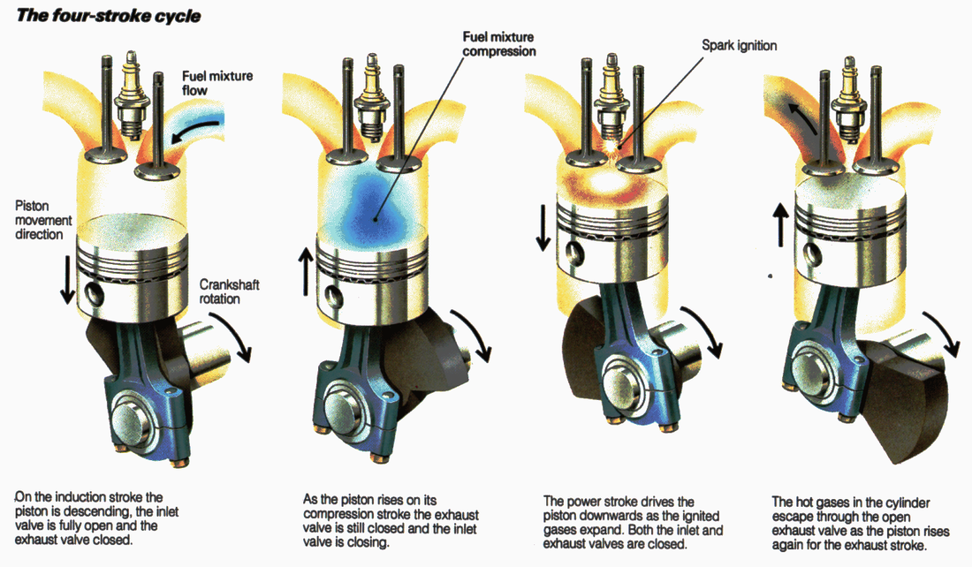

*The four-stroke cycle of a typical internal combustion gasoline engine*

*(*[*http://p3wp3w.weebly.com/blog/industrial-revolution-internal-combustion-engine*](http://p3wp3w.weebly.com/blog/industrial-revolution-internal-combustion-engine)*)*

During the compression stroke in an internal combustion engine, the gases within a cylinder are compressed to a fraction of their original volume. This causes an increase in temperature inside the cylinder. The first law thermodynamics, which is an application of the law of conservation of energy, explains this temperature increase. The first law of thermodynamics states that the total energy of an isolated system is constant; although energy can be transformed from one form to another, it cannot be created or destroyed. The key concepts of the first law of thermodynamics include internal energy, heat, and work.

Work, as defined in physics, is equal to force times distance:

W = F • d

In an internal combustion engine, work is associated with the compression or expansion of gases in the cylinder. In order to compress the gas in the cylinder, an external force must be applied to the piston, causing a decrease in the cylinder’s volume. This requires work to be done on the system. Pressure (P) can be defined as a force (F) that is applied to the surface of an object, per unit area. Area = d• d where d (distance) represents the length and width of a regularly shaped object.

P = F / A = F / d2

Since the volume of a cylinder can be calculated by multiplying the area of its base (d2) by its height (represented by the same length, d), the volume can be represented as d3. And work can be related mathematically to volume and pressure, as follows:

w = F • d = F / (d2 • d3) = (F / A) • d3 = P • V

Thus, a pressure applied to compress a gas that results in a change in volume of the gas is work, and the work done on the gases in the cylinder of an internal combustion engine can be expressed as

w = P • ΔV

A corollary to the first law of thermodynamics (the law of conservation of energy) is that work done on or by a system changes the internal energy of a system. The internal energy of any system can be measured as the sum of its potential and kinetic energy. And a change in internal energy is the result of a change in heat or work into or out of the system and can be expressed as

ΔE = q + w

where ΔE represents the change in the internal energy of a system, q represents the heat added to or removed from the system, and w represents the work done by or on the system. In an internal combustion engine, compression happens so rapidly that there is virtually no heat exchange between the gases in the cylinder and the surroundings; thus, q = 0. This type of system is referred to as an adiabatic system and the above equation can be reduced to:

ΔE = w

This means that the work done on the gases in the cylinder increases the internal energy of the system. As stated above, the internal energy of the system is the sum of the potential energy of the intermolecular attractive forces and the kinetic energy associated with the motion of the molecules. To simplify the explanation, assume that the gases in an internal combustion engine behave as ideal gases. Since there are no attractive forces between ideal gas molecules, the increase in internal energy of the gases (ΔE) in an internal combustion engine results in an increase in the kinetic energy of the molecules. Since temperature is a measure of the kinetic energy of the molecules, the increase in internal energy results in an increase in temperature of the gases in the cylinder.

Simply stated, the work done on the gases in an internal combustion engine cause an increase in internal energy of the gas molecules, which causes an increase in temperature within the cylinder.

The ideal gas equation, P • V = n • R • T, can now be used to determine an approximate temperature of the gases within the internal combustion engine. In the ideal gas equation, P represents pressure, V represents volume, n is the number of moles of gas, R is the gas constant, and T represents absolute temperature in Kelvins.

The compression ratio in a gasoline engine is usually approximately 10:1. The compression ratio is the value that represents the ratio of the volumes of the combustion cylinder, from its largest volume to its smallest volume. A compression ratio of 10:1 means that, during the compression stroke, the air-fuel mixture is compressed to 1/10 the original volume. Compression pressures in gasoline engines have been measured at between 100 to 200 pounds per square inch (psi).

Using the volume, pressure, temperature data in the table below, we can calculate the compression temperature inside a gasoline engine:

|  |  |
| --- | --- |
| **At the End of the Induction Stroke** | **Compression (just before ignition)** |
| Initial volume (V1) = 1.00 L | Final volume (V2) = 0.10 L |
| Initial pressure (P1) = 14.7 psi = 101 kPa | Final pressure (P2) = 200. Psi = 1370 kPa |
| Initial temperature (T1) = 25 °C = 298 K | Final temperature (T2) = ? |

At the end of the induction stroke, just before compression begins:

P1 • V1 = n • R • T1

Since the amount of gas in the cylinder doesn’t change (during the compression stroke), n is constant and, thus, n • R remains constant, and the ideal gas equation can be rearranged to

P1 • V1 / T1 = n • R

or

P1 • V1 / T1 = constant

(101 kPa) • (1.00 L) / 298 K = constant = 0.339 L-kPa / K

This value will remain constant, so we can now use it to determine the compression temperature (T2) in the cylinder at the end of the compression cycle.

T2 = P2 • V2 / constant

= (1370 kPa) • (0.10 L) / 0.339 L-kPa / K = 400 K = 127 °C

The Engineering ToolBox site <http://www.engineeringtoolbox.com/fuels-ignition-temperatures-d_171.html> lists the autoignition temperature of gasoline at 246 °C. Since the temperature of the fuel-air mixture in the compressed cylinder is at about 127 °C and is below the autoignition temperature, the gasoline engine will require a spark plug to explode the air-fuel mixture.

In a diesel engine (see diagram below) the air is compressed, and then the fuel is injected into the cylinder. No spark plug is present. To compensate for the absence of a spark plug, the cylinder is compressed 14 to 25 times its maximum volume during the compression cycle. So, if an engine has a 16:1 compression ratio, a cylinder that has a maximum capacity of 1.00 L when the piston is at the bottom of its stroke (maximum volume), the volume will be reduced to 0.063 L when the piston is at the top of its stroke (minimum volume). At a 16:1 compression ratio, compression pressure has been measured at about 435 psi, and the compressed fuel-air mixture will reach a temperature of about 282 °C. The temperature of the compressed air will be even higher at higher compression ratios.

|  |  |
| --- | --- |
| **At the End of the Induction Stroke** | **Compression (just before ignition)** |
| Initial volume (V1) = 1.00 L | Final volume (V2) = 0. 0.063 L |
| Initial pressure (P1) = 14.7 psi = 101 kPa | Final pressure (P2) = 435 psi = 2987 kPa |
| Initial temperature (T1) = 25 °C = 298 K | Final temperature (T2) = ? |

Since the constant remains 0.339 L-kPa / K,

T2 = P2 • V2 / constant

= (2987 kPa) • (0.063 L) / 0.339 L-kPa / K = 555 K = 282 °C

The Engineering ToolBox table at <http://www.engineeringtoolbox.com/fuels-ignition-temperatures-d_171.html> lists the autoignition temperature of diesel fuel at 210 °C. Since the air in the compressed cylinder is at a temperature that is above the autoignition temperature of diesel fuel, the fuel will combust spontaneously when it is sprayed directly into the cylinder of hot air.

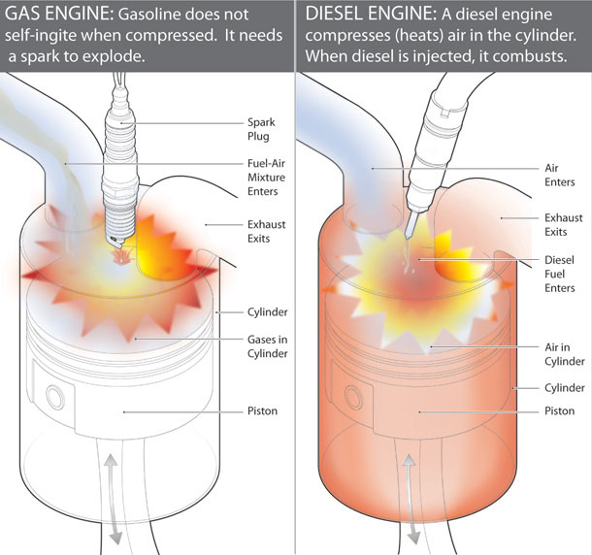

*A comparison of a gasoline engine and a diesel engine*

*(*[*https://www.carmudi.com.ph/journal/buy-car-runs-gasoline-diesel/*](https://www.carmudi.com.ph/journal/buy-car-runs-gasoline-diesel/)*)*

Car manufacturers and auto enthusiasts have applied the physics equation   
Force = Mass x Acceleration to improve acceleration. Since there is an inverse relationship between mass and acceleration, a reduction in the overall weight of a car will increase acceleration. The use of aluminum alloy and magnesium alloy wheels can reduce a car’s weight by about 10 pounds. Replacing a full sized spare tire with a smaller one will also reduce weight and, unfortunately, safety as well. The smaller tire is also narrower and has less plies than a normal tire. This reduces traction and cornering ability. Drag racers will replace heavier forged steel pistons and connecting rods with a lightweight aluminum alloy to reduce their weight by up to 20%. Reducing friction within the engine also improves engine efficiency. Car manufacturers are engineering smoother cylinder walls to reduce power loss due to friction produced by piston movement.

Engine power can also be increased by increasing the amount of air that flows into the engine. The throttle body is the part of the engine’s air intake system. Housed within the throttle body is the throttle, a type of butterfly valve. When a driver presses on the accelerator petal, the throttle opens and more air is pushed into the engine. Sensors within a device called the engine control unit detect the increase in air flow and respond by injecting more fuel into the engine. The increased air flow causes an increase in combustion, which causes an increase in acceleration. Adding a larger diameter throttle body improves engine power by up to 25 horsepower. Kits are available for the DIY auto enthusiast.

*The throttle body is an opening that is part of the air intake system and regulates the amount of air that enters the engine.*

*(*[*https://mike-thomson.com/blog/?p=1178*](https://mike-thomson.com/blog/?p=1178)*)*

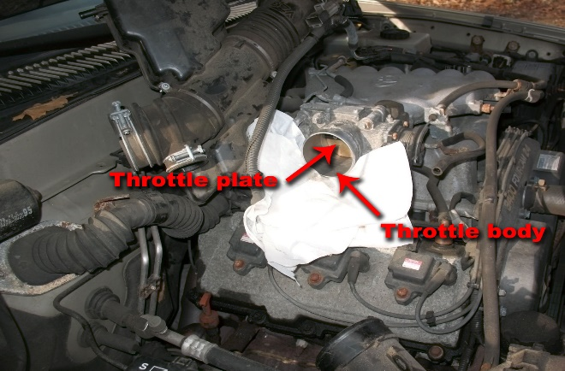

Replacing the manufacturer’s installed air intake system with a cold air intake system will increase power by up to 18 horsepower. The air intake system on a typical car is designed to reduce engine noise by reducing air flow. The reduced air flow is a result of a narrow intake pipe that contains many bends. The cold air intake system contains a wider intake pipe with fewer bends and is located outside the engine compartment. This results in colder, denser air being sucked into the engine. Since more oxygen is available, more fuel is burned.

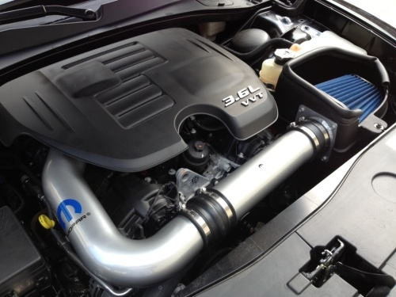

*The cold air intake system is located outside of the engine compartment.*

*(*[*http://moparonlineparts.com/dodge-charger-cold-intake-p-3608.html*](http://moparonlineparts.com/dodge-charger-cold-intake-p-3608.html)*)*

Superchargers and turbochargers are forced air induction systems that provide the greatest power increases. These devices compress the air going into the cylinders from a normal 15 pounds per square inch (psi) to about 22 psi. With more air, more fuel can be added and burned. This increases horsepower by about 50%. A supercharger is powered by a belt that connects directly to the engine, while a turbocharger uses the wasted energy from the exhaust system. Turbochargers are more efficient, but have a greater lag in acceleration.

**Engine Fuel Efficiency**

The number one consideration for most Americans when purchasing a car is fuel economy, or fuel efficiency. (<http://www.cartalk.com/content/what-americans-want-new-car-everything>) Fuel efficiency is defined as the energy that is released by the combustion of a fuel that is converted to useful work. For automobiles, this is the mechanical energy that is used to move the car forward. Energy efficiency is reflected in a car’s gas mileage, or miles per gallon (mpg). The average mid-sized, four-cylinder gasoline-powered car has a fuel efficiency of about 24 mpg, while a diesel engine car has an average fuel efficiency of about 30 mpg—a 25% higher efficiency. New technologies that involve fuel injection systems and improved transmissions are in the works for improving fuel economy in the future.

In the previous section, “Engine Power”, several devices that improve engine power by increasing engine airflow into the engine were discussed. What cost do these devices have on fuel efficiency? The increase in air flow into the engine results in the engine burning fuel lean. This results in a more complete burn of the fuel with less fuel being wasted and pushed out through the exhaust. Superchargers also improve efficiency by decreasing pumping loss, that is, the power needed by the engine to pump the pistons. This decrease in pumping loss is enough to improve fuel efficiency by two to three mpg. Turbochargers are powered by an engine’s hot exhaust gas. This feature is an added benefit to fuel efficiency. In theory, these devices increase both power and fuel efficiency. However, another factor to consider is driver behavior. Many drivers take advantage of the added power with quick accelerations and this greatly reduces gas mileage. The reality is that while devices that increase air flow to the engine can improve fuel economy, often the driver takes advantage of the increased power and the benefits of fuel economy are lost.

It was mentioned that diesel engines are 25% more fuel efficient than gasoline engines in the first paragraph of this section. There are two reasons for this increased fuel economy: a fuel’s energy content, and the thermal efficiency of the engine. First, let’s compare the fuels used in the two types of engines.

Since chemical reactions involve the making and breaking of bonds, the heat of combustion for the above reaction can therefore be predicted by using average bond energies, counting the total number of bonds broken and formed, and recording all of the energy changes.

The heat of combustion is equal to the sum of the total energy used to break the chemical bonds in all of the reactant molecules minus the sum of the total energy released as a result of the formation of bonds in all the product molecules. Breaking bonds is an endothermic process, while bond formation is an exothermic process.

Heat of combustion = total energy input as a result of breaking bonds – total energy released as a result of bond formation.

We can use a table of bond energies such as this one to estimate the heat of combustion of the two types of fuels.



*(*[*http://butane.chem.uiuc.edu/cyerkes/Chem104ACSpring2009/Genchemref/bondenergies.html*](http://butane.chem.uiuc.edu/cyerkes/Chem104ACSpring2009/Genchemref/bondenergies.html)*)*

Gasoline

Gasoline contains a mixture of hydrocarbons that consists of molecules containing from 4 to 12 carbon atoms per molecule. Octane, C8H18, is the hydrocarbon most frequently used to represent the composition of gasoline. The complete combustion reaction for octane is:

C8H18 (l) + 25/2 O2 (g) 🡪 8 CO2 (g) + 9 H2O (g) + heat

To calculate the energy needed to break the bonds of the reactant molecules, count the number of bonds broken for each reactant and multiply those numbers by the corresponding energy for each from the table above and add those energies together. [Note that it may be easier to determine the numbers of bonds broken and formed by drawing the actual structures and then counting the bonds.]

|  |  |  |  |
| --- | --- | --- | --- |
| Bond type broken | Number of moles of bonds broken | Average bond energy (kJ/mol) | Total energy change (*kJ/mol*) |
| C-H (in C8H18) | 18 | 414 | 7452 |
| C-C (in C8H18) | 7 | 347 | 2429 |
| O=O (in O2) | 25/2 | 495 | 6187.5 |

Total energy needed to break the bonds = 16068.5 kJ

Then, to calculate the energy released in forming the bonds of the product molecules, count the number of bonds formed for each product and multiply each of those numbers by the corresponding energy for each from the table above and add the energies together.

|  |  |  |  |
| --- | --- | --- | --- |
| Bond type formed | Number of moles of bonds formed | Average bond energy (kJ/mol) | Total energy change (kJ/mol) |
| C=O (in CO2) | 16 | 799 | 12784 |
| O-H (in H2O) | 18 | 467 | 8406 |

Total energy released from the formation of bonds = 21190 kJ

Heat of combustion = total energy of bonds breaking – total energy of bonds forming

= 16068.5 kJ – 21190 kJ = –5121.5 kJ

Diesel fuel

Diesel fuel is a mixture of hydrocarbons that contain between 12 and 15 carbon atoms per molecule. Taking C13H28 as an example for diesel, we can estimate the heat of combustion for this reaction:

C13H28 (g) + 20 O2 (g) 🡪 13 CO2 (g) + 14 H2O (l) + heat

Calculate the energy needed to break the bonds of the reactant molecules.

|  |  |  |  |
| --- | --- | --- | --- |
| Bond type broken | Number of moles of bonds broken | Average bond energy (kJ/mol) | Total energy change (kJ/mol) |
| C-H (in C13H28) | 28 | 414 | 11592 |
| C-C (in C13H28) | 12 | 347 | 4164 |
| O=O (in O2) | 20 | 495 | 9900 |

Total energy needed to break the bonds = 25656 kJ

Then, calculate the energy released when the product molecules’ bonds are formed.

|  |  |  |  |
| --- | --- | --- | --- |
| Bond type formed | Number of moles of bonds formed | Average bond energy (kJ/mol) | Total energy change (kJ/mol) |
| C=O (in CO2) | 26 | 799 | 20774 |
| O-H (in H2O) | 28 | 467 | 13076 |

Total energy released from the formation of bonds = 33850 kJ

Heat of combustion = total energy of bonds breaking – total energy of bonds forming

= 25656 kJ – 33850 kJ = –8194 kJ

Keep in mind that these are just estimates, because average bond energies were used in the calculations. But we can clearly see that because diesel fuels contain larger hydrocarbons, they produce more energy per mole than gasoline. For this reason, diesel fuel is said to be more energy dense.

The fuel efficiency of both types of engines can also be compared by evaluating their thermal efficiency. Internal combustion engines do work by converting the heat produced by the combustion of a fuel into mechanical energy. The performance of an internal combustion engine is measured by its thermal efficiency. The thermal efficiency of an internal combustion engine compares the heat content of the fuel that is burned to the mechanical energy that is produced. The thermal efficiencies of all internal combustion engines are less than 100% because of engine friction and heat loss. Gasoline engines generally run at 30% efficiency, while diesel engines are about 45% efficient.

A major reason for their difference in efficiencies is because of the higher compression ratio in the diesel engine. In a gasoline engine, the compression ratio is about 10:1, while in a diesel engine the compression ratio can be as high as 16:1. This increased compression ratio results in the compressed air being very hot—beyond the autoignition temperature of diesel fuel. When fuel is sprayed into the combustion chamber, it self-ignites; no spark plug is needed. A gasoline engine needs a spark to ignite its fuel. This results in a time delay between the fuel-air compression and its combustion and, so, there is a loss of heat to the exhaust, with less heat energy being converted to mechanical energy. The higher compression ratio of the diesel engine results in a larger stroke length (the distance the piston travels) converting more of the heat energy into mechanical energy. The higher compression ratio in diesel engines results in greater thermal efficiency. This greater thermal efficiency translates to better fuel efficiency.

The figure below describes why automobile engines are so fuel inefficient. Energy is lost because of engine friction, the use of accessories such as air conditioning and power steering, in the transmission (drivetrain losses), and in overcoming inertia in getting your car to move.

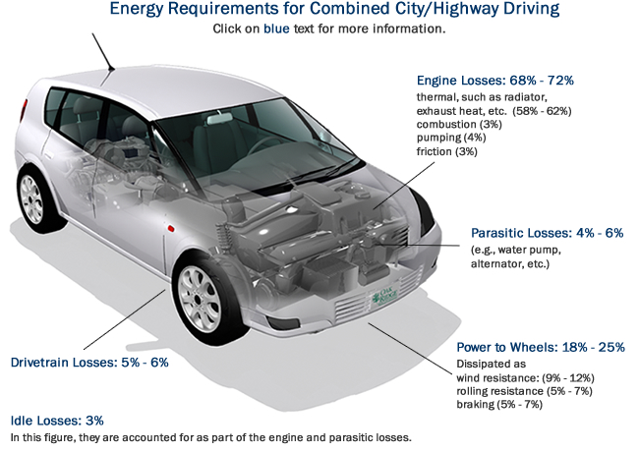

*(*[*https://www.fueleconomy.gov/feg/atv.shtml*](https://www.fueleconomy.gov/feg/atv.shtml)*)*

To improve your own fuel efficiency and thus save fuel, you can use these guidelines from the Union of Concerned Scientists:

**Keep your vehicle well tuned**. Simple maintenance—such as regular oil changes, air-filter changes, and spark plug replacements—will lengthen the life of your vehicle as well as improve fuel economy and minimize emissions. Just follow the schedule in your owner’s manual.

**Check your tires**. Keeping your tires properly inflated and aligned saves fuel by reducing the amount of drag your engine must overcome. Make sure to get a set of low rolling resistance (LRR) tires. Tires that reduce rolling resistance by 10 percent can improve gas mileage by one to two percent for most passenger vehicles.[¹](http://www.ucsusa.org/clean_vehicles/smart-transportation-solutions/better-fuel-efficiency/how-to-maximize-your.html#1) They are now more common on new vehicles, so in some cases it is just a question of buying a new set of the same thing.

**Be weight-conscious**. Don’t carry around items you don’t need. For every 100 pounds of weight in your vehicle, fuel economy decreases by one to two percent. Also, reduce drag by putting bulky items inside the vehicle or trunk instead of on a roof rack.

**Keep track of your fuel economy**. A drop in your vehicle's fuel economy can be a sign of engine trouble. Keep track of your fuel economy by noting the odometer reading and the number of gallons purchased each time you fill up. To calculate your gas mileage, divide the number of miles traveled between fill-ups by the number of gallons purchased. Most hybrid cars and even some conventional gas vehicles have special gauges that make it even easier to keep track of your fuel economy in real-time, so you can see how your driving habits are impacting your fuel efficiency.

**Keep your vehicle well tuned**. Simple maintenance—such as regular oil changes, air-filter changes, and spark plug replacements—will lengthen the life of your vehicle as well as improve fuel economy and minimize emissions. Just follow the schedule in your owner’s manual.

**Drive moderately**. A green light does not signal the start of a NASCAR race. High-speed driving and jack-rabbit starts increase both fuel use and emissions. Going 65 mph on the highway instead of 75 can cut your fuel use up to 20 percent, and making more gradual stops and starts will bring even more savings.

**Don't let your vehicle idle for more than a minute**. During start-up, your engine burns a little extra gasoline. However, letting your engine idle for more than a minute burns more fuel than turning off the engine and restarting it. You can make it easy on yourself by purchasing a vehicle with “stop-start” technology that will automatically shut off the engine and restart it when you take your foot off the brake pedal. This technology, once only found on hybrid vehicles, is beginning to enter the marketplace on conventional gas-powered cars and can cut fuel consumption by around 5 percent.

(<http://www.ucsusa.org/clean-vehicles/fuel-efficiency/how-to-maximize-fuel-economy#.WGpDC1zgnWU>)

**Pollution**

While gasoline and diesel are both mixtures of many hydrocarbons, for simplicity only the combustion of octane will be shown. For the complete combustion of octane, the only end products are water and carbon dioxide.

C8H18 (g) + 25/2 O2 (g) 8 CO2 (g) + 9 H2O (g) + 5074 kJ

Incomplete combustion of octane produces two pollutants, carbon monoxide and soot:

C8H18 (g)  +  17/2 O2 (g)  8 CO (g)  +  9 H2O (g)+ 2810 kJ

C8H18 (g)  +   9/2 O2 (g) 8 C (g)  +  9 H2O (g) + 1926 kJ

The reactions for the incomplete combustion of octane produce carbon monoxide and soot instead of carbon dioxide. Both of these reactions are not as exothermic and are less energy efficient than the complete combustion of octane.

Carbon monoxide causes serious human health risks by reacting with the hemoglobin in red blood cells to form carboxyhemoglobin (COHb). Carbon monoxide is able to displace oxygen from hemoglobin because the carbon monoxide-hemoglobin bond is 200 times stronger than the oxygen-hemoglobin bond. Normally, oxygen is bonded to hemoglobin, which then is transported through the circulatory system via the blood, carrying oxygen throughout the body. But when carbon monoxide is attached to hemoglobin instead of oxygen, the lack of oxygen being transported to the lungs, brain and heart can result in serious and sometimes permanent damage to these tissues.

Symptoms of 10–30 % CO poisoning include headaches, dizziness, fatigue, and flu-like symptoms. At 30–50%, nausea, vomiting, headaches, and breathing difficulties may occur. At CO levels above 50%, death can occur.

Treatment involves breathing pure oxygen and/or hyperbaric oxygen therapy. Breathing pure oxygen in a chamber at high air pressure speeds the replacement of carbon monoxide with oxygen.

Other pollutants that are produced inside a car’s engine are nitrogen oxides (mainly NO and NO2). Air is about 78% nitrogen and about 20% oxygen. Nitrogen and oxygen don’t react at normal air temperatures. However, the heat inside the internal combustion engine provides enough energy for a reaction to occur, and nitrogen monoxide forms.

N2 (g) + O2 (g) + heat 🡪 2 NO (g)

In the presence of excess oxygen, nitrogen monoxide then reacts with more oxygen to form nitrogen dioxide. About 50% of the nitrogen oxides in the atmosphere are produced from motor vehicles.

2 NO (g) + O2 (g) 🡪 2 NO2 (g)

Nitrogen dioxide is involved in the tropospheric production of ozone. NO2­ dissociates in the presence of sunlight:

NO2 (g) + h*ν* 🡪 NO (g) + O● (g)

The very reactive oxygen atom reacts with an oxygen molecule to form ozone:

O● (g) + O2 (g) 🡪 O3 (g)

On sunny days, when nitrogen dioxide concentrations are high, ozone levels can become dangerous for living things. Levels in excess of 125 parts per billion are considered unhealthy. A simple test for high ozone levels is to place a new stretched rubber band in a test area. After two weeks, any cracks on the rubber band indicate ozone is present.

Carbon monoxide is also responsible for the formation of ozone. On sunny days, ultraviolet radiation of wavelengths less than 320 nm provides the energy to dissociate tropospheric ozone into oxygen molecules and excited oxygen atoms (oxygen radicals).

O3 (g) + h*ν* 🡪 O2 (g) + O● (g)

The excited oxygen atoms react with water vapor to produce hydroxyl radicals.

O● (g) + H2O (g) 🡪 2 ●OH (g)

These very reactive hydroxide radicals react with carbon monoxide molecules to produce the carboxyl radical (●HOCO).

●OH (g) + CO (g) 🡪 ●HOCO (g)

The carboxyl radical reacts with oxygen to produce a peroxy radical (and a carbon dioxide molecule).

●HOCO (g) + O2 (g) 🡪 HO2● (g) + CO2 (g)

The peroxy radical then reacts with nitrogen monoxide to produce nitrogen dioxide and another hydroxyl radical.

HO2● (g) + NO (g) 🡪 ●OH (g) + NO2 (g)

This is followed by the photolysis of the nitrogen dioxide, producing nitrogen monoxide and an excited oxygen atom.

NO2 (g) + h*ν* 🡪 NO (g) + O● (g)

The excited oxygen atom produced from this reaction reacts with an oxygen molecule to produce ozone.

O● (g) + O2 (g) 🡪 O3 (g)

Besides being involved in the production of ozone, nitrogen oxides are also involved in the production of nitric acid:

4 NO2 (g) + 2 H2O (l) + O2 (g) 🡪 4 HNO3 (aq)

Since 1970, the Environmental Protection Agency (EPA) has established emission standards for carbon monoxide, hydrocarbons, nitrogen oxides, and particulate matter. As a result of a collaborative effort from vehicle manufacturers, fuel manufacturers, government, and individual citizens, air pollution from cars has been significantly reduced.

**Safety**

Striking a balance between safety, fuel efficiency, and horsepower is a complex issue. Fuel efficiency guidelines encourage smaller and lighter cars. As a result of the Arab Oil Embargo of 1973–74 and the resulting rise in fuel prices, regulations were enacted to improve average fuel economy of cars and light trucks produced for sale in the United States. In response to these new regulations, the average vehicle weight decreased by almost 1,000 pounds. Because of added safety features and consumer demand for more accessories, the average weight of cars has increased again. Newton’s laws of physics that explain the relationships between force, momentum, and impulse can explain why heavier cars are safer.

Force can be defined as mass x acceleration:

F = m • a

and acceleration can be defined as change in velocity / time. So:

F = m • Δv / t

Rearranging this equation results in:

F • t = m • Δv

Impulse is defined as force x time

I = F • t

And since F • t = m • Δt

I = m • Δt

Momentum (p) can be defined as mass x velocity, or:

Ρ = m • v

So, a change in momentum would be expressed as m • Δv

Since impulse = m • Δv

and change in momentum = m • Δv,

impulse = change in momentum, or I = Ρ

When two cars collide, the forces on each are equal but in opposite directions. In a collision, the cars experience an impulse (F • t) which is equal to a change in momentum (m • Δv)

Using the following symbols:

Fl = the force of the lighter car Fh = the force of the heavier car

ml = the mass of the lighter car mh = the mass of the heavier car

Δvl = the change in velocity Δvh = the change in velocity

of the lighter car of the heavier car

Thus,

Fl • t = Fh • t

and

ml • Δvl = mh • Δvh

The equation shows the lighter car (smaller m) will have the greater change in velocity (larger Δv). This results in greater forces on the occupants with higher risk of injury.

Size is also a safety factor. To protect occupants in crashes, cars have structural designs called crumple or crash zones in the front end and sometimes in the rear and the sides of cars. These zones are designed to deform and crumple or crush in a collision and they require a lot of space, something small cars don’t have. A common design of crush zones is a honeycomb design, because this design can easily crumble in a gradual way during a crash. Newton’s second law of physics, F • t = m • Δv, shows that by increasing the time of the crash, the forces acting on the car decrease. The crumple zones are designed to add time to the crash by absorbing energy, as well as converting some of the energy of impact into sound and heat, thus reducing the initial impact. Larger cars have larger crumple zones, so they’re safer than smaller cars in crashes.

Two important safety features that are found in the passenger compartment are airbags and seatbelts. Airbags reduce and redistribute force in the passenger compartment. The components of the airbag system include the airbag, the crash sensor, the inflation system, and the igniter, which is contained in the reaction canister. The canister contains sodium azide, potassium nitrate, and silicon dioxide.

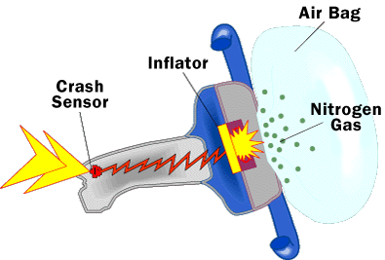

*How a typical airbag works*

*(*[*http://auto.howstuffworks.com/car-driving-safety/safety-regulatory-devices/airbag1.htm*](http://auto.howstuffworks.com/car-driving-safety/safety-regulatory-devices/airbag1.htm)*)*

A crash activates the sensor which sends an electric signal to the ignitor. The ignitor provides the activation energy to cause the decomposition of sodium azide (NaN3), producing sodium metal and nitrogen gas. The reactive sodium metal then reacts with the potassium nitrate (KNO3) to produce more nitrogen gas and metal oxides. The silicon dioxide (SiO2) reacts with the metal oxides to produce non-toxic silicate glass (Na2K2SiO4). 130 grams of sodium azide will produce 67 liters of nitrogen gas within 0.03 seconds of sensor activation.

Reaction 1: 2 NaN3 🡪 2 Na + 3 N2

Reaction 2: 10 Na + 2 KNO3 🡪 K2O + 5 Na2O + N2

Reaction 3: K2O + Na2O + SiO2 🡪 Na2K2SiO4 (alkaline silicate glass)

(<http://www.docslib.org/view/the-chemistry-of-airbags-c11209_e0e6383e718b15d5.html>)

The main function of seatbelts is to keep the occupants in a car during a crash. The laws of inertia state that an object in motion will remain in motion unless acted on by an outside force. When a car is in a collision, the outside forces acting on it cause it to decelerate. If an occupant riding in the car is not wearing a seatbelt, the occupant will continue to move with the same speed and direction as before the collision. Because the car has decelerated, but the occupant has not, the occupant may hit the dashboard, or be thrown from the car. If the occupant is wearing a seatbelt, s/he will decelerate with the car. The webbing material that seatbelts are made of give them stretch a bit. This stretch reduces the impact force of a crash by increasing the stopping distance thus causing controlled deceleration. The two straps of a seatbelt are designed to distribute the forces of a collision to the stronger parts of the body such as the pelvis and chest. The use of seatbelts by front seat passengers has reduced the risk of fatal injuries by almost 50%.

One way to conserve fuel and improve safety is to reduce speed limits. The Insurance Institute for Highway Safety (<http://www.iihs.org/iihs/news/desktopnews/speed-limit-increases-cause-33-000-deaths-in-20-years>) has data to show that “each 5 mph increase in the maximum speed limit resulted in a 4 percent increase in fatalities. The increase on interstates and freeways, the roads most affected by state maximums, was 8 percent.”

Physics explains why larger cars are safer than smaller cars. The good news is that new technologies are making all cars safer. Engineers are designing more creative ways to absorb the energy of impact in smaller cars. Smaller cars are designed so that tires, wheels, and suspensions “fly off” on impact to redistribute the force of impact. Since 2012, the government requires electronic stability control in all cars to prevent sideway skidding and loss of driver control that can lead to rollovers. Honda’s Advanced Compatibility Engineering body structure is designed to disperse impact force. And smaller cars are being equipped with crash boxes that are fastened to the reinforcement beam that attaches to plastic bumpers to absorb the energy from a crash. The table below shows that all cars are becoming safer.

|  |  |  |  |
| --- | --- | --- | --- |
| **Driver deaths per million registered passenger vehicles  1–3 years old, Source: IIHS** | | | |
|  | **Vehicle Size** | **Rate (2005)** | **Rate (2011)** |
| Cars | Mini | 144 | 65 |
| Small | 106 | 56 |
| Midsize | 70 | 34 |
| Large | 67 | 44 |
| Very Large | 44 | 24 |

*(*[*https://www.edmunds.com/car-safety/are-smaller-cars-as-safe-as-large-cars.html*](https://www.edmunds.com/car-safety/are-smaller-cars-as-safe-as-large-cars.html)*)*

While data show that smaller cars are not as safe as larger cars, they have advantages of better fuel efficiency, easier maneuverability, and are less expensive to own. And their deaths-per-million-vehicles rate has improved dramatically since 2005.

**Nomenclature**

You may have noticed that several different naming systems have been used to identify compounds in this article. CO2 is carbon dioxide, NO2 is named nitrogen dioxide, but NO is named nitric oxide. And then there is “ammonia” for NH3 and “blue vitriol” for CuSO4•5H2O. Why are there different naming systems, and which should we be using with our students?

Let’s look at how “ammonia” and “blue vitriol” got their names. The ancient Romans first noticed a crystalline deposit in the temple that the Egyptians had built to the Sun-god Amun. They named this substance sal ammoniac which translates to salt of Amun. Joseph Priestley later noticed that heating sal ammoniac produced a gas with a pungent odor. This gas was eventually named ammonia. The name tells us nothing about its chemical formula. “Blue vitriol” was the name given to copper(II) sulfate pentahydrate because crystals of this blue substance resembled pieces of colored glass. Vitriol comes from the Latin word “vitriolum” which means glassy. Again, the name tells us about a property of the compound, but nothing about its chemical formula. When “ammonia” and “blue vitriol” were named, because their chemical composition was not known, their names were based on where they were found, or what they looked like.

Common names are based on chemical formulas, but the names have to be memorized. For common naming, those compounds with “ous” have a lower oxidation number while those with “ic” have a higher oxidation number. The common name for N2O is nitrous oxide, while the common name for NO is nitric oxide. In N2O, nitrogen has an oxidation number of 1+ and in NO, nitrogen has an oxidation number of 2+.

The systematic name is the preferred name and is determined by guidelines set forth by the International Union of Pure and Applied Chemistry (IUPAC). The rules for naming simple covalent compounds is to use prefixes to indicate how many atoms of each type of element are shown in the formula. The mono prefix is not used for the first element in the formula. The “o” and “a” endings of these prefixes are dropped when they are attached to oxygen. The ending of the last element is changed to “-ide.” The elements are written in the formula from least electronegative to most. Basically, elements are placed in the formula according to their left to right location in the periodic table. The one exception is to place hydrogen between nitrogen and oxygen, because its electronegativity falls between these two elements.

|  |  |
| --- | --- |
| **Number of atoms of that element in the formula** | **Prefix** |
| 1 | mono  (most electronegative only) |
| 2 | di |
| 3 | tri |
| 4 | tetra |
| 5 | penta |
| 6 | hexa |

Here are a few examples: PH3 is named phosphorus trihydride; N2O3 is named dinitrogen trioxide; NO is named nitrogen monoxide.

**Catalysis**

One of the requirements for a chemical reaction to occur is that the reacting molecules or atoms must collide with one another with enough kinetic energy so that products can form. This minimum energy needed to get the reaction started is called the activation energy. We can use the Maxwell-Boltzmann Distribution curve (below) to relate the activation energy of a reaction to the energy distribution of the reactant particles. The distribution curve shows the energy dynamics of the particles at a particular temperature. Keep in mind that the particles are moving around and colliding with each other and energy is being transferred among particles. The kinetic energy of each particle can change over time and not all particles have the same amount of energy. At any given time, most of the particles will have kinetic energies that are close to the average kinetic energy of the sample, while few particles will have very low energies or very high energies. Now suppose a particular reaction has a high activation energy. Since at any given time very few of the particles have high kinetic energy, the reaction will occur at a very slow rate.

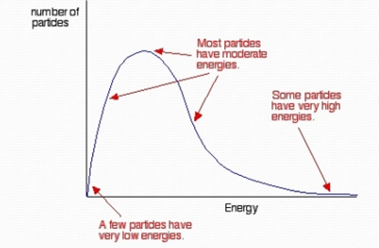

*Maxwell-Boltzmann Distribution Curve*

*(*[*http://www.slideshare.net/fitrinajiha/reaction-kinetics-29026232*](http://www.slideshare.net/fitrinajiha/reaction-kinetics-29026232)*)*

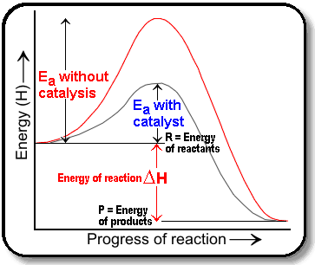 Catalysts speed up chemical reactions by providing a new pathway with a lower activation energy (Ea) for the reaction than is possible without them. While a catalyst is part of a chemical reaction and plays a crucial role therein, it is not one of the end products, nor is it a reactant, per se. That is, the catalyst is not consumed in a chemical reaction. The diagram at right compares the activation energy of an uncatalyzed reaction with that of a catalyzed reaction.

*(*[*http://chmstrylover.blogspot.com/2011/02/introduction-kinetics-study-of-rates-of.html*](http://chmstrylover.blogspot.com/2011/02/introduction-kinetics-study-of-rates-of.html)*)*

With the lower energy requirement provided by a catalyst, more molecules in the reaction will have enough energy to react, thus increasing the rate of the reaction (see diagram at left). Without the catalyst, only the particles represented by the gray area at the right of the curve have energies great enough to react. With the catalyst, the particles represented by both the pink and gray areas have energies great enough to react. Since more molecules can react, the catalyzed reaction will occur at a faster rate.

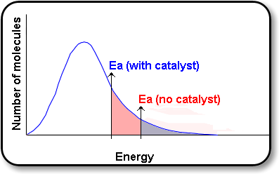

*(*[*http://alevelchem.tumblr.com/post/73107314003/rates-of-reaction-3-catalysts-can-also-be*](http://alevelchem.tumblr.com/post/73107314003/rates-of-reaction-3-catalysts-can-also-be)*)*

There are two types of catalysts, homogeneous and heterogeneous. Homogeneous catalysts are in the same phase of matter as the reactants and products, while heterogeneous catalysts are in a different phase than the reactants. For example, the catalytic converter in your car is a heterogeneous catalyst, where the catalyst is a solid and reactants and products are gases.

In the case of the catalytic converter, the catalyst is in the solid phase. It is usually a precious metal such as platinum, palladium, or rhodium. A very thin layer of the catalyst is coated on a ceramic material thus increasing the surface area of the metal. The reactants are gases such as CO, NO, and NO2, and unburned hydrocarbons.

The route by which an [sic] heterogeneous catalyst works is as follows:

Firstly the reactants are adsorbed on to the surface of the catalyst. This is a chemical reaction as there is an interaction between the electrons of the reactants and the atoms on the surface of the catalyst.

(Remember that **ad**sorption and **ab**sorption are different. In **ad**sorption a molecule binds to the surface of the material whilst in **ab**sorption it is taken in to the body of the material.)

Secondly the adsorbed reactants (particularly the lighter ones such as hydrogen) are free to migrate over the surface of the catalyst.

Thirdly, when the reactants meet they are free to react but are still bound to the surface.

Finally the products of the reaction are desorbed from the surface allowing them to move away and freeing up catalytic surface area for further reactions.

This points up that a good catalyst should bind moderately well to the intended reactants and products.

(<http://spaceflight.esa.int/impress/text/education/Catalysis/index.html>)

This diagram compares the activation energies (energy barriers) of a non-catalyzed reaction to the catalyzed reaction. The activation energy (the energy barrier) for the uncatalyzed reaction is much greater than that for the catalyzed reaction. For the catalyzed reaction, notice that there are three chemical reactions taking place that have small activation energies (or energy barriers) to overcome. The first chemical reaction takes place during the process of adsorption and usually requires a small activation energy. A second step occurs when the reactants, which are free to move along the surface of the catalyst, do so and meet. The second activation energy occurs when these adjacent molecules react to form the product, but are still bonded to the surface of the catalyst. The third activation energy is needed during the process of desorption so that the products can move away from the surface, thus freeing up the catalyst’s surface for further reactions. This last step hints at the requirement of a catalyst that will attract strongly to reactant molecules, but will bind relatively loosely with the product molecules, so that they can move along its surface, and ultimately leave the surface after reacting.

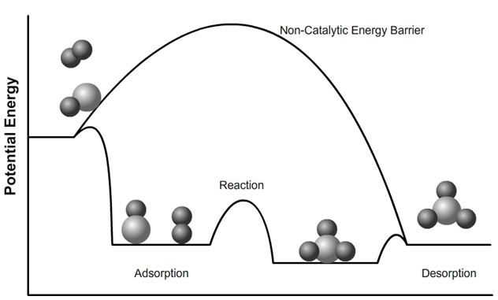

*Potential energy diagram showing catalyzed vs non-catalyzed reaction*

*(*[*http://spaceflight.esa.int/impress/text/education/Catalysis/index.html*](http://spaceflight.esa.int/impress/text/education/Catalysis/index.html)*)*

Transition metals have several properties that make them suitable as catalysts. Because catalytic converters function at high temperatures, the relatively high melting points of these metals is an advantage. Several of the reactions that occur in a catalytic converter are oxidation-reduction reactions. Since transition metals have multiple oxidation states and d-orbital outer electrons, they can easily donate and accept electrons from the reacting species. Platinum, rhodium, and palladium are the metals of choice for catalytic converters. These metals are expensive, and copper and nickel are cheaper alternatives. But nickel and copper are easily “poisoned” by traces of sulfur dioxide that are present in the exhaust, as these metals have a high affinity for sulfur.

In order to reduce emissions, car engines are programmed to burn their fuels in as close to the stoichiometric balance as possible. However, based on driving conditions, this air/fuel ratio can vary, and varying amounts of poisonous carbon monoxide, hydrocarbons, and nitrogen oxides are produced. Because there are three regulated emissions being removed by the catalytic converter, it is referred to as a three-way catalytic converter because it removes three harmful pollutants from the exhaust—carbon monoxide, nitrogen oxides, and unburned hydrocarbons.

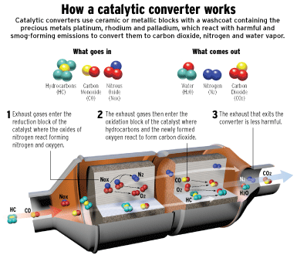

*(*[*http://carcare.sg/resources/your-car-catalytic-converter-important/*](http://carcare.sg/resources/your-car-catalytic-converter-important/)*)*

In a catalytic converter, a reduction stage uses platinum and rhodium to help decrease the amount of nitrogen oxide emissions. Reduction reactions are favored in a fuel rich (large fuel/oxygen ratio).

Reduction reaction: 2 NO2 🡪 N2 + 2 O2

Oxidation reaction: N2 + 2 O2 🡪 2 NO2

When an NO or NO2 molecule contacts the catalyst, the catalyst separates the nitrogen atom from the rest of the molecule and holds on to it, freeing the oxygen in the form of O2. The nitrogen atoms freely move along the catalyst surface and bond with other nitrogen atoms that are also stuck to the catalyst, forming N2.

A second stage of the catalytic converter decreases the amount of unburned hydrocarbons and carbon monoxide by burning, or oxidizing, them over a platinum and palladium catalyst. (See illustration below for a description of the role of platinum in this process.) This catalytic stage requires a lean burn (excess oxygen) and aids the reaction of the CO and hydrocarbons with the remaining oxygen in the exhaust gas according to these reactions:

1. 2 CO + O2 🡪 2 CO2
2. CH4 + 2 O2 🡪 CO2 + 2 H2O

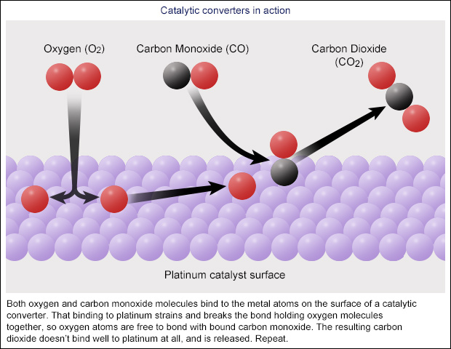

*The role of platinum in converting CO to CO2 in a catalytic converter*

*(*[*http://www.abc.net.au/science/articles/2015/05/25/4229949.htm*](http://www.abc.net.au/science/articles/2015/05/25/4229949.htm)*)*

A control system monitors the exhaust stream to control the [fuel injection system](http://auto.howstuffworks.com/fuel-injection.htm). There is an oxygen sensor mounted between the engine and the catalytic converter that communicates to the engine computer how much oxygen is in the exhaust. The engine computer can increase or decrease the amount of oxygen in the exhaust by adjusting the air-to-fuel ratio. This control system allows the engine computer to make sure that the engine is running at close-to-the stoichiometric point, and can adjust the amount of oxygen in the exhaust to allow for the oxidation and reduction reactions to occur.

Catalytic converters work at fairly high temperatures. Since diesel engines run cooler than standard engines, catalytic converters in diesel engines do not work as well in reducing nitrogen oxides. Some diesel cars are equipped with a selective catalytic reduction system to more effectively remove nitrogen oxides. A urea solution is injected in the exhaust pipe before it gets to the converter. This can remove more than 90 percent of the nitrogen oxides in exhaust gases.

**Molecular Sieves**

When you first start your car, the catalytic converter does almost nothing to reduce the pollution in your exhaust. A catalytic converter only functions when it has been heated. Also, the catalytic converter is ineffective in reducing nitrogen oxides to nitrogen and oxygen when running under lean exhaust conditions (excess oxygen), as excess oxygen present in the exhaust favors oxidation reactions. NOx adsorption was developed to allow for the removal of NOx under those conditions when the catalytic converter cannot function. NOx adsorbers are composed of zeolites (at right) because of their precise pore size and adjustable acidity. NO and NO2 are acidic oxides. If a basic oxide coating is placed on the zeolite, NO and NO2 can be trapped under lean conditions. Under rich conditions, the stored NOx can be catalytically reduced to N2 and H2O. The function of NOx adsorption is to compensate for the limits of a three-way catalyst.

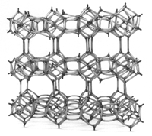

*A typical zeolite structure*

*(*[*http://www.zeoponix.com/zeolite.htm*](http://www.zeoponix.com/zeolite.htm)*)*

The cage-like structure of zeolites and other molecular sieves makes them useful for filtration and separation. Some of the uses for molecular sieves are in water purification and air filtration, where they act as molecular filters to remove impurities. The diagram below demonstrates how contaminated water is purified. Only the smaller water molecules adhere or adsorb to the microscopic pores. During the process of desorption, the purified water molecules are released.

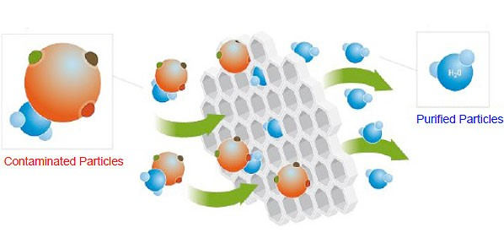

*Molecular sieve purifying contaminated water*

*(*[*http://www.ecoroqfilters.com.au/how-it-works.html*](http://www.ecoroqfilters.com.au/how-it-works.html)*)*

**More on** **“defeat devices”**

According to the EPA, a defeat device “is an auxiliary emission control device (AECD) that reduces the effectiveness of the emission control system under conditions which may reasonably be expected to be encountered in normal vehicle operation and use.” (<http://www.theicct.org/sites/default/files/publications/ICCT_defeat-devices-reg-briefing_20160322.pdf>) There is a clause in the regulation that allows such devices for protecting the engine against damage or accident and for the safe operation of the vehicle, and is to only be used during engine starting. Audi, a car manufacturing company owned by Volkswagen, originally developed the defeat device software in 1999 for their 3.0-liter V6 diesel engine. Diesel engines produce a characteristic rattle noise that is caused by ignition lag (the time interval between the start of fuel injection and the start of combustion). To reduce the rattle noise, Audi developed a device that injected additional fuel into the engine upon ignition. But the additional fuel increased emissions. Their solution was to develop a defeat device that would reduce emissions when the device detected a car undergoing emission testing.

Before Volkswagen opted for the defeat devices in their diesel engines, Volkswagen considered using selective catalytic reduction technology that uses ammonia to break down harmful nitrogen oxide emissions produced by diesel engines into nitrogen and water. This technology requires a special urea tank that requires refilling. However, since VW did not own the technology, they would have had to lease it from Mercedes-Benz, and that would have increased the price of the cars. VW then tried a “Lean Trap” method that would trap nitrogen oxide emissions in a catalytic converter. Occasionally running the engine in a fuel rich mode would convert the nitrogen oxides to nitrogen and oxygen. This lead to premature failure of the soot filters and added costs and fuel consumption. So, Volkswagen opted to install the defeat device designed by Audi. This device was installed on the firewall underneath the dashboard and contained software code to activate full emission controls only when the car was being tested. Under normal driving conditions, these cars emitted nitrogen oxides at levels that were 40 times higher than what is allowed by law.

# References

**(non-Web-based information sources)**

**The references below can be found on the *ChemMatters* 30-year DVD, which includes all articles   
published from the magazine’s inception in October 1983 through April 2013; all available Teacher’s Guides, beginning February 1990; and 12 *ChemMatters* videos. The DVD is available from the American Chemical Society for $42 (or $135 for a site/school license) at this site:** [**http://ww.acs.org/chemmatters**](http://www.acs.org/chemmatters)**. Click on the “Teacher’s Guide” tab to the left, directly under the “*ChemMatters Online"* logo and, on the new page, click on “Get the past 30 Years of *ChemMatters* on DVD!” (the icon on the right of the screen).**

**Selected articles and the complete set of   
Teacher’s Guides for all issues from the past three   
years are available free online at the same Web site, above. Click on the “Issues” tab just below the logo, *“ChemMatters Online”*.**



***30* Years of *ChemMatters !***

Available Now!

This article discusses the pros and cons of using methanol as a fuel replacement to gasoline, and its potential to reduce air pollution. (Berlfein, J. Alcohol in Your Tank. *ChemMatters*, 1988, *6* (4), pp 10–12)

There is useful information in this article about how a diesel engine compares to a gasoline engine. (Alper, J. Rudolf’s Diesel Engine. *ChemMatters*, 1990, *8* (4), pp 10–13)

This article discusses the pollution produced by diesel engines. (Alper, J. Diesel under Pressure. *ChemMatters,* 1991, *9* (1), pp 12–14)

This 1993 article discusses alternatives to the lead-acid battery needed to produce a practical electric car. (Holtzman, D. Electric Cars. *ChemMatters*, 1993, *11* (2), pp 4–7)

This experiment allows students to explore how CO2 behaves when released into the atmosphere. (Becker, B. Carbon Dioxide: A Pourable Greenhouse Gas. *ChemMatters*, 2001, *19* (3), pp 10–11)

This is a nice synopsis on greenhouse gases and global warming. (Herlocker, H. Life in a Greenhouse. *ChemMatters*, 2003, *21* (3), pp 18–21)

Information about the role of NOx in the production of O3 in the troposphere is included in this article. (Allen, J. Chemistry in Sunlight. *ChemMatters,* 2003, *21* (3), pp 22–24)

The Teacher’s Guide for the October 2003 article above provides much additional information on photochemical smog.

Read this article to find out how scientists develop mathematical models to predict long term global consequences of air pollutants. (McCue, K. Beefing Up Atmospheric Models. *ChemMatters*, 2003, *21* (3), pp 25–28)

While this article is about a family that was exposed to high concentrations of carbon monoxide in their home, it describes the blood chemistry of CO poisoning and treatments for CO poisoning. (Graham, T. The Silent Killer. *ChemMatters*, 2005, *23* (1), pp 12–15)

The Teacher’s Guide for the February 2005 article above provides additional information on the dangers of carbon monoxide poisoning and carbon dioxide in automobile exhaust.

Biodiesel, an alternative to petroleum diesel, offers safety advantages, is biodegradable and non-toxic, and is renewable. (Kirchhoff, M. Do You Want Biodiesel With That? *ChemMatters*, 2005, *23* (2), pp 7–9)

The Teacher’s Guide for the February 2005 article above provides additional information on how diesel engines work.

This article describes the chemical and physical properties of platinum, the precious metal that makes catalytic converters so expensive. (Williard, N. Going for Platinum. *ChemMatters*, 2005, *23* (2), pp 14–16)

The Teacher’s Guide for the April 2005 article above provides additional information the use of platinum in catalytic converters.

This article discusses the need for and complexities of global cooperation among scientists, political leaders, diplomats, and industry in solving environmental problems. (Herlocker, H. Clearing the Air: Treaties and Treatments. *ChemMatters*, 2005 *23* (3), pp 14–15)

While fuel cell technology has improved over the years, this article nicely describes how a fuel cell works and compares hydrogen, methanol, and ethanol as fuels. (Michalovic, M. Beyond Hydrogen: The New Chemistry of Fuel Cells. *ChemMatters*, 2007, *25* (4), pp 17–19)

For information about a creative and cost effective way to store hydrogen, an alternative fuel to gasoline, read this short article. (Dollemore, D. Atomic Bonding: Energy with Chicken Feathers. *ChemMatters*, 2009, *27* (4), p 4)

To lessen U.S. dependence on foreign oil and to reduce pollution, American scientists have been researching alternative fuels. One of these new fuels that shows promise is green gasoline. (Schirber, M. Green Gasoline: Fuel from Plants. *ChemMatters*, 2010, *28* (1), pp 13–15)

This article discusses how capturing CO2 for geological storage may be a way to reduce the concentrations of CO2 in the air. (Vos, S. Cleaning up the Air. *ChemMatters*, 2011, *29* (1), pp 14–15)

This concise article describes the chemistry of lithium air batteries that are used in electric cars. (Page, P. Electrochemistry: Making Better Electric Cars. *ChemMatters*, 2011, *29* (2), p 4)

This article discusses the advantages of hydrogen gas over gasoline as an energy source and the problems associated with its production and storage. (Baxter, R. H2GO. *ChemMatters*, 2011, *29* (2), pp 8–9).

This article describes the chemistry that operates an electric car. (Tinnesand, M. Drivers Start your [Electric] Engines! *ChemMatters*, 2013, *31* (1), pp 14–16)

This article creatively explains the function of the engine, the catalytic converter, and the exhaust system of a car. (Rohrig, B. Is your car a living thing? *ChemMatters*, 2013, *31* (1), pp 17–19)

The Teacher’s Guide for the February 2013 article above provides additional information on the chemistry of gasoline, the energy flow in a car, and the oxidation of hydrocarbons.

# Web Sites for Additional Information

**(Web-based information sources)**

**Engine Power**

This site describes ways to increase the horsepower of a car: <http://www.autoanything.com/performance-parts/increase-horsepower-torque>.

This site explains the relationship between horsepower and torque: <http://auto.howstuffworks.com/difference-between-torque-and-horsepower.htm>.

**Fuel Economy**

At this government site, you can calculate your car’s total fuel cost during time of ownership: <https://www.fueleconomy.gov/feg/savemoney.shtml>.

The *New York Times* has current and archived articles and commentaries on automobile fuel efficiency, emission standards, and the latest trends in reducing pollution: <http://www.nytimes.com/topic/subject/fuel-efficiency-gas-mileage>.

The U.S. Department of Energy provides a calculator to compare cars based on MPG, price, body make: <http://www.fueleconomy.gov/feg/findacar.shtml>.

This article describes three problems with fuel economy standards and offers a solution to the problems. (<http://www.economist.com/blogs/freeexchange/2015/07/reducing-carbon-emissions>)

**Pollution**

This tool allows you to compare the CO2 emissions of gasoline, hybrid, and battery powered cars: <http://www.ucsusa.org/clean-vehicles/electric-vehicles/ev-emissions-tool>.

This article highlights factors to consider when comparing electric and gas powered cars. (<https://www.wired.com/2016/03/teslas-electric-cars-might-not-green-think/>)

This article encourages us to consider the full lifecycle analysis of emission when comparing electric vehicles to gasoline powered cars. (<https://www.thezebra.com/insurance-news/2368/why-electric-cars-can-cause-more-pollution-than-gas-cars/>)

The “Tox Town” Web site has information on auto emissions, how the environment can impact human health, and resources for teachers. (<https://toxtown.nlm.nih.gov/>)

**Auto Safety**

This site describes the physics of car crashes: <https://education.ufl.edu/gjones/files/2013/04/teachers_guidePhysics.pdf>.

This article from *Access Magazine* describes how fuel efficiency regulations can influence safety. (<http://www.accessmagazine.org/articles/fall-2014/fuel-efficiency-standards-greener-cars-safer/>)

This article mentions the technology used to improve both safety and fuel economy: <http://www.csmonitor.com/2007/0612/p01s04-usgn.html>.

**Catalysis**

This site describes BASF’s 4 way catalytic converter and their ability to reduce NOx and particulate pollution. (<https://www.basf.com/en/company/news-and-media/science-around-us/catalytic-converter.html>)

This article describes why platinum, palladium, and rhodium are used in catalytic converters. (<http://www.easterncatalytic.com/education/tech-tips/catalyst-basics-platinum-palladium-and-rhodium-%E2%80%93-key-ingredients-that-make-converters-tick/>)

This site includes a historical overview of catalytic converters, information on current catalytic converters, and future catalytic converter technology. (<http://dev.nsta.org/evwebs/3368/Future%20Breakthroughs/futurebreakthroughs.htm>)

Because of the high costs of platinum, scientists are researching materials that could replace platinum in catalytic converters. (<http://www.automotive-iq.com/PDFS/Future%20of%20Catalytic%20Converters.pdf>)

This article explains the theory, operation and testing of catalytic converters. (<http://www.bearriverconverters.com/data/CatOpp.pdf>)

**Defeat Devices**

On January 11, 2017, Volkswagen agreed to pay a $4.3 billion settlement for violating the Clean Air Act and federal prosecutors filed criminal charges against six VW executives. This *New York Times* article describes the charges and explains the software modifications made by VW. (<https://www.nytimes.com/2017/01/11/business/volkswagen-diesel-vw-settlement-charges-criminal.html>)