

**February/March 2017 Teacher's Guide**

**Background Information**

**for**

***No-Hit Wonder! D3O®***

**Table of Contents**

About the Guide 2

Background Information 3

References 20

Web Sites for Additional Information 21

# 

# About the Guide

Teacher’s Guide team leader William Bleam and editors Pamela Diaz, Regis Goode, Diane Krone, Steve Long and Barbara Sitzman created the Teacher’s Guide article material.   
E-mail: [bbleam@verizon.net](mailto:bbleam@verizon.net)

Susan Cooper prepared the anticipation and reading guides.

Patrice Pages, *ChemMatters* editor, coordinated production and prepared the Microsoft Word and PDF versions of the Teacher’s Guide.

E-mail: [chemmatters@acs.org](mailto:chemmatters@acs.org)

Articles from past issues of *ChemMatters* and related Teacher’s Guides can be accessed from a DVD that is available from the American Chemical Society for $42. The DVD contains the entire 30-year publication of *ChemMatters* issues, from February 1983 to April 2013, along with all the related Teacher’s Guides since they were first created with the February 1990 issue of *ChemMatters*.

The DVD also includes Article, Title, and Keyword Indexes that cover all issues from February 1983 to April 2013. A search function (similar to a Google search of keywords) is also available on the DVD.

The *ChemMatters* DVD can be purchased by calling 1-800-227-5558. Purchase information can also be found online at <http://tinyurl.com/o37s9x2>.

# Background Information

**(teacher information)**

**D3O®**

The “No-Hit Wonder! D-3O®”Rohrig article features the non-Newtonian substance D3O®. As the article states, D3O® was invented in 1999 by Richard Palmer in response for his need to have comfortable, responsive, and effective protection from accidents and impact injuries while enjoying snowboarding. Prior to the invention of D3O®, most injury and shock protection in impact sports was provided from foam padded or hard plastic equipment which did not work as effectively as desired or was uncomfortable and restrictive in movement. D3O® was named for the lab in which it was formulated. According to the company Web site:

D3O is a UK based company specialising in impact protection and shock absorption.

The company develops unique, high performance impact protection technologies that are used by global brands in sports, electronics, motorcycle, defence and industrial workwear.

D3O licenses its protective solutions to leading brands and organisations worldwide including Under Armour, Schutt Sports, Snickers Workwear, Dr. Martens, US Special Forces, 3M, Furygan and Scott Sports.

D3O uses unique patented and proprietary technologies to make rate-sensitive, soft, flexible materials with high shock absorbing properties that are used in impact protection products.

Based on non-Newtonian principles, in its raw form, the material’s molecules flow freely, allowing it to be soft and flexible, but on impact, lock together to dissipate impact energy and reduce transmitted force.

(<https://www.d3o.com/what-is-d3o/>)

[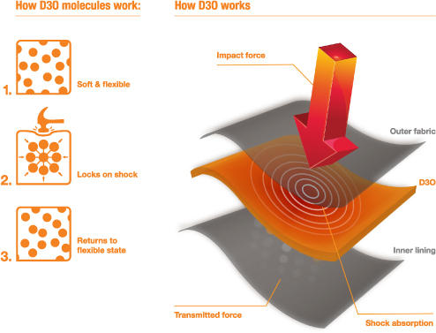](http://www.google.com/url?sa=i&rct=j&q=&esrc=s&source=images&cd=&cad=rja&uact=8&ved=0ahUKEwjb4Lrmp87QAhWoxFQKHUkfDzYQjRwIBw&url=http://skidirect.com.au/sunny-field-pro-d3o-body-armor-protective-jacket-for-extreme-sports.html&psig=AFQjCNFPK-sRemRdN4_1Urnt1WzNDz3UYA&ust=1480520350495879)

*How D3O® works*

*(*[*http://skidirect.com.au/sunny-field-pro-d3o-body-armor-protective-jacket-for-extreme-sports.html*](http://skidirect.com.au/sunny-field-pro-d3o-body-armor-protective-jacket-for-extreme-sports.html)*)*

The company does not reveal details of the composition of its proprietary material. However, a search of the U.S. Patent Office (patent number 7381460) shows that D3O® is primarily polyurethane with polyborodimethylsiloxane. The patent application states that the material is:

An energy absorbing composite comprising: i) a solid foamed synthetic elastomeric polyurethane matrix; ii) a dilatant comprising polyborodimethylsiloxane (PBDMS) distributed through the polymer of the matrix and incorporated into the polymer of the matrix during formation of i); and iii) a gas distributed through the matrix, the combination of polyurethane matrix, PBDMS and gas being such that the composite is flexible and resiliently compressible.

(<http://patft.uspto.gov/netacgi/nph-Parser?Sect1=PTO1&Sect2=HITOFF&d=PALL&p=1&u=%2Fnetahtml%2FPTO%2Fsrchnum.htm&r=1&f=G&l=50&s1=7381460.PN.&OS=PN/7381460&RS=PN/7381460>)

A material chemically similar to D3O®, and one probably more familiar to us, is Silly Putty™, which is composed of poly(dimethylsiloxane) (PDMS), sometimes called dimethicone. This compound is a repeat of the monomer of C2H6OSi. The PDMS in Silly Putty™ is crosslinked with boric acid to give it the viscoelastic properties seen as its non-Newtonian characteristics.

*An “egg” of Silly Putty™*

*(*[*http://www.dailymail.co.uk/news/article-2261147/D30-Unique-orange-goo-wrap-round-fingers-whack-mallet.html*](http://www.dailymail.co.uk/news/article-2261147/D30-Unique-orange-goo-wrap-round-fingers-whack-mallet.html)*)*

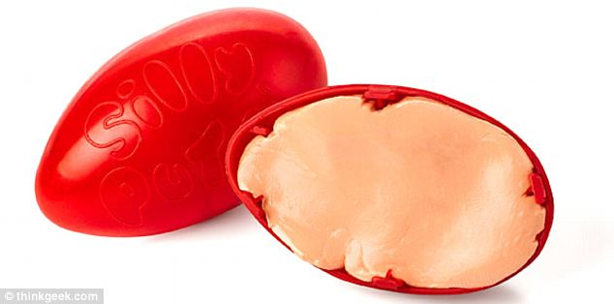

The properties of PDMS are partly responsible for silly putty’s properties. It’s what’s known as a viscoelastic solid. This basically means that it is capable of flowing like a liquid in some cases, but behaves like an elastic solid in others. The polymer chains are quite flexible, and when they are particularly long, as in the case of silly putty, they can become loosely entangled around one-another. This is what causes PDMS’s viscoelasticity.

However, the viscoelasticity of PDMS alone isn’t enough to account for silly putty’s oddities. Another ingredient in the mix, boric acid, also makes a decisive contribution. The PDMS chains in silly putty end in OH groups. The boric acid can react with these to form transient boron-mediated linkages between different polymer chains. These ‘crosslinks’ help hold the putty together, and also contribute to its properties.

When the putty is slowly molded, the crosslinks have time to break and reform at different points in the polymer chains. This means we are able to see the viscous flow of the putty. However, when the putty is pulled with suitable force, the crosslinks do not have time to break and reform, so elastic behaviour is seen. With suitable force exerted, the putty can even be shattered.

(<http://www.compoundchem.com/2015/11/10/sillyputty/>)

It is probable that the polyborodimethylsiloxane in D3O® acts similarly to Silly Putty™, due to their similar composition. The boron in D3O®'s polyborodimethylsiloxane would serve as the crosslinking component between the dimethylsiloxane units. Therefore, the D3O® acts like a non-Newtonian fluid and flows easily under no stress, but its viscosity quickly increases when subjected to a shear stress. (Learn more about shear stress, below, in the "Viscosity" section.) The more crosslinks that are formed between the polymer strands, the more brittle and solid-like the material becomes. These non-Newtonian characteristics make D3O® useful in impact-resistant sports and body armor equipment.

The Rohrig article states that "D3O® can offer impact protection…" and that "D3O® is also used to reduce concussions…" However, there are some who question the utility of D3O® as an effective impact resistance material for use in helmets. In 2011, the Lawrence Livermore National Laboratory (LLNL) released a report, “Impact resistance of US Army and National Football League helmet pad systems”, where the Laboratory "… was tasked to compare the impact responses of NFL helmet pad systems and U. S. Army pad systems compatible with an Advanced Combat Helmet (ACH) at impact velocities up to 20 ft/s." (<https://e-reports-ext.llnl.gov/pdf/471086.pdf>) D3O® was one of the materials that was included in the testing protocol.

The key findings from the LLNL report are:

1. The performance of a pad depends on the range of impact velocities. At lower impact velocity, softer pads perform better. At higher impact velocity, harder pads perform better.
2. Thicker pads perform better at all velocities, but especially at high velocities.
3. For comparable thicknesses, neither the NFL systems nor the Oregon Aero pads outperform the Team Wendy pads currently used in the ACH system in militarily-relevant impact scenarios (impact speeds less than 20 ft/s).

(<https://e-reports-ext.llnl.gov/pdf/471086.pdf>)

The D3O® pad sample was eliminated from LLNL's impact testing because of test results indicating that it was not suitable for the use as a helmet pad under the conditions that they were using.

The d3o pad material is composed of a single layer of a relatively dense foam. This foam is reportedly made of a rate-sensitive material. The samples tested were 0.99” diameter 0.25” thick cylinders. The solid lines in Figure 33 show measured stress vs. strain for fixed strain rates of 0.02/s, 2.0/s, and 50/s, up to 50% strain.

This foam does not exhibit the characteristic response of the other foams, with a plateau followed by a densification. Hence, the Puso foam model was not appropriate to capture its response. Instead, the response of the material in the loading regime of interest could be represented by a rate-independent linear elastic material model. The line with open circles in Figure 33 [see below] shows the fit of such a model to the experimental data.

Because this material is so much stiffer than all the other materials we studied, even at 0.02/s, any calculated HIC [head injury criterion] would be very large regardless of any other details of the pad geometry. Consequently, we excluded d3o from the comparisons in this report. We believe that the utility of this material as a helmet pad is questionable.

(<https://e-reports-ext.llnl.gov/pdf/471086.pdf>)

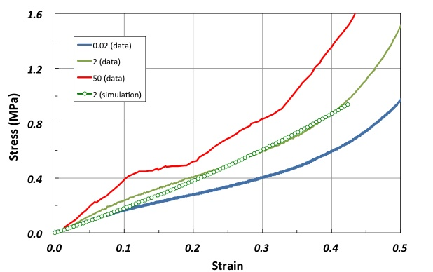

*Figure 33 – D3O foam data model fit, as referenced in the quote above*

*(*[*https://e-reports-ext.llnl.gov/pdf/471086.pdf*](https://e-reports-ext.llnl.gov/pdf/471086.pdf)*)*

**Isaac Newton**

While Isaac Newton (1643-1727) may be best known for his work with the force of gravity, he was a major contributor to many areas of science and mathematics. Newton was born a weak, premature baby and not expected to live. His father died a few months before Newton's birth and, when Newton was three, his mother remarried, and he was raised until the age of 12 by his maternal grandmother. Newton's education at King's School in Grantham introduced him to the sciences. Newton' uncle was impressed with Newton's intellect, and he convinced Newton's mother to enroll him in college. Newton enrolled in a work-study program at Trinity College, Cambridge, where he waited on tables in the dining hall and cleaned the rooms of other students.

While at Cambridge, Newton studied the standard curriculum but was more interested in advanced sciences, and he spent much of his time reading about modern philosophers. The plague of 1665 forced the university to close for two years. During this time at home, Newton worked on theories of calculus, optics, and gravitation. He returned to Cambridge in 1667 after the plague subsided and was elected a fellow at Trinity College. By 1669 he assumed the prestigious Lucasian professorship chair at Cambridge. As a professor, Newton delivered an annual course of lectures. His initial topic was optics and he used a telescope that he had designed and constructed. His work and lectures continued until 1678 when Newton suffered a nervous breakdown from his work load and the criticism of his theories and work. For six years Newton was a recluse, but continued his research on gravity, astronomy, and mathematics.



*Isaac Newton*

*(http://www.thefamouspeople.com/profiles/isaac-newton-124.php)*

In 1687, Newton published *Philosophiae Naturalis Principia Mathematica (Mathematical Principles of Natural Philosophy),* which many claim to be the most important book on physics, and possibly all of science. The book explained Newton's three laws of motion and universal gravitation (the motion of the planets, sun, and moon) and allowed the calculation of the masses of the planets. Newton also explained Earth's tides and the shape of the Earth caused by gravity. The publication of *Principia* thrust Newton into international prominence, and he soon became involved with social, political, and scientific issues.

Newton suffered another nervous breakdown in 1693, but recovered quickly and was back to work in a few months. In 1696, Newton was appointed to the position of warden of the Mint, a position he had long sought, and ultimately he became master of the Mint in 1699. He reformed the British currency and punished counterfeiters. In 1703, Newton was elected president of the Royal Society, and knighted by Queen Anne in 1705. His fame in scientific work led to his prominence in politics. Newton died in 1727, after several years of digestive problems and abdominal pain. Even long after his death, Newton's scientific work and publications remain seminal in scientific fields.

**Newtonian fluids**

Newtonian fluids have a constant viscosity regardless of the force applied or the speed at which they are forced to flow through a pipe, when at constant temperature. (See “Viscosity”, below.) Newtonian fluids were named after Sir Isaac Newton, who was the first to describe the relationship between shear strain rate and shear stress for fluids, using differential calculus (another area of study by Newton). Some examples of Newtonian fluids are water, mineral oil, milk, gasoline, and alcohol. For Newtonian fluids, their shear (flow) rate is directly proportional to the shear stress (force) applied. These liquids increase their flow rate as the force (stress) applied is increased, according to the equation for Newton’s law below.

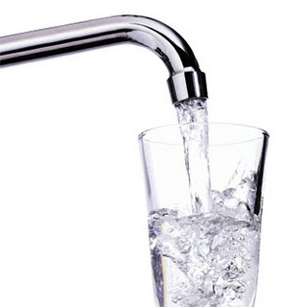

*Water, a Newtonian fluid*

*(*[*https://imk209.wikispaces.com/Nadiah_Rheology*](https://imk209.wikispaces.com/Nadiah_Rheology)*)*

Newtonslaw2.png

(<http://www.rheosense.com/applications/viscosity/newtonian-non-newtonian>)

It might be helpful to think of how Newtonian fluids behave by thinking of a water pistol. If the trigger is pulled gently, then the water comes out under low pressure and with a low flow rate. However, if the trigger on the water gun is pulled vigorously, then the water will squirt out of the gun with proportionately greater pressure and volume.

Newton devised a simple model for fluid flow that could be used to relate how hard you have to pull the trigger to how fast the liquid will squirt out of the pistol. Picture a flowing liquid as a series of layers of liquid sliding past each other. The resistance to flow arises because of the friction between these layers. If you want one layer to slide over another twice as fast as before, you'll have to overcome a resisting force that's twice as great, Newton said. The slower one layer slides over another, the less resistance there is, so that if there was no difference between the speeds the layers were moving, there would be no resistance. Fluids like water and gasoline behave according to Newton's model, and are called Newtonian fluids.

(<http://antoine.frostburg.edu/chem/senese/101/liquids/faq/non-newtonian.shtml>)

Typically, Newtonian fluids are composed of small symmetrical molecules whose orientations are not influenced by flow. These Newtonian fluids are the simplest mathematical models of fluids while accounting for viscosity. While no fluid fits this definition perfectly (just as there is not a perfectly ideal gas), water and air are common examples that closely fit the definition under ordinary conditions.

N**on-Newtonian fluids**

Non-Newtonian fluids are materials whose viscosity changes with a change in pressure or shear rate, at a constant temperature. Examples include ketchup, paints, blood, Silly Putty™, dairy cream, and oobleck (cornstarch and water).

In reality most fluids are non-Newtonian, which means that their viscosity is dependent on shear rate (Shear Thinning or Thickening) or the deformation history (Thixotropic fluids). In contrast to Newtonian fluids, non-Newtonian fluids display either a non-linear relation between shear stress and shear rate, have a yield stress, or viscosity that is dependent on time or deformation history (or a combination of all the above!).

(<http://www.rheosense.com/applications/viscosity/newtonian-non-newtonian>)

There are four categories of non-Newtonian fluids: shear-thinning, shear-thickening, thixotropic, and rheopectic ([http://sciencelearn.org.nz/Science-Stories/Strange-Liquids/Non-Newtonian-fluids).](http://sciencelearn.org.nz/Science-Stories/Strange-Liquids/Non-Newtonian-fluids).%20) The table below summarizes the four types of non-Newtonian fluids. See the subsections below for additional information on each type of non-Newtonian fluid.

|  |  |  |  |  |
| --- | --- | --- | --- | --- |
| **Type of behaviour** |  | **Description** |  | **Example** |
| Shear thinning |  | Viscosity decreases with increased stress |  | Tomato sauce |
| Dilatant or shear thickening |  | Viscosity increases with increased stress |  | Oobleck |
| Thixotropic |  | Viscosity decreases with stress over time |  | Honey – keep stirring, and solid honey becomes liquid |
| Rheopectic |  | Viscosity increases with stress over time |  | Cream – the longer you whip it the thicker it gets |

*Table of types of non-Newtonian materials and examples*

*(*[*http://sciencelearn.org.nz/Science-Stories/Strange-Liquids/Non-Newtonian-fluids*](http://sciencelearn.org.nz/Science-Stories/Strange-Liquids/Non-Newtonian-fluids)*)*

**Shear-thinning fluids**

Shear-thinning fluids become less viscous (flow more easily) when stress is applied to them. Shear-thinning is sometimes referred to as pseudoplastic behavior. You may have tried to pour ketchup from a bottle. When turned upside down, unfortunately, no ketchup comes out of the bottle. However, if you shake or hit the bottom of the bottle, the ketchup thins (becomes less viscous) and it pours out of the bottle. Typically, shear-thinning behavior is seen in polymer mixtures and complex fluids or suspensions, like ketchup, whipped cream, blood, and paint.



*Paint, a shear-thinning fluid*

*(*[*http://web.stanford.edu/~mjlgg/cnnf.pdf*](http://web.stanford.edu/~mjlgg/cnnf.pdf)*)*

Modern paint is designed such that when it is brushed (pressure applied) it thins and coats the surface evenly, but once the pressure is removed, the paint regains its higher viscosity so that it sticks and does not drip.

Tomato ketchup is a common example of a shear-thinning fluid. Tomatoes contain natural polymer chains such as starches, cellulose, and other soft fibers. These natural polymers in the tomato contribute to ketchup acting as a shear-thinning liquid.

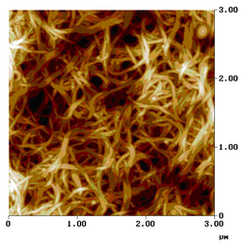

*Image of the soft matter (polymer chains)   
in a tomato.*

*(*[*https://www.ill.eu/science-technology/science-at-ill-old/soft-condensed-matter/ketchup/*](https://www.ill.eu/science-technology/science-at-ill-old/soft-condensed-matter/ketchup/)*)*

Such unusual flow properties [shear-thinning] derive from the behaviour of long chain-like molecules in the material. They obstruct movement of the liquid because they form networks, either as a result of becoming entangled or of being held together by weak attractive interactions. In household products, the chain structures are mostly polymers or surfactant micelles.

(<https://www.ill.eu/science-technology/science-at-ill-old/soft-condensed-matter/ketchup/>)

The science behind the shear-thinning effects of some fluids is not well understood. However, E. J. Hinch [a professor in Fluid Mechanics in the Department of Applied Mathematics and Theoretical Physics at the University of Cambridge] states, "Shear thinning fluids become less viscous with increasing shear rates and so have larger than linear growth with pressure-drop in the flow rate. The microstructures of such materials are smashed up at higher shear. This results in lower viscosities, hence the fluid flows more easily." (<https://www.whoi.edu/fileserver.do?id=28325&pt=10&p=17274>).

Further research may be uncovering additional clues to the reasons that shear stress causes some fluids to behave in non-Newtonian manners.

Cornell scientists led by Itai Cohen, associate professor of physics, have explored why these fluids [thinning and thickening fluids] behave like they do by watching how micron-sized suspended particles dance in real time and space. Their observations are the first to link direct imaging of the particle motions with changes in liquid viscosity under shear -- or equivalently, when the fluid is stirred.

The research is published in the journal *Science* (Chen, X., McCoy, J., Israelachvili, J., Cohen, I. Imaging the Microscopic Structure of Shear Thinning and Thickening Colloidal Suspensions. *Science.*, 2011, *333* (6047), pp 1276–1279; <http://science.sciencemag.org/content/333/6047/1276.full>; note that this link is a brief abstract only, the full article is only available to American Association for the Advancement of Science members or subscribers to the journal.) [For free access to this article, see <https://ecommons.cornell.edu/bitstream/handle/1813/30467/2011-06%20Publication%20-%20Itai%20Cohen%20-%20Imaging%20the%20microscopic%20structure.pdf?sequence=2>.]

Another article continues with additional information on understanding why shear-stress causes non-Newtonian fluid behavior.

"What we want to find out is the microscopic origin of these non-Newtonian properties," said first author Xiang Cheng, a postdoctoral associate in physics [Cornell University]. Such fluids are called non-Newtonian, because, unlike water or other Newtonian fluids, their viscosities change depending on how fast they're being sheared: think toothpaste, which is solid in the tube but flows like a liquid when squeezed or sheared.

Combining high-speed 3-D imaging techniques with a sensitive force-measuring device, the researchers tracked the motions of tiny particles suspended in the fluids while monitoring the thinning or thickening behaviors under shear. They found that fluids become thinner, or less viscous, when the random thermally induced darting motions of the particles could no longer keep up with their displacements due to the shear flows.

In addition, they showed fluids became thicker or more viscous when particles were driven past one another too quickly for the fluid between them to drain or get out of the way. At such high speeds, the particles form clusters that lock together and make the fluid more viscous. This result could partially explain why running (fast shear) across a cornstarch-water mixture doesn't cause the person to sink, but standing in the mixture (slow shear) does.

(<http://phys.org/news/2011-09-physicists-capture-microscopic-thinning-thickening.html>)

**Shear-thickening fluids**

Although more rare than shear-thinning fluids, some fluids become thicker (more viscous) under shear stress; these are called shear-thickening fluids. Common examples of these fluids include printing ink, Silly Putty™ and oobleck (a cornstarch and water slurry). Shear-thickening fluids are also known as dilatants.

Shear Thickening Fluid's (STFs) are examples of Non-Newtonian fluids, a rare set of materials and fluids who's behavior deviates from Newton's law - 'Every action has an equal and opposite reaction'.

A Dilatant material is a material that features an increase in viscosity and can even set to a solid as a result of deformation by expansion, pressure or agitation. You might think that these types of materials are extremely rare and are only available for Scientists to play with but the truth is, Dilatants can easily be created at home using simple ingredients such as Corn Flour, Water and even Sand and water etc. Child's Silly Putty is also a great, everyday example of Dilatant behavior. How can something be squashed easily in a child's hand but when you throw against a wall will also rebound like a bouncy ball?

Shear thickening behavior is observed when the force applied changes the structure within the fluid. For example wet sand / slurry on a beach can often exhibit dilatant properties. Whereby, if you stand still you might sink into the wet sand but if you were to run across the same bit of sand your feet will not sink in as much. For many this is counter-intuitive. For example; how can a liquid behave like a solid when it is hit hard but then return to behave like a liquid almost immediately after? This amazing behavior has unique applications for which industry is continually studying and developing for commercial use.

(<http://www.azom.com/article.aspx?ArticleID=6113>)

Oobleck is a common shear-thickening liquid that many people have experienced. It is a mixture of about 1 part water to about 1.5 to 2 parts cornstarch, which produces a thick slurry. The term “oobleck” was popularized in the 1949 book, *Bartholomew and the Oobleck* by Dr. Seuss. The earliest use of oobleck referring to the cornstarch/water mixture is by Cary Sneider in 1971.

(<https://www.reddit.com/r/etymology/comments/4e50t3/who_coined_the_term_oobleck_to_mean_corn_starch/>)



*Image of child playing with Oobleck*

*(*[*http://www.icanteachmychild.com/wp-content/uploads/2012/05/Oobleck.jpg*](http://www.icanteachmychild.com/wp-content/uploads/2012/05/Oobleck.jpg)*)*

Oobleck is frequently used in the classroom as early as elementary grades for investigating states of matter and eliciting questions and conversations about whether it is a liquid or a solid. In later grades, it is used as an activity to understand Newtonian and non-Newtonian fluids.

The Rohrig article addresses D3O® as a shear-thickening fluid whose function is to flow smoothly like a fluid when a person moves, but to quickly harden and protect the person from injury when the D3O® is hit or stressed. Currently, there are protective devices like body armor and knee pads on the market; however, they are typically hard plastic and can restrict the flexibility of the individual. D3O® seeks to improve both the freedom of movement and the injury protection for users of these devices.

Shear-thickening fluids are often colloids, which have solid particles (like corn starch) microscopically dispersed in another phase (like water). When there is no stress, the solid particles are capable of sliding past one another, and they can flow like a typical liquid. However, when stress is applied to the fluid, the solid particles may clump together, creating hindrances to flowing. As a result, the viscosity of the fluid increases and the fluid behaves more like a solid under the stress. An analogy of shear-thickening is to think about combing long hair. If the comb is run through the hair slowly, the comb moves (flows) easily through the long hair. However, if the comb is pulled quickly through the hair, the hair tangles (becomes more viscous) and resists the movement of the comb. In a similar way, the dispersed colloid particles (often long polymer molecules) in a shear-thickening fluid can become entangled, clump into hydroclusters (temporary changes in particle concentrations forming clusters creating tangles in the dispersing medium when stressed. The concept of shear-thickening hydroclusters in colloids is more fully discussed in this October 2009 *Physics Today* article: <http://authors.library.caltech.edu/16539/1/Wagner2009p6165Phys_Today.pdf>.

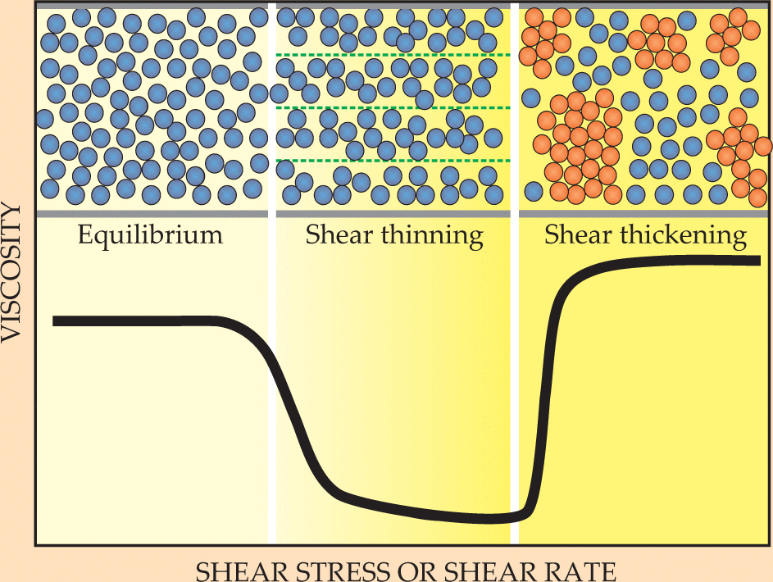

*Shear-thinning and shear-thickening due to shear stress*

*(*[*http://authors.library.caltech.edu/16539/1/Wagner2009p6165Phys_Today.pdf*](http://authors.library.caltech.edu/16539/1/Wagner2009p6165Phys_Today.pdf)*)*

The change in microstructure of a colloidal dispersion explains the transitions to shear thinning and shear thickening. In equilibrium, random collisions among particles make them naturally resistant to flow. But as the shear stress (or, equivalently, the shear rate) increases, particles become organized in the flow, which lowers their viscosity. At yet higher shear rates, hydrodynamic interactions between particles dominate over stochastic ones, a change that spawns hydroclusters (red)—transient fluctuations in particle concentration. The difficulty of particles flowing around each other in a strong flow leads to a higher rate of energy dissipation and an abrupt increase in viscosity.

(<http://authors.library.caltech.edu/16539/1/Wagner2009p6165Phys_Today.pdf>)

Other common examples of shear-thickening fluids include Silly Putty™, wet sand, and “slime” made with poly(vinyl alcohol) mixed with borax. The poly (vinyl alcohol) is a long polymer molecule which becomes partially cross-linked with the borax to form the loosely aggregated clusters. Silly Putty™ is often replicated in classrooms by students mixing white school glue, poly(vinyl acetate), with water and borax solution. This “Goofy Putty” or “Gluep” formulation, again, allows the borax to cross-link between the poly(vinyl acetate) polymer molecules to form clusters. When the Goofy Putty is slowly pulled, the polymer molecules slide past each other and the Goofy Putty can flow. However, when the Goofy Putty is stressed (pulled sharply or pressure applied) it acts more like a solid and either snaps in two when pulled quickly or solidifies under pressure.

Body armor uses shear-thickening fluids along with other materials to protect an individual from bullets or impact. Some body armor companies use nanoparticles of silica (sand) in a colloid mixture with poly(ethylene glycol) (automotive antifreeze). Kevlar is saturated with the silica/poly(ethylene glycol) mixture. The Kevlar strands hold the colloid mixture in place so that when a bullet strikes the body armor, the strong Kevlar fibers resists the penetration and, simultaneously, the silica/poly(ethylene glycol) mixture hardens as a shear-thickening fluid (<http://science.howstuffworks.com/liquid-body-armor1.htm>). One vulnerability of body armor is that it is less effective against slowly moving objects, such as a knife being slowly inserted into the body armor. Because shear-thickening fluids react to sudden stress, such as quick pressure from a bullet, a fist hitting a person, or a knife quickly thrust, it offers less protection from slow penetrations or forces.

**Thixotropic fluids**

A thixotropic fluid is one whose viscosity decreases over time with constant stress. The term thixotropic is derived from two Greek terms, *thixis* = touch and *tropo* = change. These are shear-thinning fluids, but the thinning is the result of time. In other words, while continuous constant pressure is applied to the fluid, it will flow more easily as time progresses. The longer the fluid is under stress, the more easily it flows. This phenomenon is usually because of a breakdown in the microstructure of the dispersed phase of the fluid. Examples of thixotropic fluids are ketchup, gelatin, yogurt, honey, paints, bentonite clay, and cream.

*Thixotropic flow of ketchup over time*

*(*[*http://mentalfloss.com/article/58476/why-ketchup-so-hard-pour*](http://mentalfloss.com/article/58476/why-ketchup-so-hard-pour)*)*



If a ketchup bottle is held upside down without shaking, the ketchup will exhibit thixotropic behavior and will begin to slowly pour from the bottle. So, ketchup can exhibit both shear-thinning flow (the result of stress like tapping the bottle) and thixotropic flow (time delayed) behavior. However, the thixotropic behavior of ketchup is less important than its shear-thinning behavior which is why most people will shake or tap the bottle of ketchup rather than patiently wait for it to begin to flow on its own.

Honey is another common thixotropic material. Many people have attempted to pour honey and found it to be a slow, tedious process. But with time and no shaking, the honey will begin to thin and pour more readily. Like ketchup, honey is both shear-thinning and thixotropic. Honey can be stirred and it will pour more easily, or a person can wait patiently and it will ultimately begin to thin and flow on its own.

Some soils are thixotropic, especially clay soils. If structures are erected on poor soils with thixotropic characteristics, the buildings may settle. A famous example of building settlement due, at least in part, to poor soil is the Tower of Pisa, which was built on about 30 feet of a sandy/clayey soil. Bentonite clay (sometimes used in kitty litter) is used for drilling mud (in drilling for oil or natural gas) because, in small concentrations in water, the Bentonite forms a thixotropic fluid (colloidal gel) which lubricates drilling equipment, removes cuttings from drilling, and helps to prevent blowouts due to its density.

**Rheopectic**

A rheopectic fluid is one that becomes more viscous over time when a constant force is applied. It is a relatively rare behavior, but one common example is dairy cream. If the cream is whipped vigorously with a constant force, it will thicken with sufficient time, producing whipped cream. Other rheopectic fluids include some lubricants, printer inks, and gypsum pastes. The synovial fluid found in the knee and elbow joints exhibits rheopectic characteristics. In general, a true rheopectic material will start as a liquid, but become thicker as shaking or stirring continues.

*Using a whisk to make whipped cream*

*(*[*https://pioneerwoman.files.wordpress.com/2015/11/homemade-whipped-cream-4-ways-00a.jpg*](https://pioneerwoman.files.wordpress.com/2015/11/homemade-whipped-cream-4-ways-00a.jpg)*)*

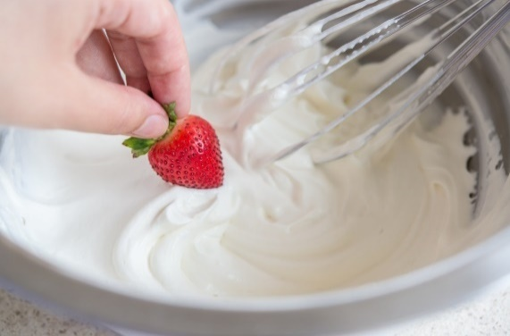

The graph below shows the relationship between viscosities of rheopectic and thixotropic fluids.



*Comparing the viscosity of   
rheopectic and thixotropic materials with stress over time*

*(*[*http://sciencelearn.org.nz/Science-Stories/Strange-Liquids/Non-Newtonian-fluids*](http://sciencelearn.org.nz/Science-Stories/Strange-Liquids/Non-Newtonian-fluids)*)*

Thixotropic fluids “thin down” over time; that is, they become less viscous and flow more easily with force applied over time, like ketchup. Rheopectic fluids, on the other hand, become thicker, or more viscous with force applied over time, like whipping cream.

**Viscosity**

Viscosity lies at the heart of understanding both Newtonian and non-Newtonian fluids. Informally defined, viscosity is the resistance of a fluid to flow. Grease is highly viscous (flows very slowly) while cooking oil is less viscous (flows more easily). Viscosity also deals with the ability of objects to move within that fluid.

Formally, viscosity (represented by the symbol η "eta") is the ratio of the shearing stress (*F*/*A*) to the velocity gradient (Δ*v****x***/Δ*z* or *dv****x***/*dz*) in a fluid.

|  |  |
| --- | --- |
| η  = | *F̅*/*A* |
| Δ*v****x***/Δz |

Or

|  |  |
| --- | --- |
| η  = | *F̅*//*A* |
| *dv****x***/*dz* |

The more usual form of this relationship, called Newton's equation, states that the resulting shear of a fluid is directly proportional to the force applied and inversely proportional to its viscosity. The similarity to Newton's second law of motion (*F* = *ma*) should be apparent.

|  |  |  |  |  |  |  |  |
| --- | --- | --- | --- | --- | --- | --- | --- |
| |  |  |  | | --- | --- | --- | | *F̅* | =  η | Δ*v****x*** | | *A* | Δz | | ⇔ |  |

|  |  |
| --- | --- |
| *F̅*  =  *m* | Δ*v* |
| Δ*t* |

Or if you prefer calculus symbols (and who doesn't)

]

|  |  |  |  |  |  |  |  |
| --- | --- | --- | --- | --- | --- | --- | --- |
| |  |  |  | | --- | --- | --- | | *F̅* | =  η | d*v****x*** | | *A* | dz | | ⇔ |  |

|  |  |
| --- | --- |
| *F̅*  =  *m* | d*v* |
| d*t* |

(from *The Physics Hypertextbook*, “Viscosity” chapter,   
<http://physics.info/viscosity/>)

The viscosity of a substance's flow behavior is dependent on three factors:

1. the substance's intermolecular structure (the greater the intermolecular forces, the more viscous);
2. the external forces acting on the fluid, including the force and the duration of the force; and,
3. the ambient conditions including the temperature and the pressure. Only Newtonian fluids are independent of external forces (<http://www.viscopedia.com/basics/factors-affecting-viscometry/>).

It's possible to think of viscosity as a measure of the internal friction of a fluid. If the fluid is thought of as having layers, viscosity becomes understandable as the friction between these layers as they move against each other. The greater the friction between layers, the greater the force that is required to cause movement (flow). This force is called shear. Shearing occurs when fluids are physically moved, poured, stirred, spread, mixed, or sprayed. Therefore, viscosity is mathematically defined as shear stress (measured in dynes) divided by shear rate (measured in reciprocal seconds). The fundamental unit for measuring viscosity is the Poise, named after Jean Leonard Marie Poiseuille (French physicist and physiologist, 1797–1869). It is more commonly expressed as centipoise units because the viscosity of water at 20 °C is nearly one exact centipoise, which is very convenient. The common International System of Units (metric) unit for measuring viscosity is the Pascal-second, and it is equal to 10 poise.

The graphic below illustrates viscosity in the context of common substances, foods. As you progress from left to right, the foods depicted have increasing viscosities. This is indicated by the lengthening of the sample drops of each liquid, proceeding left to right. The increased viscosities of the liquids are directly related to their increasingly greater intermolecular attractions (described in the graphic as bond strength). Viscosity is one of the measures of intermolecular strengths. Intermolecular forces (e.g., van der Waals or London dispersion forces) are typically described as weak; however, in sufficient numbers, they can have a relatively large effect.

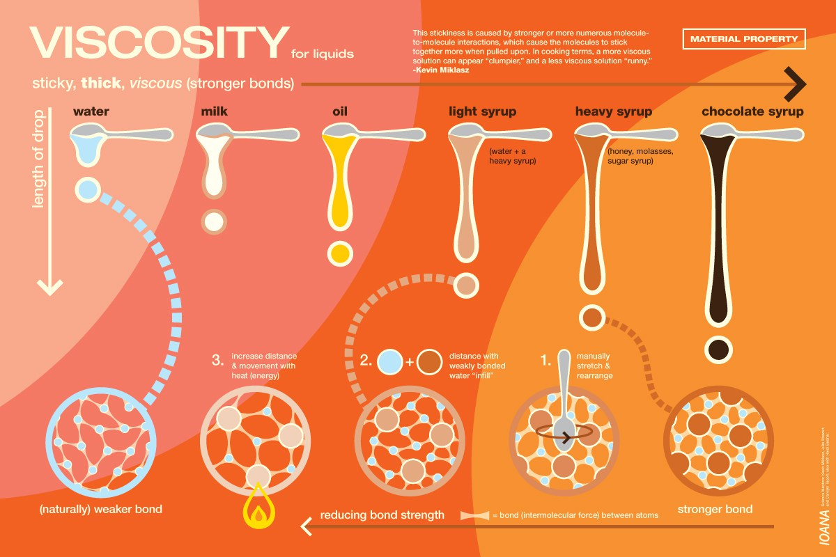

*Varying Viscosities of Common Fluids*

*(*[*https://ediblesciencefaire.wordpress.com/viscosity-poster/*](https://ediblesciencefaire.wordpress.com/viscosity-poster/)*)*

Some people may confuse viscosity with density. As stated previously, viscosity deals with the resistance of a material to flow. However, density is mass per unit of volume; it is the quantity of matter in a given unit of space. Certainly, many common substances that are more dense than water (a common comparator) are also more viscous. For example, honey is both more dense and more viscous than water. However, when compared to a concentrated salt water solution, honey is more viscous, but it is not more dense than the salt water.

While most of the people think that viscosity and density are both the same thing expressed in different forms, they are two truly different concepts. The density is a measurement of the molecular weight of the composition. In simpler words, density = number of molecules x molecular weight/volume occupied, while the viscosity is a measurement of the inter-molecular forces and molecule shapes. Viscosity tells you the “friction” between two layers of the given fluid, while density varies slightly with temperature, viscosity changes rapidly. Both density and viscosity decreases with temperature, but viscosity mostly has an exponential relationship with temperature. Density holds a linear relationship.

(<http://www.differencebetween.com/difference-between-viscosity-and-vs-density/>)

A common substance that uses the term “viscosity” is motor or engine oil. There are two types of viscosity: kinematic and dynamic (absolute). The type of viscosity measured in motor oils is kinematic viscosity which is calculated by dividing the dynamic (absolute) viscosity by the density of the fluid. Dynamic viscosity is the classic definition of viscosity: a measure of internal resistance, or resistance to flow. A common grade of motor oil may be labeled 10W-30. The numbers used indicate the Society of Automotive Engineers (SAE) numerical coding system for grading motor oil characteristics and viscosities and use numbers like 0, 5, 10, 15, 20, 30, etc. However, in 2013, the SAE changed their traditional numerical grades that had been based on 5s, and the newest motor oil grade is SAE 16.

He [Michael Covitch of Lubrizol, Chair of the SAE International Engine Oil Viscosity Classification (EOVC) task force] explained the new grade will be specified in the future by OEMs (Original Equipment Manufacturers) for cars specifically designed to use new low-viscosity oils. It is not deemed to be suitable for use with older engines or newer vehicles not designed for such low-viscosity oils. Covitch noted that the numeral in SAE 16 “has no inherent meaning” and is used only for the purpose of categorization."

SAE J300 is used worldwide to classify engine oils in terms of viscosity grade. OEMs recommend specific viscosity grades in owner manuals to ensure that their engines will perform throughout the lifetime of the vehicle. Most engine oil standards set by organizations such as the American Petroleum Institute and individual OEMs include requirements for oils to meet the limits found in J300.

Covitch told *AEI* [*Automotive Engineering International*] that the EOVC task force (a standing committee of SAE Technical Committee 1) “debated long and hard on what to call the new high-temperature viscosity grade.” Currently, the lowest high-temperature grade is SAE 20. It wasn’t a simple matter of following convention and using the next-lowest multiple of 5 for two reasons. First, J300 addresses both high- and low-temperature grades (the latter use “W” to indicate “winter”).

“The most compelling reason is that one of the most popular SAE viscosity grades for heavy-duty diesel trucks around the world and diesel passenger cars in Europe is SAE 15W-40,” Covitch said. “Our task force was concerned that adopting SAE 15 might be confusing to consumers familiar with SAE 15W-40 oils and might lead to misapplication of the wrong oil in the wrong vehicle, particularly vehicles not designed to operate on such low-viscosity lubricants."

The second incentive to adopt SAE 16 was in anticipation of new lower engine oil viscosity grades that could be defined in future revisions of J300.

"If we continued to count down from SAE 20 to 15 to 10, etc., we would be facing continuing customer confusion issues with popular low-temperature viscosity grades such as SAE 10W, SAE 5W, and SAE 0W," he noted. "By choosing to call the new viscosity grade SAE 16, we established a precedent for future grades, counting down by fours instead of fives: SAE 12, SAE 8, SAE 4."

(<http://articles.sae.org/11945/>)

The W on a viscosity rating means "winter," and indicates that the oil's viscosity was tested at 0 °F. Any oil viscosity number without a W code is tested at 210 °F, an approximate automobile engine operating temperature. To determine the kinematic viscosity of oil, it is placed in a viscometer and the time for the oil to flow through the orifice by gravity force at the specified temperature is measured. SAE has standardized orifices and criteria for assigning the viscosity grade to the oil based on the viscometer results. Multi-grade oils, such as 10W-30, contain additives to meet both the cold and hot temperature requirements. These multi-grade oils are less viscous (thinner) at colder temperatures to facilitate starting sluggish engines, but retain sufficient viscosities at hot temperatures to effectively protect engine components from the friction of moving parts. The additives typically contain long molecules which unwind as the oil gets hotter, and they slow down the rate at which the hot oil's viscosity decreases.

*A viscometer to measure oil viscosity*

*(*[*http://www.machinerylubrication.com/Read/294/absolute-kinematic-viscosity*](http://www.machinerylubrication.com/Read/294/absolute-kinematic-viscosity)*)*

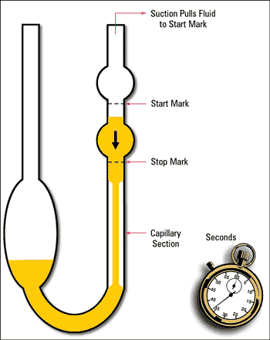

The viscosity of motor oil is largely determined by the size of the molecules, with longer, more-complex molecules (longer carbon chains) having higher viscosities due to greater inter-molecular forces. While many textbooks describe intermolecular forces as a weak force, in sufficient numbers they can become stronger than more powerful forces such as ionic or covalent bonds. Motor oils made from mineral (crude) oil have molecular sizes that may vary within a set range, so the average size determines the viscosity rating. As this mineral oil ages with use, and as temperature changes, the molecules' sizes and structures change. Thus, the viscosity and life span of the mineral oil can change over the service life of the mineral oil, resulting in typical oil changes of 3,000 miles for many vehicles.

Synthetic motor oil is a manufactured product, not the result of extracting the oil from crude oil. The manufacturing process results in oil molecules that are more identical in size and structure. This consistency allows the synthetic oil to have a longer service life because there are fewer changes in the oil's structure.

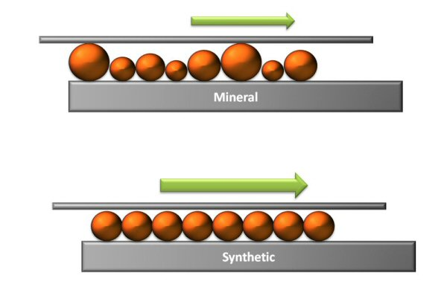

*Molecules of synthetic oils (bottom diagram) have more uniform sizes   
and structures than do molecules of mineral oils (taken from crude oil)*

*(*[*http://www.kewengineering.co.uk/Auto_oils/oil_viscosity_explained.htm*](http://www.kewengineering.co.uk/Auto_oils/oil_viscosity_explained.htm)*)*

# References

**(non-Web-based information sources)**

**The references below can be found on the *ChemMatters* 30-year DVD, which includes all articles   
published from the magazine’s inception in October 1983 through April 2013; all available Teacher’s Guides, beginning February 1990; and 12 *ChemMatters* videos. The DVD is available from the American Chemical Society for $42 (or $135 for a site/school license) at this site:** [**http://ww.acs.org/chemmatters**](http://www.acs.org/chemmatters)**. Click on the “Teacher’s Guide” tab to the left, directly under the “*ChemMatters Online"* logo and, on the new page, click on “Get the past 30 Years of *ChemMatters* on DVD!” (the icon on the right of the screen).**

**Selected articles and the complete set of   
Teacher’s Guides for all issues from the past three   
years are available free online at the same Web site, above. Click on the “Issues” tab just below the logo, *“ChemMatters Online”*.**



***30* Years of *ChemMatters !***

Available Now!

An early issue in *ChemMatters* included an article on Silly Putty™. The article discusses the discovery and chemistry of this favorite toy which is a dilatant material. (Marsella, G. Silly Putty™. *ChemMatters*, 1986, *4* (2), pp 15–17)

This Mystery Matters article describes the phenomenon of St. Januarius's centuries-old alleged blood liquefying from a clotted mass. What has been described as a miracle by some has been explained by scientists as a non-Newtonian thixotropic mixture. Read more about the mystery and the chemistry of this changing blood. (Meadows, R. Mystery Matters: Saint's Blood. *ChemMatters*, 1993, *11* (1), pp 11–15)

Color-changing Silly Putty™ is included in an article on encapsulated pigments in products. The Silly Putty™ is addressed in a one-page section titled A Successful Failure. (Goldfarb, B. Mystery Color in a Capsule. *ChemMatters*, 1998, *16* (1), pp 10–12)

Tied closely to the D3O®article is an entire article on slime, also written by Rohrig. The viscosity, non-Newtonian properties, polymer cross-linking, and an activity for making slime are highlighted in the article. The shear-thinning and shear-thickening properties of non-Newtonian materials are discussed, also. (Rohrig, B. The Science of Slime. *ChemMatters*, 2004, *22* (4), pp 13–16)

The Teacher's Guide for “The Science of Slime” (above) is rich source of content related to this Rohrig article. Background information included in the Teacher's Guide includes viscosity, Newtonian and non-Newtonian fluids, Silly Putty™, and activities for making slime.

Honey is often used as an example of a viscous (as compared to water) material. An entire article was devoted to honey in 2005. While the article does not address viscosity or other topics in the Rohrig article, honey is just a sweet topic. (Haines, G. Honey: Bee Food Extraordinaire! *ChemMatters*, 2005, *23* (5), pp 13–16)

Rohrig strikes again with the article, “Serendipitous Chemistry”, which includes the section, “Silly Putty™: Serious Fun”. A brief history, the chemistry and properties of Silly Putty™ are discussed as an example of scientific discoveries made by accident. (Rohrig, B. Serendipitous Chemistry. *ChemMatters*, 2007, *25* (3), pp 4–6)

# Web Sites for Additional Information

**(Web-based information sources)**

**D3O®**

Visit the D3O® Web site for additional pictures, product designs, news, and testing at <https://www.d3o.com/>.

Wikipedia has a short article on D3O® with links to related topics and references. (<https://en.wikipedia.org/wiki/D3o>)

For a comparison between D3O® and the conventional foam used in motorcycle protective gear and winter sports equipment, with a video clip and images, see <http://newatlas.com/d3o-motorcycle-armour-trauma-test/14227/>.

This article discusses D3O® uses in shock protection for people, cell phones, and computers. It includes images and links to two short videos, as well. (<http://www.dailymail.co.uk/news/article-2261147/D30-Unique-orange-goo-wrap-round-fingers-whack-mallet.html>)

For more information on energy-absorbing materials, check out this link which includes a discussion of non-Newtonian materials including D3O® and a similar material, Dow Corning®'s Defexion™. Images and explanations are included at the site. (<http://www.explainthatstuff.com/energy-absorbing-materials.html>)

A variety of products containing D3O® are found at this site. Two of the more unusual products include ballet pointe shoes and polo knee guards. (<http://inventorspot.com/articles/gel_cushions_falls_can_also_stop_bullets_d3o_24587>

**General** **non-Newtonian fluids**

For an in-depth discussion of the stretching and mixing of non-Newtonian fluids in polymer solutions, see <http://scholarship.haverford.edu/cgi/viewcontent.cgi?article=1093&context=physics_facpubs>.

This site is the lecture notes for a lesson on rheology. It refers to a textbook chapter and a few other materials not available, but the lecture notes and information provided are very useful without the other materials. Non-Newtonian fluids, soils and clays, and blood, are subheadings that are discussed with a variety of figures. (<http://www.physics.usyd.edu.au/super/life_sciences/PM/PM5.pdf>)

This article explains non-Newtonian fluid flows with diagrams and accompanying mathematics: <http://web2.clarkson.edu/projects/subramanian/ch330/notes/Non-Newtonian%20Flows.pdf>.

This scholarly discussion of non-Newtonian fluids provides an introduction to these unusual materials. Included in the article are examples, classification, behavior, and models of non-Newtonian fluids. The article address different types of non-Newtonian fluids. (<http://www.physics.iitm.ac.in/~compflu/Lect-notes/chhabra.pdf>)

This Web site introduces fluid mechanics and fluid properties and then proceeds into a discussion of Newtonian and non-Newtonian fluids including a differentiation between liquids and gases. (<http://www.efm.leeds.ac.uk/CIVE/CIVE1400/PDF/Notes/section1.pdf>)

This in-depth article explains codimensional non-Newtonian fluids. These codimensional features include the furrows made by a brush moving through paint, the strands of cheese on a pizza, and the thin filaments in toothpaste. Colorful pictures and a scholarly explanation which include mathematics make this an informative article. (<http://web.stanford.edu/~mjlgg/cnnf.pdf>)

In this article, readers will learn about the microscopic structure of shear-thinning and shear-thickening colloids and how the rate of shear affects the non-Newtonian properties. (<https://ecommons.cornell.edu/bitstream/handle/1813/30467/2011-06%20Publication%20-%20Itai%20Cohen%20-%20Imaging%20the%20microscopic%20structure.pdf?sequence=2>)

This article provides another description of non-Newtonian fluids with heavy mathematics. The simultaneous elastic and viscous nature of non-Newtonian fluids is discussed. (<http://www.thermopedia.com/content/986/>)

For an explanation of honey as an example of a non-Newtonian fluid including a discussion of its viscosity, see [https://blogs.scientificamerican.com/cocktail-party-physics/an-ti-ci-pa-tion-the-physics-of-dripping-honey/#](https://blogs.scientificamerican.com/cocktail-party-physics/an-ti-ci-pa-tion-the-physics-of-dripping-honey/%23).

**Shear-thinning fluids**

An experiment on a 2002 space shuttle, Critical Viscosity of Xenon-2, sought to better understand the viscosity of fluids like ketchup. Learn more about it at <http://www.firstscience.com/SITE/ARTICLES/ketchup.asp>.

To read about NASA's version of the Critical Viscosity of Xenon-2 experiment above, see <https://science.nasa.gov/science-news/science-at-nasa/2002/07jun_elastic_fluids>.

This site features the profile of a Texas Advanced Computing Center scientist, Dr. William L. Barth, who studies shear-thinning materials. Read about his career and work at <https://www.tacc.utexas.edu/documents/13601/138850/secrets_of_shear_thinning.pdf>.

This NASA Web page educates readers on the physics of whipped cream, a shear-thinning material and was linked to the Critical Viscosity of Xenon-2 experiment. Note that whipped cream is a shear-thinning fluid, while whipping cream is a shear-thickening fluid.) (<https://science.nasa.gov/science-news/science-at-nasa/2008/25apr_cvx2>)

An article concerned with the instability of shear-thinning and shear-thickening fluids and their flow is located at <https://www.mech.kth.se/~luca/papers/iman_cyl.pdf>.

This scholarly article (a term paper at Notre Dame) describes models for predicting shear-thinning behavior in polymer fluids. (<http://www3.nd.edu/~cpaolucc/termpaper.pdf>)

**Shear-thickening (dilatants) fluids**

This link is a great resource for a more complete look at shear-thickening materials including oobleck and other colloidal dispersions. (<http://authors.library.caltech.edu/16539/1/Wagner2009p6165Phys_Today.pdf>)

This Web site explains the action of shear-thickening fluids as used in liquid body armor. It includes useful graphics and brief descriptions of colloids and hydroclusters. (<http://science.howstuffworks.com/liquid-body-armor1.htm>)

This site provides an examination of two shear-thickening mixtures, glycerin with glass bubbles and water with cornstarch. The report analyzes the ballistic resistance of these two materials. (<http://www.me.rochester.edu/courses/ME241.gans/ShearThickening(2).pdf>)

For a formal analysis of cornstarch and water (oobleck) as a shear-thickening fluid, see <http://physics.wooster.edu/JrIS/Files/Price_Web_Article.pdf>

For a brief, but clear explanation of non-Newtonian fluids with an emphasis on dilatants, visit <http://www.azom.com/article.aspx?ArticleID=6113>.

This Web site reports on why non-Newtonian fluids harden on impact. It includes two short video clips to support the explanation. (<http://phys.org/news/2012-07-duo-non-newtonian-fluids-harden-impact.html>)

For an explanation of why the shear-thickening behavior of oobleck may be more complex than only shear compression, and may be more properly related to the inability of cornstarch grains to quickly move, see <http://www.sciencemag.org/news/2012/07/cornstarch-physics-shear-nonsense>.

**Thixotropic fluids**

For an overview of non-Newtonian fluids, including ketchup (considered a thixotropic material) see <http://www.rheothing.com/2012/11/is-ketchup-really-thixotropic.html>.

A complete discussion of thixotropy is provided at this Web site which includes a history, a mechanistic description, applications, and examples of thixotropy. (<http://www.dfi.uchile.cl/~rsoto/docencia/FluidosNoNewton2008/trixotropia.pdf>)

An application of thixotropy is with soils, especially clay soils. Readers will learn about the thixotropic nature of the soils in Mexico City at <http://www.pmrl.ce.gatech.edu/papers/Diaz-Rodriguez_1999a.pdf>.

A report on the stabilization efforts of the Leaning Tower of Pisa and the unstable, clay soils under it that probably caused the settling is found at <http://casehistories.geoengineer.org/volume/volume1/issue3/IJGCH_1_3_2.pdf>.

**Rheopectic fluids**

This Web site give a brief bit of information on the rarest of the non-Newtonian fluids, rheopectic, at <http://io9.gizmodo.com/this-pole-climbing-rheopectic-fluid-might-one-day-keep-1505594148>.

Wikipedia provides a short article on rheopectic materials and explains the difference between rheopectic and dilatants fluids at <https://en.wikipedia.org/wiki/Rheopecty>.

This Wikipedia page gives additional information on both thixotropic and rheopectic fluids. (<https://en.wikipedia.org/wiki/Time-dependent_viscosity>)

**Viscosity**

This Web site provides an excellent discussion of viscosity including definitions, factors affecting viscosity, motor oil, and non-Newtonian fluids. The topic is treated mathematically as well as descriptively. (<http://physics.info/viscosity/>)

Lean about the factors affecting viscosity including laminar or turbulent flow conditions, shear rate, temperature, and pressure at <http://www.viscopedia.com/basics/factors-affecting-viscometry/>.

Stress, strain, and viscosity as applied to the San Andreas Fault are discussed in a slide presentation in pdf at <http://www.csun.edu/~dsw/lect5_geodyn_stress.pdf>.

A scholarly, 32-page report on the temperature dependence of a viscosity of non-Newtonian fluid, toothpaste, is located at <https://www.ifm.tu-berlin.de/fileadmin/fg49/AbschlussarbeiteundProjekte/messungen/internship_report_FannyRoziere_Temperature_dependence_of_viscosity_of_non_Newtonian_materials.pdf>.

This Web site provides an in-depth study of viscosity, Newtonian and non-Newtonian fluids, and several other rheological topics. ([http://www.brookfieldengineering.com/education/viscosity_whymeasure.asp#newtonian](http://www.brookfieldengineering.com/education/viscosity_whymeasure.asp%23newtonian))

A more scholarly look at the concept of viscosity with mathematical formulas and an estimation of gas viscosities is located at <http://www.columbia.edu/itc/ldeo/lackner/E4900/Themelis3.pdf>.

Beautiful and useful posters with explanations related to understanding viscosity from the standpoint of foods is located at <https://ediblesciencefaire.wordpress.com/viscosity-poster/>.

A short discussion explaining that there is not a relationship between viscosity and density (for non-superfluids) is found at <http://physics.stackexchange.com/questions/158133/is-viscosity-a-function-of-density-only>.

This Web site features an archived webinar as a part of the detailed explanation of the viscosity of Newtonian and non-Newtonian fluids. Diagrams, mathematical formulas, and other relevant links are provided at <http://www.rheosense.com/applications/viscosity/newtonian-non-newtonian>.

**Motor oil**

If you would like to know more about motor oil viscosity classifications, see <http://standards.sae.org/j300_201501/>.

For help selecting the proper motor oil for your vehicle based on label codes, viscosity, and types, see <http://www.popularmechanics.com/cars/how-to/a53/1266801/>.

Additional information on motor oil viscosities and understanding the SAE (Society of Automotive Engineers) codes such as 5W-30, visit <http://www.upmpg.com/tech_articles/motoroil_viscosity/>.

A more technical explanation of SAE motor oil viscosities is located at <https://www.jcmotors.com/images/understanding_motor_oil_viscosity.pdf>.

For a different explanation on motor oil numbers, see <http://abcnews.go.com/Technology/story?id=119270&page=1>.

Measuring motor oil viscosity is explained at this site which includes a few links to related topics. (<http://auto.howstuffworks.com/fuel-efficiency/fuel-consumption/question1641.htm>)

**Quicksand**

For a simple explanation of how quicksand, a non-Newtonian fluid, works including some simple graphics, see <http://science.howstuffworks.com/environmental/earth/geology/quicksand.htm>.

This site answers the question, Can quicksand really suck you to your death? (<http://www.bbc.com/future/story/20160323-can-quicksand-really-suck-you-to-your-death>)

If a person is caught in quicksand, this site describes what not to do so that you will survive. (<http://science.howstuffworks.com/science-vs-myth/everyday-myths/quicksand-sinking1.htm>)