

**February/March 2017 Teacher's Guide**

**Background Information**

**for**

***62 Endangered Elements***

**Table of Contents**

[About the Guide 2](#_Toc472328920)

[Background Information 3](#_Toc472328921)

[References 21](#_Toc472328922)

[Web Sites for Additional Information 22](#_Toc472328923)

[General Web References 25](#_Toc472328924)

# 

# About the Guide

Teacher’s Guide team leader William Bleam and editors Pamela Diaz, Regis Goode, Diane Krone, Steve Long and Barbara Sitzman created the Teacher’s Guide article material.   
E-mail: [bbleam@verizon.net](mailto:bbleam@verizon.net)

Susan Cooper prepared the anticipation and reading guides.

Patrice Pages, *ChemMatters* editor, coordinated production and prepared the Microsoft Word and PDF versions of the Teacher’s Guide.

E-mail: [chemmatters@acs.org](mailto:chemmatters@acs.org)

Articles from past issues of *ChemMatters* and related Teacher’s Guides can be accessed from a DVD that is available from the American Chemical Society for $42. The DVD contains the entire 30-year publication of *ChemMatters* issues, from February 1983 to April 2013, along with all the related Teacher’s Guides since they were first created with the February 1990 issue of *ChemMatters*.

The DVD also includes Article, Title, and Keyword Indexes that cover all issues from February 1983 to April 2013. A search function (similar to a Google search of keywords) is also available on the DVD.

The *ChemMatters* DVD can be purchased by calling 1-800-227-5558. Purchase information can also be found online at <http://tinyurl.com/o37s9x2>.

# Background Information

**(teacher information)**

**Endangered elements**

“‘The periodic table is a thing of real beauty to chemists but we are staring at the possibility of not being able to access parts of it,’ says Mike Pitts, of the UK’s Chemistry Innovation Knowledge Transfer Network.” Pitts is the author of the “Periodic Table of Endangered Elements” that was used for this *ChemMatters* article. An element may be endangered for many reasons. Sometimes the element is scarce on Earth, but in many instances it is due to an imbalance between the rate at which the material is being used and the rate at which it is able to be reclaimed, either from its original ore or by recycling. In many of our uses of these elements we are making the elements economically unrecoverable.

Four out of the top ten most endangered elements (terbium, dysprosium, europium, and ytterbium) belong to the group of elements referred to as the Rare Earth Elements (REE). The REE, composed of the lanthanides and scandium and yttrium, are being consumed at alarming rates due to their use in modern technology and electronic gadgets. These elements are referred to as light or heavy, depending upon their density. It is interesting to note that the light rare earth elements (LREEs) all have only unpaired electrons in their *f* orbitals while the heavy rare earth elements (HREEs) have at least one set of paired electrons in the *f* orbitals. Yttrium has properties similar to the HREEs, while scandium does not share many of the properties of either group of REEs. Terbium, dysprosium, and neodymium are used to make the strong permanent magnets found in wind turbines and electric vehicles. These applications require permanent magnets that remain stable at temperatures exceeding 120 °C. With investments in green energy increasing, demand is predicted to outpace supply for these metals in little more than a decade or less. China has 37% of the world’s reserves of REEs, but it supplies 96% of the world’s refined rare earth metals.

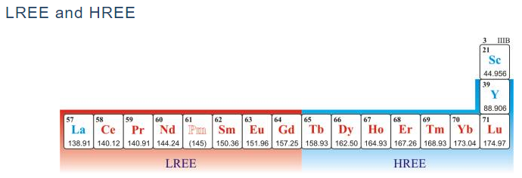

*The Positions of Light Rare Earth Elements and Heavy Rare Earth Elements on the Periodic Table*

*(*[*http://www.periodni.com/rare\_earth\_elements.html*](http://www.periodni.com/rare_earth_elements.html)*)*

Elements that are in danger of becoming economically unavailable are sometimes referred to as critical elements. Some examples of critical elements, their use, and current reserves are listed in the following table.

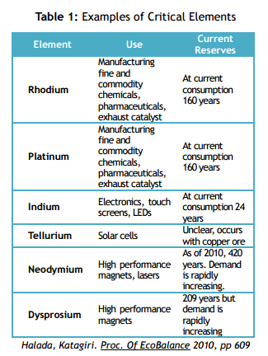

*(*[*https://www.acs.org/content/dam/acsorg/greenchemistry/industriainnovation/cs3-whitepaper2013.pdf*](https://www.acs.org/content/dam/acsorg/greenchemistry/industriainnovation/cs3-whitepaper2013.pdf)*)*

Elements that are crucial to the energy sector are referred by some as Energy Critical Elements (ECEs). Most of the endangered elements listed above belong to this category.

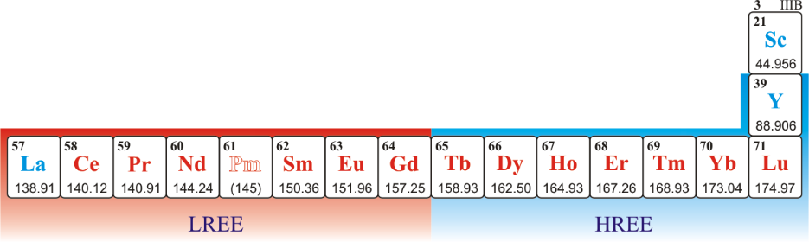An element might be “energy-critical” for a variety of reasons. It might be intrinsically rare in Earth’s crust, poorly concentrated by natural processes, or currently unavailable in the United States. Some potential ECEs, such as tellurium and rhenium, are genuinely rare in Earth’s crust. Rhenium, for example, is rarer than gold by approximately a factor of five. Others like indium, although not as rare, are unevenly distributed in Earth’s crust, causing the United States to be highly reliant on imports. Still other ECEs, such as germanium, are seldom found in concentrations that allow for economic extraction.

(<http://www.aps.org/policy/reports/popa-reports/upload/elementsreport.pdf>)

A version of the periodic table in which possible ECEs are highlighted is included here: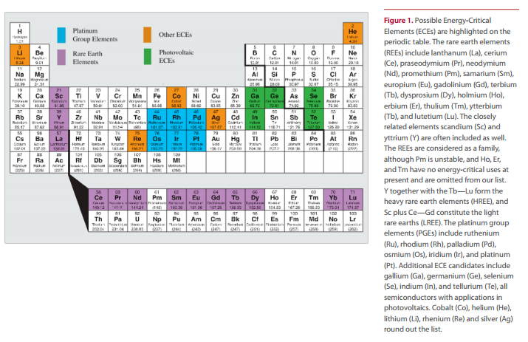

***(***[*http://www.aps.org/policy/reports/popa-reports/upload/elementsreport.pdf - p. 5*](http://www.aps.org/policy/reports/popa-reports/upload/elementsreport.pdf%20-%20p.%205)*)*

As mentioned earlier, sometimes an element is endangered or critical because of where it is located in the world. As the elements are not evenly distributed throughout the world, a few countries may control the access to some of the most critically needed elements. When a few countries control the majority of the supply, those in need of that resource are at the mercy of the individual or government that controls it. The United States currently relies on imports for more than 90% of its supply of the ECEs listed above.

The present U.S. dependence on foreign production of many mineral resources has, in many cases, evolved, not because the United States has a lack of resources or reserves, but rather because foreign producers have a competitive advantage, supplying the United States (and the world) with raw materials at the lowest price.

Serious risk may develop when production is concentrated in a small number of mines, companies, or nations. When sources of rare commodities are discovered and, subsequently, developed in underdeveloped countries, the result is sometimes increased hardship and political instability, rather than improved standard of living for the majority of citizens. The history of cobalt, copper, and tantalum production in the Democratic Republic of the Congo is one of numerous examples in Africa alone. Countries dependent on ECEs produced under such circumstances might be subject to prolonged uncertainty and are at risk for acting in ways that further exacerbate the economic and human suffering in the producing country. Conversely, when established foreign governments control a major fraction of the supply of an ECE, countries dependent on that material become vulnerable to manipulative market practices. These include (a) charging higher prices than possible were there a larger number of sellers and (b) restricting exports to the advantage of domestic users in the producing nations. Even absent explicit policy on the part of a foreign government, when supply is concentrated, users are subject to unforeseen supply disruptions due to labor or civil unrest and/or technical problems at mines or processing facilities.

There are numerous examples of disruptions driven by both foreign governments and other factors. The present “rare earth crisis”—involving dramatic price escalations and possible shortages— appears to be an example of government policy. History suggests that shortages, price spikes, and abandonment of technologies can occur when the threat of a shortage arises, even if the actual shortage never materializes, as was the case for cobalt in the Congo in the 1970s. …

Among the energy-critical elements, the rare earths, platinum group elements, and lithium are perhaps most vulnerable to geopolitical risks. Nearly all current global production of rare earths occurs in China, where the government has imposed export restrictions. China’s stated motives are to encourage responsible development of domestic processing and manufacturing industries that use rare earths, to stop highly polluting practices and to secure future supplies for domestic needs; opinion outside of China cites geopolitical control and maximization of price. Platinum production is concentrated in the hands of a small number of companies in South Africa, which produced 79% of the world’s supply in 2009. This leaves platinum users vulnerable to opportunistic behavior. Lithium also has the potential for geopolitical risks, because the world’s known resources of easily extractable lithium are largely concentrated in three South American countries: Chile, Bolivia, and Argentina.

(<http://www.aps.org/policy/reports/popa-reports/upload/elementsreport.pdf>)

While the United States has some deposits of rare earth metals, mining them stopped when they could be replaced with lower-priced Chinese ores and refined elements. China dominates the REE market because it has operated under low environmental standards and low-cost labor. REEs often occur in ores that contain radioactive elements, such as uranium and thorium. When these ores are mined, the radioactive elements are left in the tailings, releasing unacceptable levels of radiation into the surroundings. China has been mining with little environment remediation, thus lowering their cost of operation, while companies operating in the United States are subject to much more stringent environmental regulations.

The graph below shows the change in rare earth oxide mining for a period of 50 years. The effects of China’s unrestrained mining production are alarming. While the U.S. was a global leader from 1965–1985, China has steadily “cornered the market” for rare earth mining products.



*(*[*http://minerals.usgs.gov/minerals/pubs/commodity/rare\_earths/ree-trends.pdf*](http://minerals.usgs.gov/minerals/pubs/commodity/rare_earths/ree-trends.pdf)*)*

**More on substitutes for rare earth elements (REEs)**

As today’s technology becomes more dependent on a steady supply of several of the rare earth metals, the interest in finding viable alternatives to these materials is intensified. Researchers from Yale University’s Center for Industrial Ecology conducted a study of the possible substitution for various metals and metalloids presently in use and reached rather serious conclusions.

Modern life is enabled by the use of materials in its technologies. Over time, these technologies have used a larger and more diverse array of materials. Elemental life cycle analyses yield an understanding of these materials, and a definite concern that arises is that of possible scarcity of some of the elements as their use increases. We studied substitution potential for 62 different metals in their major uses. For a dozen different metals, the potential substitutes for their major uses are either inadequate or appear not to exist at all. Further, for not 1 of the 62 metals are exemplary substitutes available for all major uses.

(Graedel, T.; Harper, E.; Nassar, N.; Reck, B. On the Materials Basis of Modern Society. *Proceedings of the National Academy of Sciences of the United States of America*. PNAS *2013; published ahead of print December 2, 2013, doi:10.1073/pnas.1312752110;* abstract from <http://www.pnas.org/content/early/2013/11/27/1312752110>; complete article here: <http://www.pnas.org/content/early/2013/11/27/1312752110.full.pdf+html>)

It is interesting to note that there are 62 elements in this study just as there are 62 elements in the Patrick *ChemMatters* article. However, while there is a lot of overlap, they are not the same 62 elements. The Yale researchers restricted their study to metals while the Patrick article is based on a study that included the entire periodic table. The periodic table below from the Yale study uses the color-coded scheme to illustrate the status of substitute materials for the various elements. Note the lack of blues and true greens, indicating the lack of excellent substitutes for these elements.

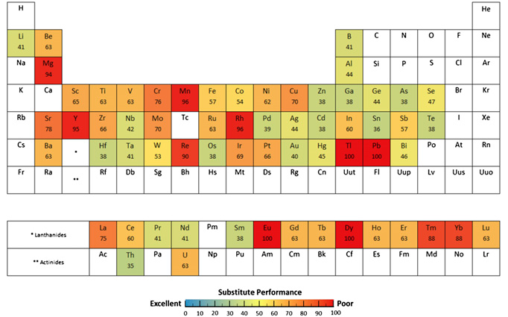

*Endangered elements and the availability of suitable substitute elements for them*

*(*[*http://www.pnas.org/content/early/2013/11/27/1312752110.full.pdf+html2*](http://theconversation.com/metals-in-your-smartphone-have-no-substitutes-21142)*)*

The Graedel et. al. article also provides online supporting information with a comprehensive, detailed table (34 pages) of those 62 elements, citing for each element: its applications in society and details thereof; the percentage of the element used in that application; the element’s primary substitute material; and the substitute’s performance. This list may be useful in your classes as you discuss metals in the curriculum, just to show students the diversity of uses for metals in today’s society.

A second supporting document contains details about how and why the study was done, as well as the periodic table from the article, and a graph showing the aggregated “ratings” of those elements as to the performance of presently available substitute materials. This graph shows that not a single metal has a substitute material that performs adequately in all applications, and roughly one-fourth of these metals have substitutes that only work extremely poorly in most applications.

(<http://www.pnas.org/content/suppl/2013/11/29/1312752110.DCSupplemental>)

**Indium**

**Brief history**

In 1863, the German chemists [Ferdinand Reich](https://en.wikipedia.org/wiki/Ferdinand_Reich) and [Hieronymous Theodor Richter](https://en.wikipedia.org/wiki/Hieronymous_Theodor_Richter" \o "Hieronymous Theodor Richter) were testing ores from the mines around [Freiberg, Saxony](https://en.wikipedia.org/wiki/Freiberg,_Saxony). They dissolved the minerals [pyrite](https://en.wikipedia.org/wiki/Pyrite), [arsenopyrite](https://en.wikipedia.org/wiki/Arsenopyrite), [galena](https://en.wikipedia.org/wiki/Galena) and [sphalerite](https://en.wikipedia.org/wiki/Sphalerite) in [hydrochloric acid](https://en.wikipedia.org/wiki/Hydrochloric_acid) and distilled raw [zinc chloride](https://en.wikipedia.org/wiki/Zinc_chloride). Reich, who was [color-blind](https://en.wikipedia.org/wiki/Color-blind), employed Richter as an assistant for detecting the colored spectral lines. Knowing that ores from that region sometimes contain [thallium](https://en.wikipedia.org/wiki/Thallium), they searched for the green thallium emission spectrum lines. Instead, they found a bright blue line. Because that blue line did not match any known element, they hypothesized a new element was present in the minerals. They named the element indium, from the [indigo](https://en.wikipedia.org/wiki/Indigo) color seen in its spectrum, after the Latin *indicum*.

Richter went on to isolate the metal in 1864. An ingot of 0.5 kg (1.1 lb) was presented at the [World Fair](https://en.wikipedia.org/wiki/Exposition_Universelle_(1867)) 1867. Reich and Richter later fell out when the latter claimed to be the sole discoverer.

(<https://en.wikipedia.org/wiki/Indium>)

**Properties**

Indium, atomic number 49, is the 68th most abundant element in the earth’s crust. It makes up 0.21 ppm of the earth’s crust. Indium is soft and malleable, similar to gallium, with a low melting point (156.60 °C). Indium has one stable isotope, In-113; however, 95.7% of all indium on earth is In-115, which has a half-life of 4.41×1014 years, four orders of magnitude greater than the age of the universe. Most indium is found in zinc sulfide ores, and the majority of indium on the market is a byproduct of zinc refinement. As indium use has increased with its applications in new technology, there has been more interest in increasing its recovery yields. Besides zinc, indium can also be recovered from tin, copper, iron, and lead ores. It is purified by electrolysis.

*A sample of indium*

*(*[*https://en.wikipedia.org/wiki/Indium*](https://en.wikipedia.org/wiki/Indium)*)*

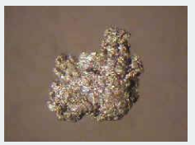

Indium’s electron configuration is [Kr]4d105s25p1. The +3 ion is the most common though it does form a +1 ion as well. In2O3 is formed when indium is burned or the hydroxide or nitrate is heated. Like alumina, indium is amphoteric, reacting with acids and bases. Indium wire is used as a cryogenic seal. An alloy of indium, gallium, and tin is liquid at room temperature and can be used to replace mercury in thermometers. Indium can also substitute for mercury in batteries as well as reduce the amount of mercury used in dental amalgams.

Estimates of the time left before our indium resources are depleted varies. The Royal Society of Chemistry projects that current resources will be depleted within this century. The Indium Corporation projects the supplies will last much longer stating that new efforts to reclaim indium lost during product manufacture and increasing recycling will protect the resources for many years to come.

When an Indium Corporation employee was asked by a high school student about the effect indium had on the environment, the employee answered on their Web site with the positive effects that indium use has on the environment. These are:

* Indium replaces mercury in batteries
* Solar panels that use indium supplement energy from fossil fuels
* LED’s use less energy than traditional light bulbs and are more environmentally friendly than fluorescent bulbs
* Flat screen TVs have replaced CRTs, which are more dangerous to the environment and are harder to recycle
* Architectural glass lowers HVAC costs,
* Indium in cryogenic seals is totally recyclable
* Lower temperature indium alloy solders use less energy

(<http://www.indium.com/blog/environmental-impact.php>)

**Indium tin oxide, ITO**

84% of global consumption of indium is as indium tin oxide, the majority of which is used in flat panel displays. Indium tin oxide (ITO or tin-doped indium oxide) is a mixture of 90% indium(III)oxide (In2O3) and 10% tin(IV)oxide (SnO2).

In powder form, indium tin oxide (ITO) is yellow-green in color, but it is transparent and colorless when deposited as a thin film at thicknesses of 1000-3000 angstroms. When deposited as a thin film on glass or clear plastic it functions as a transparent electrical conductor.

ITO is normally deposited by a physical vapor deposition process such as D.C. magnetron sputtering or electron beam deposition**.** Less frequently, ITO can be incorporated in inks using an appropriate film-forming polymer resin and solvent system, and deposited by screen printing - albeit with lower transparency and conductivity compared to a physical deposition process.

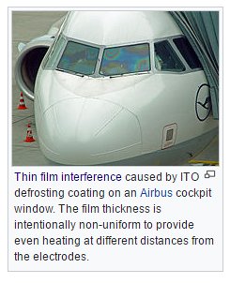

*(*[*https://en.wikipedia.org/wiki/Indium\_tin\_oxide*](https://en.wikipedia.org/wiki/Indium_tin_oxide)*)*

Of the various transparent conductive oxides (TCOs), ITO is considered the premium TCO, having superior conductivity and transparency, stability and ease of patterning to form transparent circuitry. ITO is used in a number of display technologies, such as LCD, OLED, plasma, electroluminescent, and electrochromatic displays, as well as in a number of touch screen technologies.

Further uses of this versatile material include antistatic indium tin oxide coatings, EMI shielding, photovoltaic solar cells, aircraft windshields, and freezer case glass for demisting. Yet further applications for ITO are as an infrared reflecting coating to reflect heat energy such as in low-E glass and in low-pressure sodium lamps.

(<http://www.indium.com/inorganic-compounds/indium-compounds/indium-tin-oxide/>)

Indium tin oxide is the most widely used semiconductor in the smartphone and tablet industry because of its unique material properties that are perfect for touch screen applications. It has high conductivity, is optically transparent, and can be mass produced as thin films. In touch screens ITO detects the changes in electrical state when you touch and swipe the screen, transferring that change to a grid of connections below.

ITO is a heavily doped semiconductor and, as such, has mobile electrons. The tin in the compound provides the mobile electrons accounting for the conductivity, but what makes the substance transparent? Indium oxide alone is an insulator with an optical gap of about 3.5–3.7 eV. It is the optical gap in indium oxide that makes ITO transparent. As a semiconductor it has mobile electrons and when mobile electrons interact with light they either absorb it or transmit it depending on the optical gap of the material. The optical gap or band gap is the region of free space within the crystal lattice where no electrons exist. It is the space between the overlapping orbitals, so to speak. In metals, there is no gap and in insulators the gap is too large for charge carrying electrons to cross. Semiconductors have a gap that can be bridged by mobile electrons. If the energy of light reacting with the surface is in the same energy range or greater than the materials optical gap, the light will be absorbed. Visible light has an energy range of 3.2–1.8 eV which is lower than ITO’s band gap making this material transparent.

The following diagrams help illustrate this phenomenon.

The optical and electronic properties of semiconductors is governed by their band structure. In semiconducting and insulating materials, the valence and conduction bands do not overlap, leading to a range of energies which cannot be occupied by charge carriers (i.e. a band gap, Eg).

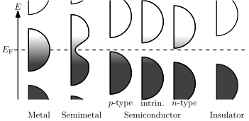

[*https://en.wikipedia.org/wiki/Electronic\_band\_structure*](https://en.wikipedia.org/wiki/Electronic_band_structure)

The presence of defects and/or impurities can lead to conductivity, since they can alter the materials fermi level, Ef, by supplying charge carriers into either the conduction band or valence band. This is what leads to conductivity in semiconductors.

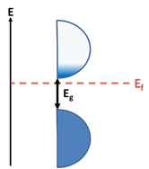

The materials bandgap also determines which wavelengths will be absorbed and which will transmit through. Silicon’s band gap, Eg, is 1.1 eV, which means that any light with an energy greater than 1.1 eV will be absorbed. Visible light has a wavelength range between 390 to 700 nm, corresponding to energies between 3.2 to 1.8 eV. So, Si is not transparent under visible light since it absorbs those wavelengths. However, it is transparent for a range of wavelengths with energies less than that 1.1 eV (1100 nm or 1.1 micrometers)

Indium tin oxide (ITO) is a semiconductor formed by alloying indium oxide (80%) with tin oxide (20%). Indium oxide has a bandgap between 3.5 to 3.7 eV. The highest energy visible light can have is 3.2 eV making this material transparent. Its conductivity stems from the presence of tin, which provides charge carrying electrons into the conduction band, leading to conductivity.

(<https://www.quora.com/How-can-indium-tin-oxide-be-conductive-and-transparent-at-the-same-time>)

**Health Hazards of ITO**

While indium tin oxide is thought to be relatively safe, as time has progressed, some health problems have been observed in those who work with the material. This has precipitated the change in how this material is handled and the conditions of the factories where it is processed.

Workers engaged in finishing compacted ITO targets by wet grinding in a Japanese plant that manufactured ITO sputtering targets exhibited lung disease, the severity of which generally increased with duration of exposure and with serum indium concentrations. Two of five cases from the same Japanese plant experienced bilateral pneumothorax and at least one of these cases died. One of the five workers, diagnosed with lung fibrosis, improved upon removal to another work area. A cohort study of 108 workers from this plant reported that 23 (21%) had significant interstitial changes and 14 (13%) had emphysematous changes. Only modest lung function decrements were noted. These conditions were reported to most likely be due to inhalation of micrometer-sized ITO particles. High serum concentrations of indium in a large fraction of the workers and former workers indicated indium dissolution from ITO particles. Biomarkers of interstitial lung changes increased with increasing mean serum indium concentrations in 20 of 93 workers who were exposed to indium metal (~10%), ITO (~50%), or other insoluble indium compounds (~40%) at two ITO target manufacturing plants and two recycling plants, and in nine of 40 (22.5%) workers who had extended exposure to other insoluble indium species. Indium was suggested as the main toxicant, as well as in studies with other indium compounds such as indium oxide and indium phosphide.

(<https://ntp.niehs.nih.gov/ntp/noms/support_docs/ito060309_508.pdf>)

**Alternatives to ITO**

As the price for indium increases with increased demand and decreased supply, it becomes imperative that alternatives to this material be sought. Material scientists and industry experts are pursuing both more efficient ways to use indium and the development of more sustainable alternatives. Only 30% of the indium tin oxide that is used in the sputtering technique of creating the thin films finds its target, though approximately 65% of the waste can now be recycled for reuse. Also, there is increased interest in developing new methods of producing the thin film that are not as inefficient. Some of the alternative materials that are receiving interest are:

* Aluminum doped zinc oxide AZO
* Gallium zinc oxide
* Carbon nanotubes
* Graphene
* Conductive polymers
* Amorphous transparent conducting oxides
* Adding silver nanoparticles to ITO to make an ITO hybrid

Of the materials mentioned above, graphene has received a lot of attention. It is 90% as transparent as ITO and has lower electrical resistance, but it is not ready for large scale production as of yet. Also, once enough layers of graphene are applied to handle the current, it may not be as transparent. Conductive polymers are showing promise for some applications. Their conductivity is lower, but they are more flexible, less expensive, and more environmentally friendly to produce. Amorphous transparent conducting oxides reduce indium content, improve electrical homogeneity, and are easier to produce. They are finding a use in organic solar cells.

(<http://www.azom.com/article.aspx?ArticleID=9634>)

**Helium**

**Brief history of helium**

Helium is another element whose discovery came from observing unusual spectral lines. In 1968 French astronomer Jules Janssen observed a bright yellow line while observing a solar eclipse in India. Later that year English astronomer Norman Lockyer observed the same line in the solar spectrum. He concluded that it was from an element in the sun that was unknown on earth. He and chemist Edward Franklin named the element Helium from the Greek word for sun, “Helios”. In 1895, the Scottish chemist Sir William Ramsay, while looking for argon, isolated helium from a sample of a uranium ore.

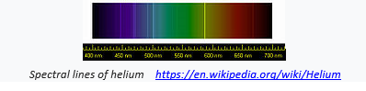

*(*[*https://en.wikipedia.org/wiki/Helium*](https://en.wikipedia.org/wiki/Helium)*)*

**Properties of helium**

Helium is an odorless, colorless, and tasteless gas that is theorized to have formed in the early moments of the Big Bang as a fusion of hydrogen atoms and neutrons. It is the second most abundant element in the universe after hydrogen. On Earth, its concentration is only 5.2 ppm in the atmosphere. Due to its low density, any helium that is formed on Earth is able to quickly escape through the atmosphere. It has the lowest boiling point of all the elements, at 4.22 K. Below 2.176 K, helium still remains a liquid at standard pressure.

On earth, helium is formed as a product of the nuclear decay of uranium and thorium in minerals that make up the earth’s crust. Uranium and thorium are part of nuclear disintegration series that decay by the loss of alpha particles until a stable isotope of lead is achieved. After the ejected alpha particles acquire two electrons, they become atoms of helium. If this happens in nonporous rock in the earth’s crust then the gas will accumulate in pockets of natural gas. Whether helium is present in a sample of natural gas depends on the geology of the area where it is found. The United States has some natural gas deposits that have the highest helium concentration in the world. These are located in the Texas and Oklahoma panhandles and southern Kansas.

The initial hint that helium was lurking in natural gas occurred in 1903, according to the [American Chemical Society](http://www.acs.org/content/acs/en/education/whatischemistry/landmarks/heliumnaturalgas.html) (ACS). At a celebration of a new gas well in Dexter, Kansas, the mayor attempted to ignite the escaping gases, only to find that the flames went out. Most of the townspeople were disappointed, but Kansas state geologist Erasmus Haworth became curious. He had the gas from the well collected and discovered that 12 percent was made of an "inert residue." Further experiments over the next two years at the University of Kansas revealed helium gas among this residue.

(<http://www.livescience.com/28552-facts-about-helium.html>)

Helium is extracted from natural gas by fractional distillation. In 1925, the U.S. government established a National Helium Reserve at Amarillo, Texas. Over time, the nearby gas fields were connected to a huge natural underground reservoir called the Bush dome, which was managed at the Amarillo facility. The National Reserve was established to secure a helium supply for military purposes in time of war and for commercial uses in time of peace. When the Reserve was established, the U.S. was the only provider of helium to the world. In 1927, the Helium Control Act restricted the export of helium only to nations with favored status. Though designed for helium, German airships like the Hindenberg had to rely on hydrogen as their buoyant gas. (After a successful trans-Atlantic flight, the Hindenburg caught fire as it was landing on May 6, 1937 in New Jersey, bringing an abrupt end to the hydrogen-buoyed passenger airship era.)

**National Helium Reserve Timeline**

|  |  |
| --- | --- |
| **1925** | National Helium Reserve Established |
| **1927** | Helium Control Act restricts the sale of helium to some countries The U.S. is the only supplier of helium to the world |
| **1950s** | Increased helium use by the space industry for rocket fuel production |
| **1960s** | More pipelines constructed to connect nearby wells to the Bush dome reservoir, More helium purchased for the Reserve |
| **1990s** | Algeria begins helium production to meet Europe’s needs |
| **1995** | Federal Helium Reserve was 1.4 billion dollars in debt |
| **1996** | Helium Privatization Act ordered the reserve to start selling off the helium reserves in order to relinquish the debt. The private sector was to take over supplying helium. Due to low prices, the private sector did not invest in helium production |
| **2007** | Amarillo helium plant put up for auction |
| **2010** | Helium supply and demand pressures noticed |
| **2012** | U.S. Reserve accounts for only 30% of the world’s helium |
| **2013** | Helium Stewardship Act prevented the government from undercutting private producers in order to encourage more sources of U.S. helium production to go online. |
| **2014** | Helium is overproduced due to new plants in Algeria and Qatar, the largest in the world |
| **2016** | Large quantity of helium gas discovered in Tanzania |

In June 2016, a large reservoir of helium gas was discovered in Tanzania by geologists who had been looking specifically for helium. By studying rock formations, volcanic activity, and geological shifts, a site was chosen for exploration. In the past, helium has been found as a component of a natural gas reservoir. This marked the first discovery of a helium reservoir. (<https://www.newscientist.com/article/2095196-huge-newfound-deposit-of-helium-will-keep-mri-scanners-running/>)

Even though more deposits of helium have recently been found, helium is a non-renewable resource and will always be under pressure of being able to meet demand in the long run. As prices for helium increase, the hope is that recycling efforts will become cost effective.

Yet the American reserve is in danger. Between 10 and 12 billion cubic feet of recoverable helium are expected to remain in the reservoir by the end of 2014, Walter Nelson, director of helium sourcing for Air Products and Chemicals, Inc., told the U.S. Senate Energy and Natural Resources Committee in May. "At current production rates of about 2 billion cubic feet per year, the reservoir could continue to produce helium for five to six more years." But, he said, the computer modeling that predicts the amount of helium the reservoir will be able to produce, considering its complex geology, has determined that the reservoir production rates "will decline to approximately 1 billion cubic feet per year after 2014," he said. "As a result, the usable life of the reservoir will be extended to 2018 or perhaps even 2020."

(<http://www.popularmechanics.com/science/health/a4046/why-is-there-a-helium-shortage-10031229/>)

**Uses of helium**

Besides the Goodyear blimp and the Macy’s Thanksgiving Day Parade balloons, helium is increasingly finding a use in modern technology and research.

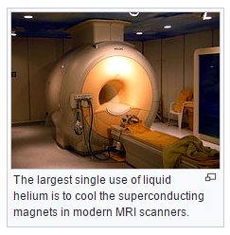

*(*[*https://en.wikipedia.org/wiki/Helium*](https://en.wikipedia.org/wiki/Helium)*)*

Liquid helium is used in [cryogenics](https://en.wikipedia.org/wiki/Helium_cryogenics) (its largest single use, absorbing about a quarter of production), particularly in the cooling of [superconducting magnets](https://en.wikipedia.org/wiki/Superconducting_magnet), with the main commercial application being in [MRI](https://en.wikipedia.org/wiki/MRI) scanners. Helium's other industrial uses—as a pressurizing and purge gas, as a protective atmosphere for [arc welding](https://en.wikipedia.org/wiki/Arc_welding), and in processes such as growing crystals to make [silicon wafers](https://en.wikipedia.org/wiki/Silicon_wafer)—account for half of the gas produced. A well-known but minor use is as a [lifting gas](https://en.wikipedia.org/wiki/Lifting_gas) in [balloons](https://en.wikipedia.org/wiki/Balloon) and [airships](https://en.wikipedia.org/wiki/Airship). As with any gas whose density differs from that of air, inhaling a small volume of helium temporarily changes the timbre and quality of the [human voice](https://en.wikipedia.org/wiki/Human_voice). In scientific research, the behavior of the two fluid phases of helium-4 (helium I and helium II) is important to researchers studying [quantum mechanics](https://en.wikipedia.org/wiki/Quantum_mechanics) (in particular the property of [superfluidity](https://en.wikipedia.org/wiki/Superfluidity" \o "Superfluidity)) and to those looking at the phenomena, such as [superconductivity](https://en.wikipedia.org/wiki/Superconductivity), produced in matter near [absolute zero](https://en.wikipedia.org/wiki/Absolute_zero).

*Industrial uses for helium*

*(*[*https://en.wikipedia.org/wiki/Helium*](https://en.wikipedia.org/wiki/Helium)*)*

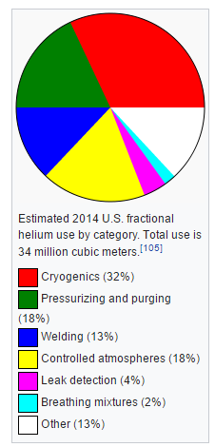

(<https://en.wikipedia.org/wiki/Helium>)

Helium-3 is a rare isotope of helium that on Earth is a product of the beta decay of hydrogen’s isotope tritium, H-3. The U.S. stockpile of tritium, a by-product of the nuclear weapons industry, is in use in the nation’s airports as a neutron detector to screen passengers for nuclear contraband.

**Helium hazards**

Helium is nontoxic as long as it is used cautiously. Students often get a kick out of hearing their voice after they have breathed in the helium from a balloon. The speed of sound traveling through helium is three times that of air, making the pitch of their voice higher. There have been instances where students have died from inhaling helium, though. In 1998, a 15-year-old Texas girl died from helium inhalation, and an Australian girl fell unconscious and turned blue after inhaling the entire contents of a party balloon. When a person is robbed of oxygen because of displacement with helium there is a risk of asphyxia. If the helium is brought down into the lungs it can cause the lungs to rupture (barotrauma). In some cases, the inhaled helium has caused the formation of an air bubble that blocks the blood flow to the brain causing hypoxia. The Wikipedia site for helium gives the details of several incidences of accidents from helium misuse. This would be a useful precaution to give students.

**Phosphorus**

**Brief history**

The discovery of phosphorus is another example of the serendipity of finding the incredible while searching for something that is mundane by comparison.

Phosphorus was the 13th element to be discovered. For this reason, and also due to its use in explosives, poisons and nerve agents, it is sometimes referred to as "the Devil's element". It was the first element to be discovered that was not known since ancient times. The discovery of phosphorus is credited to the German alchemist [Hennig Brand](https://en.wikipedia.org/wiki/Hennig_Brand" \o "Hennig Brand) in 1669, although other chemists might have discovered phosphorus around the same time. Brand experimented with [urine](https://en.wikipedia.org/wiki/Urine), which contains considerable quantities of dissolved phosphates from normal metabolism. Working in [Hamburg](https://en.wikipedia.org/wiki/Hamburg), Brand attempted to create the fabled [philosopher's stone](https://en.wikipedia.org/wiki/Philosopher%27s_stone) through the [distillation](https://en.wikipedia.org/wiki/Distillation) of some [salts](https://en.wikipedia.org/wiki/Salt) by evaporating urine, and in the process produced a white material that glowed in the dark and burned brilliantly. It was named *phosphorus mirabilis* ("miraculous bearer of light").His process originally involved letting urine stand for days until it gave off a terrible smell. Then he boiled it down to a paste, heated this paste to a high temperature, and led the vapors through water, where he hoped they would condense to gold. Instead, he obtained a white, waxy substance that glowed in the dark. Brand had discovered phosphorus. We now know that Brand produced ammonium sodium hydrogen phosphate, (NH4NaHPO4. While the quantities were essentially correct (it took about 1,100 litres [290 US gal] of urine to make about 60 g of phosphorus), it was unnecessary to allow the urine to rot. Later scientists discovered that fresh urine yielded the same amount of phosphorus.

Brand at first tried to keep the method secret,[[55]](https://en.wikipedia.org/wiki/Phosphorus" \l "cite_note-55) but later sold the recipe for 200 thalers to D. Krafft from Dresden,[[13]](https://en.wikipedia.org/wiki/Phosphorus#cite_note-mellor-717-13) who could now make it as well, and toured much of Europe with it, including England, where he met with [Robert Boyle](https://en.wikipedia.org/wiki/Robert_Boyle). The secret that it was made from urine leaked out and first [Johann Kunckel](https://en.wikipedia.org/wiki/Johann_von_L%C3%B6wenstern-Kunckel) (1630–1703) in Sweden (1678) and later Boyle in London (1680) also managed to make phosphorus, possibly with the aid of his assistant, [Ambrose Godfrey-Hanckwitz](https://en.wikipedia.org/wiki/Ambrose_Godfrey), who later made a business of the manufacture of phosphorus. Boyle states that Krafft gave him no information as to the preparation of phosphorus other than that it was derived from "somewhat that belonged to the body of man". This gave Boyle a valuable clue, so that he, too, managed to make phosphorus, and published the method of its manufacture. Later he improved Brand's process by using sand in the reaction (still using urine as base material),

4 NaPO3  + 2 SiO2  + 10 C → 2 Na2SiO3  + 10 CO +  P4

Robert Boyle was the first to use phosphorus to ignite sulfur-tipped wooden splints, forerunners of our modern matches, in 1680.

In 1769, [Johan Gottlieb Gahn](https://en.wikipedia.org/wiki/Johan_Gottlieb_Gahn) and [Carl Wilhelm Scheele](https://en.wikipedia.org/wiki/Carl_Wilhelm_Scheele) showed that calcium phosphate (Ca3(PO4)2) is found in bones, and they obtained elemental phosphorus from bone ash. [Antoine Lavoisier](https://en.wikipedia.org/wiki/Antoine_Lavoisier) recognized phosphorus as an element in 1777. Bone ash was the major source of phosphorus until the 1840s.

(<https://en.wikipedia.org/wiki/Phosphorus>)

Today phosphorus is an essential component of commercial fertilizer made from phosphate rock. Ninety percent of all phosphate rock mined comes from five countries – Morocco, China, South Africa, Jordan, and the United States. Some phosphate mining is also done in Russia, Tunisia, Brazil, Israel, and Senegal. The United States has been a leader in phosphate mining with mines in Florida, North Carolina, Idaho, and Utah. Since 2010, additional deposits have been discovered in the Sahara, Algeria, and Iraq. According to scientists at MIT, Phosphate rock deposits are even fewer and more concentrated than oil deposits and only a small fraction of them can be mined due to physical, economic, energy, or legal constraints. The time rock reserves will last is debatable. The U.S. has about 25 years of phosphate rock reserves left and has stopped exporting phosphate except as the refined products. The U.S. currently imports some phosphate rock from Morocco. Morocco’s phosphate reserves are estimated to be six times the size of the U.S. reserves and is the world’s leading supplier of phosphate rock.

In estimating the amount of time remaining before the earth’s phosphate rock is depleted the term “peak phosphorus” is used. It refers to peak production where the rate of phosphate rock being mined equals the amount that is used. It is not based on the time the rock will be depleted but on when easily extracted ore is used up. At that time, production will become too costly. Scientists at the Massachusetts Institute of Technology project that peak phosphorus will be achieved before 2040.

Most production of phosphorus-bearing material is for agriculture fertilizers. For this purpose, phosphate minerals are converted to phosphoric acid. It follows two distinct chemical routes, the main one being treatment of phosphate minerals with sulfuric acid. The other process utilizes white phosphorus, which may be produced by reaction and distillation from very low grade phosphate sources. The white phosphorus is then oxidized to phosphoric acid and subsequently neutralized with base to give phosphate salts. Phosphoric acid produced from white phosphorus is relatively pure and is the main route for the production of phosphates for all purposes, including detergent production.

(<https://en.wikipedia.org/wiki/Phosphorus>)

Phosphate mining involves stripping large swaths of land exposing some elements like uranium and cadmium to air and water. These elements can become part of the run off during a heavy rain storm causing environmental concerns. Also, processing the phosphate rock into phosphoric acid using sulfuric acid generates massive amounts of waste product called phosphogypsum which contains low levels of radiation and toxic heavy metals. Five tons of phosphogypsum is formed for every one ton of phosphoric acid produced.

Phosphogypsum, like natural gypsum, is calcium sulfate, a relatively innocuous material that is used to make things like wallboard. Phosphogypsum, however, is slightly more radioactive than natural gypsum. The radium that is found naturally associated with phosphate rock becomes associated with the phosphogypsum after the rock is reacted with sulfuric acid.

The U.S. EPA prohibits the use of phosphogypsum because of the radioactivity. An exception is made for phosphogypsum with an average concentration of less than 10 pCi/g radium which can be used as an agricultural amendment, but for no other use. Phosphogypsum in north Florida has 10 pCi/g radium. Central Florida phosphogypsum averages 26 pCi/g radium.

(<http://www.fipr.state.fl.us/about-us/phosphate-primer/phosphogypsum-and-the-epa-ban/>)

In countries with fewer regulations, phosphogypsum could possibly be used just as gypsum would. Chinese-made drywall used in more than 20,000 homes primarily in Florida and Louisiana after the hurricane season of 2005 later caused problems for the homeowners exposed to it. Hydrogen sulfide gas was among the chemicals given off by the drywall, especially in warm moist climates, causing nosebleeds, headaches, and asthma attacks in many of the occupants. In 2012 the Drywall Safety Act set chemical standards for domestic and imported drywall. Tainted Chinese drywall is no longer sold in the U.S.

**The phosphorus cycle**

The following is an explanation of the phosphorus cycle (see also diagram on next page).

Phosphorus is irreplaceable in organic life. It's a central atom in the backbone of DNA, shared by every living creature on earth, and it is used by human cells in adenosine triphosphate (ATP) as the primary means of energy storage. In the natural phosphorus cycle, mineral phosphate is freed from rock by erosion, makes its way into soil, and is absorbed by plants. Plants are then consumed by humans and animals, and phosphorus is re-introduced to the environment through waste and decomposition. For thousands of years, agriculture used only organic waste and remains to fertilize crops. The production, consumption and disposal of food formed a closed loop, and net phosphorus in the cycle remained relatively constant. Today, however, large-scale agriculture in the wake of the green revolution demands focused, synthetic fertilizers to provide the nutrients for higher-yield crops. Phosphorus and nitrogen are mined from the ground and removed from the air, such that the entire cycle is thrown out of balance.

(<http://web.mit.edu/12.000/www/m2016/finalwebsite/problems/phosphorus.html>)

*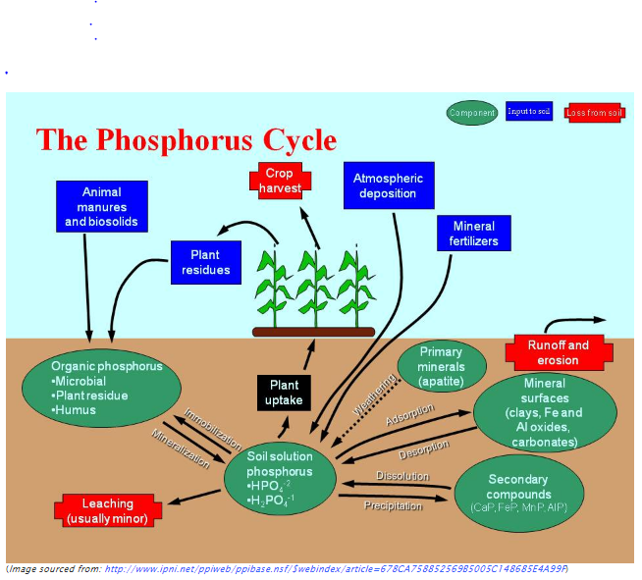*

[*http://slc4u.org/moodle20/mod/page/view.php?id=9*](http://slc4u.org/moodle20/mod/page/view.php?id=9)

Due to runoff and erosion, unused phosphates end up in rivers, lakes, and oceans. This often contributes to the eutrophication of rivers and lakes. Dead zones emerge, due to increased plant growth (algae) which, when it dies, uses up the oxygen in the water when it decays. Fish and other aquatic life in that region, that require oxygen, die.

**Fertilizers**

Without commercial fertilizers, it is estimated that about one-third of the food produced now could not be produced. The use of phosphate fertilizers has increased from nine million tons per year in 1960 to 40 million tons per year in 2000. Plants need phosphorus for photosynthesis. It helps plants develop strong root systems and helps them utilize carbon dioxide.

Commercial fertilizer manufacturers use a three-number code for their fertilizers. That code refers to the nitrogen, phosphorus, and potassium content of the fertilizer. The first number is always nitrogen, then phosphorus, and last, potassium. A fertilizer that is marked with 10-10-10 is 10% nitrogen, 10% phosphorus, and 10% potassium. A 50 lb bag of this fertilizer would contain 5 lbs of nitrogen, 5 lbs of phosphorus, and 5 pounds of potassium. The remaining 35 lbs would be micronutrients and fillers. A saying that helps one remember what the fertilizer components do is “up, down, and all around”. Nitrogen is responsible for the green leafy growth above ground, phosphorus helps the plant grow strong roots and also boosts blooming and fruit production, and potassium helps build strong cells and plant tissue.

**Managing phosphorus resources**

The projections of how much longer our current phosphorus resources will be easily available run anywhere from 15 to 100 years. This time can be increased if the reserves we know of now are managed judiciously.

With a world population that is projected to reach 9 billion by 2050 and require 70 percent more food than we produce today, and a growing global middle class that is consuming more meat and dairy, phosphorus is crucial to global food security. Yet, there are no international organizations or regulations that manage global phosphorus resources. Since global demand for phosphorus rises about 3 percent each year (and may increase at an even faster rate as the global middle class grows and consumes more meat), our ability to feed humanity will depend upon how we manage our phosphorus resources.

(<http://blogs.ei.columbia.edu/2013/04/01/phosphorus-essential-to-life-are-we-running-out/>)

There are several things that can be done to encourage a more efficient use of the phosphorus resources that we have.

* Improve efficiency of the mining process so that less waste is produced
* Use manure as fertilizer
* Make fertilizer application more targeted so that less is used
* Prevent soil erosion and agricultural run off by promoting no-till farming, terracing, contour tilling, and use of wind breaks
* Eat a plant based diet
* Reduce food waste
* Recover phosphorus from human waste

Recovering phosphorus from human waste is making it out of the lab and into full scale practice.

In some parts of Sweden, all new toilets must be able to divert urine for storage and use by local farmers. UK water company Thames Water is building a ‘nutrient recovery facility’ to remove a compound called struvite, which contains phosphorus and ammonia, from sewage at its works in Slough. The phosphorus extracted from Slough’s wastewater is predicted to form 150 tons of phosphate fertilizer pellets per year which can be spread directly onto soil.

(<http://www.rsc.org/images/Endangered%20Elements%20-%20Critical%20Thinking_tcm18-196054.pdf>)

# References

**(non-Web-based information sources)**

**The references below can be found on the *ChemMatters* 30-year DVD, which includes all articles   
published from the magazine’s inception in October 1983 through April 2013; all available Teacher’s Guides, beginning February 1990; and 12 *ChemMatters* videos. The DVD is available from the American Chemical Society for $42 (or $135 for a site/school license) at this site:** [**http://ww.acs.org/chemmatters**](http://www.acs.org/chemmatters)**. Click on the “Teacher’s Guide” tab to the left, directly under the “*ChemMatters Online"* logo and, on the new page, click on “Get the past 30 Years of *ChemMatters* on DVD!” (the icon on the right of the screen).**

**Selected articles and the complete set of   
Teacher’s Guides for all issues from the past three   
years are available free online at the same Web site, above. Click on the “Issues” tab just below the logo, *“ChemMatters Online”*.**

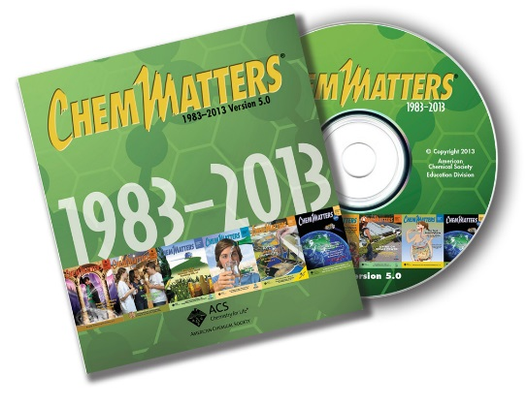

***30* Years of *ChemMatters !***

Available Now!

This article covers the use of tantalum (one of the endangered elements) in cell phones but also reveals the unstable supply of the element due to wars in the Congo over mining operations. (Michalovic, M. Tantalum, Congo, and Your Cell Phone. *ChemMatters,* 2007, *25* (3), pp 16–18).

A deeper discussion on the geopolitics of mining Tantalum in the Congo as well as a great deal of information about tantalum can be found in the October 2007 Teacher’s Guide for the above article.

When looking for a replacement for indium tin oxide, graphene is often mentioned. In this *ChemMatters* article, author Tinnesand writes about graphene and its possible future use in cell phones. (Tinnesand, M. Graphene: The Next Wonder Material? 2012, *30* (3), pp 6–8)

The Teacher’s Guide for the October 2012 *ChemMatters* issue referenced above contains additional information on flexible, printable solar cells.

A nice infographic on the elements in a cell phone can be found in the February 2014 issue of *ChemMatters*. (As a Matter of Fact. Your Smart Phone Contains Valuable Chemicals. *ChemMatters*, 2014, *32* (1), p 4)

More explanation for students on semiconductors and photovoltaics can be found in an article concerning solar energy. (Warner, J. A Solar Future. *ChemMatters,* 2014, *32* (2), pp 9–11)

The Teacher’s Guide for the April 2014 article mentioned above contains an additional explanation about energy bands and gaps in conductors, semiconductors, and insulators.

The elements found in a smart phone is the topic of this 2015 *ChemMatters* article. Additional explanation of how a touch screen works is also included. (Rohrig, B. Smartphones, Smart Chemistry. *ChemMatters*, 2015, *33* (2), pp 10–12)

The history and extensive information about the rare earth metals and their supply and demand can be found in the April 2015 Teacher’s Guide for the article mentioned above. This Teacher’s Guide also provides links to classroom activities that could apply to the endangered elements.

Plant nutrients such as phosphorus are discussed in a *ChemMatters* article on hydroponics. Also discussed are the pressures for increased food production for an increasing population. (Pickett, M. Dirt, Who Needs It? *ChemMatters*, 2015, *33* (3), pp 14–15)

More information on plant nutrients is discussed in the Teacher’s Guide to the article mentioned above. Links to classroom activities involving growing plants hydroponically are provided. Using this, students could alter the amount of phosphorus provided the plants and document the difference in growth.

# Web Sites for Additional Information

**(Web-based information sources)**

**Endangered elements**

In this article, “Endangered Elements: Critical Thinking”, Emma Davies explains the shortages of various elements and what is being done about their shortage. While she too concentrates on He, In, and P, there is more information about REEs. (<http://www.rsc.org/images/Endangered%20Elements%20-%20Critical%20Thinking_tcm18-196054.pdf>)

An overview of the main elements facing supply restrictions can be found in this whitepaper from the 2013 5th Chemical Science and Society Summit. The ideas of critical elements and energy critical elements are explained here. Several charts and graphics are used. (<https://www.acs.org/content/dam/acsorg/greenchemistry/industriainnovation/cs3-whitepaper2013.pdf>)

This Web site contains information on some of the endangered elements, in particularly helium, indium, and the rare earth metals. The site contains links to other articles with information on endangered elements. (<http://www.compoundchem.com/2015/08/19/endangered-elements/>)

The elements featured in the article originated from the work of Mike Pitts. His work and periodic tables are located at this site. A year after publishing his work he posted an updated periodic table which highlighted 62 elements rather than the original 44. That can be found here as well. (<http://www.thechemicalengineer.com/~/media/Documents/TCE/Articles/2011/844/844elements.pdf>)

The role of chemical sciences in finding alternatives to critical resources is the topic of the material found at this Web site. This link is to chapter 4 of the materials from a National Research Council Chemical Sciences workshop but the entire content of the book is available by selecting the content link. Chapter 5 contains information specific to indium and its use in photovoltaics. Chapter 6 has a good discussion of chemical use in batteries. The use of precious metals in automotive catalytic converters is a particularly interesting discussion in chapter 4 and one that students may relate to. (<https://www.ncbi.nlm.nih.gov/books/NBK100035/>)

“Securing Materials for Emerging Technologies” is the topic of this report by the American Physical Society. The Energy Critical Elements are addressed here. This is a good site for learning more about the geopolitical aspects of the distribution and use of the elements. (<http://www.aps.org/policy/reports/popa-reports/upload/elementsreport.pdf>)

“Element Recovery and Sustainability” is the topic of the book that can be accessed online here. This is a preview of the first 51 pages. There is lots of information on the critical elements in the material available. Nice graphics and another periodic table that could be easily used in power point presentations. There is additional information on the different methods of element extraction from ores. (<https://books.google.com/books?id=QmbfLX4TgGEC&lpg=PR13&ots=zGLXNET-hI&dq=Element%20Recovery%20and%20Sustainability&pg=PP1#v=onepage&q=Element%20Recovery%20and%20Sustainability&f=false>)

**Indium and indium tin oxides**

This site contains information about indium tin oxide as well as multiple links to related topics concerning this compound and its uses: <https://en.wikipedia.org/wiki/Indium_tin_oxide>.

On the Web site of the Indium Corporation, information about indium and indium tin oxide can be accessed. Information about ITO is linked here: <http://www.indium.com/inorganic-compounds/indium-compounds/indium-tin-oxide/>.

This is an interesting blog post from an Indium Corporation employee. It outlines many things that indium is used for that actually have a positive effect on the environment. This might be an interesting read for students that would prompt them to think if the benefits of using indium outweigh the hazards. (<http://www.indium.com/blog/environmental-impact.php>)

Another blogpost about the unsuitability of graphene as a replacement for ITO is found here. This would be a good read for the student who is excited about the future applications of graphene. (<http://www.indium.com/blog/graphene-an-unlikely-candidate-to-replace-ito-in-flat-panel-displays.php>)

Additional information about ITO, its touch screen and other applications, as well as possible alternatives, can be accessed at this Web site: <http://www.azom.com/article.aspx?ArticleID=9634>.

This site presents the health hazards that are beginning to be associated with exposure to inhalation of ITO. The most informative data comes from workers at a processing plant in Japan. ITO when inhaled can produce interstitial lung disease. This is the National Toxicology report. (<https://ntp.niehs.nih.gov/ntp/noms/support_docs/ito060309_508.pdf>)

“Electrons and Holes in Semiconductors” is the name of the chapter of a book at this site. It goes into depth in explaining semiconductors and the chemistry involved. Band gap, valence bands, and conduction bands are explained, as well as many other terms encountered in a discussion of semiconductors and energy transmission. (<https://people.eecs.berkeley.edu/~hu/Chenming-Hu_ch1.pdf>)

**Helium**

This *Popular Mechanics* article addresses the reasons behind the possible Helium shortage and explains the politics behind it. (<http://www.popularmechanics.com/science/health/a4046/why-is-there-a-helium-shortage-10031229/>)

Some interesting facts about superfluid helium and its ability to “climb walls” can be found in this *Scientific American* article: <https://www.scientificamerican.com/article/superfluid-can-climb-walls/>.

General information about helium can be found at this site. There is a good deal of information about the health hazards encountered with helium’s misuse near the end of the article that would be good to share with students. (<https://en.wikipedia.org/wiki/Helium>)

This January 26, 2015 article on the *Live Science* Web site is an up to date article about Helium general facts and current research. (<http://www.livescience.com/28552-facts-about-helium.html>)

The story of the history of helium’s discovery in natural gas can be found here. It could be used as an example of scientific inquiry in solving the mystery behind a puzzling observation. (<https://www.acs.org/content/acs/en/education/whatischemistry/landmarks/heliumnaturalgas.html>)

Information on helium’s use in MRI machines and how an MRI machine works can be found here: <http://summitsourcefunding.com/blog/helium-used-mri-machines/>.

This article provides news of the latest discovery of a helium reservoir in Tanzania. This is the first time helium has been the purpose of the geological exploration. (<https://www.newscientist.com/article/2095196-huge-newfound-deposit-of-helium-will-keep-mri-scanners-running/>)

**Phosphorus**

This is a blog post that discusses whether or not we are truly running out of phosphorus. (<http://blogs.ei.columbia.edu/2013/04/01/phosphorus-essential-to-life-are-we-running-out/>)

A February 2016 article about phosphorus depletion can be found at this site. The phosphorus cycle is illustrated and discussed. (<http://phys.org/news/2016-02-great-phosphorus-shortage-short-food.html>)

This current article on a phosphorus and nitrogen imbalance in the North Sea would be a good read for students interested in environmental chemistry or marine biology. (<http://phys.org/news/2016-01-environmental-policy-imbalance-phosphorus-nitrogen.html#nRlv>)

For a description of phosphorus mining practices and the effects they have on the environment the following article is a good place to start. (<http://www.motherjones.com/environment/2013/05/fertilizer-peak-phosphorus-shortage>)

The supply and demand issues concerning phosphorus are discussed in this MIT report: <http://web.mit.edu/12.000/www/m2016/finalwebsite/problems/phosphorus.html>.

Florida Institute of Phosphate Research provides a wealth of information on phosphate, how it is reclaimed and how it is used. (<http://www.fipr.state.fl.us/about-us/phosphate-primer/chemical-processing-of-phosphate/>)

**Fertilizers**

This Web site contains information about the ingredients in modern commercial fertilizers and the purpose for each ingredient with an emphasis on phosphorus. (<https://www.planetnatural.com/phophorus-fertilizer/>)

Fertilizer labels and what they mean is the topic for the article found here: <http://www.growingagreenerworld.com/the-numbers-on-fertilizer-labels-what-they-mean/>.

# General Web References

**(Web information not solely related to article topic)**

The Los Alamos interactive periodic table can be accessed here: It is a resource about all the elements that can be used throughout the year. (<http://periodic.lanl.gov/index.shtml>)

A Wake Forest professor who has worked extensively in the field of MRI maintains a Web site that entertains questions over all aspects related to MRI. It contains a wealth of current information. His explanations are in depth, yet easy to understand. (<http://mri-q.com/index.html>)