

**February/March 2017 Teacher's Guide**

**Background Information**

**for**

**Brush Up on Toothpaste!**

**Table of Contents**

About the Guide 2

Background Information 3

References 30

Web Sites for Additional Information 31

# 

# About the Guide

Teacher’s Guide team leader William Bleam and editors Pamela Diaz, Regis Goode, Diane Krone, Steve Long and Barbara Sitzman created the Teacher’s Guide article material.   
E-mail: [bbleam@verizon.net](mailto:bbleam@verizon.net)

Susan Cooper prepared the anticipation and reading guides.

Patrice Pages, *ChemMatters* editor, coordinated production and prepared the Microsoft Word and PDF versions of the Teacher’s Guide.

E-mail: [chemmatters@acs.org](mailto:chemmatters@acs.org)

Articles from past issues of *ChemMatters* and related Teacher’s Guides can be accessed from a DVD that is available from the American Chemical Society for $42. The DVD contains the entire 30-year publication of *ChemMatters* issues, from February 1983 to April 2013, along with all the related Teacher’s Guides since they were first created with the February 1990 issue of *ChemMatters*.

The DVD also includes Article, Title, and Keyword Indexes that cover all issues from February 1983 to April 2013. A search function (similar to a Google search of keywords) is also available on the DVD.

The *ChemMatters* DVD can be purchased by calling 1-800-227-5558. Purchase information can also be found online at <http://tinyurl.com/o37s9x2>.

# Background Information

**(teacher information)**

**The** **history of dental care and caries**

Currently, the earliest evidence of dental intervention was shown in a skeleton discovered in Northern Italy in 1988. Scientists dated the remains of the skeleton at 13,820 to 14,160 years ago. The male skeleton is estimated to be that of a 25-year-old. A tooth (shown at right) displayed evidence of dental caries and showed scratches indicating crude “brushing” or tooth scraping. Experiments done by scientists on this and other teeth indicate that a flint tool was used to scrape the inside of the tooth, most likely in an effort to repair the cavity.

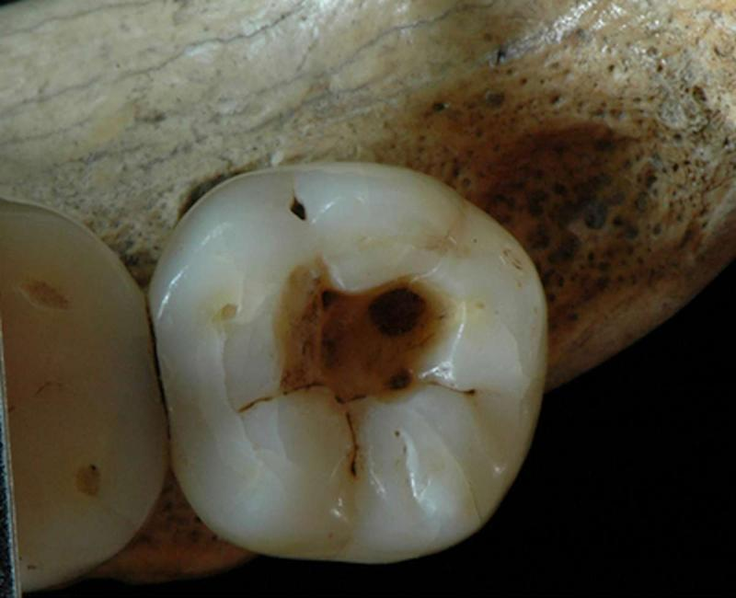

*Earliest evidence of   
dental caries manipulation*

*(*[*http://medicalxpress.com/news/2015-07-earliest-evidence-dental-cavity.html*](http://medicalxpress.com/news/2015-07-earliest-evidence-dental-cavity.html)*)*

(<http://www.nature.com/articles/srep12150#f2>)

Skulls from a 9,000-year-old grave in Pakistan show evidence of dental work done by Stone Age nomadic hunter-gatherers. Several teeth retrieved from this grave indicate early dental drilling. They show edges that have been leveled, smoothed and drilled (one shown at left). These teeth also showed signs of decay, suggesting that drilling was done for medical rather than simply cosmetic reasons. Scientists say that evidence suggests that early “dentists” rotated sharp flint tipped wooden drills in their work on teeth. Researchers supported this hypothesis by constructing flint “drills” that made similar marks on teeth.

(<http://news.nationalgeographic.com/news/2006/04/0405_060405_teeth_drill.html>)

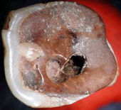

*9,000 year old tooth   
drilled by Stone Age dentist*

*(*[*http://news.nationalgeographic.com/news/2006/04/0405_060405_teeth_drill_2.html*](http://news.nationalgeographic.com/news/2006/04/0405_060405_teeth_drill_2.html)*)*

An artificial tooth found in a third-century B.C. burial ground in Northern France was made from an iron pin (see photos, next page). Speculation is that the pin was originally bonded to a tooth or to artificial material that has since decayed. The left photo below shows the teeth of a 20- to 30-year-old woman. Her iron “tooth” is the dark brown rod located between the first and second teeth at the lower left. The photo on the right shows one of the woman’s normal teeth next to her iron “tooth”.

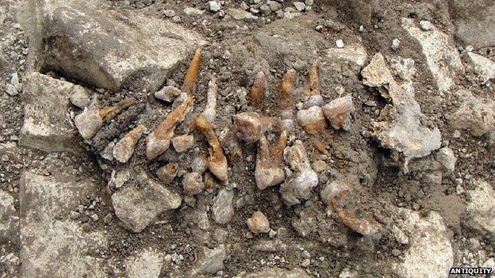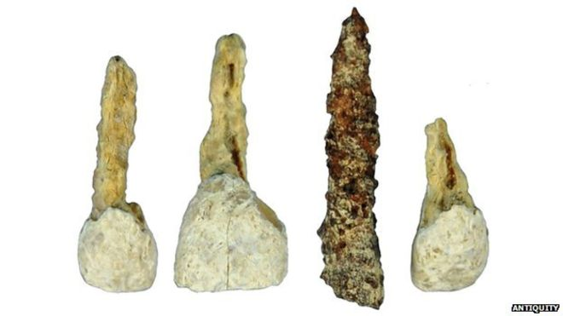

*Artificial iron tooth, in set of teeth (left photo), and isolated with another tooth (right photo)*

*(*[*http://www.bbc.com/news/science-environment-27587104*](http://www.bbc.com/news/science-environment-27587104)*)*

In Mesoamerica before the Spanish Conquests of the 1500s, dentists drilled and decorated teeth with semi-precious stones held in place by plant sap. The “drill” was made of obsidian, a hard stone capable of puncturing bone. The skull at right, unearthed in Chiapas, Mexico, indicates that early dentists understood how to drill in the outer enamel layer only, thus avoiding penetration of the inner tooth.

(<http://news.nationalgeographic.com/news/2009/05/090518-jeweled-teeth-picture.html>)

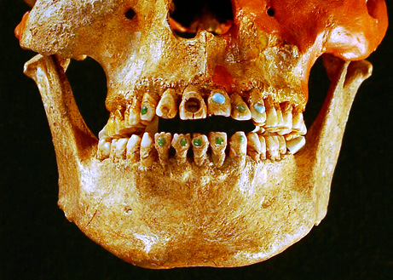

*Jeweled Teeth*

*(*[*http://news.nationalgeographic.com/news/2009/05/090518-jeweled-teeth-picture.html*](http://news.nationalgeographic.com/news/2009/05/090518-jeweled-teeth-picture.html)*)*

Dental caries is the scientific term for tooth decay or cavities. Teeth of the hunter-gatherer Paleolithic, Old Stone Age people (before 10,000 BC) show few cavities. This is probably due to their diet of primarily meat and some wild grains. As the Neolithic, New Stone Age people (10,200 B.C. to 2,000 B.C.) began to farm, they ate more carbohydrates, which contributed to increased tooth decay (more on this topic later in this Teacher’s Guide).

Fossilized teeth from the Neolithic Age display scratch marks resembling those made by rudimentary tooth picks. This was probably done to reduce the pain of dental caries. In the Middle Ages there was a sharp increase both in farming and in dental decay. The teeth of Western French people, whose diet consisted of high amounts of carbohydrates (cereals), showed more cavities than those who lived in poorer areas near the coast, where they subsisted on primarily fish and fruit. This report from *Nature* describes the experimental procedures and data from a study of dental caries in Upper Paleolithic Age people. (<https://www.ncbi.nlm.nih.gov/pmc/articles/PMC3227510/>)

Another indication of early “dentistry” was discovered in Slovenia. Traces of beeswax were found in a human canine tooth (conical teeth located between the incisors and the premolars) of a 6,500-year-old Neolithic human. The tooth contained a vertical crack that extended down to the dentin (tooth material under the enamel). If the crack was filled before death, the beeswax probably reduced the pain of exposed dentin. (<http://journals.plos.org/plosone/article?id=10.1371/journal.pone.0044904>)

The figure below is from the original study described above. This discovery was announced in *U.K. Daily Mail,* September 2012. Researchers used a variety of scanning techniques to reveal the beeswax filling on the tooth below. The micrographs show:

1. Section of the lower left canine tooth
2. Three views of the detail of the crown showing the thickness of the beeswax (shown in yellow) and how it completely fills the upper enamel and the dentin. The tooth surface (within the dotted line) was completely covered by beeswax.
3. These tooth cross-sections show cracks in the enamel that were filled with beeswax.

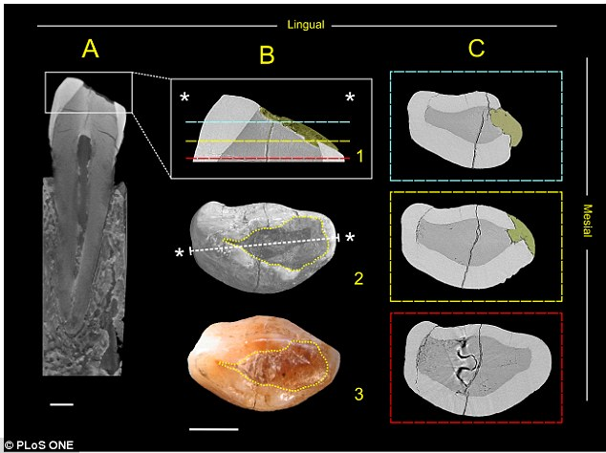

*Beeswax as dental filling on a Neolithic human tooth*

*(*[*http://www.dailymail.co.uk/sciencetech/article-2205919/How-trips-dentists-troubled-ancestors-6-500-years-ago-Early-dentists-gave-patients-beeswax-fillings-tackle-toothache.html*](http://www.dailymail.co.uk/sciencetech/article-2205919/How-trips-dentists-troubled-ancestors-6-500-years-ago-Early-dentists-gave-patients-beeswax-fillings-tackle-toothache.html))

**The oral microbiome**

The focus of early pathogen research was on a specific disease caused by a single microorganism. These investigations led to vaccines for diseases such as polio and diphtheria. Now, researchers recognize that dental caries may be caused by more than one species of oral bacteria working together. (<http://www.cda.org/Portals/0/journal/journal_072016.pdf>)

While modern dentists scrape plaque off our teeth, plaque on the teeth of early man kept forming, layer upon layer. At times, the layers of plaque were even larger than the original tooth. Until recently, researchers typically scraped the teeth of ancient human skeletons, and they discarded the plaque during the cleaning process. Now anthropologists have found that dental calculus, the hardened, mineralized form of dental plaque, is a rich reservoir of information about the oral microbiome. The fossilized remains of oral bacteria are trapped in the calculus. Even their DNA is preserved because the hydroxyapatite mineral strongly binds to DNA. In addition, bits of food, like starch granules, have been found trapped in the calculus. These studies clearly support the relationship between the dietary changes and dental caries, from hunter-gatherer to farmer, by showing the increase of dental caries as the diets changed to contain more carbohydrates.

DNA studies of the microorganisms trapped in fossilized dental plaque show that, although diet and dental hygiene have changed, the bacteria that cause dental caries are basically the same as they were 1,000 or more years ago. (<http://articles.latimes.com/2014/feb/28/science/la-sci-sn-microbial-pompeii-teeth-20140225>)

**Oral bacteria**

The human oral microbiome contains over 700 species of bacteria, but the one that causes dental caries is *Streptococcus mutans* (*S. mutans*). *S. mutans* bacteria (shown at right) are considered a normal part of the oral microbiome. They are anaerobic gram-positive cocci (spherical) shaped bacteria always present in the oral cavity. This bacterium is particularly dangerous because it aids in the formation of water-insoluble chains of glucose molecules that become plaque, produces lactic acid, and survives in an acidic environment. *S. mutans* convert carbohydrates to lactic acid. The acid lowers the pH in the mouth, thus creating the potential for the demineralization of tooth enamel.

*Streptococcus-mutans‎*

*(*[*https://microbewiki.kenyon.edu/index.php/File:Streptococcus-mutans.jpeg*](https://microbewiki.kenyon.edu/index.php/File:Streptococcus-mutans.jpeg)*)*

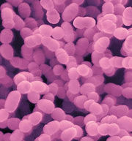

Soon after eating carbohydrates—especially sucrose—a sticky film of glycoproteins (proteins with carbohydrates attached) binds to teeth and begins to form plaque. Simultaneously,   
*S. mutans* attaches to the glycoproteins and begins to break down the sucrose. The structural formulas on the left (below) show sucrose being hydrolyzed to form glucose and fructose (simple sugars).

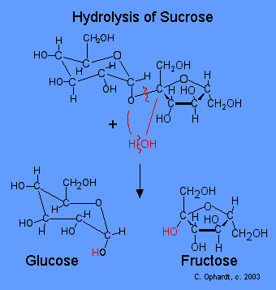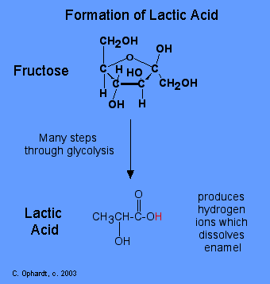

*(*[*http://chemistry.elmhurst.edu/vchembook/548toothdecay.html*](http://chemistry.elmhurst.edu/vchembook/548toothdecay.html)*)*

*S. mutans* bacteria gain energy by fermenting fructose anaerobically (without oxygen), as shown on the right, above. The final product is lactic acid. Note that lactic acid can ionize, releasing the hydrogen ion (shown in red on the lactic acid structure). Now the hydrogen ion (H+) will be free to disrupt the hydroxyapatite equilibrium shown in the Brown “Brush up on Toothpaste!” article. This disruption of the equilibrium results in further breakdown of the hydroxyapatite. (<http://chemistry.elmhurst.edu/vchembook/548toothdecay.html>) This process will be discussed in the “Demineralization” section of this Teacher’s Guide.

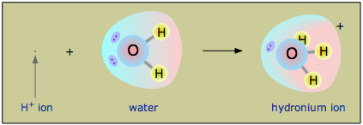 Note that, for simplicity, when writing chemical equations, chemists often use hydrogen ions (H+), while evidence shows that free hydrogen ions do not exist. In solution, a strong attraction between the H+ ions and the polar water molecules results in the formation of hydronium ions (H3O+) as seen in the picture at right. Further, a hydrogen ion does not stay fixed on a particular water molecule; rather, it moves from one molecule to another in solution. H3O+ is the most accurate way to show the acidic species in a water solution. Some molecules of water automatically dissociate as shown in the following equilibrium:

*Formation of the hydronium ion*

*(*[*http://chem.libretexts.org/Core/Physical_and_Theoretical_Chemistry/Acids_and_Bases/Aqueous_Solutions/The_Hydronium_Ion*](http://chem.libretexts.org/Core/Physical_and_Theoretical_Chemistry/Acids_and_Bases/Aqueous_Solutions/The_Hydronium_Ion)*)*

2 H2O ⇌ OH− + H3O+

(<http://chem.libretexts.org/Core/Physical_and_Theoretical_Chemistry/Acids_and_Bases/Aqueous_Solutions/The_Hydronium_Ion>)

As *S. mutans bacteria* gain energy from the fermentation of fructose, they divide, forming many microcolonies that adhere to the tooth surface and creating a biofilm within the slime layer. Other non-cavity producing bacteria also join in producing the biofilm. As the colony size continues to increase and further metabolize fructose, the biofilm can become plaque if not removed by flossing and brushing. And, hydrogen ions will continue to be produced as the lactic acid forms and ionizes.

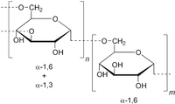

*Dextran (polymer of glucose molecules)*

*(*[*https://en.wikipedia.org/wiki/Dextran*](https://en.wikipedia.org/wiki/Dextran)*)*

*Dextran (polymer of glucose molecules)*

*(*[*https://en.wikipedia.org/wiki/Dextran*](https://en.wikipedia.org/wiki/Dextran)*)*

Meanwhile the glucose cleaved during the hydrolysis of sucrose (left picture, preceding page) polymerizes to form a dextran polymer composed of chains of glucose molecules (structure at right). These chains of various lengths help cement the colonies of *S. mutans* to the teeth. This forms the matrix for plaque formation on the teeth.

(<https://microbewiki.kenyon.edu/index.php/Streptococcus_mutans-_Tooth_Decay>)

**pH**

One way to remember the meaning of pH is consider it as the “the power of hydrogen” (or the number of free H+) ions in a solution. pH gives a quantitative value to the acidity or alkalinity of a solution. Note that low pH numbers show as large H+ type size in the diagram below. This represents high concentrations of hydrogen ions, meaning very acidic solutions. When pH = 7 the solution is neutral, represented in the diagram as equal sizes (concentrations) of H+ (acidic) and OH– (basic). Professor Hubert Alyea of Princeton University developed this pattern to help students better visualize the pH scale:

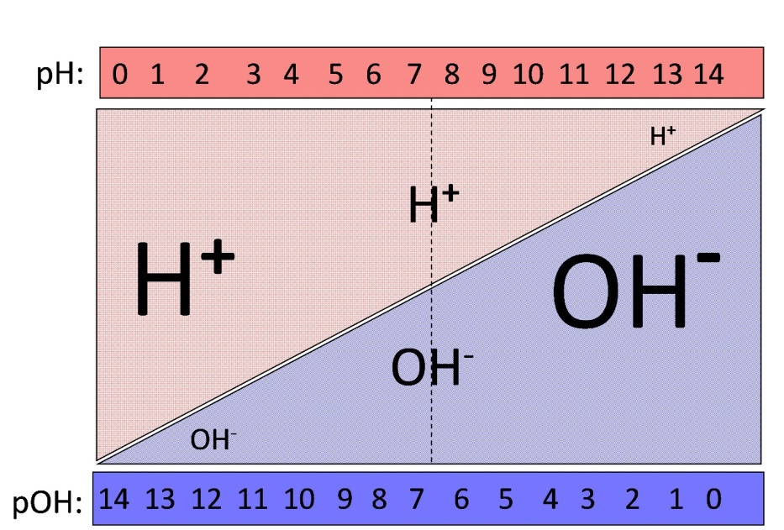

*Visual interpretation of the pH scale*

*Hubert Alyea, Princeton University; Woodrow Wilson Dreyfus Chemistry Institute, 1982*

pH is calculated by taking the –log10 of the concentration in mol/L of H+ in a solution. In chemical shorthand this is written:

pH = –log10 [H+]

Square brackets mean concentration in mol/L. The pH of the solution (the scale above the diagram) shows that, as the pH number increases, the [H+] decreases in text size (and concentration).

Students who have not studied the base 10 logarithmic scale can be easily shown that when the concentration is 0.1 mol/L (this can be written 1 x 10–1), the log of 1 x 10–1 is –1 so the negative value of this number is 1 or pH = 1. When the [H+] concentration (acidity) is 10 times less, 0.01 mol/L or 1 x 10–2, the pH = 2. To further clarify, concentration values for each pH can be written above the pH values on the scale (as shown below). This makes it easy to connect the negative of the concentration exponents to the pH values and see that the concentrations decrease tenfold at each successive higher pH value.

10–0 10–1 10–2 10–3 10–4  10–5 10–6  10–7 10–8 10–9 10–10 10–11 10–12 10–13 10–14

**pH: 0 1 2 3 4 5 6 7 8 9 10 11 12 13 14**

The pOH shown at the bottom of the H+/OH– diagram above is the value of the alkalinity of the solution, pOH. This is defined the same way as pH:

pOH = –log10[OH–]

Note that, at any point on the diagram, the sum of the values of pH (top, pink scale) plus pOH (bottom, blue scale) always equals 14. The equilibrium constant of water (Kw) is determined by the product of the concentrations of its ions: Kw = [H+] [OH–]. So, at neutrality, as shown on the diagram,

Kw = (1x10–7) (1x10–7) = 1 x 10–14

Using the Kw equilibrium expression, either the [H+] or the [OH–] can be calculated, provided the other one is known. For example, when pH = 3, [H+] = 1 x 10–3, and

Kw = (1x10–3) (OH–) = 1x10–14 and [OH–] = 1x10–14 = 1x10–11

1x10–3

A table like this might help students unfamiliar with logarithms:

|  |  |  |  |
| --- | --- | --- | --- |
| **[H+] (mol/L)** | **pH** | **Kw =**  **[H+] [OH–] (mol/L)** | **pOH =**  **14 – pH** |
| 0.1 or 1x10**–1** | 1 | (1x10–1) (1x10–13) = (1x10–14) | 14 – 1 = 13 |
| 0.01 or 1x10**–2** | 2 | (1x10–2) (1x10–12) = (1x10–14) | 14 – 2 = 12 |
| 0.001 or 1x10**–3** | 3 | (1x10–3) (1x10–11) = (1x10–14) | 14 – 3 = 11 |
| 0.0001 or 1x10**–4** | 4 | (1x10–4) (1x10–13) = (1x10–13) | 14 – 4 = 10 |

**Anatomy of the human tooth**

Only about one-third of the tooth is located above the surface. The tooth consists of four major tissues: enamel, dentin, pulp and cementum. The visible portion of the tooth is the enamel, composed primarily (96%) of an inorganic calcium phosphate mineral (hydroxyapatite), the hardest material in the body. Note the illustration from *Web*MD below. This site also describes the primary tooth tissues. (<http://www.webmd.com/oral-health/picture-of-the-teeth>)

*[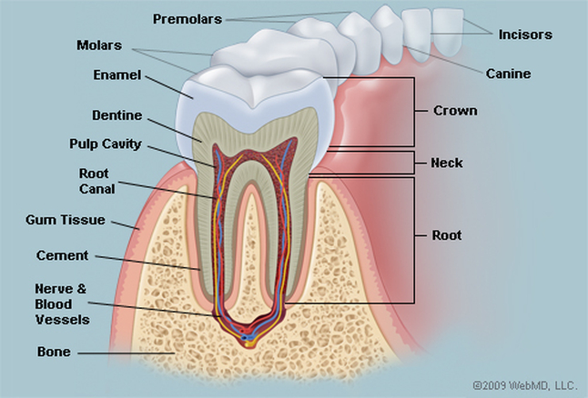](http://www.google.com/url?sa=i&rct=j&q=&esrc=s&source=imgres&cd=&cad=rja&uact=8&ved=0ahUKEwi-o-eduvLQAhUCz2MKHYmAAHkQjRwIBw&url=http://www.webmd.com/oral-health/picture-of-the-teeth&psig=AFQjCNEvZyP85pSb6piA-vXnCPrUz3iNAg&ust=1481762668282204)*

*Human tooth structure*

*(*[*http://www.webmd.com/oral-health/picture-of-the-teeth*](http://www.webmd.com/oral-health/picture-of-the-teeth)*)*

The enamel covers the dentin. Composed of approximately 45% hydroxyapatite, 33% organic material (structural proteins) and 22% water, the dentin is similar to bone but not as hard as enamel, and it serves as a connective tissue. It is secreted by living cells in the dental pulp. Dentin forms a protective layer and supports the tooth crown (enamel). This tissue surrounds the pulp and covers the cementum on the root. (<https://en.wikipedia.org/wiki/Dentin>)

Pulp is soft tissue that contains the blood vessels to nourish the tooth and nerves that signal damage (painfully). As seen in the illustration above, nerves and blood vessels thread throughout the pulp cavity that covers the tooth root. (<https://en.wikipedia.org/wiki/Pulp_(tooth)>

The cementum (labeled “cement” in the diagram above) is the central part of the tooth. It is composed of soft connective tissue that keeps the tooth roots in place between the gums and the jaw bone. It is composed of an approximately 50:50 mixture of hydroxyapatite and watery organic material (structural proteins). This material is secreted by cells in the tooth root. (<https://en.wikipedia.org/wiki/Cementum>)

There is also a periodontal ligament that helps hold the teeth in place (not pictured in the diagram above). This ligament surrounds the tooth holding it tightly against the jaw but allowing some movement of individual teeth during chewing. Bundles of fibers attach the gum to the cementum and jaw bone. (<http://dental.pitt.edu/periodontal-ligament-functions>)

**Hydroxyapatite structure**

Enamel is the first and major protective barrier against tooth decay. While composed of a hard, strong, inorganic crystalline matrix of a calcium phosphate mineral, hydroxyapatite, it is still vulnerable to demineralization in acidic (low pH) environments where the compound is slightly soluble. The crystal is a hexagonal structure.

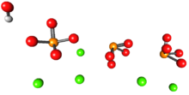

*One-half of a unit cell of hydroxyapatite*

*(*[*https://en.wikipedia.org/wiki/Hydroxylapatite*](https://en.wikipedia.org/wiki/Hydroxylapatite)*)*

To the right is a 3D visualization of one-half of a unit cell of the crystal hydroxyapatite. The chemical formula for the hydroxyapatite unit cell is:   
Ca10 (PO4)6(OH)2. Note that one-half of the chemical formula is represented by three phosphate ions (PO43–), each containing one yellow-orange phosphate atom attached to four red oxygen atoms; the lone hydroxide ion (OH–) has a red oxygen atom and a small grey hydrogen atom; and there are five green calcium ions (Ca2+).

The image below represents the structure of bone obtained by MIT researchers using supercomputers. Note that the image of hydroxyapatite (enamel) is located on the bottom of this picture. This image shows that, in bone, collagen (structural protein) molecules (top part of image) combine with hydroxyapatite (at the bottom of the image) to form “hard, tough and slightly flexible” bone material. This combination behaves differently from the two individual parts of the bone tissue.

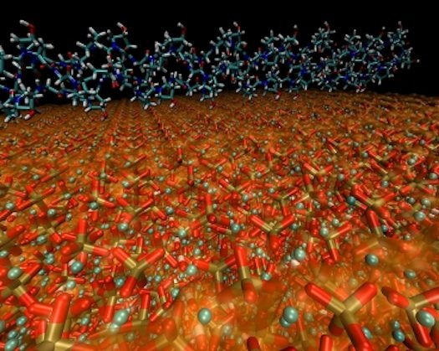

*Bone: collagen molecules (on top); hydroxyapatite structure (on bottom)*

(<http://www.zmescience.com/medicine/molecular-structure-of-bone-deciphered-906346/>)

**Dental equilibrium**

As long as the environmental conditions in the oral cavity remain stable (normal pH—sufficient calcium and phosphate ions), the equilibrium between demineralization and mineralization is maintained. As the equilibrium expression below indicates, the rate of demineralizing (forming the products, ions) remains equal to the rate of mineralizing (forming the reactant, solid hydroxyapatite crystal). This equilibrium expression is given in the Brown article:

Ca10(PO4)6(OH)2 (s) ⇌ 10 Ca2+ (aq) + 6 PO43– (aq) + 2 OH– (aq)

When the rate of the forward reaction of a reversible equilibrium such as the one above equals the rate of the reverse reaction, the system is at equilibrium. But, it is important to remember that this is a dynamic equilibrium state where, although there are no notable physical changes, the reactant mineral (hydroxyapatite) is constantly demineralizing and the product ions are constantly remineralizing to reform the mineral.

The effects described above are in keeping with Le Châtelier’s Principle: When a stress is placed on a system at equilibrium, the equilibrium will shift to adjust to the change and reestablish a new dynamic equilibrium.

When the hydroxyapatite equilibrium is stressed by the removal of hydroxide and phosphate ions (see equations in the next section below that explain why/how this happens), these ions are no longer present to collide and form more hydroxyapatite, so the equilibrium shifts to the right (products), producing more ions (to relieve the stress on the equilibrium of too few ions) by breaking down the hydroxyapatite (demineralization). The opposite shift occurs when saliva provides a supersaturated non-acidic environment of calcium and phosphate ions. The larger the number of these ions, the greater the chance of collisions that shift the equilibrium to the left, forming additional hydroxyapatite (remineralization) as the ion concentrations are decreased, again, to relieve stress on the equilibrium system. Demineralization and remineralization are discussed below.

**Demineralization**

As shown in the Brown article, during normal conditions hydroxyapatite is in equilibrium with its ions, meaning that the rate of demineralization is the same as the rate of mineralization. Thus, the tooth enamel is healthy and not prone to corrosion. The pH of saliva is normally between 6.5 and 7.5. The critical pH is the acidity level at which the hydroxyapatite ions are saturated in solution with the solid form of the mineral. For tooth enamel this is pH 5.5 and for dentine it is 4.5. If the pH is above this value (more basic), the solution will be supersaturated with respect to the solid hydroxyapatite and more of the mineral will precipitate. If the pH is more acidic (lower) than pH 5.5, the hydroxyapatite will dissolve/demineralize into its ions. (<http://www.oralhealthgroup.com/features/dental-remineralization-simplified/>)

Colin Dawes, the author of “What is the Critical pH and Why does a Tooth Dissolve in Acid?” published in the *Journal of the Canadian Dental Association* (2003), states, “However, these fluids cannot be supersaturated with respect to their individual ions, such as calcium and phosphate, as some authors state.” Although dental enamel is primarily composed of the mineral hydroxyapatite, it also contains some impurities including ions of carbonate (CO32–) and fluoride (F–) that can affect the solubility. Moreover, the concentration of these impurities differs from person to person; the solubility of hydroxyapatite cannot be a fixed value. For example, if a person drinks fluoridated water or uses fluoridated toothpaste some of the hydroxyapatite is replaced by fluorapatite, Ca5(PO4)3F. Replacing the hydroxide ion with a fluoride ion produces this compound, which is more resistant to demineralization.

[Note that the ions in the formula for a unit cell of fluorapatite crystal are in exactly the same ratio as those in the unit cell of hydroxyapatite. But, only one-half the number is given. (<https://en.wikipedia.org/wiki/Fluorapatite>)]

When the pH of saliva is in the normal range, hydroxyapatite is only sparingly soluble, with an extremely low Ksp on the order of 10-117*. Ksp is the solubility product constant, the product of the dissolved ion concentrations raised to the power of their coefficients in the equilibrium expression. In this case, Ksp = [Ca2+]10[PO43–]6[OH–]2, where the square brackets contain the concentration of each ion in moles/L. The extremely low Ksp reflects the very low water solubility of hydroxyapatite.

*The estimated, “on the order of” Ksp value used above and given in this article (link in next paragraph) is much smaller than accepted values, around 2.34 x 10–59.

As shown in the “Oral bacteria” section of this Teacher’s Guide, when *S. mutans* bacteria in the biofilm consume carbohydrates (sugars) they produce lactic acid. If excess sugar is present and biofilm is not cleaned from the teeth, the pH of the plaque may drop to between 4.5 and 5.5, shifting the hydroxyapatite equilibrium toward demineralization (the ionic side of the expression), which ultimately destroys some of the enamel and forms caries. (<https://www.cda-adc.ca/jcda/vol-69/issue-11/722.pdf>)

As discussed in the Brown article, acid increases the solubility of hydroxyapatite by removing both the hydroxide and the phosphate ions. Removal of these ions drives the equilibrium toward the product side, increasing the solubility of the hydroxyapatite (the tooth enamel) to possibly dangerous levels. Hydroxyapatite equilibrium with its ions as found in the mouth:

Ca10(PO4)6(OH)2 (s) ⇌ 10 Ca2+ (aq) + 6 PO43– (aq) + 2 OH– (aq)

When *S. mutans* bacteria break down sugars to produce the energy to divide and form more colonies, lactic acid is the by-product. In solution, some lactic acid ionizes to form hydronium ions (H3O+) and lactate ions (C2H3O2–).

HC2H3O2 (aq) + H2O (l) ⇌ H3O+ (aq) + C2H3O2– (aq) Ka = 1.38 x 10–4

The acid dissociation constant (Ka) is used to compare the strength of acids. The calculation is the same as for the constants for other equilibria (Keq, Kb, or Ksp). Ka equals the product of the concentrations of the dissociated ions divided by the concentration of the molecular (undissociated) acid. The stronger the acid, the more hydronium ions (H3O+) are present in the solution. So as acid strength increases; the value of Ka increases. The equilibrium expression for lactic acid is shown here:

Ka = [H3O+] x [C2H3O2–] = 1.38 x 10–4

[HC2H3O2]

Or, simplifying and eliminating water from the expression because its concentration is constant, and using H+ in place of the hydronium ion (H3O+), the K may be written as

Ka = [H+] x [C2H3O2–] = 1.38 x 10–4

[HC2H3O2]

These extra hydronium ions (or hydrogen ions) produced in the presence of *S. mutans* are available to react with both the hydroxide ions and the phosphate ions, thus disturbing the hydroxyapatite equilibrium by removing some of both of these ions. This drives the demineralization of hydroxyapatite equilibrium to the right, increasing the solubility of the mineral. See the four equations below:

H3O+ (aq) + OH– (aq) ⇌ 2 H2O (l)

The phosphate ion has a –3 charge. This results in three reactions occurring between hydronium ions and phosphate ions to finally form the triprotic phosphoric acid. Note that an additional hydrogen ion is added to the original phosphate ion in each reaction.

H3O+ (aq) + PO43– (aq) ⇌ HPO42– (aq) + H2O (l)

H3O+ (aq) + HPO42– (aq) ⇌ H2PO4– (aq) + H2O (l)

H3O+ (aq) + H2PO4– (aq) ⇌ H3PO4 (aq) + H2O (l)

As seen in the four equations above, when a hydronium ion is added, the hydroxide and phosphate ions are pulled from the equilibrium products. This is the driving force that pushes the equilibrium to the right to produce more ions and reestablish the equilibrium. This demineralizes (dissolves) the hydroxyapatite crystal and eventually creates holes (dental caries) in the enamel. (<http://www.ccchemistry.us/equilibrium%20-%20part%202.pdf>)

In the section above, the discussion has focused on Ka (the acid dissociation constant), defined as, and calculated by, the ratio of: the mathematical product of the concentrations of the products divided by the product of the concentration of the reactants. All of these have varying concentrations in solution. For example, the Ka for lactic acid, mentioned earlier, is written:

Ka = products = [H3O+] x [C2H3O2–] = 1.38 x 10–4

reactants [HC2H3O2]

Since the size of the Ka indicates the extent to which the acid dissociates into its ions, the Ka can be used to compare the strength of acids.

As noted previously, the demineralization of hydroxyapatite is also an equilibrium system but when looking at demineralization, the equilibrium is between a solid and its ions:

Ca10(PO4)6(OH)2 (s) ⇌ 10 Ca2+ (aq) + 6 PO43– (aq) + 2 OH– (aq)

But since the reactant is a solid, the amount does not affect the equilibrium because its concentration cannot change (it’s constant). Therefore the solid’s (constant) concentration is effectively incorporated into the (constant) Ksp, so it does not appear in the equilibrium expression. The Ksp (solubility product constant) is represented and calculated by the mathematical product of the concentration of the products raised to the power of their coefficients in the equation, with no denominator in the expression. For example, the Ksp for hydroxyapatite is:

Ksp hydroxyapatite = [Ca2+]10 x [PO43–]6 x [OH–]2 Ksp = 2.34 x 10–59 *

And as discussed earlier when fluorine is added, a more stable compound, fluorapatite, forms.

Ksp fluorapatite = [Ca2+]10 x [PO43–]6 x [F–]2 Ksp = 3.16 x 10–60 *

The slightly larger Ksp for hydroxyapatite shows a slightly greater amount of ionization (erosion of the tooth enamel into its ions) than shown by the Ksp for the fluoride mineral. The lower Ksp for fluorapatite indicates its greater resistance to acid attack.

*Note: Although the Ksp constants for these apatites vary among sources, the ones used here and given in the Google eBook, *Nanotechnology in Endodontics: Current and Potential Clinical Applications, p 178,* edited by Anil Kishen are cited most consistently. (<https://books.google.com/books?id=dS2CBwAAQBAJ&pg=PA178&lpg=PA178&dq=ksp+for+ca10(po4)6f2+fluorapatite?&source=bl&ots=GweH8quf5i&sig=o_NnPE8MSUYj0KwAMhlsKxfpF1o&hl=en&sa=X&ved=0ahUKEwiGvpzv07rRAhWkr1QKHTE3Db0Q6AEILzAE#v=onepage&q=ksp%20for%20ca10(po4)6f2%20fluorapatite%3F&f=false>)

**Remineralization**

For reference, the hydroxyapatite equilibrium equation is shown here again:

Ca10(PO4)6(OH)2 (s) ⇌ 10 Ca2+(aq) + 6 PO43– (aq) + 2 OH– (aq)

Note that, according to Le Châtelier’s Principle, the forward reaction decomposes (demineralizes) hydroxyapatite, eroding tooth enamel. The reverse reaction can replace (remineralize) the lost hydroxyapatite, forming new enamel.

From his research, Colin Dawes (mentioned in the section above) concluded that the *critical pH* (the point at which enamel just begins to dissolve) is not a fixed value. It varies among individuals, depending upon the amount of calcium and phosphate ions in their saliva. When the saliva contains a high concentration of these ions, the equilibrium favors the reverse reaction (remineralization), thus reducing the critical pH value, meaning that it requires a lower pH (more acidic environment) to begin dental corrosion.

The remineralization process at any pH level requires that:

1. Demineralization must have occurred within enamel located below an intact enamel surface. If the surface enamel has been severely eroded, it cannot be replaced (remineralized) because the matrix required for the growth of mineral crystal is lacking.
2. The concentration of calcium and phosphate ions in the saliva and plaque fluids must be sufficient to favor the reverse hydroxyapatite equilibrium. Note that plaque fluids are the aqueous phase of dental plaque. They are located outside bacterial cells and provide a medium for exchange of substances between the saliva (through the plaque) and the tooth surface. (<http://student.ahc.umn.edu/dental/2012/5302/2009-L3-27Mar.pdf>) Dawes also found that saliva flow can be stimulated by chewing sugar-free gum. This is important because saliva contains phosphate ions to help remineralize the enamel.

Persons with severe xerostomia (reduced or no saliva flow) must receive fluoride rinses or gel treatments daily to prevent caries. Fluoride ions convert hydroxyapatite to fluorapatite, a less soluble mineral that effectively reduces the critical pH. (<https://www.cda-adc.ca/jcda/vol-69/issue-11/722.pdf>)

*S. mutans* bacteria are not the only source of acid in the mouth; some fruit juices and sodas have a pH of less than three. These can also disrupt the hydroxyapatite equilibrium, driving it forward. The extra H+ ions, a stress on the system, react with and remove hydroxyl and phosphate ions. If the ions in saliva are not sufficient to reverse this action, tooth enamel can demineralize. When consuming acidic foods, it is important to allow time for the saliva to neutralize the acid. To avoid prolonged contact between enamel and acid, eat or drink these foods or beverages with a regular meal, sip water while eating as a snack, and wait 20 minutes before brushing your teeth, to allow time for reestablishment of a safe hydroxyapapite equilibrium. (<https://www.deltadentalins.com/oral_health/acid_wear.html>)

Citrus fruits such as oranges, lemons and limes have pH values less than three. The following table lists drinks with pH levels below 3.00.

**Drink pH Drink pH Drink pH**

|  |  |
| --- | --- |
| **Lime Juice** | 2.00-2.35 |
| **Lemon juice** | 2.00-2.60 |
| **Cranberry Juice, canned** | 2.30-2.52 |
| **Vinegar** | 2.40-3.40 |
| **Sunny Delight** | 2.4 |
| **Gatorade Clear** | 2.4 |
| **Pepsi** | 2.49 |
| **Country Time Lemonade** | 2.5 |
| **SoBe Sugarfree Tropical** | 2.5 |
| **RC Cola** | 2.50 |
| **Cherry Coke** | 2.52 |
| **Coke Classic** | 2.53 |
| **SoBe Strawberry-Grape** | 2.6 |
| **Capri Sun** | 2.6 |
| **Orange Crush** | 2.7 |
| **Hi-C Blast Fruit Punch** | 2.7 |
| **Tang** | 2.7 |
| **HiC Lemonade** | 2.7 |
| **Extran** | 2.74 |
| **Powerade** | 2.75 |
| **Orange Minute Maid** | 2.80 |
| **Mellow Yellow** | 2.8 |
| **Diet Cherry Coke** | 2.8 |
| **Welch's White Grape** | 2.8 |
| **Mr. Pibb** | 2.8 |
| **Hawaiin Fruit Punch** | 2.82 |
| **Squirt** | 2.85 |
| **Lipton Brisk** | 2.87 |
| **Upside Down 7-Up** | 2.9 |
| **Grapefruit Juice, canned** | 2.90-3.25 |
| **Cranberry Juice, white** | 2.9 |
| **Dr Pepper** | 2.92 |
| **Gatorade** | 2.95 |
| **Nestea Sweetened Lemon Iced Tea** | 2.97 |

*A list of common beverages with pH less than 3.00*

*(*[*https://www.21stcenturydental.com/ph_drinks.html*](https://www.21stcenturydental.com/ph_drinks.html)*)*

**Dental caries**

The following dental vocabulary may be helpful as you read this section:

|  |  |
| --- | --- |
| **Technical Name** | **Common Name** |
| Initial oral biofilm | Pellicle |
| Dental plaque | Biofilm |
| Dental Carries | Cavities |
| Tartar | Plaque |
| Gingivitis | Gum disease |
| Periodontitis | Inflammation of deep teeth structures |

Seconds after a professional cleaning or after chewing, a very thin initial biofilm (the pellicle) begins to form on the teeth. Formed from proteins in the saliva, this film serves as a protective layer to prevent damage from acids that release minerals, rough food, or grinding with other teeth. Soon, bacteria begin to attach to the pellicle forming a sticky mixture of proteins and sugar from the saliva.

If left on the pellicle, bacteria begin forming more colonies and create a thicker dental plaque which is another type of biofilm, a colorless solution that sticks to teeth. This watery mixture is primarily composed of bacteria, including colonies of *S. mutans*. These pathogenic bacteria gain energy by decomposing the polysaccharides and glycoproteins that are mixed with saliva and plaque. Lactic acid and glucose are the decomposition products. (<https://www.curaprox.com/us-en/plaque-or-pellicle>)

The table below describes the six stages involved in the formation of plaque:

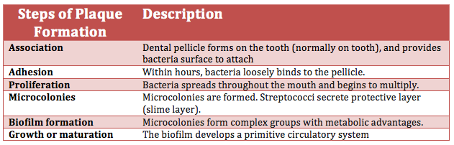

By Themolarbear - Own work, CC BY-SA 4.0

*The steps in the formation of plaque*

*(*[*https://commons.wikimedia.org/w/index.php?curid=39312781*](https://commons.wikimedia.org/w/index.php?curid=39312781)*)*

As discussed earlier in this Teacher’s Guide, if plaque is not removed from the teeth by regular brushing and flossing, lactic acid produced by *S. mutans* reduces the pH and shifts the hydroxyapatite equilibrium to the right (ions), demineralizing the enamel. Although one might be eager to rid one’s mouth of all this plaque, it is best to wait approximately twenty minutes to brush teeth after eating. This provides time for the minerals (ions) that saturate the saliva to replace those lost from the enamel during acidic demineralization. During this process the hydroxyapatite equilibrium is reestablished and the pH of the saliva can return to the normal, slightly alkaline 6.6 to 7.5 range.

When teeth are not cleaned, or they are brushed so quickly after eating that minerals in the saliva are washed away, the equilibrium continues to shift toward the products (ions). As more and more hydroxyapatite dissolves, the enamel becomes porous. Small holes begin to appear in the surface of the enamel layer. These are dental caries (cavities) that soon enlarge and require the attention of a dentist. Most caries form in molars and premolars because the surfaces of major chewing teeth contain grooves. Tiny crevices provide an ideal site for bacteria to settle and continue to produce acid, especially when sugars are present in the saliva. (<https://www.sharecare.com/health/cavities/mouth-do-cavities-often-develop>)

**Gum disease**

In the company of other bacterial species, *S. mutans* bacteria continue to consume sugar and form colonies. As bacteria die within the calculus, the surface becomes rough and forms a scaffold for easy deposition of more mineral material, such as calcium and phosphate ions from decomposed hydroxyapatite. Layers upon layer of mineralized plaque is deposited. Soon this becomes a yellowish-brown mass, called tartar. This hard material cannot be removed by simply brushing and flossing; it must be scraped off by dental professionals. When the enamel demineralizes, the tartar builds up in the space between the teeth, both above and below the gum line. This leads to receding gums and gingivitis (gum disease).

*Porphyromonas gingivalis*

*(*

*[https://www.researchgate.net/profile/Richard_Lamont/publication/12122844](https://www.researchgate.net/profile/Richard_Lamont/publication/12122844Belton_CM_Izutsu_KT_Goodwin_PC_Park_Y_Lamont_RJ_Fluorescence_image_analysis_of_the_association_between_Porphyromonas_gingivalis_and_gingival_epithelial_cells_Cell_Microbiol1_215-223/links/542949a50cf2e4ce940c9899.pdf)*

*[Belton_CM_Izutsu_KT_Goodwin_PC_Park_Y_Lamont_RJ_Fluorescence_image_analysis_of_the_association_between_Porphyromonas_gingivalis_and_gingival_epithelial_cells_Cell_Microbiol1_215-223/links/542949a50cf2e4ce940c9899.pdf](https://www.researchgate.net/profile/Richard_Lamont/publication/12122844Belton_CM_Izutsu_KT_Goodwin_PC_Park_Y_Lamont_RJ_Fluorescence_image_analysis_of_the_association_between_Porphyromonas_gingivalis_and_gingival_epithelial_cells_Cell_Microbiol1_215-223/links/542949a50cf2e4ce940c9899.pdf))*



(<https://www.ncbi.nlm.nih.gov/pmc/articles/PMC4746253/>)

As layers of plaque continue to accumulate, the gums become irritated. *Porphyromonas gingivalis* (*P*. *gingivalis*) is the bacterium that initiates gum inflammation. Like *S. mutans*,this is an anaerobic bacterium. It displays black pigmentation and according to Kah Yah How, the author of the paper published in *Frontiers of Microbiology*, **“**Porphyromonas gingivalis**:** An Overview of Periodontopathic Pathogen below the Gum Line”, “… evidence points to it (*P*. *gingivalis*) as the significant keystone species of periodontal disease”.

When the human body reacts to this bacterium, the gums become inflamed. This is part of the body’s immune system. Swollen or receding gums indicate that the body is attempting to defend itself against bacterial invaders. In early stages gingivitis is not painful, but gum swelling should serve as a warning of inadequate care of the teeth. With proper dental treatment to remove the plaque, gingivitis can be reversed. (<http://www.tepe.com/tips-advice/gum-disease/>)

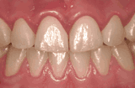

*Gum Inflammation – Gingivitis*

*(*[*http://www.tepe.com/tips-advice/gum-disease/*](http://www.tepe.com/tips-advice/gum-disease/)*)*

Gingivitis *can* be reversed by professional removal of plaque but, if left untreated, deeper tooth structures such as the periodontal ligament, jawbone and cementum may become inflamed. This condition (periodontitis) may lead to destruction of the supporting tissue of the tooth, including bone loss. Ultimately untreated periodontitis can lead to the loss of teeth. (<https://www.ncbi.nlm.nih.gov/pmc/articles/PMC4746253/>)

Dentists and physicians are looking at the links between their medical fields, as increasing evidence shows connections between severe periodontitis and other systemic problems. Researchers find that gum inflammation affects the body’s susceptibility and resistance to cardiovascular system problems, bacterial pneumonia, diabetes, and low birth weight. (<https://www.ncbi.nlm.nih.gov/pmc/articles/PMC2443711/>)

**Biofilm detection**

The first line of defense against cavities and more serious dental diseases is regular brushing and flossing. But sometimes it is difficult to verify that the plaque has been completely removed before calculus forms. One way to detect the removal of biofilm is the use of chewable disclosing tablets. This product can be purchased over the counter and used to show the location of plaque by coloring it pink. To determine how well you brush and floss, chew a tablet after cleaning, then rinse your teeth. In places that have been missed, the remaining plaque will be colored and you can remove it before it becomes tartar. The tablets use phloxime B, a water-soluble, vegetable-based dye. When used as directed it is harmless to humans. Phloxime B is a disodium compound (shown below, left). It dissolves readily in water, forming a solution of positive sodium ions and the organic anion. The anion binds to gram-positive *S. mutans* bacteria, coloring them pink and showing where teeth need to be cleaned more thoroughly.

Advertising for disclosing tablets is frequently directed toward parents of toddlers. Those who are just beginning to brush their teeth can learn how to better direct their cleaning efforts by the location of the stain left by the dye (image at right below).

*Phloxime B*

*(*[*https://en.wikipedia.org/wiki/Phloxine*](https://en.wikipedia.org/wiki/Phloxine)*)*

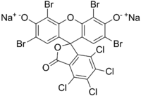

*Dental plaque revealed after chewing phloxime B tablet*

*(*[*http://www.softdental.com/houston_dentist/Disclosing_Tablets.html*](http://www.softdental.com/houston_dentist/Disclosing_Tablets.html)*)*

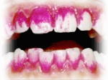

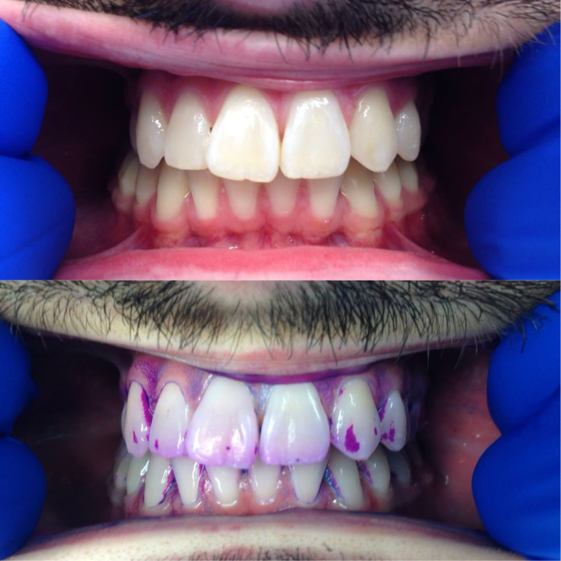Another product uses a combination of several dyes for a tricolored approach (below) that stains immature plaque red, mature plaque purple, and pathological plaque acidic blue. The three-colored disclosing product was used in this clinical study to identify the “pathogenicity of the plaque biofilm so as to predict the caries risk”. The synthetic food dyes used (rose Bengal and brilliant blue, FCF) were pH-selective. Note: FCF is the acronym for “For Coloring Food”. These dyes were placed in a sucrose containing solution. The blue pigment could be easily rinsed off new plaque because the plaque was only covered by a thin layer of biofilm. This left the immature plaque a pink/red color; older mature plaque with a dense structure trapped both blue and red pigments to form a blue/purple color; high-risk plaque contained *S. mutans* which metabolized the sucrose in the dye solution, lowering the pH to less than 4.5, as lactic acid was continually formed. At this acidity level the red pigment was no longer visible and the dye was seen as light blue. The findings of this study support the relationship between caries, plaque, and cariogenic microorganisms (*S. mutans)*.

(<https://www.ncbi.nlm.nih.gov/pmc/articles/PMC4549987/>)

By Ajeverett - Own work, CC BY-SA 4.0

*Tricolor plaque disclosing gel—  
before (top) and after (below)*

*(*[*https://commons.wikimedia.org/w/index.php?curid=39312831*](https://commons.wikimedia.org/w/index.php?curid=39312831)*)*

The best way to protect teeth is to prevent the formation of hard tartar, as described above. When biofilm is kept in an amorphous state by regular flossing, brushing and rinsing, bacterial biofilm can be easily removed before it hardens on the teeth. A diet heavy on carbohydrates (sugars and starches) provides continual energy for bacteria to grow and enlarge their colonies, so excess bacterial food must be quickly removed to prevent formation of hard tartar as discussed above.

Toothpaste plays an important role in reducing plaque formation. Many toothpaste choices appear on market shelves. Manufacturers categorize their ingredients as either “active” (antibacterial agents) or “inactive” (abrasives, flavoring, etc.).

**Toothpaste—active ingredients**

Colgate and Crest toothpaste Web sites provide this information for the many varieties of their products. All Colgate toothpastes listed contain sodium fluoride (NaF) as an “anticavity” ingredient and triclosan (C12H7Cl3O2), [IUPAC ID](https://www.google.com/search?biw=1366&bih=576&q=triclosan+iupac+id&stick=H4sIAAAAAAAAAOPgE-LUz9U3MKwyrszV0shOttJPzkjNzSwuKaqEsJITc-KT83ML8kvzUqwySwsSkxUyUwDP9l5MNwAAAA&sa=X&sqi=2&ved=0ahUKEwikm-X8u_zQAhUj54MKHS1ZDLMQ6BMIowEoADAR): 5-chloro-2-(2,4-dichlorophenoxy)phenol, as an “antigingivitis” agent. (<http://www.colgate.com/en/us/oc/oral-health/basics/selecting-dental-products/article/what-is-in-toothpaste-five-ingredients-and-what-they-do-0814>)

All Crest toothpastes list a form of fluoride, one with sodium fluoride (NaF) and others with stannous fluoride (SnF2), IUPAC ID: tin(II) fluoride. (<http://www.pgsdscpsia.com/productsafety/ingredients/Crest_Pro_Health_Toothpastes.pdf>)

**Fluoride compounds**

Fluoride protects the teeth by reducing demineralization and increasing remineralization of enamel and by interfering with bacterial activity. Both fluoride compounds listed above (NaF and SnF2) are water soluble, and the fluoride ion, F–, readily replaces the hydroxide ion, OH–, in hydroxyapatite, Ca10(PO4)6(OH)2, to form fluorapatite, Ca10(PO4)6F2, a compound that increases enamel’s resistance to acidic demineralization.

2NaF (aq) + Ca10(PO4)6(OH)2 (s) ⇌ Ca10(PO4)6F2 (s) + 2 NaOH (aq)

While the critical pH of hydroxyapatite (the point at which it is vulnerable to acid attack and subsequent demineralization) is 5.5, the critical pH of fluorapatite is approximately 4.5. This means that the fluoride compound will remain stable in a much more acidic solution, thus better protecting tooth enamel from demineralization. (<http://www.oralhealthgroup.com/features/dental-remineralization-simplified/>)

Fluoride ions work at the tooth surface to reduce demineralization by binding to the surface calcium ions of hydroxyapatite and holding them together firmly to prevent demineralization. As reported in *Nature* (see link below),the primary computer simulation of this process was done by Nora H. de Leeuw. Regarding her work, Peter Shellis, of the University of Bristol Dental Hospital, says, "This provides good evidence for a specific mechanism for how the surface fluoride works. Various theories for this have been put forward, but not the one proposed here.”

Since fluoride only works at the tooth surface, its effectiveness may be reduced by brushing and chewing food. Therefore, de Leeuw suggests that access to fluoride ions needs to be continual via water supplies, toothpaste or regular treatments. (<http://www.nature.com/news/2004/040122/full/news040119-8.html>)

Fluoride ions are too large to penetrate bacterial cell walls, but fluorine is highly electronegative. This means that it has a very strong ability to attract electrons to itself in a covalent bond. When fluoride ions (F–) are present, the hydrogen ions (H+) from the lactic acid (produced when *S. mutans* bacteria consume sugars) combine to form hydrogen fluoride (HF) molecules. This covalent H─F bond within the molecule is very strong, thus HF is a weak acid that ionizes to a very small extent (Ka = 7.2 x 10–4). Unlike fluoride ions, hydrofluoric acid can easily enter bacterial cells where it disrupts bacterial enzymatic activity. (<http://www.oralhealthgroup.com/features/dental-remineralization-simplified/>)

The World Health Organization (WHO) discusses the importance of fluoride sources, but it has concerns about the problems of excess fluoride from high natural concentrations in ground water and from eating crops irrigated with this water. Excess fluoride contributes to “skeletal fluorosis” which is associated with osteosclerosis (hardening of bone and increased bone density), calcification of tendons and ligaments, and bone deformities. This abnormal bone structure may lead to fractures. (<http://www.who.int/ipcs/assessment/public_health/fluoride/en/>)

Dental fluorosis changes the physical appearance of teeth. A mild condition can be seen as white spots on the teeth (picture below). More severe symptoms produce enamel pitting and brown coloring. Severe fluorosis occurs when excess fluoride ions interfere with the normal demineralization and remineralization equilibrium of the hydroxyapatite. This leaves the enamel fragile and brittle. Hydroxyapatite forms fluorohydroxyapatite by replacing one hydroxyl (OH–) ion by one fluoride (F–) ion in an acidic solution. This is shown in the chemical equation below:

Ca10(PO4)6(OH)2 (s) + F− (aq) + H+ (aq) → Ca10(PO4)6(OH)F (s) + H2O (l)

(<https://en.wikipedia.org/wiki/Dental_fluorosis>)

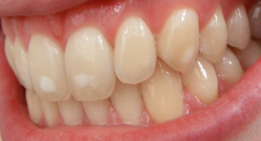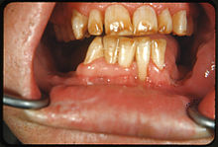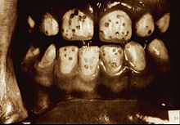

*Mild Dental Fluorosis Severe Dental Fluorosis Severe Dental Fluorosis*

*With mottling of teeth with discoloring with pitting and discoloring*

*(*[*https://en.wikipedia.org/wiki/Dental_fluorosis*](https://en.wikipedia.org/wiki/Dental_fluorosis)*)*

Children up to age eight are most susceptible to excess fluoride, because teeth are developing under the gums. The U.S. Centers for Disease Control and Prevention (CDC) suggests carefully monitoring the amount of fluoride ingested by young children. The most common source of fluoride is drinking water supplies. In the U.S., most decisions about fluoride addition to drinking water are made locally by municipalities and water districts. U.S. companies selling bottled water are not required to list the fluoride concentration in their water.

In addition to water, young children may receive excess amounts of fluoride by eating toothpaste containing fluoride; drinking beverages and eating foods processed with fluoridated water; consuming dietary supplements that contain fluoride; and by using fluoride containing mouth rinses, gels or foams. (<https://www.cdc.gov/fluoridation/safety/dental_fluorosis.htm>)

**Triclosan**

Triclosan has been used in hand washes, as well as Colgate toothpaste, for a long time. While it is proven to be effective against gingivitis, triclosan is a suspected hormone disruptor, as stated in the Brown article. It may also cause muscle weakness and contribute to bacterial resistance to antibiotics. From the chemical formula, C12H7Cl3O2, and the structural formula (at right) students may be able to recognize the [IUPAC ID](https://www.google.com/search?biw=1366&bih=576&q=triclosan+iupac+id&stick=H4sIAAAAAAAAAOPgE-LUz9U3MKwyrszV0shOttJPzkjNzSwuKaqEsJITc-KT83ML8kvzUqwySwsSkxUyUwDP9l5MNwAAAA&sa=X&sqi=2&ved=0ahUKEwjr3YaG74DRAhWESCYKHVrdClIQ6BMI2gEoADAi) as: 5-chloro-2-(2,4-dichlorophenoxy)phenol.

*Triclosan,   
5-chloro-2-(2,4-dichlorophenoxy)phenol*

*(*[*https://pubchem.ncbi.nlm.nih.gov/compound/triclosan#section=Top*](https://pubchem.ncbi.nlm.nih.gov/compound/triclosan#section=Top)*)*

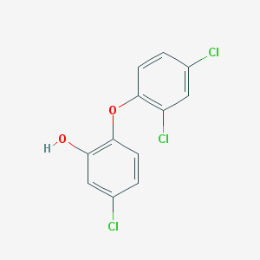

In September 2016, the antibacterial triclosan was banned in the U.S. from soaps and other household cleaning products. However, in 1997, the U.S. Food and Drug Administration (FDA) accepted data from Colgate-Palmolive toxicology studies that showed that triclosan was effective against gingivitis and concluded that the benefit outweighed the risk. This approval is still in effect, so Colgate is the only toothpaste on the market containing triclosan. (<http://www.nytimes.com/2016/09/07/well/live/why-your-toothpaste-has-triclosan.html?_r=0>)

**“Natural” ingredients**

While the U.S. FDA does not define rules for the use of the word “natural” on food labels, the longstanding policy is that “natural” means that no artificial or synthetic ingredients such as food coloring, salt, sugar or fat have been added. In addition any food processing has been minimal. For example, freshly cut fruits and vegetables are considered “natural”. The U.S. FDA considers that the use of “natural” doesn’t imply that the product has any nutritional or health benefit. (<http://www.fda.gov/Food/GuidanceRegulation/GuidanceDocumentsRegulatoryInformation/LabelingNutrition/ucm456090.htm>)

**Melaleuca**

Although not regulated by the U.S. FDA, Australian Tea Tree oil (melaleuca) dental gel, is available over the counter and can be used to make your own toothpaste. One small controlled study (34 people), reported in “Antimicrobial effect of Melaleuca alternifolia dental gel in orthodontic patients” (published in the February 2014 issue of the *American Journal of Orthodontics and Dentofacial Orthopedics*), showed melaleuca’s effectiveness against gingivitis when used in Colgate toothpaste. (The abstract is available here: (<https://www.ncbi.nlm.nih.gov/pubmed/24485734>; only subscribers can obtain the entire article.)

Aboriginal tribes have used melaleuca as a general antiseptic for thousands of years. When Captain Cook landed at Botany Bay (New South Wales, Australia), he learned from the Gweagal aboriginal tribe that the thick sticky leaves of the melaleuca tree were successfully used to treat cuts, burns, and skin infections. Cook observed the Gweagal boil these leaves for tea. So he brewed the crushed leaves for the Endeavor crew. Legend attributes this discovery to a means of preventing scurvy.

*Melaleuca*

*(*[*https://en.wikipedia.org/wiki/Melaleuca*](https://en.wikipedia.org/wiki/Melaleuca)*)*

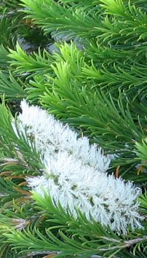

(<http://www.etouchforhealth.com/news/capt_cook_preventive_health.html>)

Australian clinical trials have shown that the tree oil is an effective antiseptic against bacteria. The *Registered Dental Hygienist Magazine* states that currently tea tree oil is “the subject of a great deal of international research” because questions remain about its antiseptic properties and its possible role (like triclosan) as a hormone disruptor. (<http://www.rdhmag.com/articles/print/volume-26/issue-8/columns/mind-body-spirit/tea-tree-oil-just-a-fad.html>)

**Xylitol**

This compound, used as a sweetener, is found in the fibers of many fruits and vegetables. Its chemical formula is C5H12O5. Xylitol is considered “tooth friendly” because *S. mutans* bacteria prefer disaccharides or simple sugars. They are unable to ferment this sweetener, so it does not promote the formation of dental caries. Supporters claim that, since xylitol is a sweetener that is not consumed by acid-producing bacteria, chewing xylitol gum encourages the formation of saliva without decreasing the pH. It has no known toxicity in humans.

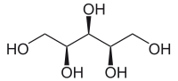

*Xylitol*

*(*[*https://en.wikipedia.org/wiki/Xylitol*](https://en.wikipedia.org/wiki/Xylitol)*)*

Although many still question the evidence that xylitol reduces cavities, the article, “The use of sorbitol- and xylitol-sweetened chewing gum in caries control”, published in the February 2006 *Journal of the American Dental Association,* concludes that there is sufficient evidence to promote the use of xylitol chewing gum along with “frequent fluoride exposure, good oral hygiene and regular dental appointments” to prevent dental caries. Note that the value of xylitol as a cavity reducer is predicated on the willingness of the subject to chew xylitol gum! Abstract is available here: <https://www.ncbi.nlm.nih.gov/pubmed/16521385>; only subscribers have access to the entire study.

**Tetrasodium pyrophosphate (TSPP)**

TSPP is added to toothpaste for tartar control. This compound is a chelating agent that replaces its sodium ions with calcium and magnesium ions from saliva. Once chelated (trapped), calcium and magnesium ions are not available to form calculus on teeth and the resulting stable, locked complexes can be easily flossed, brushed and rinsed away. TSPP is also used in dental rinses with instructions to brush after rinsing. (<http://www.google.com/patents/US20060134020>)

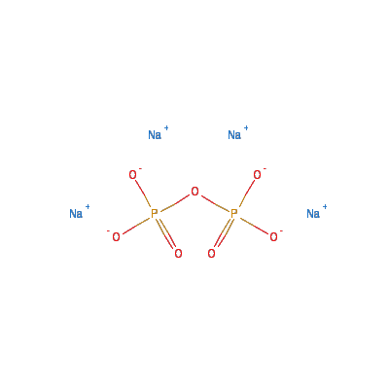

*Tetrasodium pyrophosphate*

*(*[*http://scitoys.com/ingredients/tetrasodium_pyrophosphate.html*](http://scitoys.com/ingredients/tetrasodium_pyrophosphate.html)*)*

**Toothpaste—inactive ingredients**

Looking at the inactive ingredients listed on a toothpaste box, one will note that they far outnumber the active ingredients. And, they differ from brand to brand. Some are designed to better clean and polish your teeth; others provide a pleasant flavor; and many are involved in keeping the paste hydrated and moving slowly out of the tube in response to gentle pressure. [Note: this is an example of non-Newtonian fluid behavior. For more on this topic, see “No-Hit Wonder! D3O” in this issue of *ChemMatters*. Also see the accompanying Teacher’s Guide on this article for background information and activities related to the topic of non-Newtonian fluids.]

The application process for a product to receive an American Dental Association (ADA) seal of approval involves “Four Key Points” of evaluation. The ADA Laboratory and Science Staff look for:

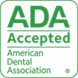

*ADA Seal of Acceptance*

*(*[*http://www.ada.org/en/science-research/ada-seal-of-acceptance/how-to-earn-the-ada-seal*](http://www.ada.org/en/science-research/ada-seal-of-acceptance/how-to-earn-the-ada-seal)*)*

* Objective clinical and/or laboratory studies that demonstrate safety and effectiveness
* FDA-approved ingredients
* Manufacturing standards that assure purity and uniformity
* Packaging and advertising claims that are supported by science

**(**<http://www.ada.org/en/science-research/ada-seal-of-acceptance/how-to-earn-the-ada-seal>)

**Abrasives**

Most toothpaste consists of approximately 50% abrasive ingredients. Along with brushing and flossing, abrasives in toothpaste are designed to help dislodge food particle debris, scrape away plaque before it becomes tartar, and remove stains from teeth. Abrasives are insoluble, so they are brushed and washed away as teeth are cleaned. Unlike the historic reference to egg and oyster shells or pumice and pulverized bones mentioned in the Brown article, these products are designed to clean and polish without scratching the enamel.

A small amount of enamel is lost during an abrasive treatment, so it is important to avoid excessive use. Recommended Dietary Allowance (RDA) values are assigned to abrasives; dentists often recommend using a toothpaste with an RDA no higher than 50. A long list by brand name, plus guidance for acceptable values, can be found at sites from several dental groups, such as <http://dendds.com/uploads/RDA_index.pdf> and <http://www.lincolndentalcenter.com/relative-dentin-abrasivity-rda>.

**Aluminum hydroxide**

Aluminum hydroxide, Al(OH)3, is used as an abrasive in toothpastes. A 1990 review of studies done in Norway, England and the Netherlands were published in the Belgian dentistry journal *Revue Belge De Medecine Dentaire* article, “The use of aluminum-containing toothpaste and its potential risk”. (See abstract in *PubMed* below.) Data showed a marked increase in Alzheimer’s disease in Norwegian and English areas where drinking water contained concentrated amounts of aluminum. Another Dutch study looked for links between Alzheimer’s and aluminum in toothpaste. It is suggested that the exposure from toothpaste containing aluminum may be greater than the risk in drinking water. (Abstract is available here: <https://www.ncbi.nlm.nih.gov/pubmed/2287776>: only subscribers to *PubMed* can access full article.)

**Silicon dioxide (sand)**

Silicon dioxide, SiO2, in its hydrated form, SiO2 • nH2O, has varying amounts of water incorporated into its formula. This compound is frequently used as a gentle abrasive in gel toothpastes. On toothpaste labels it is also listed as silicic acid or silica gel. A slightly coarser grind produces an ingredient that is used in tooth-brightening compounds. (<https://en.wikipedia.org/wiki/Hydrated_silica>)

**Other mineral abrasives**

Zeolites are minerals with porous structures that can hold a variety of cations, such as: Na+, K+, Ca2+ and Mg2+. These ions can be easily exchanged with others present in their saliva environment. Mica, another abrasive, is composed of sheets of silicates. In addition to its abrasive qualities, it adds a bit of glitter to toothpaste (e.g., in Kid’s Crest® Sparkle Fun”). Calcium carbonate, CaCO3, is used as a dietary calcium supplement and as an antacid in products like Tums. Also, it functions as an abrasive in toothpaste.

**Flavors**

Toothpastes that contain decay-causing sugars will not receive the ADA Seal of Acceptance. So, manufacturers, who want to reduce the bitterness of TSPP use non-sugar sweeteners such as saccharin or sorbitol. In addition, Oral B caters to children with its bubble gum flavor; Crest adds cinnamon; and Colgate toothpastes have a mint stripe.

Sorbitol (C6H14O6) is used as a sugar substitute, because the human body metabolizes it more slowly than sugar. The ball and stick model for the molecule in the diagram below shows the six carbon atoms in black, six oxygen atoms in red, and 14 hydrogen atoms in white.

When scientists discovered the relationship between hydroxyl (OH) groups and sweetness, they looked for sugar substitutes with structures containing OH groups similar to sugars. Note that both sorbitol and glucose (C6H12O6) contain several OH groups (see two diagrams below. Sweetness is related to the ability of a molecule to hydrogen bond to certain sugar receptor proteins in taste buds that are located at the tip of the tongue. OH groups are great at hydrogen-bonding. (<http://butane.chem.uiuc.edu/pshapley/GenChem2/B4/book.pdf>)

[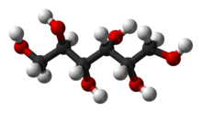](https://en.wikipedia.org/wiki/File:Sorbitol-3D-balls.png)[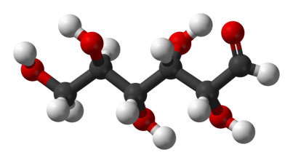](https://upload.wikimedia.org/wikipedia/commons/5/5a/D-glucose-chain-3D-balls.png)

*Sorbitol Glucose*

*(*[*https://en.wikipedia.org/wiki/Sorbitol*](https://en.wikipedia.org/wiki/Sorbitol)*)*

*(*[*https://commons.wikimedia.org/wiki/File:D-glucose-chain-3D-balls.png*](https://commons.wikimedia.org/wiki/File:D-glucose-chain-3D-balls.png)*)*

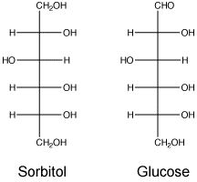

[*http://www.chem.umass.edu/~cmartin/Courses/Chem250/Sugars/index.html*](http://www.chem.umass.edu/~cmartin/Courses/Chem250/Sugars/index.html)

**Humectants and thickeners**

These ingredients are essential to maintaining the consistency of the toothpaste, keeping it stable and assuring that it squeezes out smoothly until the tube is empty. Humectants keep toothpaste moist and prevent water loss after the tube is opened.

Sorbitol (pictured above) is used as a humectant as well as a sweetener. Propylene glycol (C3H8O2) and glycerol (C3H8O3) (below) are also commonly used humectants in toothpaste. Glycol also sweetens toothpaste. The OH groups on each molecule classify them as organic alcohols. These hydroxyl groups give each compound (sorbitol, propylene glycol and glycerol) the ability to hydrogen bond between their own molecules and to water molecules, accounting for their high water-solubility, their thickness, and their ability to keep toothpaste moist.

[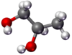](https://en.wikipedia.org/wiki/File:PropyleneGlycol-stickAndBall.png) [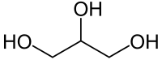](https://en.wikipedia.org/wiki/File:Glycerin_Skelett.svg) [Ball-and-stick model of glycerol](https://en.wikipedia.org/wiki/File:Glycerol-3D-balls.png) [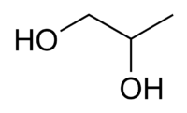](https://en.wikipedia.org/wiki/File:Propylene_glycol_chemical_structure.png)

*Propylene glycol Glycerol (glycerine)*

*Ball-and stick model and skeletal formula Ball-and stick model and skeletal formula*

*(*[*https://en.wikipedia.org/wiki/Propylene_glycol*](https://en.wikipedia.org/wiki/Propylene_glycol)*)* [*https://en.wikipedia.org/wiki/Glycerol*](https://en.wikipedia.org/wiki/Glycerol)

There is much overlap in the uses of the non-active ingredients found in toothpastes. One example is the use of organic alcohols as humectants, thickeners and sweeteners. The molecular structure is responsible for this. The number of OH groups on the molecule determines its properties.

Carrageenans are thickeners extracted from seaweed. They are composed of long sulfated polysaccharide chains that bind proteins together. This thickens and stabilizes, as well as sweetens, toothpaste. Cellulose gum (carboxymethylcellulose sodium) is a derivative of cellulose that contains carboxymethyl groups (–CH2COOH) bonded to hydroxyl groups that thicken by hydrogen bonding. (<http://www.colgate.com/en/us/oc/oral-health/basics/selecting-dental-products/article/what-is-in-toothpaste-five-ingredients-and-what-they-do-0814>)

Another toothpaste ingredient, carbomer 956, is used as a thickener and a stabilizer   
for emulsions. A carbomer is pronounced “carbo-mer” to indicate that it is composed of   
carbon-containing parts. Note that “mer” means parts, as in polymer (many parts). A carbomer is a molecule expanded by replacing single (alkane) bonds (C–C) with triple (alkyne) bonds (C≡C). (<https://en.wikipedia.org/wiki/Carbo-mer>)

**Detergents**

A small amount of detergent is added to some types of toothpaste to thoroughly clean the tooth surface and wash away bits of food debris. Detergents are surfactants (surface active agents), compounds that act by reducing surface tension. The surfactant sodium lauryl sulfate, [C](https://en.wikipedia.org/wiki/Carbon)[H](https://en.wikipedia.org/wiki/Hydrogen)3(CH2)11[S](https://en.wikipedia.org/wiki/Sulfur)O4[Na](https://en.wikipedia.org/wiki/Sodium), is an anionic detergent. When dissolved, the sodium ion (Na+) leaves (see the diagrams at right) and the remainder of the molecule is an organic anion. The charged end of the anion bonds to water and water-soluble material; the nonpolar (carbon based) end bonds with any greasy (nonpolar) foods, pulls this debris from the surfaces of teeth and between teeth; and the entire mixture can be brushed and rinsed out of the mouth.   
(<http://www.rsc.org/learn-chemistry/resources/chemistry-in-your-cupboard/finish/6>)

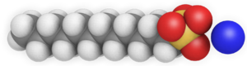

*Sodium lauryl sulfate*

*(*[*https://en.wikipedia.org/wiki/Sodium_dodecyl_sulfate*](https://en.wikipedia.org/wiki/Sodium_dodecyl_sulfate)*)*

**S**odium lauryl sulfate (SLS) and the compound cocamidopropyl betaine are added as foaming agents in toothpaste. They assist in emulsifying and maintaining the consistency of the toothpaste flavors, and foam helps spread the toothpaste throughout the teeth, removing debris so that it can be rinsed away.(<http://www.mnn.com/health/fitness-well-being/stories/whats-in-toothpaste>)

SLS is found in many types of toothpaste, but its use is questioned. It has been linked to skin irritations and canker sores. And, it is suggested that it limits the bioavailability of fluoride. (<http://www.freysmiles.com/blog/view/why-to-avoid-toothpastes-with-sodium-lauryl-sulfate>)

**Preservatives**

Toothpastes that do not contain fluoride as an active ingredient require a mild antimicrobial agent for preservation. Sodium benzoate is a preservative and antifungal agent. Parabens (methyl and ethyl) are also added to toothpaste as antibacterials. These derivatives of benzoic acid are suspected of mimicking hormones, increasing the possibility of breast cancer. (<http://www.paraben.co.uk/>)

**Toothpaste coloring**

Titanium dioxide or titanium(IV) oxide (TiO2) is often used to give toothpaste a bright white color. U.S. FDA-approved food colorings are used for other colors such as red, blue and green. Titanium dioxide also serves as a mild abrasive. (<http://www.nairaland.com/1307883/does-colour-toothpaste-matter>)

The sparkle in toothpaste often comes from tiny plastic polyethylene microbeads. Many personal care products and household cleaners contain these plastic beads for use as mild abrasives. Unfortunately, the little beads are washed down the drain during teeth brushing, face cleansing, etc. The plastic is non-biodegradable, so the little bits stay in the environment for a long time.

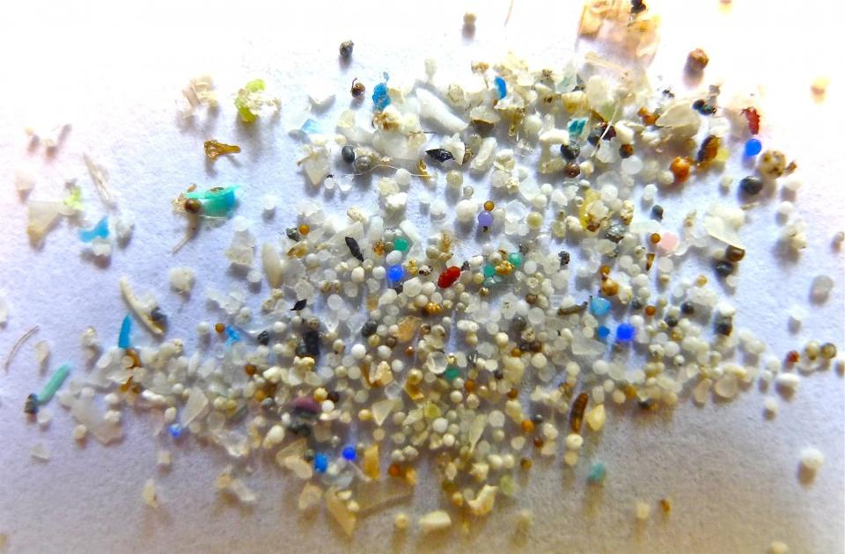 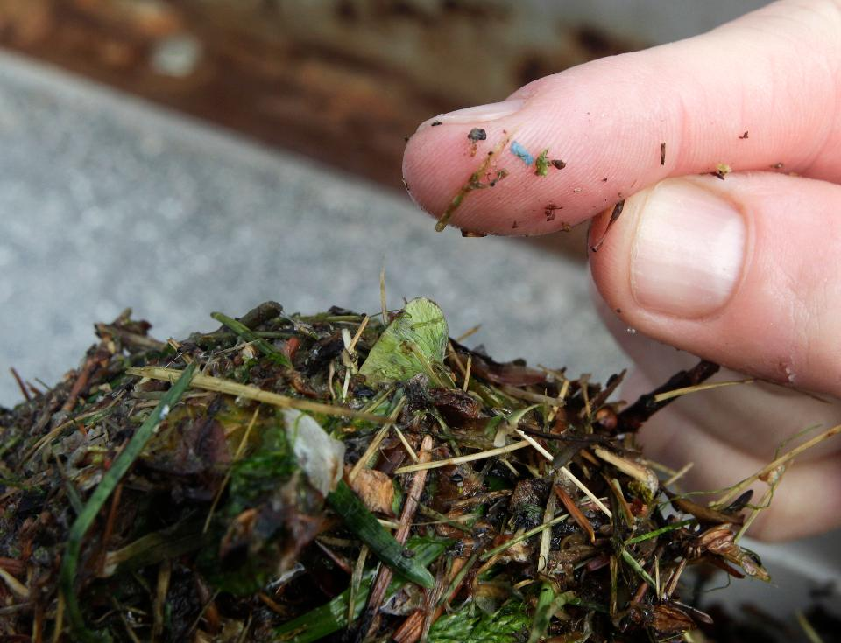

*Plastic microbeads Blue microplastic found in sediment*

(Credit: Flickr/5Gyres and Oregon State Univ. (AP Photo/Ted S. Warren)

*(*[*http://www.forbes.com/sites/carmendrahl/2016/01/09/what-you-need-to-know-about-microbeads-the-banned-bath-product-ingredients/#6fc078895f35*](http://www.forbes.com/sites/carmendrahl/2016/01/09/what-you-need-to-know-about-microbeads-the-banned-bath-product-ingredients/#6fc078895f35)*)*

During a study of seawater and sediment from Puget Sound, researchers found the tiny piece of blue plastic )shown in the photo above, right) in a collection filter pulled through the Thea Foss Waterway in Tacoma, Washington.

Microbeads range in size from a pinhead to the order of one micrometer, a bead too small to see with the naked eye. Waste water filters are not designed to remove particles this small, so they end up in rivers, lakes and oceans. The problem lies in the fact that the plastic beads bind to polychlorinated biphenyls (PCBs), non-biodegradable compounds that can adversely affect human health in various ways. In addition, fish perceive them as food. When ingested they can cause internal abrasions and they also stunt fish growth. With a stomach filled with microbeads, fish no longer look for additional food. The plastic accumulates in the food chain as other animals (including humans) eat these fish. ([http://www.huffingtonpost.com/entry/obama-microbead-ban fail_us_57432a7fe4b0613b512ad76b](http://www.huffingtonpost.com/entry/obama-microbead-ban%20fail_us_57432a7fe4b0613b512ad76b))

Several European countries have banned or are considering a ban on the use of microbeads in groceries and general merchandise such as cosmetics, lotions and toothpaste. President Obama signed a bill to ban them in 2015 but, unfortunately, the law covered only toothpaste and products that wash off skin. Many products such as detergents, cosmetics left on the skin,and materials used for sandblasting were not included. Several states are considering bans, and some companies have willingly removed the microbeads from their products. (<http://www.forbes.com/sites/carmendrahl/2016/01/09/what-you-need-to-know-about-microbeads-the-banned-bath-product-ingredients/#6fc078895f35>)

# References

**(non-Web-based information sources)**

**The references below can be found on the *ChemMatters* 30-year DVD, which includes all articles   
published from the magazine’s inception in October 1983 through April 2013; all available Teacher’s Guides, beginning February 1990; and 12 *ChemMatters* videos. The DVD is available from the American Chemical Society for $42 (or $135 for a site/school license) at this site:** [**http://ww.acs.org/chemmatters**](http://www.acs.org/chemmatters)**. Click on the “Teacher’s Guide” tab to the left, directly under the “*ChemMatters Online"* logo and, on the new page, click on “Get the past 30 Years of *ChemMatters* on DVD!” (the icon on the right of the screen).**

**Selected articles and the complete set of   
Teacher’s Guides for all issues from the past three   
years are available free online at the same Web site, above. Click on the “Issues” tab just below the logo, *“ChemMatters Online”*.**



***30* Years of *ChemMatters !***

Available Now!

Some of the many ingredients in toothpaste and their uses are listed by category, along with explanations. Additional details regarding foaming agents, solvents and binders are included. Also discussed is the hypersensitivity to eating hot, cold or sour foods experienced by some people as tooth pain. This problem can be alleviated by use of Sensodyne® toothpaste containing potassium nitrate, sodium citrate or strontium chloride. This article does a nice job of condensing much of the background information contained in this Teacher’s Guide. (Yohe, B. Toothpaste. *ChemMatters*, 1986, *4* (1), pp 12–13)

Students often ask why orange juice tastes bitter after you brush your teeth, yet some students will disagree. This article explains the genetic differences in people’s perception of bitterness following brushing with toothpaste containing the detergent sodium lauryl sulfate (SLS). This article was written in 1995; some now question the potential for side effects linked to the use of SLS. This is noted in the section, “Detergents” in this Teacher’s Guide. (DeCristofaro, P. The Taste Effect of Sodium Lauryl Sulfate or Why does orange juice taste so bad after you brush your teeth? *ChemMatters*, 1995, *13* (2), pp 14–15)

The Teacher’s Guide for the April 1995 *ChemMatters* article above contains information and data from participants who were asked to compare sweet, sour and bitter tastes before and after brushing with an SLS containing toothpaste. Further information is given about the genetic differences in bitterness perception following oral exposure to SLS.

The function of ingredients in mouth wash are described (e.g., oils used to mask the taste of thymol, an antibacterial and fungicide, and to sweeten bad breath). Several structural formulas are included. In addition, ingredients used to reduce plaque and thus reduce cavity formation are discussed. (Baxter, R. Mouthwash What’s In It for You? *ChemMatters*, 1996, *14* (4), pp.6–8)

While not involved in tooth brushing, this article presents an exciting way to discuss the importance of dynamic equilibrium. Maintenance of the solubility equilibrium between oxygen gas and hemoglobin is vital to the survival of Mt. Everest climbers. This article focuses on Le Châtelier’s Principle to explain the results of stresses placed on this equilibrium by the altitude and by the pH changes in the climber’s blood. (Rohrig, B. Mt. Everest Climbing in Thin Air. *ChemMatters*, 2000, *18* (1), pp 4–6)

This article contains a section on “Smelly Breath” attributed to failure to brush teeth before bedtime. This gives bacteria time to “munch” on leftover food particles during the night, preventing the remineralization of hydroxyapatite and leading to tooth decay. Nice illustrations and explanations are included that could be used to augment material in the Brown article. (Rohrig, B. Demystifying Gross Stuff. *ChemMatters*, 2011, *29* (3), pp 12–14)

The Teacher’s Guide for the October 2011 *ChemMatters* article above contains additional information about the role that fluoride ions play in protecting tooth enamel. In addition, a detailed explanation of the biochemistry involved in the metabolism of sugar by *S. mutans* is included.

A nice microscopic picture showing how enamel is composed of the bundles of crystalline rods is included this article. The how, why and safety of teeth-whitening methods is discussed. (Sitzman, B. and Goode, R. Open for Discussion: Teeth Whiteners. *ChemMatters*, 2013, *31* (1), p 4)

This article contains detailed information about the risks and benefits of triclosan in everyday products. Chemical structures indicate the ease of triclosan’s ability to mimic other hormones. (Harper, K. Bacteria Buster! Triclosan Kills Bacteria, but Is It Safe? *ChemMatters*, 2015, *33* (4), pp 13–15)

The Teacher’s Guide for the December 2015 *ChemMatters* article above contains additional information about triclosan’s structure and characteristic properties. These contribute to the molecule’s ability to cross cell membranes and interfere with the actions of human hormones such as estrogen and thyroxine.

# Web Sites for Additional Information

**(Web-based information sources)**

**History of dental care**

In July 2015, *Nature* published an article describing the process of analyzing indications of early dentistry on prehistoric teeth. The entire research article, “Earliest evidence of dental caries manipulation in the Late Upper Paleolithic” is available at <http://www.nature.com/articles/srep12150#f2>.

This site titled “Human Teeth Fossils” contains many photographs with short descriptions of the fossil teeth, including those showing early “dental” practices. The site references *National Geographic Study* and BBC programs. (<http://www.crystalinks.com/fossilteeth.html>)

The Colgate-Palmolive Manufacturing Company published an article about early teeth cleaning processes; it discusses the early toothbrushes described in the Brown article. “The history of toothbrushes and toothpaste” is located at: (<http://www.colgateprofessional.com/patient-education/articles/history-of-toothbrushes-and-toothpastes>)

**History of human dental caries**

In 2004, the World Health Organization (WHO) published a thorough study of public health nutrition, “Diet, nutrition and the prevention of dental diseases”. Their investigation compares the oral health of people in industrialized nations with that of those who live in developing countries. The investigation describes the effects on the health of teeth by the amount of free sugars, carbohydrates and fluorides in the diet. Free sugars are those from honey, fruit juices and syrups, plus those added by manufacturers and consumers. (<http://www.who.int/nutrition/publications/public_health_nut7.pdf>)

This *Scientific American* article discusses the details and shortcomings of the “Paleo Diet” designed to follow the diet of hunter-gatherers, people who lived before the age of agriculture. (<https://www.scientificamerican.com/article/why-paleo-diet-half-baked-how-hunter-gatherer-really-eat/>)

**The oral microbiome**

This paper published in the *Journal of Young Investigators* in December 2007 provides an excellent description of Yale University research. Investigators looked at the high rate of dental caries in low income populations. They attribute this to diets high in sugar that disrupt the homeostasis of the oral microbiome, shifting the acid-base equilibrium of hydroxyapatite leading to tooth decay. The research findings include modes of transmission and treatment options. One example shows that when Swedish children were given medication to prevent *S. mutans* colonization, the development of dental caries was delayed by an average of three years. (<http://www.jyi.org/issue/the-role-of-streptococcus-mutans-and-oral-ecology-in-the-formation-of-dental-caries/>)

The July 2016 *Journal of the Canadian Dental Association (CDA)* features four articles on the “Oral Microbiome”, stating that the microbiome is “Critical for Understanding Oral Health and Disease”. These articles discuss research data from the 2008 U.S. National Institutes of Health (NIH) “Human Microbiome Project” (HMP):

* Ancient Dental Calculus: Dental calculus from ancient teeth contains trapped human and microbial DNA. Analysis of this material leads to better understanding of the evolution of the human oral microbiome.
* Subgingival Microbiome Shifts: During the last 50 years, identification of oral bacterial species has increased seven fold. This enables scientists to better describe bacterial adaptations and host responses during transitions from gingivitis to periodontitis.
* Caries Pathology: *S. mutans* is not the only acid producing bacterium. Some beneficial bacteria actually help mitigate the acid producing response to sugars. Better understanding may lead to improved therapies caries prevention.
* Uncultured Oral Bacteria: New technologies have led to increased ability to culture bacteria and better understanding of species that remain uncultured.

(<http://www.cda.org/Portals/0/journal/journal_072016.pdf>)

Elmhurst College has produced a “Virtual ChemBook” that contains excellent diagrams and explanations in the section “Sugar and Tooth Decay”. These structural diagrams might serve as a good way to introduce the chemistry behind the formation of acid that causes dental caries. (<http://chemistry.elmhurst.edu/vchembook/548toothdecay.html>)

**Gum disease**

This paper, “Life below the Gum Line: Pathogenic Mechanisms of *Porphyromonas gingivalis*”was originally published in *Microbiology and Molecular Biology Reviews*. It provides details of the colonization and virulence features of the bacteria that cause gingivalis. *P. gingivalis* has a commensal relationship with its host, where it successfully adheres to teeth structures. While its activity is generally limited to tooth structures, if untreated it may lead to more systemic problems such as cardiovascular disease and premature births. (<https://www.ncbi.nlm.nih.gov/pmc/articles/PMC98945/>)

This article describes the relationship between health and inflammation. The link between inflammation of dental tissues and systemic problems (diseases) is informative. (<http://www.colgateprofessional.com/professional-education/articles/inflammation-relationship-between-oral-health-systemic-disease>)

The paper “Systemic Diseases Caused by Oral Infection” acknowledges that current epidemiological research can describe the relationships between oral problems and systemic diseases, but the research does not explain the causes of these links. (<https://www.ncbi.nlm.nih.gov/pmc/articles/PMC88948/>)

“Chronic inflammation in periodontal diseases: immunopathogenesis and treatment”, published in *Dentistry,* discusses plaque formation and the role of inflammation and its effects on other body systems. Along with a classification of periodontal diseases, the article shows radiographs of teeth in various stages of aggressive periodontitis.

(<http://www.dentistryiq.com/articles/gr/print/volume-2/issue-3/original-article/chronic-inflammation-in-periodontal-diseases-immunopathogenesis-and-treatment.html>)

**Biofilm detection**

This *WebMD* article, “Self-Examination for Dental Plaque”, discusses the formation of dental plaque and how it can be detected at home after inadequate brushing and flossing. Detailed instructions on the use and risk of self-disclosing tablets are given. (<http://www.webmd.com/oral-health/self-examination-for-dental-plaque#1>)

“Disclosing Agents in Periodontics: An Update Paper” provides some history of attempts to develop dyes designed to indicate how well biofilm has been removed by tooth brushing. There are also suggestions for dentists on how to instruct their patients on proper dental hygiene and the use of disclosing dyes to identify areas that have not been cleaned. (<https://nebula.wsimg.com/5d867182ab0040f0f175ee9bef4988b7?AccessKeyId=E54D0FD2D82F47860512&disposition=0&alloworigin=1>)

Researchers used a three-dye disclosing agent to study the relationship between the risk of caries development and the formation of plaque. This study was mentioned in the section on biofilm detection in the background information section of this Teacher’s Guide. The complete paper on the study contains details on the experimental design and the data collected and analyzed. “Efficacy of three-tone disclosing agent as an adjunct in caries risk assessment” is available at this URL: <https://www.ncbi.nlm.nih.gov/pmc/articles/PMC4549987/>.

**Tooth structure**

The University of Pittsburg School of Dental Medicine article, “Introduction: The Periodontium Supporting Structure of Teeth” contains additional information on the function and structure of major tooth tissues. (<http://dental.pitt.edu/periodontium>)

**Demineralization and equilibrium**

This site discusses the equilibrium (cycles) involved in the demineralization and mineralization of tooth enamel at the biofilm/tooth interface. Also discussed are normal and dangerously low oral pH values for children as well as for adults. (<http://www.oralhealthgroup.com/features/dental-remineralization-simplified/>)

**Le Châtelier’s Principle**

Le Châtelier’s Principle is defined, dynamic equilibrium is described, and shifts in response to changes in concentration, temperature and pressure are discussed with examples. An explanation is given to dispel the misconception that catalysts affect the equilibrium position. (<http://www.chemguide.co.uk/physical/equilibria/lechatelier.html>)

**Toothpaste ingredients**

This URL takes you to a blog about toothpaste and the many varieties on store shelves. The blogger lists five active ingredients and the incredibly long list of inactives. He also lists the probable use of each! (<http://theatticlight.net/posts/Toothpaste/>)

“Toothpaste─What’s in it?” provides a good summary of toothpaste ingredients divided into sections of abrasives, detergents, fluoride compounds, humectants systems and flavoring. This might provide a good beginning for a classroom discussion. (<http://www.deardoctor.com/articles/toothpaste-whats-in-it/>)

**Active ingredients**

The original research, “Resisting the Onset of Hydroxyapatite Dissolution through the incorporation of Fluoride” by Nora de Leeuw (School of Crystallography, Department of Chemistry, University College London) was done by computer simulation and published in the *ACS Journal of Physical Chemistry* in 2004. Abstract is available here: <http://pubs.acs.org/doi/full/10.1021/jp036784v>; only subscribers can access the full article.

This wiki site describes the history of contentious situations regarding the use of fluoride in U.S. municipal water supplies. Students may find it interesting to check the laws regarding their water supplies. (<https://en.wikipedia.org/wiki/Water_fluoridation_in_the_United_States>)

**Fluoride and dental** **fluorosis**

This *Web*MD article, “Fluorosis: Symptoms, Causes and Treatments”, summarizes the dental condition that affects teeth below the gum line as they mature. Only one in four people in the U.S. (between the ages of four and forty nine) are affected by dental fluorosis. Most cases are so mild that they are not noticeable. But about 2% have moderate fluorosis, and 1% of the cases are severe as shown in the pictures in the “Fluoride—excess” section of this Teacher’s Guide. These ugly teeth are not a symptom of a severe health problem, but they can present a serious cosmetic (psychological) problem. (<http://www.webmd.com/children/fluorosis-symptoms-causes-treatments>)

**Triclosan**

The U.S. FDA compares the risks with the benefits of triclosan use in “Antibacterial Soap? You Can Skip It -- Use Plain Soap and Water”. As the title suggests, washing thoroughly with soap and water is a very effective way to remove bacteria. Whereas, the risk of antibacterial resistance is a serious, often deadly, problem in our health care system. Data from studies has led to the ban on household use of triclosan (except in Colgate toothpaste). (<http://www.fda.gov/ForConsumers/ConsumerUpdates/ucm378393.htm>)

**Xylitol**

The March 27, 2015 article in the *American Dental Association (ADA) News, “*New research shows clinical evidence unclear on effects of xylitol products preventing dental caries”, sheds more light on the questions about xylitol as a cavity preventing agent. This article discusses the need for better designed studies that include randomized, placebo-controlled trials that include data on side effects such as bloating and diarrhea. (<http://www.ada.org/en/publications/ada-news/2015-archive/march/new-research-shows-clinical-evidence-unclear-on-effects-of-xylitol-products-preventing-dental-carie>)

**Inactive ingredients**

This site contains a physical geology student’s paper on minerals used as abrasives in toothpastes. This Cochise College student project includes nice color pictures and descriptions of the minerals that might be useful for display in the classroom. (<http://skywalker.cochise.edu/wellerr/students/toothpaste/project.htm>)

**Sweeteners**

“The Theory of Sweet Taste”, published in the *ACS Journal of Chemical Education*, discusses the connection between the molecular structure of compounds and their sweet taste. The abstract is available here: <http://pubs.acs.org/doi/abs/10.1021/ed049p171>; only subscribers can access the full article.