October/November 2016 Teacher's Guide

Background Information

for

E-Cycling: Why Recycling Electronics Matters

Table of Contents

About the Guide 2
Background Information 3
References 14
Web Sites for Additional Information 15

About the Guide

Teacher’s Guide team leader William Bleam and editors Pamela Diaz, Regis Goode, Diane Krone, Steve Long and Barbara Sitzman created the Teacher’s Guide article material.
E-mail: bbleam@verizon.net

Susan Cooper prepared the anticipation and reading guides.

Patrice Pages, ChemMatters editor, coordinated production and prepared the Microsoft Word and PDF versions of the Teacher’s Guide.
E-mail: chemmatters@acs.org

Articles from past issues of ChemMatters and related Teacher’s Guides can be accessed from a DVD that is available from the American Chemical Society for $42. The DVD contains the entire 30-year publication of ChemMatters issues, from February 1983 to April 2013, along with all the related Teacher’s Guides since they were first created with the February 1990 issue of ChemMatters.

The DVD also includes Article, Title, and Keyword Indexes that cover all issues from February 1983 to April 2013. A search function (similar to a Google search of keywords) is also available on the DVD.

The ChemMatters DVD can be purchased by calling 1-800-227-5558. Purchase information can also be found online at http://tinyurl.com/o37s9x2.

Background Information
(teacher information)
E-waste

What is E-waste?

E-waste is short for electronic waste. It is any electronic device that has been discarded by its owner because it is outdated or obsolete. E-waste includes computers, mobile phones, tablets, and televisions. There is not a clear definition for e-waste. There is some discussion over whether electrical appliances, such as microwaves and refrigerators, should be grouped into this category.

E-waste contains hazardous substances, so it cannot be thrown in the trash. Each state determines how electronic waste should be handled. Most states do not allow electronic waste in landfills and it must be sent to an e-waste recycler. The amount of e-waste is growing because, as we desire more and better technology, the lifespan of our devices is getting shorter. Companies answer this demand by updating and improving devices and equipment quicker than ever before. The United States produces more e-waste annually than any other country. The following data was compiled by Electronic TakeBack Coalition from Environmental Protection Agency (EPA) data.

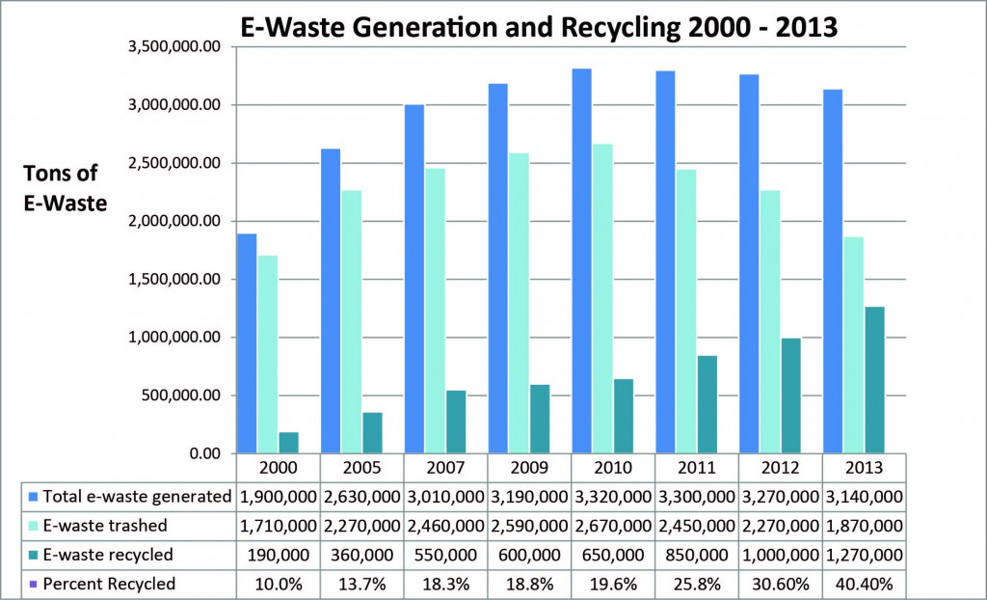

EPA data from “Municipal Solid Waste Generation, Recycling and Disposal in the United States, 2012 ,” Feb 2014; These EPA numbers are for “selected consumer electronics” which include products such as TVs, VCRs, DVD players, video cameras, stereo systems, telephones, and computer equipment.

(http://www.electronicstakeback.com/wp-content/uploads/Facts_and_Figures_on_EWaste_and_Recycling.pdf)

Problems with E-waste

E-waste creates both environmental and health problems. According to the EPA, electronic waste is the fastest growing municipal waste stream in the United States. The United Nations reports that 20–50 million metric tons of e-waste are discarded every year. Although this makes up only 2% of the trash in US landfills, it produces 70% of the overall toxic waste.

Only about 12.5% of the electronic waste is recycled worldwide. These products are not easy to recycle, since the safe recycling may cost more than the materials are worth. In order to evaluate the recycling process, two things must be considered. What is the value of the raw materials in the electronic device, and how difficult is the process to recover them? Since the first step is to disassemble the device, the easier that process is, the more likely it is to be worthwhile. As devices get smaller and lighter, this becomes more of a problem, because they can be difficult to take apart. To make the devices smaller and lighter, companies turn to glue and adhesives, instead of mechanical parts such as screws. All the glue must be removed before any recyclable material can be melted down. Other things that can make a device non-profitable to recycle include using non-standard screws, hazardous materials, large amount of glass and plastics, and waterproofing.

Unfortunately many electronics recyclers do not actually recycle the devices themselves. Instead they sell old electronics to exporting waste companies that send them overseas to developing countries for dismantling and recycling under horrid conditions. In these countries the wages are extremely low and the health, safety and environmental laws and their enforcement are very weak.

One of the best known and world’s largest electronic waste sites is the town of Guiyu in the providence of Guangdong, China. At its peak, tens of thousands of people worked in about 5,000 workshops processing 15,000 tons of electronic waste daily. Most of the workshops are poorly ventilated and the workers use little protective equipment as they pry open electronics with their bare hands, extract chips from circuit boards, grind plastic computer cases into particles and dip circuit boards in acid baths to dissolve precious metals. This work often takes place near the streets. Large amounts of pollutants, such as heavy metals and dioxin, are released, resulting in ground water and surface water contamination and atmospheric pollution. The health of the residents is affected. Eighty-two percent of the children have dangerously high blood-lead levels, which can impact the development of their central nervous system. In addition, there is a high incidence of skin damage, headaches, vertigo, nausea, chronic gastritis and ulcers among those recycling electronics.
“Cooking” of circuit boards.

(http://www.electronicstakeback.com/global-e-waste-dumping/img_0244/)

Unfortunately Guiyu, China is not the only such site for dumping of E-waste. There are many sites worldwide in countries such as India, Ghana and Nigeria.
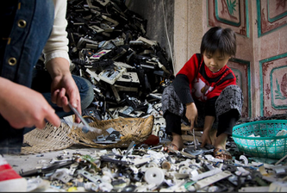
Child sorting through e-waste in his home

(http://www.occupyforanimals.net/electronic-waste--the-truth.html)

Only a small amount of E-waste is recycled. The rest either ends up in a landfill or is incinerated. According to the Electronic TakeBack Coalition:

While recycling is increasing, according to the EPA, currently about 60% of discarded electronics end up in the trash. While many states are passing laws to prevent e-waste from going into their landfills and incinerators, it’s still legal to trash electronics in many states. This is problematic because the hazardous chemicals in them could leach out of landfills into groundwater and streams. Burning the plastics in electronics can emit dioxin. Out of 3.14 [million] tons of e-waste generated in the U.S. in 2013, 1.87 million tons went into landfills and incinerators (60%) and only 1.27 million tons (40%) was recovered for recycling. (http://www.electronicstakeback.com/designed-for-the-dump/e-waste-in-landfills/)

Recycling of E-waste

Recycling of electronics by certified recyclers is not only good for the environment and our health, it can also be profitable. Each day approximately 350,000 cell phones are discarded, which translates to 128 million cell phones discarded each year. And yet by recycling 1 million cell phones, 35,000 pounds of copper, 772 pounds of silver, 75 pounds of gold and 33 pounds of palladium could be recovered. It is estimated that Americans trash $60 million dollars’ worth of gold and silver with their phones. Recycling e-waste also preserves our natural resources. Electronic waste can be more valuable than mining ore, since one ton of circuit boards contains between 40–800 times more gold than one ton of ore. (Most of these facts came from http://earth911.com/eco-tech/20-e-waste-facts/ and were verified for reliability.)

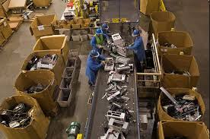
You may wonder, why isn’t recycling e-waste “the norm”—why isn’t it done on a larger scale? Although recycling e-waste preserves natural resources and can be lucrative, it is highly labor intensive. The process used by certified recyclers varies slightly but generally follows the same basic steps.
Dismantling and sorting electronic waste

(http://www.seas.columbia.edu/earth/wtert/sofos/Namias_Thesis_07-08-13.pdf)

- Picking.

The electronic waste devices are manually sorted and batteries are removed.

- Disassembly.

This process is seriously labor intensive. It requires the manual dismantling of the devices to recover and sort the various materials and components. The materials are separated into parts that can be reused and those that will be recycled. At this point the circuit board and microprocessors are frequently separated and sent to a separate recycler.

- Initial Size Reduction

Items that cannot be dismantled efficiently are shredded with the other dismantled parts into pieces that are about 5 centimeters (2 inches) in diameter.

- Secondary Size Reduction

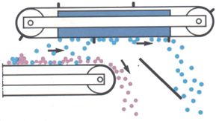
The waste at this point is spread out by an automatic shaking process on the conveyor belt. It then goes through a second shredder that produces poker chip size fragments that are optimal for the separation process.
Over-band Magnet

(http://www.jkmagnetics.com/overband.html )

- Over-band Magnet

The fragments pass under a large magnet that removes the steel and iron fragments. These are sold to metal recyclers to produce new steel.

- Nonmetallic and Metallic Component separation—Eddy Current Separator

At this stage the metals are separated from the nonmetallic materials. This is done commonly using an eddy current separator. The principle behind this separation process is given here:

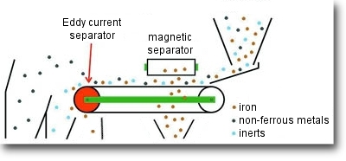
The principle is that an electrical charge is induced into a conductor by changes in magnetic flux cutting through it. Such changes in magnetic flux can be achieved by moving permanent magnets past a conductor. The effect of these currents is to induce a secondary magnetic field around the particle; this field reacts with the magnetic field of the rotor, resulting in a combined driving and repelling force which literally ejects the conducting particle from the product stream.
Eddy Current Separator

(http://www.cogelme.com/eng/e-eddy-current-metal-separator-pictures.htm)

(http://www3.uninsubria.it/uninsubria/allegati/pagine/6484/Ed.pdf )

These metals are then sold as raw materials.

- Water Separation

In the final step used by many recyclers, plastics are separated from glass using water. In this process the glass is denser and sinks, while the plastic floats.
(http://www.conserve-energy-future.com/e-waste-recycling-process.php)

The bulk of the copper, silver and gold in electronic waste comes from circuit boards and microprocessors. The circuit boards contain all three while the microprocessors only contain gold. The copper, silver and gold are stripped from the circuit boards, melted down and formed into plates. Through a series of electrolysis processes, the metals are separated and purified (see electrolysis section below). Since the microprocessors generally only contains gold, it is easier to recover it from these than from the circuit boards. The microprocessors are placed in a vat of aqua regia, where the gold is converted to AuCl₄¯ and dissolves in the solution. The gold is then recovered using either electrolysis or a sacrificial metal such as zinc.

Electrolysis
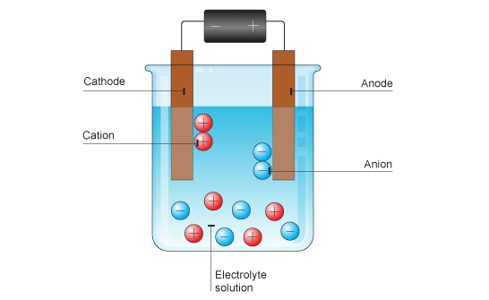
A typical electrolysis apparatus

(http://www.bbc.co.uk/schools/gcsebitesize/science/add_gateway_pre_2011/periodictable/electrolysisrev1.shtml
Electrolysis is the process of using electrical energy to cause a chemical reaction to occur. Electrolysis occurs in an electrolytic cell, which consists of two electrodes and a molten salt or an electrolyte solution (one that conducts electricity). The molten salt or the electrolyte consist of ions that are free to move. A battery or other voltage source is attached across the two electrodes.

The battery serves as an electron pump drawing electrons in at the positive electrode and forcing them out at the negative electrode. The positive ions (anions) move to the negative electrode, where they gain these electrons and are reduced. This electrode is the cathode, which is the electrode where reduction occurs. The electrons that enter the battery at its positive terminal must be obtained from negative ions (cations) in the electrolyte. The negative ions lose their electrons and are oxidized. This electrode is the anode.

The electrolysis of molten ionic compounds such as sodium chloride produces two elements. The electrolysis of sodium chloride produces sodium at the cathode and chlorine gas at the anode.

Cathode: Na⁺ (l) + 1e– Na (s)
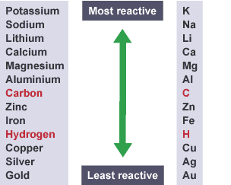
Short metal reactivity series

(http://www.bbc.co.uk/education/guides/zk96fg8/revision/3)
Anode: 2Cl– (l) Cl₂ (g) + 2e–

Using electrolytes (aqueous solutions of ionic compounds) instead of molten salts makes predicting the products a little more difficult. This is because water in the solutions can produce hydrogen ions, H⁺, and hydroxide ions, OH–, as well as the ions from the salt. The metal ions and hydrogen ions will be competing to be reduced. If the metal ion is less reactive than the hydrogen ion, the metal will be produced. Shown at right is a short metal reactivity series. If sodium chloride is dissolved in water the sodium metal is more reactive, so the hydrogen ion is reduced, forming hydrogen gas. If copper (II) ions are in solution, they are less reactive than the hydrogen, so copper will be produced at the cathode.

Applications of Electrolysis

The production of aluminum requires the use of electrolysis. Aluminum is one of the most abundant elements but, because it is very reactive, it is found in nature as its oxide, Al₂O₃, in an ore called bauxite. Aqueous solutions of aluminum ions could not be used because they are more reactive than hydrogen. In order to melt bauxite requires a temperature of 2050 ºC, which is not practical. A mixture of bauxite and cyrolite, Na₃AlF₆, melts at 1000 ºC. This mixture can then be used to obtain aluminum metal electrolytically. It is believed that the mixture reacts as follow:

Al₂O₃ + 4 AlF₆^{3–} 3 Al₂OF₆^{2–} + 6 F–

The electrolysis reactions are thought to be:

Cathode: AlF₆^{3–} + 3 e– Al + 6 F–

Anode: 2 Al₂OF₆^{2–} + 12 F– + C 4 AlF₆^{3–} + CO₂ + 4 e–

This electrolysis process produces aluminum that is 99.5% pure. The schematic diagram below shows the electrolytic cell typically used to produce aluminum.

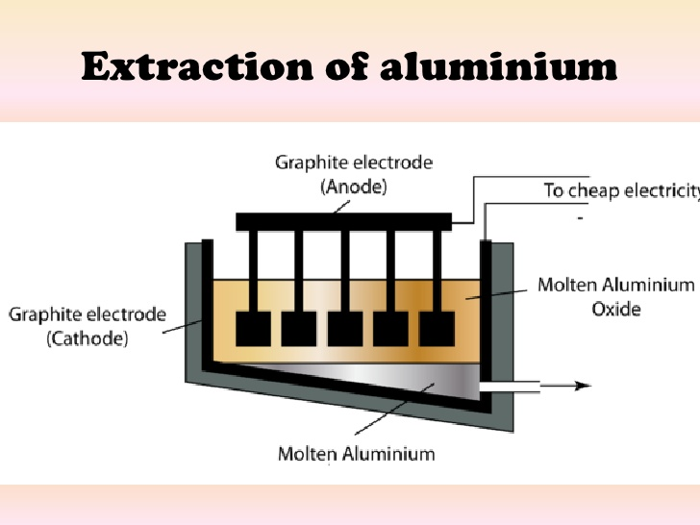

(http://spmchemistry.onlinetuition.com.my/2013/10/industrial-applications-of-electrolysis_4966.html)

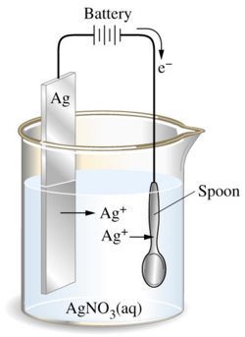
Electroplating is an electrolytic process for producing a thin and firm layer of metal onto a surface. The purposes of the plating include appearance, protection, special surface properties and engineering or mechanical properties. The substance to be plated is the cathode, and the anode is the metal to be deposited. The electrolyte is the metal salt in the electrolytic cell. The schematic below shows the electroplating of silver. The silver ions, Ag⁺, are attracted to the cathode (on the right) where the silver metal is plated out. Silver metal is the anode (on the left).
Electroplating of silver by electrolysis

(http://chemwiki.ucdavis.edu/Core/Analytical_Chemistry/Electrochemistry/Electrolytic_Cells/Electroplating)

Purification of metal is another important application of electrolysis. The impure metal serves as the anode and thin sheets of the pure metal form the cathode. The electrolyte is a solution of the metal salt. As the electric current is applied, the impure metal in the anode is oxidized, dissolved into the electrolyte and then is reduced at the cathode.

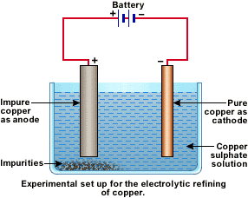
In the purification of copper, the cathode is a strip of pure copper. The anode is a block of impure copper. A solution of its metal salt (CuSO4) is used as the electrolyte in the electrolytic cell.
(http://look4chemistry.blogspot.com/2011/12/applications-of-electrolysis.html)

At anode, copper anode is oxidized and dissolved to form Cu²⁺ ions.

Cu (s) → Cu²⁺ (aq) + 2 e–

At cathode, Cu²⁺ ions are preferentially reduced than water molecules due to its more positive Eº value.

Cu²⁺ (aq) + 2 e– → Cu (s)

(http://look4chemistry.blogspot.com/2011/12/applications-of-electrolysis.html)

The metals (copper, silver and gold) from the circuit boards are purified by electrorefining. This mixture of metals is melted and formed into plates. Then through a series of electrolysis processes the metals are separated. The first electrolytic reaction purifies the copper, since it is the most reactive (see diagram above). The impure (combined) metal plate is the anode and a pure copper plate is the anode, with copper (II) sulfate serving as the electrolyte. The copper atoms at the anode are oxidized, dissolved in the electrolyte and then reduced at the cathode.

After this process the silver and gold remain. The silver and the gold plate is then placed in a second electrolytic cell where it is the anode and either a silver or an inert metal is used as the cathode. The electrolyte is usually nitric acid. Silver is oxidized to silver ions at the anode. The silver ions are attracted to the cathode where they are reduced and adhere to this electrode. At the end of this process the anode is relatively pure gold.

Heavy metals

The term heavy metal generally refers to metals or metal compounds that have a high density, atomic weight or atomic number and are toxic. However, in the sixty-plus years that the term has been used, no authoritative body has ever defined it. According to a technical report by the International Union of Pure and Applied Chemistry (IUPAC):

No relationship can be found between density (specific gravity) and any of the various physicochemical concepts that have been used to define “heavy metals” and the toxicity or ecotoxicity attributed to “heavy metals”.

Understanding bioavailability is the key to assessment of the potential toxicity of metallic elements and their compounds. Bioavailability depends on biological parameters and on the physicochemical properties of metallic elements, their ions, and their compounds. These in turn depend upon the atomic structure of the metallic elements, which is systematically described by the periodic table. Thus, any classification of the metallic elements to be used in scientifically based legislation must itself be based on the periodic table or some subdivision of it.

(http://iupac.org/publications/pac/pdf/2002/pdf/7405x0793.pdf)

A striking example of the confusion with the term “heavy metal” can be seen with the metals cadmium and gold. Cadmium metal is toxic and considered a heavy metal. It has an atomic number of 48 and a density of 8.65 g/mL. Metallic gold is not considered toxic, but its atomic number is 79 and its density is 18.88 g/mL.

Toxic metals which are generally considered heavy metals include mercury, cadmium, and lead. Arsenic is a metalloid which presents significant potential for adverse health outcomes. These elements are dangerous because they tend to bioaccumulate. Bioaccumulation is the increase in the concentration of a chemical in a biological organism over time, when compared to the chemical’s concentration in its environment. The following is a brief summary of some of the uses, sources of exposure, and health effects of the metals.

Element | Uses | Sources of Exposure | Health Effects
Mercury | - Thermometers  - Barometers  - Chloro-alkali industry to produce chlorine  - Dental amalgams  - Batteries  - Paint pigments | - Eating of fish contaminated with Hg  - Combustion of coal in power plants and industries  - Recycling of mercury containing waste | Inorganic Hg (tends to be reversible)  - Liver damage  - Tremors  - Anxiety  - Sleep disturbance  Organic Hg (nonreversible)  - Nervous system damage  - Kidney damage
Cadmium | - Nickel-Cadmium rechargeable batteries  - Alloys  - Electroplating coatings  - Solar Cells  - Plastic stabilizers  - Pigments  - Neutron absorbers in nuclear reactors | - Industrial workers in manufacturing of cadmium containing products  - Landfill workers and those recycling electronic parts  - Inhalation of cigarette smoke  - Food grown in Cd contaminated soil | - Highly toxic  - Carcinogenic  - Cadmium disrupts zinc metabolism due to its similar properties  - Renal dysfunction

Lead | - Lead storage batteries  - Lead alloys used in ammunition, pipes, solder, and fishing weights  - Paint | - Inhalation from lead dust and fumes at a work sites such as mines, smelters, or glass production  - Ingestion of lead paint  - Drinking of contaminated water from lead pipes | - Neurological effects  - Anemia  - Kidney disease  - Disrupts calcium metabolism  - Displaces magnesium and iron from certain enzymes that construct the building blocks of DNA.  - Disrupts the activity of zinc in the synthesis of heme in red blood cells

Treatment of Toxic (Heavy) Metal Poisoning

Mercury, cadmium, lead and arsenic serve no function in the human body. As stated in the Scientific World Journal,

Cadmium, lead, and mercury have no essential biochemical roles, but exert diverse, severe toxicities in multiple organ systems as they bind in tissues, create oxidative stress, affect endocrine function, block aquaporins, and interfere with functions of essential cations such as magnesium and zinc. Toxic metals pose particular risks to the very young, as exposures early in life compromise development, with lifelong physical, intellectual, and behavioural impairments. In adults, major chronic diseases, including cardiovascular and renal disease, and neurological decline, are also strongly associated with toxic elements. The International Agency for Research on Cancer (IARC) classifies cadmium as a known carcinogen, inorganic lead a probable carcinogen, and methylmercury a possible carcinogen.

(http://www.ncbi.nlm.nih.gov/pmc/articles/PMC3654245/)

The first step in reducing the effects of heavy metal poisoning is to eliminate the source of the metal poisoning. Chelation therapy is the common medical procedure used to eliminate the toxic metals from the body.

“Chelation,” from “chelos” the Greek word for claw, involves the incorporation of a mineral ion or cation into a complex ring structure by an organic molecule, the chelating agent. Typically, electron-donor atoms on the chelating molecule include sulfur, nitrogen, and/or oxygen.

The strength of the chemical bonds within coordination complexes that are formed between chelators and metal ions depends upon the elements involved and details of the stereochemistry. With a variety of metal ions that could bind competitively with the chelator (e.g., calcium, magnesium, zinc, copper, manganese, and other metals, that typically exceed concentrations of toxic elements), the identity of the metal predominately bound by a chelating agent depends both upon accessibility of the chelator to the tissues, how strongly the metal is already bound in the tissues, how strongly the metal binds to the chelator, and to some extent the relative quantities of various ions. Chelators have the effect of mobilizing metals from tissues and maintaining the chelate moiety during circulation to the kidneys for excretion in the urine, and to the liver for excretion in the bile. There are significant concerns related to enterohepatic recirculation and reabsorption in the kidney.

(http://www.ncbi.nlm.nih.gov/pmc/articles/PMC3654245/)

Chelation therapy usually involves an intravenous injection of a chelating agent, although there are oral treatments as well. The chelating agent used will depend on the toxic metal needed to be removed. Calcium disodium ethylenediaminetetraacetate CaNa₂EDTA, is an ester derived from the synthetic amino acid ethylenediaminetetraacetic acid. It is commonly used as a chelating agent. It is particularly good at chelating cadmium and lead and, to a lesser extent, mercury. The calcium salt of EDTA is most commonly used, since it does not deplete the body of calcium, which is a side effect of some chelating agents.
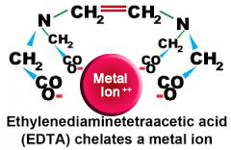
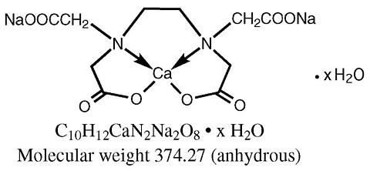
(https://innovativemedicine.com/chelation-therapy/)
CaNa₂EDTA

(https://www.drugs.com/drp/edetate-
calcium-disodium.html)

The diagram below shows the chemical reaction involving chelation of lead by CaNa₂EDTA.
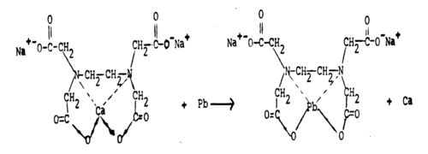
Chelating reaction of EDTA with lead

(https://o.quizlet.com/-d99l0IFfvv3q0RApWdbrg.png)

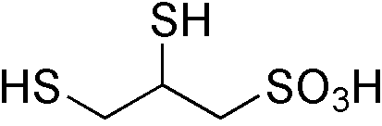
DMPS

(https://en.wikipedia.org/wiki/2,3-Dimercapto-1-propanesulfonic_acid)
DMPS, 2,3-dimercapto-1-propanesulfonic acid, is an intravenous chelating agent used for mercury detoxification.
It is also affective in chelating arsenic.

An oral chelating agent commonly used to treat mild to moderate lead poisoning is dimercaptosuccinic acid, DMSA, or succimer. It is also used for mercury and arsenic poisoning. The side effects of this chelating agent are less severe than with the other agents.

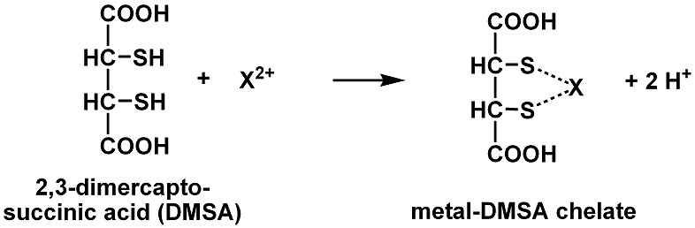

(http://www.chemistry.wustl.edu/~coursedev/Online%20tutorials/Quizzes/chemformquiz.htm)

References
(non-Web-based information sources)
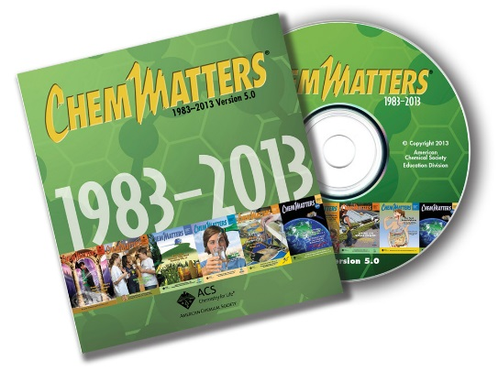
The references below can be found on the
ChemMatters 30-year DVD, which includes all articles
published from the magazine’s inception in October 1983 through April 2013, all available Teacher’s Guides, beginning February 1990, and 12 ChemMatters videos. The DVD is available from the American Chemical Society for $42 (or $135 for a site/school license) at this site: http://ww.acs.org/chemmatters. Click on the “Teacher’s Guide” tab directly under the ChemMattersonline logo and, on the new page, click on “Get the past 30 Years of ChemMatters on DVD!” (the icon on the right of the screen).

Selected articles and the complete set of
Teacher’s Guides for all issues from the past three
years are available free online at the same Web site, above. Click on the “Issues” tab just below the logo, “ChemMattersonline”.
30 Years of ChemMatters !
Available Now!

Author Withgott describes heavy metal poisoning from lead in this article. (Withgott, J. Lead—Beethoven’s Heavy Metal Ailment. ChemMatters, 2001, 19 (4), pp 14–15)

An article about the recycling of aluminum that describes the electrolysis of aluminum can be found here: Husband, T. Recycling Aluminum: A Way of Life or A Lifestyle? ChemMatters, 2012, 30 (2), pp 15–17.

The Teacher’s Guide for the April 2012 article above contains additional information on oxidation-reduction reactions and the electrolysis of alumina, using redox reactions to explain the process.

This article describes the environmental problem and the bioaccumulation of mercury. (Agner, M. Frozen Fish Stick Blues. ChemMatters, 2016, 34 (2), pp12–13)

The Teacher’s Guide for the April 2016 article above is loaded with information about the heavy metal mercury and its effects on our health. It also includes several activities that investigate mercury in our environment.

Web Sites for Additional Information
(Web-based information sources)
E-waste—basic information

Basic information about e-waste is given at this site. It is short but provides clear and concise information. (https://planetgreenrecycle.com/fundraising/e-waste-problem)

This article, “Facts and Figures on E-Waste and Recycling,” provides detailed information on the facts and data about electronic waste and its recycling. It is loaded with data in tables and graphs. (http://www.electronicstakeback.com/wp-content/uploads/Facts_and_Figures_on_EWaste_and_Recycling.pdf)

These two sites list interesting facts about electronic waste that students would find interesting and amazing. (http://earth911.com/eco-tech/20-e-waste-facts/ and (https://www.dosomething.org/us/facts/11-facts-about-e-waste)

This site provides a stepwise explanation of what to do when you are ready to recycle an old computer. (http://www.digitaltrends.com/computing/how-to-recycle-your-old-computer/)

This site provides a table of hazardous materials found in e-waste and where they occur. It also gives a brief description of some of the hazardous materials. (http://ewasteguide.info/hazardous-substances)

An interactive map of the United States that provides information by state of the legislation governing electronic waste can be found here: http://www.ecycleclearinghouse.org/content.aspx?pageid=10.

E-waste—problems with e-waste

This site provides an overview of the problems with e-waste. It highlights the major problems and provides links for additional information. (http://www.electronicstakeback.com/resources/problem-overview/)

Through pictures and graphics, the problems of electronic waste are presented at this site. These would make good pictures and graphics for a presentation. (http://ifixit.org/ewaste)

E-waste—recycling

At this site a step by step process of recycling electronic waste is given. It also suggests uses for the recycled material. (http://www.conserve-energy-future.com/e-waste-recycling-process.php)

“Printed Circuit Board Recycling Methods” is a detailed paper on the recycling of printed circuit boards and can be found at this site. It includes information about printed circuit boards, characterizes their waste, and details the commercial recycling process, including some of the chemistry. (https://www.epa.gov/sites/production/files/2014-05/documents/handout-10-circuitboards.pdf)

This site describes the theory behind the eddy current separator, as well as describing how it works. It includes graphics that aid in the explanation. (http://www3.uninsubria.it/uninsubria/allegati/pagine/6484/Ed.pdf)

Electrolysis

This site provides extensive information on electrolysis. It includes basic information on electrolysis, the electrolysis of molten salts and ionic solutions, redox half reactions, instructions on how to do basic quantitative calculations, purification of copper and electroplating. It also contains a link to an interactive video (mentioned in the simulations section above) and a short quiz that can be used to test a students’ understanding. (http://www.bbc.co.uk/education/guides/zk96fg8/revision)
Another site that describes electrolysis, compares electrolytic cells to voltaic cells, and describes applications of electrolysis can be found here: http://chemwiki.ucdavis.edu/Core/Analytical_Chemistry/Electrochemistry/Electrolytic_Cells/Electrolysis.
This site not only explains electrolysis, but also provides a little history of its use and provides sample calculations. It also has short concise explanations and graphics that describe the chloro-alkali process for the production of chlorine gas and the electrolytic refining of aluminum. (http://www.chem1.com/acad/webtext/elchem/ec8.html#IN)

Heavy metals

This article, “Heavy Metals”—A Meaningless Term? (IUPAC Technical Report), extensively describes the problem with the term “heavy metal”. It also describes the numerous ways that are used to classify metals. It discusses factors to be considered when classifying metals for toxicity and other possible ways to classify metallic elements as a basis for their toxicity assessment. (http://iupac.org/publications/pac/pdf/2002/pdf/7405x0793.pdf)

At this site a brief overview of heavy metals is given. Brief statements about several toxic metals are provided and each has a link that provides more detailed information about each one. (https://www.osha.gov/SLTC/metalsheavy/)

Another site that provides information about heavy metals and their effects on the environment can be found here: http://www.lenntech.com/processes/heavy/heavy-metals/heavy-metals.htm.

“Chelation: Harnessing and Enhancing Heavy Metal Detoxification—A Review” is an extensive article dealing with chelation therapy for the treatment of toxic metal poisoning. It describes background information, describes various chelating agents, including natural and pharmaceutical ones, as well as the benefits of using chelation therapy. (http://www.ncbi.nlm.nih.gov/pmc/articles/PMC3654245/)

At this site chelation therapy is described. It describes several different substances used as chelators and the element or elements for which they work best. (http://www.lifeextension.com/Protocols/Health-Concerns/Heavy-Metal-Detoxification/Page-08)

