

**October/November 2016 Teacher's Guide**

**Background Information**

**for**

***Expiration Dates: What Do They Mean?***

**Table of Contents**

About the Guide 2

Background Information 3

References 23

Web Sites for Additional Information 24

# About the Guide

Teacher’s Guide team leader William Bleam and editors Pamela Diaz, Regis Goode, Diane Krone, Steve Long and Barbara Sitzman created the Teacher’s Guide article material.   
E-mail: [bbleam@verizon.net](mailto:bbleam@verizon.net)

Susan Cooper prepared the anticipation and reading guides.

Patrice Pages, *ChemMatters* editor, coordinated production and prepared the Microsoft Word and PDF versions of the Teacher’s Guide.

E-mail: [chemmatters@acs.org](mailto:chemmatters@acs.org)

Articles from past issues of *ChemMatters* and related Teacher’s Guides can be accessed from a DVD that is available from the American Chemical Society for $42. The DVD contains the entire 30-year publication of *ChemMatters* issues, from February 1983 to April 2013, along with all the related Teacher’s Guides since they were first created with the February 1990 issue of *ChemMatters*.

The DVD also includes Article, Title, and Keyword Indexes that cover all issues from February 1983 to April 2013. A search function (similar to a Google search of keywords) is also available on the DVD.

The *ChemMatters* DVD can be purchased by calling 1-800-227-5558. Purchase information can also be found online at <http://tinyurl.com/o37s9x2>.

# Background Information

**(teacher information)**

**The history of food dating labels in the U.S.**

Before the 1970s, labels with a month, date, and year visible to the consumer—referred to as open date labels—generally were not placed on foods. Instead, manufacturers used a closed labeling system of codes that only the retailer could interpret, to help manage the store inventory. A system referred to as “closed” does not convey information to the customer, so customers had no way of knowing when their food was produced or how long it had been on the shelf. Increased urbanization of the U.S. meant fewer people were growing their own food, and more people had to rely on the retailer to assure them of the freshness of the food they purchased.

During the 1970s, many supermarkets adopted open dating practices in response to consumer demands. By 1973, ten states were regulating open dating of certain food products. By 1975, some in the food safety agencies started advocating a uniform date-labeling system that would be used by all.

In 1979, the Office of Technology Assessment (OTA) established a multifaceted task force to study the development of a system of dating food. Even at this time, the task force determined that open dating of food could not ensure microbial safety, and consumers may be led to think the food they were buying was safe until the date on the label. Shortly afterwards, the initial legislation to regulate open date labeling of food was introduced to the U.S. Congress.

None of the bills that would have regulated date labeling passed out of Congress. Supermarket chains were apprehensive about open dating because they felt customers would pick through the shelves looking for the most recent dates, leaving items with older dates on the shelf until they had to be discarded. The supermarkets were afraid this would increase waste and increase costs. Therefore no national legislation has been passed that would regulate food dating except for legislation that regulates the open dating of infant formula and baby food.

Below is a brief timeline of the need for and development of, food labeling in the U.S.

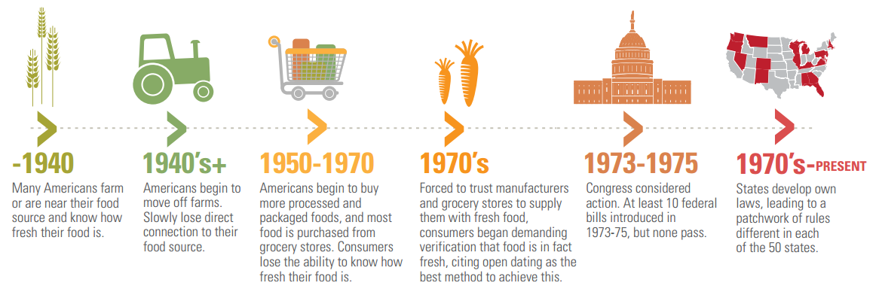

*(*[*https://nrdc.org/sites/default/files/dating-game-report.pdf*](https://nrdc.org/sites/default/files/dating-game-report.pdf)*)*

In the absence of any federal regulations, some states have regulated labels enthusiastically, while others have done very little. From state to state, the jurisdiction of date labels falls to different agencies, such as the Department of Health, the Department of Agriculture, the Department of Commerce, or the Department of Weights and Measures. All of these may have developed their own protocols.

Even though there are no federal laws concerning open dating of food, there are three major U.S. agencies that are tasked with the oversight of the nation’s food supply. Some foods fall under the U.S. FDA (Food and Drug Administration), while others fall under the jurisdiction of the USDA (U.S. Department of Agriculture); each of these organizations has different protocols for date labeling. The USDA requires a calendar date preceded by “Best by”, “Sell by” or “Use by”, but it does not define these terms, so, essentially, they can be used interchangeably. The Federal Trade Commission (FTC), has authority to create regulations necessary to prevent the deception of consumers and to prevent “unfair or deceptive acts or practices in or affecting commerce.” So, in the event that product labeling may be misleading to the public or creating an unfair market advantage for some companies, the FTC also has a voice in the way food is labeled.

The National Conference on Weights and Measures (NCWM) developed model regulations on open dating that is published in the National Institute of Standards and Technology (NIST) handbook for federal voluntary guidance, referred to as the “Uniform Open Dating Regulation Handbook”, or Handbook 130, which is used to provide guidance to the food industry. In this document, “Sell by” is recommended for prepackaged perishable foods, while “Best if used by” is recommended for semi-perishable or long-shelf-life foods. Even though guidance has been provided that attempts to standardize food date labels, only five states (Arkansas, Connecticut, Nevada, Oklahoma, and West Virginia) have regulations in place to automatically adopt the most recent NCWM Uniform Open Dating Regulations published in NIST Handbook 130. (<https://www.nrdc.org/sites/default/files/dating-game-report.pdf>)

In the following figure from the National Resources Defense Council (NRDC) “Dating Game Report” by Dana Gunders, the different agencies that are involved in the Federal Food Labeling System are outlined.

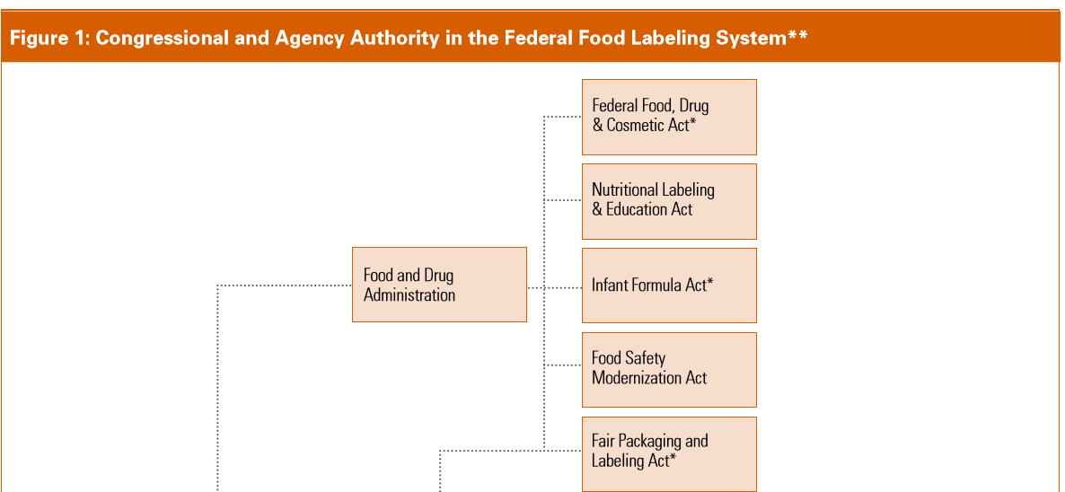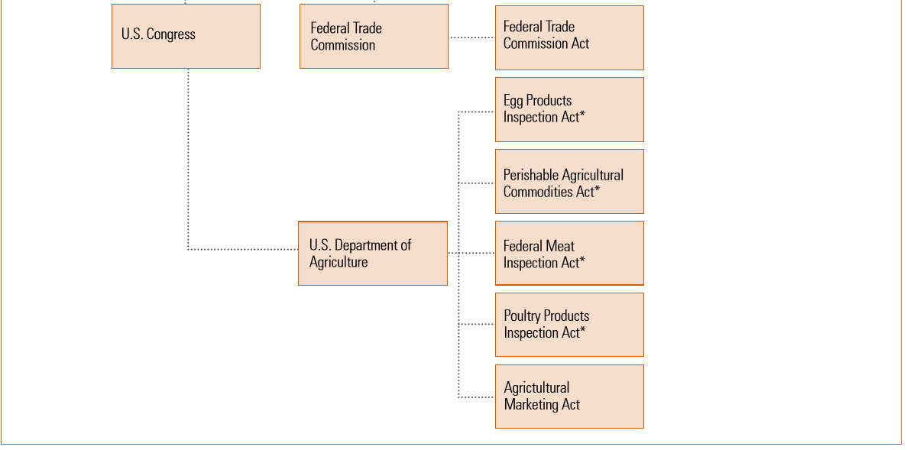*(*[*https://nrdc.org/sites/default/files/dating-game-report.pdf*](https://nrdc.org/sites/default/files/dating-game-report.pdf)*)*

**Proposed changes to date labeling**

From Figure 1 above, it is clear that there are multiple agencies that are trying to advise or regulate a system of dating foods. To date, there has not been any regulatory legislation regarding date labels for foods that has made it out of congress. In “The Dating Game: How Confusing Food Date Labels Lead to Food Waste in America” written by Dana Gunders from the NRDC, in conjunction with the Harvard Food Law and Policy Clinic, several recommendations are made. These are divided between three recommendations concerning date labeling practices, and three recommendations for activities that industry, government, and consumers should take to encourage reform.

**Recommendations for date labeling practices:**

1. Make Sell by dates invisible to the consumer.

“Sell by” dates are designed for stock control by the retailers as a business-to-business communication between manufacturers and retailers. These are often misinterpreted by consumers as safety dates.

1. Establish a reliable, coherent, and uniform consumer-facing dating system.
2. Establish standard, clear language for both quality-based and safety based date labels. A suggested phrase to replace “use by” could be “safe if used by”, followed by the date. “Best before”, a quality date phrase, could be replaced by “Peak freshness guaranteed before MMDDYY”, or this disclaimer: “This date is an indicator of quality. Product safety has not been tested or linked to this date.”
3. Include “Freeze by” dates and freezing information where applicable. This could serve as a reminder to the consumer to freeze the product instead of discarding it.
4. Remove or replace quality based dates on nonperishable, shelf-stable products. Use something like “Best within XX days of opening”.
5. Ensure date labels are clearly and predictably located on packages.
6. Employ more transparent methods for selecting dates. Product testing should be employed to set these date guidelines.
7. Increase the “Use of Safe Handling” instructions and “Smart Labels”.

Quick Response Codes (QR codes) could be used to allow consumers to use their smartphones to read a barcode linking to additional information about the food item.

For activities in which industry, government, and consumers should participate, to encourage reform:

1. Food industry actors would commit to
2. Converting to a closed-date system for sell by information.
3. Establishing a more standardized, easily understandable consumer-facing dating system.
4. Selling or donating near-expiration or expired products.
5. Educating consumers on the meaning of expiration dates and on safe food handling.
6. Policy change would be undertaken by the following actors:
7. Congress
8. FDA, USDA and other relevant agencies
9. NCWM, NIST
10. States—creating consistency across state laws
11. All levels of government—should conduct public education campaigns
12. Consumers and consumer-facing agencies and organizations would act now by:
13. Educating themselves and their constituents on the meaning of date labels.
14. Educating themselves and their constituents on safe food handling and consumption, including proper refrigeration temperatures.
15. Learning to tell when food can still be safely consumed.

(<https://nrdc.org/sites/default/files/dating-game-report.pdf>)

These recommendations, as well as others, are in The Food Recovery Act of 2015, introduced in the House and the Senate by Senator Richard Blumenthal (D-CT) and Representative Chellie Pingree (D-ME). The bill addresses the need to reduce food waste at multiple levels—consumer, farmer, retailer, schools, federal government, and landfills. In March of 2016 it was assigned to a subcommittee for further action. The bill can be accessed on Representative Pingree’s site: <https://pingree.house.gov/foodwaste>. Senator Blumenthal addresses the need for this legislation in this video (2:36): “Shrinking America’s Food Waste Mountain”. ([www.usatoday.com/videos/news/nation/2016/08/11/88553718/](http://www.usatoday.com/videos/news/nation/2016/08/11/88553718/))

**Food safety**

Food safety involves a multifaceted system to ensure that illness or harm will not result from eating food. Everyone involved with food—from the farm to the table—plays a role in keeping our food supply safe. When it comes to the role of date labels,

Here's a superbly-kept secret: All those dates on food products -- sell by, use by, best before --almost none of those dates indicate the safety of food, and generally speaking, they're not regulated in the way many people believe. The current system of expiration dates misleads consumers to believe they must discard food in order to protect their own safety. In fact, the dates are only suggestions by the manufacturer for when the food is at its peak quality, not when it is unsafe to eat.

(<https://www.nrdc.org/resources/dating-game-how-confusing-food-date-labels-lead-food-waste-america>)

In fact, many foods may be dangerous to eat well before their expiration date if they have not been handled properly or if they were contaminated during processing. The bacteria that are associated with the normal decay of food are generally not the bacteria that cause illness. In the U.S., the Food Safety and Inspection Service (FSIS) is the public health agency that is responsible for ensuring that the nation’s commercial supply of meat, poultry, and egg products is safe.

Many students often get their first job in the food retail business. If they work in a restaurant, they may have taken a food handler’s course and taken a test in order to get a permit to work with food served to the public. (This is required in some but not all fifty states.) Students are often eager to share what they learned, if you have time to let them share this in class. Hopefully they will be able to mention the 4 C’s of food safety. These are:

1. CLEAN—Wash hands with soap for at least 20 seconds. Wash food preparation surfaces often. Wash vegetables before peeling and, if they are rough, use a vegetable brush to remove all the dirt.
2. COOK—Bring all foods to the proper temperature. Use a thermometer to ensure you have reached the prescribed temperature. For example, ground beef should be cooked to 71 °C (160 °F) while leftovers should be warmed to at least 74 °C   
   (165 °F).
3. COMBAT CROSS CONTAMINATION—Separate meats and raw vegetables from the time you place them in the grocery cart. If possible, use different cutting boards for meats and vegetables. If that is not possible, wash all surfaces after they have been in contact with meat before using that surface for food that will not be cooked. After grilling meats, place them on a clean plate.
4. CHILL—Keep cold foods refrigerated at temperatures ≤ 40 °F. Freezers should be set to 0 °F. The danger zone for most foods is between 40 °F and 140 °F. In this temperature range bacteria can grow. Any perishable foods left out at room temperature for longer than two hours should be discarded.

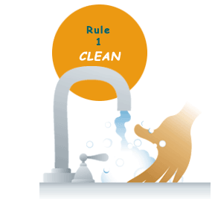 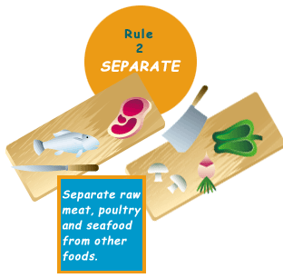

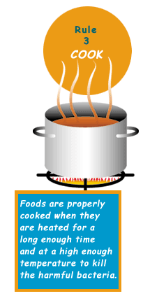 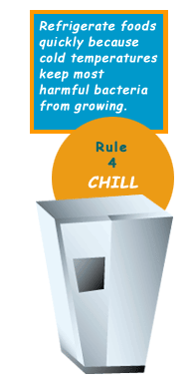

*The Four Rules of Food Safety*

*(*[*http://www.fda.gov/Food/FoodborneIllnessContaminants/PeopleAtRisk/ucm182679.htm*](http://www.fda.gov/Food/FoodborneIllnessContaminants/PeopleAtRisk/ucm182679.htm)*)*

For tables and charts containing information on the safe storage times for certain perishable food items see the U.S. Department of Health & Human Services’ “Foodsafety.gov” Web site at <https://www.foodsafety.gov/keep/charts/index.html>. Following the four main safety rules cited above will go a long way in preventing foodborne illnesses.

Here are a few examples of why following all of these steps is important. Some types of bacteria form spores that aren’t killed by cooking. Spores are a survival mode in which those bacteria make an inactive form that can live without nutrition and that develops very tough protection against the outside world. After cooking, the spores may change and grow into bacteria, when the food cools down. Refrigerating food quickly after cooking can help keep the bacteria from multiplying. On the other hand, cooking does kill most harmful bacteria. Cooking is especially important when a pathogen is hard to wash off of a particular kind of food, or if a bacterium can grow at refrigerator temperatures, as is true of *Listeria monocytogenes* and *Yersinia enterocolitica.”*

From the Bad Bug Book a practical handbook about the microorganisms that cause foodborne illness.

([www.fda.gov/downloads/Food/FoodborneillnessContaminants/UCM297627.pdf](http://www.fda.gov/downloads/Food/FoodborneillnessContaminants/UCM297627.pdf))

**A 5-second expiration date?**

How many times have you heard students, or even adults, claim the “five second rule”, as they pick up a piece of food they just dropped on the floor and put it in their mouth? The five second rule is the belief that food that drops to the floor is still safe to eat, as long as it is picked up within five seconds. The theory (hypothesis, really) is (was) that bacteria require more than that time to transfer from the floor to the food’s surface.

Researchers at Rutgers University set out to test the five second rule by conducting a series of experiments, repeated 20 times, that related contact time to cross contamination of food with bacteria. They used four different surfaces—stainless steel, ceramic tile, carpet, and wood; and four different foods—watermelon, bread, buttered bread, and gummy candy; and four different contact times—less than 1 second, 5 seconds, 30 seconds, and 300 seconds. Their results were published in *Applied & Environmental Microbiology*, and summarized in the September 12, 2016 issue of *Food Safety Magazine*.

Food science professor and extension specialist Donald Schaffner found that cross contamination can occur in less than one second, dependent upon certain conditions—moisture level, surface type, and contact time. … “Transfer of bacteria from surfaces to food appears to be affected most by moisture,” says Schaffner. “Bacteria don’t have legs, they move with the moisture, and the wetter the food, the higher the risk of transfer. Also, longer food contact times usually result in transfer of more bacteria from each surface to food.”

([www.foodsafetymagazine.com/news/the-5-second-rule-is-bogus-say-rutgers-researchers](http://www.foodsafetymagazine.com/news/the-5-second-rule-is-bogus-say-rutgers-researchers))

For the record, the surface that transferred the most bacteria was stainless steel while carpet transferred the least. Watermelon picked up the most bacteria in the shortest amount of time while gummy candy picked up the least bacteria. As for contact times, the longer the food was in contact with the contaminated surface the more bacteria were transferred, so, in this aspect, the five second rule is real. (<https://foodpoisoningbulletin.com/2016/5-second-rule-depends-on-food-and-contact-surface/>)

However, regardless of whether the five-second rule is reality or myth, the research above shows that food dropped on a floor should probably not be eaten. So, you could say that unwrapped food that hits the floor has immediately and automatically met or surpassed its own **expiration date!**

**Food poisoning**

Food poisoning, otherwise known as foodborne illness, is any illness that results from eating contaminated foods. Food poisoning is always a miserable experience but, for the most vulnerable people, such as infants and children under 5, adults over 60, and persons with weakened immune systems, food safety can literally be a matter of life and death. Every year one in six Americans get sick from food poisoning, 128,000 cases require hospitalization, and 3,000 persons die.

Bacteria cause the most problems; however, some foodborne illness can be caused by parasites or fungi. In the U.S., the most common foodborne parasites are protozoa, roundworms, and tapeworms.

The majority of all cases of foodborne illness can be attributed to one of the agents in the following table:

|  |  |  |  |
| --- | --- | --- | --- |
| **Bacteria** | **Common Food Source** | **Onset of illness after ingestion** | **Symptoms** |
| ***Salmonella*** | Eggs, poultry, cheese, meat, unpasteurized milk, contaminated raw vegetables | 6–48 hours | Diarrhea, fever, vomiting, abdominal cramps |
| ***Clostridium perfringens***  Over 1 million illnesses per year | Beef, poultry, gravies. Foods kept warm for long periods of time before serving. Cooking kills the bacteria but not the spores. | 8–16 hours | Intense abdominal cramps, watery diarrhea |
| ***Campylobacter jejuni*** | Raw and undercooked poultry, unpasteurized milk, contaminated water | 1–3 days | Diarrhea, cramps, fever, and vomiting; diarrhea may be bloody |
| **Noroviruses** | Raw produce, contaminated water, uncooked foods and cooked foods not reheated after contact with an infected food handler; shellfish from contaminated waters | 12–48 hours | Nausea, vomiting, abdominal cramping, diarrhea, fever, headache. |
| ***Listeria monocytogenes*** | Unpasteurized milk, soft cheeses made with unpasteurized milk, ready-to-eat deli meats. These bacteria can grow in refrigerator temperatures. | 9–48 hours initial symptoms  2–6 wks full disease onset | Fever, muscle aches, and nausea or diarrhea. In pregnant women infection can lead to premature delivery or stillbirth. Elderly or immunocompromised patients may develop bacteremia or meningitis |
| ***Staphylococcus aureus*** | Unrefrigerated or improperly refrigerated meats, potato and egg salads, cream pastries | 1–6 hours | Sudden onset of severe nausea, vomiting, abdominal cramps, with fever possible |
| ***Escherichia coli***  ***E.coli*** | Water or food contaminated with human feces | 1–3 days | Watery diarrhea, abdominal cramps |
| ***E.coli* 0157:H7** | Undercooked beef (especially hamburger), unpasteurized milk and juice, raw fruits and vegetables (e.g. sprouts), and contaminated water | 1–8 days | Severe (often bloody) diarrhea, abdominal pain, vomiting, usually no fever. Can lead to kidney failure and if the patient gets dehydrated—seizures. |

For more information, a more comprehensive coverage of this table can be found at <http://www.fda.gov/downloads/Food/FoodborneIllnessContaminants/UCM187482.pdf>.

Compared to other foodborne germs, *Salmonella* is the deadliest. *Salmonella* infections result in more hospitalizations and deaths than any other bacteria found in food, causing over $365,000,000 in medical costs annually. There have been several outbreaks of foodborne illness caused by *Salmonella* in the U.S. in the past several years—from outbreaks due to tainted eggs to outbreaks from contaminated cucumbers, tomatoes, and alfalfa sprouts.

*Salmonella* can be present inside the eggs laid by infected chickens, which is why eggs should be cooked well before eating them. *Salmonella* is present in chicken litter, and farmers who use chicken litter as fertilizer run the risk of their crops being tainted with *Salmonella,* such as in the 2015 outbreak where 907 cases of foodborne illness due to *Salmonella* were traced back to cucumbers grown on a Mexican farm that used poultry litter as fertilizer. In 2016 there was an outbreak of 611 cases that were traced back to live poultry from backyard flocks. (<http://www.cdc.gov/salmonella/live-poultry-05-16/index.html>)

*E.coli* 0157:h7 is a virulent strain of *E.coli* that can cause severe illness. It is often the source of infection that is caused by eating undercooked ground beef. Education campaigns launched by the FDA have helped decrease the incidence of foodborne illness from *E.coli* 0157:H7. Similar campaigns for *Salmonella* have not produced the same results, as indicated in the following graph.

**Change in *E. coli* O157 and *Salmonella* infection, 1996–2010**

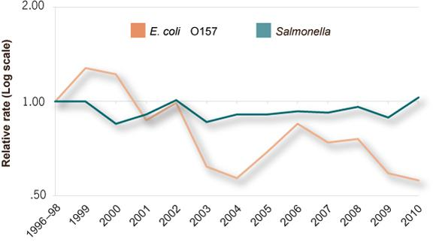

*Source: Foodborne Diseases Active Surveillance Network, 2010*

*(*[*https://www.cdc.gov/vitalsigns/FoodSafety/*](https://www.cdc.gov/vitalsigns/FoodSafety/)*)*

*(*[*http://www.cdc.gov/foodborneburden/PDFs/Trends-in-Foodborne-Illness-1996-2010-508c.pdf*](http://www.cdc.gov/foodborneburden/PDFs/Trends-in-Foodborne-Illness-1996-2010-508c.pdf)*)*

The Centers for Disease Control and Prevention is the link between illness in people and the food safety policies and practices of the government agencies, food producers, and retail food establishments. When the CDC is notified of suspected foodborne illness they will determine the specific genotype of the bacterium involved and get information from the victims, in order to trace the bacteria to its source. Suspected food related illnesses should first be reported to the local health department, where the environmental health specialist, or sanitarian, will begin tracking the source of the disease.

**Food waste**

On average, each person in the U.S. discards approximately 300 lbs. of food each year. Ninety percent of us throw out food too soon, while it is still “good”. This is confirmed from this quote from “The Dating Game” published by the NRDC:

U.S. consumers and businesses needlessly trash billions of pounds of food every year as a result of America's dizzying array of food expiration date labeling practices, which need to be standardized and clarified. Forty percent of the food we produce in this country never gets eaten. That's nearly half our food, wasted -- not just on our plates, but in our refrigerators and pantries, in our grocery stores and on our farms. Much of it perfectly good, edible food -- worth $165 billion annually -- gets tossed in the trash instead [of] feeding someone who's hungry. Misinterpretation of date labels is one of the key factors contributing to this waste.

(<https://www.nrdc.org/resources/dating-game-how-confusing-food-date-labels-lead-food-waste-america>)

When food goes to waste, so do all the resources used to grow, store and transport it. Wasting food wastes everything—water, fuel, labor and money. According to an Agricultural Department study, four percent of U.S. annual oil consumption and twenty-five percent of our nation’s fresh water goes into producing and transporting food that is never eaten. Most of this food will ultimately end up in a landfill. Food waste is the single largest component of solid waste in our landfills, comprising over 20 percent of all waste. In the landfill, the decaying food is turned into methane gas, which is 21 times more potent than carbon dioxide as a greenhouse gas. Every ton of wasted food results in 3.8 tons of greenhouse gas emissions. ([www.endfoodwastenow.org/index.php/resources/facts](http://www.endfoodwastenow.org/index.php/resources/facts))

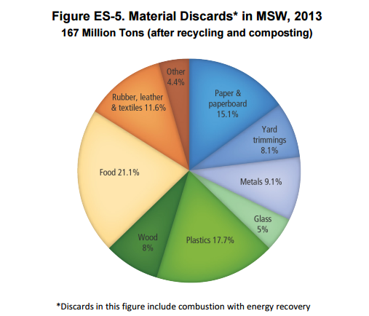

(MSW = Municipal Solid Waste)

*(*[*https://www.epa.gov/sites/production/files/2015-09/documents/2013_advncng_smm_rpt.pdf*](https://www.epa.gov/sites/production/files/2015-09/documents/2013_advncng_smm_rpt.pdf)*)*

If we as a nation were able to cut our food waste by 50% we would extend the life of landfills by decades and reduce soil depletion. ([www.scientificamerican.com/article/earth-talk-waste-land/](http://www.scientificamerican.com/article/earth-talk-waste-land/))

The following graph breaks down food loss by category:

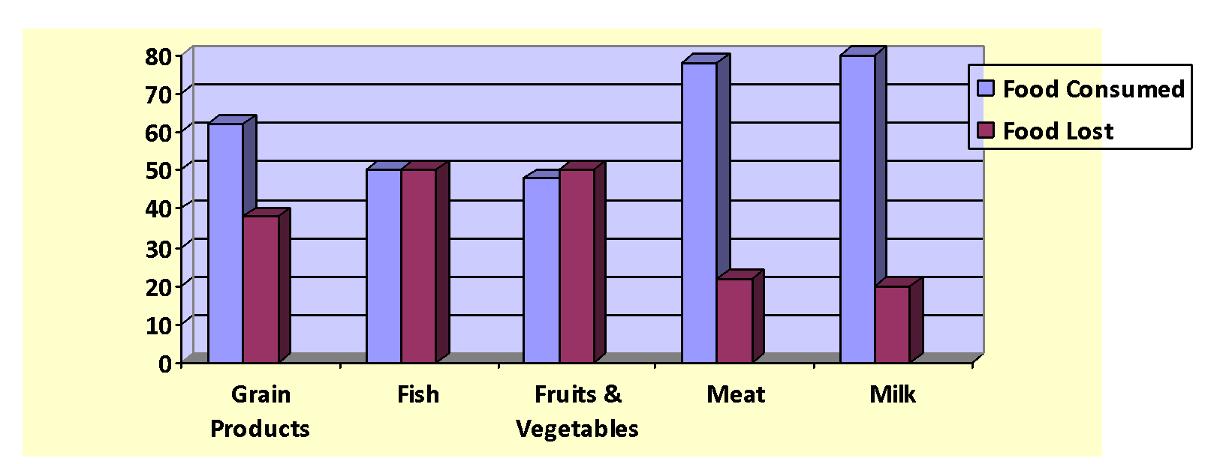

***Food Consumed Versus Food Loss\****

*\*Percentages calculated collectively for USA, Canada, Australia, and New Zealand*

*Data Source: Food and Agriculture Organization 2011*

*(Adapted from bar chart found here:* [*https://www.nrdc.org/sites/default/files/wasted-food-IP.pdf*](https://www.nrdc.org/sites/default/files/wasted-food-IP.pdf)*)*

There are multiple reasons why so much food is wasted.

* Some food is never harvested
* Some food that is harvested is discarded for cosmetic reasons—U.S. consumers don’t buy “ugly” produce
* Restaurants prepare more food than they sell
* Grocery stores pull food when it reaches the expiration date on the package
* Consumers toss food that has reached the date on the package

The Food Recovery Act that has been introduced in Congress addresses each of these sources of food waste. At the consumer level, there are proposed changes to the food dating system. Farms, grocery retailers, and restaurants may receive a tax deduction for donating high quality food to organizations serving food-insecure people. Ugly fruit and vegetables that are still perfectly good can be used in the school lunch program and the schools could be connected to farms that may be interested in school food waste to feed their livestock. There are also provisions in the legislation to support research to develop ways to reclaim energy from waste, or to use the waste as a resource for the creation of new materials. Efforts to reclaim energy from waste range from capturing the methane produced at landfills so it can be used as a fuel, to finding what components of discarded food can be used to produce new materials. In a short (2:33) YouTube video Dr. Ivan Cornejo, a research engineer at The Colorado School of Mines, talks about his research that uses some types of food waste as material to make glass. (<https://www.youtube.com/watch?v=J_3zDkLg_BI>)

Several agencies and special interest groups, such as “Save the Food”, have developed programs to increase awareness of food waste and to educate the general public regarding this problem. An example of a program that can be used by schools is the USDA’s Food Waste Challenge. Classes or schools can take on the challenge to reduce food waste at their school, and they are provided ideas and tools to help them learn more about reducing food waste. See [www.usda.gov/oce/foodwaste/join.htm](http://www.usda.gov/oce/foodwaste/join.htm) for more information on taking the challenge. Food Rescue, which started in Indiana, is another program to help students get involved in reducing food waste. (<http://www.foodrescue.net/>)

In an April 20, 2016 article in *Time* magazine, Tom Colicchio of Bravo’s reality cooking show provided these six tips to enjoy more food and waste less of it. They are:

1. plan before shopping,
2. freeze any excess food purchased while it is still fresh,
3. reinvent leftovers so that they get used,
4. make soup with excess items before they go bad,
5. use every part of a vegetable—add the green leafy tops from carrots to a salad,
6. compost scraps.

([www.time.com/4299928/save-the-food/](http://www.time.com/4299928/save-the-food/))

**Enzymatic browning of phenolic compounds**

The primary reaction that causes the brown color of many fruits and vegetables when they are cut is the reaction between the plant enzyme polyphenol oxidase (PPO) and the various polyphenolic compounds in the plant. These are kept separate when the plant is intact, but are released from the cell cytoplasm when the plant is cut. In the presence of oxygen, the phenolic compounds are oxidized. The oxidized phenolic products are more reactive and can combine with each other and other proteins to form a brown- or black-colored complex. This process is referred to as enzymatic browning.

Polyphenols are normally complex organic substances, which contain more than one phenol group:

*Phenol*

[*https://en.wikipedia.org/wiki/Phenols#/media/File:Phenol_chemical_structure.png*](https://en.wikipedia.org/wiki/Phenols#/media/File:Phenol_chemical_structure.png)

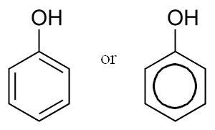

*Theaflavin, a polyphenol in tea*

*(*[*https://en.wikipedia.org/wiki/Theaflavin*](https://en.wikipedia.org/wiki/Theaflavin)*)*

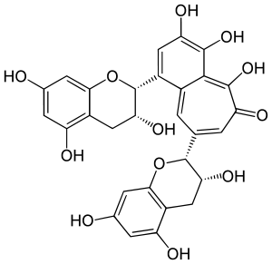

Image result for applePolyphenols can be divided into many different subcategories, such as: anthocyanins that are responsible for the pink, red, and blue colors of plants; flavonoids, associated with yellow, blue and red pigments and found in tea and wine; and non-flavonoids, components found in gallic acid in tea leaves. Flavonoids are formed in plants from the aromatic amino acids phenylalanine and tyrosine.

*anthocyanin pigments are responsible for an apple’s red color*

([*http://www.themonitordaily.com/apple-a-day-might-not-keep-the-doctor-away/21255/*](http://www.themonitordaily.com/apple-a-day-might-not-keep-the-doctor-away/21255/)

**Table 1: An overview of known polyphenols involved in browning**

|  |  |
| --- | --- |
| **Source** | **Phenolic substrates** |
| Apple | chlorogenic acid (flesh), catechol, catechin (peel), caffeic acid, 3,4-dihydroxyphenylalanine (DOPA), 3,4-dihydroxy benzoic acid, *p-*cresol, 4-methyl catechol, leucocyanidin, *p-*coumaric acid, flavonol glycosides |
| Apricot | isochlorogenic acid, caffeic acid, 4-methyl catechol, chlorogenic acid, catechin, epicatechin, pyrogallol, catechol, flavonols, *p-*coumaric acid derivatives |
| Avocado | 4-methyl catechol, dopamine, pyrogallol, catechol, chlorogenic acid, caffeic acid, DOPA |
| Banana | 3,4-dihydroxyphenylethylamine (Dopamine), leucodelphinidin, leucocyanidin |
| Cacao | catechins, leucoanthocyanidins, anthocyanins, complex tannins |
| Coffee beans | chlorogenic acid, caffeic acid |
| Eggplant | chlorogenic acid, caffeic acid, coumaric acid, cinnamic acid derivatives |
| Grape | catechin, chlorogenic acid, catechol, caffeic acid, DOPA, tannins, flavonols, protocatechuic acid, resorcinol, hydroquinone, phenol |
| Lettuce | tyrosine, caffeic acid, chlorogenic acid derivatives |
| Lobster | Tyrosine |
| Mango | dopamine-HCl, 4-methyl catechol, caffeic acid, catechol, catechin, chlorogenic acid, tyrosine, DOPA, *p-*cresol |
| Mushroom | tyrosine, catechol, DOPA, dopamine, adrenaline, noradrenaline |
| Peach | chlorogenic acid, pyrogallol, 4-methyl catechol, catechol, caffeic acid, gallic acid, catechin, dopamine |
| Pear | chlorogenic acid, catechol, catechin, caffeic acid, DOPA, 3,4-dihydroxy benzoic acid, *p-*cresol |
| Plum | chlorogenic acid, catechin, caffeic acid, catechol, DOPA |
| Potato | chlorogenic acid, caffeic acid, catechol, DOPA, *p-*cresol, *p-*hydroxyphenyl propionic acid, *p-*hydroxyphenyl pyruvic acid, *m-*cresol |
| Shrimp | Tyrosine |
| Sweet potato | chlorogenic acid, caffeic acid, caffeylamide |
| Tea | flavanols, catechins, tannins, cinnamic acid derivatives |

*(*[*www.food-info.net/uk/colour/enzymaticbrowning.htm#1*](http://www.food-info.net/uk/colour/enzymaticbrowning.htm#1)*)*

**Polyphenoloxidase**

**Polyphenoloxidases** are a class of enzymes that were first discovered in mushrooms and are widely distributed in nature. They appear to reside in the plastids and chloroplasts of plants, although freely existing in the cytoplasm of senescing or ripening plants. Polyphenoloxidase is thought to play an important role in the resistance of plants to microbial and viral infections and to adverse climatic conditions.

In the presence of oxygen from air, the enzyme catalyzes the first steps in the biochemical conversion of phenolics to produce quinones, which undergo further polymerization to yield dark, insoluble polymers referred to as melanins.

These melanins form barriers and have antimicrobial properties which prevent the spread of infection or bruising in plant tissues. Plants, which exhibit comparably high resistance to climatic stress, have been shown to possess relatively higher polyphenoloxidase levels than susceptible varieties.

([www.food-info.net/uk/colour/enzymaticbrowning.htm#1](http://www.food-info.net/uk/colour/enzymaticbrowning.htm#1))

An example of the formation of melanins from a simple polyphenol, tyrosine, is shown in the figure below:

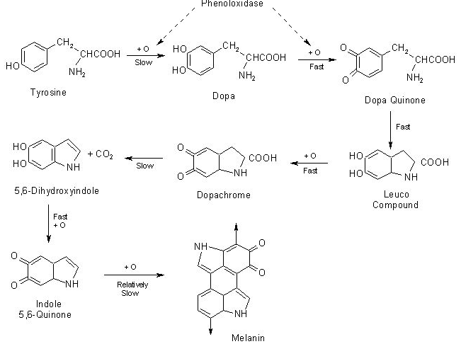

*Formation of melanins from tyrosine*

*(*[*www.food-info.net/ukcolour/enzymaticbrowning.htm#1*](http://www.food-info.net/ukcolour/enzymaticbrowning.htm#1)*)*

As browning in most fruits and vegetables is undesirable, there is tremendous interest in preventing it. Enzymatic browning can generally be prevented by employing the factors that either deactivate or inhibit enzyme activity. Enzymes are proteins and, hence, are sensitive to pH changes and to temperature changes. Some of the methods that are employed to prevent enzymatic browning in the food industry are:

* **Blanching**: Heating the plant to 70–100 °C as in blanching, will inactivate the enzyme and prevent browning. Sometimes the heat alters the texture of the food and blanching is not favored.
* **Refrigeration**: Refrigeration at 7 °C inhibits the enzyme but does not destroy it. Browning will still occur; it will just proceed at a slower rate. Freezing is like refrigeration in that the enzyme is not denatured but browning will not proceed when the food is frozen. When the food is brought to room temperature, enzymatic browning will proceed.
* **Changing the pH:** Enzymatic browning can be prevented by lowering the pH below 4 by adding citric or ascorbic acid. Lemon juice is a good source of these. Polyphenol oxidase has a narrow range in which it is most active. Outside this range the enzyme does not function well.
* **Dehydration:** Dehydrationremoves water which is necessary for PPO to function. The enzyme is inhibited but not destroyed. When the food is rehydrated, enzymatic browning will proceed.
* **Irradiation:** When food is submitted to ionizing radiation, such as gamma rays or X-rays, bacteria is killed and enzyme activity is reduced. Public acceptance of this method has not been high. Food that has been irradiated must be marked to inform the consumer.
* **Ultrafiltration**: This method removes large molecules like polyphenol oxidase, but not lower weight molecules like polyphenols. It is used on wines and fruit juices to preserve color and prevent enzymatic browning.
* **Supercritical CO2**: Treatment of food with supercritical carbon dioxide results in a lowering of the pH due to the formation of carbonic acid, H2CO3, which prevents enzyme function. This method is used for shrimp, lobsters, and potatoes.
* **Addition of Inhibitors**: Sometimes other substances can be added to the food to deter browning. These work by either inhibiting the enzyme, by removing the substrate such as oxygen or the phenolic compounds, or by changing the composition of the melanin product. Some of the most important inhibitors and their mode of action are listed in the table below.

**Table 2: Inhibitors of enzymatic browning**

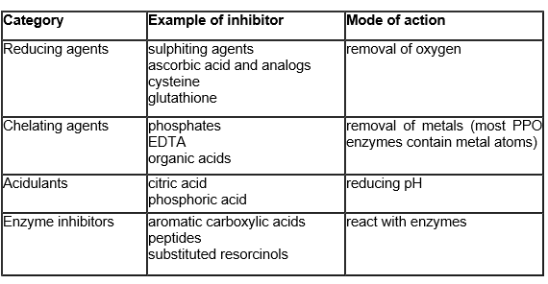

*(*[*www.food-info.net/ukcolour/enzymaticbrowning.htm#1*](http://www.food-info.net/ukcolour/enzymaticbrowning.htm#1)*)*

**Non-enzymatic browning**

Non-enzymatic browning in food can proceed along different pathways depending on the chemical composition of the food. If the food is sucrose, the reaction is caramelization. If the food contains reducing sugars such as glucose and also contains amino acids, the browning is a product of the Maillard reaction (see below).

**Caramelization** is the decomposition of carbohydrates such as sucrose into smaller molecules. In the case of sucrose, the products are fructose and glucose. These sugars further decompose into smaller molecules and fragments that can combine in a variety of different compounds that will give the final product a brown color and a different flavor.

Caramelization reactions are sensitive to the chemical environment. By controlling the level of acidity (pH) the reaction rate (or the temperature at which the reaction occurs readily) can be altered. The rate of caramelization is generally lowest at near-neutral acidity (pH around 7), and accelerated under both acidic (especially below 3) and basic (especially pH above 9) conditions.

(<https://en.wikipedia.org/wiki/caramelization>)

The flavor of the caramel can change depending on the combination of products that are formed in the cascade of reactions.

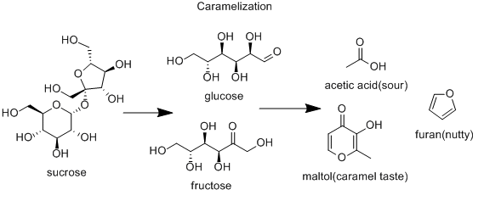

*(*[*https://bondingwithfood.files.wordpress.com/2012/02/chem2.gif*](https://bondingwithfood.files.wordpress.com/2012/02/chem2.gif)*)*

**The Maillard reaction**

The **Maillard reaction** is a chemical reaction between an amino acid and a reducing sugar, usually requiring the addition of heat. Like caramelization, it is a form of non-enzymatic browning. The reactive carbonyl group of the sugar interacts with the nucleophilic amino group of the amino acid, and interesting but poorly characterized odor and flavor molecules result. This process accelerates in an alkaline environment because the amino groups do not neutralize. This reaction is the basis of the flavoring industry, since the type of amino acid determines the resulting flavor.

(<http://www.scienceofcooking.com/maillard_reaction.htm>)

The Maillard reaction produces distinct flavors as a result of heating sugars within foods to high temperatures. Some of the foods (and the flavors) that you might recognize are: grilled steaks, deep-fried French fries, toasted toast, campfire-roasted marshmallows, roasts (meats roasted), caramelized onions, baked bread (browned crust), roasted coffee, and caramel candies, just to name a few. (Getting hungry yet?)

The Maillard reaction can be broken down into three main steps. First, the carbonyl group of the sugar reacts with the amino group of the amino acid, producing N-substituted glycosylamine and water. Second, the unstable glycosylamine undergoes Amadori rearrangement forming ketosamines. Third, the ketosamines react further in multiple ways that can produce water and reductones, diacetyl or pyruvaldehydes, or nitrogenous polymers and melanoidins which will give the brown color.

These steps can be viewed here: <http://compoundchem.com/wp-content/uploads/2015/01/The-Maillard-Reaction.pdf>.

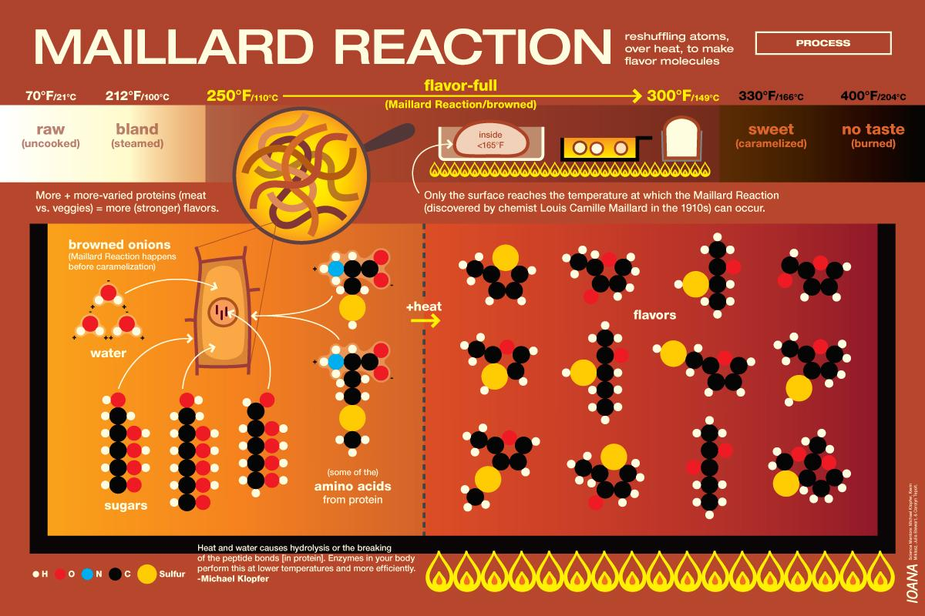

*A graphic depiction of the Maillard reaction*

*(*[*http://blog.ioanacolor.com/wp-content/uploads/2011/06/ioana_top-chef-masters_science_maillard-reaction.jpg*](http://blog.ioanacolor.com/wp-content/uploads/2011/06/ioana_top-chef-masters_science_maillard-reaction.jpg)*)*

An example where both caramelization and the Maillard reaction are employed in cooking is in the caramelization of carrots.

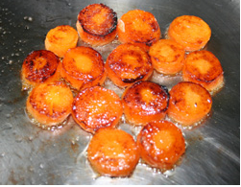

*Caramelization of carrots*

*(*[*http://www.scienceofcooking.com/caramelized_carrots.jpg*](http://www.scienceofcooking.com/caramelized_carrots.jpg)*)*

Carrots have a higher natural sugar content than all other vegetables with the exception of beets. In the photo above [at right] the high sugar content produced a highly caramelized surface. Carrots are high in glucose, fructose and sucrose (depending on the breed of carrot) which promote caramelization. In the case of carrots the reaction actually contains both caramelization products and Maillard reaction products since vegetables also contain amino acids along with reducing sugars.

(<http://www.scienceofcooking.com/caramelization.htm>)

**Rancidification reactions**

When fatty foods are stored for long periods of time, they undergo chemical changes that produce unpleasant odors or flavors associated with foods. We say have become rancid. There are two main causes of this—hydrolytic rancidity and oxidative rancidity.

Oxidative rancidity is caused by the reaction of the carbon-carbon double bonds in unsaturated fatty acids and triglycerides with molecular oxygen. Free radicals of the fatty acid molecule are formed as illustrated below:

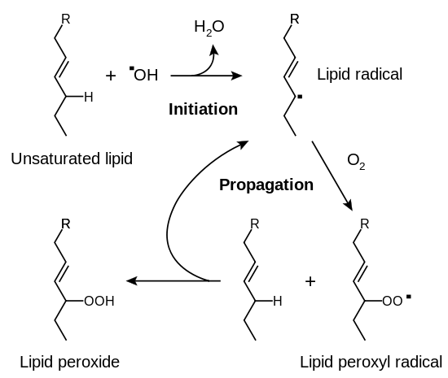

*(*[*https://en.wikipedia.org/wiki/Rancidification#/media/File:Lipid_peroxidation.svg*](https://en.wikipedia.org/wiki/Rancidification#/media/File:Lipid_peroxidation.svg)*)*

Unsaturated fats are more susceptible to oxidation than saturated fats because of the less stable double bonds. Fish oils are highly unsaturated and therefore more susceptible to oxidative rancidity and the foul odors and flavors that accompany it. Ground beef is less stable because it has been exposed to more oxygen in the grinding process. Vegetable fats, although unsaturated, are usually more stable than animal fats because they contain natural antioxidants such as Vitamin E. Metals such as copper, iron, manganese, and chromium increase the rate of fat oxidation. This is important to remember when selecting food storage containers.

Hydrolytic rancidity is caused by the hydrolysis of ester bonds in triglycerides to produce glycerol and three fatty acids (see reaction below). This reaction occurs when food is exposed to moisture or has high water content. The reaction is catalyzed by enzymes found naturally in plant oils (lipoxygenase) and animal fat (lipase). Microbial rancidity is this same process except that the microbes supply the enzymes to break down the chemical structure of the oil, producing the foul odors and flavors.

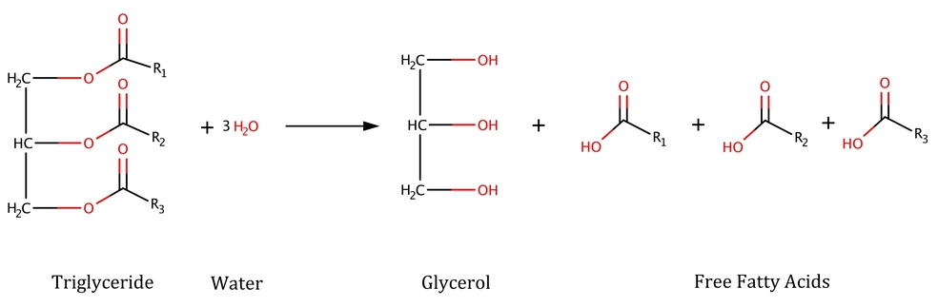

*Hydrolytic rancidification reaction of a triglyceride*

*(*[*http://nordicfoodlab.org/blog/2016/1/29/aged-butter-part-2-the-science-of-rancidity*](http://nordicfoodlab.org/blog/2016/1/29/aged-butter-part-2-the-science-of-rancidity)*)*

Factors that can speed up rancidity reactions are: increased temperatures, exposure to light, increased moisture, increased oxygen exposure, and catalysts such as trace metal ions and inorganic salts. Oxygen is eight times more soluble in fats than it is in water. Therefore, fatty foods should be stored in a cool dark place in nonmetallic containers covered to keep oxygen out. Commercially, antioxidants are added to prevent fats and oils from becoming rancid. Some of the most common antioxidant additives are BHA (butylated hydroxyanisole), BHT (butylated hydroxytoluene), propyl gallate, and tocopherols.

The products of rancidification reactions are not always safe to consume as noted in an article from *Natural Products Insider:* “Ingestion of rancid lipids has been linked to the development or exacerbation of many diseases, including atherosclerosis, cataracts, diarrhea, kidney disease and heart disease, and can cause cellular membrane damage, nausea, neurodegeneration and carcinogenesis.” (<http://www.naturalproductsinsider.com/articles/2009/08/understanding-rancidity-of-nutritional-lipids.aspx>)

# References

**(non-Web-based information sources)**

**The references below can be found on the   
*ChemMatters* 30-year DVD, which includes all articles   
published from the magazine’s inception in October 1983 through April 2013, all available Teacher’s Guides, beginning February 1990, and 12 *ChemMatters* videos. The DVD is available from the American Chemical Society for $42 (or $135 for a site/school license) at this site:** [**http://ww.acs.org/chemmatters**](http://www.acs.org/chemmatters)**. Click on the “Teacher’s Guide” tab directly under the *ChemMattersonline* logo and, on the new page, click on “Get the past 30 Years of *ChemMatters* on DVD!” (the icon on the right of the screen).**

**Selected articles and the complete set of   
Teacher’s Guides for all issues from the past three   
years are available free online at the same Web site, above. Click on the “Issues” tab just below the logo, *“ChemMattersonline”*.**

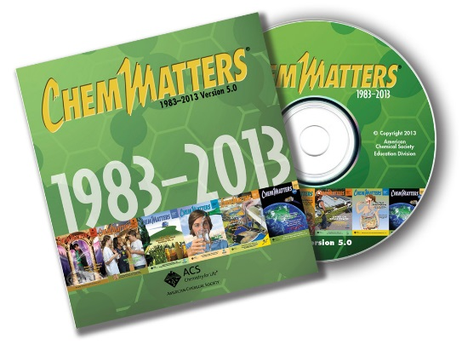

***30* Years of *ChemMatters !***

Available Now!

Tinnesand, M. The Big Reveal: What’s Behind Nutrition Labels? *ChemMatters,* 2012, *30* (4) pp 6–8. This article discusses nutrition labels on food and explains the different tests that are run to establish the values present on the labels. This might be used to tie into the testing of foods that needs to be done to determine how the nutrient value of the food changes with time.

Husband, T. Two Is Better Than One. *ChemMatters,* 2012, *30* (4), pp 9–11. This article specifically addresses the Maillard reaction in non-enzymatic browning. It would make a nice supplement to the article if food chemistry is discussed.

Warmflash, D. Double, Double Oil and Trouble. *ChemMatters,* 2015, *33* (4), pp 16–17. This article is about fats in the diet. Saturated and unsaturated fats are discussed. This could be used to enhance the discussion of the rancidification reaction mentioned in the Wetterschneider date labels article.

Porterfield, A. Antioxidants Go the Extra Mile. *ChemMatters,* 2016, *34* (2), pp 14–15. The article contains extra information on flavonoids and some other polyphenol compounds in foods. Oxidation and reduction reactions are covered more in depth

The April 2016 Teacher’s Guide that accompanies the Porterfield article above provides considerable chemistry background material about polyphenolic compounds and oxidation. There is a Vitamin C lab that could be used here also.

____________________

McGee, H. *The Curious Cook;* North Point Press: San Francisco, 1990; pp 56–73. In chapter 8, titled *The Green and the Brown,* Harold McGee discusses enzymatic browning. He relays his quest for the perfect green color in salads, guacamole, and pesto. He approaches the problem with the tools of a scientist using all the parts of the scientific method that students are taught. His experiments could be used for inquiry in the classroom. This book is out of print but if you can find a copy of it, it is an excellent resource for explaining the chemistry of food.

# Web Sites for Additional Information

**(Web-based information sources)**

**Expiration date labels**

This site contains more information on date labels, as well as time lines for how long specific foods should be kept after they are purchased. It also contains food safety tips.

([www.webmd.com/a-to-z-guides/features/do-food-expiration-dates-matter](http://www.webmd.com/a-to-z-guides/features/do-food-expiration-dates-matter))

This site also contains more information on date labels, as well as lists for how long certain foods can be kept after they are purchased, if students want to look up specific food items. ([www.fsis.usda.gov/wps/portal/fsis/topics/food-safety-education/get-answers/food-safety-fact-sheets/food-labeling/food-product-dating/](http://www.fsis.usda.gov/wps/portal/fsis/topics/food-safety-education/get-answers/food-safety-fact-sheets/food-labeling/food-product-dating/))

This is a short article concerning food labels and how they can be interpreted. It underscores the need for the general population to understand the meaning of the labels so they do not dispose of food that is still safe to eat. ([www.consumerreports.org/cro/magazine/2015/10/is-expired-food-safe-to-eat/index.htm](http://www.consumerreports.org/cro/magazine/2015/10/is-expired-food-safe-to-eat/index.htm))

**Food safety**

This site can be used for finding additional information about the most recent food recalls, the Foodkeeper App, safety guidelines, and food poisoning information: [www.FoodSafety.gov](http://www.foodsafety.gov).

This is an index to several articles that cover food safety. It would be a good site to give students who have additional questions about the foods they eat. (<http://www.consumerreports.org/cro/health/food-safety-and-sustainability-guide/index.htm>)

Education materials including an activity book on safe food handling and a crossword puzzle as a recap activity can be found here. They are geared to middle school or upper elementary but may be able to be adapted. Facts sheets and additional information on food product dating can also be found on this site. (<http://www.fsis.usda.gov/wps/portal/fsis/topics/food-safety-education>)

This site is good for infographics about food safety that you can print off and display in your room: <https://www.cdc.gov/vitalsigns/FoodSafety/infographic.html>.

**Food safety and the “five-second rule”**

The report of the research concerning the reality of the “five-second rule”, as conducted by food scientists at Rutgers University, can be found in its entirety in this article accepted by *Applied and Environmental Microbiology* in September 2016 for publication. This would be good for students to read and note the experimental design and to learn how research is reported. (<http://aem.asm.org/content/early/2016/08/15/AEM.0183816.full.pdf+html?ijkey=FLERGaGuAW0EM&keytype=ref&siteid=asmjournals>)

A short article about the Rutgers research and its findings is reported in the September 12, 2016 issue of *Food Safety Magazine*. The link to this article is [www.foodsafetymagazine.com/news/the-5-second-rule-is-bogus-say-rutgers-researchers](http://www.foodsafetymagazine.com/news/the-5-second-rule-is-bogus-say-rutgers-researchers).

**Food poisoning**

“The Burger that Shattered Her Life”, an article from a 2009 issue of *The New York Times*, is a gripping, real life example of the devastating effects of food poisoning. A young dance instructor was sickened with a virulent strain of *E.coli* that was eventually traced to a package of hamburger patties purchased at Sam’s Club. The young girl suffered seizures and was left a paraplegic after her battle with food poisoning. This story could be used as a hook to get students to respect safe food handling procedures.

(<http://www.nytimes.com/2009/10/04/health/04meat.html?pagewanted=1&_r=1>)

*The Bad Bug Book* is a handbook of bacteria and other organisms that cause foodborne illness. A different organism is featured in each chapter. It would be a good resource for that student who wanted to learn more about the organisms that cause food poisoning. ([www.fda.gov/downloads/Food/FoodborneillnessContaminants/UCM297627.pdf](http://www.fda.gov/downloads/Food/FoodborneillnessContaminants/UCM297627.pdf))

This is site especially for teens where students can find out everything they may want to know about food poisoning. You can also select Spanish text if you have a high population of English Language Learners in your class.

([www.kidshealth.org/en/teens/food-poisoning.html?WT.ac=t-ra](http://www.kidshealth.org/en/teens/food-poisoning.html?WT.ac=t-ra))

**Food waste**

**Food waste and labels**

This would be a good site to visit for best storage practices of specific foods. Students who wanted to check on how to store their favorite food would find it by using the site’s search function. ([www.stilltasty.com](http://www.stilltasty.com))

If you would like to read the full NRDC report on dating labels and food waste, it can be found here: <https://nrdc.org/sites/default/files/dating-game-report.pdf>. A short synopsis of the report can be found here: <https://www.nrdc.org/resources/dating-game-how-confusing-food-date-labels-lead-food-waste-america>.

This is the NRDC home site for food waste issues. It is a good place to find out all that the NRDC is doing concerning this issue. There are also links to other sites with information on this issue. (<https://nrdc.org/issues/food-waste>)

**Food waste reduction**

This site provides statistics on the amount of food that is wasted each year. It is also the site of the public service video titled, “Life of Strawberry”. ([www**.**SaveTheFood.com](http://www.savethefood.com)**)**

A *U.S. Today* article about a small town in Japan that has established the goal of zero waste by 2020 can be found at this site. By contrast, the U.S. goal is to reduce waste by 50% by 2030. Students can read how this Japanese town is reaching their goal. (<http://www.usatoday.com/story/news/world/2016/06/24/shikoku-town-basks-limelight-moves-toward-zero-waste-target/86174300/>)

If you would like your students to read more about food waste from a news source, this would be a good article to assign. It is about the amount of foods Americans throw out each year. (<https://www.washingtonpost.com/news/wonk/wp/2014/09/23/americans-throw-out-more-food-than-plastic-paper-metal-or-glass/>)

**Food waste and labeling legislation**

This is a May 2016 press release from the NRDC that updates the status of food waste legislation: <https://www.nrdc.org/media/2016/160518>.

A summary of the Food Recovery Act that is currently (fall 2016) in congress can be found here: <https://pingree.house.gov/foodwaste/billsummary>.

**Enzymatic and non-enzymatic browning**

More information on enzymatic browning can be found here:

[ww.food-info.net/uk/colour/enzymaticbrowning.htm](http://www.food-info.net/uk/colour/enzymaticbrowning.htm).

Harold McGee, author and chemist, explains his recent experiments with caramelizing sugar in this article. His experiments could be adapted for an interesting classroom project or lab. Recent research shows sugar does not have to melt before it caramelizes. (<http://www.curiouscook.com/site/2012/09/caramelization-new-science-new-possibilities.html>)

This site contains considerable information on caramelization with a link to another non-enzymatic browning reaction, the Maillard reaction.

(<https://en.wikipedia.org/wiki/caramelization>)

The history behind the Maillard reaction, as well as its explanation, can be found at this site: [www.scienceofcooking.com/maillard_reaction.htm](http://www.scienceofcooking.com/maillard_reaction.htm).

This slide show describes in depth the various reactions that occur when foods are changed by the Maillard reaction: <http://www.slideserve.com/barbra/flavor-compounds-formation-by-maillard-reaction>.

**Rancidification**

This sitecontains information that compares oxidative and hydrolytic rancidity and the storage requirements for fats to prevent these reactions from occurring. (<http://www.gcca.org/wp-content/uploads/2012/09/RancidityAntioxidants.pdf>)

The science of oxidation in fats and the safety of eating the newly oxidized products is presented in this blog post by a food scientist at Nordic Food Lab. The reactions involved in rancidification are thoroughly explained and outlined. The project the scientist is working on concerns whether the rancidification reaction can be used to produce rancid butter with a desirable flavor so that it can be used as a new product.

(<http://nordicfoodlab.org/blog/2016/1/29/aged-butter-part-2-the-science-of-rancidity>)