

**October/November 2016 Teacher's Guide**

**Background Information**

**for**

***Guilty or Innocent? Fingerprints Tell the Story***

**Table of Contents**

About the Guide 2

Background Information 3

References 20

Web Sites for Additional Information 22

# About the Guide

Teacher’s Guide team leader William Bleam and editors Pamela Diaz, Regis Goode, Diane Krone, Steve Long and Barbara Sitzman created the Teacher’s Guide article material.   
E-mail: [bbleam@verizon.net](mailto:bbleam@verizon.net)

Susan Cooper prepared the anticipation and reading guides.

Patrice Pages, *ChemMatters* editor, coordinated production and prepared the Microsoft Word and PDF versions of the Teacher’s Guide.

E-mail: [chemmatters@acs.org](mailto:chemmatters@acs.org)

Articles from past issues of *ChemMatters* and related Teacher’s Guides can be accessed from a DVD that is available from the American Chemical Society for $42. The DVD contains the entire 30-year publication of *ChemMatters* issues, from February 1983 to April 2013, along with all the related Teacher’s Guides since they were first created with the February 1990 issue of *ChemMatters*.

The DVD also includes Article, Title, and Keyword Indexes that cover all issues from February 1983 to April 2013. A search function (similar to a Google search of keywords) is also available on the DVD.

The *ChemMatters* DVD can be purchased by calling 1-800-227-5558. Purchase information can also be found online at <http://tinyurl.com/o37s9x2>.

# Background Information

**(teacher information)**

**The history of fingerprinting**

Dermatoglyphics (coming from [ancient Greek](https://en.wikipedia.org/wiki/Ancient_Greek), *derma* = skin, [*glyph*](https://en.wikipedia.org/wiki/Glyph) = carving) is the scientific study of [fingerprints](https://en.wikipedia.org/wiki/Fingerprint). Dactylography (coming from Greek, *dactyl* = finger or toe, *graphy* = drawing or representing) is a term used for the study of fingerprints to identify people. Fingerprints (friction ridge skin impressions) were used to identify individuals in China as early as 300 B.C., in Japan as early as A.D. 702, and in the United States since 1902. Friction ridge skin was first described in the Western Hemisphere in detail by Dr. Nehemiah Grew in 1684. It wasn't until 1788 that J. C. A. Mayer, a German doctor and anatomist, wrote that friction ridge skin is unique to each individual. In 1823, Dr. Johannes E. Purkinje, a German professor, classified fingerprint patterns into nine categories and gave each a name, and those names are still used today. In 1911, Joseph Faurot, a New York Police Department fingerprint expert presented testimony in Charles Crispi’s burglary trial. Faurot's use of a fingerprinting demonstration and crime evidence were so impressive that Crispi changed his own plea to guilty. *People v Crispi* (1911) is likely the first conviction using only fingerprint evidence in the United States. (<https://www.ncjrs.gov/pdffiles1/nij/225321.pdf>)

**How fingerprints are formed**

The process of fingerprint formation in infant development is complex. It is a combination of both genetics, involving multiple genes, and environmental factors. Fingerprints are formed in the fetus between the third and sixth months of development. Genetic factors likely influence the size, shape, and spacing of the friction ridge skin. However, environmental influences such as fetal thumb sucking, contact with the womb surface, and the density of the mother's amniotic fluid also contribute. (<https://ghr.nlm.nih.gov/primer/traits/fingerprints>) It is generally accepted that no two individuals (even twins) have identical fingerprints due to the environmental variations.

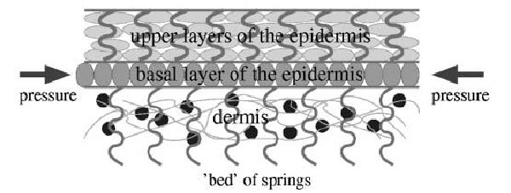Michael Kücken and Alan Newell of the University of Arizona found that creation of the [fingerprint] patterns involves stresses in a sandwiched sheet of skin called the basal layer. In a fetus, the basal layer grows faster than the surrounding layers – the epidermis on the outside and the inner dermis. The basal layer buckles and folds in several directions, forcing complex shapes.

*Layers of the skin responsible for fingerprint formation*

*(*[*http://www.livescience.com/30-lasting-impression-fingerprints-created.html*](http://www.livescience.com/30-lasting-impression-fingerprints-created.html)*)*

Stresses are created at skin boundaries, including fingernails and knuckle creases, as well as around shrinking fingertip pads.

(<http://www.livescience.com/30-lasting-impression-fingerprints-created.html>)

To read Kücken's and Newel's complete 2005 journal article, you can access it online at: (<http://math.arizona.edu/~anewell/publications/Fingerprint_Formation.pdf>). The scholarly article uses equations to mathematically study the buckling patterns. This article includes an introduction into fingerprints, biological background, theories of ridge formation and topographical issues, the mathematical model with some analysis, computer simulations, and results with conclusions. Numerous pictures, figures, and diagrams enrich the article.

**Altering or losing fingerprints**

While fingerprints are genetically and environmentally influenced, they *can* be altered. Abrasion, acids, bleach or chemotherapy treatments may temporarily remove or alter a person's fingerprints, but they will grow back (genetics) the same as before. People have tried to burn off, sand off, and even bite off their fingerprints, but they grow back

(<http://www.scientificamerican.com/article/lose-your-fingerprints/>).

Certainly injuries, scars, and other trauma can alter a person's fingerprints, but these factors then become a distinguishing characteristic of the fingerprints. Some criminal cases where individuals attempted to alter their fingerprints include: John Dillinger (discussed in the article) mutilating his fingertips with acid, Gus Winkler changing his pattern type from a double loop to a left whorl, Robert J. Phillips transplanting skin from his chest onto his fingerprints, Marc George implanting skin from the sole of his foot to his fingertips, and Gerald Perez obliterating his fingertips with heavy stitches.

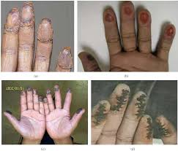

*Photographs of altered fingerprints: (a) Transplanted fingerprints from feet, (b) bitten fingers, (c) fingers burned by acid, and (d) stitched fingers.*

*(*[*https://encrypted-tbn3.gstatic.com/images?q=tbn:ANd9GcTHxcVacz9o89K3P76Ktisn-_TOvrkqT2ew1mRCtmY1QPrMbJIe*](https://encrypted-tbn3.gstatic.com/images?q=tbn:ANd9GcTHxcVacz9o89K3P76Ktisn-_TOvrkqT2ew1mRCtmY1QPrMbJIe)*)*

Noncriminal cases of fingerprint alteration include a woman using a laser to alter her fingerprints, swapping the friction ridge skin of the thumbs and index fingers between left and right hands, a variety of surgeries to remove or alter the fingerprints. (<http://www.cse.msu.edu/rgroups/biometrics/Publications/Fingerprint/YoonFengJain_AlteredFP_AnalysisDetection_PAMI11.pdf>)

A very rare genetic condition, adermatoglyphia, causes some people to be born without fingerprints. The condition is so rare that it has only been found in a few families worldwide.

(<http://www.ncbi.nlm.nih.gov/pmc/articles/PMC3155166/>).

*Fingers of patient with adermatoglyphia,   
a natural lack of fingerprints*

*(*[*http://news.nationalgeographic.com/content/dam/news/photos/000/386/38624.adapt.590.1.jpg*](http://news.nationalgeographic.com/content/dam/news/photos/000/386/38624.adapt.590.1.jpg)*)*

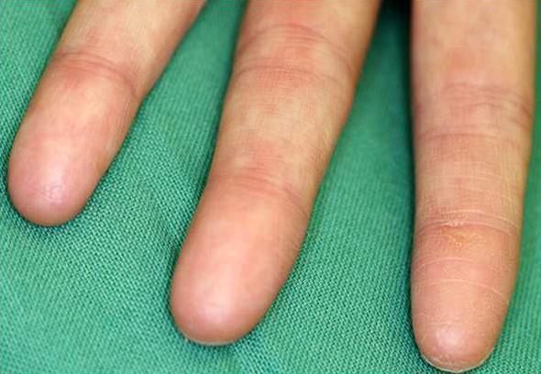

This genetic disease has been dubbed the "immigration delay disease" because in 2007 a Swiss woman was trying to travel to the U. S. Regulations require that all non-residents of the U.S. be fingerprinted upon entering the country, and she could not enter because she didn't have any fingerprints

(<http://www.sciencemag.org/news/2011/08/mystery-missing-fingerprints>).

The condition is caused by a mutation related to the SMARCAD1 gene. It is an autosomal dominant inheritance pattern which requires an individual to inherit only one allele to exhibit the disease. Additional information with resources and more references on adermatoglyphia can be found at <https://ghr.nlm.nih.gov/condition/adermatoglyphia>.

**Fingerprints, identification, and the law**

People typically are curious about the legalities of obtaining and using a person's fingerprints. There are also concerns regarding the problems associated with the use of fingerprints in legal cases. For high school age students, state regulations govern the ages of and conditions under which juveniles may be fingerprinted.

The authorization to fingerprint, however, does not usually apply to all arrested juveniles. For example, New York allows youth to be fingerprinted as young as age 11. More common age thresholds, according to the NIJ [National Institute of Justice] document, begin at 14 in other States. As of 1995, 48 States authorized law enforcement agencies to fingerprint arrested juveniles.

The types of crimes for which fingerprinting of juveniles is allowed vary by State but most often include serious offenses and felonies.

(<http://www.ojjdp.gov/pubs/reform/ch2_i.html#jr>)

The legalities of using fingerprints (or other impressions) as legal evidence is thoroughly discussed in “Fingerprints and the Law” (<https://www.ncjrs.gov/pdffiles1/nij/225333.pdf>), a chapter from *The Fingerprint Sourcebook* (described in the “Web Sites for Additional Information” section below). This chapter explains the Federal Rules of Evidence (FRE) as they pertain to fingerprinting, provides examples and details of the various court cases involving fingerprinting, and details nuances that affect the use of fingerprint evidence in court. Also included are explanations of the Federal Rules of Criminal Procedure interpreted specifically for fingerprinting. Legal challenges to fingerprinting and an historical account of fingerprints in U.S. courts round out the chapter.

Fingerprints are widely used in situations other than court cases. Many people today use their fingerprints as identification to securely protect their smartphones. It is also possible to use fingerprints to allow only the owner of a firearm (or another authorized fingerprinted user) to fire that weapon (<http://www.cnn.com/2014/03/26/tech/innovation/smart-guns-know-whos-firing/>).

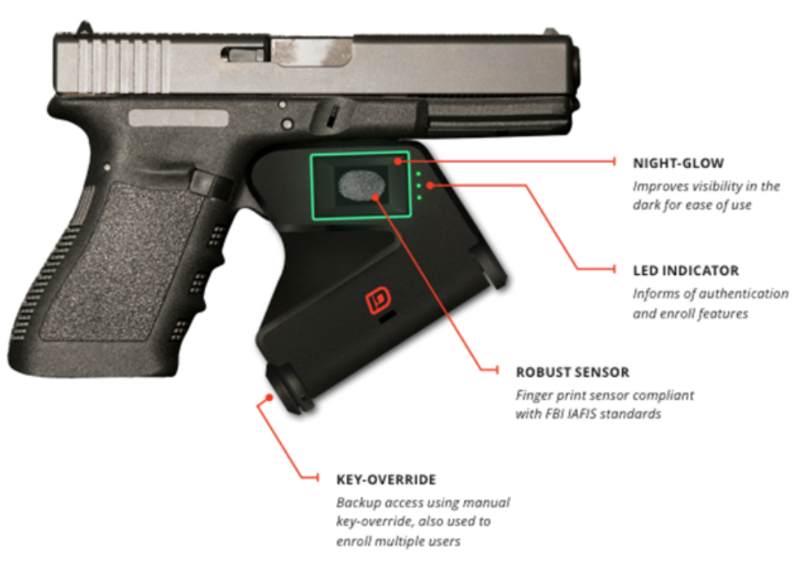

*Security features on a handgun, using fingerprint identification*

*(*[*http://www.richardbanks.com/trends/wp-content/uploads/2014/03/image82.png*](http://www.richardbanks.com/trends/wp-content/uploads/2014/03/image82.png)*)*

Gun safes can also be purchased which use fingerprint security to prevent children or unauthorized individuals from acquiring the weapon.

More mundane occurrences of fingerprint use include applying for some jobs. Teachers are often fingerprinted as a condition of their employment, and their fingerprints are checked against child offender or sex abuser registries. Applicants for most governmental jobs and military service positions are required to have their fingerprints taken and stored. People applying for U.S. citizenship and green card applicants (lawful permanent residents) are required to submit biometric data including fingerprints for individuals between ages 14 and 79. Some states use fingerprints to verify the individuals who receive social services and aid, thereby reducing fraud and waste of government funds. (<http://www.cdss.ca.gov/cdssweb/entres/forms/English/pub337.pdf>) Many organizations that work closely with children, youth, or vulnerable adults—including churches, schools, daycare centers, and nursing homes—require both workers and volunteers to submit fingerprints to allow the organizations to verify their background histories.

**Problems associated with fingerprints as evidence**

While highly reliable, fingerprint analyses are subject to numerous variables that determine the quality of the fingerprint evidence. The National Academies of Science (NAS) concluded in a 2009 report that no peer-reviewed scientific studies have been done to prove the belief that fingerprints are unique to a specific individual (http://www.nap.edu/catalog/12589/strengthening-forensic-science-in-the-united-states-a-path-forward. The NAS report also states that contextual bias plays a role in analyses made by experts. Indeed, other biometric or biological forensic evidence types have their issues, but DNA analysis has the highest validity.

One example of a highly-publicized case of mistaken fingerprint identity was that of Brandon Mayfield. (Also see "Misidentified fingerprint cases", below.)

Most famously, Brandon Mayfield, an Oregon lawyer, spent two weeks in jail in 2004 because three FBI experts matched his prints with those found on a plastic bag that was evidence in the investigation of the Madrid train bombings. Spanish authorities continued to try to match the prints after the FBI arrested Mayfield and eventually linked them to an Algerian man. Since defendants rarely challenge the accuracy of fingerprint evidence, there could be many more undiscovered mistakes. Regardless of the exact number, it is clear that innocent people have been jailed because of fingerprint identifications that were wrong.

(<http://www.bu.edu/sjmag/scimag2005/opinion/fingerprints.htm>)

In addition, the techniques used in finding, obtaining, and analyzing the latent fingerprints are not uniform, resulting in validity problems. Some countries require as many as 30 points of similarity between the fingerprint evidence and the individual's fingerprint; the United States has no uniform requirements for points of similarity.

Examiners link a partial print from a crime scene to a whole one taken from a suspect by matching particular characteristics of the fingerprint. They compare the overall print pattern and other ridge characteristics, including width of the ridges and the spacing of oil pores, according to Ed German, a fingerprint examiner with the U.S. Army. But examiners primarily rely on matching points on both prints where ridges end, bifurcate, or change direction. Examiners conclude a crime scene print came from a suspect after matching between three and sixteen points (FBI examiners found 15 points on Mayfield’s print). But there are no standards on the number of points that must be matched. Instead each lab, and sometimes each examiner, determines the number needed.

(<http://www.bu.edu/sjmag/scimag2005/opinion/fingerprints.htm>)

Factors influencing the quality of the fingerprint evidence include: the size of the print (complete or fragment), the surface from which it was obtained, whether contaminated or distorted, the age of the fingerprint, the reliability and experience of the expert analyst, how the print was preserved, and the chain of evidence. Rarely in the past was fingerprint evidence questioned in courts of law; however, this may be changing, partially based upon the NAS report. The error rate that experienced fingerprint analysts make is uncertain, but it certainly cannot be zero. Errors can be the result of using only a partial print (sometimes only 20%, and that may be smudged), bias, and peer pressure.

One known flaw in fingerprinting is that examiners may taint the identification process through bias and peer pressure. A panel of outside print examiners convened by the FBI to review the Mayfield case found that a supervisor made the initial identification and lower-ranking examiners, when asked to confirm or reject their boss’ work, felt pressured to confirm. …

The handful of studies of fingerprints show a troubling pattern of errors. Since 1995, Collaborative Testing Services, a company that evaluates the reliability and performance of fingerprint labs, has administered an annual and voluntary test. It sends fingerprint labs a test that includes eight to twelve pairs of prints that examiners confirm or reject as matches. The pairs usually consist of complete, not partial prints, making identifications easier than the real situations examiners face. Nevertheless the error rate has varied from 3% to a dismal 20%.

(<http://www.bu.edu/sjmag/scimag2005/opinion/fingerprints.htm>)

And it isn’t only the opinion of the source above, as this quote from the article “Fingerprints: Not a Gold Standard” in the Fall 2003 volume of *Issues in Science and Technology* shows:

Although some FBI proficiency tests show examiners making few or no errors, these tests have been criticized, even by other fingerprint examiners, as unrealistically easy. Other proficiency tests show more disturbing results: In one 1995 test, 34 percent of test-takers made an erroneous identification. Especially when an examiner evaluates a partial latent print—a print that may be smudged, distorted, and incomplete—it is impossible on the basis of our current knowledge to have any real idea of how likely she is to make an honest mistake. The real-world error rate might be low or might be high; we just don’t know.

(<http://issues.org/20-1/mnookin/>)

Given the conundrum of whether, or how, to use fingerprint evidence (in the same source, directly above), Jennifer Mnookin, a respected law professor at the University of Virginia School of Law, asks and answers, "Given fingerprinting’s weaknesses, what should be done? Clearly, more research is necessary. There should be serious efforts to test and validate fingerprinting methodologies and to develop difficult and meaningful proficiency tests for practitioners."

**Latent fingerprint techniques**

Determining which type of surface (porous or nonporous) is expected to bear a fingerprint is important in determining the technique that will be used to visualize the print. It is imperative to use a suitable technique, proper reagents (and in the correct sequential order) to obtain the best evidence. Porous surfaces (paper, wood, and other cellulose-based materials) permit the substances in the fingerprints to absorb into the material. These surfaces may require the use of amino acid techniques (see the discussion of ninhydrin below). Nonporous surfaces (glass, metal, plastic, and painted wood) do not absorb the prints; therefore, the prints are more likely to be damaged because they are on just the surface. These latent prints typically use powders, stains, and cyanoacrylate.

A common type of fingerprinting powder is black in color and contains a mixture of rosin, ferric oxide, and carbon (lampblack). Most fingerprinting powders are composed of a pigment and a binder. The pigment makes the print visible, and the binder assists the pigment in adhering to the print.

Carbon, or lampblack, (colloidal carbon) is one of the oldest pigments and is still widely used. Lampblack is a form of carbon that is different than common soot because of lampblack's much greater surface area and low multi-ring hydrocarbon content. It is this great surface area/volume ratio that allows the nonpolar lampblack to chemically bind so effectively to the nonpolar components of the fingerprints. Besides fingerprinting powders, lampblack is widely used in plastics, automotive tires, and paints.

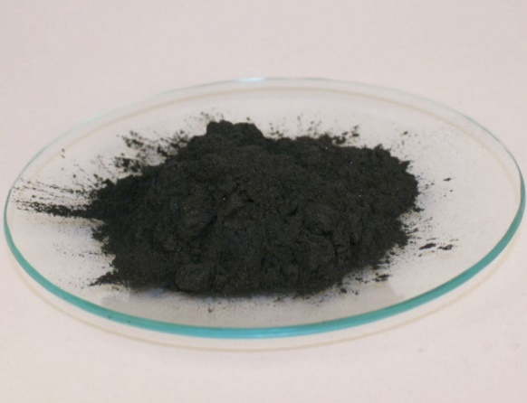

*Lampblack*

*(*[*http://www.skylighter.com/images/web_pictures/Lampblack.jpg*](http://www.skylighter.com/images/web_pictures/Lampblack.jpg)*)*

In addition to the lampblack in the fingerprinting powder described above, the rosin serves as the binder, and ferric oxide (a dark reddish-brown) is an additional pigment. Dusting this mixture on the latent fingerprint allows the pigments and binder to adhere to the oils and moisture in the fingerprint, making them visible.

(<http://www.scientificamerican.com/article/how-does-fingerprint-powd/>)

Sometimes a white powder (titanium dioxide) will be used on glass or dark colored surfaces to form a better image with greater contrast. A gray (aluminum) powder can be used on glass, plastic or rubber surfaces. Both of these lighter colored materials provide higher contrast and better fingerprint images when used on dark substrates.

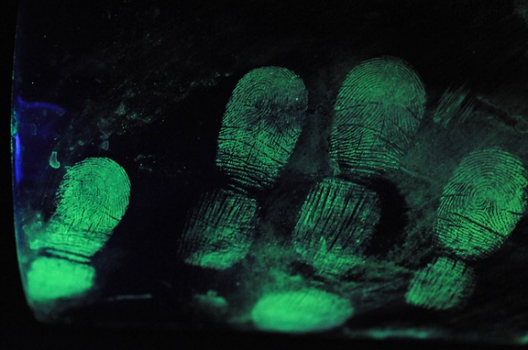

*Fingerprints dusted with fluorescent powder, under UV light*

*(*[*https://jscimedcentral.files.wordpress.com/2013/07/30.jpg*](https://jscimedcentral.files.wordpress.com/2013/07/30.jpg)*)*

There are other types of fingerprinting powders that may be used for special circumstances. Fluorescent powders are used in conjunction with a black light (UV) or laser to allow the fingerprints to glow and enhance their visibility. The benefit of fluorescent powders is their ability to distinguish the print from its surface, like a convenience store counter.

Magnetic powders may have colors associated with the metallic powder. This powder can be applied with a magnet so there is minimal abrasion of the delicate latent fingerprint or of delicate surfaces.

Another type of powder, called magnetic or magna powder, allows for application with a magnetized rod that has no bristles. This type of powder can be light, dark, or fluorescent and utilizes the ferromagnetic properties of iron powder mixed with pigment powders. The magnetized applicator (magna brush) is dipped into the powder, picking up a ball of the iron and particle mixture, essentially forming its own brush.



*Applicator for   
magnetic powder*

*(*[*https://www.ncjrs.gov/pdffiles1/nij/225327.pdf*](https://www.ncjrs.gov/pdffiles1/nij/225327.pdf)*)*

It is important to note that the magnetic powder ball formed with a magna brush is much softer than conventional filament brushes and typically causes less damage to fragile latent prints.

(<https://www.ncjrs.gov/pdffiles1/nij/225327.pdf>)

Fingerprints are composed primarily of water (~98%) but also contain small traces of amino acids. On porous surfaces, the water will evaporate, but the amino acids (and other solids) in the fingerprint will be captured and will not migrate. Ninhydrin is a chemical that was first described circa 1910 and was observed to turn purple when it reacts with the amino acids in

skin. However, it was not used in forensic sciences with fingerprints unit about 1954. Today, it is a popular technique for working with cellulose-based surfaces (e.g., paper, cardboard, and wood) and developing latent fingerprints on them. Ninhydrin techniques are not as useful on colored surfaces or with fingerprints that are older.

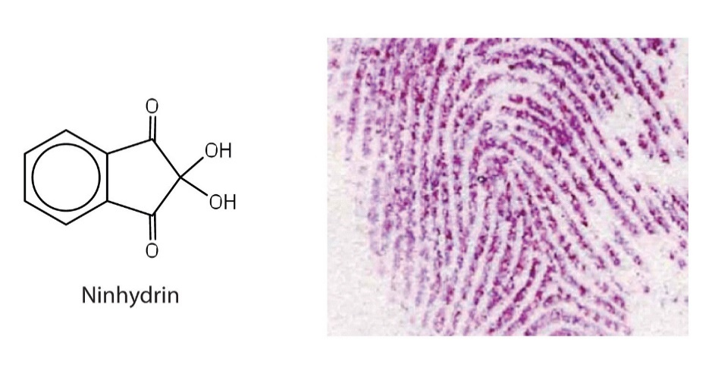

*Latent finger print, developed with ninhydrin (structure at left)*

*(*[*http://2012books.lardbucket.org/books/introduction-to-chemistry-general-organic-and-biological/section_21/2563dcc3db90b5aaef85fd6e82bf7e36.jpg*](http://2012books.lardbucket.org/books/introduction-to-chemistry-general-organic-and-biological/section_21/2563dcc3db90b5aaef85fd6e82bf7e36.jpg)*)*

The amino acids in a fingerprint can be used to determine the gender of the individual leaving the print. This determination is based on research that indicates that females have about double the number of amino acids in their sweat than males.

([http://cen.acs.org/articles/93/web/2015/11/Amino-Acids-Help-Determine-Sex.html](http://cen.acs.org/articles/93/web/2015/11/Amino-Acids-Help-Determine-Sex.html%20))

Note that this link provides a brief

abstract only; the full article is only available to American Chemical Society members.

Regardless of the powder or technique used, when the fingerprint is visualized, it must still be preserved. There are two common processes for preserving the visualized fingerprints. The easiest and most commonly used method is to lift the visible print from the surface. A high-quality, clear adhesive tape is simply placed over the fingerprint, rubbed to make good contact and remove air bubbles, pulled off of the surface, and placed on a card with a contrasting color for best visibility. The lifted fingerprint taped on the card can then be photographed for digital storage, if desired. The other method is to photograph the visible fingerprint *in situ*. If only photography is used, then the choice of fingerprint powder and suitable lighting to provide maximum contrast becomes extremely important. (<https://www.ncjrs.gov/pdffiles1/nij/225327.pdf>)

**Fingerprint patterns**

Fingerprints can be classified by the type of patterns they exhibit. The simplest classification of fingerprints uses three patterns called arches, loops, and whorls. Arch patterns comprise only 5% of all fingerprint patterns. Loops are the most common and are found in 60–70% of fingerprints. Whorls comprise 20–25% of the fingerprints.

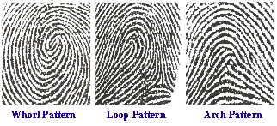

*Examples of the three main fingerprint patterns*

*(*[*https://behindthecrime.files.wordpress.com/2009/05/loop-pattern.gif*](https://behindthecrime.files.wordpress.com/2009/05/loop-pattern.gif)*)*

Of course, there are multiple variations on these three basic patterns. These variations are crucial in differentiating the fingerprints of people from one another. See the graphic and descriptions of some types of variations below.

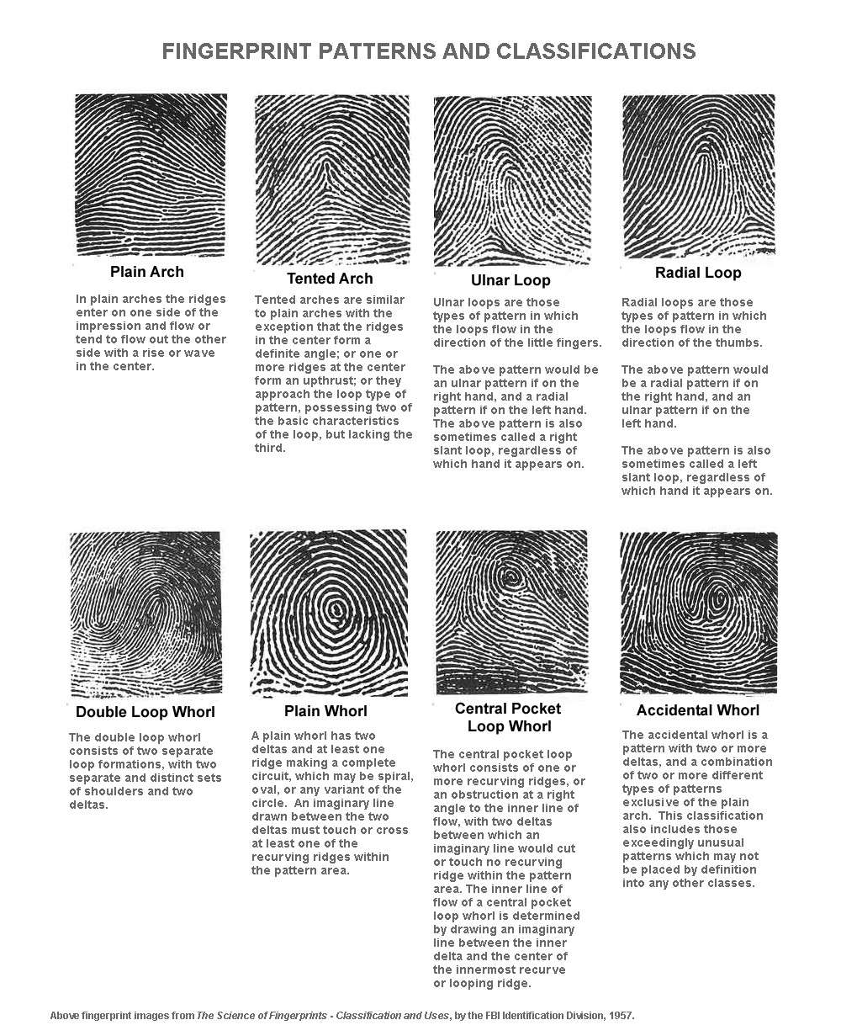

*(*[*http://onin.com/fp/fmiru/fppatterns.gif*](http://onin.com/fp/fmiru/fppatterns.gif)*)*

Even beyond these expanded pattern types, there are fine details called minutiae that allow expert analysts to distinguish among similar appearing fingerprints. These minutiae are the final discrimination factor that fingerprint analysts use to make positive identification. The image below shows three levels of details that fingerprint analysts can use in making identifications. In this image, the minutiae are the enlarged Level 2 and 3 Features.

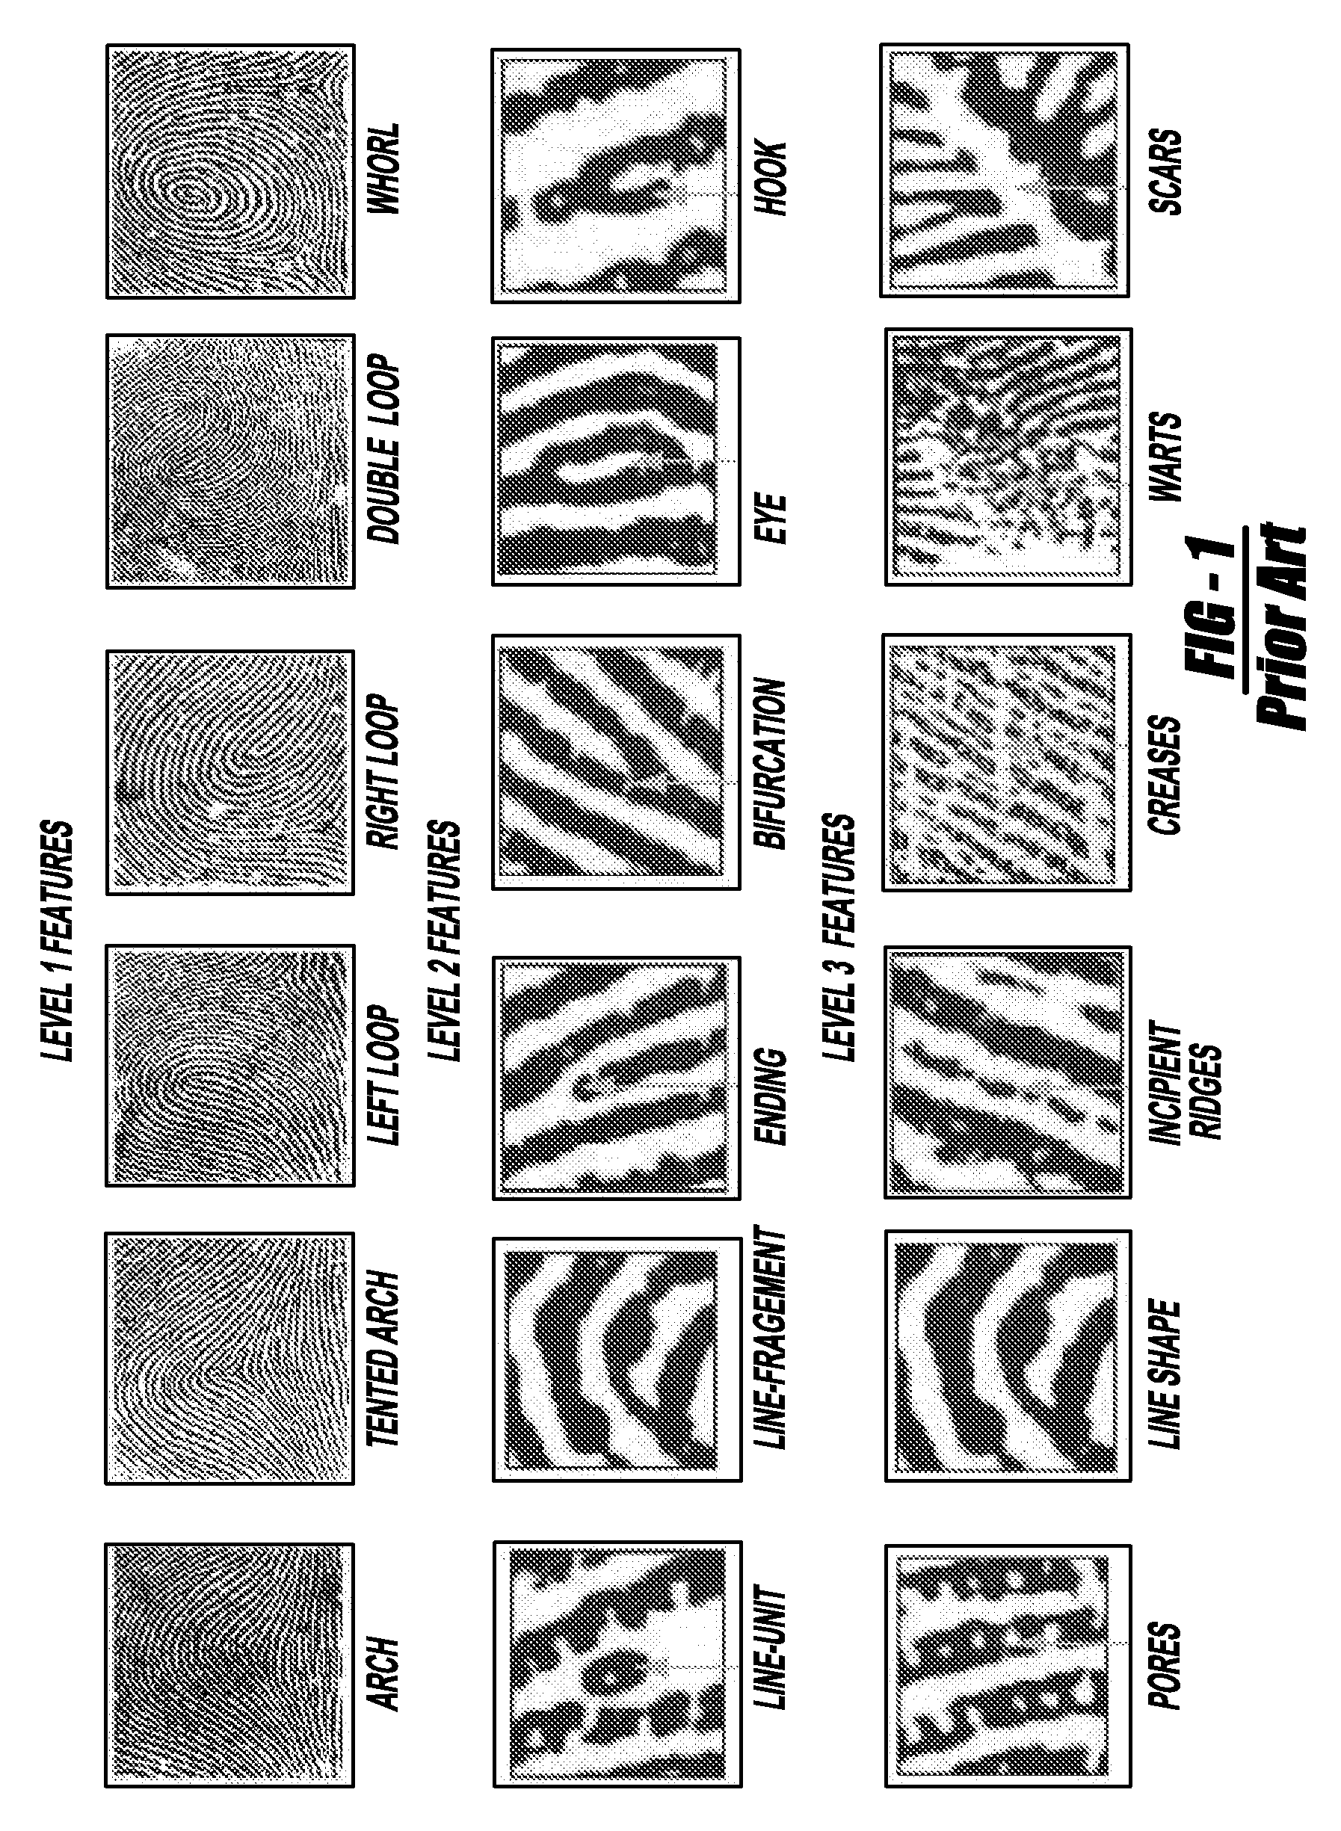

*Levels of detail in fingerprint analysis/identification*

*(*[*http://patentimages.storage.googleapis.com/US20070230754A1/US20070230754A1-20071004-D00001.png*](http://patentimages.storage.googleapis.com/US20070230754A1/US20070230754A1-20071004-D00001.png)*)*

**Misidentified fingerprint cases**

While fingerprints are generally believed to be unique, with no two people sharing an identical fingerprint, there are cases where fingerprint evidence has led to an incorrect match. One high-profile case of mistaken fingerprints occurred in 2004 with an Oregon attorney, Brandon Mayfield.

In a 2004 national press release, the FBI apologized to Mayfield and he was exonerated. Their explanation of the situation follows.

After the March terrorist attacks on commuter trains in Madrid, digital images of partial latent fingerprints obtained from plastic bags that contained detonator caps were submitted by Spanish authorities to the FBI for analysis. The submitted images were searched through the Integrated Automated Fingerprint Identification System (IAFIS). An IAFIS search compares an unknown print to a database of millions of known prints. The result of an IAFIS search produces a short list of potential matches. A trained fingerprint examiner then takes the short list of possible matches and performs an examination to determine whether the unknown print matches a known print in the database.

Using standard protocols and methodologies, FBI fingerprint examiners determined that the latent fingerprint was of value for identification purposes. This print was subsequently linked to Brandon Mayfield. That association was independently analyzed and the results were confirmed by an outside experienced fingerprint expert.

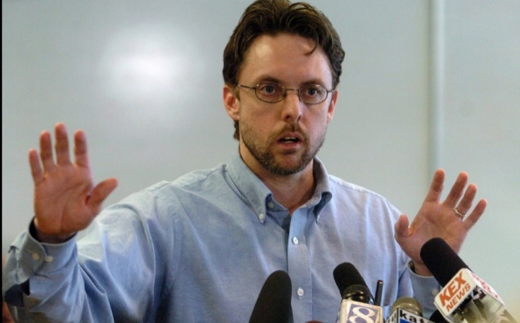

*Brandon Mayfield*

([*http://america.aljazeera.com/content/ajam/opinions/2014/2/the-terrifying-surveillancecaseofbrandonmayfield/jcr:content/mainpar/adaptiveimage/src.adapt.960.high.brandon_mayfield_020714.1391881499601.jpg*](http://america.aljazeera.com/content/ajam/opinions/2014/2/the-terrifying-surveillancecaseofbrandonmayfield/jcr:content/mainpar/adaptiveimage/src.adapt.960.high.brandon_mayfield_020714.1391881499601.jpg)*)*

Soon after the submitted fingerprint was associated with Mr. Mayfield, Spanish authorities alerted the FBI to additional information that cast doubt on our findings. As a result, the FBI sent two fingerprint examiners to Madrid, who compared the image the FBI had been provided to the image the Spanish authorities had.

Upon review it was determined that the FBI identification was based on an image of substandard quality, which was particularly problematic because of the remarkable number of points of similarity between Mr. Mayfield's prints and the print details in the images submitted to the FBI.

The FBI's Latent Fingerprint Unit will be reviewing its current practices and will give consideration to adopting new guidelines for all examiners receiving latent print images when the original evidence is not included.

The FBI also plans to ask an international panel of fingerprint experts to review our examination in this case.

The FBI apologizes to Mr. Mayfield and his family for the hardships that this matter has caused.

(<https://archives.fbi.gov/archives/news/pressrel/press-releases/statement-on-brandon-mayfield-case>)

Another interesting misidentification case involved a Scottish police constable, Shirley McKie. A woman was found murdered in her home, and a handyman was suspected of the murder. His fingerprints were found at the crime scene, but another thumbprint was found there, that did not match the suspect or the victim. Scottish Criminal Record Office (SCRO) experts claimed it was McKie's. However, McKie adamantly denied ever setting foot in the murdered woman's house. McKie was subsequently suspended from her job, fired, arrested, charged with perjury, and sent to trial. Fortunately, two U.S. fingerprint experts stated that the thumbprint did not belong to McKie, but the SCRO experts did not waiver. A member of the Scottish Parliament uncharacteristically invited fingerprint analysts from around the world to review the evidence. The 171 experts all agreed that the thumbprint did not belong to McKie. However, the damage to McKie's career and reputation was complete, and the actual murderer was not identified. (<https://locardslab.com/2015/05/12/forensic-fails-the-shirley-mckie-fingerprint-scandal/>)



*Shirley McKie*

*(*[*http://ichef-1.bbci.co.uk/news/560/media/images/57322000/jpg/_57322785_002559974-1.jpg*](http://ichef-1.bbci.co.uk/news/560/media/images/57322000/jpg/_57322785_002559974-1.jpg)*)*

Lana Canen was a less fortunate victim of incorrect fingerprint identification. Canen spent eight years in prison before being freed for the 2002 Thanksgiving Day murder of Helen Sailor. Canen and her co-defendant were accused of attempting to rob and murder Sailor. Canen maintained her innocence throughout her trial, but a crucial fingerprint found on a medicine bottle was claimed by fingerprint experts to match Canen's. She was convicted and sentenced to 55 years in prison. Canen appealed her conviction, and an Arizona fingerprint expert discovered that a sheriff's deputy had misidentified Canen's print on the bottle. Canen spent a total of eight years in prison through the trial-and-appeal before her release, the sheriff's deputy was disciplined for the mistake and continued working for the department.

([https://www.law.umich.edu/special/exoneration/pages/casedetail.  
aspx?caseid=4047](https://www.law.umich.edu/special/exoneration/pages/casedetail.aspx?caseid=4047)).

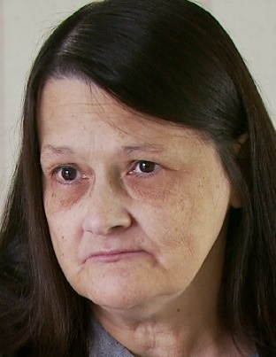

*Lana Canen*

*(*[*https://www.law.umich.edu/special/exoneration/PublishingImages/Lana_Canen.jpg*](https://www.law.umich.edu/special/exoneration/PublishingImages/Lana_Canen.jpg)*)*

**“Like dissolves like”**

The adage “like dissolves like” succinctly summarizes solubility rules based on polarities of substances. That is, polar substances tend to dissolve in other polar substances, and nonpolar substances tend to dissolve in other nonpolar substances. Fingerprints are primarily composed of sweat or water (polar) and oils (nonpolar). So, in the fingerprinting powders, there are typically some polar components (ferric oxide) and some nonpolar components (carbon and rosin).

 The polarity of a molecule is caused by the larger differences in electronegativities between the bonded elements in the substance, and the asymmetrical arrangement of the polar bonds. The larger the electronegativity differences, the more polar the bond that is formed in the molecule. When the electronegativity differences between the bonded elements are small, a nonpolar bond results. Molecules can be nonpolar if they contain polar bonds, as long as the polar bonds are arranged symmetrically, resulting in an electrical cancellation of dipole forces.

*(*[*http://www.chem.ucla.edu/~harding/notes/notes_14C_noncoval02.pdf*](http://www.chem.ucla.edu/~harding/notes/notes_14C_noncoval02.pdf)*)*

The polarity of the bonds is a sliding scale and not a plateau; bonds are not either just polar or nonpolar, instead there are degrees of polarity. Similarly, molecules have varying degrees of polarity due to the varying polarity of the bonds and the degree of symmetry of the molecule. When a polar molecule, like ammonia in the diagram above, is in close proximity to other polar molecules, such as water, then intermolecular attractions (dipole or hydrogen bonds) cause the two polar molecules to attract each other. This is what occurs in fingerprints when polar pigments (ferric oxide) in the fingerprinting powder are attracted to the polar water in the fingerprints.

In the diagram at right, nonpolar iodine and nonpolar bromine interact due to the weak intermolecular (dispersion) forces that are present among nonpolar molecules.



*(*[*http://www.chem.ucla.edu/~harding/notes/notes_14C_noncoval02.pdf*](http://www.chem.ucla.edu/~harding/notes/notes_14C_noncoval02.pdf)*)*

Likewise, when a nonpolar molecule such as the sebum or lipids in fingerprints are exposed to another nonpolar substance, carbon (fingerprinting powder), then the weak dispersion attraction occurs, binding the powder to the oily fingerprint.

**Dispersion-force attractions**

Dispersion-force attractions, also known as dispersion forces or London dispersion forces, are the weakest of the intermolecular van der Waals attractions. However, their weakness belies their significance in the properties of nonpolar materials. These dispersion forces are what permit nonpolar molecules to exist in liquid and solid states at room temperature. Dispersion forces are formed by the unequal instantaneous distribution of electrons in a typical nonpolar molecule. These fleeting, unequal electron distributions in a nonpolar molecule cause slight positive (δ+) and slight negative (δ-) charges which can interact with opposite charges on adjacent nonpolar molecules, or they can induce an opposite charge on an adjacent nonpolar molecule. In the diagram, the red shading indicates unequal electron distribution in both molecules. The lighter shade indicates less electron density, which results in a slight positive charge, and the darker shade indicates a greater electron density and produces a slight negative charge. The lipids in a fingerprint are nonpolar molecules, but they are solids or liquids (oils) at room temperature due to the dispersion forces. These solid and liquid states of matter allow the lipids to form a lasting fingerprint on many types of surfaces. For a full discussion and additional graphics, see <http://www.chemguide.co.uk/atoms/bonding/vdw.html>.



*Dispersion forces arise due to instantaneous dipoles*

*(*[*http://www.chemguide.co.uk/atoms/bonding/vdw.html*](http://www.chemguide.co.uk/atoms/bonding/vdw.html)*)*

**Eccrine, apocrine, and sebaceous glands**

Human sweat is primarily produced by eccrine and apocrine glands located in the reticular dermis (thick, lower dermis layer) or in the subcutaneous fat. Eccrine glands are found almost everywhere on the skin; however, they are most populous in the palms, soles, forehead, and axillae (underarms). These glands primarily excrete water (~99%) and salts, and they are responsible for cooling the skin. (https://www.derm101.com/inflammatory/embryologic-histologic-and-anatomic-aspects/eccrine-units/

*Sweat glands*

*(*[*http://www.mayoclinic.org/~/media/kcms/gbs/patient%20consumer/images/2013/08/26/10/41/_bhtestimage.png*](http://www.mayoclinic.org/~/media/kcms/gbs/patient%20consumer/images/2013/08/26/10/41/_bhtestimage.png)*)*

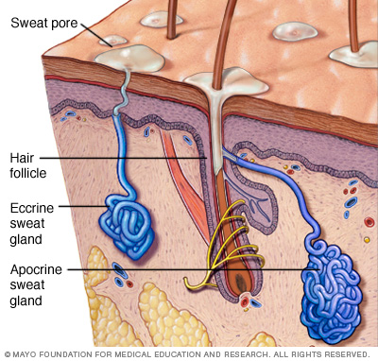

Apocrine glands are more localized and are found in the parts of the body with more hair follicles: genital area, anal region, external ear, breast, eyelids, and axillae. These apocrine glands respond to emotional stimuli and release an oily, opaque, odorless secretion. Bacterial decomposition of the oily apocrine secretions are the main source of body odor. (<https://www.derm101.com/inflammatory/embryologic-histologic-and-anatomic-aspects/apocrine-units/>)

Both the water in the eccrine secretions and the oils in the apocrine secretions are components of fingerprints. In addition, proteins, amino acids, and other lipids from both types of sweat glands are found in fingerprints.

Sebaceous glands produce sebum, and these glands are found in various sizes all over the surface of the skin, except on the palms, soles, and dorsa of the feet. The sebaceous glands are most prevalent and productive on the scalp, forehead, nose, shoulders, and the upper part of the back and chest. (<https://www.derm101.com/inflammatory/embryologic-histologic-and-anatomic-aspects/sebaceous-units/>) While fingertips do not have abundant sebaceous glands, when people touch their faces or other body regions, the sebum is transferred to the fingertips. So, the oily sebum becomes an important component of fingerprints because it does not readily vaporize. Sadly, this same sebum is the primary culprit in the common teenage malady, acne.

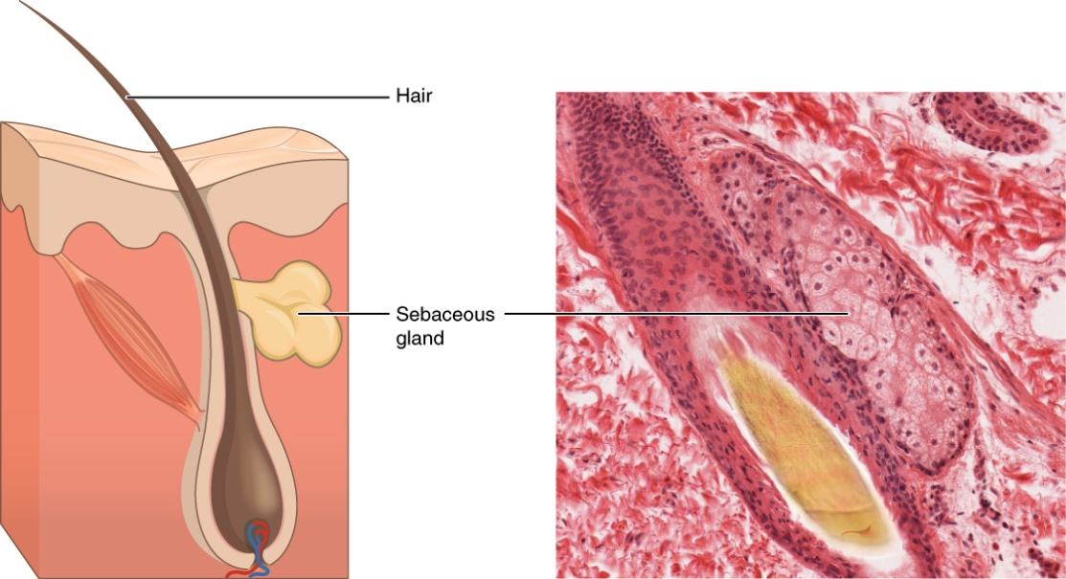

*Sebaceous glands secrete sebum, which adheres to fingers and contributes to latent fingerprints*

*LM × 400. (Micrograph provided by the Regents of University of Michigan Medical School © 2012)*

*(*[*http://cnx.org/resources/bdf1712166f277cd568ff235ce52ef1b5fdd3640/407_Sebaceous_Glands.jpg*](http://cnx.org/resources/bdf1712166f277cd568ff235ce52ef1b5fdd3640/407_Sebaceous_Glands.jpg)*, images taken from* [*http://cnx.org/contents/oWqVExrJ@3/Epithelial-Tissue*](http://cnx.org/contents/oWqVExrJ@3/Epithelial-Tissue)*)*

**Biometric identification**

Biometric identification (or verification) involves using one or more biological traits to uniquely identify a person. Common biometric identifiers include fingerprints and DNA. Newer forms of biometrics include retina or iris patterns, facial recognition technology, and earlobe geometry. Some behavioral characteristics such as voice, body odor, signature, typing rhythm, and walking gait may supplement biometric identification.

The need for security and positive identification is increasing rapidly in our world. Restricting access to rooms or areas; protecting one's identity; securing electronic data, computers, and cloud accounts; and tracking missing children or escaped prisoners are but a few of the actions today that can depend on biometric data. Passwords that protect our smartphones, computers, and online accounts are weak points in the attempt to prevent unauthorized use. Passwords are used because they are relatively simple and (sometimes) easy to remember. However, any skilled hacker can break numeric or alphanumeric passwords in short order.

Today, our identities are verified almost exclusively by one of two methods—things that you carry with you and things you remember. Driver’s licenses and passports are examples of the former, passwords and PINs the latter. But physical identification is easy to fake, and passwords are easily cracked by hackers, who then have nearly unfettered access to our credit cards, bank accounts, and personal data.

(<http://www.pbs.org/wgbh/nova/next/tech/biometrics-and-the-future-of-identification/>)

Therefore, biometric identification has seen a surge in attention because it is harder to fake, break, or manipulate. Biometric identification involves the familiar, like DNA matching, fingerprinting, voice recognition, and face recognition (e.g., Facebook), and body odor, as well as some that may be less familiar, such as ear (shape), eye (iris and retina patterns), gait, typing recognition, vein patterns, and dynamic signature recognition. (<http://www.biometricsinstitute.org/pages/types-of-biometrics.html>)

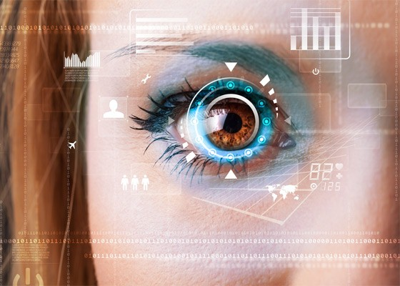

*Iris scan biometric for identification*

*(*[*http://www.easysecurityonline.com/wp-content/uploads/2015/10/Retina-scan.jpg*](http://www.easysecurityonline.com/wp-content/uploads/2015/10/Retina-scan.jpg)*)*

Since the 9/11 attack on the World Trade Centers in 2001, the need for accurate identification of people has escalated. The role of the National Security Agency (NSA) has mushroomed in response to the need to identify and track terrorist and others. Whether it's the need to identify victims of an accident or crime, or authenticate the permission for a person to enter a restricted area or access restricted files, biometric identification demands are increasing. The problem with using biometric data lies with protecting the biometrics—who owns it; who is storing it; who is collecting it, with or without permission; how is it being shared; and how is it being used, with or without your permission?

The debate over the extent and uses of government databases has intensified since the public became aware of the surveillance program PRISM, run by the National Security Agency, known as the NSA. According to news reports citing leaked confidential information, the NSA created PRISM to monitor the electronic communications and digital breadcrumbs of foreigners suspected of being terrorists. It siphons data about phone calls, search histories, email messages, and more from private servers run by technology companies, including Google, Facebook, and others. The volume is so great that innocent U.S. citizens are likely caught in the broad net.

While biometrics haven’t been mentioned as being stored in the PRISM database, there’s a good chance a biometric of yours is stored in at least one of those companies’ databases—Facebook. “Facebook has the largest facial recognition database in the entire world,” Lynch says. Whenever someone uploads a photo to Facebook, the company’s algorithms scan the image for faces and sifts through their own records to suggest a name. It sounds innocuous enough, but there’s no guarantee they won’t be used for another purpose in the future.

(<http://www.pbs.org/wgbh/nova/next/tech/biometrics-and-the-future-of-identification/>)

Are there practical ways that the typical citizen will use biometrics? Certainly, many people use their fingerprint to access their smartphone or verify online purchases. Facebook uses facial recognition software to tag the people in the photos that are uploaded to profile pages. Some stores are starting to use facial recognition technology to identify the age, gender, and race of shoppers to target them with appropriate advertisements.

Already, we’re seeing glimpses of what this biometric future will look like. Electronic payment company Square recently released a feature where you can pay simply by carrying your phone in your pocket or purse. When you walk in a shop, Square’s software will bring up your photo on the store’s register. If you want to buy something, a clerk can complete the transaction by verifying that the image on screen is, in fact, you. It’s a similar process to that used at border crossings in many countries, where citizens or visitors wave their electronic passports over a sensor and immigration officials verify that the information stored on the passport matches the individual in front of them.

*Smart phone using fingerprint identification security*

*(*[*http://cdn2.macworld.co.uk/cmsdata/  
features/3471071/HowToUseTouchID.jpg*](http://cdn2.macworld.co.uk/cmsdata/features/3471071/HowToUseTouchID.jpg)*)*

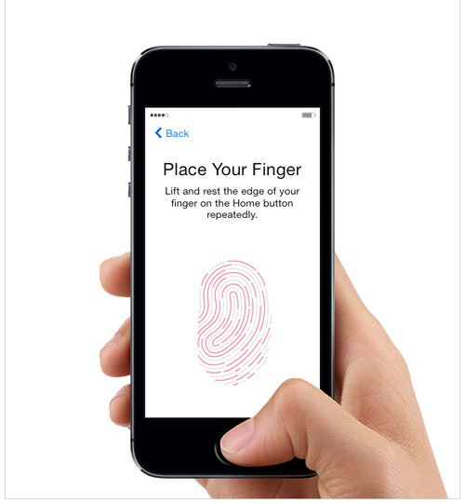

With these systems, Savvides [Dr. Mario Savvides, research professor at Carnegie Mellon University] says, “The human is doing the biometric matching.” They aren’t fully automated, which means they fall short of what researchers like Savvides consider true biometric systems. But they’re “starting to bridge the gap,” he says. It’s easy to imagine replacing the human in these situations with a camera and a computer. “Wouldn’t it just be so much faster and increase throughput to have an automated system that does that?” he asks.

(<http://www.pbs.org/wgbh/nova/next/tech/biometrics-and-the-future-of-identification/>)

# References

**(non-Web-based information sources)**

**The references below can be found on the   
*ChemMatters* 30-year DVD, which includes all articles   
published from the magazine’s inception in October 1983 through April 2013, all available Teacher’s Guides, beginning February 1990, and 12 *ChemMatters* videos. The DVD is available from the American Chemical Society for $42 (or $135 for a site/school license) at this site:** [**http://ww.acs.org/chemmatters**](http://www.acs.org/chemmatters)**. Click on the “Teacher’s Guide” tab directly under the *ChemMattersonline* logo and, on the new page, click on “Get the past 30 Years of *ChemMatters* on DVD!” (the icon on the right of the screen).**

**Selected articles and the complete set of   
Teacher’s Guides for all issues from the past three   
years are available free online at the same Web site, above. Click on the “Issues” tab just below the logo, *“ChemMattersonline”*.**



***30* Years of *ChemMatters !***

Available Now!

This 1997 article is an interesting comparison to the current article. Advances in techniques and knowledge can be compared as well as similarities. The article describes a kidnapped child who was found using clothing fibers, not fingerprints, because children's fingerprints have a different composition than adults and disappear more quickly. (Noble, D. The Disappearing Fingerprints. *ChemMatters*, 1997, *15* (1), pp 9–12)

There is a variety of forensic science techniques, including fingerprints, in this article. Several examples of cases are used where forensic evidence was important. (Baxter, R. Forensics: Finding the Chemical Clues. *ChemMatters*, 2002, *20* (2), pp 12–13)

A discussion of the van der Waals forces that help geckos climb on slick surfaces like glass is included in this article about glues. Dispersion forces which cause fingerprinting powders to stick to latent fingerprints are a type of van der Waals force, and these dispersion forces are included in the discussion about glue. (Shiber, L. Sticky Situations: The Wonders of Glue. *ChemMatters*, 2006, *24* (4), pp 8–10)

The use of van der Waals forces related to nonpolar fats similar to the lipids and oils in fingerprints is found in this article dealing with dietary fats. Explanations regarding the nonpolar nature of fats, including diagrams, may benefit students requiring assistance with this concept. (Kimbrough, D. The Solid Facts about Trans Fats. *ChemMatters*, 2007, *25*, (4), pp 14–16)

While fingerprints are not the focus of this CSI-type article, the forensic techniques and the philosophy behind solving crimes is complementary to the feature article on fingerprinting. An activity using paper chromatography to identify inks is included in this article. (Brownlee, C. Forensic Chemistry: Solving Mysteries with Fascinating Science. *ChemMatters*, 2010, *28* (3), pp 17–19)

Solubility, polarity, and intermolecular forces are important in coloring foods. These same concepts are at work in fingerprinting and are explained in the article. (Rohrig, B. Eating with Your Eyes: The Chemistry of Food Coloring. *ChemMatters*, 2015, *33*, (4), pp 5–7)

____________________

“Solving the Mystery of Fading Fingerprints with London Dispersion Forces” is a closely linked article to the featured Rohrig article. The fading fingerprints refer to children's fingerprints and the way they disappear more rapidly than those of an adult. A discussion of London dispersion forces is also prominent in the article. (DeLorenzo, R.; Kimbrough, D.Solving the Mystery of Fading Fingerprints with London Dispersion Forces. *J. Chem. Educ.*, 1998, *75* (10), pp 1300–1301; <http://pubs.acs.org/doi/pdf/10.1021/ed075p1300>; note that this link is a brief abstract only, the full article is only available to American Chemical Society members or subscribers to the journal.)

The National Academies of Science published a powerful book in 2009 that critiqued the collection and use of forensic evidence in the United States and resulted in a major examination of forensic science practices and uses in the U.S. It is often referenced in forensic science papers and is important to read and know for people working in forensic sciences. This book has challenged forensic scientists to refine their collection and analysis methodology and to use more scientific processes in forensic sciences. (National Research Council, *Strengthening Forensic Science in the United States: A Path Forward*; National Academies Press: Washington, DC 2009). The book is available for purchase in printed form, or it can be downloaded for free at the National Academies Press Web site. (<http://www.nap.edu/catalog/12589/strengthening-forensic-science-in-the-united-states-a-path-forward>)

An article describing the chemistry behind some fingerprint visualization techniques is discussed in “Forensic Chemistry: The Revelation of Latent Fingerprints”. Two categories of visualization—those that react with the fingerprint residues and those that use intermolecular forces to adhere to the fingerprint residue—are explained in this article. (Friesen, J. Forensic Chemistry: The Revelation of Latent Fingerprints. *J. Chem. Educ.*, 2015, *92* (3), pp 497–504; <http://pubs.acs.org/doi/pdf/10.1021/ed400597u>; note that this link provides a brief abstract only, the full article is only available to American Chemical Society members or subscribers to this journal)

Two latent fingerprint activities designed for high school students using a structured-inquiry approach designed are described in “Activities Designed for Fingerprint Dusting and the Chemical Revelation of Latent Fingerprints”. One activity uses fingerprint dusting and the second uses chemical revelation techniques which are best conducted in a fume hood. (Friesen, J. Activities Designed for Fingerprint Dusting and the Chemical Revelation of Latent Fingerprints. *J. Chem. Educ.*, 2015, *92* (3), pp 505–508; <http://pubs.acs.org/doi/pdf/10.1021/ed500406v>; note that this link is a brief abstract only, the full article is only available to American Chemical Society members or subscribers to the journal)

After the 2009 National Academies of Science report (above) condemning current forensic evidence techniques (including fingerprinting), the field of forensic science has steadily worked and improved to make forensics more science than craft. This article, written in layman's language, discusses some of the issues with forensic evidence and has great photographs, as well. (Greenwood, V. Beyond Reasonable Doubt. *National Geographic*, July 2016, pp 30–55)

# Web Sites for Additional Information

**(Web-based information sources)**

**Fingerprints**

The definitive resource for all things related to fingerprints comes from this publication from the National Criminal Justice Reference Center: *Fingerprint Sourcebook,* which is available online. The book includes these chapters:

1: History

2: Anatomy and Physiology   
of Adult Friction Ridge Skin

3: Embryology, Physiology,   
and Morphology

4: Recording Living and Postmortem  
Friction Ridge Skin Exemplars

5: Systems of Friction Ridge Classification

6: Automated Fingerprint Identification  
System (AFIS)

7: Latent Print Development

8: The Preservation of Friction Ridge  
Information

9: Examination Methodology

10: Documentation of Friction Ridge  
Impressions: From the Scene to the  
Conclusion

11: Equipment

12: Quality Assurance

13: Fingerprints and the Law

14: Scientific Research in the Forensic  
Discipline of Friction Ridge  
Individualization

15: Special Abilities and Vulnerabilities in  
Forensic Expertise

(<https://www.ncjrs.gov/App/Publications/abstract.aspx?ID=247300>)

The U.S. Marshalls Service provides a condensed, chronological history of fingerprinting at <https://www.usmarshals.gov/usmsforkids/fingerprint_history.htm>.

The Federal Bureau of Investigation (FBI) has information on multiple aspects of fingerprinting with links to additional information and resources on its Biometric Center of Excellence Web page. The FBI site includes fingerprint information on history, the concept, hardware, software, standards overview, and notable U.S. government fingerprint programs. (<https://www.fbi.gov/about-us/cjis/fingerprints_biometrics/biometric-center-of-excellence/modalities/fingerprint>)

The FBI has a Web site providing summary information on fingerprinting as well as additional biometric initiatives. The site also has links to further information on many of the topics. (<https://www.fbi.gov/about-us/cjis/fingerprints_biometrics>)

The fear of biometric invasion is discussed in this *Scientific American* article from 2014: <http://www.scientificamerican.com/article/biometric-security-poses-huge-privacy-risks/>.

In addition, *USA Today* had an article in 2014 discussing future biometric measures (body odor) and the use of smartphones for pleasure and health (gait analysis, electrocardiograms, and fingerprints). The article wisely addresses the hot topic of who has the rights to collect, access, and use your biometric data. Find this provocative article at <http://www.usatoday.com/story/news/world/2014/04/19/ozy-biometric-identification/7904685/>.

An interesting article on using month-old fingerprints to catch poachers on ivory illegally harvested from elephants in Africa is found at <http://www.scientificamerican.com/article/new-powders-can-lift-poacher-prints-from-ivory-a-month-after-the-crime/>.

This site describes the process of recovering fingerprints from wiped metals, a particularly challenging task. The process uses the corrosion on the metals from the salts and other components found in the fingerprint. (<http://www.rsc.org/chemistryworld/News/2008/June/06060801.asp>)

In a bizarre case, an Idaho wakeboarder's severed finger is found inside a fish and identified, using his fingerprint. (<http://www.cbsnews.com/news/human-finger-found-inside-idaho-trout-belongs-to-wash-wakeboarder/>)

The ACS National Chemistry Week (NCW) theme for 2016 is “Solving Mysteries through Chemistry”. (<https://www.acs.org/content/acs/en/education/outreach/ncw.html>) The just-developed NCW 12-page brochure by the same name offers activities using chemistry to solve questions. The activity “Dusting for Fingerprints” on page 7 of the downloadable 2016 NCW pdf brochure describes a simple process to produce a latent fingerprint on glass and visualize it using black tempera powder or cocoa powder. (<https://www.acs.org/content/dam/acsorg/education/outreach/ncw/educationalresources/2016/ncw-2016-brochure-low-res.pdf>)

**Forensic science**

The ACS ChemClub Web site has a section devoted to forensics. This is an extensive resource containing activities, articles, and videos related to the popular field of forensic science. Some of these specifically relate to fingerprinting, but additional forensic science processes are also explored. The links and materials are appropriate for both students and teachers. (<https://www.acs.org/content/acs/en/education/students/highschool/chemistryclubs/activities/forensics.html>)

NOVA has an interesting article, “Forensic Tools: What's Reliable and What's Not-So-Reliable”, published in 2012. The problems with fingerprints, "lying" matching hairs, arson investigations, and drug testing are discussed in the article. (<http://www.pbs.org/wgbh/frontline/article/forensic-tools-whats-reliable-and-whats-not-so-scientific/>)

**Biometrics**

For a brief discussion from the Biometric Institute on the theft of your biometrics, see: <http://www.biometricsinstitute.org/pages/faq-6.html>.

What other types of biometric identification are available other than fingerprints? For that answer read the *USA Today* article, “Biometric Identification that Goes Beyond Fingerprints”, at <http://www.usatoday.com/story/news/world/2014/04/19/ozy-biometric-identification/7904685/>.

**Intermolecular forces**

A concise comparison of the strength of London dispersion forces and hydrogen bonds to French fries is made in the article, “Can London Dispersion Forces Be Stronger than Dipole-Dipole Forces, Including Hydrogen Bonds?” (Earles, T. Can London Dispersion Forces Be Stronger than Dipole-Dipole Forces, Including Hydrogen Bonds? *J. Chem. Educ.*, 1995. *72* (8), p 727; <http://pubs.acs.org/doi/pdf/10.1021/ed072p727>; note that this is a brief abstract only, the full article is only available to American Chemical Society members or subscribers to the journal.)

This is a technical discussion of the science behind the immiscibility of oil and water that goes further than the traditional "like dissolves like". The author suggests omitting most high school textbook explanations that may be misleading if the complete explanation cannot be included. (Silverstein, T. The Real Reason Why Water and Oil Don't Mix. *J. Chem. Educ.*, 1998. *75* (1), pp 116–118; <http://pubs.acs.org/doi/pdf/10.1021/ed075p116>; note that this is a brief abstract only, the full article is only available to American Chemical Society members or subscribers to the journal.)

“Intermolecular Bonding—Van der Waals Forces”, is a good explanation of van der Waals forces, with diagrams. Access it at <http://www.chemguide.co.uk/atoms/bonding/vdw.html>.

**Other sites**

This site provides an in-depth look at Locard's Exchange Principle, including the history behind the principle and other factors involved in crime scene reconstruction can be found at <http://www.profiling.org/journal/vol1_no1/jbp_ed_january2000_1-1.html>.

For a one-minute video, “Sweating”, describing eccrine and apocrine sweat glands in the body, see <http://www.nlm.nih.gov/medlineplus/ency/anatomyvideos/000127.htm>.