October/November 2016 Teacher's Guide

Background Information

for

Vertical Farming: Does It Stack Up?

Table of Contents

About the Guide 2
Background Information 3
References 27
Web Sites for Additional Information 28

About the Guide

Teacher’s Guide team leader William Bleam and editors Pamela Diaz, Regis Goode, Diane Krone, Steve Long and Barbara Sitzman created the Teacher’s Guide article material.
E-mail: bbleam@verizon.net

Susan Cooper prepared the anticipation and reading guides.

Patrice Pages, ChemMatters editor, coordinated production and prepared the Microsoft Word and PDF versions of the Teacher’s Guide.
E-mail: chemmatters@acs.org

Articles from past issues of ChemMatters and related Teacher’s Guides can be accessed from a DVD that is available from the American Chemical Society for $42. The DVD contains the entire 30-year publication of ChemMatters issues, from February 1983 to April 2013, along with all the related Teacher’s Guides since they were first created with the February 1990 issue of ChemMatters.

The DVD also includes Article, Title, and Keyword Indexes that cover all issues from February 1983 to April 2013. A search function (similar to a Google search of keywords) is also available on the DVD.

The ChemMatters DVD can be purchased by calling 1-800-227-5558. Purchase information can also be found online at http://tinyurl.com/o37s9x2.

Background Information
(teacher information)
Open Field Agriculture

Open-field agriculture is the method most people think of when farming is mentioned. A farmer plows an open field, plants a crop, tends it until it is ready (hopefully), harvests it, and ships it to market. Although this is the method man has used since civilization began, there are problems with this method today. These problems are developed more fully later in this Teacher’s Guide.

A historical look at open-field agriculture will help us understand how it developed and why it is so important to mankind.

Villages, also called manors, were self-contained economic units that existed during the middle Ages. There were two levels of people in the society: the peasants, or serfs, who raised the food, and the lord or priest, who lived off the labors of the serfs. Serfs were neither fully free nor slaves and they could not leave the village, sell an ox, or marry without the Lord’s permission. The villages were self-contained economic units where the villagers ate most of the food that was raised and surplus food was sold during the good years. These “developments” were found in Western Europe, Russia, Iran, and Turkey and existed until the 20th century.

Each manor had two or three large fields, usually several hundred acres each, which were divided into many narrow strips of land. Since the land was not uniform, the productivity of different parts of a village's land responded differently to variation in the weather. In years of high rain fall, low lying land might have been waterlogged and given low yields, while higher land might have been productive. When rainfall was light, the upland might have been too dry to produce well, while yields might have been high in the low lands. Each serf paid to work a strip of land, called a selion, or ridge. The strip was defined by the acre, which was the amount of land the farmer could plow in one day’s work. The serf would have a set amount of days they would be required to work on the Lord’s land. Since these strips of land were unfenced, it was called the open field system. In this system, temporary hedges were set up to keep cattle out of the fields. The strips were only owned by the serf during the time of crop growing. The open-field system required co-operation among the inhabitants of the manor and was a deterrent to developing the land or conserving the soil. The manor also included woodland and pasture areas for common usage and fields belonging to the Lord of the Manor and the church which the serfs were also required to cultivate. These farmers customarily lived in individual houses in a nucleated village with a much larger manor house and church nearby.

In the early manors, the arable land was divided into two fields or groups of fields; one group was planted with wheat, barley, or rye, while the other was allowed to lie uncultivated until the next planting season to recover its fertility. After crops were harvested, the first group of fields laid uncultivated and the livestock were permitted to graze on the stalks and stems and enrich the soil with their droppings.

Sometime during the 8th century farmers replaced the two-field with a more sophisticated three-field system where only a third of the land was uncultivated. In the autumn one third was planted with wheat, barley, or rye. Oats, barley, and legumes were planted in the spring and harvested in late summer. The legumes (peas and beans) improved the quality of the soil by their nitrogen-fixing ability and also improved the human diet. Because spring planting required summer rains, it was principally effective north of the Loire and the Alps. By providing two harvests a year it reduced the risk of crop failure and famine. It also made plowing more effective in two ways. First, by doing slightly more plowing than under the two-field system, a community of peasants could roughly double their crop yield, though in practice the uncultivated land was usually plowed twice to turn under the green manure. Secondly, the cultivation of a surplus of oats in the spring planting provided feed that made possible the substitution of the swifter gaited horse for ox power, after the introduction of the padded horse collar. This system helped drive agriculture toward the modern model of individual land-owning farmers.

By the end of the 17th century, a four course system, developed in Norfolk County, England, allowed farmers to do away with the uncultivated field and emphasized fodder crops. Wheat was grown in the first year, turnips and barley in the second, and clover and ryegrass in the third. The clover and ryegrass were grazed or cut for feed in the fourth year. The turnips were used to feed cattle and sheep in the winter.

The fodder crops eaten by the livestock produced large supplies of previously scarce animal manure, which was richer because the animals were better fed. When the sheep grazed the fields, their waste fertilized the soil, promoting heavier cereal yields in following years. This new method of farming enabled farmers to grow enough to sell some of their harvest without having to leave any land unplanted. Also, with these additional crops, farmers could now keep cattle though the winter, thus providing meat year around.
(https://www.britannica.com/topic/Norfolk-four-course-system)

By 1800 most British farms became enclosed farms. By the end of the 19th century, much of continental Europe adopted this system. Instead of communal farming, the land was farmed by individuals. This new system encouraged farmers to experiment with new types of farming techniques and fertilizes and they were able to profit from better farm production year after year. Today, agricultural science helps countries adjust to healthier methods of food production, and scientists are developing new, high-yield varieties of crops that require fewer fertilizers or pesticides.

The image below is a generic map of a medieval manor showing strip farming and crop planting times.

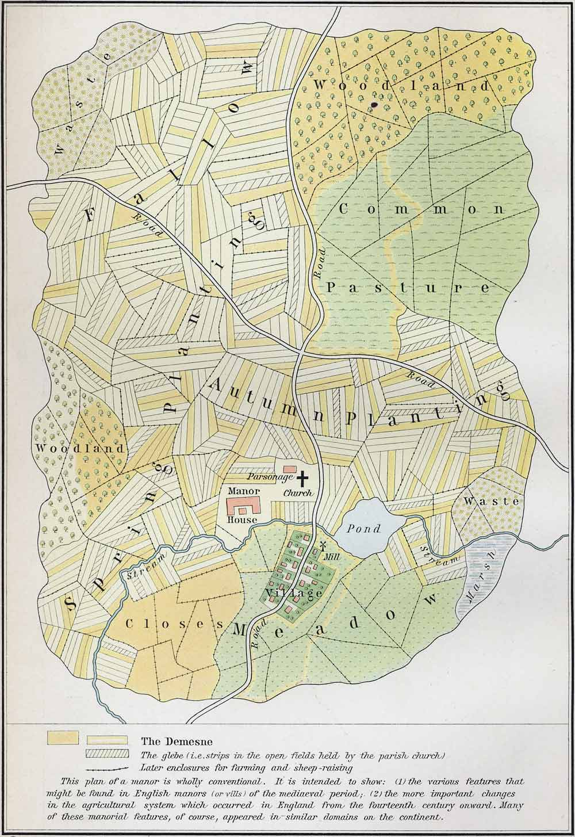
Plans of a medieval manor

(http://www.shadowedrealm.com/medieval-maps/plans/view/plan_of_a_medieval_manor)

Problems with open-field farming

By the year 2050, nearly 80% of the earth’s population will reside in urban centers. Applying the most conservative estimates to current demographic trends, the human population will increase by about 3 billion people during the interim. An estimated 269,000,000 acres of new land (about 20% more land than is represented by the country of Brazil) will be needed to grow enough food to feed them, if traditional farming practices continue as they are practiced today. At present, throughout the world, over 80% of the land that is suitable for raising crops is in use. A potential solution to the problem is vertical farming. (http://www.verticalfarm.com/)
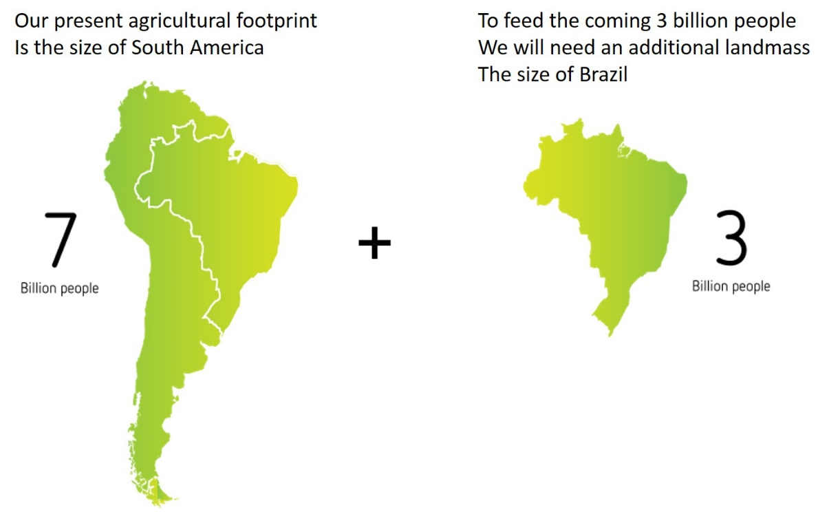
The world’s agricultural footprint

(https://vertical-farming.net/info/#footprint)

The global challenges of open field agriculture as it is practiced today include:
- Pesticide use causes pollution to our waters
- About 70–80% of all fresh water is used in agriculture
- Food transport leads to significant food waste and greenhouse gas emissions.
- Urbanization is causing increasing demands for food in cities
- Increasing population: by 2050 the human population will increase by three billion
- We will need to increase our agricultural footprint.

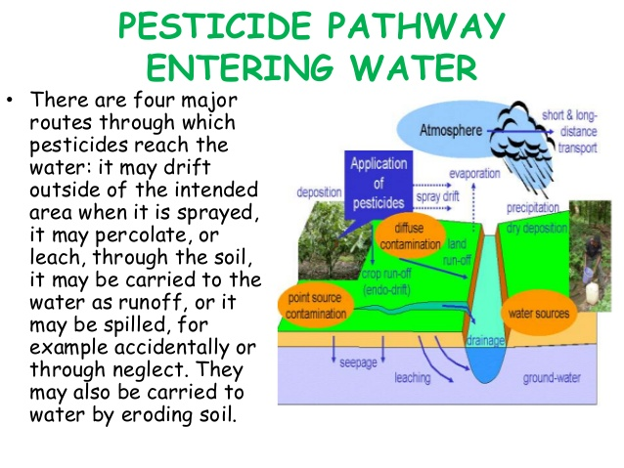
As mentioned above, the use of pesticides to grow crops causes extensive water pollution. The diagram at the right outlines the four major pathways in which pesticides reach our waters.

Pesticide use causes pollution
from runoff.
(http://image.slidesharecdn.com/shruthikrishnan-150417121931-conversion-gate02/95/effect-of-agrochemicals-on-environment-19-638.jpg?cb=1429273286)

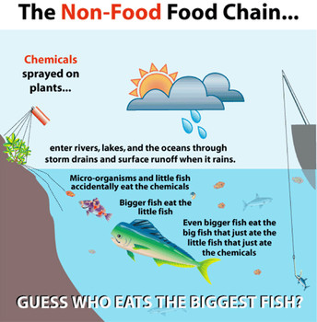
How is pesticide runoff a problem?

(http://www.worldthreadstraveler.com/wp-content/uploads/2015/09/5f24cb0fa3e4b097a4e3c2216c66e028.jpg)

What is the major problem caused by the passage of pesticides into our waters? Water soluble pesticides are easily transported from targeted areas to other unintended areas and cause damage to these plants and animals. Pesticides can alter or destroy food chains and can cause a decline in animal populations.

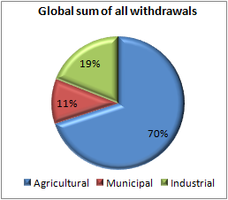
As was mentioned earlier, agricultural use of water is by far the largest percentage of all water use (see pie chart at right).
Global water use

(http://www.fao.org/nr/water/aquastat/water_use/index.stm)

Transportation of food over long distances results in spoilage and waste, before the food ever arrives at its final destination (grocery stores, for instance). It is interesting to note that more than a third of all of the food that's produced on our planet never reaches a table. It's either spoiled in transit or thrown out by consumers in wealthier countries. Thus, growing food locally is a key way to reduce food spoilage.

But transportation of food is an even bigger problem due to the use of fossil fuels and the production of greenhouse gases by the trucks, ships and airplanes that carry the food. It is difficult to estimate the relationship between food transport and carbon emissions because of the many variables such as type of fuel, mode of transportation, and distance traveled. The energy that goes into the production, harvesting, transporting, and packaging of wasted food generates more than 3.3 billion metric tons of CO₂. (http://news.nationalgeographic.com/news/2015/01/150122-food-waste-climate-change-hunger/)

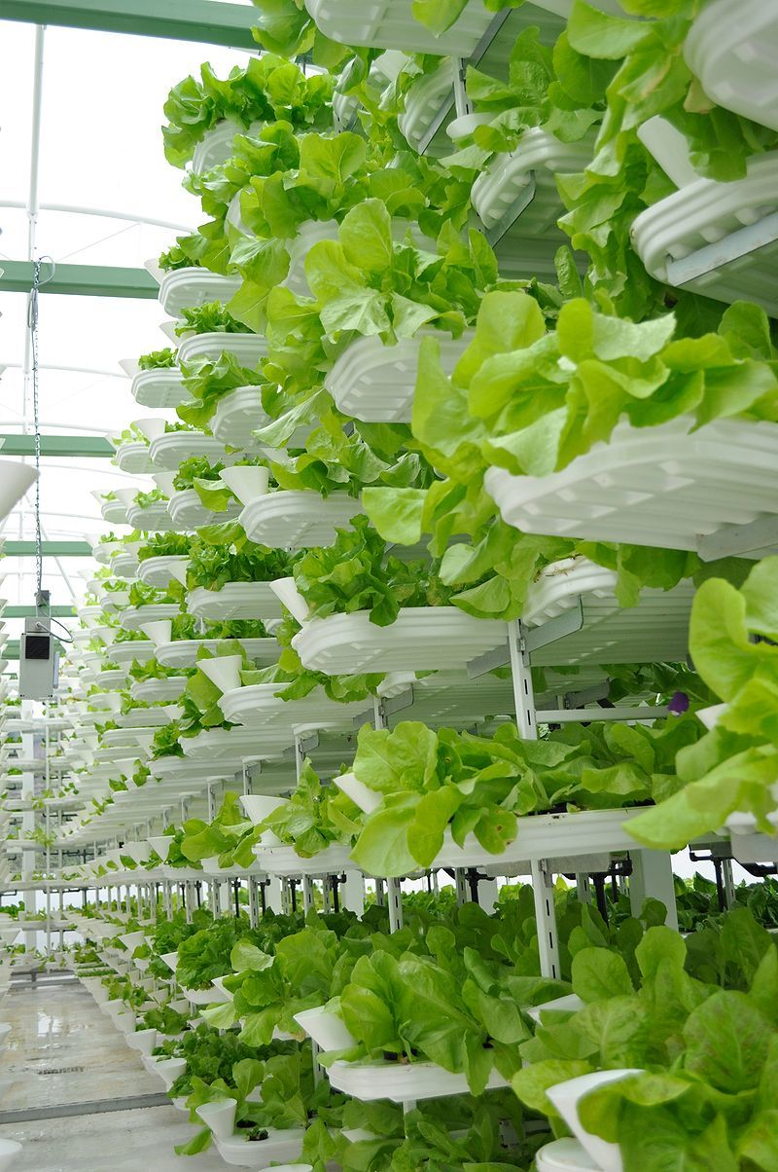
Vertical farming

So, how can we improve on or solve these problems? One way is to use vertical farming. Vertical farming is the practice of producing food in vertically stacked layers, vertically inclined surfaces and/or integrated in other structures. The modern idea of vertical farming uses controlled-environment agriculture (CEA) technology, where all environmental factors can be controlled.

Layers of lettuce growing in
an industrial-scale vertical farm

The VertiCrop system (Credit: Valcentu/CC BY-SA 3.0)

(http://io9.gizmodo.com/how-vertical-farming-is-revolutionizing-the-way-we-grow-1730550597)

Vertical farming has these advantages over open field agriculture:

- Limited agricultural runoff
- Year round crop production
- Resilient to climate change
- Uses up to 98 % less water compared to open field agriculture
- Less food miles due to local production
- Creates new green jobs
- Promotes restoration of damaged ecosystems
- Ideal for vacant urban spaces
- Higher yields and faster growth rates
- Delivers consistent, fresh and local produce
(https://vertical-farming.net/info/)

Vertical farms are high-tech grow houses that typically inhabit buildings in urban areas. Produce is grown in stacks for local consumption. They use artificial lighting, climate control and, hydroponics or aeroponics to grow salad greens and herbs. Seasonality isn't a factor and there's no risk of poor weather conditions or seed contamination—a worry that comes up when growing non-GMO seeds in an open field. Other benefits include lower transportation costs and less spoilage, since many of these farms supply local restaurants and supermarkets.

These indoor companies are emerging throughout the United States, trying to change the way vegetables are grown. Among them: AeroFarms in Newark, New Jersey; FarmedHere in Bedford Park, Illinois; Green Sense Farms in Portage Indiana, Vertical Harvest in Jackson Hole, Wyoming; Green Spirit Farms in New Buffalo, Michigan; and Alegria Fresh in Irvine, California.

"On average, we're growing in 16 days what otherwise takes 30 days in a field—using 95 percent less water, about 50 percent less fertilizers, zero pesticides, herbicides, fungicides," said David Rosenberg, chief executive and co-founder of AeroFarms.

AeroFarms grows its plants "aeroponically," using a nutrient mist on plants anchored in a reusable cloth made of recycled plastic bottles, for which the company holds a patent. Its trays sit under specialized LED lights that cause the plants to initiate photosynthesis. Green Sense Farms, which supplies products to Whole Foods and other retailers in the Chicago area, uses a "modified hydroponic ebb-and-flow process" that involves pumping nutrient-laden water into the bottom of tubs filled with ground coconut husk. The water flows into the root system before being drained and re-pumped into the tubs.

“The big advantage of indoor vertical farming is that we have less impact on the environment. We conserve the water, the nutrients, we don't pollute or generate emissions," said Robert Colangelo, co-founder and chief executive of Green Sense Farms. "But more importantly, we can grow a large crop yield in a small footprint."

(http://www.cnbc.com/2015/06/24/vertical-farming-the-next-big-thing-for-food-and-tech.html)

It is hard to calculate the amount of food that comes from vertical farming, but it is thought to be a small fraction of all food grown. One reason that vertical farming remains a small, obscure niche is that farmers need to make money, not just food. Mr. Oshima said that AeroFarms was “cost competitive today with the field farmer.” But vertical farming has many skeptics and critics who expect that whatever energy and money are saved by shortening the distance from farm to table to be lost, and then some, by the high cost of artificial lighting and other equipment needed to produce food indoors and even outdoors in many urban settings.
It may be feasible to grow certain crops efficiently in certain circumstances in certain settings, they say, but only to a certain extent and at certain times. They consider it unlikely for the foreseeable future that vertical farming could produce enough food of different varieties to feed a significant number of people in a commercially viable way.

The advantages of vertical farming include less land, less fertilizer, less pesticides, and less water. Because plants are grown in stacks up to 100 high, one acre of vertical farming can do the work of up to 100 acres of farm land. According to Stephen J. Ventura, Professor of Environmental Studies and Soil Science, University of Wisconsin, “There are situations in dense urban areas where space is highly limited that growing food with artificial lights, stacked vertically, makes sense, especially highly perishable products like sprouts or salad greens where there is an immediate market for them.” (https://www.washingtonpost.com/lifestyle/food/will-indoor-vertical-farming-help-us-feed-the-planet--or-hurt-it/2016/06/16/f1faaa98-3332-11e6-8ff7-7b6c1998b7a0_story.html)

Because indoor plants are fed by fertilizer either delivered hydroponically or aeoroponically, they get only what they need. Since there is no runoff there are no algae blooms in rivers, lakes and estuaries.

Indoor plants are grown in a controlled environment with no soil to harbor pests. The workers are exposed to fewer toxic substances, and there are no threats to honeybees or other desirable plants or animals.

Vertical farming can cut water use by up to 95 percent. This is a big advantage since water is in such short supply in many parts of the world.

The two major disadvantages of vertical farming include cost and the carbon footprint. Property in urban areas is expensive. And some argue that many cities have arable land on the outskirts of town that is much cheaper than prime urban real estate and close enough to consumers to keep shipping costs to a minimum. Also, providing artificial light to the indoor plants is energy intensive with a large carbon footprint. Louis Albright, director of Cornell University’s Controlled Environment Agriculture program, estimates that each kilogram of indoor lettuce has a climate cost of four kilograms of carbon dioxide. Compared to field grown lettuce, indoor lettuce production has a carbon footprint between 7 to 20 times greater.

There are some ways to reduce the carbon footprint of vertical farming. LED’s are becoming more efficient. A spokesperson at Phillips lighting expects their LED lights to eventually become 10 percent more efficient. Pumping carbon dioxide into the air is another way to make lighting more efficient. Plants use carbon dioxide for photosynthesis. With the same amount of light, plants grow better with an increase in carbon dioxide in the atmosphere. That can increase efficiency by another 20 percent. However, that increase in efficiency is still not enough to make vertical farming climate competitive with field farming.

Another factor to consider in reducing the carbon footprint of vertical farming is the source of its electricity. If the farm uses coal, the carbon cost is high. Using natural gas reduces the costs. About a fifth of the electricity in this country is generated by nuclear plants, which have a carbon footprint close to zero. And, as renewable energy sources such as solar and wind start to contribute more to the energy grid, the carbon cost of vertical farms will go down.

Hans Hassle is founder of Plantagon International AB in Sweden. Vertical farming is one of the company’s premier projects. He realizes the many challenges of making vertical farming profitable in large cities. “Vertical farming as an industry is very much at the beginning,” Mr. Hassle said. “We have focused on making it industrial and scalable, and that’s a little bit crazy. It’s like trying to do the impossible. It looks almost like science fiction.” (http://www.nytimes.com/2016/05/18/business/energy-environment/farms-that-rise-to-the-challenge.html)

Hydroponics

Vertical farming relies on growing plants in soil free environments, relying exclusively on water solutions of the nutrients for the plants. A summary of the types of hydroponic systems is described at the Growth Technology website.

Wicks System

Seen as the most simplistic hydroponic system. The Wick system is described as a passive system, by which we mean there are no moving parts. From the bottom reservoir, your specific Growth Technology nutrient solution is drawn up through a number of wicks into the growing medium. This system can use a variety of mediums, perlite, soil or coco.

Water Culture

This system is an active system with moving parts. As active hydroponic systems go, water culture is the simplest. The roots of the plant are totally immersed in the water which contains the specific Growth Technology nutrient solutions. An air pump with help oxygenate the water and allow the roots to breathe. Very few plants other than lettuce will do well in this type of system.

Ebb and Flow System (Flood and Drain)

This hydroponic system works by temporarily flooding the grow tray. The nutrient solution from a reservoir surrounds the roots before draining back. This action is usually automated with a water pump on a timer.

Drip System (recovery or non-recovery)

Dip [sic] systems are a widely used hydroponic method. A timer will control a water pump, which pumps water and the Growth Technology nutrient solutions through a network of elevated water jets. A recovery system will collect excess nutrient solution back into the reservoir. A non-recovery drip system will avoid this allowing the pH of the reservoir not to vary. If using a recovery system, be sure to check the pH level of the reservoir regularly and adjust using either pH UP or pH Down solutions on a more frequent basis.

Nutrient Film Technique System (N.F.T.)

The N.F.T. system is at the forefront of people’s minds when hydroponics is mentioned. Nutrient Film Technique uses a constant flow of your Growth Technology nutrient solution (therefore no timer is required). The solution is pumped from a reservoir into the growing tray. The growing tray requires no growing medium. The roots draw up the nutrients from the flowing solution. The downward flow pours back into the reservoir to be recycled again. Pump and electric maintenance is essential to avoid system failures, where roots can dry out rapidly when the flow stops.

(http://www.growthtechnology.com/growtorial/what-is-hydroponic-growing/.)

Some of the advantages of hydroponics include:

- Reduction in water usage by allowing for recycling of the water.
- Since the grower has better control of nutrient and pH levels, the grower has more control of the growth process and can more easily protect plants from pollutants and pests. This results in higher crop yield.
- Since the hydroponics system does not depend on external environmental conditions, plants can be grown anywhere and year round.
- Since the root systems of hydroponically grown plants are smaller, plants can be grown closer together.

Some of the disadvantages of hydroponic farming include:

- Many hydroponic systems are energy-intensive and, therefore, expensive.
- Initial costs can be high.
- Technical knowledge is required to monitor systems.
- They are susceptible to power outages.
- Micro-organisms that are water-based can quickly destroy plants.
(http://dyna-gro-blog.com/hydroponics-advantages-and-disadvantages/)

There are a number of commercial companies that sell ready-made hydroponic solutions, but homemade solutions are less expensive and less mysterious than the “solutions in a bottle” offered by the commercial companies. Garden Culture Magazine provides basic recipes for preparing one gallon stock hydroponic solutions (see Web site below).

VEGETATIVE NUTRIENT
(Analysis: 9.5-5.67-11.3)
- 6.00 gr Calcium Nitrate – Ca(NO₃)₂
- 2.09 gr Potassium Nitrate – KNO₃
- 0.46 gr Sulfate of Potash – K₂SO₄
- 1.39 gr Monopotassium Phosphate – KH₂PO₄
- 2.42 gr Magnesium Sulfate – MgSO₄ * 7H₂O
- 0.40 gr Chelated 7% Fe Trace Elements – recipe below

FLOWERING NUTRIENT
(Analysis: 5.5-7.97-18.4)
- 4.10 gr Calcium Nitrate – Ca(NO₃)₂
- 2.80 gr Potassium Nitrate – KNO₃
- 0.46 gr Sulfate of Potash – K₂SO₄
- 1.39 gr Monopotassium Phosphate – KH₂PO₄
- 2.40 gr Magnesium Sulfate – MgSO₄ * 7H₂O
- 0.40 gr Chelated 7% Fe Trace Elements – recipe below

FRUITING NUTRIENT
(Analysis: 8.2-5.9-13.6)
- 8.00 gr Calcium Nitrate – Ca(NO₃)₂
- 2.80 gr Potassium Nitrate – KNO₃
- 1.70 gr Sulfate of Potash – K₂SO₄
- 1.39 gr Monopotassium Phosphate – KH₂PO₄
- 2.40 gr Magnesium Sulfate – MgSO₄ * 7H₂O
- 0.40 gr Chelated 7% Fe Trace Elements – recipe below

CHELATED TRACE ELEMENT MIX
- 7.00% Iron – Fe
- 2.00% Manganese – Mn
- 0.40% Zinc – Zn
- 0.10% Copper – Cu
- 1.30% Boron – B
- 0.06% Molybdenum – Mo

(http://gardenculturemagazine.com/garden-inputs/nutrients/make-your-own-hydroponic-nutrients)

To make one gallon of the solution, each ingredient is added, one at a time to ¾ gallon of hot distilled water. Each salt is completely dissolved before the next is added. After all of the ingredients have dissolved, water is added make one gallon of solution. The solution is cooled to room temperature and the pH is checked. Ideal pH for the solution is between 5.8 and 6.3. If the pH is above this, a small amount of dilute sulfuric, phosphoric or nitric acid can be added. More detailed directions and safety procedures can be found in Keith Roberto’s ebook How-To Hydroponics, at http://www.calgarycmmc.com/E-books/E-%20Books%20D-E-F-G-H/How%20To%20-%20Hydroponics%20-%20Keith%20Roberto.pdf.

The “Analysis” at the beginning of each recipe refers to the amount, in percent, of the macronutrients nitrogen, phosphorus, and potassium that are present within the recipe. Thus, “Analysis: 9.5–5.67–11.3” is interpreted as 9.5% Nitrogen, 5.67% Phosphorus, and 11.3% Potassium.

The essential macronutrients calcium (Ca), magnesium (Mg), nitrogen (N), phosphorus (P), potassium (K), and sulfur (S) are supplied by Ca(NO₃)₂, MgSO₄ • 7H₂O, KNO₃, KH₂PO₄, and K₂SO₄. The chelated 7% Fe trace element mix (above) can be purchased from a hydroponic supply company.

This table summarizes the roles of each of the nutrients contained in the homemade hydroponic solution:

Macronutrient | Role
Calcium | Essential for strong cell walls.
Magnesium | Responsible for the transport of phosphorous and is necessary for photosynthesis to occur.
Nitrogen | The basic element of proteins, chloroplasts, vitamins and nucleic acids.
Phosphorus | Key in the storage of energy. It helps produce flowers and fruit.
Potassium | Regulates water uptake by the plant and regulates cell wall development.
Sulfur | Essential for formation of amino acids.
Micronutrient
Boron | Needed for calcium uptake and therefore, the formation of cell walls.
Copper | Activates enzymes needed for photosynthesis and cellular respiration.
Iron | Is found in many structural and enzyme proteins and is required for photosynthesis and respiration.
Manganese | Is required for photosynthesis, respiration, and lipid metabolism.
Molybdenum | Is responsible for nitrogen metabolism
Zinc | Is essential for protein synthesis and chlorophyll production.
(adapted from http://agriculture.vic.gov.au/agriculture/dairy/pastures-management/fertilising-dairy-pastures/what-nutrients-do-plants-require)

The chemistry that takes place in solutions of the trace element mix is interesting. The salts contained in this mixture include ferrous sulfate (FeSO₄), manganous sulfate (MnSO₄), zinc chloride (ZnCl₂), copper carbonate (CuCO₃), and boric acid (H₃BO₃). (http://www.ukaps.org/forum/threads/making-own-trace-liquid-dtpa-or-edpa.16865/)

When water is added to this mix, double displacement reactions between some of the cations in some compounds may react with the anions in other compounds to form precipitates. For example the Fe²⁺ will react with CO³⁻ and FeCO₃ will precipitate out. Oxidation reactions between the metal cations and the oxygen dissolved in the aerated hydroponic solution also form precipitates. For example Fe²⁺ will react with oxygen gas to form insoluble Fe₂O₃. But only soluble nutrients are available for plant uptake. Chelators are used to solve these solubility problems.

A chelate contains a metal ion attached to a multi-bonded ligand. The bonds that holds the ion to the ligand are coordinate covalent bonds. In hydroponics, a common ligand is ethylenediaminetetraacetic acid (EDTA) which is an organic molecule. The ETDA ligand surrounds the Fe ion and “protects it” from precipitation. This complex is available for plant uptake. (https://manicbotanix.com/chelates-in-hydroponic-solutions/).
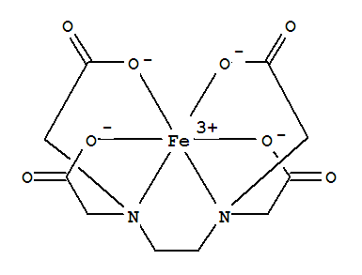
Fe³⁺ - EDTA is an example of a chelate

(http://img1.guidechem.com/chem/e/dict/119/15275-07-7.jpg)

Aeroponics

Aeroponics is a method of growing plants in a special growing chamber with the roots suspended in air. A fine mist of nutrient solution is sprayed on the plants at timed intervals and the excess spray is recycled. This system uses 75% less water and nutrients than hydroponics. Click on http://www.biocontrols.com/Howitwrk.gif to view an animation of a functioning aeroponic chamber.

Aeroponics DIY, a company that provides aeroponic systems to farmers and gardeners, discusses the two types of aeroponic systems:

There are two types or forms of aeroponic systems. The first one is HPA (High Pressure Aeroponics), and the other is LPA (Low Pressure Aeroponics).

HPAs are considered to be True Aeroponics and was used by NASA to grow vegetables. It also is the most expensive and the most complicated growing system to build. However, HPAs use less resources for plant grow: 98% less water, 60% less fertilizer, and 100% less pesticides (no pesticides), all supported by NASA laboratory studies.

LPAs are lower cost system. LPA systems are the most common used and built by DIYers.

High Pressure Aeroponics is True

The HPA (True Aeroponics) system was revolutionized by NASA in the 1990’s by reporting it as the most efficient way to grow plants in space. Studies have shown many benefits of growing plants with aeroponic techniques on both Earth and in space.

HPA systems must operate at a high pressure, normally above 80 PSI, but ideally at 100 PSI. The high pressure is used to atomize the nutrient water through a small orifice (hole) to create water droplets of 50 microns or less in diameter, in other words a fine mist like hair spray.

One micron is one-millionth of a meter. The average diameter of human hair is 80 microns. So we are talking about a really tiny water drop.

HPA also must run on a much accurate time cycle. HPAs might run 1 to 5 seconds on, and then off for three to five minutes. Specific components are required in controlling the timing interval and creating the proper size mist.

The basic components of a HPA are as follows:

1. High-Pressure water pump
2. Pre-Pressurize Accumulator Tank
3. Electrical-Solenoid hooked to an adjustable relay timer
4. Pressure switch
5. Mister nozzles

Low Pressure Aeroponics is Cheaper

LPA systems use a standard magdrive pump couple to some PVC or tubing, and a few miniature sprinkler heads. The water spray from an LPA sprinkler head has large droplets that drown the plant roots.

LPAs generally run the pump 24 hours and 7 days a week, continually wetting the roots. This works well, and are cheap and easy to build. However they are not as efficient as HPA systems.

Also, for this to be truly an aeroponics system the reservoir most be separated from the grow chamber of the plants.

The basic components of a LPA are as follows:

  - High flow water pump
  - Micro sprinklers

(http://aeroponicsdiy.com/what-is-aeroponics/)

The advantages of aeroponic farming include:

- Fast plant growth because the roots are exposed to a lot of oxygen.
- All that is needed to maintain is the root chamber which needs regular disinfecting, and periodically, the reservoir and irrigation channels.
- Aeroponic plants need less nutrients and water because the nutrient absorption rate is higher, and plants usually respond to aeroponic systems by growing even more roots.
- Plants can be moved around without too much effort, as all that is required is moving the plants from one collar to another.
- Not much space is needed to start an aeroponics garden.

The disadvantages include:

- The constant semi-moist environment of the root chamber which invites bacterial growth.
- A typical aeroponics system is made up of high pressure pumps, sprinklers and timers. If any of these break down, plants can be damaged or killed easily.
- Knowledge of nutrients amounts required by plants is essential, because there is no soil to absorb excess/wrong nutrients supplied.
- Most aeroponic systems are expensive.
(http://www.gardeningsite.com/aeroponics/aeroponics-benefits-and-disadvantages/)

Artificial light

There are four main types of artificial light used for growing plants: incandescent, fluorescent and high intensity discharge (HID) lights, and light-emitting diodes (LEDs). We’ll discuss each of these below.

Incandescent lights

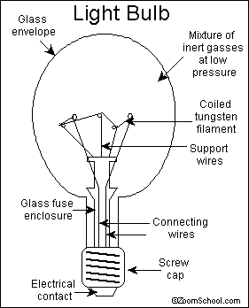
The incandescent bulb is a very inefficient one, with heat comprising 95% of the energy, with only 5% of the energy in the form of visible light. The bulb works on the principle that a high resistance is created when a current flows through a long thin wire that has been coiled. The wire gets extremely hot and gives off light. Because the temperature of the wire can get as hot as 2500 °C, tungsten, which has a melting point of 3400 °C, is used.
The parts of an
incandescent light bulb

(http://www.enchantedlearning.com/inventors/page/i/incandescentbulb.shtml)
(http://hypertextbook.com/facts/1999/AlexanderEng.shtml)

While tungsten is a relatively unreactive metal, it does oxidize at temperatures above 400 °C. To prevent this oxidation, the air in the bulb is removed and replaced with an inert gas such as argon or nitrogen. Because of its low efficiency and high carbon footprint, the incandescent light bulb is being phased out in the U.S.

The advantages of incandescent bulbs are: they have a somewhat long life, they are not affected by temperature and can be used outdoors, and they light up instantly. But there is a high electricity cost, and a large environmental impact, to using incandescent bulbs.

Fluorescent lights
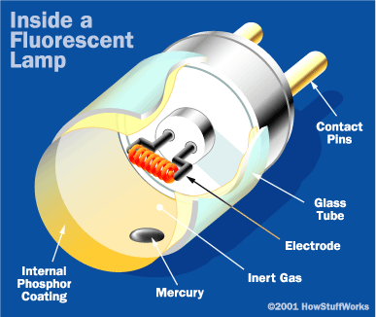
(http://home.howstuffworks.com/fluorescent-lamp2.htm)
Fluorescent lights use 75% less energy than incandescent lights and are suitable for plants that require low to medium light intensity. They use phosphors to convert ultraviolet light into visible light. A fluorescent lamp is a type of discharge tube that contains tungsten electrodes, argon gas, and a small amount of liquid mercury in a glass tube coated with phosphors.

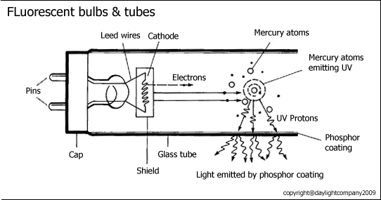
When an electric current passes through the electrodes, they heat up and give off electrons which ionize the argon gas and an electric arc forms between the electrodes. This arc vaporizes the mercury. The electrons in the atoms of mercury vapor are excited to a higher energy state and, when they fall back down to their ground state, they release ultraviolet light. This ultraviolet light is absorbed by the phosphors that coat the lamp’s tube. Some of the energy from the UV light is converted into heat. The rest of the energy is released as visible light, which is of a lower energy than the UV light. The type of phosphors used control the color of light emitted.
Visible light is produced when the phosphor coating
on the inside of the tube fluoresces, due to photons
of ultraviolet light from excited mercury atoms hitting it.

(https://fr.daylightcompany.co.uk/faq/)

Modern fluorescent lamps called triphosphors use a combination of three phosphors to produce a white light. Fluorescent grow lamps emit light in the blue and red ranges, as these are the wavelengths used for photosynthesis. Phosphors used in fluorescent lamps usually contain rare earth metal ions such as Tb³⁺, Ce³⁺, and Eu²⁺ to produce the desired colors of light.

Color | Phosphor Name | Chemical Formula | Wavelength
Blue | Barium Aluminate (BAM) | BaMg₂Al₁₆O₂₇ : Eu²⁺ | 450nm
or | SrCaBaMg Chloroapatite | (Sr,Ca,Ba,Mg)₅(PO₄)₃Cl : Eu²⁺ | 453nm
Green | Calcium Tungstate (CAT) | Ce_{0.65}Tb_{0.35}MgAl₁₁O₁₉ | 543nm
or | Lanthanum Phosphate (LAP) | LaPO₄ : Ce³⁺Tb³⁺ | 544nm
Orange-Red | Yttrium Oxide (YOX) | Y₂O₃ : Eu³⁺ | 611nm

Triphosphor materials and colors

(http://www.lamptech.co.uk/Documents/FL%20Phosphors.htm)

To ensure uniform brightness on both sides of the tube, alternating current (AC) is used. If direct current (DC) were used, the cathode end, which has a greater concentration of electrons, would be brighter.

Ballasts are used to control the voltage to create the arc and to prevent the lamp from shorting and self-destructing. Formation of the electric arc requires a high voltage; when the lamp is turned on, the ballast provides the increases the voltage. Once the arc forms, the ballast limits the current to prevent the system from shorting out. (http://home.howstuffworks.com/fluorescent-lamp.htm, (http://www.edisontechcenter.org/Fluorescent.html)

High intensity discharge lights

Metal halide high intensity discharge (HID) lamps promote leafy plant growth. These lamps contain tungsten electrodes, an inert gas such as argon, xenon, neon or krypton, and a mixture of metal salts inside a quartz capsule. The color of the light is determined by the type of metal halides used. For example, lithium salts and indium salts will produce the red and blue colored lights needed by plants. When electricity is applied, an electric arc forms in the ionized gas between the tungsten wires. The heat from the arc evaporates the metal salts and a plasma forms that intensifies the light. Because high voltage is needed to initiate the arc, a ballast is needed. HID lights produce less heat and brighter lights than both incandescent and fluorescent lights. However, a disadvantage of these lamps is their short life. (http://www.bulbs.com/learning/hid.aspx)

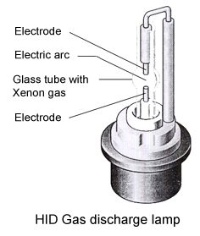
Another type of HID lamp used by the plant industry is the high pressure sodium discharge (HPS) lamp which emits a white light similar to incandescent light. A mixture of xenon and an amalgam of mercury and sodium are contained in an arc tube composed of aluminum oxide ceramic. The aluminum oxide can withstand the high heat of the electric arc and the reactive sodium metal. As can be seen in the image below, this lamp produces most of its light in the red-orange-yellow spectrum, which is characteristic of sodium. This spectrum of light promotes flowering. The blue-violet spectrum is a result of the mercury. (http://www.edisontechcenter.org/SodiumLamps.html)
(http://www.bulbs.com/learning/hid.aspx)

It is common to use a combination of metal halide and high pressure sodium lamps where grow lamps are used commercially.

The image below compares the emission spectra for sunlight with lights from an incandescent bulb, a fluorescent lamp, a metal halide lamp, and sodium discharge tubes.

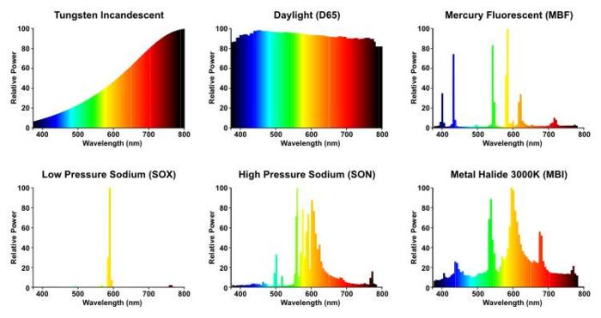
Comparison of emission spectra of various types of grow lamps with sunlight

(http://www.lamptech.co.uk/Documents/SO%20Spectral.htm)

Light-emitting diodes

The science behind diodes

Before discussing what light-emitting diodes are, we first need to describe the science behind their function.

At the microscopic level, solids can be classified as metals, semiconductors, or insulators based on the amount of energy needed to excite electrons from localized bonds to a higher energy state where they are free to move about the solid. This energy is called the band gap energy, ΔE. In metals, the band gap energy is very small, resulting in many delocalized electrons and high conductivity. In insulators, the band gap energy is very large, so insulators are poor conductors. Semiconductors have electrical conductivity between metals and conductors. See diagram below for more information.

Let’s use silicon to explain how semiconductors can become good conductors of electricity. Silicon, which has four valence electrons, is a semiconductor. In a silicon crystal, each atom of silicon can bond to four other atoms of silicon and there are no free electrons to move around. In this case silicon acts as an insulator. Silicon can be doped by adding impurities to the crystal and its conducting properties will change.

One way to dope the silicon is to add a small amount of phosphorous or arsenic. Each of these atoms have 5 valence electrons. The fifth electrons of these atoms have nothing to bond with and are free to move around. Because this type of doped silicon has an excess of electrons, and electrons are negatively charged, this is called an N-type silicon, or an N-type semiconductor.

Elements like boron or gallium each have three valence electrons and they can also be used to dope silicon. In this instance, electrons in the silicon atoms have nothing to bond with which causes electron holes. This type of doping produces a P-type semiconductor because the lack of electrons creates positive charge.
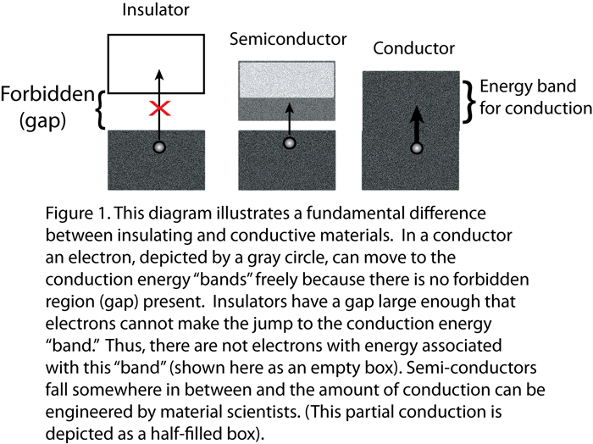
(http://jqi.umd.edu/sites/default/files/images/bandgap_large.png)
Both of these doped semiconductors are good conductors of electricity. These semiconductors can be joined and where they meet is called the junction. These type of semiconductors are called diodes. Separately both the N-type semiconductor and P-type semiconductor are good conductors. But when they are joined they become insulators. This is because at the junction the electrons in the N-type semiconductor fill the holes in the P-type semiconductor and an insulating layer forms.
If you connect the cathode end of a battery to the N-type semiconductor, the electrons in the semiconductor repel the electrons at the cathode and move toward the junction. The holes move away from the anode end of the battery toward the junction and the electrons now fill the holes. New electrons and new holes form and as this process continues, current flows.

The diagrams below illustrate how diodes operate.
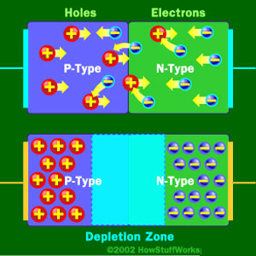
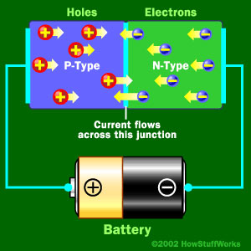
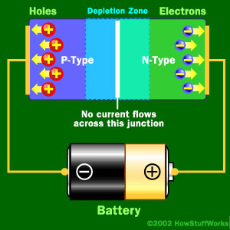
An insulator forms when a P-type semiconductor is joined with an N-type semiconductor. At the junction, free electrons from the N-type material fill holes from the P-type material. This creates an insulating layer in the middle of the diode, called the depletion zone.

Current flows when the negative end of the circuit is hooked up to the N-type layer and the positive end is hooked up to P-type layer, electrons and holes start moving and the depletion zone disappears.
But when the positive end of the circuit is hooked up to the N-type semiconductor and the negative end is hooked up to the P-type semiconductor, free electrons collect on one end of the diode and holes collect on the other. The depletion zone gets bigger and electricity can’t flow.

(http://electronics.howstuffworks.com/led1.htm)

How light emitting diodes work

Diodes that produce light are called light emitting diodes (LEDs). Aluminum-gallium-arsenide (AlGaAs) is a common semiconductor in LEDs. As in pure silicon, pure aluminum-gallium-arsenide has all of the atoms bonded perfectly to their neighbors, leaving no free electrons to conduct electricity. By doping the AlGaAs to become N-type or P-type semiconductors and it will conduct electricity as electrons fill holes. In the process, energy is released in the form of light. (http://www.thenakedscientists.com/HTML/questions/question/1135/)

The band gap energy of an LED is associated with the wavelength and color of the photon released; for visible light, this energy ranges from 1.8 eV to 3.0 eV.

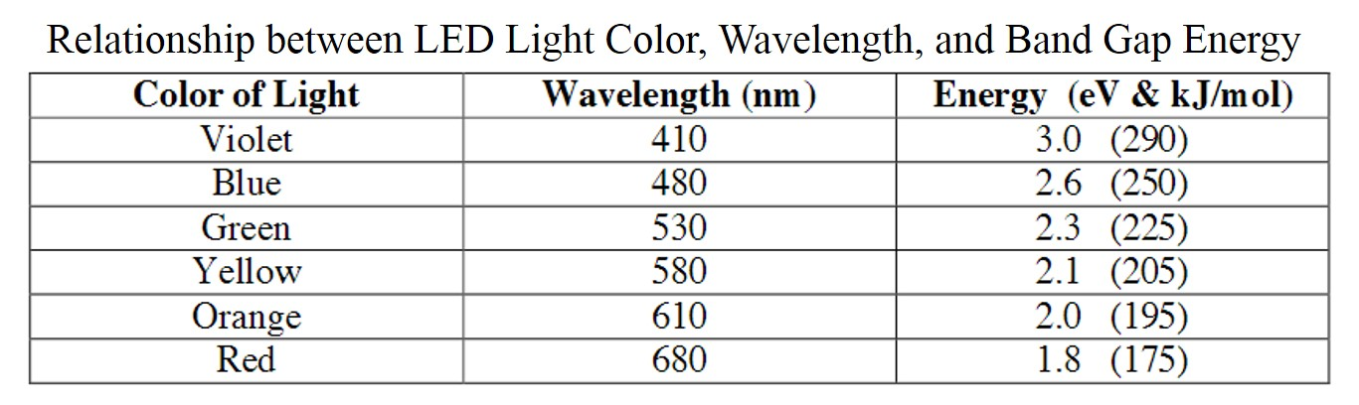
(http://faculty.sites.uci.edu/chem1l/files/2013/11/RDGLED.pdf)

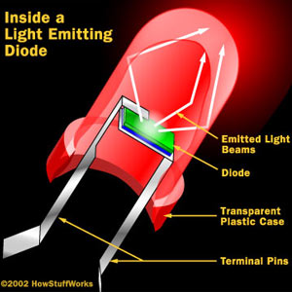
Free electrons moving across a diode can fall into empty holes from the P-type layer. This involves a drop in energy from the conduction band to a lower orbital, so the electrons release energy in the form of photons. This happens in any diode, but you can only see the photons when the diode is composed of certain material. The atoms in a standard silicon diode, for example, are arranged in such a way that the electron drops a relatively short distance. As a result, the photon's frequency is so low that it is invisible to the human eye—it is in the infrared portion of the light spectrum. Visible light-emitting diodes (VLEDs) are made of materials characterized by a wider gap between the conduction band and the lower orbitals. The size of the gap determines the frequency of the photon—in other words, it determines the color of the light.
(http://www.jimonlight.com/wp-content/uploads/2008/09/led-diagram1.jpg)

LEDs are specially constructed to release a large number of photons outward. They are housed in a plastic bulb that concentrates the light in a particular direction. LEDs offer several advantages over incandescent lights. LEDs are even easy to dim and are perfect for encouraging plant growth, since they efficiently give off a lot of light without producing heat that could potentially be damaging to plant life.

Photosynthesis

In green plants, the process of photosynthesis occurs in the chloroplasts. The overall balanced equation for the reaction is

6 CO₂ + 6 H₂O → C₆H₁₂O₆ + 6 O₂
Sunlight energy

The process of photosynthesis essentially involves a redox reaction that transfers the electrons from the oxygen in the water molecules to the carbon atoms. Plants have to break the bonds of two stable compounds, CO₂ and H₂O, rearrange electrons, and produce two compounds which are less stable relative to the first two. It would not be profitable for the plants to do this using their own energy. Instead plants use an energy source that is readily available to them, sunlight. (http://www.gardeningsite.com/aeroponics/aeroponics-benefits-and-disadvantages/)

But, interestingly, only 3% of the sun’s energy is actually used in photosynthesis. Why is there such a great loss? Only part of the visible spectrum is useful in order for photosynthesis to take place. From the visible light spectrum, only red and blue wavelengths of light are used in photosynthesis. And, some of this energy is lost to reflection. Additional sunlight that could have been used by the plants is instead absorbed and used by the microorganisms in the soil (see diagram below).

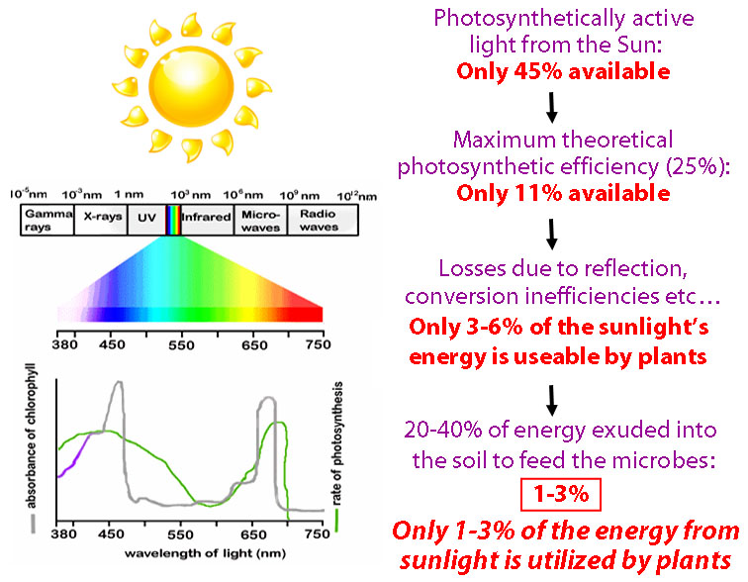

Relative amounts of sunlight available for photosynthesis
and wavelengths of sunlight absorbed by chlorophyll in photosynthesis

(http://www.greenearthagandturf.com)

The light reaction for photosynthesis occurs in sac-like structures called thylakoids. This phase of photosynthesis requires light, and the pigmented chlorophyll molecule is used to absorb this light. The structure of a chlorophyll molecule consists of a ring portion that contains a magnesium complex, which can easily accept and donate electrons, and a non-polar side chain which anchors the chloroplast in the thylakoid membrane. The ring portion of the chlorophyll gives it its characteristic green color and this is where the light is absorbed. There are two types of chlorophyll, chlorophyll a, which absorbs light at 430 nm and 663 nm, and chlorophyll b, which absorbs at 453 nm and 642 nm.
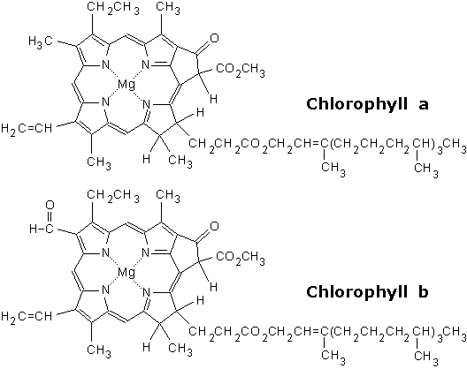
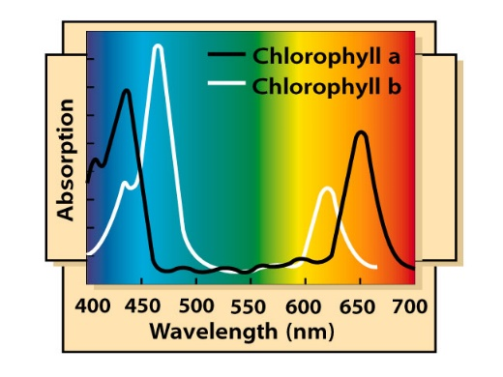
The slight difference in structure (shaded in blue) between
chlorophyll a and chlorophyll b
accounts for the difference in absorption of light.

(http://www.food-info.net/uk/colour/chlorophyll.htm)
The wavelengths of visible light absorbed by
chlorophyll a and chlorophyll b

(https://wiki.bio.purdue.edu/biol13100/images/6/61/Chlorophyll.JPG)

The energy from the excited electrons in this complex is then transferred to a chain of electron carriers. Electrons flow from water molecules to NADP⁺, forming NADPH and free oxygen molecules. ATP also forms. This is a highly endothermic reaction, and light provides the energy to transfer electrons from the water to the oxygen. This reaction can be summarized as:
2 H₂O 4 e⁻ + 4 H⁺ + O₂

The second phase of photosynthesis, called the Calvin cycle, occurs in the thick fluid matrix of the chloroplasts called the stroma. While this reaction does not require light, it is dependent on the light reaction to provide the NADPH and ATP that reduces the carbon dioxide to glucose:
6 CO₂ + 18 ATP + 12 NADPH C₆H₁₂O₆ + 18 ADP + 12 NADP⁺

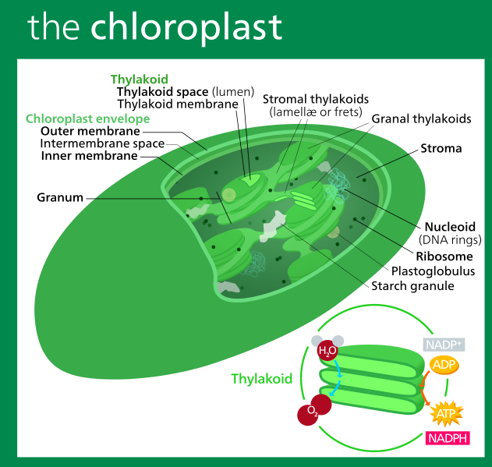
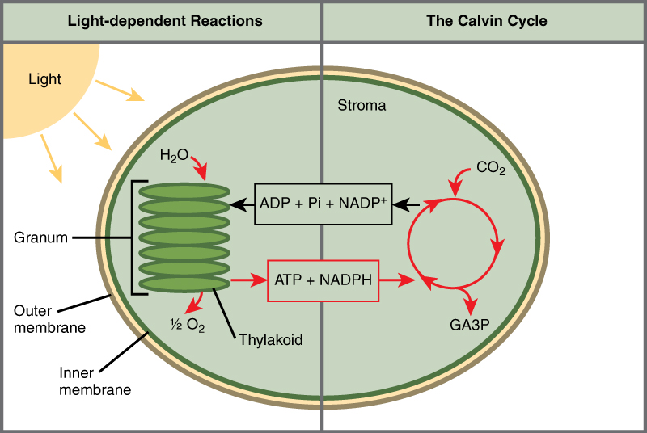
Chloroplast Structure

(https://commons.wikimedia.org/wiki/File:Chloroplast_II.svg)
The light reaction of photosynthesis occurs in the thylakoids,
producing the energy needed for the Calvin cycle in the form of NADPH
and ATP. The Calvin cycle occurs in the stroma.

(https://figures.boundless-cdn.com/18852/full/figure-08-01-06.%402x.jpeg)

Sustainable agriculture

The term ''sustainable agriculture'' is defined by U.S. Code Title 7, Section 3103. The five components of sustainable agriculture:

- Satisfy human food and fiber needs.
- Enhance environmental quality and the natural resource base upon which the agriculture economy depends.
- Make the most efficient use of nonrenewable resources and on-farm resources and integrate, where appropriate, natural biological cycles and controls.
- Sustain the economic viability of farm operations.
- Enhance the quality of life for farmers and society as a whole.

(https://nifa.usda.gov/program/sustainable-agriculture-program)

The Grace Communication Foundation, which promotes consumer actions and public policies that support sustainable food production, further defines sustainable agriculture based on the following principles.

Environmental Preservation

Sustainable farms produce crops and raise animals without relying on toxic chemical pesticides, synthetic fertilizers, genetically modified seeds, or practices that degrade soil, water, or other natural resources. By growing a variety of plants and using techniques such as crop rotation, conservation tillage, and pasture-based livestock husbandry, sustainable farms protect biodiversity and foster the development and maintenance of healthy ecosystems.

Protection of Public Health

Food production should never come at the expense of human health. Since sustainable crop farms avoid hazardous pesticides, they're able to grow fruits and vegetables that are safer for consumers, workers, and surrounding communities. Likewise, sustainable livestock farmers and ranchers raise animals without dangerous practices like use of nontherapeutic antibiotics or arsenic-based growth promoters. Through careful, responsible management of livestock waste, sustainable farmers also protect humans from exposure to pathogens, toxins, and other hazardous pollutants.

Sustaining Vibrant Communities

A critical component of sustainable agriculture is its ability to remain economically viable, providing farmers, farmworkers, food processors, and others employed in the food system with a livable wage and safe, fair working conditions. Sustainable farms also bolster local and regional economies, creating good jobs and building strong communities.

Upholding Animal Welfare

Sustainable farmers and ranchers treat animals with care and respect, implementing livestock husbandry practices that protect animals' health and wellbeing. By raising livestock on pasture, these farmers enable their animals to move freely, engage in instinctive behaviors, consume a natural diet, and avoid the stress and illness associated with confinement.

(http://www.sustainabletable.org/246/sustainable-agriculture-the-basics)

It is questionable as to whether hydroponics and aeroponics are considered sustainable farming. Sites that sell these types of systems will say yes, these are sustainable systems because they cut down on the use of water and on transportation costs. (http://www.thehydroponicum.com/page.php/21/Is_it_sustainable.html)

On the other hand, others will say that hydroponics is not a sustainable farming practice because the systems rely on fossil fuels to supply energy for the systems; hydroponics often relies on artificial lights which add to their carbon footprint, and crops are limited to leafy vegetables and herbs. These costs can be higher than the savings from transportation costs. (http://www.conserve-energy-future.com/sustainable-farming-practices.php)

Is vertical farming sustainable? Costs for LED lights are high, but the technology is improving. Energy consumption is high but there have been improvements in renewable energy sources. Property in urban areas where vertical farms are located are high, but transportation costs are much less than that for traditional open field agriculture. Because vertical farming is so new, standards for comparison are still being developed and there is not yet enough data to determine its sustainability. (https://www.linkedin.com/pulse/how-sustainable-vertical-farming-columbia-students-try-gordon-smith)

References
(non-Web-based information sources)
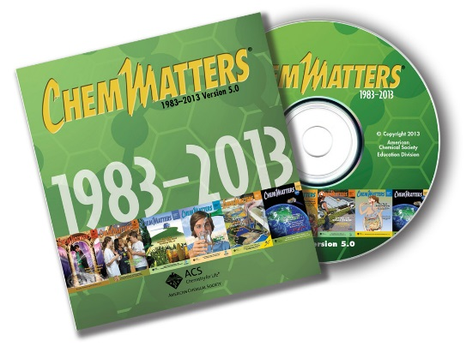
The references below can be found on the
ChemMatters 30-year DVD, which includes all articles
published from the magazine’s inception in October 1983 through April 2013, all available Teacher’s Guides, beginning February 1990, and 12 ChemMatters videos. The DVD is available from the American Chemical Society for $42 (or $135 for a site/school license) at this site: http://ww.acs.org/chemmatters. Click on the “Teacher’s Guide” tab directly under the ChemMattersonline logo and, on the new page, click on “Get the past 30 Years of ChemMatters on DVD!” (the icon on the right of the screen).

Selected articles and the complete set of
Teacher’s Guides for all issues from the past three
years are available free online at the same Web site, above. Click on the “Issues” tab just below the logo, “ChemMattersonline”.
30 Years of ChemMatters !
Available Now!

Graham, T. Light Emitting Diodes—Tune into the Blues. ChemMatters, 2001, 19 (2), pp 4–5. This article contains information on the chemistry and electronics of LEDs.

Pickett, M. Dirt? Who needs it? How Hydroponics is Poised to Change the World. ChemMatters, 2015, 33 (1), pp 14–15. This article contains information about hydroponic agriculture as a possible alternative to growing plants in soil.

Web Sites for Additional Information
(Web-based information sources)
Open-field agriculture

For some historical information on open-filed farming, go to http://historylink101.com/lessons/farm-city/middle-ages.htm.

Vertical farming

This article from food columnist Tamar Haspel, “Will Indoor, Vertical Farming Help Us Feed the Planet—Or Hurt It? Comes from the food section of the June 17, 2016 edition of The Washington Post. It discusses in detail the benefits of vertical farming (not so much about the “hurt us” part). In the end, its utility as a food source in the future seems to come down to the cost of electricity in the future. (https://www.washingtonpost.com/lifestyle/food/will-indoor-vertical-farming-help-us-feed-the-planet--or-hurt-it/2016/06/16/f1faaa98-3332-11e6-8ff7-7b6c1998b7a0_story.html)

The article “How Vertical Farming is Revolutionizing the Way We Grow Food”, from Gizmodo’s 9/14/2015 issue, provides a thorough discussion of the topic. It includes several nice photo examples of present-day industrial vertical farming. (http://io9.gizmodo.com/how-vertical-farming-is-revolutionizing-the-way-we-grow-1730550597)

This short video clip (2:32) from AeroFarms, located in New Jersey, shows their industrial facility for vertical farming. (http://www.reuters.com/article/us-new-jersey-vertical-farming-idUSKCN0ZE24L)

This 5:29 video clip shows VertiCrop, an industrial vertical farm, growing lettuce and herbs on the rooftop of a parking garage in the city of Vancouver. (http://grow.verticrop.com/vertical-farming/)

Photosynthesis

The Royal Society of Chemistry provides teacher background material on many topics. This one on photosynthesis is from the Biochemical Society and includes nice detail on the chemistry of photosynthesis, including condensation reactions and oxidation-reduction reactions. There are several PowerPoint slides that you can use with your students to help them understand the chemistry involved at each step. If you don’t have PowerPoint, you can download a free version of PowerPoint Viewer to open the slides. (http://www.rsc.org/Education/Teachers/Resources/cfb/Photosynthesis.htm)

LEDs

This article, “Plant Productivity in Response to LED Lighting”, describes the potential of LEDs as a light source for plants.
(http://hortsci.ashspublications.org/content/43/7/1951.full)

Sustainable food

This site helps students understand the role food plays in the economy and in their health: http://www.chgeharvard.org/resources

Learn what effect your food choices have on the local economy. Visit http://www.buylocalfood.org/.

Hydroponics

Could hydroponics solve agricultural challenges in deserts—and even on Mars? What are the innovations of some of the hydroponic visionaries? (http://www.truth-out.org/speakout/item/35885-solar-powered-hydroponics-could-be-the-future-of-agriculture)

