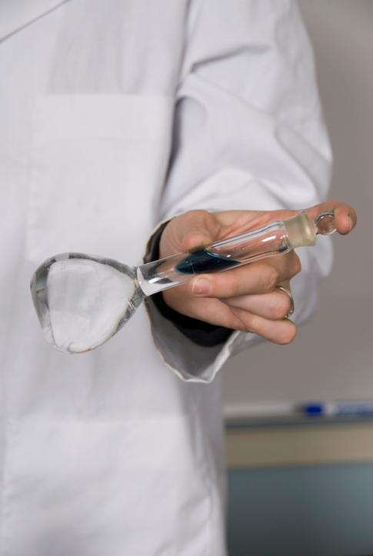
Acid-Base Titrations
Figure 1: Image courtesy of Creative Commons

Learning Outcomes
At the end of this module, students will be able to:
- Prepare and standardize a NaOH solution
- Be able to set up the apparatus for a titration
- Develop the hands-on skill of using a burette
- Set up and complete an acid-base titration
- Determine the concentration of an unknown acid solution

Supplies
Glassware
- 100 mL Volumetric flasks
- Buret
- 250 mL Erlenmeyer flasks
- 100-250 mL beakers
Equipment
- Electronic stirrer
- Stir bar
- Buret clamp
- Ring stands, clamps
Reagents
- 30% by weight NaOH solution or a 0.500 M standardized solution of NaOH (Instructors may also opt for students to make a solution using solid NaOH - 20.0 g of NaOH per each 1 L of solution)
- White Vinegar (purchased from the grocery)
- DI Water
- Potassium hydrogen phthalate (KHP)
Other items
- Phenolphthalein indicator

Safety Considerations
Lab participants must follow all the safety rules and regulations as outlined by the course instructor and the institution.

Experimental Question
White vinegar used for cooking is a solution of acetic acid and water. What type of experiment could we use to determine the concentration of acetic acid in white vinegar?

Balanced Reaction
NaOH_{(aq)} + CH₃COOH_{(aq)} → Na⁺CH₃COO⁻_{(aq)} + H₂O_{(l)}

Procedure

Preparation of the Titrant
If a standardized 0.500 M solution of NaOH is available, please skip to Titration of Vinegar

Be sure to wear gloves while handling the 30% by weight NaOH stock solution.
- Carefully decant about 12.5 ml of the 30%, by weight, NaOH stock solution into a graduated cylinder, being careful to not disturb any (if present) solid at the bottom of the stock container.
- Add it to the 250-ml volumetric flask.
- Use a couple of small samples of distilled water to rinse out the graduated cylinder.
- Use a funnel to pour distilled water into the volumetric flask.
- Fill the volumetric flask to the etched volume mark on its neck with distilled water, adding the final drops with an eyedropper to not overshoot the mark.
- Stopper the flask or cover the opening with a piece of parafilm.
- Holding the stopper in place with your thumb, invert the flask at least ten times to thoroughly mix the contents.
- Thoroughly rinse the graduated cylinder with multiple volumes of tap water once you’ve transferred the concentrated NaOH; since concentrated NaOH can permanently etch the glass if allowed to remain in contact with it.

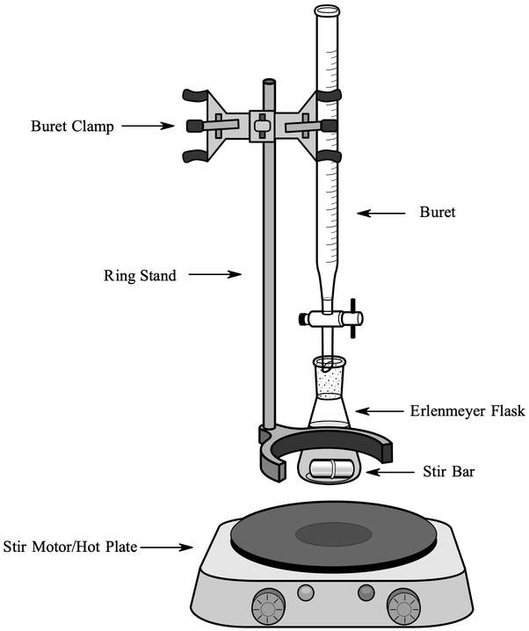
Preparation of the Burette
Figure 2: Standard set up for titration. Image courtesy of Creative Commons
- Clean a 50-mL burette with soap solution and a burette brush.
  - Rinse first with tap water, watching to see if water drains cleanly down the walls, leaving no droplets behind.
  - Then rinse with distilled water.
  - Finally add two separate ~5-mL samples of NaOH solution to the burette with the stopcock closed; gently allow it to roll over all surfaces of the internal walls of the burette before letting it drain out.
- Mount the burette on a ring-stand using a buret clamp (see Figure 2).
- Use a long-necked funnel to fill the burette with the NaOH solution. Gently place the funnel in the burette (if it is dropped into the burette, both the top of the buret and the neck of the funnel may break).
- Keeping in mind that volume read from a burette must be at eye-level and being careful to not add so much titrant to the funnel that the buret will overflow, fill the burette. While waiting to do the first titration, place a piece of parafilm over the top of the burette to limit the contact of the NaOH with air. Remove the parafilm once you begin the titration.

Standardization of NaOH
If you are using a standardized NaOH solution, you may skip this section. Provide the concentration of the standardized solution.

- Weigh out between 1.2 - 1.5 g of the primary standard, potassium hydrogen phthalate (KHP). Record the mass. Molar mass of KHP = 204.22 g/mol
- Transfer the KHP to a 250 mL Erlenmeyer flask and dissolve it in ~10-20 mL of distilled water. Swirl the sample to dissolve completely.
- Add two drops of phenolphthalein indicator and a magnetic stir bar.
Figure 3: Reading the meniscus. Image courtesy of Creative Commons
- Place the Erlenmeyer flask on a stir plate and set to stir gently.
- Arrange the Erlenmeyer flask on the stir plate so that it is directly under the burette. Drops from the burette should land directly into the solution. Be sure to read the volume at the bottom of the meniscus (see Figure 3).
- Record the initial volume (to the nearest 0.01 mL) of NaOH in the burette.
- Calculate the volume of NaOH at which you anticipate observing the phenolphthalein endpoint.
- Add ~ 2.0 mL of NaOH from the burette. Read the new burette volume (to the nearest 0.01 mL); record the volume in your lab notebook
- Continue adding ~1.0 mL aliquots of NaOH, recording burette volumes for each addition, until you are within 2 mL of the minimum volume you estimated in step 7.
- By this time each addition of NaOH will probably cause the solution to turn at least temporarily pink, only to go colorless as it is stirred
- Begin adding NaOH in ~0.2 mL aliquots, recording volume as before. Carefully monitor the color to have a feel for how close you are to the phenolphthalein color change.
- When longer stirring becomes necessary to dissipate the pink color, slow the NaOH additions to 0.1 mL.
- Record the volume, to the nearest 0.01 mL, at which the first permanent (lasts for at least 30 seconds) pale pink color is observed.
- Calculate the concentration of the NaOH solution (note that there is one acidic H⁺ in KHP)

Titration of Vinegar
- Prepare two samples of vinegar solution.
  - For each sample, pipet 12.5 mL of the vinegar into a 100 mL volumetric flask and add distilled water up the mark. Cover with a stopper or parafilm and invert the solution 5-7 times to ensure that the solution is homogeneous.
- Prepare another buret with the standardized NaOH solution, setting it up exactly as you did for the standardization.
- Transfer the first sample of diluted vinegar solution to a 250 Erlenmeyer flask, add a stir bar, and 2 drops of phenolphthalein indicator.
- Titrate the vinegar solution to a pale pink endpoint. Record the volume of titrant used to obtain the endpoint. As you get near to the endpoint, add smaller and smaller aliquots. You may find that you “overshoot” the endpoint in the first sample. Note the volume where you may have overshot and use that volume to help you titrate the second sample.
  - For example, if the first sample turned pale pink after the addition of 29 mL of NaOH, but 31 mL of NaOH turned it a dark pink, you know that the endpoint is near 29 mL of added titrant. In the second sample, start adding smaller and smaller aliquots at ~25 mL. (Note that these volumes are for example purposes only, do not assume that you will see a color change at these volumes)
- Given the dilution of the original vinegar solution in Step 1 and the volume of standardized NaOH needed to reach the endpoint, calculate the concentration in M of vinegar.

Deliverable
Calculations:
- Concentration of the standardized NaOH solution
- Concentration of the original vinegar sample.

Activity for Practical
Determine the concentration of an unknown sample of acetic acid. Standardized NaOH solution should be provided.

Instructor Notes - Concepts
Titrations - Weak Acid/Strong Base
In this module students will be asked to determine the concentration of acetic acid in a sample of white vinegar. Students will first standardize an NaOH solution, which will be used as the titrant. Students will then complete a titration of their vinegar sample and use the endpoint of the titration to determine the concentration of acetic acid in their sample.

Background information for students

Discussion Topics
- Why does the NaOH solution have to be standardized rather than prepare it as we did in Module 1 by weighing the appropriate mass of NaOH and dissolving it in distilled water?
- Describe the structure of KHP and why it is used as a standard.
- Discuss how phenolphthalein works as an indicator.
- Demonstrate reading the volume on a buret.
- Demonstrate how to set up a titration experiment.
- How is the endpoint of a reaction determined?
- Why do we do two titrations for the vinegar sample?
- Describe the balanced equation for the reaction between NaOH and KHP and between NaOH and acetic acid.
- Explain that vinegar is a solution of acetic acid in water.

Calculations
**These calculations are not to be shared with the students, but instead can be used to illustrate the methods used to determine the concentration of acetic acid in white vinegar by using titration**
Preparation of the Titrant
- Determining the approximate concentration of NaOH of 30% by weight solution
30% by weight = 30 g NaOH in 100 g solution
30 g NaOH = 0.75 mol NaOH (molar mass for NaOH = 40 g/mol)
100 g solution = 75.19 mL = 0.07519 L (density for 30% NaOH solution is 1.33 g/mL at STP)
[NaOH] ~ 9.97 M

You could also have students prepare a stock solution that is approximately 10 M in NaOH starting with solid NaOH.

- Determine the approximate concentration of the titrant (12.5 mL of stock diluted to 250 mL)
$$M_{1}V_{1} = M_{2}V_{2}$$
Calculate M₂
Where M₁ ~ 9.97 M NaOH and V₁ = 12.5 mL = 0.0125 L
and V₂ = 250 mL = 0.250 L
The approximate concentration of the NaOH before standardization is: 0.500 M

Standardization of NaOH
- Assuming 1.30 g of KHP (molar mass = 204.22 g/mol) = 6.365 x 10⁻³ mol KHP

KHP (C₈H₅KO₄) is monoprotic (i.e. has one acidic proton)
NaOH _{(aq)} + C₈H₅KO₄ _{(aq)} → Na⁺C₈H₄KO₄⁻ _{(aq)} + H₂O_{(l)}

To determine the concentration of the NaOH solution (KHP is monoprotic):

At the endpoint, mol H⁺ = mol OH⁻ or 6.365 x 10⁻³ mol OH⁻ and since 1 mol OH⁻ = 1 mol NaOH, then the concentration of the standardized NaOH solution can be calculated by using:

$\frac{6.365 × {10}^{-3}mol NaOH}{volume at endpoint in L} =\left[NaOH\right]$

Note that the volume needed to reach the endpoint will be approximately 12-15 mL. You can ask students to estimate the endpoint by doing the calculations above. This may prevent them from overshooting the endpoint.

Titration of Vinegar

Instructors can use the calculation below to make adjustments to the volume of vinegar used in the exercise.

Note that the concentration of acetic acid in white vinegar is typically 4-8% v/v
(CH₃COOH: density = 1.05 g/mL, molar mass 60.052 g/mol)

Sample calculation for volume of NaOH needed for the titration. All values are approximated. This calculation can be used to determine the estimated volume of titrant needed.

- By using the same logic as for the NaOH solution, the approximate concentration of acetic acid in vinegar (assuming a 5% v/v concentration, Also, these values are approximated and used solely for illustrative purposes).
  - 5% (v/v) CH₃COOH = 5 mL of CH₃COOH in 100 mL solution

  - Use the density of the CH₃COOH solution and the molar mass to find the mass of CH₃COOH:
5.00 mL x 1.05 g/mL = 5.25 g CH₃COOH or 8.75 x 10⁻² mol CH₃COOH

  - The concentration can then be calculated as 0.875 M (the equivalent of a 5% v/v concentration)

  - Use this value to determine the approximate concentration of the acetic acid sample that was titrated.
    - 12.5 mL of vinegar contains 0.01094 mol CH₃COOH

  - If the [NaOH] = 0.500 M, then it would take approximately 21.8 mL of titrant to neutralize the CH₃COOH in the sample.

- Example calculation for calculation of [CH₃COOH] in vinegar using the experimental data

The reaction between acetic acid and sodium hydroxide:

NaOH_{(aq)} + CH₃COOH_{(aq)} → Na⁺CH₃COO⁻_{(aq)} + H₂O_{(l)}

- Standardized [NaOH] = 0.500 M
(These values are for illustrative purposes only)
  - Experimental volume of NaOH to reach endpoint = 25 mL
  - At the endpoint:
Mol NaOH = mol OH⁻ = mol H⁺ = mol CH₃COOH (acetic acid has one acidic proton)

So $0.500 M NaOH × 0.0250 L NaOH×\frac{1 mol OH^{-}}{1 mol NaOH} ×\frac{1 mol H^{+}}{1 mol OH^{-}} ×\frac{1 mol CH_{3}COOH}{1 mol H^{+}} = 0.0125 mol C{H_{3}COOH }^{}$

  - This means that the 12.5 mL aliquot of vinegar that was transferred from the stock vinegar solution had a concentration of 1.00 M. (Note, given that the literature value of 0.875 M CH₃COOH in vinegar is slightly lower than this “experimental” value the student most probably overshot the endpoint.)

Materials

Instructions for Stockroom (assuming 24 students per lab)

Each student or team will need the following
Preparation of the Titrant
- 12.5 mL of 30% NaOH solution
- 250 mL volumetric flask
- Graduated cylinder (25 mL volume)

Preparation of the Burette
- Glass funnel
- Parafilm or stoppers for the volumetric flasks
- 50-mL buret
- Ring stand
- Buret clamp
- 125 mL Erlenmeyer flask
- Stir bar
- Stir plate

Standardization of NaOH
- 1.2 – 1.5 g KHP
- Balance that can measure to the hundredth place
- 250 mL Erlenmeyer flask
- 1-2 drops of phenolphthalein
- Buret set up as described under “Preparation of the Burette” section above
- 50 mL of NaOH solution as prepared in the Preparation of the Titrant section of the exercise.

Titration of Vinegar
- 25 mL of white vinegar
- Graduated pipet that can measure 12.5 mL
- 100 mL volumetric flask
- 1-2 drops of phenolphthalein
- Buret set up as described under “Preparation of the Burette” section above
- 50 mL of standardized NaOH solution as prepared during the Standardization of NaOH section of the exercise

Acknowledgements
Thanks to the following authors and reviewers for the modules:

Dr. Michelle M. Brooks, American Chemical Society
Dr. Felicia Fullilove, American Chemical Society
Dr. Natalia Martin, American Chemical Society
Dr. Lily Raines, American Chemical Society

Dr. Jennifer Barber, Westlake High School
Dr. Michelle Boucher, Utica College
Dr. Bonnie Dixon, University of Maryland – College Park
Dr. Elizabeth Jenson, Aquinas College
Dr. Shanina Johnson, Spelman College

