Module 3: Heating Under Reflux (Fischer Esterification)
This module is modified from:
A Visual Organic Chemistry Reaction: The Synthesis of 4-Amino-3-nitrobenzoic Acid Methyl Ester via Fischer Esterification. Caleb M. T. Kam, Stephan M. Levonis, and Stephanie S. Schweiker. Journal of Chemical Education 2020 97 (7), 1997-2000
DOI: 10.1021/acs.jchemed.9b01168

Learning Outcomes
- Students will learn how to conduct thin layer chromatography.
- Students will learn how to accurately assemble, monitor, and disassemble a reaction that must heat under reflux.
- Students will learn best practices for operating a heating mantle.

Supplies
Glassware

- Reflux Condenser
- Rubber tubing
- round bottom flask(s)
- Clamps
- Weigh paper or boats
- Balance
- TLC plate
- Glass TLC spotters
- Glass TLC chamber
- Beakers
- Boiling chips
- Keck clips
- Clamps
- Graduated cylinder
- Grounded variable transformer
- UV Light (for TLC visualization)

Chemical Reagents
- 4-amino-3-nitrobenzoic acid
- Sulphuric Acid
- Methanol
- Dichloromethane

Safety Considerations
MSDS Sheets
Heat gloves
Nitrile gloves
Goggles
Corrosive Acid

Experimental and Safety Questions
- What factors must be considered when heating a reaction mixture?
- How do those factors impact the method and glassware used to conduct the heating?
- What could happen if we add too much or too little solvent into the reaction mixture?
- What is the role of the water running through the reflux condenser?
- Why is it important for the reaction mixture to remain open to air?
- How do we determine if the reaction is under reflux?
- Why is it important to never plug a heating mantle directly into an outlet?
- How did the reaction mixture change (visually) over the course of the reaction?
- How is thin layer chromatography used to determine the identity of the reaction mixture?
- What is a retention factor?
- Explain why pens cannot be used for the preparation of a TLC plate.
- How should you disassemble a reflux apparatus?
- What other considerations should be made when handling a TLC plate?
- Compare and contrast heating under reflux and distillation.

Procedure

Part I: Heating Under Reflux (See Figure 1)

- In a 50 mL round bottom flask (rbf), dissolve 150 mg of 4-amino-3-nitrobenzoic acid in 10 mL of methanol.
- Add a magnetic stirring rod and 1-2 boiling chips.
- Connect the heating mantle to the monkey bars or support stand and sit the rbf into the heating mantle
- Add 3 drops of sulphuric acid and attach the reflux condenser to the rbf. Use a Keck clip to hold the reflux condenser to the round bottom flask.
- Clamp the reflux condenser and the round bottom flask to the monkey bars or support stand.
- Attach the rubber tubing and slowly turn on the water.
- Plug the heating mantle into the grounded variable transformer and turn the power to 45 (if on a scale of 0-100).
- Turn on the stir plate.
- Allow the mixture to heat at reflux for 1 hour. (Note: The reaction mixture should not boil too vigorously).
- After 1 hour, turn off the heating mantle and stir plate. Allow the reaction mixture to cool for 10 minutes.
- Turn off the water after the mixture has cooled.
- Disassemble the reflux set-up and place the rbf to the side. We will next TLC the mixture, which contains our crude (unpurified) product. Afterwards, we will use the crude mixture for the next module

Data Table
Compound Name | Molecular Formula | Density | mols | Amount (mg) | Volume
4-amino-3-nitrobenzoic acid
methanol
Sulfuric acid

Part II: Thin Layer Chromatography (TLC) (See Diagram)

- Gather one TLC sheet, three glass spotters, and a TLC chamber. (Your lab instructor may have already cut the sheets into smaller square portions for each student)
- Using a pencil, draw a line 0.5 cm from the bottom of the TLC plate
- On the line, draw three dots and label the dots SM (for starting material), RXN (for reaction), and P (for product).
- Dip one glass spotter into a dilute sample of the 4-amino-3-nitrobenzoic acid (this is considered your solute). Once the spotter has suctioned a small amount of the compound, release the contents of the spotter onto the TLC dot labeled SM. Repeat this step for your reaction mixture and product. Be sure to use a clean spotter each time.
- In a TLC chamber (or beaker) place 1-2 mL of dichloromethane. The DCM level should not be higher than the “start line” on the TLC plate.
- Place your TLC plate into the chamber. If you are using a beaker, cover the beaker with a watch glass. The solvent will rise up the TLC plate via capillary action. Do not disturb the chamber until the solvent is approximately 0.5 cm from the top of the plate. Reminder - Do not allow the solvent to run off the TLC plate. Stop the TLC plate when the solvent is approximately 0.5 cm from the top.
- Remove the plate from the chamber.
- Place the TLC plate under a UV lamp.
- With a pencil, trace the spotted compounds and calculate a retention factor (R_{f} value) of the starting material, product and the components of your reaction mixture.

Data and Calculations
Draw your TLC plate below and calculate the R_{f} value of the starting materials, product and your reaction mixture. (Note: the calculation of R_{f} = distance traveled by solute/ distance traveled by solvent.)

Activity for Practical
Model a reflux under heating set-up using water.
Prepare a TLC plate and chamber.

Instructor Notes
- Instructors are encouraged to 1) demonstrate proper techniques or 2) provide pre-recorded videos/demonstrations for student reference.
- After 1 hour of reflux the reaction should yield ~45% of 4-amino-3-nitrobenzoic acid methyl ester. Longer reflux times will lead to higher yields. Full conversion of the starting material takes ~16 hours. See Caleb M. T. Kam, Stephan M. Levonis, and Stephanie S. Schweiker. Journal of Chemical Education 2020 97 (7) for more information.

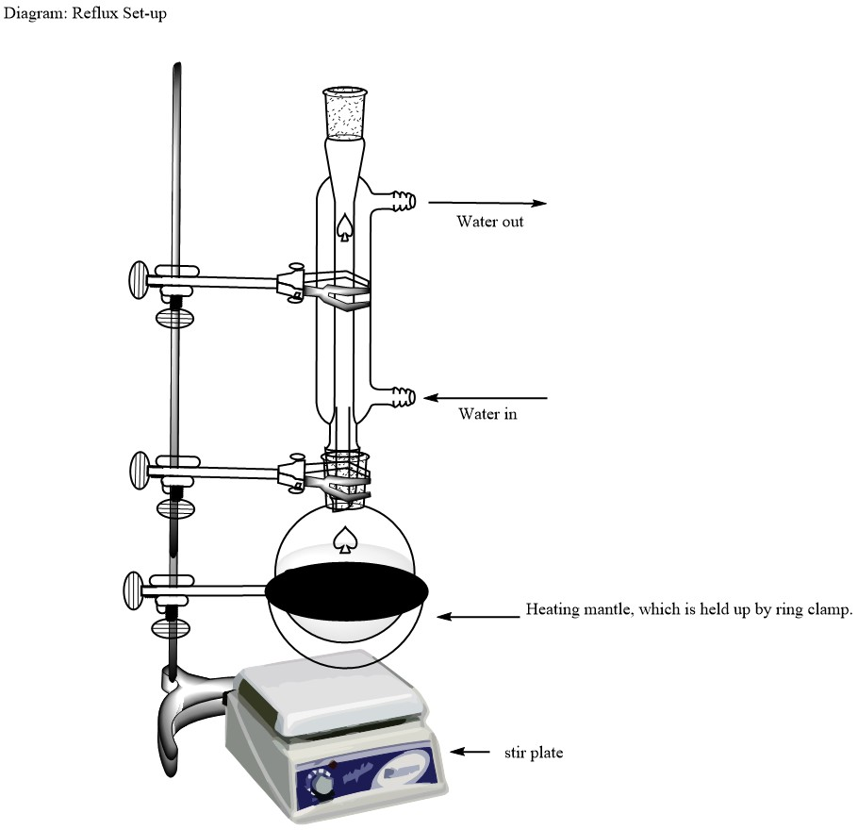
Figure 1: Reflux apparatus and experimental set up.

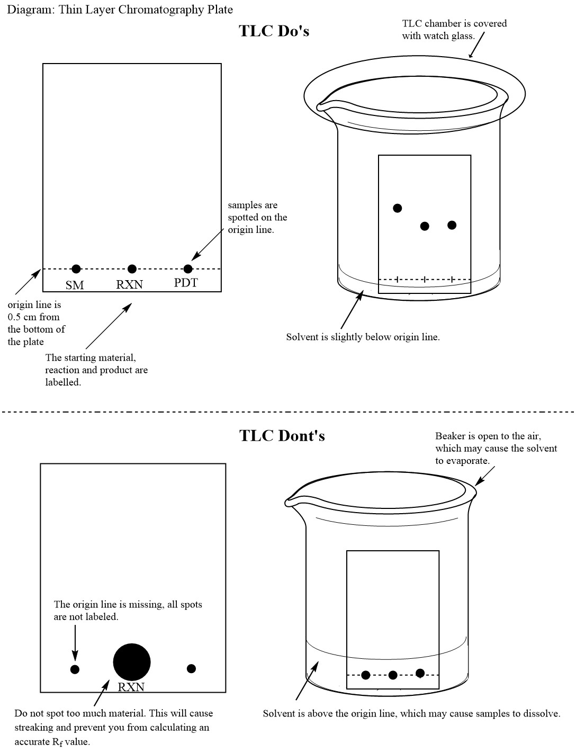
Figure 2: Best practices for TLC

Acknowledgements
Thanks to the following authors and reviewers for the modules:

Dr. Michelle M. Brooks, American Chemical Society
Dr. Felicia Fullilove, American Chemical Society
Dr. Natalia Martin, American Chemical Society
Dr. Lily Raines, American Chemical Society

Dr. Jennifer Barber, Westlake High School
Dr. Michelle Boucher, Utica College
Dr. Bonnie Dixon, University of Maryland – College Park
Dr. Elizabeth Jenson, Aquinas College
Dr. Shanina Johnson, Spelman College

