Module 4 Isolation and Purification of a Methyl Ester
This module is modified from:
A Visual Organic Chemistry Reaction: The Synthesis of 4-Amino-3-nitrobenzoic Acid Methyl Ester via Fischer Esterification. Caleb M. T. Kam, Stephan M. Levonis, and Stephanie S. Schweiker. Journal of Chemical Education 2020 97 (7), 1997-2000
DOI: 10.1021/acs.jchemed.9b01168

Learning Outcomes
Students will learn liquid-liquid extraction.
Students will learn how to prepare a silica plug and use it for purification.
Students will learn how to prepare a sample for characterization. (Optional)

Supplies
Glassware and Materials

- Separatory funnel
- Erlenmeyer flasks
- Long-stem funnel
- Filter paper
- Silica
- NMR tube
- Fritted Funnel
- Round bottom flasks
- Vacuum line
- Rotovap

Reagents
- Reaction Mixture from Module 3

Chemicals
- Saturated Sodium Bicarbonate Solution (~100 mL per student)
- Ethyl Acetate (~ 50 mL per student)

Safety Considerations
MSDS Sheets

Experimental Questions
- A liquid-liquid extraction is a type of separation based upon what physical property?
- In this module, what is in the top layer and what is in the bottom layer?
- What is the density of ethyl acetate?
- What are you removing by washing the ethyl acetate solution with the saturated sodium bicarbonate solution?
- How did the saturated sodium bicarbonate solution change during the liquid/liquid extraction?
- What was the role of the silica plug?
- Why is it important to ensure the final product is dry before characterization?

Procedure

Part I: Liquid/Liquid Extraction
- Add 20 mL of saturated sodium bicarbonate solution to the rbf containing the reaction mixture from Module 3.
- Place a clean separatory funnel in a ring stand. Ensure that the stopcok is closed and add the contents of the rbf to a separatory funnel. Then add 20 mL of ethyl acetate to the separatory funnel.
- Gently shake the separatory funnel four times, be sure to release the pressure after each shake by opening the stopcock.
- Remove the separatory funnel’s top and allow the sodium bicarbonate solution layer to drip into a clean beaker. Sit this beaker to the side.
- To the ethyl acetate layer, add 20 mL more of the saturated sodium bicarbonate solution.
- Repeat steps 3-5 two more times or until the sodium bicarbonate layer is clear.
- Take the ethyl acetate layer and place it in a new rbf. Concentrate the sample under vacuum.
- Then redisolve the sample in 20 mL of ethyl acetate and sit it to the side.

Part II: Silica Plug

- Connect a fritted funnel to a round bottom flask. Clamp the funnel and flask to a support stand or monkey bars.
- Connect the fritted funnel to a vacuum line or water pump.
- Add approximately 0.5 cm of sand to the fritted funnel.
- In a beaker or erlenmeyer flask create a slurry of silica with ethyl acetate. Add the slurry to the fritted funnel.
- Tap the side of the funnel with a cork ring to settle the silica and remove any bubbles.
- Add solvent to the funnel and turn on the vacuum slowly until the solvent level is slightly above the silica.
- Turn off the vacuum and replace the rbf with a clean rbf.
- Now load the 20 mL sample (dissolved in ethyl acetate) and turn on the vacuum. Add 20 more mL of ethyl acetate, then turn off the vacuum. (Note: You may need to change round bottom flasks to prevent overflow)
- Using TLC, check the fractions collected for product then concentrate the solution using a rotary evaporator and dry the resultant solution with a vacuum.

Part III: Sample Prep For Characterization (Optional)
Students should be encouraged to prepare the sample for characterization by melting point, IR and/or NMR.

Deliverable
Calculate the percent yield of 4-Amino-3-nitrobenzoic Acid Methyl Ester.

Activity for Practical
Demonstrate the proper technique for shaking a separatory funnel.
Demonstrate the proper technique for preparing a silica plug. (optional)

Instructor Notes
- Instructors are encouraged to 1) demonstrate proper techniques or 2) provide pre-recorded videos/demonstrations for student reference.

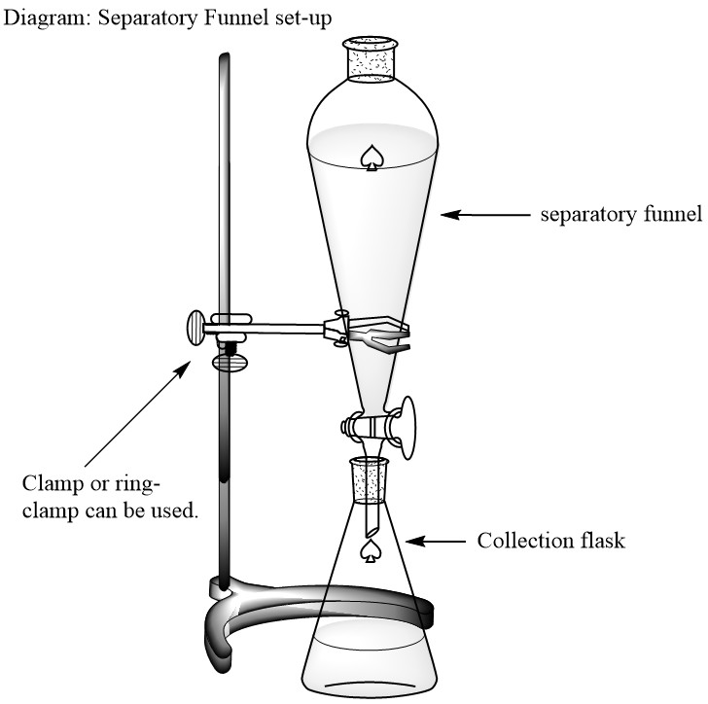
Figures
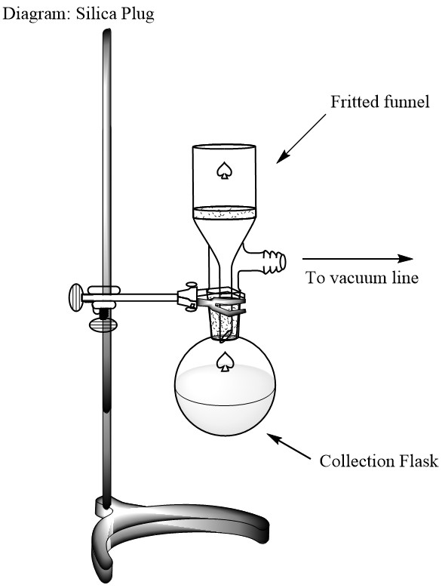

Acknowledgements
Thanks to the following authors and reviewers for the modules:

Dr. Michelle M. Brooks, American Chemical Society
Dr. Felicia Fullilove, American Chemical Society
Dr. Natalia Martin, American Chemical Society
Dr. Lily Raines, American Chemical Society

Dr. Jennifer Barber, Westlake High School
Dr. Michelle Boucher, Utica College
Dr. Bonnie Dixon, University of Maryland – College Park
Dr. Elizabeth Jenson, Aquinas College
Dr. Shanina Johnson, Spelman College

