Second Grade PRE-Project Survey
Print Your Name: ______________________________________ Circle One:
Girl Boy

Circle your school: Bismarck Central North County

Please circle one answer or picture that best completes each sentence.

- I think science is __________________.

- a lot of fun b. a little fun c. okay d. boring
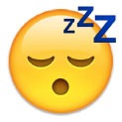

- Sciences makes me feel ____________.

- excited b. happy c. worried or scared d. mad

- I think science is ________________.

- easy b. not too hard c. hard
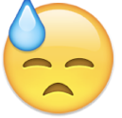

- I _______________ learning about science.

- love b. like c. don’t like d. hate

