Name |  | Teacher
Circle Your School | Bismarck Elementary | Central R-3 Elementary | North County Primary

Directions: Draw a line to match the name or idea with its correct picture.
--------------------------------------------------------------------------------------------------------------------------------------------------------------------------------Three Branches of Science
Physics | 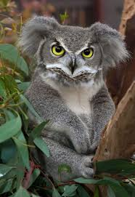
Biology
Chemistry | 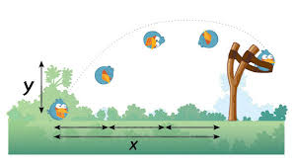
--------------------------------------------------------------------------------------------------------------------------------------------------------------------------------
Matter and Changes in Matter
Atom
Physical Change | 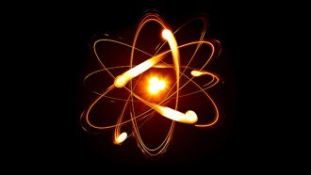
Chemical Change
