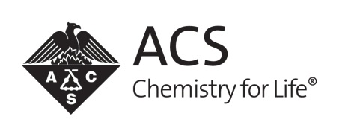
American Chemical Society
Local Section Innovative Project Grant
Coordinator/Planner Evaluation

1. What type of activity/event did your ACS Local Section conduct? (Select one.)
☐ | Workshop/short course |  | ☐ | Community outreach
☐ | Student outreach |  | ☐ | Technical symposia programming

2. Which of the following did your local section use to publicize your activity/event? (Select all that apply.)
☐ | Print media (newspaper, magazine) |  | ☐ | Social networking
☐ | Television coverage |  | ☐ | Webcast/podcast
☐ | Radio coverage |  | ☐ | Local section/chapter website
☐ | Flyer |  | ☐ | Email
☐ | Local section/chapter newsletter |  | ☐ | Other:

3. Did your local section utilize any of the following materials or resources provided by the ACS for your activity/event?
☐ | Yes | ☐ | No | ☐ | Not sure

4. Which of the following did your local section partner with for this activity/event? (Select all that apply.)
☐ | Grade schools |  | ☐ | Libraries/museums
☐ | Colleges or universities |  | ☐ | Civic organizations
☐ | Companies/industry |  | ☐ | Youth group (e.g., Scouts, 4-H)
☐ | ACS Student Member Chapters |  | ☐ | Other
☐ | ACS High School Chem Clubs |  | ☐ | Our local section had no partners.

5. Estimate the amount of money that was allotted by or contributed to your ACS Local Section for this activity/event according to the source.
Your local section | Choose an option.
In-kind or monetary donations | Choose an option.
Grants | Choose an option.
Industry support | Choose an option.

6. Approximate number of volunteers used to support your activity/event: Click here to enter text.

7. Approximate the total number of people that attended your activity/event: Click here to enter text.

8. How effective do you feel your activity/event was in connecting chemistry with the community? (Select one.)
☐ | Very effective
☐ | Somewhat effective
☐ | Not very effective
☐ | Not at all effective
☐ | N/A

