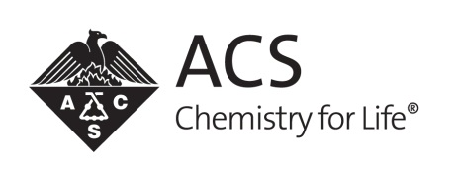
American Chemical Society
Local Section Innovative Project Grant
Attendee Evaluation

1. Did you learn something new or interesting at the activity/event today?
❍ | Yes | ❍ | No

2. Will you be able to apply what you learned to your research or work?
❍ | Yes | ❍ | No | ❍ | Not sure

3. Did participating in the activity/event further your interest to learn more about chemistry or a specific field/discipline within chemistry?
❍ | Yes | ❍ | No

4. How satisfied were you with the following activity/event features?
 | Very Satisfied | Satisfied | Dissatisfied | Very dissatisfied | Not Applicable
Pre-activity/event information
Organization of the activity/event
Quality of information presented
Relevance of activity/event to your field/interest
Networking opportunities
Activity/event location
Facility amenities
Responsiveness of staff

5. Would you like to participate in another activity/event like this in the future?
❍ | Yes | ❍ | No | ❍ | Not sure

6. What other types of activities/events would you be interested in?

7. How well did this activity/event meet your expectations?
❍ | Exceeded expectations | ❍ | Met expectations | ❍ | Failed to meet expectations

8. Would you recommend an activity/event, like this one, to a friend or colleague?
❍ | Yes | ❍ | No | ❍ | Maybe

9. Do you have any suggestions for how activities/events like this can be improved?

10. How involved are you with your ACS Local Section?
5 - Highly involved | 4 | 3 | 2 | 1 - Not at all involved | Unfamiliar with ACS Local Sections
❍ | ❍ | ❍ | ❍ | ❍ | ❍

11. As a result of attending this activity/event, how likely are you to seek more information about ways to get involved with your ACS Local Section?
Very likely | Somewhat likely | Unlikely | Not at all likely | Does not affect my involvement
❍ | ❍ | ❍ | ❍ | ❍

