Chapter 1—Student Reading

Chemistry is the study of matter
You could say that chemistry is the science that studies all the stuff in the entire world. A more scientific term for “stuff” is “matter.” So, chemistry is the study of matter. Matter is all the physical things in the universe. All the stars in the galaxies, the sun and planets in our solar system, the Earth, and everything on it and in it are matter.

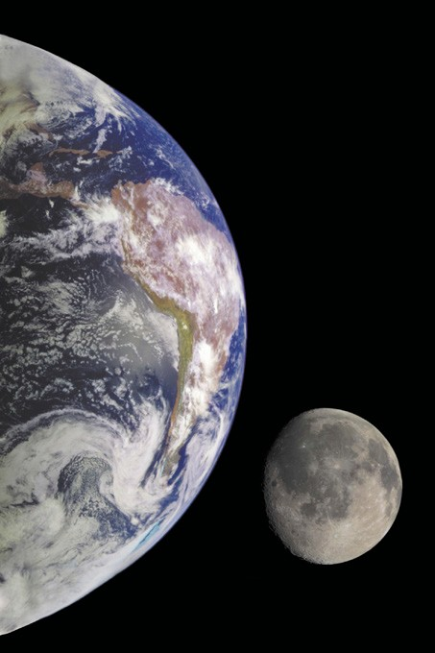

All human-made objects, all organisms, the gases in the atmosphere, and anything else that has mass and takes up space, including you, are examples of matter.

Chemistry is special because it looks at matter all the way down to its smallest parts: the atoms and molecules that matter is made of. To give you an idea about how small atoms and molecules are, use a metric ruler to look at the length of one millimeter. It is about the size of a dash like this one -. Try drawing a tiny line or dot that is about 1/10 as long as the dash. It might be about the size of a period like the one at the end of this sentence. A hydrogen atom is about 1 ten millionth of the size of the period. So, it would take about 10 million hydrogen atoms lined up next to each other to go from one side of the period to the other.

Here is another way to imagine how small atoms and molecules are. In about 1 tablespoon of water, there are about 600 billion trillion water molecules. That’s 600,000,000,000,000,000,000,000. This number is so huge that even if you could count one million molecules every second, it would take you about 200 million centuries or about 20 billion years to count all the molecules in a tablespoon of water.
Studying chemistry can help make sense of many of the different things you see and do every day. What you eat and drink, the weather outside, the soap and water you wash with, and the clothes you wear, are all a result of chemistry. The sports equipment you use, the materials your house is made of, the way you get to school, and the electronic equipment you use are all a result of the interactions of atoms and molecules.
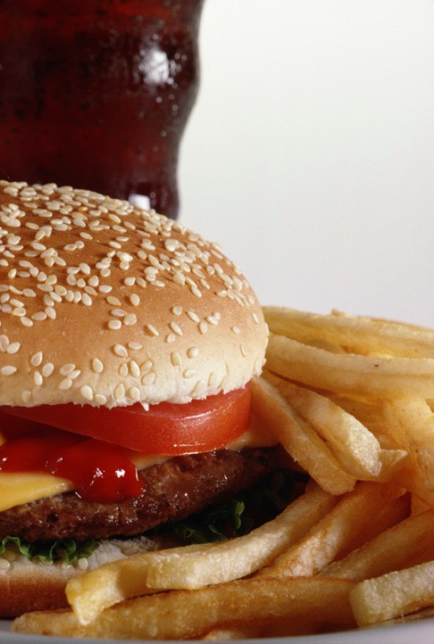
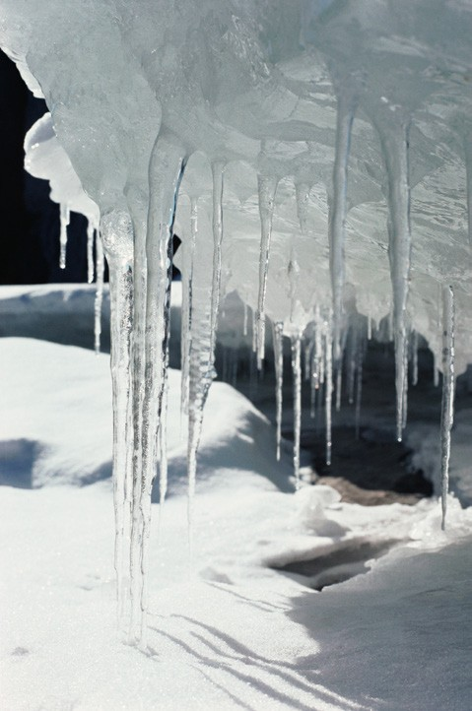

Having a better idea of what atoms and molecules are and how they interact can help you better understand the world around you.
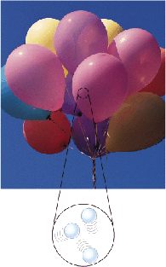

Matter is made of atoms and molecules
We have already used the term atom and molecule a couple of times. You will learn a lot more about atoms and molecules in later chapters. For now, let’s say that atoms and molecules are the extremely tiny particles that make up all the matter on Earth. An atom is the basic building block of all matter. A molecule is made of two or more atoms connected or bonded together.

Even though atoms and molecules are not the same, the model we are using in Chapter 1 shows both atoms and molecules as little circles or spheres. This model makes it easier to show some of the basic characteristics of the different states of matter on Earth.
Gas

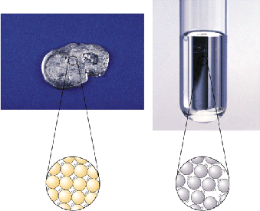
Matter—Solid, Liquid, Gas
On Earth, matter is either found as a solid, liquid, or gas. A particular solid, liquid, or gas might be made up of individual atoms or molecules.

Here is a simplified model of three different substances. One is a solid, another is a liquid, and the other is a gas.
Liquid
Solid
In the picture, the little motion lines show that the particles (atoms or molecules) that make up the solid, liquid, and gas are moving. In later chapters, the models of atoms and molecules will be shown with more detail.

As you look at these pictures, think about these two big ideas which are always true when talking about matter:
- Matter (solid, liquid, and gas) is made up of tiny particles called atoms and molecules.
- The atoms or molecules that make up matter are always in motion.
These first two ideas make up a very important theory called the Kinetic-molecular theory of matter.

Another big idea is that:
- The atoms or molecules that make up a solid, liquid or gas are attracted to one another.
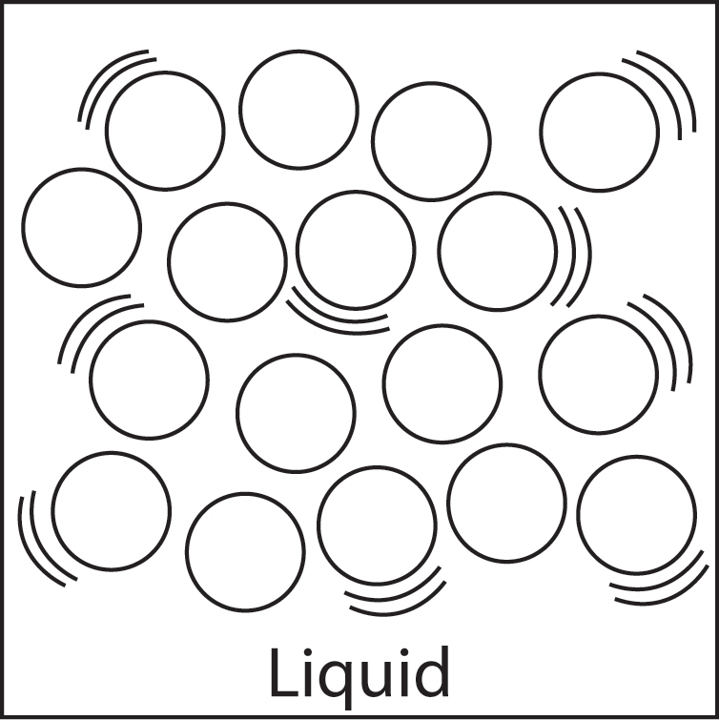
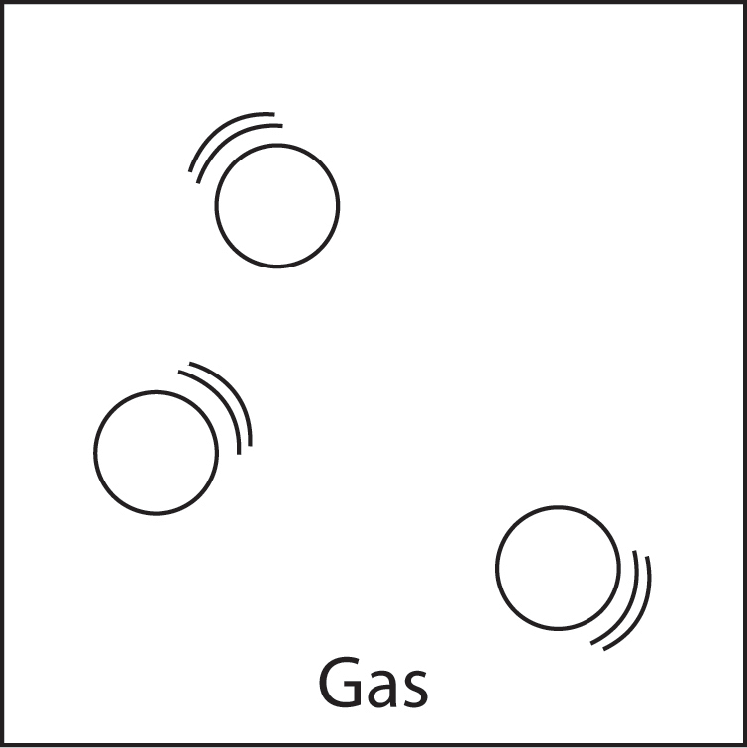
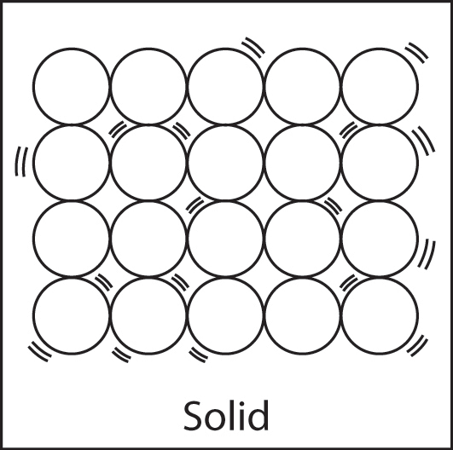

In a solid, the atoms are very attracted to one another. Because of this strong attraction, the atoms are held tightly together. The attractions are strong enough that the atoms can only vibrate where they are. They cannot move past one another. This is why a solid keeps its shape.

In a liquid, the molecules are also in motion. The attractions between the molecules in liquids are strong enough to keep the molecules close to each other but not in fixed positions. Although the molecules stay very near one another, the attractions allow the molecules of a liquid to move past one another. This is why a liquid can easily change its shape.

In a gas, the molecules are also moving. The attractions between the molecules of a gas are too weak to bring the molecules together. This is why gas molecules barely interact with one another and are very far apart compared to the molecules of liquids and solids. A gas will spread out evenly to fill any container.
When looking at the different states of matter, it’s kind of like a competition between the attractions the molecules have for each other compared to the motion of their molecules. The attractions tend to keep the atoms or molecules together while the motion tends to make the atoms or molecules move apart.

Comparing Matter
 | Solids | Liquids | Gases
Attractions | Atoms or molecules are very attracted to one another. | Atoms or molecules are attracted to one another. | Atoms or molecules are barely attracted to one another.
Movement | Vibrate but do not move past one another. | Vibrate and are able to move past one another. | Vibrate and move freely past each other.
Volume and Shape | Have a definite volume and a definite shape. | Have a definite volume, but do not have a definite shape. | Do not have a definite volume or a definite shape.

Heating and cooling liquids
Heating and cooling a liquid can affect how far apart or close together the molecules are.
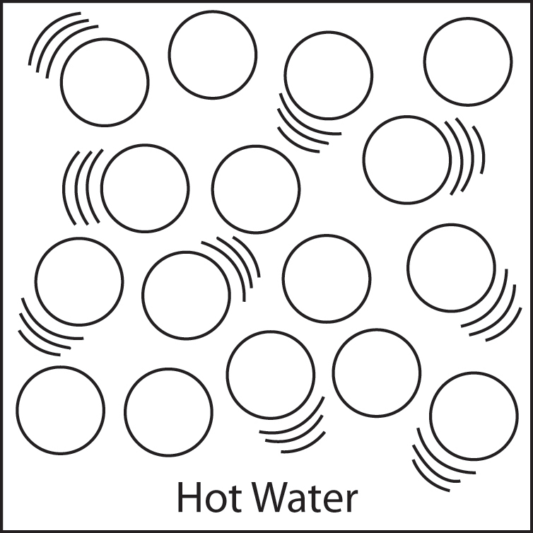
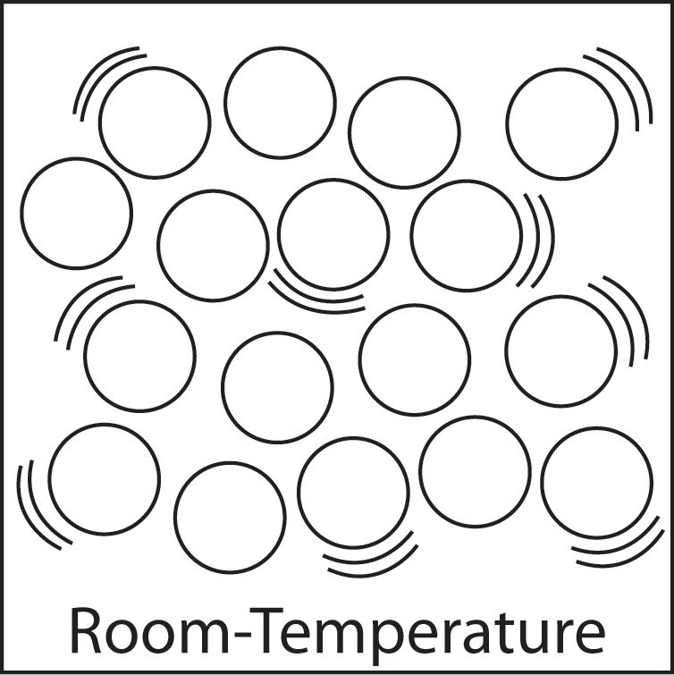
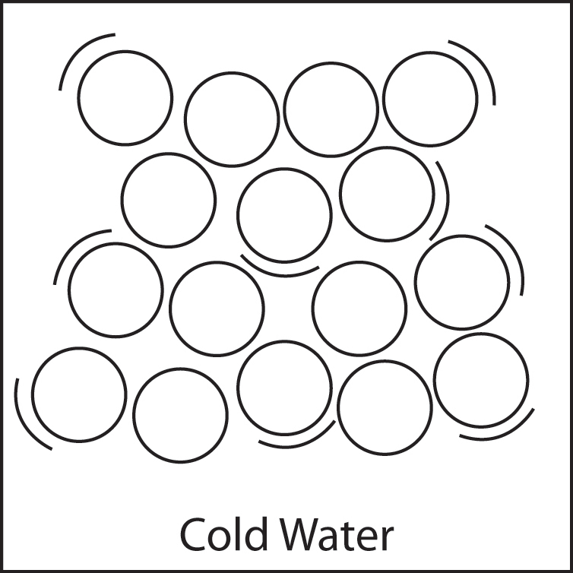

One example is the red alcohol inside the thin tube of a thermometer. When the thermometer is heated, the molecules of alcohol move faster. This faster motion competes with the attraction between the molecules which causes them to spread out a little. They have nowhere else to go so they move up the tube.

When the thermometer is cooled, the molecules of alcohol slow down and the attractions bring the molecules closer together. This attraction between the molecules brings the alcohol down in the tube.

Heating and cooling solids
There is a device made out of a metal ball and ring that lets you see the effect of heating and cooling a solid. At room temperature, the ball just barely fits through the ring.
When the ball is heated sufficiently, it will not fit through the ring.
This is because heating the metal ball increases the motion of its atoms. This motion competes with the attractions between the atoms and makes the atoms move slightly further apart. The slightly larger ball no longer fits through the ring.
When the metal ball is cooled, the atoms slow down, and their attractions bring the atoms closer together. This allows the metal ball to fit through the ring again.
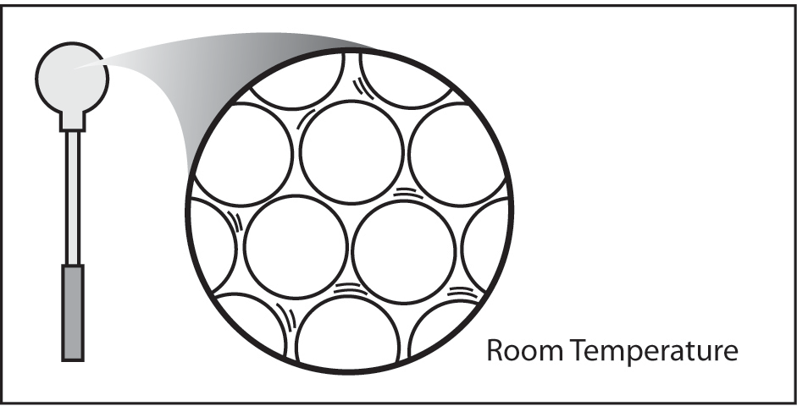
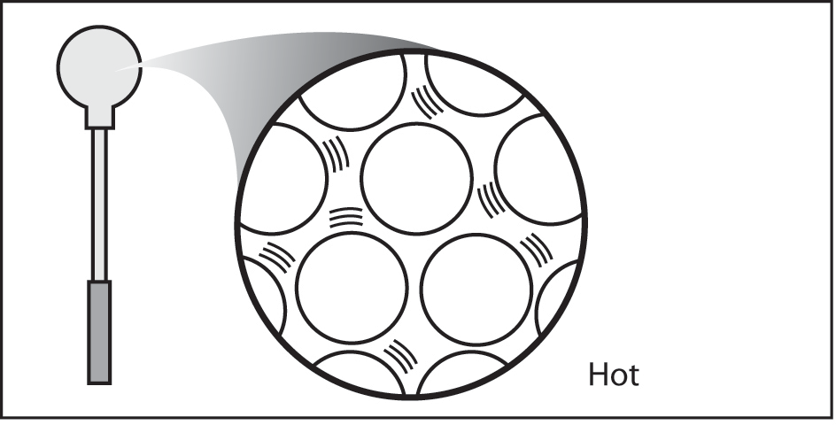

Heating and cooling gases
The molecules of a gas are not very attracted to each other and are much further apart than in liquids and solids. This is why heating a gas easily increases the motion of the gas molecules.
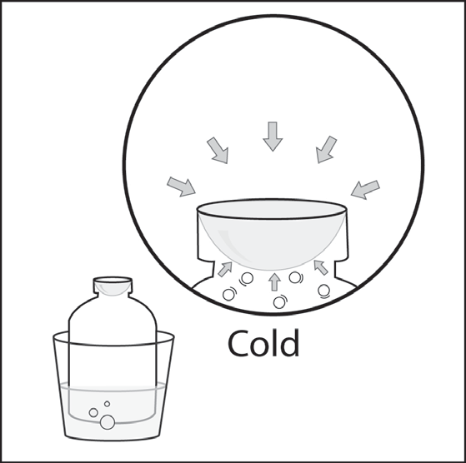
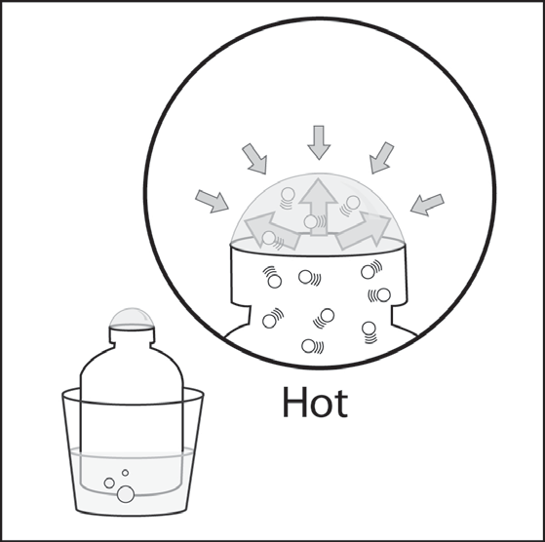
For example, if you dip the opening of a bottle in a detergent solution and then heat the bottle, a bubble will form on the bottle. This happens because heating the bottle increases the motion of the gas molecules inside the bottle. Since molecules of the gas are not very attracted to each other, they spread out quickly and easily. The molecules hit the inside of the bottle and the bubble film harder and more often. The molecules push against the inside of the film harder than the surrounding air pushes from the outside. This pushes the bubble film out and forms a bubble.

If you cool the bottle while the bubble is still on top, the bubble will shrink and may go inside the bottle. This happens because cooling the gas causes its molecules to slow down. These slower-moving molecules hit the inside of the bubble film less often and with less force. The molecules in the outside air are moving faster and push against the bubble from the outside. Since the outside molecules are pushing harder, the bubble gets pushed down and in and gets smaller.

