Activity Sheet Answers
Chapter 1, Lesson 1
Molecules Matter

WHAT DID YOU OBSERVE?

- When you squeezed the drop of water out of the dropper, did the water break apart or did it hold together?
The water held together.

- When you were pulling the drop around the wax paper, did the water seem to hold together or come apart easily?
The water held together in a drop.

- When you tried to split your drop, did the drop separate easily?
It was not so easy to separate the drop.

- Was it easy or difficult to make the drops come together?
The drops came together easily. When they touched, they quickly joined together.

DEMONSTRATION

- Your teacher placed a drop of food coloring in a cup of water. The color slowly mixed into the water without being stirred. What does this tell you about water molecules?
The water molecules must be moving. The food coloring molecules may be moving too.
The movement of the molecules made the water and food coloring mix.

EXPLAIN IT WITH ATOMS & MOLECULES

- Using circles and motion lines to represent water molecules, draw a model of water on the molecular level. Be sure to show that water molecules are:
- Randomly arranged
- Close together because they attract each other
- Moving
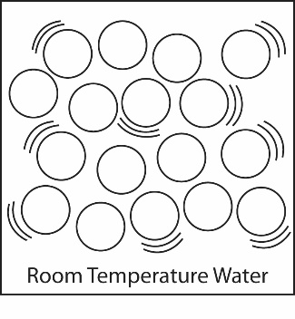
The circles should be close together, but not touching. Most circles should have two motion lines around them to signify movement.

- What is it about water molecules that helps explain why the water drops were difficult to split apart but easy to join together?
Water molecules are attracted to one another.

TAKE IT FURTHER

- Why do you think the water keeps its shape the moment the balloon is popped?
The water molecules are attracted to each other, and the film is in super slow motion.

- Imagine a drop of water hanging from your finger. How is this similar to the water staying together after the balloon is popped?
When a drop of water hangs from your finger, the water molecules are attracting each other and holding the drop together so that it keeps its shape and doesn’t come apart. Also, maybe the water molecules are also attracted somewhat to the skin on your finger so they hang from it.

