Activity Sheet Name
Chapter 1, Lesson 1
Molecules Matter Date

In the activity below, you will investigate some of the characteristics of water. You will also begin to model and explain, on the molecular level, why water acts the way it does.

ACTIVITY

Question to investigate
Does water hold together well or come apart easily?

Materials for each group
- Water in small cup
- Dropper
- 2 popsicle sticks
- 2 index cards covered with wax paper

Procedure
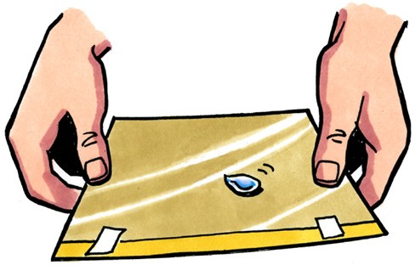
  - Use a dropper to gently squeeze out one drop of water but try not to let the drop fall completely out of the dropper. See how far you can make the drop hang off the end of the dropper without the drop falling.

  - Place 4 or 5 drops of water together on the wax paper to make a medium size drop.

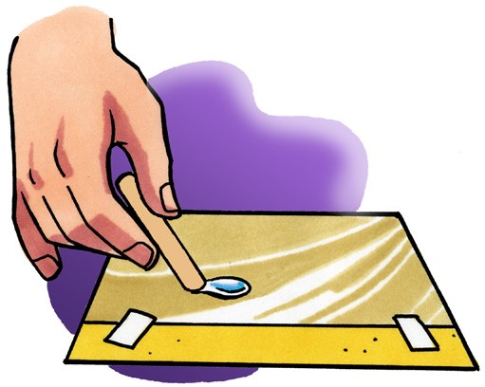
  - Gently tilt the wax paper in different directions so that the drop moves.

  - Use a popsicle stick to slowly move your drop around the wax paper. Try using your popsicle stick to separate your drop into two.

  - Use your popsicle stick to move the two drops near each other. Then move one drop so that the two drops touch.

WHAT DID YOU OBSERVE?

- When you squeezed the drop of water out of the dropper, did the water break apart or did it hold together?

- When you were pulling the drop around the wax paper, did the water seem to hold together or come apart easily?

- When you tried to split your drop, did the drop separate easily?

- Was it easy or difficult to make the drops come together?

DEMONSTRATION

- Your teacher placed a drop of food coloring in a cup of water. The color slowly mixed into the water without being stirred. What does this tell you about water molecules?

EXPLAIN IT WITH ATOMS & MOLECULES
You saw an animated molecular model of water. Now you will draw your own molecular model.

- Using circles and motion lines to represent water molecules, draw a model of water on the molecular level. Be sure to show that water molecules are:

  - Randomly arranged
  - Close together because they attract each other
  - Moving

- What is it about water molecules that helps explain why the water drops were difficult to split apart but easy to join together?

TAKE IT FURTHER

In the video of the water balloon, you saw what happens in slow motion when a water balloon is popped. Surprisingly, there is a moment when the water hangs in the air in a balloon-shape, after the balloon has been popped.

- Why do you think the water keeps its shape the moment the balloon is popped?

- Imagine a drop of water hanging from your finger. How is this similar to the water staying together after the balloon is popped?

