Activity Sheet Answers
Chapter 1, Lesson 2
Molecules in Motion

WHAT DID YOU OBSERVE?

- Describe what the colors looked like and how they moved and mixed in the cold water.
In the cold water, the yellow and blue colors drifted and slowly swirled and spread a bit but were in streaks. The colors didn’t mix very much.

- Describe what the colors looked like and how they moved and mixed in the hot water.
In the hot water, the colors spread more quickly and mixed together more than in the cold water. The water turned greener in the hot water than it did in the cold water.

- What does the speed of the mixing colors tell you about the speed of the molecules in hot and cold water?
Since the colors moved faster in the hot water, it means that the water molecules in the hot water move faster than the molecules in cold water.

- There were several variables in this experiment:
  - Amount of water in each cup
  - Type of cup used
  - Number of drops of food coloring
  - When the coloring was added to the water
Pick one of these variables and explain why you made sure it was kept the same in the two cups.
The number of drops used needs to be kept the same for each cup. This is because you are trying to see how fast the color spreads in each cup so using different amounts would not be a fair test because the extra color might cause more spreading but has nothing to do with the temperature.

EXPLAIN IT WITH ATOMS AND MOLECULES

- Based on your observations and the animations, fill in the blanks with the words increases or decreases.

Heating a substance increases molecular motion.
Cooling a substance decreases molecular motion.
As molecular motion increases, the space between molecules increases .
As molecular motion decreases, the space between molecules decreases .

- Using circles to represent water molecules, draw a model of the molecules in cold and hot water.
  - Use motion lines to show the speed of the molecules.
  - Consider the space between molecules in each temperature of water.

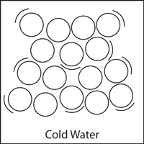
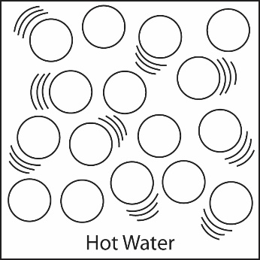
Molecules in cold water are closer together and have fewer motion lines. Molecules in hot water are further apart and have more motion lines.

TAKE IT FURTHER

- Using what you know about the attractions between water molecules and the way heat affects molecular motion, explain why the volume of water in the graduated cylinder increases when it is heated.
The volume of water increases when the water is heated because heating makes the water molecules move faster. The extra speed of the molecules competes with their attraction for one another and causes them to move slightly further apart. Since the molecules move further apart, the same amount of water takes up more room in the graduated cylinder.

