Activity Sheet Name
Chapter 1, Lesson 2
Molecules in Motion Date

ACTIVITY

Question to investigate
Is the speed of water molecules different in hot and cold water?

Materials for each group
- Hot water in a clear plastic cup
- Cold water in a clear plastic cup
- Food coloring (yellow and blue)
- 4 droppers
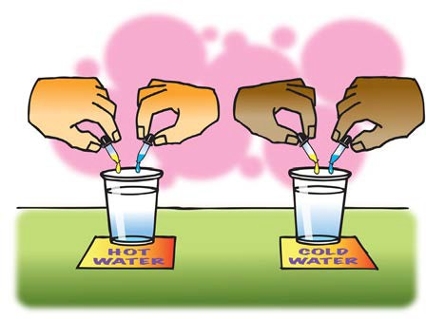

Procedure
  - With the help of your partners, use droppers to carefully place 1 drop of yellow and 1 drop of blue food coloring into the hot and cold water at the same time.
  - Allow the colors to mix on their own as you watch them for a couple of minutes.

WHAT DID YOU OBSERVE?

- Describe what the colors looked like and how they moved and mixed in the cold water.

- Describe what the colors looked like and how they moved and mixed in the hot water.

- What does the speed of the mixing colors tell you about the speed of the molecules in hot and cold water?
- There were several variables in this experiment:
  - Amount of water in each cup
  - Type of cup used
  - Number of drops of food coloring
  - When the coloring was added to the water

Pick one of these variables and explain why you made sure it was kept the same in the two cups.

EXPLAIN IT WITH ATOMS AND MOLECULES
You saw an animation of water molecules being heated and cooled. Now you can draw your own molecular model.

- Based on your observations and the animations, fill in the blanks with the words increases or decreases.

Heating a substance molecular motion. Cooling a substance molecular motion.
As molecular motion increases, the space between molecules . As molecular motion decreases, the space between molecules .
- Using circles to represent water molecules, draw a model of the molecules in cold and hot water.

  - Use motion lines to show the speed of the molecules.
  - Consider the space between molecules in each temperature of water.
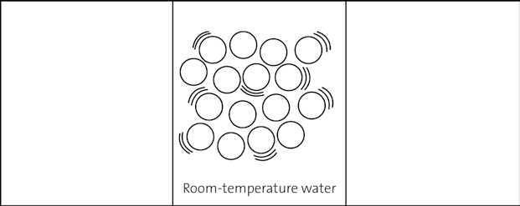

TAKE IT FURTHER
Let’s say that you measure exactly 100 milliliters of water in a graduated cylinder. You heat the water to 100 °C and notice that the volume increases to 104 milliliters.
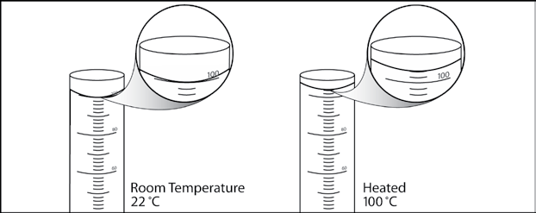

- Using what you know about the attractions between water molecules and the way heat affects molecular motion, explain why the volume of water in the cylinder increases when it is heated.

