Activity Sheet Name Chapter 1, Lesson 4
Moving Molecules in a Solid Date

EXPLAIN IT WITH ATOMS & MOLECULES
After you watch the molecular model animations of liquids and solids, answer the questions below.

- How is the motion of the atoms in solid metal different from the motion of the molecules in liquid water?

- What is it about atoms and molecules in liquids and solids that keep them close to one another even though they are moving?

DEMONSTRATION

- At room temperature the metal ball fits through the ring. What happened when your teacher tried to push the heated ball through the ring?

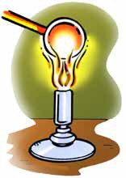
- What happened to the atoms in the heated metal ball so that it didn’t fit through the ring?

- After the ball was cooled by putting it in the water, why do you think it fit through the ring again?

EXPLAIN IT WITH ATOMS & MOLECULES
You saw in the animation that atoms in a solid move faster and get slightly further apart when heated. You also saw that they slow down and get slightly closer together when cooled. Use this information to make your own drawing on the molecular level of the metal ball.

- Draw a model of the atoms in the metal ball at room temperature and after it has been heated. Use circles and motion lines to show the speed and spacing of the atoms in the room temperature ball. Include captions like “atoms faster and further apart” or “atoms slower and closer together” to describe your drawings

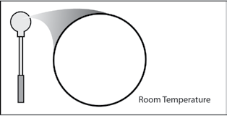
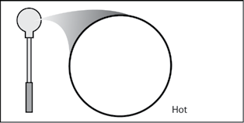

TAKE IT FURTHER

Look at the picture of the road of a bridge. The road on a bridge gets colder in the winter and hotter in the summer than the road leading to it and away from it.
Many bridges have a flexible connection like the one shown in the picture.
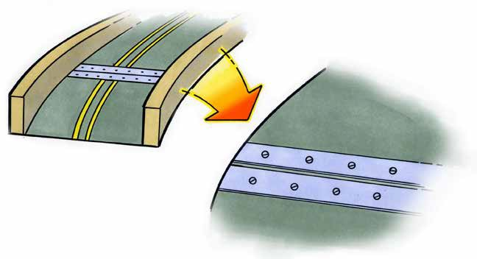
- Knowing what you do about how solids act when they are heated and cooled, why do you think they put flexible connections in the road on a bridge?

