Chapter 1, Lesson 4: Moving Molecules in a Solid
Key Concepts
- In a solid, the atoms are very attracted to one another. The atoms vibrate but stay in fixed positions because of their strong attractions for one another.
- Heating a solid increases the motion of the atoms.
- An increase in the motion of the atoms competes with the attraction between atoms and causes them to move a little further apart.
- Cooling a solid decreases the motion of the atoms.
- A decrease in the motion of the atoms allows the attractions between atoms to bring them a little close together.
Summary
Students will see a demonstration with a metal ball and ring showing that heat causes atoms to spread a little further apart. They will also see that cooling a solid causes the atoms to get a little closer together. The same rules they discovered about liquids also apply to solids.
Objective
Based on their observations students will describe, on the molecular level, how heating and cooling affect the motion of atoms in a solid.
Evaluation
The activity sheet will serve as the “Evaluate” component of each 5-E lesson plan. The activity sheets are formative assessments of student progress and understanding. A more formal summative assessment is included at the end of each chapter.
Safety
Be sure you and the students wear properly fitting goggles.
Materials for the Demonstration
- Ball and ring designed specifically for this demonstration
- Bunsen burner for heating the ball
- Room temperature water (to cool the ball)
Notes about the materials
The metal ball and ring are available from Flynn Scientific (AP9031) or other suppliers.

About this Lesson
The solid explored in this lesson is a metal. Metal is composed of individual atoms instead of molecules like in the water and alcohol students learned about in Lessons 1–3. Although atoms and molecules are different, we will represent atoms the same way we represented molecules, using a circle or sphere. This simple representation will help students focus on the motion and position of the particles when they are heated and cooled.

ENGAGE

Review what students have discovered about molecules in a liquid and discuss whether these same ideas might apply to solids, too.
Ask students:

What do you know about the molecules in a liquid?
Be sure students understand that the molecules in a liquid are attracted to each other but are able to move past each other.

How does heating or cooling affect the speed of the molecules and the distance between them?
Heating speeds up the motion of molecules and cooling slows them down. We’ve also seen that speeding the molecules up makes them move a little further apart and slowing them down allows them to move a little closer together.

Ask students if these statements also apply to solids:

Do you think the atoms in a solid are attracted to each other?
Students will probably realize that the atoms of a solid are attracted to each other. Explain that this is how a solid stays together.
  - Do you think heating or cooling a solid might affect the motion of the atoms? Students should realize that if you heat a solid, the atoms or molecules move faster and move further apart. If you cool a solid, the molecules move more slowly and move a little closer together.

Show an animation to help students compare atoms and molecules in solids and liquids.
Explain that the little balls represent the particles of a solid, in this case the atoms in a metal. Although atoms and molecules are different, this same simple model of balls is used for both. Let students know that for now, they will use circles or spheres to represent atoms and molecules, but eventually they will use a more detailed model. Tell students that they should focus on the motion of the molecules, how they interact, and their distance from one another.

Show the molecular model animation Particles of a Solid.
www.acs.org/middleschoolchemistry/simulations/chapter1/lesson4.html

Point out the following about solids:
  - The particles (atoms or molecules) are attracted to each other.
  - The particles (atoms or molecules) vibrate but do not move past one another.
  - The solid retains its shape.

Show the molecular model animation Comparing Solid and Liquid.
www.acs.org/middleschoolchemistry/simulations/chapter1/lesson4.html

Click on both tabs and make sure students notice the differences in the movement of the atoms and molecules.
  - The atoms in a solid are so attracted to each other that they vibrate and don’t move past each other.
  - The molecules of a liquid are attracted to each other but move more freely and past one another.

Give each student an activity sheet.
Students will record their observations and answer questions about the animation on the activity sheet. The Explain It with Atoms & Molecules and Take It Further sections of the activity sheet will either be completed as a class, in groups, or individually depending on your instructions. Look at the teacher version of the activity sheet to find the questions and answers.

EXPLORE

Do a demonstration to show that solid metal expands when it is heated and contracts when cooled.
It is harder to show that the particles of a solid move faster when heated than it is to show the same thing with a liquid like in Lesson 2. But you can do it if you have a special ball and ring apparatus that shows the expansion of a metal when heated. This inexpensive device, available through science education equipment companies, consists of a rod with a metal ball on the end and another rod with a metal ring. At room temperature, the ball just barely fits through the ring. But when the ball is heated sufficiently, it will not pass through the ring. If you do not
have this equipment, you can show students a video of this demonstration titled Heating and Cooling a Metal Ball.
www.acs.org/middleschoolchemistry/simulations/chapter1/lesson4.html

Question to investigate
How do heating and cooling affect a solid?

Materials for the presenter
  - Ball and ring designed specifically for this demonstration
  - Bunsen burner for heating the ball
  - Room temperature water (to cool the ball)
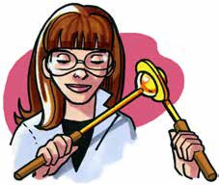

Procedure
- Heating the metal ball
  - Hold the ball in one hand and the ring in the other. Show students how the ball fits through the ring.
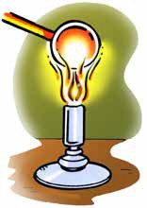
  - Place the metal ball in the flame of a Bunsen burner for about 1–2 minutes.
  - Try to push the ball through the metal ring again.

Expected results
The ball will not fit through the ring.

Ask students:

Why won’t the ball fit through the ring?
Students should infer that the speed of the atoms in the metal ball has increased. This increased motion competes with the attractions the atoms have for each other, causing the atoms to move slightly further apart. This is why the heated ball is too big to fit through the ring.

When students see that the ball expands, they may wonder if the atoms themselves expanded. Tell students that the atoms do not expand. Instead, the atoms in a solid follow the same rules as the molecules in a liquid. Heating increases molecular motion, causing the atoms to spread a little further apart.

- Cooling the metal ball
Ask students:

What could we do to the metal ball to make it fit through the ring again?
Students should suggest cooling the ball.
- Dip the ball in room temperature water.
- Push the ball through the metal ring.

Expected results
The ball will fit through the ring. Ask students:

Why does the ball fit through the ring now?
Students should infer that the atoms slow down enough so that their attractions pull them closer together, making the ball smaller so that it can fit through the ring.

EXPLAIN

Show an animation and explain what happened to the atoms in the metal ball as it was heated and cooled.
Show the molecular model animation Heating and Cooling a Solid. www.acs.org/middleschoolchemistry/simulations/chapter1/lesson4.html

Point out that when metal is heated, the atoms move faster and move slightly further apart. This makes the heated ball expand, which prevents it from passing through the ring.
Point out that when the metal is cooled, the atoms move slower and move slightly closer together. This makes the cooled metal ball get slightly smaller so that it fits through the ring again.
Give students time to complete the questions and drawings on the activity sheet about heating and cooling the metal ball.
Project the image Molecules in a Room Temperature and Hot Metal Ball.
Help students draw circles to represent the atoms in the ball at room temperature and after it is heated. Have students write captions describing the speed and distance of the atoms in each picture.
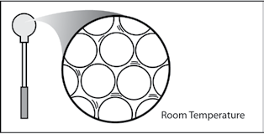
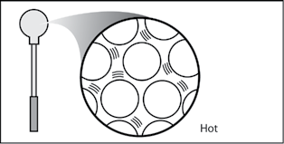

EXTEND

Have students apply what they have learned about heating and cooling solids to explain why bridges have flexible connections.
Show students the picture of the flexible connection in the road on a bridge. Explain that the surface of the bridge gets colder in winter and hotter in summer than the road on either end of the bridge. This is because the bridge is completely surrounded by cold air in the winter and by hot air in the summer. It is not insulated by the ground beneath it.
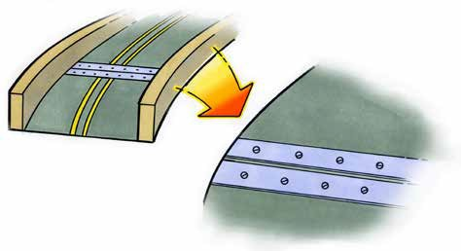

Ask students:

Knowing what you do about how solids act when they are heated and cooled, why do you think they put flexible connections in the surface of a bridge?
Students should realize that if the bridge is hotter than the land around it, it should be able to expand a bit without breaking. If it is colder than the land around it, it should be able to contract a bit without breaking.
After the class discussion, have students write their own response to the question about flexible bridge connections on the activity sheet.

