Activity Sheet Answers
Chapter 2, Lesson 1
Heat, Temperature, and Conduction
ACTIVITY
- Why do you think the temperature of the water in your cup changes more than the water in the control cup?
Metal washers were placed in one cup but not in the control cup. The energy from the hot water was transferred to the room temperature washers. This made the temperature of the water go down.

EXPLAIN IT WITH ATOMS & MOLECULES
- Explain, on the molecular level, how energy was transferred from the hot water to the room-temperature spoon.
The molecules in the hot water are moving quickly and contact the atoms in the room temperature spoon which are moving more slowly. The faster-moving water molecules transfer some of their energy to the atoms in the spoon through conduction.
- Draw motion lines near the atoms and molecules in the “After” illustration to show how the speed of the molecules in the spoon and water changed.
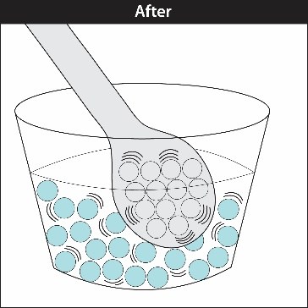
There are more motion lines around the atoms of the spoon and fewer motion lines around the water molecules. This shows that the hot water transferred some of its energy to the spoon in the form of heat.

- Now that you know what happens when a spoon is placed in hot water, explain what happened in the activity:
- Why did the metal washers get warmer while the water got cooler?
When the room temperature washers were placed in hot water, they got warmer because energy from the water was transferred to the washers. This makes the atoms in the washers move faster and the molecules of the water slow down. This means that the temperature of the washers increases while the temperature of the water decreases.

- Explain, on the molecular level, how the heat was conducted from the hot spoon to the room-temperature water.
The atoms in the hot spoon are moving quickly and contact the molecules in the room temperature water which are moving more slowly. The faster-moving atoms transfer some of their energy to the molecules in the spoon through conduction.

- Draw motion lines near the atoms and molecules in the “After” illustration to show how the speed of the atoms in the spoon and molecules in the water changed.
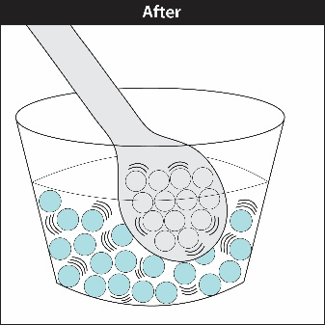
There are fewer motion lines around the molecules of the spoon and more motion lines around the water molecules. This shows that the spoon transferred some of its energy to the water in the form of heat.

- Now that you know what happens when a hot spoon is placed in room-temperature water, explain what happened in the activity:

  - Why did the hot metal washers get cooler?

  - Why did the water get warmer?

When the hot metal washers were placed in room-temperature water, they got cooler because energy from the washers was transferred to the water. This makes the molecules of the water speed up and the atoms in the washers slow down. This means that the temperature of the washers decreases while the temperature of the water increases.

- You saw an animation that showed that temperature is a measure of the average kinetic energy of the atoms of molecules of a substance. Does this mean that all the molecules in a cup of water are moving at the same speed or at a variety of speeds? Explain.
The kinetic energy of an atom or molecule is made up of its mass and its speed. At any temperature, the atoms or molecules of a substance are moving at a variety of speeds so there are a variety of kinetic energies. When taken together, the temperature of the substance is the average kinetic energy of the atoms or molecules of the substance.

TAKE IT FURTHER
- Touch your metal chair or desk leg and then touch your wooden or plastic desktop or some other wood or plastic.

  - Which feels colder, the metal or the wood/plastic?

  - Explain why the metal feels colder even though it is the same tempera- ture as the wood or plastic.

The metal feels colder than the wood or plastic. Even though the metal and wood are the same temperature, the metal conducts heat better than wood or plastic. So when you touch the metal, energy is transferred from your finger to the metal and your finger gets colder than when you touch the wood or plastic.

- Even though room-temperature water and room-temperature air are about the same temperature, the water feels colder when you put your finger in it. Use what you know about conduction to explain why the water feels colder than the air.
The water feels colder than the air because even though the water and air are the same temperature, the water conducts heat better than air. So when you touch the water, energy is transferred from your finger to the water and your finger gets colder than when you touch the air.

- Let’s say that you put a cup of cold water in one room and a cup of hot water in another room. Both rooms are room-temperature. Why does the cold water get warmer and the hot water get cooler?
The cold water gets hotter because energy is transferred from the warmer room-temperature air to the colder water. This will keep happening until the water and the air are the same temperature. The hot water gets colder because energy from the hotter water is transferred to the colder room-temperature air. This will keep happening until the water and the air are the same temperature.

