Chapter 2, Lesson 1: Heat, Temperature, and Conduction
Key Concepts
- Adding energy (heating) atoms and molecules increases their motion, resulting in an increase in temperature.
- Removing energy (cooling) atoms and molecules decreases their motion, resulting in a decrease in temperature.
- Energy can be added or removed from a substance through a process called conduction.
- In conduction, faster-moving molecules contact slower-moving molecules and transfer energy to them.
- During conduction the slower-moving molecules speed up and the faster-moving molecules slow down.
- Temperature is a measure of the average kinetic energy of the atoms or molecules of a substance.
- Heat is the transfer of energy from a substance at a higher temperature to a substance at a lower temperature.
- Some materials are better conductors of heat than others.
Summary
Students will do an activity in which heat is transferred from hot water to metal washers and then from hot metal washers to water. Students will view a molecular animation to better understand the process of conduction at the molecular level. Students will also draw their own model of the process of conduction.
Objective
Students will be able to describe and draw a model, on the molecular level, showing how energy is transferred from one substance to another through conduction.
Evaluation
The activity sheet will serve as the “Evaluate” component of each 5-E lesson plan. The activity sheets are formative assessments of student progress and understanding. A more formal summative assessment is included at the end of each chapter.
Safety
Make sure you and your students wear properly fitting goggles. Use caution when handling hot water.

Materials for Each Group
- 2 sets of large metal washers on a string
- Styrofoam cup filled with hot water
- Room-temperature water
- 2 thermometers
- Graduated cylinder or beaker
Materials for the Teacher
- 1 Styrofoam cup
- Thermometer
- Hot plate or coffee maker
- Large beaker or coffee pot

Note: Energy can also be transferred through radiation and convection, but this lesson and chapter only deal with heat transfer through conduction.

ENGAGE

Discuss what happens when a spoon is placed in a hot liquid like soup or hot chocolate.
Ask students:

Did you ever put a metal spoon in hot soup or hot chocolate and then touch the spoon to your mouth? What do you think might be happening, between the molecules in the soup and the atoms in the spoon, to make the spoon get hot?
It’s not necessary for students to answer these questions completely at this time. It is more important that they begin to think that something is going on at the molecular level that causes one substance to be able to make another hotter.

Give each student an activity sheet.
Students will record their observations and answer questions about the activity on the activity sheet. The Explain It with Atoms & Molecules and Take It Further sections of the activity sheet will either be completed as a class, in groups, or individually depending on your instructions. Look at the teacher version of the activity sheet to find the questions and answers.

EXPLORE

Have students explore what happens when room temperature metal is placed in hot water.
If you cannot get the materials for all groups to do this activity, you can do the activity as a demonstration or show students the videos: www.acs.org/middleschoolchemistry/simulations/chapter2/lesson1.html

Question to investigate
Why does the temperature of an object change when it is placed in hot water?

Materials for each group
- 2 sets of large metal washers on a string
- Styrofoam cup filled with hot water
- Room-temperature water
- 2 thermometers
- Graduated cylinder or beaker

Materials for the teacher
- 1 Styrofoam cup
- Thermometer
- Hot plate or coffee maker
- Large beaker or coffee pot

Teacher preparation
- Use a string to tie 5 or 6 metal washers together as shown. Each group of students will need two sets of washers, each tied with a string.
- Hang one set of washers for each group in hot water on a hot plate or in water in a coffee maker so that the washers can get hot. These washers will need to remain hot until the second half of the activity.
- The other set should be left at room-temperature and may be distributed to students along with the materials for the activity.
- Immediately before the activity, pour about 30 milliliters (2 tablespoons) of hot water (about 50 °C) into a Styrofoam cup for each group. Be sure to pour one cup of hot water for you to use as a control.

Tell students that they are going to see if the temperature of hot water changes as a result of placing room-temperature metal washers in the water. The only way to tell if the washers cause the temperature to change is to have a cup of hot water without washers. Explain that you will have this cup of hot water, which will be the control.

You will need to place your thermometer in the cup of hot water at the same time the students do. Have students record the initial temperature of the control in their charts on the activity sheet, along with the initial temperature of their own cup of hot water. The temperature of the two samples should be about the same.
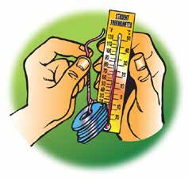

Procedure
- Place a thermometer in your cup to measure the initial temperature of the water. Record the temperature of the water in the “Before” column in the chart on the activity sheet. Be sure to also record the initial temperature of the water in the control cup.
- Use another thermometer to measure the temperature of the washers. Record this in the “Before” column.

Note: It is a little awkward to take the temperature of the washers with a regular thermometer because there is such a small point of contact between the bulb of the thermometer and the surface of the washers. The washers should be about room-temperature.

Ask students to make a prediction:

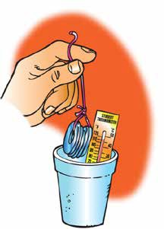
What will happen to the temperature of the water and the washers if you place the washers into the hot water?

- With the thermometer still in the water, hold the string and lower the metal washers all the way into the hot water.
- Observe any change in the temperature of the water. Leave the washers in the water until the temperature stops changing. Record the temperature of the water in each cup in the “After” column.

Room-temperature washers placed in hot water
Temperature of… | Before | After
Water in your cup
Water in the control cup
Metal washers
- Remove the washers from the water. Then take and record the temperature of the washers in the “After” column.
- Empty the cup in a waste container or sink.

Expected results
The temperature of the water will decrease a bit and the temperature of the washers will increase a bit. The amount of temperature decrease and increase is really not that important. What is important is that there is a temperature decrease in the water and a temperature increase in the washers.
Note: Eventually two objects at different temperatures that are in contact will come to the same temperature. In the activity, the washers and water will most likely be different temperatures. For the purposes of this activity, the washers and water are only in contact for a short time, so most likely will not come to the same temperature.
Students may ask why the temperature of the water went down by a different amount than the temperature of the washers went up. The same amount of energy left the water as went into the washers, but it takes a different amount of energy to change the temperature of different substances.
Read more about energy and temperature in the Teacher Background section.

Have students explore what happens when hot metal is placed in room-temperature water.
Ask students:

How do you think the temperature will change if you place hot washers into room-temperature water?

Pour about 30 milliliters of room-temperature water into the control cup. Place a thermometer in the cup and tell students the temperature of the water.

Procedure
- Pour about 30 milliliters of room-temperature water into your Styrofoam cup.
- Place a thermometer into the water and record its temperature in the “Before” column in the chart on the activity sheet. Be sure to also record the initial temperature of the water in the control cup.
- Remove the washers from the hot water where they have been heating and quickly use a thermometer to measure the temperature of the washers. Record this in the “Before” column on your activity sheet.
- With the thermometer still in the water, hold the string and lower the hot metal washers all the way into the water.
- Observe any change in the temperature of the water. Leave the washers in the water until the temperature stops changing. Record the temperature of the water in your cup in the “After” column in the chart below. Also record the temperature of the water in the control cup.
- Remove the washers from the water. Take and record the temperature of the washers.
Hot washers placed in room-temperature water
Temperature of… | Before | After
Water in your cup
Water in the control cup
Metal washers

Expected results
The temperature of the water increases and the temperature of the washers decreases.

Discuss student observations and what may have caused the temperature of the metal washers and water to change.
Ask students:

How did the temperature of the washers and water change in both parts of the activity?
Based on their data, students should realize that the temperature of both the washers and water changed.

Knowing what you do about heating and cooling atoms and molecules, why do you think the temperature changed?
If necessary, guide students’ thinking about why the temperature of each changed by asking them which were probably moving faster, the atoms in the metal washers or the molecules in the water. Tell students that the molecular model animation you will show next will show them why the temperature of both changed.

EXPLAIN

Show two animations to help students understand how energy is transferred from one substance to another.
Show the molecular model animation Heated Spoon.
www.acs.org/middleschoolchemistry/simulations/chapter2/lesson1.html
Point out to students that the water molecules in the hot water are moving faster than the atoms in the spoon. The water molecules strike the atoms of the spoon and transfer some of their energy to these atoms. This is how the energy from the water is transferred to the spoon. This increases the motion of the atoms in the spoon. Since the motion of the atoms in the spoon increases, the temperature of the spoon increases.

It is not easy to notice, but when the fast-moving water molecules hit the spoon and speed up the atoms in the spoon, the water molecules slow down a little. So when energy is transferred from the water to the spoon, the spoon gets warmer and the water gets cooler.

Explain to students that when fast-moving atoms or molecules hit slower-moving atoms or molecules and increase their speed, energy is transferred. The energy that is transferred is called heat. This energy transfer process is called conduction.

Show the molecular model animation Cooled Spoon.
www.acs.org/middleschoolchemistry/simulations/chapter2/lesson1.html
Point out to students that in this case, the atoms in the spoon are moving faster than the water molecules in the cold water. The faster-moving atoms in the spoon transfer some of their energy to the water molecules. This causes the water molecules to move a little faster and the temperature of the water to increase. Since the atoms in the spoon transfer some of their energy to the water molecules, the atoms in the spoon slow down a little. This causes the temperature of the spoon to decrease.
Ask students:

Describe how the process of conduction caused the temperature of the washers and water to change in the activity.

Room-temperature washers in hot water
When the room-temperature washers are placed in hot water, the faster-moving water molecules hit the slower-moving metal atoms and make the atoms in the washers move a little faster. This causes the temperature of the washers to increase. Since some of the energy from the water was transferred to the metal to speed them up, the motion of the water molecules decreases. This causes the temperature of the water to decrease.

Hot washers in room-temperature water
When the hot metal washers are placed in the room temperature water, the
faster-moving metal atoms hit the slower-moving water molecules and make the water molecules move a little faster. This causes the temperature of the water to increase. Since some of the energy from the metal atoms was transferred to the water molecules to speed them up, the motion of the metal atoms decreases. This causes the temperature of the washers to decrease.

Discuss the connection between molecular motion, temperature, and conduction.
Ask students:

How does the motion of the atoms or molecules of a substance affect the temperature of the substance?
If the atoms or molecules of a substance are moving faster, the substance has a higher temperature. If its atoms or molecules are moving slower, then it has a lower temperature.

What is conduction?
Conduction occurs when two substances at different temperatures are in contact. Energy is always transferred from the substance with the higher temperature to the substance at lower temperature. As energy is transferred from the hotter substance to the colder one, the colder substance gets warmer and the hotter substance gets cooler. Eventually the two substances become the same temperature.

Students tend to understand heating but often have a misconception about how things are cooled. Just like heating a substance, cooling a substance also works by conduction. But instead of focusing on the slower-moving molecules speeding up, you focus on the faster-moving molecules slowing down.
The faster-moving atoms or molecules of the hotter substance contact slower-moving atoms or molecules of the cooler substance. The faster-moving atoms and molecules transfer some of their energy to the slower-moving atoms and molecules. The atoms and molecules of the hotter substance slow down, and its temperature decreases.
An object or substance can’t get colder by adding “coldness” to it. Something can only get colder by having its atoms and molecules transfer their energy to something that is colder.

7. Have students draw molecular models to show conduction between a spoon and water.
Note: In the model you will show students, the change in speed of both the water molecules and the atoms in the spoon is represented with different numbers of motion lines. Students may remember that when atoms or molecules move faster, they get further apart, and when they move slower, they get closer together. For this activity, the change in distance between water molecules or between atoms in the spoon is not the focus, and therefore it is not shown in the model. You could tell students that models can emphasize one feature over another in order to help focus on the main point being represented.

Room-temperature spoon placed in hot water
Project the illustrations Spoon in Hot Water Before & After from the activity sheet.
www.acs.org/middleschoolchemistry/simulations/chapter2/lesson1.html

Have students look at the motion lines in the “Before” picture on their activity sheet. Then ask students how the motion of the atoms and molecules would change in the “After” picture. The activity sheet, along with the image you are projecting, does not have motion lines drawn in the “After” picture. Putting these in correctly is the students’ task.
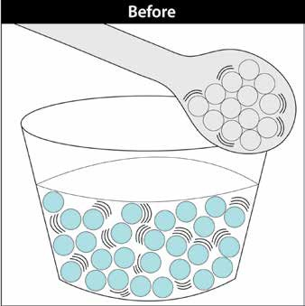
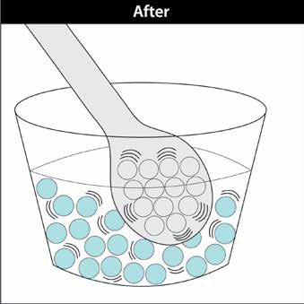

Tell students to add motion lines to the “After” illustration and add descriptive words like “warmer” or “cooler” to describe the change in temperature of the water and the spoon.

The lines have been added in the “After” picture to indicate what students should draw.

Hot spoon placed in room-temperature water

Project the illustrations Hot spoon in room-temperature water before & after from the activity sheet
www.acs.org/middleschoolchemistry/simulations/chapter2/lesson1.html

Have students look at the second set of “Before” and “After” pictures. Tell students to add motion lines to the “After” illustration and add descriptive words like “warmer” or “cooler” to describe the change in temperature of the water and the spoon.

The lines have been added in the “After” picture to indicate what students should draw.
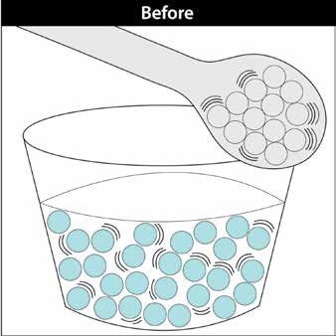
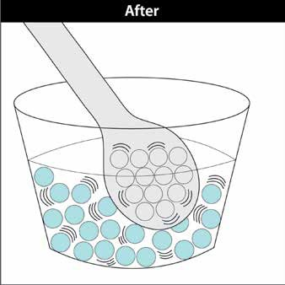

8. Show a simulation to illustrate that temperature is the average kinetic energy of atoms or molecules.
The following simulation shows that at any temperature, the atoms or molecules of a sub- stance are moving at a variety of speeds. Some molecules are moving faster than others, some slower, but most are in-between.

Note: After pressing “Start”, the simulation works best if you cycle through all the buttons before using it for instruction with students.

Show the simulation Temperature.
www.acs.org/middleschoolchemistry/simulations/chapter2/lesson1.html
After cycling through the “Cold”, “Medium”, and “Hot” buttons, choose “Medium” to begin the discussion with students. Tell students that this simulation shows the relationship between energy, molecular motion, and temperature.

Tell students that anything that has mass and is moving, no matter how big or small, has a certain amount of energy, called kinetic energy. The temperature of a substance gives you information about the kinetic energy of its molecules. The faster the molecules of a substance move, the higher the kinetic energy, and the higher the temperature. The slower the molecules move, the lower the kinetic energy, and the lower the temperature. But at any temperature, the molecules don’t all move at the same speed, so temperature is actually a measure of the average kinetic energy of the molecules of a substance.

These ideas apply to solids, liquids, and gases. The little balls in the simulation represent molecules and change color to help visualize their speed and kinetic energy. The slow ones are blue, the faster ones are purple or pink, and the fastest are red.
Explain also that individual molecules change speed based on their collisions with other molecules. Molecules transfer their kinetic energy to other molecules through conduction. When a fast-moving molecule hits a slower-moving molecule, the slower molecule speeds up (and turns more red) and the faster molecule slows down (and turns more blue).

Explain that at any temperature, most of the molecules are moving at about the same speed and have about the same kinetic energy, but there are always some that are moving slower and some that are moving faster. The temperature is actually a combination, or average, of the kinetic energy of the molecules. If you could place a thermometer in this simulation, it would be struck by molecules going at different speeds so it would register the average kinetic energy of the molecules.

To add energy, start with “Cold” and then press “Medium” and then “Hot”.

Ask students:

What do you notice about the molecules as energy is added?
As energy is added, more molecules are moving faster. There are more pink and red molecules but there are still some slower-moving blue ones.

To remove energy, start with “Hot” and then press “Medium” and then “Cold”.

Ask students:

What do you notice about the molecules as energy is removed?
As energy is removed, more molecules are moving slower. There are more purple and blue molecules, but a few still change to pink.

EXTEND

Have students try one or more extensions and use conduction to explain these common phenomena.
Compare the actual temperature and how the temperature feels for different objects in the room.

Ask students:

Touch the metal part of your chair or desk leg and then touch the cover of a textbook. Do these surfaces feel like they are the same or a different temperature?

They should feel different.
  - Why does the metal feel colder even though it is the same temperature as the cardboard of the textbook cover?
Tell students that even though the metal feels colder, the metal and the cardboard are actually the same temperature. If students don’t believe this, they can use a thermometer to take the temperature of metal and cardboard in the room. After being in the same room with the same air temperature, both surfaces should be at the same temperature.

Show the animation Conducting Energy to help answer the question about why metal feels colder than cardboard. www.acs.org/middleschoolchemistry/simulations/chapter2/lesson1.html

Tell students to watch the motion of the molecules in the metal, cardboard, and in the finger.

Explain that the molecules in your finger are moving faster than the molecules in the room-temperature metal. Therefore, the energy from your finger is transferred to the metal. Because metal is a good conductor, the energy is transferred away from the surface through the metal. The molecules in your skin slow down as your finger continues to lose energy to the metal, so your finger feels cooler.

Like the metal, the molecules in your finger are moving faster than the molecules in the room-temperature cardboard. Energy is transferred from your finger to the surface of the cardboard. But because cardboard is a poor conductor, the energy is not easily transferred away from the surface through the cardboard. The molecules in your skin move at about the same speed. Because your finger does not lose much energy to the cardboard, your finger stays warm.

Compare the actual temperature and how the temperature feels for water and air.
Have students use two thermometers to compare the temperature of room-temperature water and the temperature of the air. They should be about the same.

Ask students:

Put your finger in room-temperature water and another finger in the air.
Do the water and the air feel like they are the same or a different temperature?
The finger in the water should feel colder.

Why does the water feel cooler even though it is the same temperature as the air?
Remind students that even though the water feels colder, the water and the air are actually about the same temperature. Students should realize that water is better than air at conducting energy. As energy is drawn more rapidly away from your finger, your skin feels colder.

Consider why cups of cold and hot water both come to room-temperature.
Have students think about and explain the following situation:

Let’s say that you put a cup of cold water in one room and a cup of hot water in another room. Both rooms are at the same room-temperature. Why does the cold water get warmer, and the hot water get cooler?
In both cases, energy will move from an area of higher temperature to an area of lower temperature. So, the energy from room-temperature air will move into the cold water, which warms the water. And the energy from the hot water will move into the cooler air, which cools the water.

