Activity Sheet Answers
Chapter 2, Lesson 2
Changing State—Evaporation

ACTIVITY
- One of the variables in the experiment was the amount of water placed on the brown paper towels. Why was it important to use the same amount of water on both pieces of paper towel?
It is important to use the same amount of water on both paper towels because the experiment is trying to test whether temperature affects the rate of evaporation. The only thing different between the two samples of water should be the temperature they are exposed to. It wouldn’t make sense to use different amounts of water because different amounts could affect how long it takes for the water to evaporate.

- Another variable was when the paper towels were placed on the plastic bags. Why was it important to put each paper towel on the plastic bag at the same time?
In an experiment, the samples being used should be treated the exact same way except for the one thing being tested. If you put one sample on the plastic bag with room temperature water and waited before putting the other on the plastic bag with hot water, this would not be a fair test. The samples would be on different surfaces when they should be treated the same way as much as possible.

- Does adding energy increase the rate of evaporation? What evidence do you have from the experiment to support your answer?
Adding energy does increase the rate of evaporation. The evidence is that the water placed on the hot bag evaporated faster than the same amount of water placed on the room temperature bag.

EXPLAIN IT WITH ATOMS & MOLECULES
You saw an animated model of your experiment showing water molecules evaporating from the paper towels.
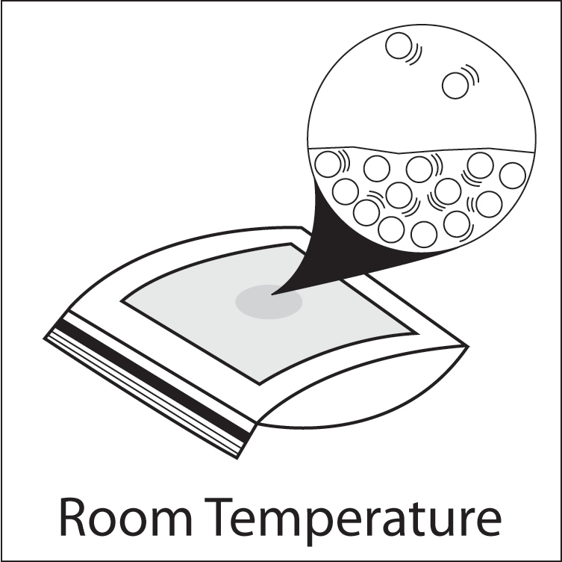
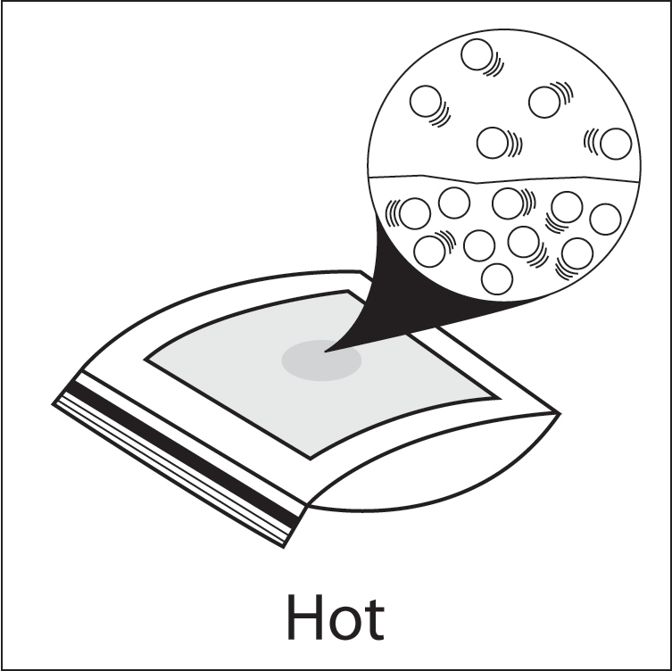

- Explain, on the molecular level, why heating water increases the rate of evaporation from the paper towel.
Adding energy to the water on the paper towel makes the water molecules move faster. This motion competes with the attraction between water molecules and causes more of them to break away and evaporate.

TAKE IT FURTHER
- The wet paper towel from the beginning of class was not heated. Why did the water evaporate anyway?
Even though the wet paper towel was not heated water was able to evaporate because some water molecules were moving fast enough to evaporate.

- You saw an animation using space-filling models of water. When water evaporates do the water molecules themselves break apart or do whole water molecules separate from one another?
When water evaporates, whole water molecules separate from other whole water molecules. The molecules do not come apart into their individual atoms.

