Activity Sheet Name Chapter 2, Lesson 2
Changing State—Evaporation Date

Question to investigate
Does adding energy increase the rate of evaporation?

Materials for each group
- 2 quart-size zip-closing plastic storage bags
- Hot water (about 50 ºC)
- Room-temperature water
- 2 squares of brown paper towel
- 2 droppers

Procedure
  - Add room-temperature water to a zip-closing plastic bag until it is about ¼-filled. Get as much air out as possible, and seal the bag securely. Lay the bag down flat.
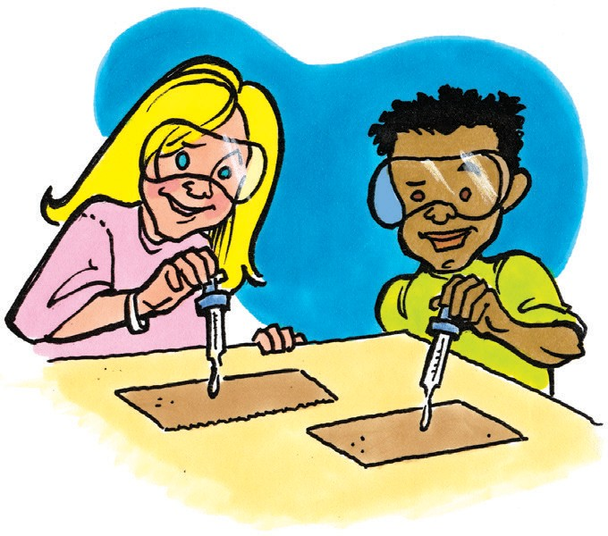
  - Add hot tap water to a different zip-closing plastic bag until it is about ¼-filled. Get as much air out as possible and seal the bag securely. Lay the bag down flat. This bag will serve as a heat source. The bag with the room-temperature water will serve as the control.
  - Place 2 pieces of paper towel on your table. You and your partner should each use a dropper to place 1 drop of room-temperature water in the center of each piece of paper towel at the same time.
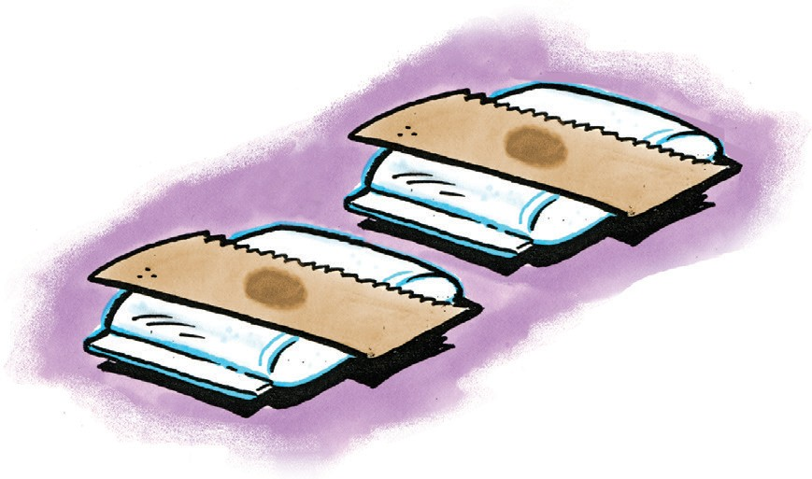
  - Allow the drops to spread for about 10 seconds until they don’t seem to be spreading any more.
  - At the same time, place one paper towel on each bag.
  - Observe every few minutes. Compare the amount of water on each paper towel.

- One of the variables in the experiment was the amount of water placed on the brown paper towels. Why was it important to use the same amount of water on both pieces of paper towel?

- Another variable was when the paper towels were placed on the plastic bags. Why was it important to put each paper towel on the plastic bag at the same time?

- Does adding energy increase the rate of evaporation? What evidence do you have from the experiment to support your answer?

EXPLAIN IT WITH ATOMS & MOLECULES

You saw an animated model of your experiment showing water molecules evaporating from the paper towels.
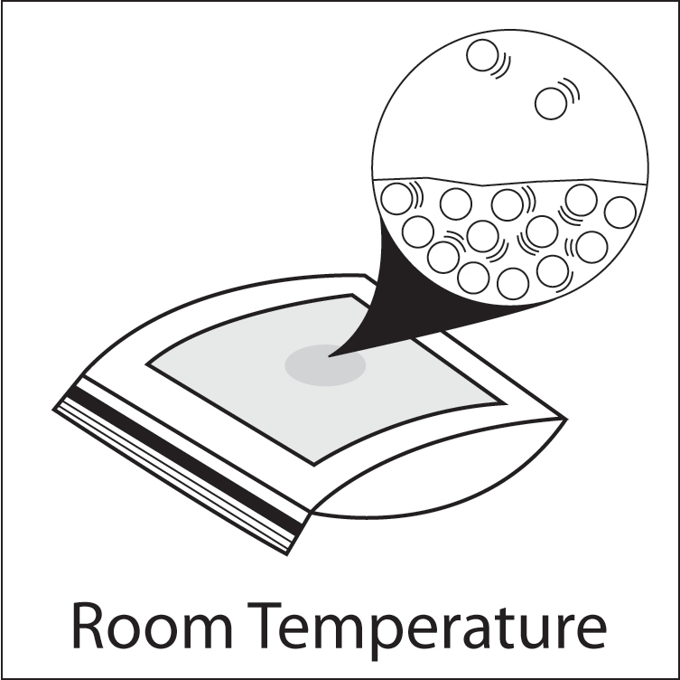
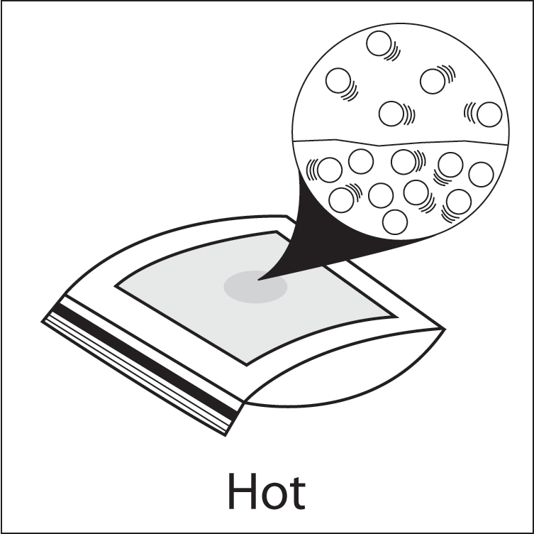

4. Explain, on the molecular level, why heating water increases the rate of evaporation from the paper towel.

Hint: In your answer, remember to include that water molecules are attracted to one another, and that heat increases molecular motion.

TAKE IT FURTHER
5. The wet paper towel from the beginning of class was not heated. Why did the water evaporate anyway?

6. You saw an animation using space-filling models of water. When water evaporates do the water molecules themselves break apart or do whole water molecules separate from one another?

ACTIVITY
Make water molecules that will be used in later lessons to model how water changes state.

Materials for each student
  - 2 Styrofoam balls (11/2-inch)
  - 4 Styrofoam balls (1-inch)
  - 2 flat toothpicks
  - School glue
  - Permanent marker

Procedure
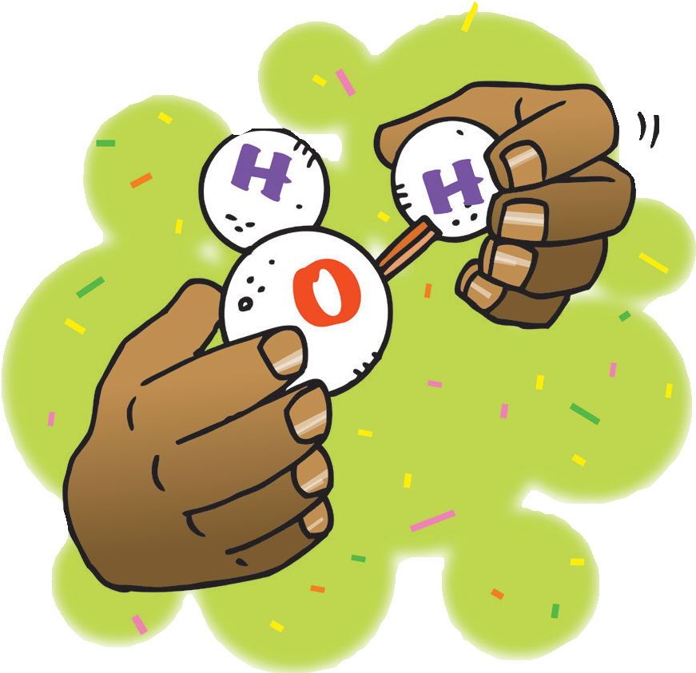
- Break toothpicks in half so that there are 4 half-toothpicks.
- Use a permanent marker to write an O on each of the large balls and an H on each of the small balls.
- Push a half-toothpick about half- way into each small ball.
- Push two small balls onto each larger ball at the angle shown.
- Add 1 or 2 drops of glue where the hydrogen atoms meet the Oxygen atom. Allow the glue to dry overnight.
Contribute your two water molecules to the group.

