Chapter 2, Lesson 4: Changing State—Freezing
Key Concepts
- Freezing is the process that causes a substance to change from a liquid to a solid.
- Freezing occurs when the molecules of a liquid slow down enough that their attractions cause them to arrange themselves into fixed positions as a solid.

Summary
Students will mix ice and salt in a metal can to make it very cold. They will then see liquid water and ice form on the outside of the can. Students will watch an animation of water molecules arranged as ice.

Objective
Students will be able to explain on the molecular level why a low enough temperature can cause the water vapor in air to condense to liquid water and then freeze to form ice.

Evaluation
The activity sheet will serve as the “Evaluate” component of each 5-E lesson plan. The activity sheets are formative assessments of student progress and understanding. A more formal summative assessment is included at the end of each chapter.

Safety
Make sure you and your students wear properly fitting goggles.

Materials for Each Group
- Empty clean metal soup can
- Salt
- Ice
- Metal spoon or sturdy stick
- Teaspoon
- Paper towel

Materials for the Teacher
- Pliers
- Duct tape

About this Lesson
If the level of humidity in your classroom is too low, you cannot do the activities in the Explore section of this lesson. However, you can still teach the lesson by showing students the video “Ice on a Can”. It may be helpful to show students the difference in your results: www.acs.org/middleschoolchemistry/simulations/chapter2/lesson4.html

ENGAGE

Show students that liquid water expands when it freezes to become solid ice.
Teacher Preparation
  - Place 50 milliliters of water into a plastic 100 ml graduated cylinder and place it in the freezer overnight.
  - The next day, bring it into class and show students that the level of ice is higher than the level of water you started with. Explain to students that as water freezes, it expands and takes up more space than it did as liquid water.

Show the movie Ice Bomb
www.acs.org/middleschoolchemistry/simulations/chapter2/lesson4.html
This video is from the Chemistry Comes Alive! series and is used with permission from the Division of Chemical Education of the American Chemical Society.
Ask students:
- Why do you think freezing water in the metal container caused it to burst?
Water molecules move further apart when water freezes. This movement caused the metal container to burst.
- Why are roads likely to develop potholes during cold winters? Hint: Think about what happened to the metal container.
When water gets in small cracks in the road and freezes it expands and breaks the asphalt. When this continues to happen below the surface, it eventually forms a pothole.
Ask students:

What do you think happens to water molecules when liquid water changes to solid ice?
Students learned that when water vapor is cooled, attractions between water molecules cause them to condense and become liquid water. Students may say that the water molecules slow down enough that their attractions hold them together as ice.
Note: Students may say that water molecules get closer together to form ice. Water is unusual because its molecules move further apart when it freezes. The molecules of just about every other substance move closer together when they freeze. This will be covered in more detail in Chapter 3, Density.

Give each student an activity sheet.
Students will record their observations and answer questions about the activity on the activity sheet. The Explain It with Atoms & Molecules and Take It Further sections of the activity sheet will either be completed as a class, in groups, or individually depending on instructions. Look at the teacher guide to find the questions and answers.

EXPLORE

2. Have students chill a metal can so that ice forms on it.

Question to investigate
How can you make the water vapor in air condense and then freeze?

Materials for each group
  - Empty clean metal soup can
  - Salt
  - Ice
  - Metal spoon or sturdy stick
  - Teaspoon
  - Paper towel

Materials for the teacher
  - Pliers
  - Duct tape

Teacher preparation
Use pliers to bend sharp edges on the can down. Then cover the rim with 2–3 layers of duct tape to prevent possible injuries.

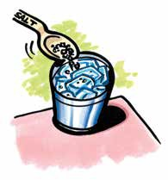
Procedure
- Dry the outside of a can with a paper towel.

- Place 3 heaping teaspoons of salt in the bottom of the can. Fill the can about halfway with ice.

- Add another 3 heaping teaspoons of salt.

- Add more ice until the can is almost filled and add another 3 teaspoons of salt.
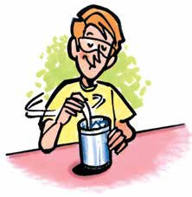
- Hold the can securely and mix the ice-salt mixture with a metal spoon or sturdy stick for about 1 minute. Remove the spoon, and observe the outside of the can. Do not touch it yet.

- Wait 3–5 minutes. While you wait, watch the animations.

Note: After completing Step 5, you may choose to have students place a thermometer inside the can. The temperature of the salt and ice mixture will be below the normal freezing point of water, which is 0 °C.
Read more about why salt lowers the temperature of an ice water mixture in Teacher Background.

Expected results
A thin layer of ice will appear on the outside of the can. Students may also see liquid water on the upper part of the can where it isn’t as cold.

Discuss student observations and ask how the attractions and motion of molecules can explain the changes in state.
Ask students:

Look at and touch the outside of the can. What do you observe?
A thin layer of ice covers the coldest part of the can. Some small drops of water may appear higher on the can where it is not as cold.

Describe what happens to water molecules as they move from being water vapor near the can to ice on the can.
Water vapor molecules in the air near the can cooled when energy from the air transferred to the cold can. These water molecules slowed down, condensed to liquid water, and then froze to become ice.

Your can might have some water and some ice on the outside of it. Explain how this is possible.
Tiny drops of water appear on the part of the can above the ice because the molecules slow down and condense to liquid water. Ice appears on the colder part of the can because the water vapor that came in contact with this part of the can was cooled so much that it froze.

Give students time to answer questions about the activity and the animations.

EXPLAIN

Show a molecular model animation to help students visualize what happens when water freezes.
Project the animation Ice structure
www.acs.org/middleschoolchemistry/simulations/chapter2/lesson4.html
Point out that when water freezes, the water molecules have slowed down enough that their attractions arrange them into fixed positions. Water molecules freeze in a hexagonal pattern and the molecules are further apart than they were in liquid water.
Note: The molecules in ice would be vibrating. The vibrations are not shown here but are shown on the next animation.

Project the animation Ice different angles
www.acs.org/middleschoolchemistry/simulations/chapter2/lesson4.html
Explain that this animation shows different views of the ice crystal. Point out that even though the ice is cold the molecules still have motion. They vibrate but cannot move past one another.

Have students compare molecular models of liquid water and ice.
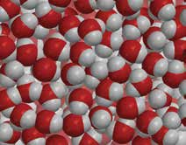
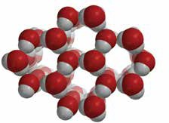
Project the image Water and Ice
www.acs.org/middleschoolchemistry/simulations/chapter2/lesson4.html

Ask students:

What are some of the differences between liquid water and solid ice?
The molecules in liquid water are closer together than they are in ice. Compared to other substances, water is unusual in this way. The molecules in the liquid are moving past one another. The hydrogen end of one water molecule is attracted to the oxygen end of another but only for a short time because they are moving.
The molecules in ice are further apart than in liquid water. This is why ice floats in water. The molecules in ice are in fixed positions but still vibrate.

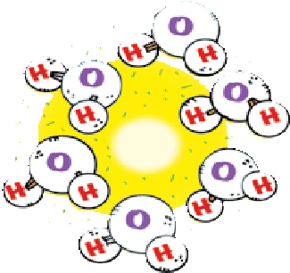
Have each group arrange their water molecules into a six-sided ring of ice.
Students do not need to orient the molecules exactly as they are in the space-filling model, but they should try to have a hydrogen atom of one molecule near an oxygen atom of another. Ask students to handle their models gently because they will need them for other lessons.

Discuss why different liquids have different freezing points.
Tell students that the temperature at which a substance freezes is called the freezing point. The freezing point of water is 0 °C (32 °F). Corn oil and isopropyl alcohol have lower freezing points than water. This means that they need to be cooled to lower temperatures to make them freeze.

Water | 0 °C
Corn oil | about –20 °C
Isopropyl alcohol | –88.5 °C

Ask students:

Why do you think different liquids have different freezing points?
Help students realize that each liquid is made up of different molecules. The molecules of a liquid are attracted to each other by different amounts. The molecules have to slow down to different levels before their attractions can take hold and organize them into fixed positions as a solid.

Have students consider the freezing point of a gas.
Tell students that the air around them is made of different kinds of gases. The attractions between the molecules of gases in air (except water vapor) are so weak that they need to be cooled to very low temperatures in order to condense to a liquid or freeze to a solid.

Nitrogen gas makes up about 80% of the air. If nitrogen is made cold enough, the weak attractions between its molecules can cause it to condense to a liquid. Nitrogen condenses to a liquid at –196 °C.

Show the video Liquid Nitrogen.
Have students observe how cold liquid nitrogen is by watching the following video.
www.acs.org/middleschoolchemistry/simulations/chapter2/lesson4.html

EXTEND

Show some pictures of frost and introduce how substances can sometimes change directly from a gas to a solid.
Tell students that under some conditions a gas can turn directly to a solid without going through the liquid phase. Explain that this process is called deposition. Some of the ice that formed on the outside of the metal can may have been a result of deposition.
Read more about how changes of state relate to the weather in Teacher Background.

Project the image Frost.
www.acs.org/middleschoolchemistry/simulations/chapter2/lesson4.html
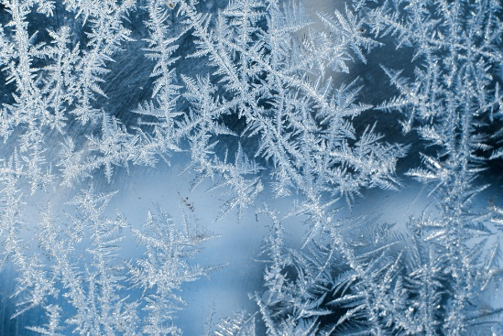
Tell students that the frost that forms on the ground, windows, or grass in winter is formed by deposition.

Give students time to answer questions about freezing points, nitrogen, and deposition to complete their activity sheets for this lesson.

You could also show students images of snowflakes from
www.its.caltech.edu/~atomic/snowcrystals and the video of a snowflake forming at snowcrystals.com/videos/videos.html.

